Additional Problems: Linear & Exponential Sequences

**Exponential Decay**

1. Gabriella buys a bag of 30 apples on the first day. The second day, she eats one-third of the bag. Each day after, she eats one-third of what is left in the bag. Create a sequence formula that describes the number of apples Gabriella will have on any given day.
2. Jahmar buys a bag of 40 candies on the first day. The second day, he eats one-fourth of the bag. Each day after, he eats one-fourth of what is left in the bag. Create a sequence formula that describes the number of candies Jahmar will have on any given day.
3. In a certain forest, the population of a particular species of birds is decreasing at a rate of 4% per year. If there are currently 800 birds in the forest, create an exponential decay function to model the problem. If the decrease in population continues at this rate, how many birds will be in the forest after 15 years? Round your answer to the nearest whole number.

After 15 years there will be ______ birds.

1. In a specific lake, the fish population is declining at a rate of 3.5% per year. If there are currently 1,200 fish in the lake, create an exponential decay function to model the problem. If the decrease in population continues at this rate, how many fish will be in the lake after 20 years? Round your answer to the nearest whole number.

After 20 years there will be ______ fish.

1. In a specific forest, the population of a particular species of deer is decreasing at a rate of 5% per year. If there are currently 150 deer in the forest, create an exponential decay function to model the problem. Let *y* represent the number of deer after *t* years.
   1. y = 150(0.5)^t
   2. y = 150(0.05)^t
   3. y = 150(0.95)^t
   4. y = 150(1.05)^t
2. In a certain lake, the population of a type of fish is decreasing at a rate of 3% per year. If there are currently 200 fish in the lake, create an exponential decay function to model the problem. Let *y* represent the number of fish after *t* years.
   1. y = 200(0.3)^t
   2. y = 200(0.03)^t
   3. y = 200(0.97)^t
   4. y = 200(1.03)^t
3. Use the table to answer the question

|  |  |  |  |  |  |
| --- | --- | --- | --- | --- | --- |
| Years(t) | 0 | 3 | 6 | 9 | 12 |
| Number of Bacteria |  |  |  |  |  |

Complete the input-output table and determine which graph matches the sequence of the decay rate of a specific species of bacteria modeled by the equation y = 8,000(0.90)^t.

Determine which graph matches the sequence of decay rate.

* 1. 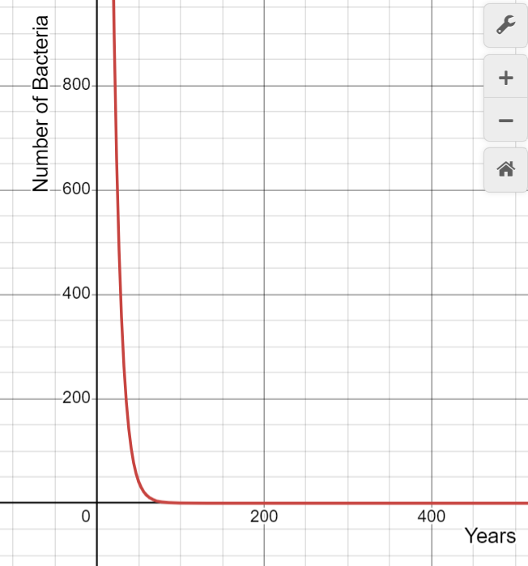
  2. 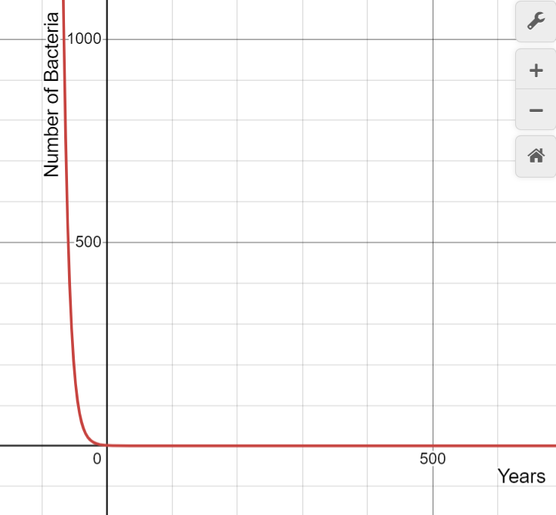
  3. 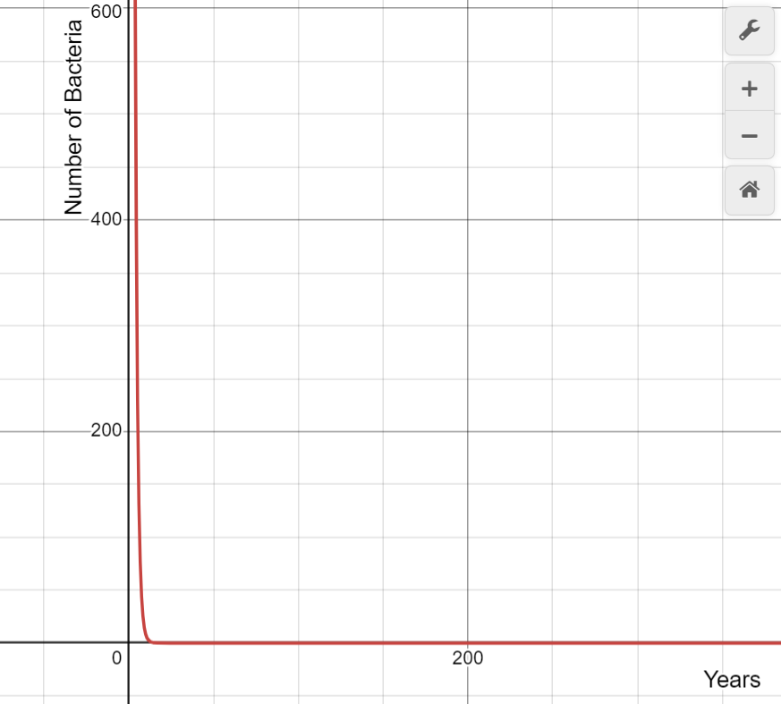
  4. 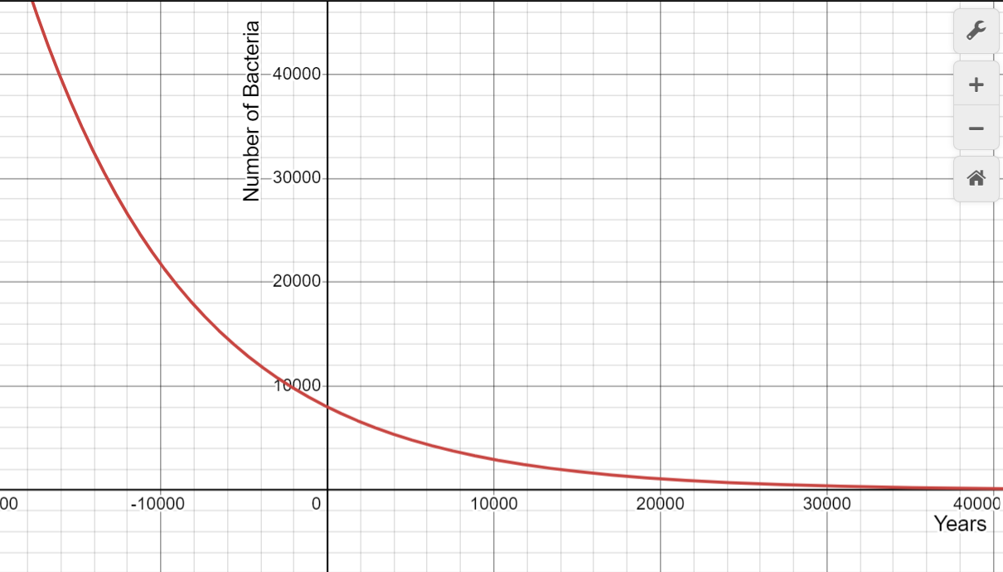

1. Use the table to answer the question

|  |  |  |  |  |  |
| --- | --- | --- | --- | --- | --- |
| Years(t) | 0 | 4 | 8 | 12 | 16 |
| Number of Fish |  |  |  |  |  |

Complete the input-output table and determine which graph matches the sequence of the decay rate of a specific species of fish modeled by the equation y = 5,500(0.85)^t.

Determine which graph matches the sequence of decay rate.

* 1. 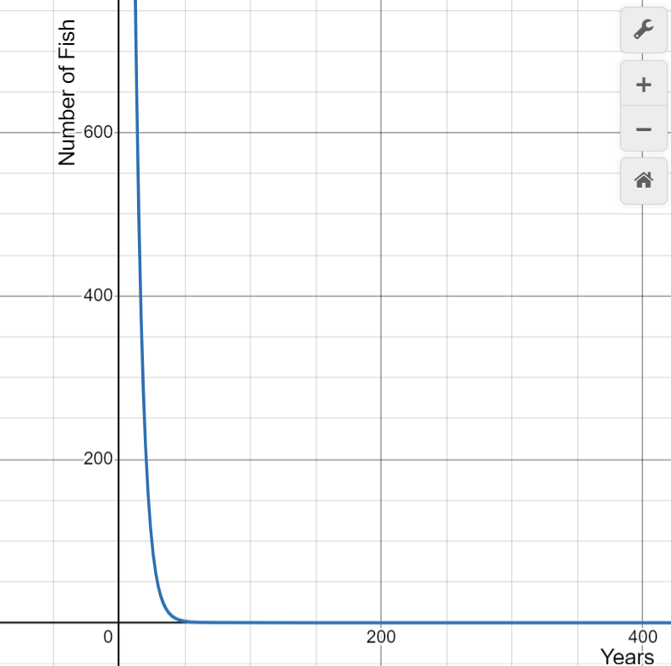
  2. 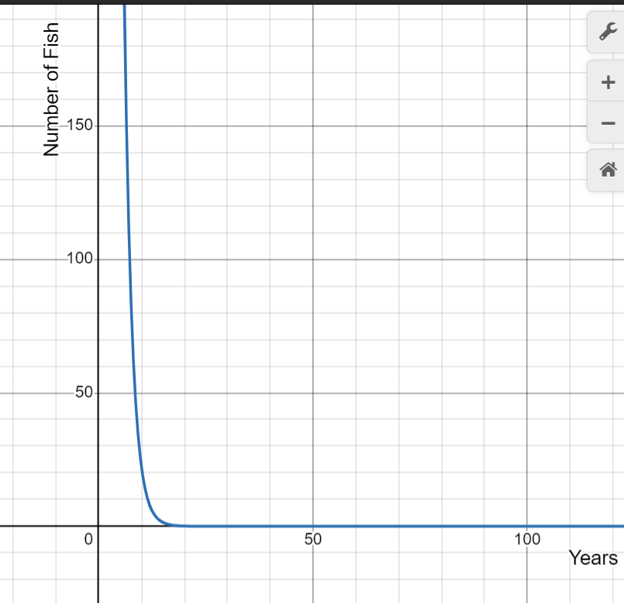
  3. 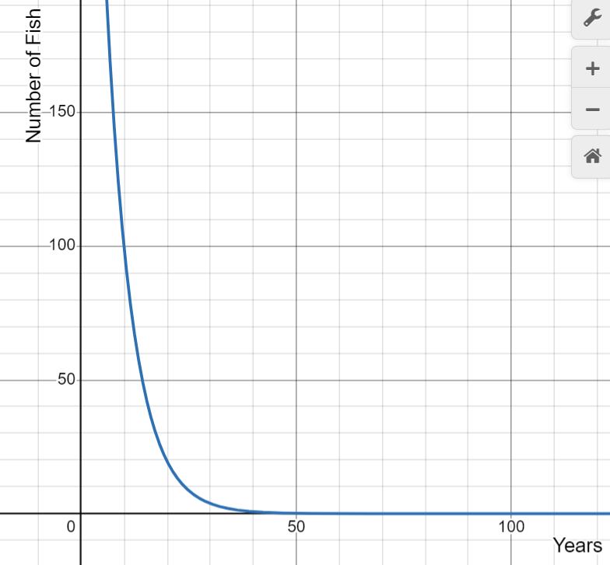
  4. 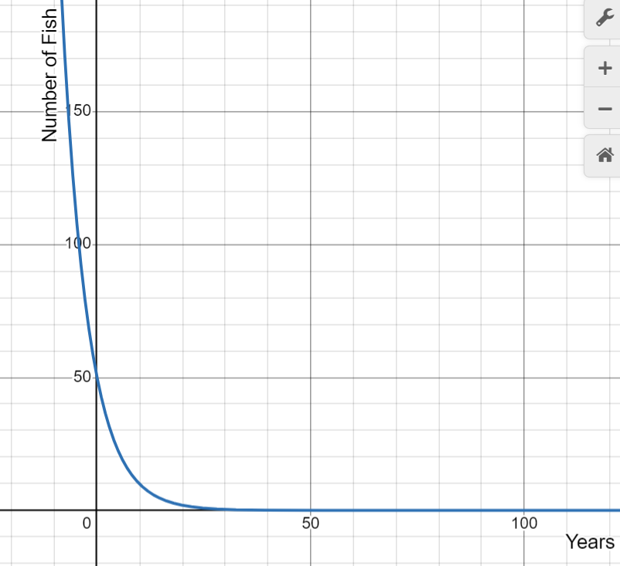

1. A car was purchased for $30,000. After 5 years, the car's value had depreciated at a rate of 8 percent per year. Which equation would you use to create a sequence modeling this situation?
   1. $a_{n}$ = 30,000(0.92)^n
   2. $a_{n}$ = 30,000(0.92)^n-1
   3. $a_{n}$ = 30,000(0.08)^n
   4. $a_{n}$ = 30,000(0.08)^n-1
2. A piece of machinery was bought for $50,000. Over the next 7 years, it depreciated at a rate of 5 percent per year. Which equation would you use to create a sequence modeling this situation?
   1. $a_{n}$ = 50,000(0.95)^n
   2. $a_{n}$ = 50,000(0.95)^n-1
   3. $a_{n}$ = 50,000(0.05)^n
   4. $a_{n}$ = 50,000(0.05)^n-1