Additional Problems: Linear & Exponential Sequences

**Arithmetic Sequences**

1. Dante and Yusuf are collecting books for the local library. For every person they ask to donate, they receive an average of 5 books. Create a table and graph an arithmetic sequence to model this scenario. What would be the most appropriate label for the y-axis?
2. Liam and Katelynn are collecting toys for a children's charity. For every person they ask to donate, they receive an average of 7 toys. Create a table and graph an arithmetic sequence to model this scenario. What would be the most appropriate label for the y-axis?
3. Ja’cori and Bailey are planting trees for an environmental project. On day one, they planted 4 trees, on day two, they planted 9 trees, and on day three, they planted 14 trees. What is the slope for this arithmetic sequence?
   1. 4
   2. 5
   3. 6
   4. 9
4. Owen and Jayda are making handmade cards. On day one, they made 7 cards, on day two, they made 13 cards, and on day three, they made 19 cards. What is the slope for this arithmetic sequence?
   1. 5
   2. 7
   3. 6
   4. 12
5. Use the table to answer the question.

|  |  |
| --- | --- |
| **x** | **y** |
| 1 | A |
| 3 | b |

Use the arithmetic sequence formula $a_{n}$ = 4 + (n-1) • 5 to find the missing values in the table.

* 1. a=4; b=9
  2. a=5; b=12
  3. a=4; b=14
  4. a=6; b=16

1. Use the table to answer the question.

|  |  |
| --- | --- |
| **x** | **y** |
| 2 | A |
| 5 | b |

Use the arithmetic sequence formula $a_{n}$ = -7 + (n-1) • 4 to find the missing values in the table.

* 1. a=-3; b=9
  2. a=-5; b=7
  3. a=-3; b=8
  4. a=-2; b=10

1. Santiago has $50.00 and wants to buy notebooks. If each notebook costs $6.00, create a table and graph the arithmetic sequence to display how much money Santiago has left after each notebook purchase. Which graph is an accurate representation of the problem?
   1. 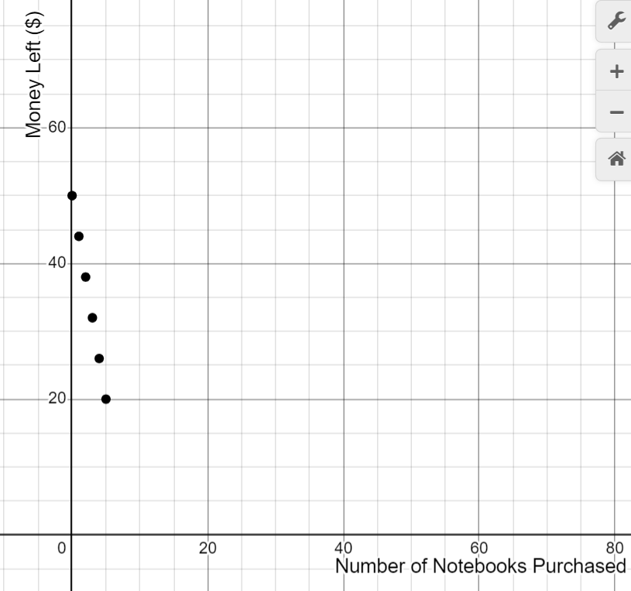
   2. 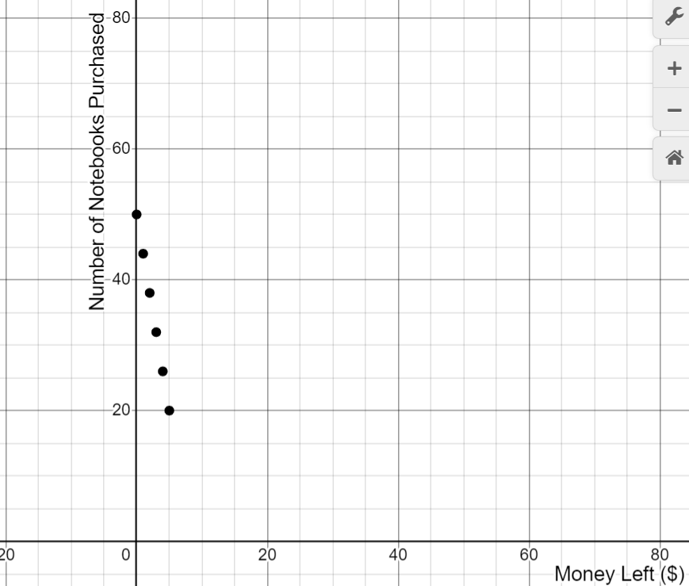
   3. 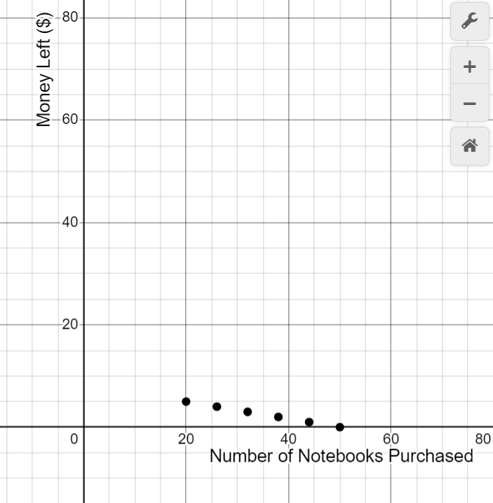
   4. 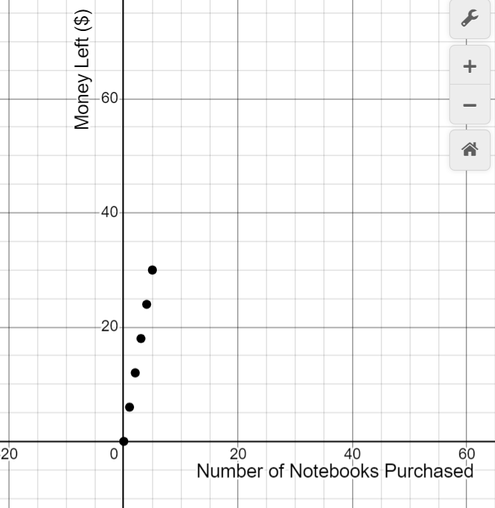
2. Alaza has $35.00 and wants to buy action figures. If each action figure costs $5.00, create a table and graph the arithmetic sequence to display how much money Alaza has left after each action figure purchase. Which graph is an accurate representation of the problem?
   1. 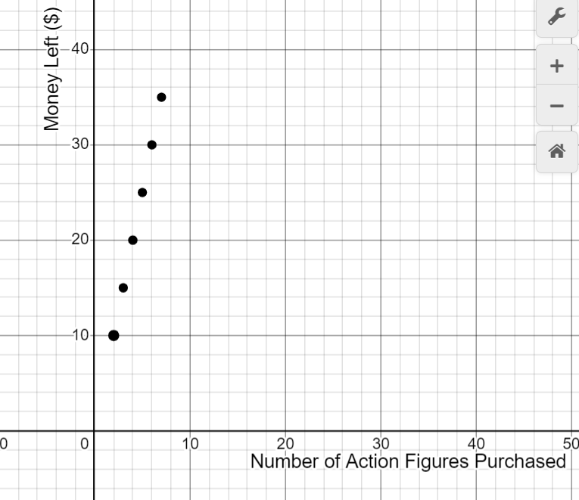
   2. 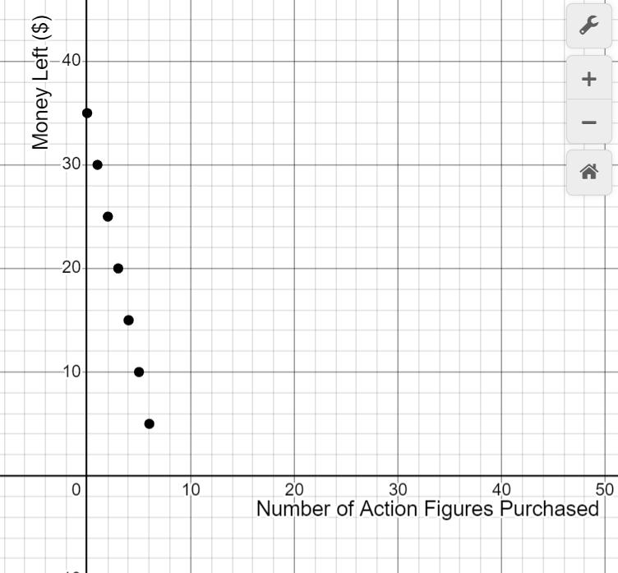
   3. 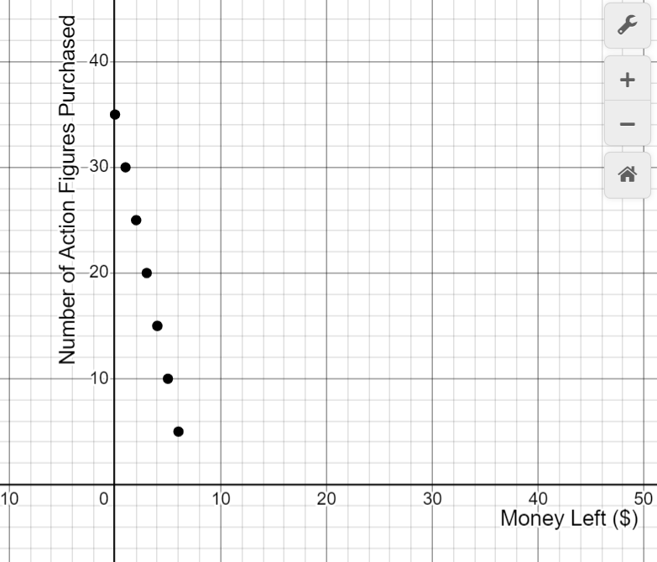
   4. 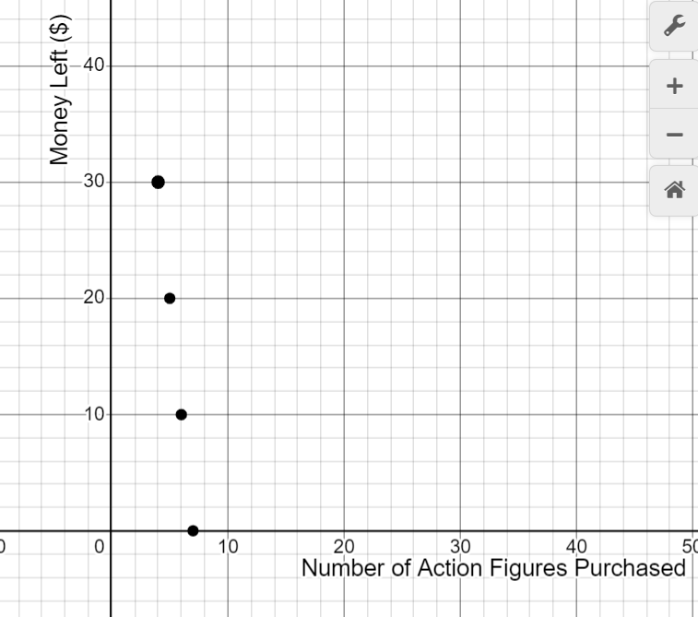
3. To show that arithmetic sequence formulas have the same structure as linear functions, choose the linear function equation that has the same structure as the arithmetic sequence $a_{n}$ =3+(n−1)⋅5.
   1. y = 5x + 3
   2. y = 3x – 5
   3. y = 5x – 2
   4. y = 2x + 5
4. To show that arithmetic sequence formulas have the same structure as linear functions, choose the linear function equation that has the same structure as the arithmetic sequence $a_{n}$ =-4+(n−1)⋅7.
   1. y = 7x - 11
   2. y = 11x - 7
   3. y = -4x + 7
   4. y = 7x - 4