Additional Problems: Polynomial Functions & Graphs

**Roots of Polynomials**

Solutions are listed with some problems. Be sure to remove before using with students.

1. Factor to solve the equation $3x^{2}+9x+4=-5$.

a. $x=-1$

b. $x=1$

c. $x=-\frac{4}{3}$

d. $x=-\frac{4}{3}$

**Solution: $x=-\frac{4}{3}$

1. Factor to solve the equation $2x^{2}+8x+3=-2$.

a. $x=-\frac{3}{2}$

b. $x=\frac{3}{2}$

c. $x=-1$

d. $x=1$

**Solution: $x=-1$

1. Factor to solve the equation $5x^{2}+15x+6=-7$.

a. $x=-1$

b. $x=1$

c. $x=-2$

d. $x=2$

**Solution: $x=-1$

1. What are the additional linear factors of $x^{3}-5x^{2}+6x-4$ if $x-2$ is a factor?

a. $\left(x-1\right)\left(x-2\right)$

b. $\left(x-2\right)\left(x+1\right)$

c. $\left(x-2\right)\left(x-3\right)$

d. $\left(x-1\right)\left(x+2\right)$

**Solution: $\left(x-1\right)\left(x-2\right)$

1. What are the additional linear factors of $x^{3}-4x^{2}+3x-2$ if $x-1$ is a factor?

a. $\left(x-2\right)\left(x-1\right)$

b. $\left(x-1\right)\left(x+2\right)$

c. $\left(x-2\right)\left(x+1\right)$

d. $\left(x-1\right)\left(x-3\right)$

**Solution: $\left(x-2\right)\left(x+1\right)$

1. What are the additional linear factors of $x^{3}-7x^{2}+14x-8$ if $x-4$ is a factor?

a. $\left(x-2\right)\left(x-1\right)$

b. $\left(x-4\right)\left(x-2\right)$

c. $\left(x-2\right)\left(x-3\right)$

d. $\left(x-1\right)\left(x-4\right)$

**Solution: $\left(x-2\right)\left(x-1\right)$

1. Find the zeros of $f\left(x\right)=x^{3}-6x^{2}+11x-6$, given the graph.

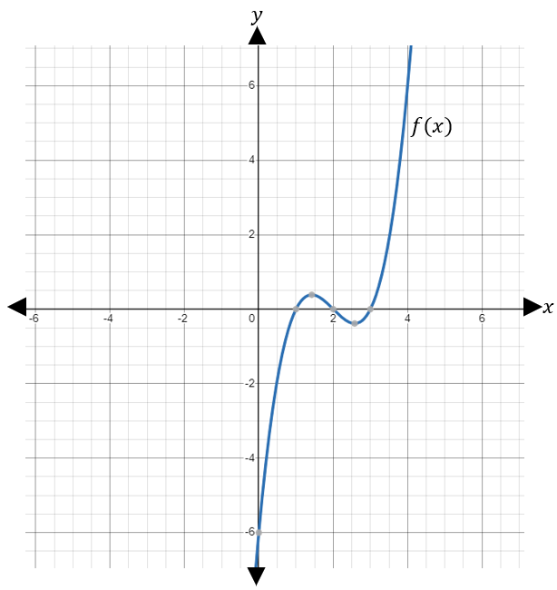

** Solution: $x=\left\{1, 2, 3\right\}$

1. Find the zeros of $p\left(x\right)=x^{3}-4x^{2}-7x+10$, given the graph.

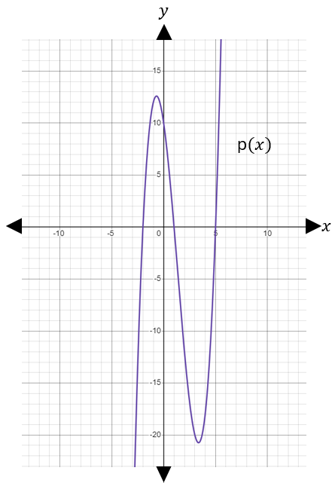

**Solution: $x=\left\{-2, 1, 5\right\}$

1. Find the zeros of $f\left(x\right)={2x}^{3}+5x^{2}-4x-3$, given the graph.

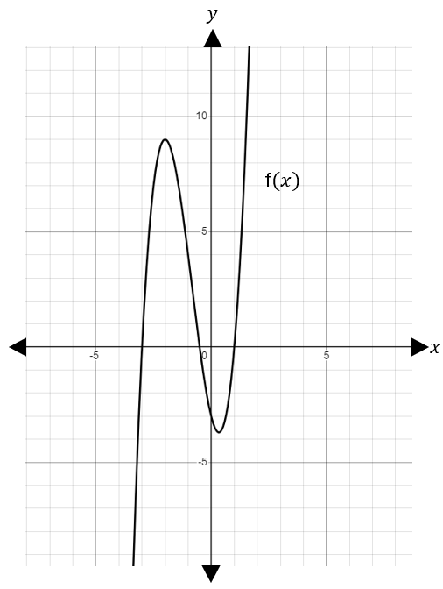

** Solution: $x=\left\{-3, - \frac{1}{2}, 1\right\}$