Additional Problems: Quadratic Equations

**Graphs of Quadratic Equations**

1. Identify the vertex and axis of symmetry of the parabola
   1. 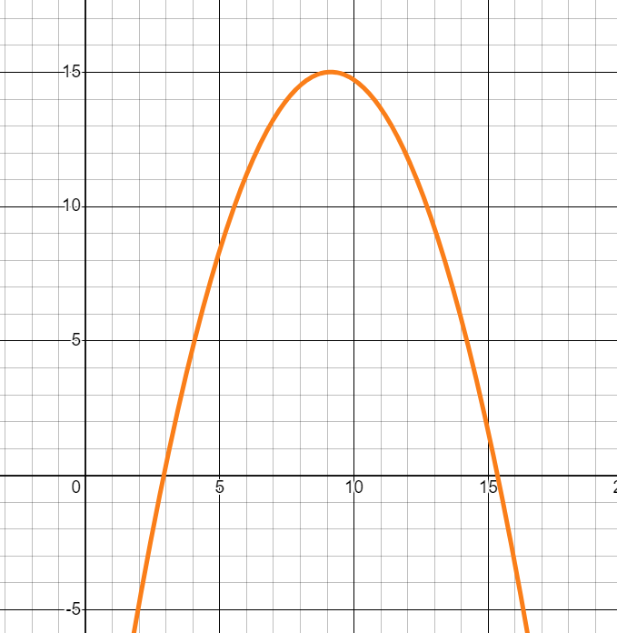
2. Identify the vertex and axis of symmetry of the parabola
   1. 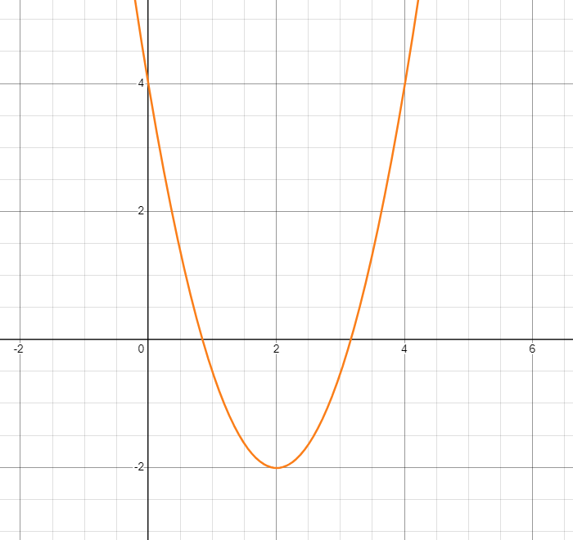
3. Identify the vertex and axis of symmetry of the parabola
   1. 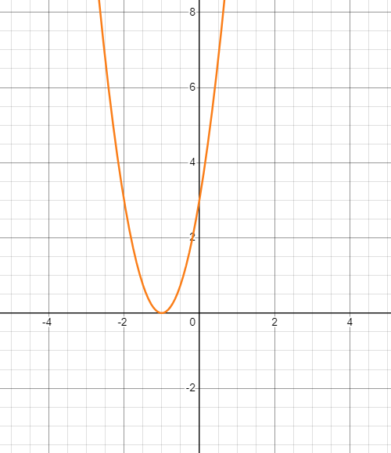
4. Which of the following is a point you can generate to create the parabola for the quadratic equation y = 2x^2 – 4x + 1?
   1. (1, -1)
   2. (2, 3)
   3. (0, 1)
   4. (-1, 7)
5. Which of the following is a point you can generate to create the parabola for the quadratic equation y = x^2 + 5x – 4?
   1. (2, 2)
   2. (3, 2)
   3. (1, 0)
   4. (4, 0)
6. Identify one of the zeros (or x-intercepts on the graph)

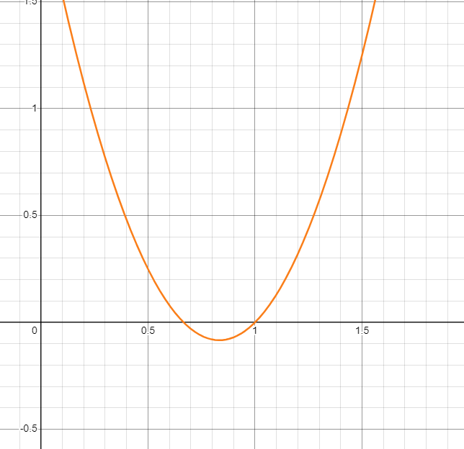

* 1. (1, 0)
  2. (0, 0)
  3. X=1
  4. (-1, 0)

1. Complete all four problems linked [here](https://www.khanacademy.org/math/algebra/x2f8bb11595b61c86:quadratic-functions-equations/x2f8bb11595b61c86:quadratic-forms-features/e/graphing_parabolas_2).