* **Unit 2 Lesson 2: Why Study History?**
* **The Value of History**

**Objective 1**: In this section, you will discuss why historians study the past.

**Essential Question**: Why study the past?

**Key Terms**:

1. Empathy: Understanding and sharing the feelings of others.

2. Ethical: Acting in a way that is right and true to your values.

3. Inclusion: Valuing and accepting everyone.

4. Perspective: Seeing things from other people's viewpoints.

5. Social Justice: Working to ensure everyone is treated fairly and has equal rights.

**Big Ideas**:

• Understanding Different Perspectives: Studying history is more than remembering dates and names. It's about seeing events from different viewpoints. By doing this, we can find patterns and themes that help us understand our world today. 

• Contextualizing the Present: History helps us understand why things are the way they are now. It shows us the root causes of today's issues.

• Empathy and Ethical Judgment: Learning about the past helps us develop empathy. We can better understand others' experiences. It also helps us make fair judgments by learning from past mistakes.

• Recognizing Multiple Histories: History is made up of many stories, not just one. Looking at different viewpoints helps us get a complete picture.

• Creating Inclusion: Studying history from different perspectives helps everyone feel like they belong. It helps us understand our complex world.

**Check-In:**

1. In what ways can studying the past benefit our lives today?

- Answer: Studying history can help us understand our world and ourselves. Studying history can also address situations we believe to be unjust.

2. How does the study of history help us understand today’s societal norms?

- Answer: By studying history, we can examine past decisions and events that created the world in which we live today.

**Practice:**

1. How does the study of history help develop empathy?

- Answer: The study of history requires us to look at multiple viewpoints to understand others’ experiences.

2. How can the study of history help people challenge unjust systems?

- Answer: Understanding the historical context in which unjust decisions were made helps us better understand how to address them.

* **Using History Today**

**Objective 2**: In this section, you will discuss why historians study the past.

**Essential Question**: How and why is the study of the past important to our lives today?

**Key Terms**:

1. Geopolitical: Related to international relations, geography, and politics.

2. Narrative: A story or framework for understanding.

3. Perspective: Seeing things from other people's viewpoints.

4. Symbolism: Using images or visuals to show meaning.

5. Empathy: Understanding and sharing the feelings of others.

**Big Ideas**:

• Historical Context and Current Issues: Knowing history helps us address current problems. For example, understanding why Spanish is spoken in South America involves looking at Spanish conquests.

• Multicultural Understanding: The world is interconnected. Understanding diverse perspectives helps us interact globally.

• Symbolic Connections: Architecture and images often connect to historical influences. For instance, U.S. government buildings look like Greek and Roman structures to symbolize power and stability. 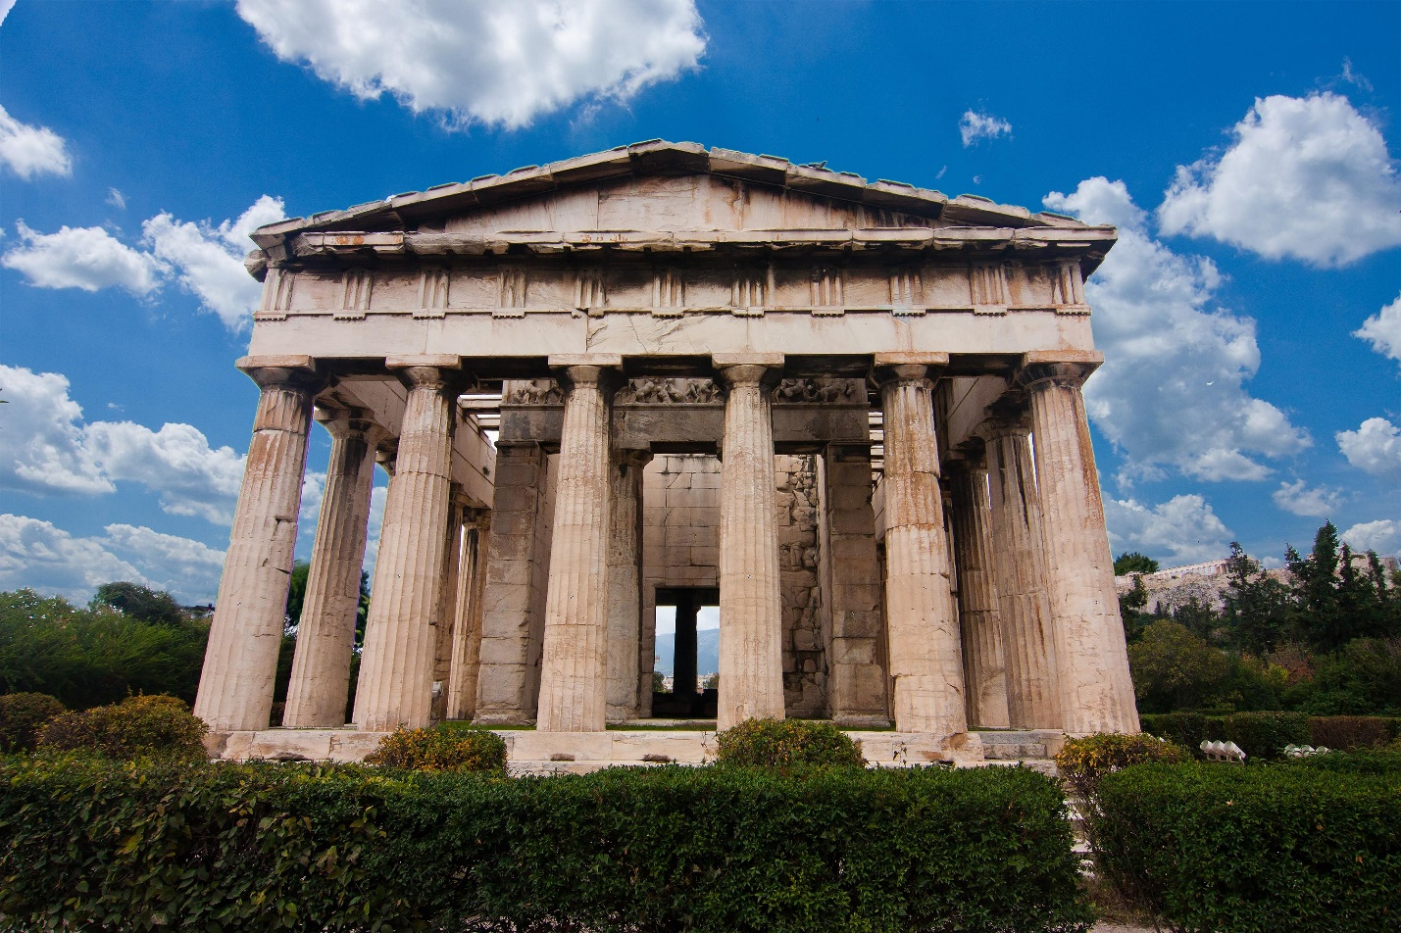

• Universal Human Experience: Learning about stories from the past, like ancient cave paintings, connects us to people throughout history, showing our shared human experiences.

**Check-In:**

1. What is one of the best ways to find answers to geopolitical questions?

- Answer: Look to the past.

2. What are many U.S. government buildings modeled upon?

- Answer: Important Greek and Roman structures.

**Practice**:

1. Imagine you were asked to design a new government building. Think creatively about the symbolic messages you might want to convey. What would your building look like?

- Answer: I would design a government building to look like a Greek temple with columns like the Temple of Hephaestus. Greek temples were a big part of Greek society and I’d want my government building to carry the same importance.

2. Recall an important event in your life. How did you experience it? How might others who witnessed it have a different experience? Think creatively to make a drawing or sketch that displays these different experiences in your journal.

- Sample answer: I won a 5k in my town and I was so proud of myself. It was a great experience for me. One of my competitors that came in second place was really disappointed and she was not happy after the race. Though we both participated in the event, we had very different perspectives on the race. In my sketches, I drew myself really happy after winning and my opponent really sad after losing.

* **The "How" and "Why"**

**Objective 3**: In this section, you will explain the importance of studying history in our everyday lives.

**Essential Question**: How and Why is the study of the past important to our lives today?

**Key Terms**:

1. Bias: Favoring or being against a person or group unfairly.

2. Collective Memory: Shared information and stories passed down through generations.

3. Historical Context: Details surrounding an event.

4. Historiography: The writing of history.

5. Identity: How people see themselves and what they believe.

**Big Ideas**:

• Foundation of Memory and Identity: History shapes our shared memories and identity, influencing our values and understanding of ourselves.

• Contextual Understanding: Knowing the context of events helps us understand movies, books, and other cultural things better.

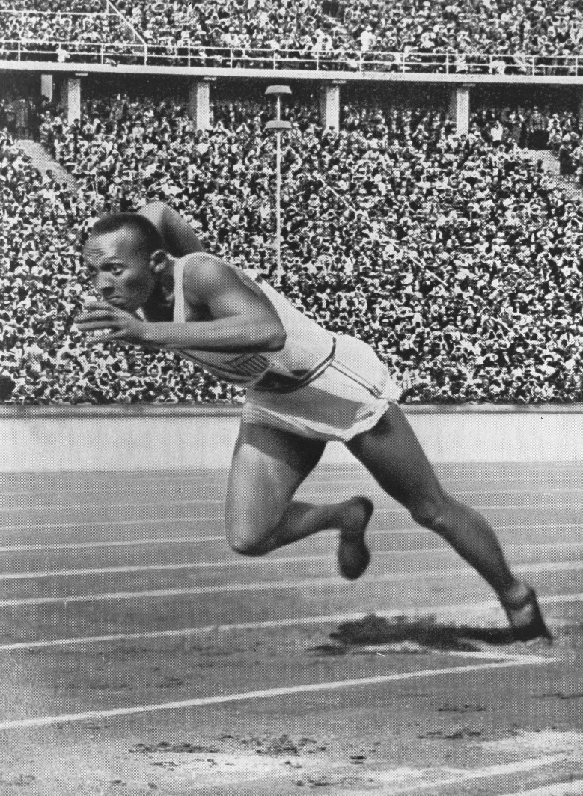

• Historiography: Studying how history is written helps us see different biases and viewpoints.

• Living History: Our current cultural practices are linked to historical events, reinforcing our sense of identity.

**Check-In:**

1. When studying history, remembering people, events, key dates, and places should be considered the __________.

- Answer: Starting point.

2. Imagine you are writing a paper on track-and-field star Jesse Owens and the 1936 Berlin Olympics. In your report, what kind of source would a photograph of Jesse Owens from his race be?

- Answer: Primary source.

**Practice:**

1. Why is learning the historical context of a book, song, movie, or video game important?

- Answer: Knowing the historical context can make a book, song, movie, or video game with a historical setting more meaningful.

2. Think of the tree ring example from the video. What important information about the tree’s life could be learned from a secondary source?

- Sample answer: Investigating a secondary source could give me information about the climate the tree grew in, as drought or heavy rains could have changed the pattern of the tree's growth. These sources could also tell me about the environment or events that occurred during the tree’s life.

* **The Value of Analysis**

**Objective 4**: In this section, you will summarize why historical issues are important to analyze.

**Essential Question**: How did farming change human societal organization?

**Key Terms**:

1. Analysis: Investigating historical evidence to understand the event and its implications.

**Big Ideas**:

• Investigating Like Detectives: Historians analyze past events like detectives, putting together clues to understand why things happened.

• Connecting Past to Present: Historical analysis helps us see patterns, offering insights into current events.

• Contextualizing Protests (Example: Hong Kong): Protests in Hong Kong trace back to the Opium Wars and British control, helping us understand the current situation better.

• Predicting Outcomes: Analyzing past events helps us predict future outcomes and develop empathy by understanding different viewpoints.

**Check-In:**

1. The process of investigating an event in order to better understand the event as a whole is called __________.

- Answer: Analysis.

2. Analysis helps historians understand why events occur, identify universal themes or patterns, and see different perspectives.

- Answer: Predict possible outcomes.

**Practice:**

1. Investigate a major historical event that has taken place in the last 100 years by doing an online search. Analyze historical factors that might explain the why the event is significant and summarize them in three to five sentences.

- Sample answer: 9/11 is significant because it started a chain of events that led to the invasion of Afghanistan, the war in Iraq, and increases in government power like the Patriot Act. The cultural landscape of the U.S. changed after 9/11, with an increase in discrimination against Muslim Americans, and strict security in places like airports.

2. Think about a major event in your life. Use analysis to investigate historical factors that might have contributed to the event and summarize them in three to five sentences.

- Sample answer: Moving to the U.S. from Bhutan was a major event in my life. Our family is from Nepal, and my grandparents moved to Bhutan in 1960 to work. The Bhutanese government passed a law in 1985 that declared that our family was not citizens, and in 1995, my parents were forced to leave Bhutan. We moved to the U.S. as refugees after I was born. I have many opportunities in the U.S., but I wonder how my life would be different if my family was treated fairly in Bhutan.

* **Unit 2 Lesson 3: How to Study History?**
* **Examining the Past**

**Objective 1**: In this section, you will explain different methods historians use to examine the past.

**Essential Question**: How do historians use different methods and sources to examine the past?

**Key Terms**:

1. Bias: A feeling or action that favors one viewpoint over another.
2. Frame of Reference: A collection of beliefs and viewpoints held by someone and used to create understanding and opinions of an event.
3. Historical Context: The background details surrounding events and places.
4. Point of View: The author's perceptions that influence the creation of a source.
5. Primary Source: A historical record created by a person who experienced something firsthand.
6. Secondary Source: A historical record created by a person who did not experience events firsthand.

**Big Ideas**:

* Historians study humans interacting with each other and the earth over time, using different methods and sources.
* They research, analyze, and interpret diverse sources to form conclusions about the past.
* Historians use primary sources (created by someone who experienced the event) and secondary sources (created by someone who did not experience the event firsthand).
* Understanding the point of view, historical context, bias, and frame of reference is crucial when evaluating sources.
* A comprehensive picture of history requires considering diverse perspectives from various authors and backgrounds.

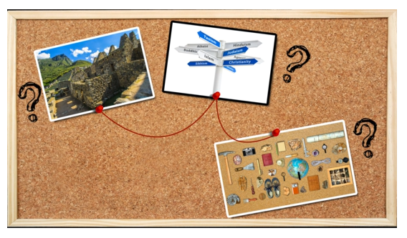

**Check-In:**

1. What type of source is written by an author who did not personally experience an event?

- Answer: A secondary source is written by an author who did not personally experience an event.

2. What are at least two things that a historian should consider when conducting research involving primary and secondary sources?

- Answer: A historian should consider a source’s point of view, frame of reference, historical context, and possible bias. They should also research sources from diverse perspectives.

**Practice:**

1. In 1-2 sentences, explain what type of source, and its characteristics, a historian would use if they wanted to know what it was like to experience a historical event as it was happening.

- Answer: The historian would use a primary source such as a diary entry, a photograph, or a government document. They would use it because it is created by a person who experienced something firsthand as it was happening.

2. If a historian has several pieces of data from upper socioeconomic sources, explain how they could continue their research to include diverse perspectives.

- Answer: The historian could research to find sources from lower and middle socioeconomic authors as well.

* **The Importance of Primary and Secondary Sources**

**Objective 2:** In this section, you will discuss the importance of primary and secondary sources to the study of history and historical analysis.

**Essential Question**: Why are both primary and secondary sources needed to study history and perform historical analysis?

**Key Terms**:

1. Biography: A book about the life and accomplishments of a person.
2. Primary Source: A historical record created by a person who experienced something firsthand.
3. Secondary Source: A historical record created by a person who did not experience events themselves.

**Big Ideas:**

* Primary sources are firsthand accounts created by someone present at the time of an event, providing direct evidence.



* Secondary sources interpret primary source material, offering analysis from someone who did not witness the event.

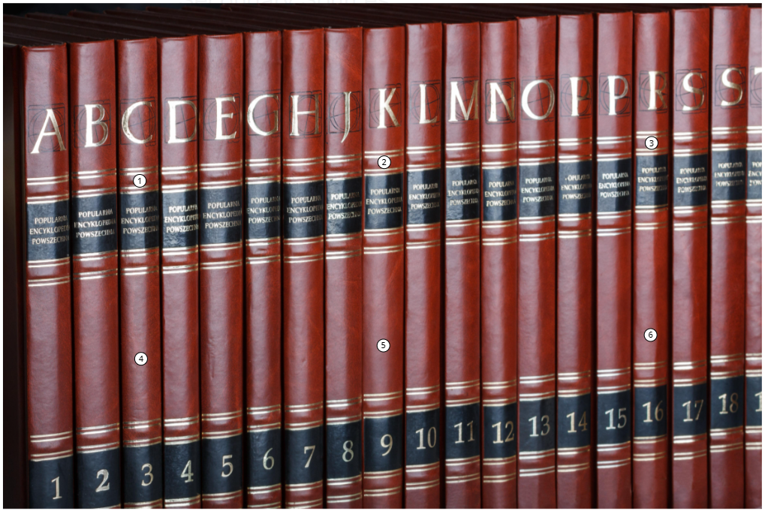

* Both primary and secondary sources are essential for a comprehensive understanding of history.
* Primary sources offer firsthand evidence but can be difficult to interpret due to language or customs of the time.
* Secondary sources provide interpretations and can include multiple viewpoints, but may carry the author's biases.

**Check-In:**

1. If a researcher is looking into events about the United States Civil War, what types of primary sources could be helpful?

- Answer: A letter from a soldier, government orders written to the military, a detailed log of supply shipments, photographs of soldiers or battles.

2. What is one limitation to consulting only secondary sources in research?

- Answer: Secondary sources might include commentary and analysis, which can make it difficult to draw new conclusions.

**Practice:**

1. In two to three sentences, discuss why secondary sources are beneficial in doing research on a topic.

- Answer: A secondary source provides an interpretation of primary source material because the creator was not a direct witness to the events or time period being explained. They can provide information from multiple primary sources, making them an effective tool for researchers.

2. For a research assignment on the history of the Aztecs, what primary and secondary sources would be used and why? Discuss in three to four sentences.

- Answer: A researcher could use primary sources such as artifacts and secondary sources like an encyclopedia or textbook. Quotations from documents and analysis of artifacts help create a unique understanding of history. Exploring diverse sources helps develop analysis skills and make connections.

* **Using Sources to Further Inquiry and Communicate Findings**

**Objective 3**: In this section, you will explain how the analysis of sources helps historians to create questions that guide further research and inquiry.

**Essential** **Question**: How do historians use sources to produce questions that lead to further research and inquiry?

**Key** **Terms**:

1. Bias: A feeling or action that favors one viewpoint over another.
2. Citation: The credit given to sources used when conducting research.
3. Inquiry: The process of conducting research of multiple and varied sources in order to answer a question.

**Big Ideas**:

* Historians read, analyze, and interpret sources to create new questions about historical events or processes.
* These questions guide further research, taking into account bias to ensure valid results.
* Historians need to consult diverse sources to create an inclusive picture of history, recognizing suppressions due to biases and prejudices.



* Clear communication of findings includes reasoning effectively and citing sources appropriately.
* Historians share their research process, sources used, and personal perspectives to reveal comprehensive insights.

**Check-In:**

1. How many sources should a historian use when conducting research?

- Answer: A historian should consult as many sources as necessary to provide a broad range of reliable evidence.

2. How does a historian communicate to an audience their research is reliable and they can reason effectively about their findings?

- Answer: A historian reveals their interpretations of sources, connects those interpretations, and cites sources correctly to provide a well-reasoned answer.

**Practice**:

1. When conducting inquiry research, how should a historian show that they can reason effectively when communicating their findings?

- Answer: Historians should present their interpretations of different sources and connect their interpretations to answer their inquiry question. It is important to cite sources thoroughly and correctly.

2. How must historians reason effectively when selecting sources for their inquiry research?

- Answer: Historians must examine sources for bias and preconceived ideas and use reasoning to ask why some sources are available and others are not. They must select diverse sources to present valid findings.

* **People in the Present Shape the Way We Look at the Past**

**Objective 4**: In this section, you will summarize how perspectives and potential bias are important to acknowledge when studying history, and how people in the present shape interpretations of the past.

**Essential** **Question**: How do people in the present shape interpretations of the past?

**Key Terms**:

1. Abolitionist: A person who favors ending the practice of a particular institution, such as slavery.
2. Bias: A feeling or action that favors one viewpoint over another.
3. Historian: A person who studies history and communicates their findings to others.
4. Perspective: The outlook or viewpoint of an author or source that includes their experiences, beliefs, and thoughts on a particular topic.
5. Underground Railroad: A secret system of routes, places, and people that escaped enslaved people from the South used to find safety in free states or Canada.

Big Ideas:

* Scholars and historians create resources that shape our understanding of the past.
* Considering an author's perspective and potential bias is crucial when studying historical sources.
* Multiple perspectives, such as those of Harriet Tubman, a Northern abolitionist, and a Southern slaveholder, provide a fuller picture of historical events.

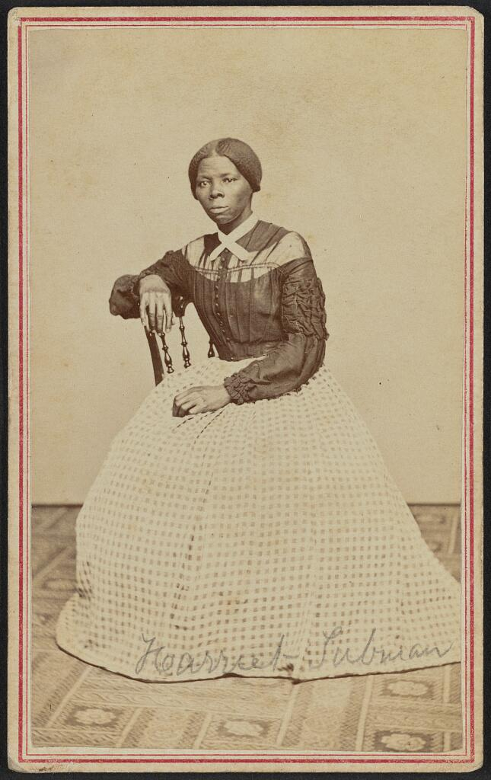

* Recognizing bias helps ensure inclusive information by comparing various viewpoints.
* People's interpretations of historical events change over time, influenced by new sources and perspectives.
* Historians in the present shape our understanding of past events by interpreting these viewpoints.

**Check-In:**

1. What shapes a person’s interpretation of past events?

- Answer: Perspective and bias.

2. Why do historians look for bias in someone’s perspective of an event?

- Answer: Bias leads to someone favoring one viewpoint over another.

**Practice**:

1. In the 1500s, the Spanish conquistador Hernán Cortés overthrew the Aztec Empire of South America. What are two perspectives through which this historical event could be viewed?

- Answer: Potential perspectives could be from the conquering force of the Spanish and the under-siege population of the Aztec Empire.

2. In the 1500s, the Spanish conquistador Hernán Cortés overthrew the Aztec Empire of South America. How would a historian communicate reliably about events of Cortes and his encounters with the Aztec Empire?

- Answer: A historian needs to include multiple perspectives when communicating about the fall of the Aztec Empire to the Spanish. Research needs to include several sources from each perspective to give a complete picture of the event.

* **Unit 2 Lesson 4: Understanding Historical Themes**
* **Themes in World History**

**Objective 1**: In this section, you will describe relevant themes in world history to help you study the past.

**Essential** **Question**: What are the relevant themes used to study world history?

**Key Terms**:

1. Cultural Trait: Characteristic or quality of a culture.

2. Diffuse: To spread.

3. Diplomacy: Negotiations between nations.

4. Interact: To come into contact.

5. Norm: Standard expectation or behavior.

**Big Ideas**:

• The study of history encompasses stories of the past, analyzed through different themes to connect events across time and place.

• Human-Environment Interaction: This involves studying how humans and their environments affect each other using tools like maps, GPS, and surveys. For example, rainfall, climate, and available resources influence how societies develop, and human activities like farming can change the environment. 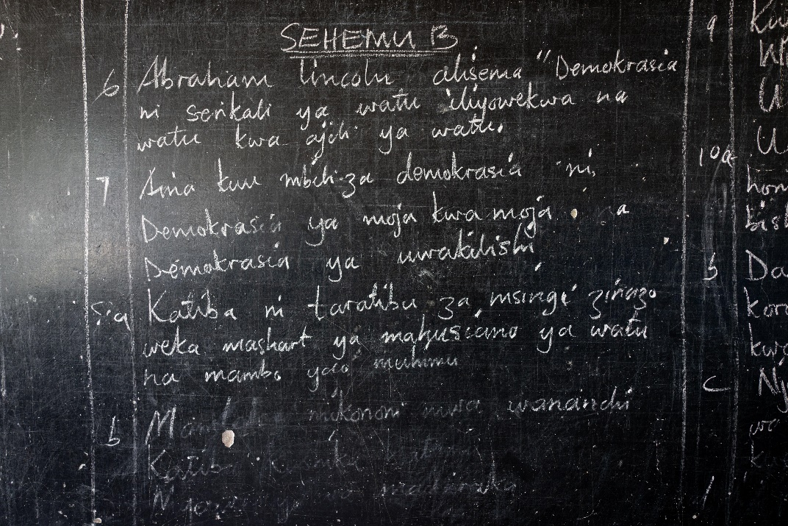

• Development and Interaction of Societies: Humans form groups and societies based on relationships, shared culture, and social norms. These societies can interact and influence each other, leading to cultural diffusion, as seen with the creation of the Swahili language from Arab and East African interactions.

• Conflict and Compromise: Differences in opinions, resources, or beliefs can lead to conflicts between nations or groups, which sometimes end in compromise or escalate into wars, like World Wars I and II.

• Ideas, Expansion, and Transformation: Societies evolve by expanding and adapting new ideas. Innovations in politics, economics, religion, or social structures can transform societies, such as the development of communism or new religious beliefs.

**Check-In:**

1. What is human-environment interaction?

- Answer: Human-environment interaction is how humans adapt to and change the environment.

2. What is the most basic social foundation?

- Answer: The family is the most basic social foundation.

3. What methods do geographers use to study the relationship between people and their environments?

- Answer: Geographers use methods that include observations, surveys, and interviews.

**Practice**:

1. Why does conflict occur in world history?

- Answer: Differences of opinion regarding lawmaking, division of labor, governance, and religion can create conflict.

2. How do ideas expand and transform societies?

- Answer: Ideas expand through trade or diplomacy.

* **Identifying Historical Themes**

**Objective 2**: In this section, you will explain how identifying historical themes builds a deeper understanding of history.

**Essential Question**: How do historical themes provide a deeper understanding of history?

**Key Terms**:

1. Civil Disobedience: A peaceful form of political protest.

2. Communism: A political ideal based on the theories of Karl Marx believing in public ownership of property and that wages be more based on need than skill.

3. Democracy: A government system based on personal freedoms and choosing leaders by voting.

4. Empire: A system of government where there is one authority (individual or group) who rules over a large territory.

5. Picketing: The act of protesting with signs outside places of work or government.

**Big Ideas**:

• Historical themes give deeper insights into history by connecting causes and effects over time.

• Brazil’s Belo Monte Dam: This project illustrates human-environment interaction as Brazil transforms the Amazon to meet energy needs, displacing Indigenous tribes and affecting flora and fauna.

• Conflict and Vietnam War: The Vietnam War exemplifies political conflict over control and ideology, highlighting the larger context of the Cold War between the communist Soviet Union and democratic U.S.

• Women’s Rights: The women's suffrage movement is a case of social transformation, using creative tactics like rallies and civil disobedience to raise awareness and eventually succeed in granting voting rights to women.

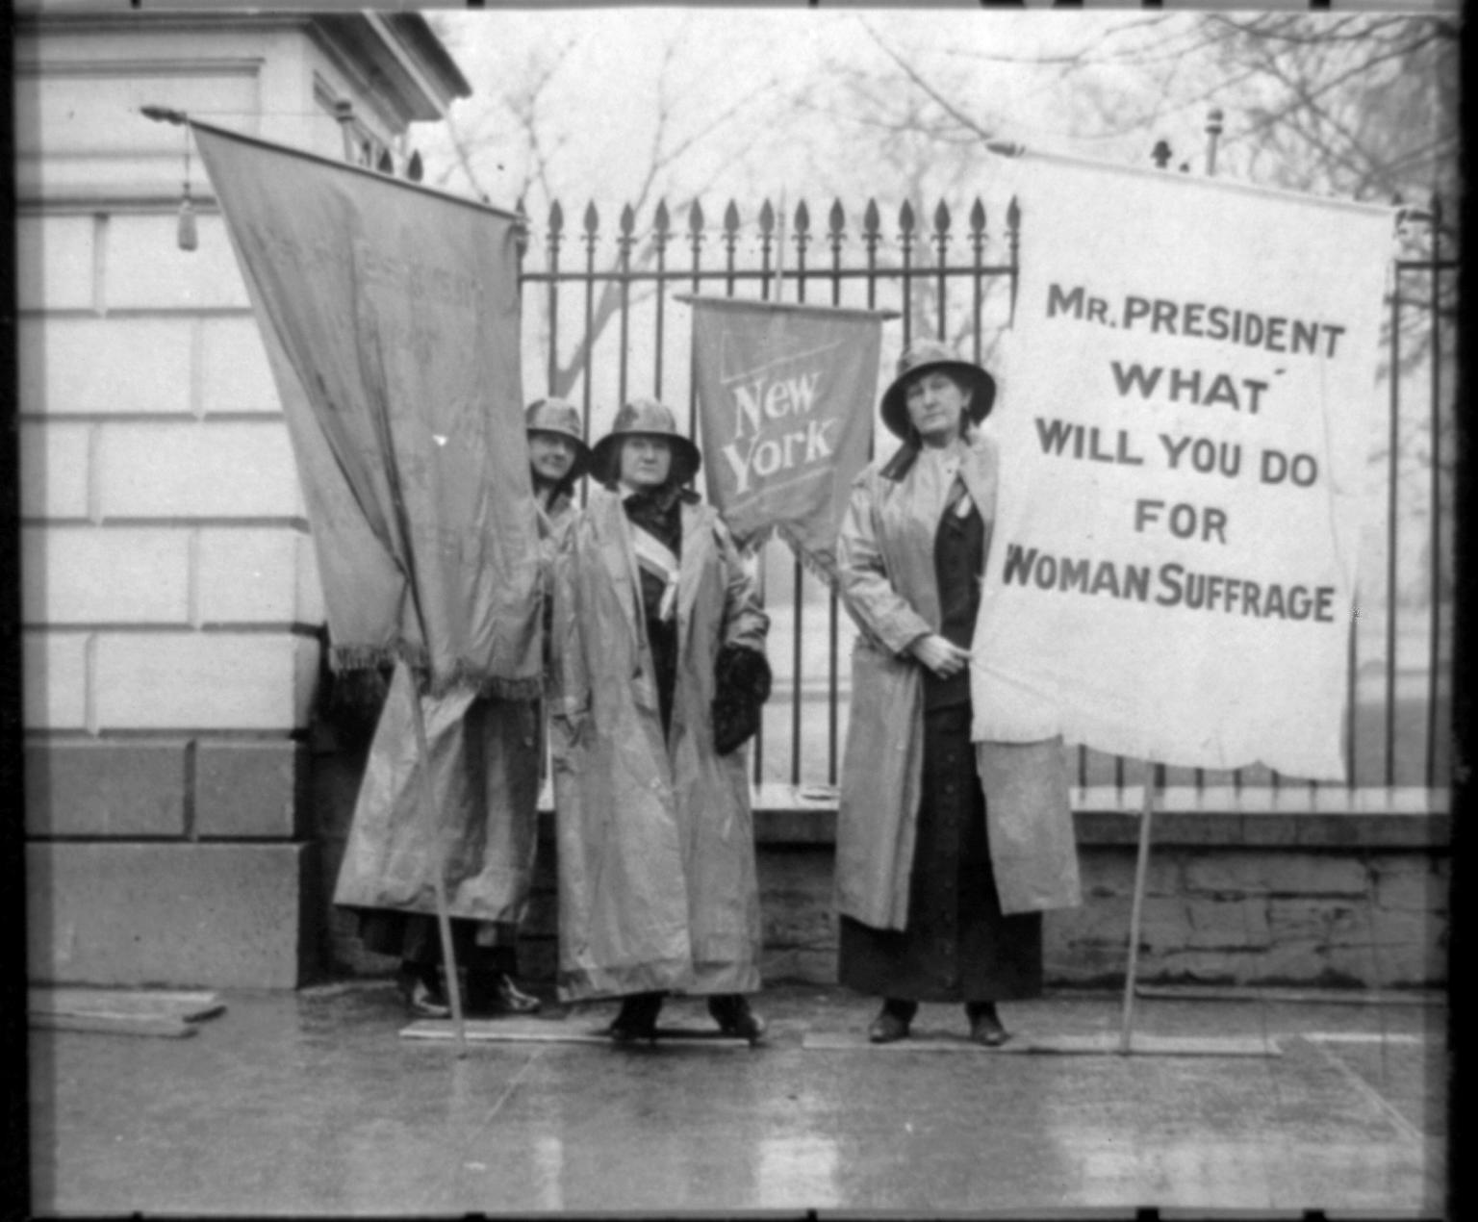

**Check-In:**

1. Which historical theme can be identified in the example of Brazil’s Belo Monte Dam?

- Answer: The dam represents the theme of human-environment interaction.

2. How does a study of the Vietnam War provide a deeper understanding of the theme of conflict?

- Answer: The Vietnam War can be placed in a larger global context, the Cold War.

**Practice**:

1. How does the women’s rights movement illustrate creative thinking?

- Answer: Women used creative tactics such as mass rallies, marches, and civil disobedience to raise awareness of their cause.

2. Search online for one news article about COVID-19 and mandated vaccinations. Read the article. Write a statement about how mandated vaccinations are a type of social transformation. What is the creative thinking people are using to justify this social change?

- Answer: People who believe in vaccinations are pushing that all of society should be vaccinated to prevent the spread of COVID-19. Many people resist this mandate as they feel it takes away their freedom to choose.

* **Relationships in History**

**Objective 3:** In this section, you will explain the complex relationships between people, places, ideas, and environments.

**Essential Question**: How are people, places, ideas, and environments interconnected?

**Key Terms**:

1. Cardinal Directions: The four main points of a compass: north, south, east, and west.

2. Infamy: A condition of being well-known for something bad.

3. Interconnected: Having different parts connected to or related to each other.

4. Internment Camp: A prison or facility to house political prisoners or enemies of war.

5. Modernize: To make more modern in appearance, design, character; to update.

6. Samurai: The military fighters who fought for a noble family who owned land.

7. Solstice: A time when the tilt of the Earth and the sun’s position create the longest and shortest days of the year; occurs once in winter and once in summer and marks the beginning of each season.

**Big Ideas:**

• History should be studied in context, recognizing the complex relationships and connections between events, people, ideas, and the environment.

• Inca Empire: Their rise involved adapting to mountainous terrain through terrace farming and building Machu Picchu, reflecting their beliefs and environment. The Spaniards' invasion due to their pursuit of riches disrupted the Inca, emphasizing the interconnectedness of events and cultures.

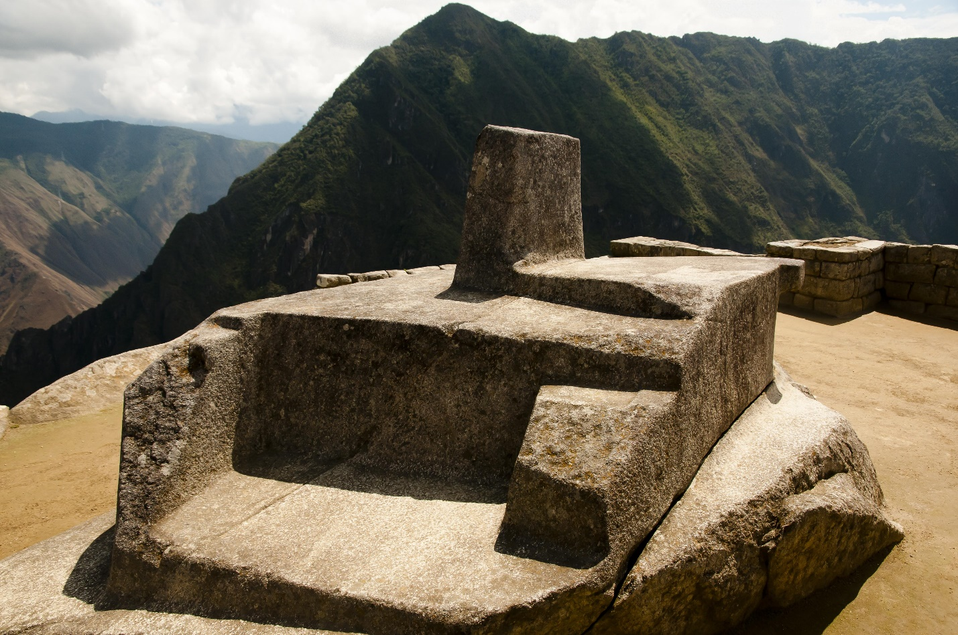

• Japan and the United States: The arrival of the U.S. in Japan led to modernization, following the realization that Japan needed to catch up technologically. This transformation had significant impacts, leading to Japan's increased power, involvement in World War II, and the internment of Japanese Americans in the U.S.

**Check-In:**

1. How did Machu Picchu’s construction show a relationship to the sun?

- Answer: The construction of the Intihuatana aligns with the sun, the four cardinal directions, and the solstices.

2. Why was the United States interested in Japan?

- Answer: The United States was looking for more markets to trade goods.

**Practice**:

1. What can you reasonably conclude is the reason Japan modernized?

- Answer: They realized they were technologically behind and wanted to be more competitive with countries such as the United States.

2. How do you know the answer to Practice Question 1 is a reasonable conclusion?

- Answer: Japan learned from the United States, rose in power, and ultimately became a global power, starting World War II and attacking Pearl Harbor.