- Unit 4 Lesson 1: Mediterranean
- Mediterranean Introduction

Timeline:
Greek Civilization (c. 800 BCE - 146 BCE)
- Emergence of Greek City-States (Polis)
- Notable City-States: Athens, Sparta
- Greek Political Structures
- Direct Democracy in Athens
- Oligarchy in Sparta
- Greek Culture
- Literature, Philosophy (e.g., Socrates, Plato, Aristotle)
- Polytheism and Major Deities
- Advancements in Mathematics and Science
- Alexander the Great's Empire (336–323 BCE)
- Expansion and Hellenization of the Mediterranean World

Roman Republic-Empire Transition (509 BCE - 27 BCE)
- Roman Republic
- Government Structure and Comparison to Other Civilizations
- Decline of the Republic
- Key Events and Figures: Julius Caesar, Augustus
- Formation of the Roman Empire (27 BCE)
- Augustus as the First Emperor

Roman Empire (27 BCE - 476 CE)
- Early Empire
- Consolidation and Expansion
- Role and Impact of Christianity
- Origins and Spread of Christianity
- Key Figures and Events Leading to Acceptance (313 CE - Edict of Milan)
- Division of the Empire
- Eastern and Western Roman Empires (395 CE)
- Fall of the Western Empire (476 CE)
- Causes and Consequences

Byzantine Empire (330 CE - 1453 CE)
- Foundation by Constantine
- Conversion to Christianity
- Justinian Dynasty (527-565 CE)
- Expansion and Legal Reforms
- Religious Schisms and Key Figures
- Schism between Eastern Orthodox and Roman Catholic Churches (1054 CE)
- Decline and Fall
- Capture of Constantinople by the Ottomans (1453 CE)

Rise of Islam (610 CE - Present)
- Founding and Early Expansion
- Prophet Muhammad and the Early Caliphates (7th Century CE)
- Islamic Golden Age (750 CE - 1258 CE)
- Contributions to Art, Science, and Culture
- Major Key Figures and their Contributions
- Expansion of Muslim Empires
- Umayyad and Abbasid Caliphates

Medieval Period and Crusades (1096 CE - 1291 CE)
- Interactions among Muslim, Christian, and Jewish Societies
- Crusades and Their Impact on Mediterranean Society

Ottoman Empire (1299 CE - 1922 CE)
- Rise and Expansion
- Capture of Constantinople (1453 CE)
- Cultural and Economic Impact
- Trade Routes and Military Conflicts

Objective: Understand the societies, geography, and cultural influences in the Mediterranean world from the final centuries BCE to 1500 CE. Highlight the development and impact of major civilizations and religions in the region.

Essential Question: How has religion transformed societies?

Key Terms:
1. Mediterranean: A sea connected to the Atlantic Ocean, surrounded by Europe, Asia, and Africa.
2. Greek Civilization: Ancient society influential in politics, philosophy, science, and the arts.
3. Roman Empire: Ancient empire known for its vast territory and influence on law, government, and Christianity.
4. Christianity: A major world religion that began in the Roman Empire.
5. Islam: A major world religion that emerged in the 7th century and spread across the Mediterranean.

Big Ideas:
- Geographic Importance: The Mediterranean Sea was crucial for travel and trade, linking various civilizations.
- Cultural and Religious Influence: Greek and Roman civilizations played significant roles in shaping politics, religion, and philosophy in Europe.
- Greek Colonization: The geography of Greece promoted the establishment of colonies and partnerships across the Mediterranean region.
- Roman Empire's Impact: The Roman Empire's support of Christianity facilitated the spread of the religion and showcased the complexity of large states.
- Innovation and Cultural Exchange: Despite the collapse of the Roman Empire, the Mediterranean remained a center for trade, innovation, and the rise of Islam.

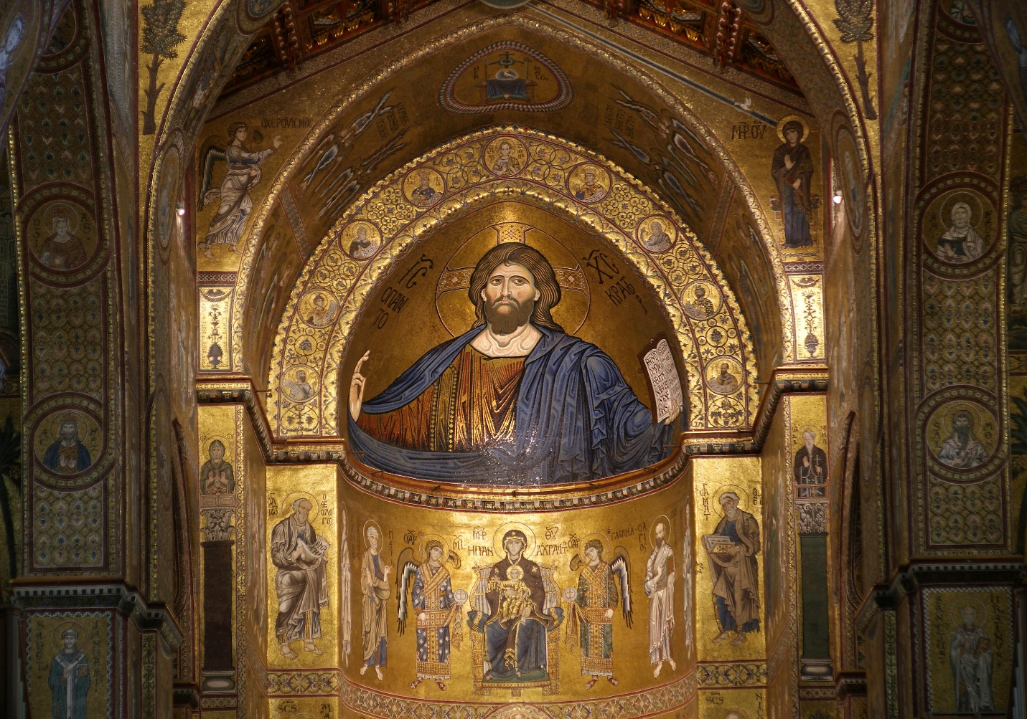
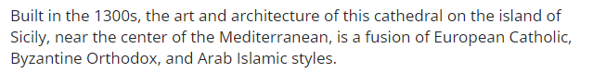

Check-In Questions:
1. Why was the Mediterranean Sea important for ancient civilizations?
- Answer: The Mediterranean Sea was a primary route for travel and trade, connecting various cultures and fostering economic and cultural exchange.

2. What were some contributions of the Greek civilization to European culture?
- Answer: Greek civilization contributed to European culture through advancements in politics (like democracy), philosophy, literature, science, and the arts.

Practice Questions:
1. How did geography influence Greek civilization and its colonization efforts?
- Answer: The geography of Greece, with its many islands and peninsulas, encouraged the establishment of colonies and partnerships across the Mediterranean, spreading Greek culture and influence.

2. Describe how the Roman Empire facilitated the spread of Christianity in the Mediterranean region.
- Answer: The Roman Empire's vast network and infrastructure allowed for easier travel and communication. When the empire embraced Christianity, this support helped the religion spread rapidly throughout the region.

- Unit 4 Lesson 2: Ancient Greece
- Lesson Title: Governments of Ancient Greece

Objective 1: Describe the characteristics of direct democracies, monarchies, and oligarchies in ancient Greece.

Essential Question: What were the characteristics of direct democracies, oligarchies, and monarchies in ancient Greece?

Key Terms:
1. Democracy: A system of government by the whole population, typically through elected representatives.
2. Monarchy: A form of government with a monarch at the head.
3. Oligarchy: A small group of people having control of a country or organization.
4. Ecclesia: An assembly of citizens in ancient Greek democracy with the power to make decisions.
5. Polis: A city-state in ancient Greece.

Big Ideas:
- Direct Democracy: Athens was famous for its democracy where citizens could directly vote and participate in decision-making through the ecclesia.
- Monarchy: The Mycenaean Greeks used a monarchy, where the king (wanax) ruled and was usually succeeded by family members.
- Oligarchy: Rule by a few elites. Sometimes in Athens, a group like the Thirty held power and could be tyrannical.
- Variations in Government: Different city-states had their unique forms of governance, shaping their societies in distinct ways.
- Social Hierarchies: These governance systems were linked to varying social structures and citizen rights.
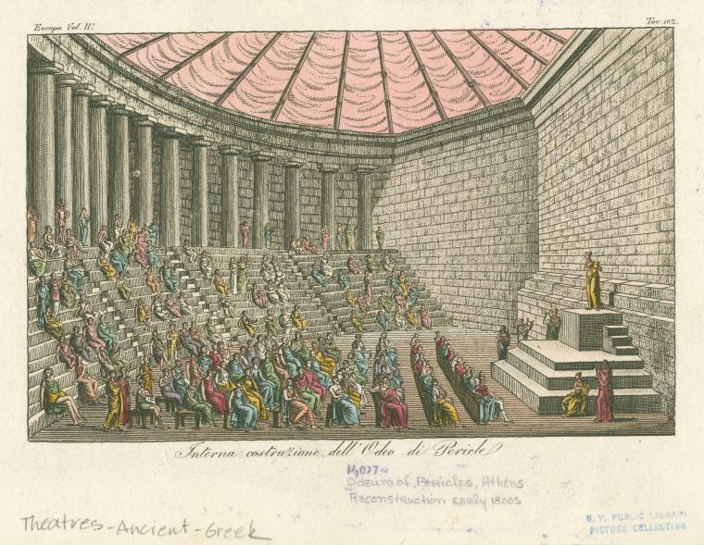

Check-In Questions:
1. What type of government was ancient Greece most known for?
- Answer: Democracy, specifically in Athens.
2. What was the system of government the Mycenaeans used?
- Answer: Palatial monarchy.

Practice Questions:
1. Construct a three-column chart of the three different forms of government in ancient Greece: Democracy, Monarchy, Oligarchy.

Sample Answer:

Government Type | Key Characteristics
- Democracy: Ruled by the people; Had an ecclesia where members were randomly chosen by lot; Citizens had the freedom to vote on key issues |
- Monarchy: Ruled by a hereditary king or queen (wanax); Centralized power around a palace; Religion was significant in governance |
- Oligarchy: Ruled by a few elites; Could be tyrannical; Limited citizen participation |

- Governing Ancient City-States

Objective: Compare the government systems of Athens, Sparta, and Carthage using diagrams.

Essential Question: How are the government systems of Athens, Sparta, and Carthage similar and different?

Key Terms:
1. Polis: A city-state in ancient Greece.
2. Ecclesia: An assembly of citizens in ancient Greek democracy with the power to make decisions.
3. Ekklesia: An assembly like the ecclesia, used in Sparta.
4. Gerousia: A council of elders in Spartan government.
5. Suffetes: Elected officials in Carthage.

Big Ideas:
- Athens - Democracy: Focused on democratic principles with its ecclesia where citizens could vote on important issues.
- Sparta - Oligarchy with Monarchical Elements: Two hereditary ruling kings and a council of elders (Gerousia); focused heavily on military matters.
- Carthage - Evolved from Monarchy to Oligarchy: Initially a monarchy, it later employed elected leaders called suffetes.
- Similarities and Differences: Despite their unique forms, these city-states shared common traits like assemblies but differed in their specific structures and processes.

Check-In Questions:
1. What form of government did Athens use?
- Answer: Democracy.
2. What form of government did Sparta use?
- Answer: Oligarchy.

Practice Questions:
1. Construct diagrams for the Athenian and Spartan governments:

Athenian Government
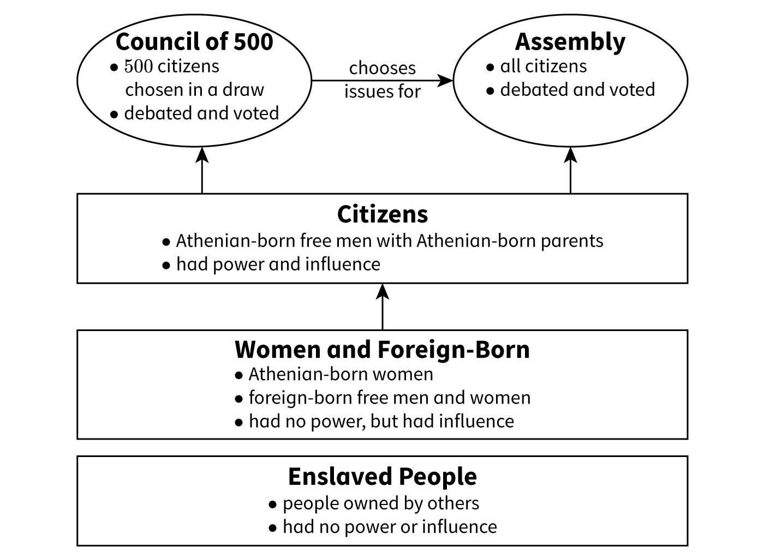

Spartan Government
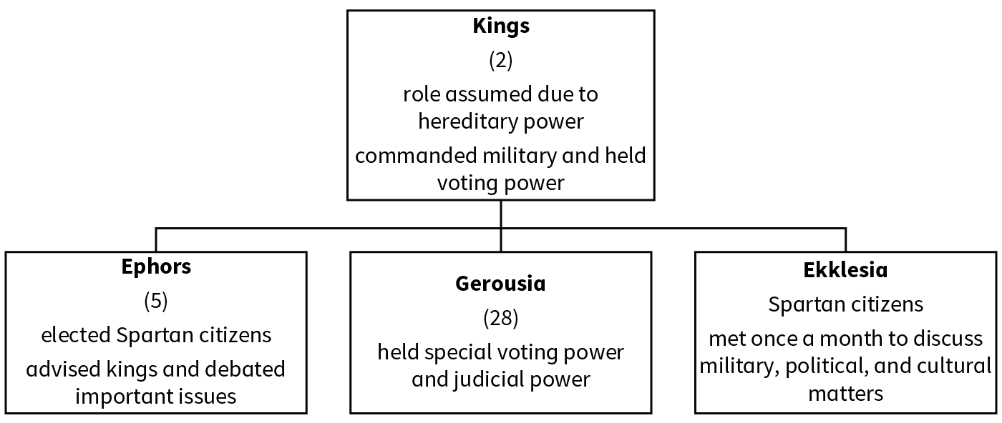
The Athenian and Spartan systems both used an assembly and council. The Athenian assembly was called an ecclesia, while the Spartan system was called an ekklesia. Both assemblies consisted of citizens. In terms of councils, the Athenian Council of 500 consisted of Athenian citizens chosen by lot, while Sparta’s council, Gerousia, consisted of 28 men. While Sparta was more focused on military matters, Athens was focused on democratic processes. Sparta had a unique system of leadership that used a pair of hereditary kings, while Athens did not have hierarchical rulers.

2. Compare the governments of Carthage and Sparta:
The two forms of government compared are the Spartan government and Carthaginian government.

Spartan Government

Carthaginian Government
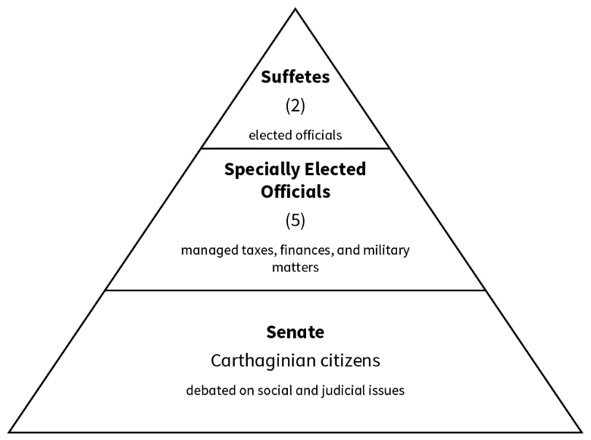
The major difference between the Carthaginian and Spartan governments was that Carthage used elected leaders called suffetes, while Sparta had two hereditary kings. The Carthaginian government and Spartan government both had an oligarchy form of government. Both had an assembly that consisted of citizens. Sparta’s assembly, the ekklesia, focused on military, political, and cultural matters, while the Carthage assembly, the senate, debated social and judicial issues.

- The Greek Polis and Its People

Objective 3: Examine the social structure of the Greek city-states.

Essential Question: Why did Greek city-states create a hierarchical social structure?

Key Terms:
1. Polis: A city-state in ancient Greece.
2. Aristoi: The upper class of wealthy and influential citizens in the polis.
3. Artisans: Skilled workers who crafted specialized goods and services.
4. Perioikoi: Lower-class citizens or dwellers living on the outskirts of the polis.
5. Helots: Laborers or enslaved people in the polis, often working in agriculture.

Big Ideas:
- Hierarchical Structure: Different roles were established within city-states to manage social functions effectively, leading to a stratified society.
- Upper Class - Aristoi: Wealthy citizens holding significant power, land, and government positions.
- Middle Class - Artisans: Skilled workers providing crucial goods and services but viewed as less important than elites.
- Lower Class - Perioikoi: Landowners who lived on the outskirts; had similar rights but were considered lesser citizens.
- Women and Laborers: Women had restricted roles, unable to vote or own land, while laborers and enslaved people had the least rights and provided essential labor.

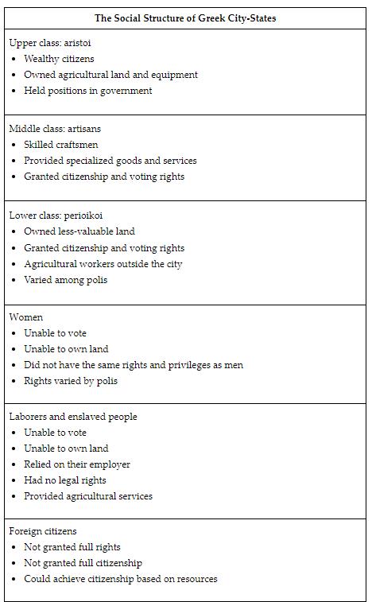

Check-In Questions:
1. What was a foreign person temporarily residing in a Greek city-state called?
- Answer: Metic.
2. What were the lower-class citizens who dwelled outside of the main cities called?
- Answer: Perioikoi.

Practice Questions:
1. Research the treatment of social classes in Greek city-states and propose how to solve inequalities within a polis.

Sample Answer:
Source: "Ancient Greek Society" on worldhistory.org. Social classes were treated differently based on rights. To solve inequality, propose new policies in the ecclesia to grant citizenship and voting rights to women and lower classes, creating a fairer society.

2. Examine one social class's role in a polis using various sources.

Sample Answer:
Sources: "Sparta," "Women in Ancient Greece," and "Ancient Greek Religion" on worldhistory.org. Spartan women had more privileges than other Greek women, owning land and participating in activities. They could become priests, showing some roles were significant despite lower social status.

- Phillip, Macedon, and Alexander

Objective 4: Describe how Alexander the Great built an empire, considering historical perspectives and empathy.

Essential Question: Why did Alexander the Great construct his empire?

Key Terms:
1. Macedonian Phalanx: A military formation of soldiers with long spears.
2. Companion Cavalry: Elite cavalry troops used by Alexander the Great.
3. Sarissa: A long spear used in the Macedonian phalanx.
4. Sieges: Military operations where a city is surrounded and attacked until it surrenders.
5. Hellenization: The spread of Greek culture, language, and traditions.

Big Ideas:
- Background: Alexander inherited a strong foundation from his father, Philip II, with advanced military strategies like the Macedonian phalanx.
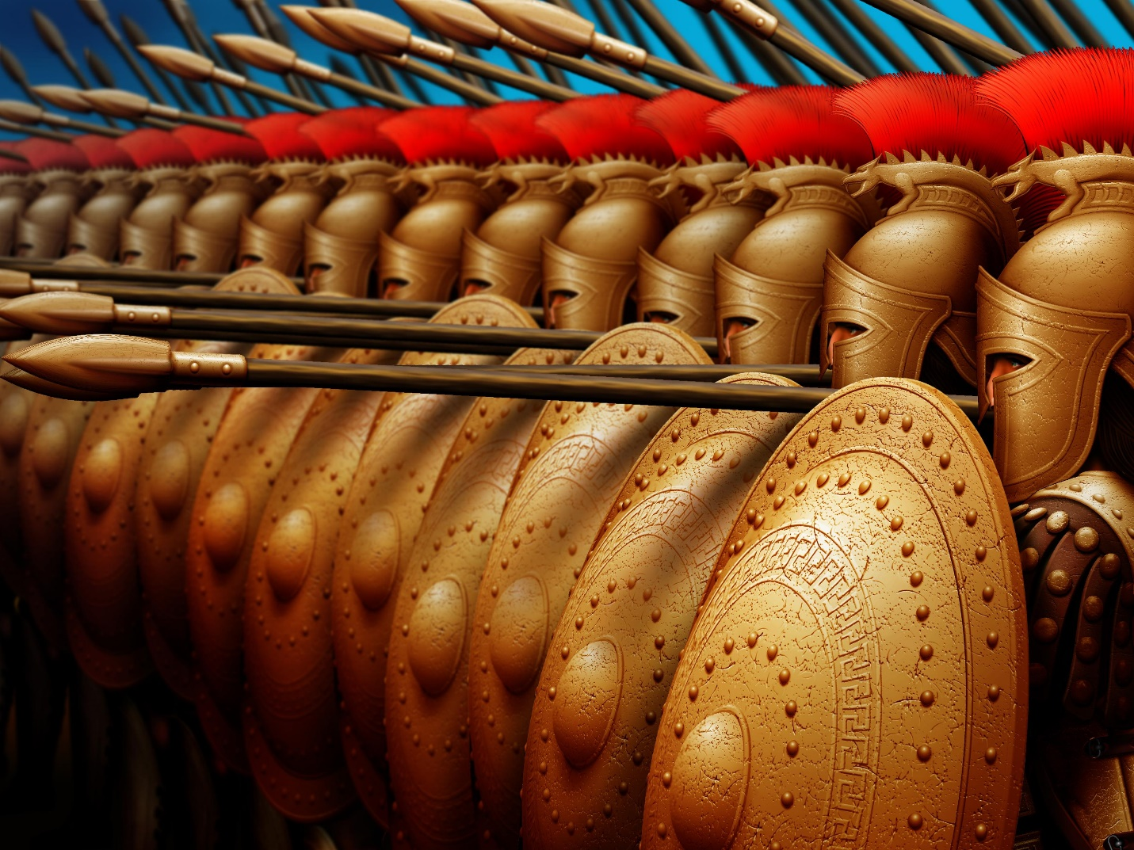
- Military Campaigns: Alexander's tactical intelligence led to many victories, including battles in Asia Minor, Egypt, and Persia.
- Cultural Tolerance: Alexander adopted local cultures and religions, promoting hellenization and allowing different groups to coexist peacefully.
- Historical Empathy: To understand Alexander's actions, it's crucial to view them through the lens of the ancient period, considering what made rulers great at that time—success in battle and the ability to govern diverse societies.
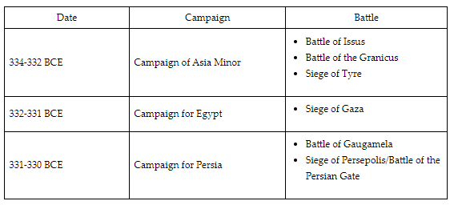

Check-In Questions:
1. Why do historians use a lens of historical empathy when studying Alexander the Great and ancient history?
- Answer: Historians use historical empathy to contextualize actions from the past, appreciating achievements while understanding these actions might not align with modern values.
2. Would Alexander have been as successful if he had not adopted and tolerated local culture and religion? Why or why not?
- Answer: No, Alexander’s success relied on his acceptance and adoption of local cultures and religions, which stabilized his rule and reduced resistance.

Practice Questions:
1. Construct a timeline of events that describes how Alexander the Great built his empire.

Sample Answer:

Date Battle/Event Description
338 BCE - Battle of Chaeronea - Fought under Philip II, added Greece to Macedon
334 BCE - Battle of Granicus - Defeated Persian troops in Asia Minor
333 BCE - Battle of Issus - Victory against Darius III, key Persian battle
332 BCE - Siege of Tyre - Conquered Tyre, demonstrating military dominance
332 BCE - Siege of Gaza - Conquered Gaza, gaining support in Egypt
331 BCE - Founded Alexandria - Promoted hellenization, established key cities
331 BCE - Battle of Gaugamela - Defeated Darius III, major Persian victory
330 BCE - Conquered Persepolis - Captured Persian capital, declared shahanshah

2. Create a podcast script discussing Alexander’s title "Great."

Sample Points:
- Introduction: Brief history of Alexander the Great.
- Military Campaigns: Discuss key battles and victories.
- Positive Aspects: Adoption of local cultures, promotion of hellenization.
- Negative Aspects: Sieges and massacres.
- Conclusion: Summarize points and let listeners decide if Alexander deserves the title "Great."

- Unit 4 Lesson 3: Greek Culture and Religion
- Lesson Title: Ancient Greek Polytheism

Objective 1: Identify the cultural role of the major deities in Greek polytheism.

Essential Question: What role did religion play in Greek society?

Key Terms:
1. Polytheistic: Belief in or worship of multiple deities.
2. Deities: Gods and goddesses.
3. Mt. Olympus: Mythical home of the Greek gods.
4. Abstract: Existing in thought or as an idea but not having a physical or concrete existence.
5. Libations: Liquid offerings poured out to a deity.

Big Ideas:
- Ancient Greece was a polytheistic society with many gods and goddesses, each with specific roles and attributes.
- Major deities like Zeus, Hera, Athena, and Poseidon played significant roles in the daily lives and beliefs of the Greeks.
- Religion was deeply intertwined with daily life, influencing various activities, ceremonies, and societal norms.
- Worship practices included rituals, sacrifices, and the construction of grand temples and acropolises dedicated to different gods. 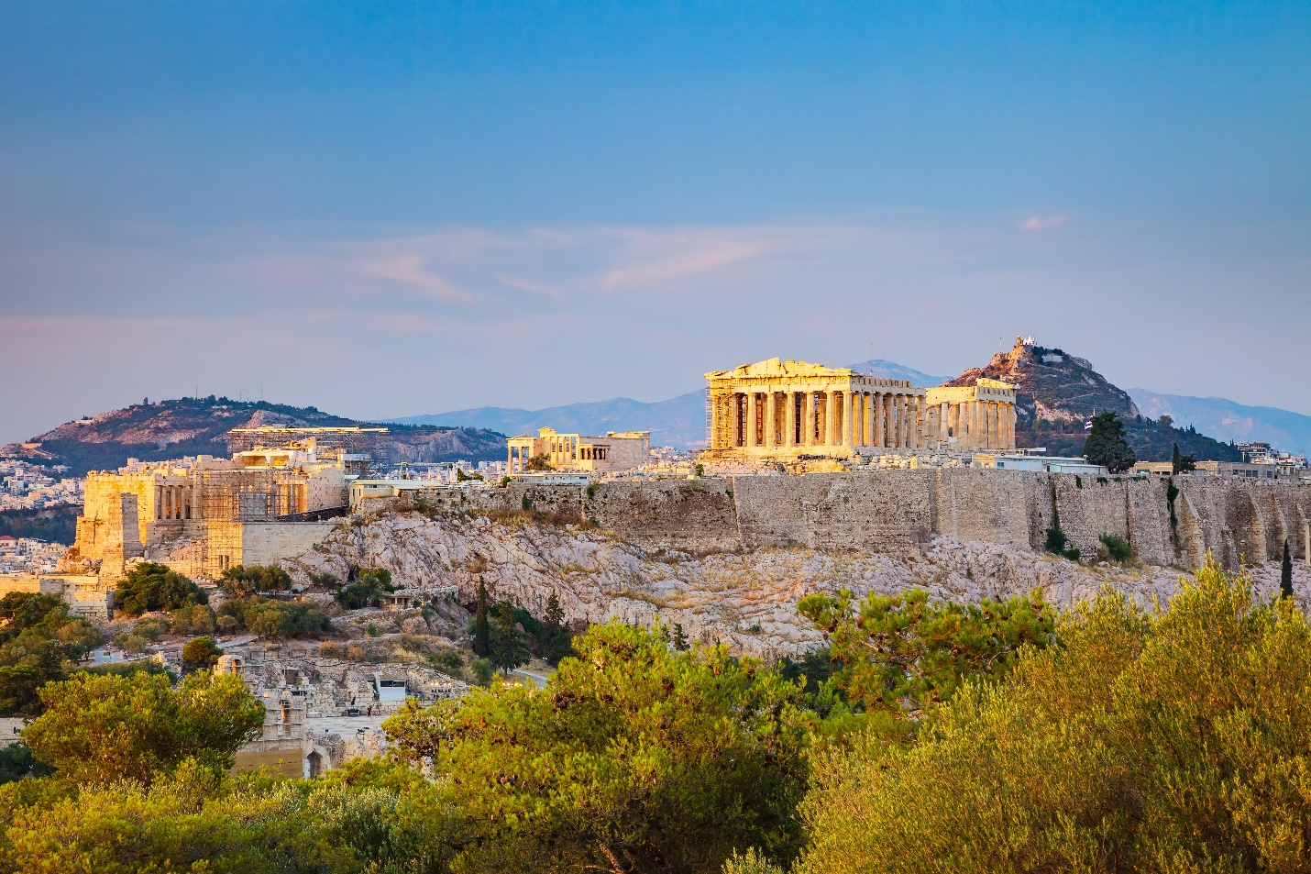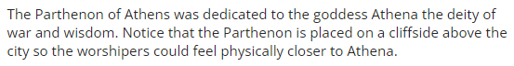
- Festivals and theatrical performances were held in honor of the deities, contributing to the cultural unity and identity of ancient Greece.

Check-In Questions:
1. Name three Greek deities and identify what they were the goddess or god of.
- Answer: Apollo: god of art, music, and beauty; Artemis: goddess of hunting and nature; Hephaistos: god of fire and metals.
2. What is the purpose of myths in Greek culture and religion?
- Answer: Myths were used to explain where the gods came from, how the world was created, offer stories of heroes and villains, and teach valuable life lessons.

Practice Questions:
1. Why are Greek myths still told today, thousands of years after they were created?
- Answer: Greek myths are still relevant today because they are stories that have valuable life lessons in them, are entertaining, and teach us about Greek history.
2. Select one Greek deity and identify the cultural role they played in the everyday lives of Greek people.
- Answer: Zeus was the god of thunder and the supreme deity of all the gods and people of ancient Greece. He was a hugely influential deity who the people would pray to daily for guidance and to whom many festivals were dedicated. One example is the Olympic Games, held every four years at Olympia.

- Ancient Greek Literature

Objective 2: Summarize the major themes of Greek literature and how they reflect the history of the time period in which they were produced.

Essential Question: How did Greek literature reflect the history of the time?

Key Terms:
1. Epic: A long, narrative poem, often recounting heroic deeds.
2. Archaic Period: The early period of Greek history, from about 800 BCE to 480 BCE.
3. Classical Period: The period of Greek history from 480 BCE to 323 BCE.
4. Oral Tradition: The passing of stories, history, and information by word of mouth from one generation to another.
5. Polis: A city-state in ancient Greece.

Big Ideas:
- Greek literature is divided into the Archaic and Classical periods, each reflecting the history, culture, and innovations of its time.
- The Archaic period featured epic poetry like Homer's "The Iliad" and "The Odyssey," focusing on myths, gods, heroes, and historical tales.
- The development of city-states (polis) in the Archaic period influenced literature that reflected unique local histories and cultures.
- The Classical period brought advancements in democracy, arts, philosophy, and theater, leading to works by playwrights like Aeschylus, Sophocles, and Euripides. 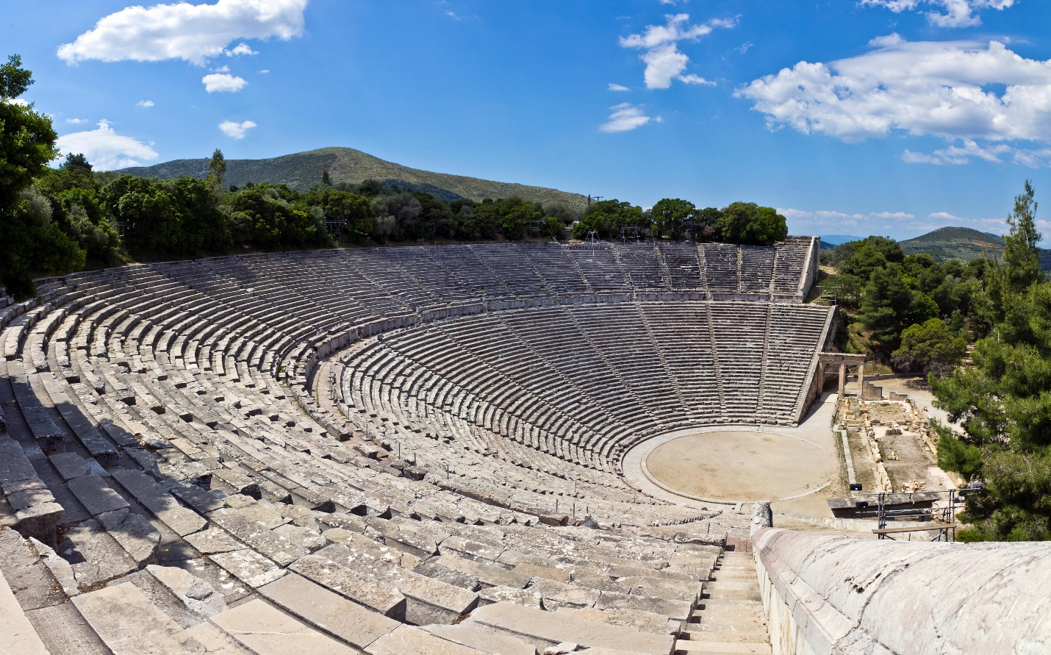
- Themes in Classical literature often included human experiences, societal changes, and philosophical ideas reflective of the era's developments.

Check-In Questions:
1. During the Archaic period, how were stories mainly told?
- Answer: Through oral tradition/spoken word.
2. What event marks the beginning of the Greek Classical period?
- Answer: Greece’s victory over Persia.

Practice Questions:
1. What are the major themes of Greek literature in the Archaic period, and what does that tell you about the history of that time?
- Answer: Many stories of the Greek Archaic period were centered around myths that told stories about the relationships between gods and humans. Archaic literature was about Greece’s history. The tales were partly true and partly fiction. Some of the stories were about the Trojan War, "The Odyssey," and the Olympic Games.
2. Identify the major themes of Greek literature in the Classical period. What does that tell you about the history of that time?
- Answer: Classical period literature was centered around tragedies or comedies that told stories more relatable to the human experience of the time. They still included stories of the deities but also conveyed important messages or lessons. Classical literature reflected new developments in democracy, art, and architecture of the time period.

- Greek Advancements in Mathematics

Objective 3: Analyze the significance of Greek advancements in math and science as it relates to your own life and to the world today.

Essential Question: How did Greek literature reflect the history of the time?

Key Terms:
1. The Elements: A comprehensive math textbook by Euclid, focusing on geometry and math.
2. Deductive Reasoning: The formation of an idea or conclusion based on traditionally accepted statements or facts.
3. Empirical: Based on observation or experience rather than theory or pure logic.
4. Fibonacci Sequence: A sequence of numbers where each number is the sum of the two preceding ones.
5. Alarm Clock: A device used to alert or awaken individuals at a set time, notably invented by Plato.

Big Ideas:
- Ancient Greek scholars made significant discoveries in math, science, and technology that have endured through the ages.
- Euclid’s "The Elements" provided foundational knowledge in geometry and math that are still taught today.
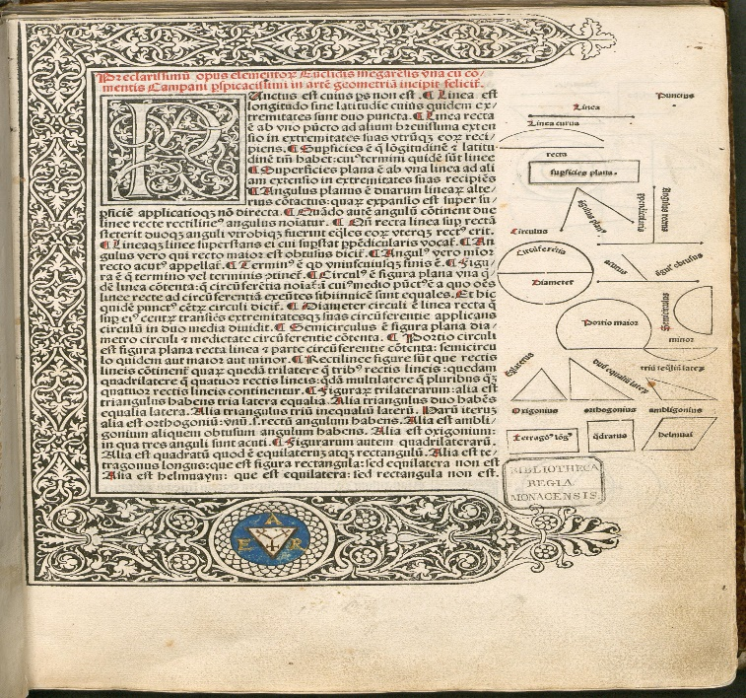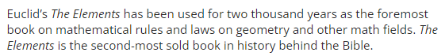
- The use of deductive reasoning shaped Greek advancements but also showed its limitations without empirical evidence.
- Influential Greek figures like Aristotle, Ptolemy, and Hippocrates contributed to fields like logic, astronomy, and medicine.
- Technological advancements like Plato’s alarm clock and the development of screws have practical applications in modern life. 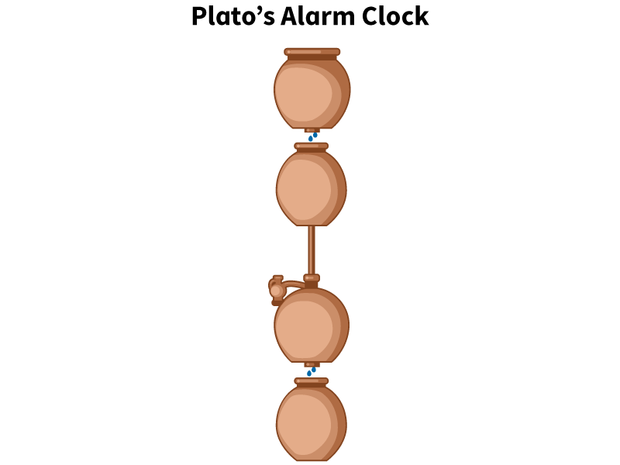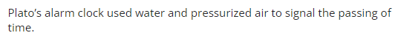
- Greek knowledge spread widely through travel, trade, and conquests, influencing cultures far beyond ancient Greece.

Check-In Questions:
1. Identify one Greek scholar and a significant contribution they made to either math or science.
- Answer: Aristarchus measured the size of the Earth and moon and hypothesized that the sun rather than Earth is the center of the solar system.
2. What did David and Daniel use to solve Euclid’s line problem creatively?
- Answer: They used a computer program to run simulations of different shapes, lines, and angles until they arrived at a Fibonacci sequence that gave them the answer to the line problem.

Practice Questions:
1. What scientific and technological ideas spread from Greece to other ancient civilizations and continue to influence the modern world?
- Answer: Greek scientific and technological ideas spread widely across ancient Europe, the Middle East, and North Africa. Ideas such as Aristarchus's heliocentric theory, Eratosthenes's earth size estimation, Euclid's mathematical theorems, and Hippocrates's medical ethics remain relevant today. Key technologies like nuts, bolts, screws, and water pumps also originated in Ancient Greece.
2. How did science and technology spread throughout ancient Greece?
- Answer: Science and technology spread throughout ancient Greece through written texts, interactions between philosophers and scholars, and institutions such as Hippocrates's school of medicine.

- Greek City-States

Objective 4: Present the ways that Greek city-states were culturally united with an evidence-based explanation.

Essential Question: What cultural factors united Greek city-states?

Key Terms:
1. City-State: An independent, self-governing city and its surrounding territory.
2. Polis: The term for a city-state in ancient Greece.
3. Acropolis: A fortified high area or citadel within a Greek city-state, often containing temples.
4. Panathenaea: A major festival in ancient Athens dedicated to the goddess Athena.
5. Greco-Persian Wars: Wars fought between the Greek city-states and the Persian Empire from 490 BCE to 448 BCE.

Big Ideas:
- Ancient Greece was not a single unified nation but a collection of independent city-states (polis) with unique governments, cultures, and social structures.
- Despite their differences, Greek city-states were united by common language, religious beliefs, and cultural practices like festivals and theater.
- Major city-states like Athens, Sparta, and Corinth serve as examples of the diversity and unity within Greek civilization.
- Shared religious practices and the construction of temples and acropolises indicate a common faith across city-states.
- The Greek language facilitated communication, trade, and collaboration among city-states.
- Cultural events like the Olympic Games and festivals such as Panathenaea brought people together from different poleis to celebrate their shared heritage. 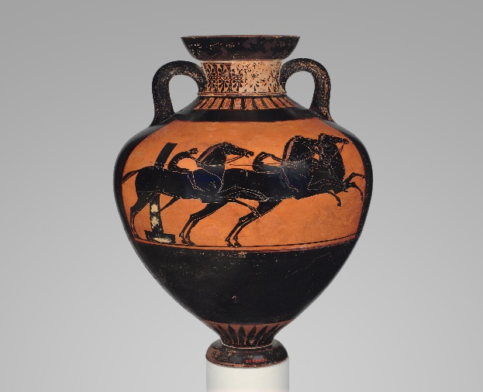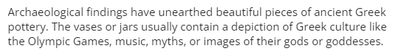
- The Greek city-states united against common external threats, such as during the Greco-Persian Wars, demonstrating their ability to come together in defense of their collective culture.

Check-In Questions:
1. What evidence have historians found that show the Greeks were united by theater?
- Answer: Historians and archaeologists have found amphitheaters all over Greece.
2. Choose one of the Greek festivals and explain its importance to ancient Greek culture.
- Answer: The Panathenaea festival held in Athens was a massive event that honored the deity Athena and brought together poleis in religious ceremonies and various competitions.

Practice Questions:
1. What evidence is there for historians to know that Greek city-states shared a unified religion?
- Answer: Archaeologists have discovered that religious temples and acropolises are the center attraction of many poleis all over Greece. Many statues and monuments dedicated to specific deities have been found and can be visited today.
2. What evidence does examining ancient Greek pottery communicate to historians about the Greek’s unified culture?
- Answer: The pottery pieces depict important aspects of Greek culture, such as athletes competing, performers playing instruments, deities, and theatrical performances, showcasing a shared cultural and religious identity.

- Unit 4 Lesson 4: Roman Republic
- The Roman Republic’s Place in the Ancient Mediterranean

Objective 1: In this section, you will examine the similarities and differences between the Roman Republic and other civilizations in the Mediterranean and Asia by using charts.

Essential Question: What explains the rise of the Roman Republic to regional power?

Key Terms:
1. Consuls - Elected leaders who governed the Roman Republic.
2. Senate - A governing body composed of wealthy individuals.
3. Patrician - Wealthy citizens in the Roman Republic’s upper class.
4. Plebeian - Middle-class citizens in the Roman Republic.
5. Imperium - Roman authority over military matters.

Big Ideas:
- Governance Systems: The Roman Republic used a unique governance system with elected officials (consuls) rather than monarchs. This was different from other Mediterranean and Asian civilizations. 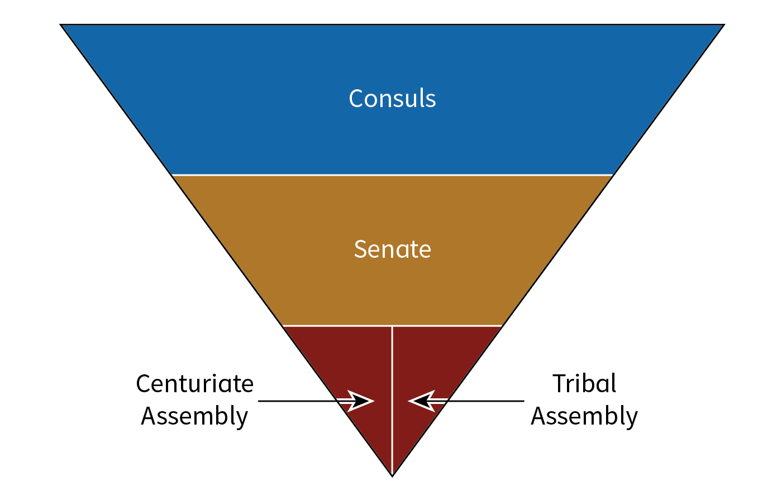
- Social Structure: The Roman Republic had a distinct social structure with patricians and plebeians, which influenced its political dynamics.
- Conflict Management: Romans developed different structures for handling conflicts and decision-making, such as the Centuriate Assembly for military matters.
- Rise to Power: The Republic's ability to adapt leadership and governance helped it manage both internal social structures and external military challenges effectively, which contributed to its regional dominance.
- Transition to Empire: The Roman Republic eventually transformed into the Roman Empire due to internal power struggles and reforms, such as those instigated by Julius Caesar. 

Summary:
The Roman Republic was founded in 509 BCE, replacing a monarchy with a system where power was divided between elected consuls and the senate. The social structure included patricians (wealthy upper class) and plebeians (middle class). The Roman Republic was notable for its sophisticated governance, which led its rise to regional power. However, the concentration of military power under certain leaders like Julius Caesar eventually led to the transformation into the Roman Empire.

Check-In Questions:
1. What led to the creation of the Roman Republic?
- Answer: The Roman Republic was created to replace the tyrannical rule of monarchs, like Superbus, with a more balanced system where power was divided between elected officials, known as consuls, and the senate.

2. Who were the plebeians in the Roman Republic?
- Answer: Plebeians were middle-class citizens who held jobs such as artisans, farmers, merchants, and traders but were not part of the wealthy upper class.

Practice Questions:
1. How did the Roman Republic differ from the Achaemenid Empire in terms of governance?
- Answer: The Achaemenid Empire had a centralized government ruled by a king, who used satraps (governors) for provincial control, while the Roman Republic was governed by elected consuls and a senate, which represented a more democratic form of governance.

2. Compare the Roman Republic’s consuls to the governance in the Greek polis.
- Sample answer: The consuls in the Roman Republic were elected leaders who managed both civil and military affairs. In contrast, the Greek polis like Athens used a democratic assembly called the ecclesia where all citizens could vote directly on major decisions.

- The Roman Republic in a Global Context

Objective 2: In this section, you will explain the similarities and differences between the Roman Republic and other civilizations in the Americas by using charts and diagrams.

Essential Question: In what ways was the Roman Republic similar to and different from the Inca and Mayan civilizations?

Key Terms:
1. Consuls - Elected leaders of the Roman Republic.
2. Senate - The main legislating body in the Roman Republic.
3. Sapa Inca - The king of the Inca Empire.
4. Deme - Territory within Athens dictating participation in the ecclesia and Council of 500.
5. Ecclesia - The democratic assembly in the Athenian polis.

Big Ideas:
- Comparative Governance: The Roman Republic had elected leaders and a structured senate, differing from the monarchies and centralized control in the Inca and Mayan civilizations.
- Social Dynamics: Both the Roman Republic and the Mayan civilization had hierarchical class systems, but the Inca Empire had a strict, labor-intensive society.
- Decision-Making Bodies: The governance system of the Roman Republic included consuls and assemblies, whereas the Inca Empire utilized territorial officials and the Mayan civilization had demigod leaders.
- Stability Through Structure: The Roman Republic aimed for broad representation through election, while the Inca Empire centralized control under the Sapa Inca and his advisors.
- Geographical Influence: Governance in ancient civilizations was often shaped by their geography, e.g., the isolation of Greek city-states and the vast control of the Inca Empire.

Summary:
The Roman Republic, Inca Empire, and Mayan civilization all had unique forms of governance and social structures. The Roman Republic was known for its elected consuls and senate, contrasting sharply with the centralized monarchic structures of the Inca and Mayan civilizations. The Inca Empire, for example, had a tiered system with the Sapa Inca at the top, while the Mayans had demigod rulers. Despite these differences, each civilization managed complex and vast territories in their own distinct ways. 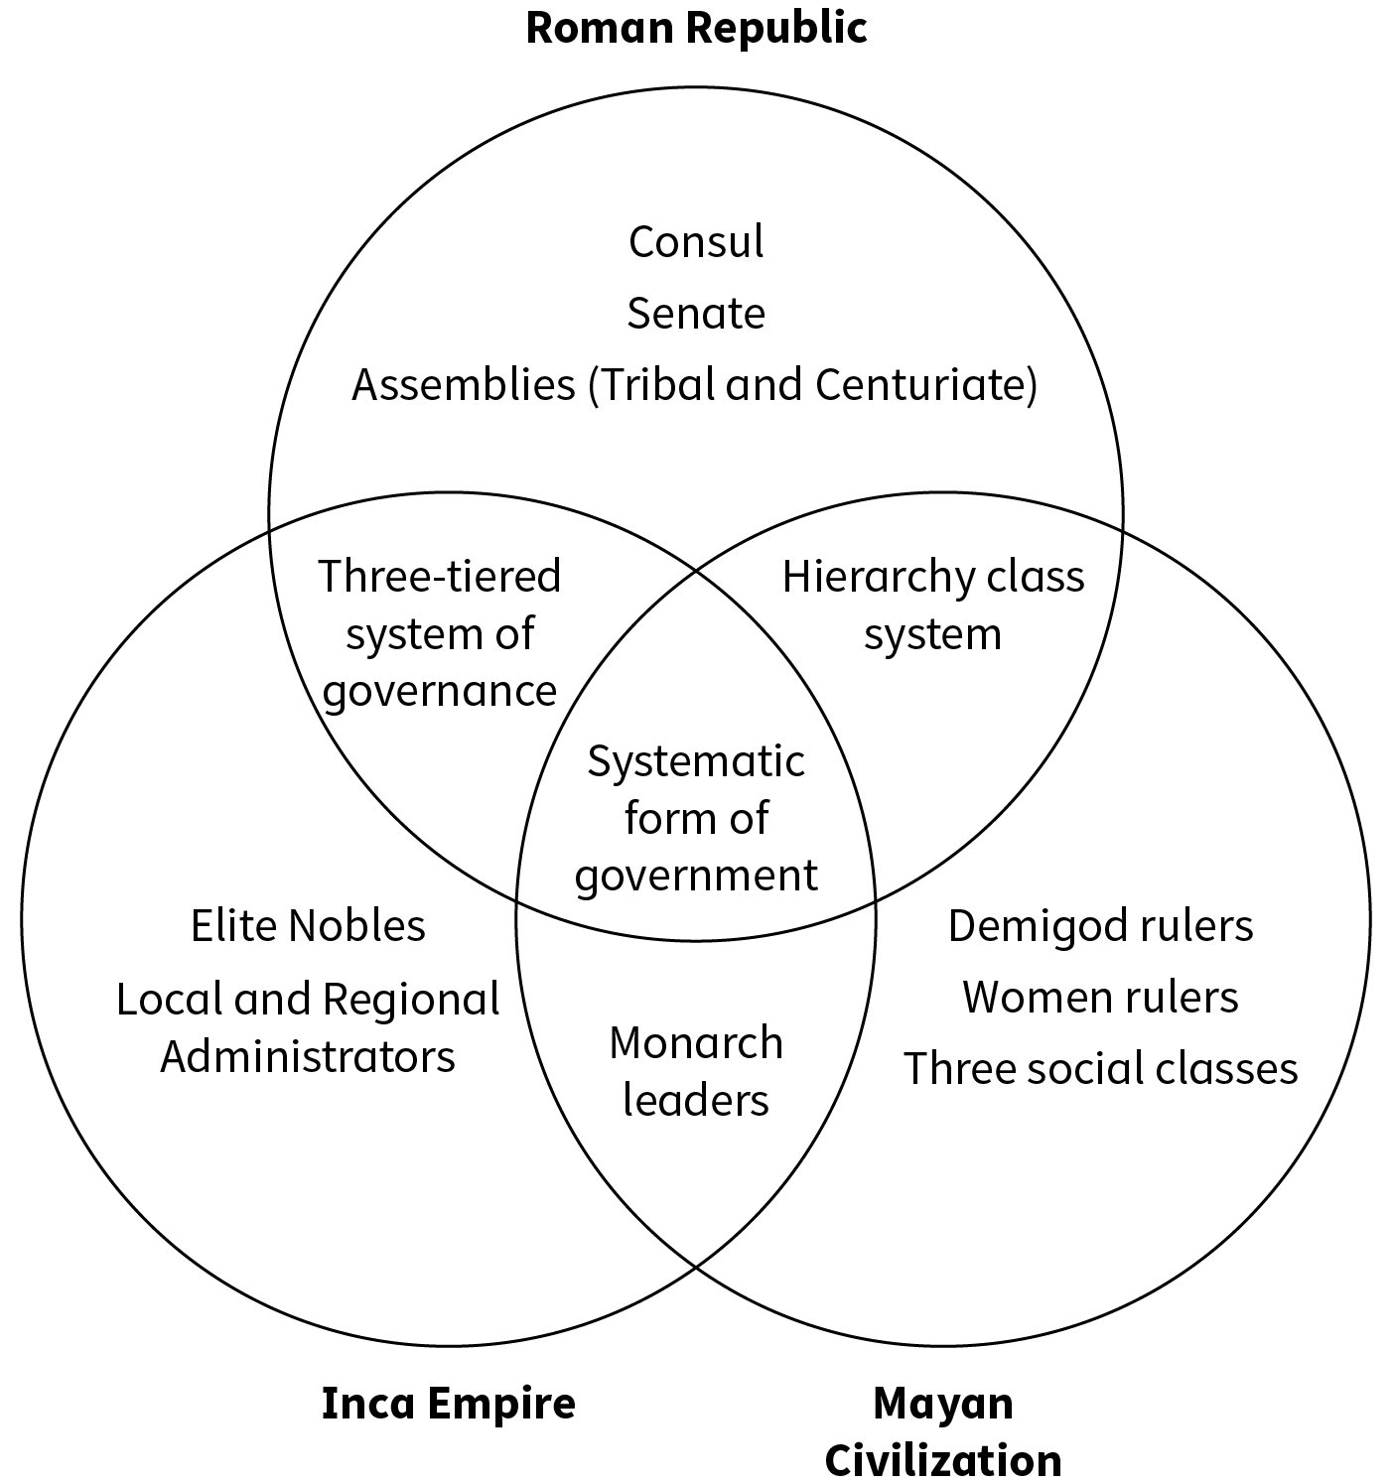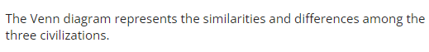

Check-In Questions:
1. What are the main governing bodies of the Inca Empire?
- Answer: The king (Sapa Inca), nobles, regional administrators, and local administrators.

2. What is a major difference between the Roman Republic and the Mayan civilization?
- Answer: The Mayan civilization used a demigod monarch as a ruler, whereas the Roman Republic had two elected consuls.

Practice Questions:
1. Create a chart listing the major differences and similarities between the Inca Empire and the Roman Republic governments. Then, write 3-5 sentences explaining those similarities and differences.
- Sample answer: Similarities between the Roman Republic and the Inca Empire: Both systems had three major parts of governance. The Republic used a senate, assemblies, and elected consuls, while the Inca Empire used territorial officials and nobility. Differences: The Inca Civilization had a monarch (Sapa Inca), unlike the elected officials in the Roman Republic. The Inca system was more centralized, with stricter control over provinces compared to the semi-autonomous assemblies of the Roman Republic.

- The Collapse of a Republic and Rise of an Empire

Objective 3: In this section, you will summarize the key figures and events that led to the collapse of the Roman Republic and the formation of the Roman Empire.

Essential Question: What figures and events contributed to the collapse of the Roman Republic and the formation of the Roman Empire?

Key Terms:
1. Consuls - Elected leaders of the Roman Republic.
2. Senate - The governing body of the Roman Republic.
3. Dictator - A ruler with total control, especially in times of crisis.
4. Triumvirate - A political alliance of three leaders holding power.
5. Imperator - The title given to a commander of the Roman Empire.

Big Ideas:
- Political Struggles: Power struggles between the plebeians and patricians, as well as between different political factions, weakened the Roman Republic.
- The Role of Julius Caesar: Julius Caesar's rise to power, his reforms, and his eventual assassination were pivotal events that led to the end of the Roman Republic. 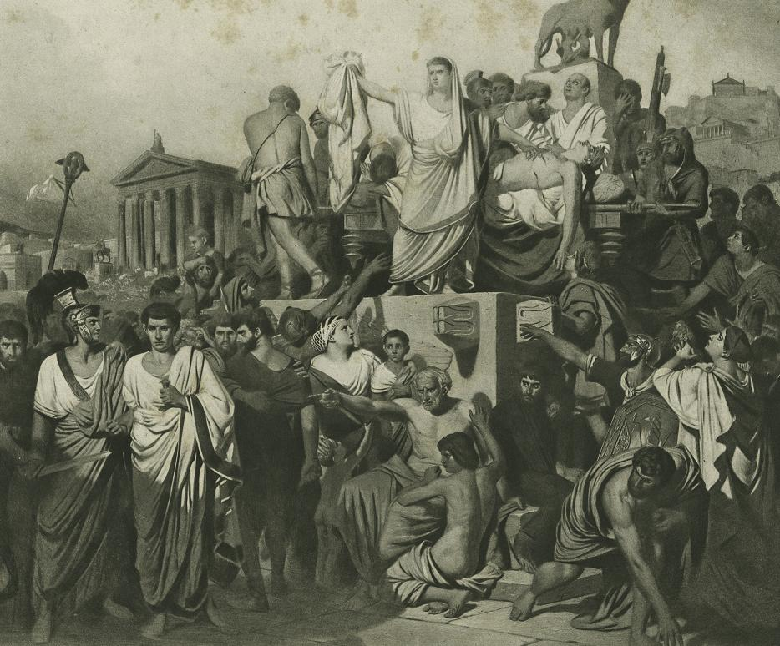
- Civil Wars: The internal conflicts and civil wars between powerful Roman generals significantly contributed to the Republic's collapse.
- The Rise of the Empire: The transition from a Republic to an Empire began with Augustus Caesar becoming the first emperor, after the defeat of Antony and Cleopatra.
- Pax Romana: Augustus Caesar’s reign led to a period of peace and stability known as Pax Romana that lasted nearly 200 years.

Summary:
The Roman Republic faced several internal conflicts and power struggles that eventually led to its collapse. Key figures like Julius Caesar played significant roles as his rise to power and assassination catalyzed political changes. The power struggles within the Roman Republic led to civil wars, and the establishment of the First and Second Triumvirates further highlighted these conflicts. The eventual victory of Octavian (Augustus Caesar) over Antony marked the end of the Republic and the beginning of the Roman Empire, ushering in a period of peace known as Pax Romana.

Check-In Questions:
1. What was Augustus Caesar’s name before being called an imperator?
- Answer: Octavian

2. Along with Caesar and Crassus, who was the third member of the First Triumvirate?
- Answer: Pompey the Great

Practice Questions:
1. Construct a timeline of events that summarizes the fall of the Roman Republic and the formation of the Roman Empire.
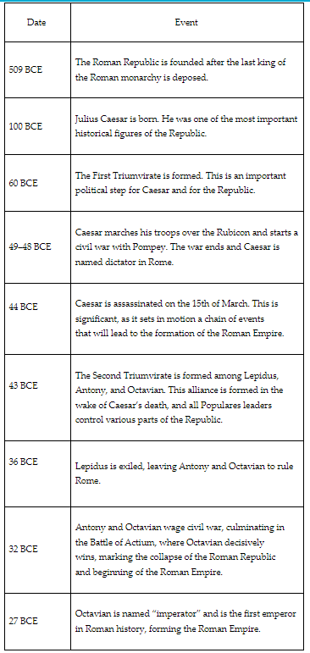
- Sample answer:
- 509 BCE: The Roman Republic is founded after the last king is deposed.
- 100 BCE: Julius Caesar is born.
- 60 BCE: The First Triumvirate is formed.
- 49–48 BCE: Caesar marches his troops over the Rubicon and starts a civil war with Pompey. The war ends and Caesar is named dictator.
- 44 BCE: Caesar is assassinated on March 15th (Ides of March).
- 43 BCE: The Second Triumvirate is formed among Lepidus, Antony, and Octavian.
- 32 BCE: Octavian defeats Antony at the Battle of Actium, marking the end of the Republic and the start of the Empire.
- 27 BCE: Octavian is named “imperator” and becomes the first emperor of Rome.

2. In 2-4 sentences, summarize why Julius Caesar formed the First Triumvirate.
Sample Answer: The senate was made up of the Populares and Optimates. These parties clashed in their needs and wants, which often caused a deadlock. Since Caesar was part of the Populares, he needed support from the Optimates in the Senate. Thus, Caesar, Crassus, and Pompey formed the First Triumvirate to streamline Roman politics for the time being.

- The History of Rome: Birth of an Empire

Objective 4: In this section, you will construct a timeline that identifies important people and events that led to the collapse of the Roman Republic and the rise of the Roman Empire.

Essential Question: What people and events contributed to the collapse of the Roman Republic and the beginning of the Roman Empire?

Key Terms:
1. Consuls - Elected leaders of the Roman Republic.
2. Tribune - Officials elected to represent plebeians’ interests.
3. Populares - Political leaders who supported the cause of the plebeians.
4. Optimates - Political leaders who supported the patrician class and status quo.
5. Imperator - The title given to the emperor of Rome.

Big Ideas:
- Early Political Violence: The assassinations of the Gracchi brothers marked the beginning of political violence in Rome.
- Sulla and Marius: Their power struggles and actions set a precedent for military intervention in politics.
- Julius Caesar: His formation of the First Triumvirate, crossing the Rubicon, and subsequent rule as dictator greatly impacted Rome’s political landscape.
- Transformation through Conflict: Internal conflicts and civil wars played a significant role in transitioning from Republic to Empire.
- Augustus and Pax Romana: Octavian’s (Augustus) victory solidified his rule, leading to the establishment of the Roman Empire and a period of peace and prosperity.

Summary:
The collapse of the Roman Republic and the rise of the Roman Empire were marked by significant events and influential figures. Political violence began with the Gracchi brothers’ assassinations, and power struggles between Sulla and Marius further destabilized the Republic. Julius Caesar’s rise, including his formation of the First Triumvirate and crossing of the Rubicon, led to his rule as dictator and his eventual assassination. The Second Triumvirate and subsequent victory of Octavian at the Battle of Actium marked the final transformation from Republic to Empire. Augustus’ reign brought about the Pax Romana, a period of peace and stability in Rome.

Check-In Questions:
1. Which historical events helped shape the politics of the Roman Republic?
- Answer: The Gracchi brothers’ assassinations, Sulla’s march on Rome, the First Triumvirate, Caesar’s march across the Rubicon, the Ides of March, and the Battle of Actium.

2. When did political violence become normalized in Roman politics?
- Answer: Political violence became normalized when the Gracchi brothers were assassinated.

Practice Questions:
1. Construct a timeline of important people and events that led to the fall of the Roman Republic and rise of the Roman Empire.
- Sample answer:
- 133 BCE: Plebeian tribune Tiberius Gracchus is assassinated.
- 121 BCE: Plebeian tribune Gaius Gracchus is assassinated.
- 88 BCE: Sulla marches on Rome, deposing Marius.
- 60 BCE: First Triumvirate of Caesar, Pompey, and Crassus is established.
- 49 BCE: Caesar declares war on Rome by marching troops over the Rubicon.
- 44 BCE: Ides of March, Caesar is assassinated, marking the collapse of the Roman Republic.
- 43 BCE: Octavian succeeds Caesar and forms the Second Triumvirate.
- 31 BCE: Octavian’s victory at the Battle of Actium over Mark Antony marks the start of the Roman Empire.
- 27 BCE: Beginning of the Pax Romana—prosperity for Rome.
- 180 CE: End of the Pax Romana.

2. Fill in the chart with missing names, dates, or significant events. Then in 3–5 sentences, explain why these were significant events that led to the fall of the Roman Republic.

Name | Date | Event
Tiberius Gracchus
Sulia | 88 BCE
 |  | Ides of March-end of the Roman Republic

- Sample answer:
- Name: Tiberius Gracchus | Date: 133 BCE | Event: The first Gracchus brother is assassinated for angering the patricians, marking the beginning of violence in Roman politics.
- Name: Sulla | Date: 88 BCE | Event: Sulla marches on Rome, using the might of his legions to force his political will upon the Roman people.
- Name: Julius Caesar | Date: 44 BCE | Event: Ides of March—end of the Roman Republic. Tiberius Gracchus and Sulla were important to the fall of the Roman Republic. They both normalized different forms of violence within Roman politics. Caesar was important because he won the first civil war between himself and Pompey, showcasing the power a single dictator had within the Republic.

- Unit 4 Lesson 5: Rise of Christianity
- Introduction: Religion and Civilization

Objective 1: In this section, you will construct a table diagram to compare and contrast the beliefs of Judaism and Christianity.

Essential Question: What factors led to the rise of Judaism and Christianity around the world?

Key Terms:
1. Polytheism - The belief in or worship of more than one god.
2. Monotheism - The belief in one god.
3. Judaism - One of the first and oldest monotheistic religions.
4. Tanakh - The holy text of Judaism, divided into three sections (Torah, Nevi’im, Ketuvim).
5. Christianity - The religion that believes Jesus is the son of God and the Savior.

Big Ideas:
- Judaism: One of the first monotheistic religions, originating over 3,000 years ago. It is based on the belief in one God and the teachings written in the Tanakh. Judaism was practiced in the ancient land of Canaan and later became centered around laws and holy texts after the Babylonian Exile. 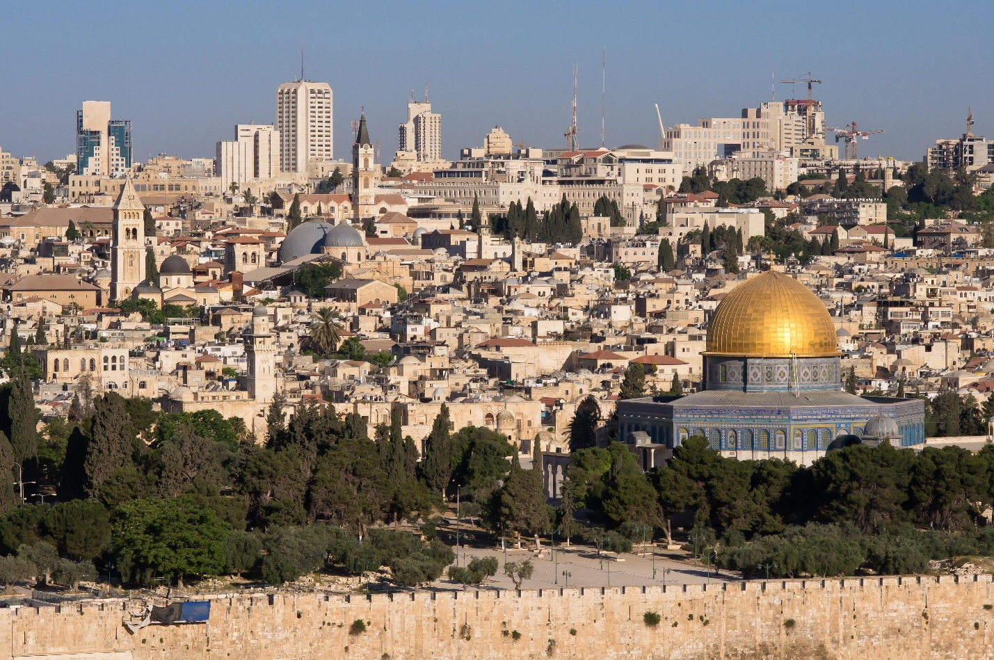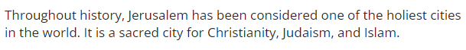
- Christianity: Christianity began as a branch of Judaism during the Roman Empire and became the dominant religion after Emperor Constantine's conversion in 300 CE. Christians believe that Jesus is the son of God who died for the sins of humanity and was resurrected. Their teachings are recorded in the Holy Bible.
- Common Grounds and Differences: Both Judaism and Christianity are monotheistic and share some historical roots and holy sites like Jerusalem. However, one of the major differences is that Christians believe Jesus is the Messiah, while Judaism does not.

Summary:
Throughout human history, polytheism was widely practiced, as seen in ancient Greek, Roman, and Egyptian civilizations. Monotheistic Judaism emerged over 3,000 years ago, with beliefs centered on a single God and teachings found in the Tanakh. Christianity later branched out from Judaism during the Roman Empire and gained prominence after Emperor Constantine's conversion, establishing its holy text, the Holy Bible. Both religions influenced global religious practices, with key figures and teachings that shaped their respective growth and significance.

Check-In Questions:
1. What is the difference between a polytheistic and monotheistic religion?
- Answer: A polytheistic religion has more than one god, whereas a monotheistic religion has one god.

2. What are the holy texts of both the Jewish and Christian faiths?
- Answer: Judaism’s holy text is the Tanakh and Christianity’s holy text is the Bible.

3. What are the foundations of Judaism and Christianity?
- Answer: Judaism’s foundations are that God came to the prophet Abraham and told him his people would found a great nation based on God’s laws. Christianity’s foundations are that Jesus is the Lord, Christ, and Savior, sent by God to free people from their sins.

Practice Questions:
1. What were the causes for the development of Judaism?
- Answer: Around 2000 BCE, the monotheistic Hebrews took over Canaan and became known as the Israelites. The Babylonians captured Judah, leading to the creation of the Diaspora and a focus on laws and holy texts.

2. Identify two similarities between Judaism and Christianity.
- Sample answer:
- Both religions are monotheistic.
- Both see God as the creator of the Earth and universe.

3. Identify two differences between Judaism and Christianity.
- Sample answer:
- Different major religious holidays.
- Different holy texts.

- Development of Early Christianity

Objective 2: In this section, you will summarize the fundamental beliefs of Christianity and its development in the Roman province of Judea, using evidence from a variety of primary and secondary sources.

Essential Question: What factors led to the rise of Christianity in the Roman Empire?

Key Terms:
1. Judea - The region where Christianity originated, in present-day Israel.
2. Christianity - Religion based on the teachings of Jesus.
3. Apostles - Early followers of Jesus who spread his teachings.
4. Messiah - A savior or liberator of a group of people; Jesus in Christianity.
5. Persecuted - Subjected to hostility and ill-treatment, especially because of religion.

Big Ideas:
- Origins in Judea: Christianity started as a small, unorganized religious movement in Judea, with Jesus as its central figure.
- Spread of Teachings: Jesus preached about God and the kingdom of heaven, gaining followers through his teachings and reported miracles. His disciples continued his work after his crucifixion. 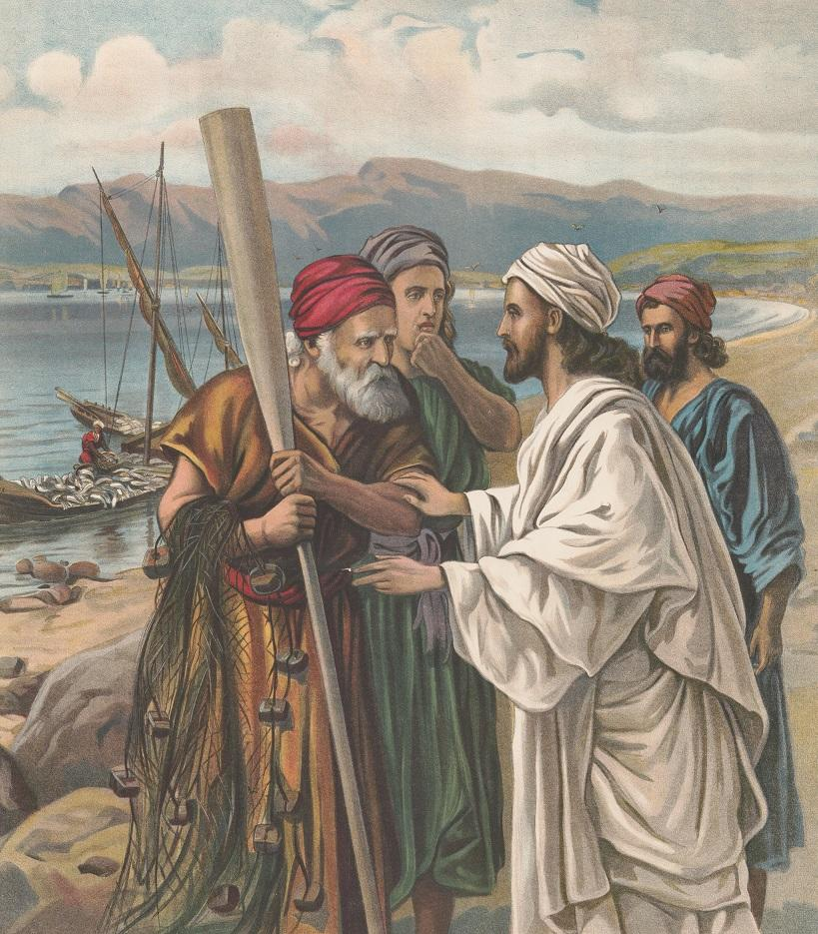
- Persecution: Early Christians were persecuted for their beliefs, often meeting in private homes to worship. Despite this, the religion grew in popularity.
- Archaeological Findings: Discoveries such as mosaic floors suggest that early Christians may have gathered more publicly than previously thought.
- Paul's Role: Apostle Paul played a significant role in spreading Christianity across the Roman Empire, speaking Greek and traveling widely.

Summary:
Christianity emerged in Judea during the Roman Empire while Judaism was the prominent religion. Jesus, born between 4 and 6 BCE, preached about God and performed miracles, which attracted many followers. His crucifixion by the Romans did not end his influence; instead, his apostles, especially Paul, spread his teachings throughout Judea and the Roman Empire. Despite early persecution, the teachings of hope and eternal life resonated with the poor and marginalized, helping Christianity grow rapidly.

Check-In Questions:
1. List two fundamental beliefs of Christianity.
- Answer: Christians believe in one God and follow the teachings in the Holy Bible.

2. Which groups of people were most attracted to the messages of Jesus and Christianity?
- Answer: Poor and marginalized people were most attracted to the Christian message.

Practice Questions:
1. Using evidence from paragraphs six and seven of the EBSCO article titled “First Churches of the Jesus Cult,” determine the common meeting places for early Christians in Judea.
- Answer: Many Christians gathered in the private homes of followers.

2. Summarize why Christianity was attractive to its earliest followers using the primary source in the St. James Bible, “The Epistle of Paul the Apostle to the Romans” and the section titled Conception of 'Teacher' in Early Christianity in the secondary source “Teachers in Early Christianity.”
- Answer: Christianity offered a better life after death free of misery in Heaven.

- Development of a World Religion

Lesson Objective 3: In this section, you will summarize how Christianity spread throughout the Roman world by using various perspectives.

Essential Question: How did the spread of Christianity impact Roman society?

Key Terms:
1. Sect - A subgroup of a larger religious movement.
2. Disciples - Followers of Jesus who spread his teachings.
3. Martyr - Someone who dies for their religious beliefs.
4. Apostle - An early Christian teacher, with Paul being one of the most notable.
5. Edict of Milan - Decree issued by Emperor Constantine in 313 CE that legalized Christianity.

Big Ideas:
- Jesus and His Disciples: Jesus preached throughout Judea and nearby regions, performing miracles and gathering followers. His disciples continued spreading his teachings after his crucifixion.
- Paul the Apostle: Paul was instrumental in spreading Christianity across the Roman Empire. A Roman citizen fluent in Greek, Paul traveled extensively to preach about Jesus. 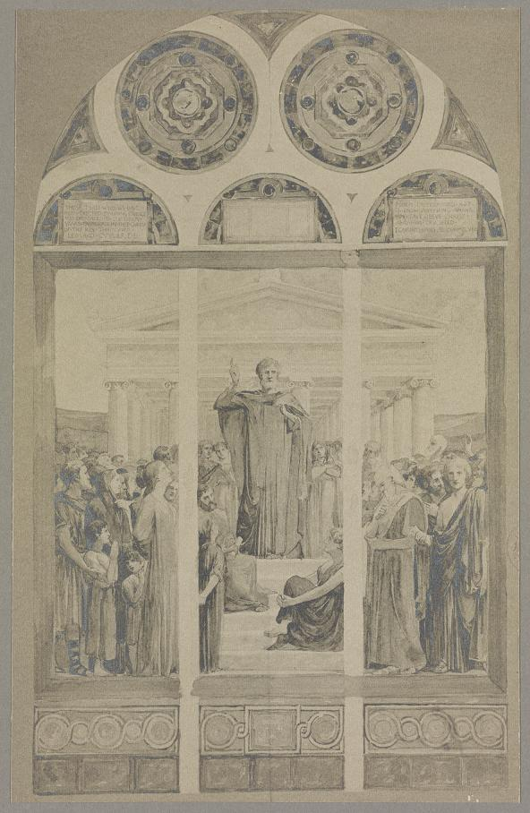
- Emperor Constantine: Constantine's conversion to Christianity and the Edict of Milan were significant, allowing Christianity to become the Roman Empire's major religion.
- Communication: Effective communication by Jesus, Paul, and other disciples helped spread Christianity through word of mouth.
- Language and Infrastructure: Common languages (Latin and Greek) and Rome's extensive road networks facilitated the spread of Christian teachings.

Summary:
The spread of Christianity in the Roman world was significantly influenced by key figures such as Jesus, his disciples, Paul, and Emperor Constantine. Jesus' teachings provided hope and promise of eternal life, appealing to the poor and marginalized. Paul, with his extensive travels and effective communication, helped in spreading these teachings across the Roman Empire. Constantine's conversion and the Edict of Milan in 313 CE allowed Christians to freely practice their faith, leading to its acceptance and growth as the dominant religion.

Check-In Questions:
1. What impact did the Edict of Milan have on the spread of Christianity in the Roman world?
- Answer: The Edict of Milan allowed Christians to freely practice their beliefs and allowed for people to freely convert to Christianity without fear of being persecuted.

2. The apostle Paul traveled all over the eastern Roman Empire. List three places that Paul traveled to spread Christianity.
- Answer: Greece, Rome, Cyprus, Naples, present-day Turkey, present-day Israel.

Practice Questions:
1. During the Roman Empire, important messages such as the beliefs of Christianity were spread via word of mouth. Is information still communicated via word of mouth today? What are some ways information is spread differently now?
- Answer: Information and messages today are still spread by word of mouth but more so through social media, written/news media, and text messaging.

2. Jesus and the apostle Paul had to be strong speakers to clearly communicate their ideas about Christianity to grow and spread the religion. Search online for some effective ways to be a strong communicator in our society today.
- Answer: Strong communicators know the objective of what they want to get across, speak confidently and clearly, actively listen to responses, and collaborate with others.

3. Summarize the impact of Christianity’s spread across Europe.
- Sample Answer: In the early days of Christianity, the faith offered the poor of Roman society the promise of an eternal life free from hardship and inequality. Later, after Constantine’s military victory in 312, he promoted Christianity so that it became the major religion of the empire. Millions of people in the Roman world converted and polytheistic beliefs of the Roman world became less popular.

- Christianity Over Time

Objective 4: In this section, you will construct a timeline identifying important people and events from the origins of Christianity through the recognition of Christianity as the major religion of the Roman Empire.

Essential Question: How did Christianity impact Roman society throughout time?

Key Terms:
1. Edict of Milan - Decree issued in 313 CE by Emperor Constantine that legalized Christianity.
2. Constantine - Roman Emperor who converted to Christianity.
3. Theodosius - Roman Emperor who made Christianity the official religion in 392 CE.
4. Council of Nicaea - A gathering in 325 CE to unify Christian beliefs.
5. Polytheism - The belief in multiple gods, which was prevalent in Rome before Christianity.

Big Ideas:
- From Sect to Dominance: Christianity began as a small sect within Judaism in Judea but grew to become the Roman Empire's official religion by 392 CE.
- Emperor Constantine: Played a critical role in promoting Christianity after his conversion in 312 CE, leading to the Edict of Milan in 313 CE.
- Council of Nicaea: Established in 325 CE to unify Christian beliefs and practices, cementing Christianity's influence in the Roman Empire.
- Emperor Theodosius: Made Christianity the official religion of the Roman Empire in 392 CE, marking a significant shift from Rome's polytheistic past.
- Persecution and Peace: Christianity faced persecution before gaining acceptance and eventually flourishing under supportive Roman emperors.

Summary:
Christianity's evolution from a persecuted sect to the dominant religion of the Roman Empire involved several pivotal events and influential figures. Jesus' teachings laid the foundation, while Paul the Apostle spread these teachings extensively. Emperor Constantine's conversion and the Edict of Milan in 313 CE marked a turning point, leading to the formation of the Council of Nicaea in 325 CE to unify Christian beliefs. Finally, Emperor Theodosius declared Christianity as the official religion in 392 CE, securing its central role in Roman society.

Check-In Questions:
1. When was the Edict of Milan issued?
- Answer: 313 CE

2. When did Emperor Theodosius make Christianity the official religion of the Roman Empire?
- Answer: 392 CE

Practice Questions:
1. Describe the major effects of the development of Christianity in the Roman Empire.
- Answer: Early Christians faced persecution for refusing to worship Roman gods. Constantine's Edict of Milan in 313 allowed Christians to openly practice their beliefs. The Council of Nicaea further unified Christian doctrines, and Theodosius' declaration in 392 made Christianity the official religion, reducing the prevalence of polytheistic beliefs.

2. Finish constructing the timeline to identify important events and people that played a role in the development of Christianity.
- Sample answer:
- Timeline: Spread of Christianity
- Year: 4 CE | Event: Birth of Jesus
- Year: 30 CE | Event: Jesus crucified
- Year: 36 CE | Event: Paul the Apostle has a vision of Jesus
- Year: 64 CE | Event: Great Fire of Rome occurs
- Year: 312 CE | Event: Constantine’s conversion to Christianity
- Year: 313 CE | Event: Edict of Milan issued
- Year: 325 CE | Event: Council of Nicaea meets
- Year: 392 CE | Event: Christianity becomes the official religion of the Roman Empire

3. Select an event that occurred during Christianity’s development. Identify when it occurred and explain its significance in the spread of Christianity.
- Sample answer: In 312 CE, Emperor Constantine converted to Christianity. This led to Roman officials accepting the religion and to its eventual acceptance throughout the empire. After Constantine's conversion, Christians did not have to worry about the threat of official persecution and could openly practice their religion.

- Unit 4 Lesson 6: Western and Eastern Empires Split
- Constantine and the Christian Roman Empire

Objective 1: Develop a thesis about the importance of Constantine’s conversion to Christianity and the lasting effects on the Western and Eastern Roman Empire.

Essential Question: How did Constantine’s conversion to Christianity change the course of the Roman Empire?

Key Terms:
1. Milvian Bridge - The battle where Constantine claimed to see a vision of a cross.
2. Edict of Milan - Agreement allowing Christians to practice their religion freely.
3. Constantine - The first Roman emperor to convert to Christianity.
4. Nicene Creed - The affirmation of faith created during the Council of Nicaea.
5. Donatist Schism - A disagreement about the integrity of church leaders.

Big Ideas:
- Conversion to Christianity: Constantine's conversion to Christianity following the Battle of Milvian Bridge marked a significant shift in the Roman Empire’s religious direction.
- Legal and Social Changes: The Edict of Milan legalized Christianity, giving Christians the freedom to worship openly and hold public office.
- Council of Nicaea: Held by Constantine, this council aimed to unify Christian doctrine and resulted in the creation of the Nicene Creed and further solidified the Church's influence in the empire. 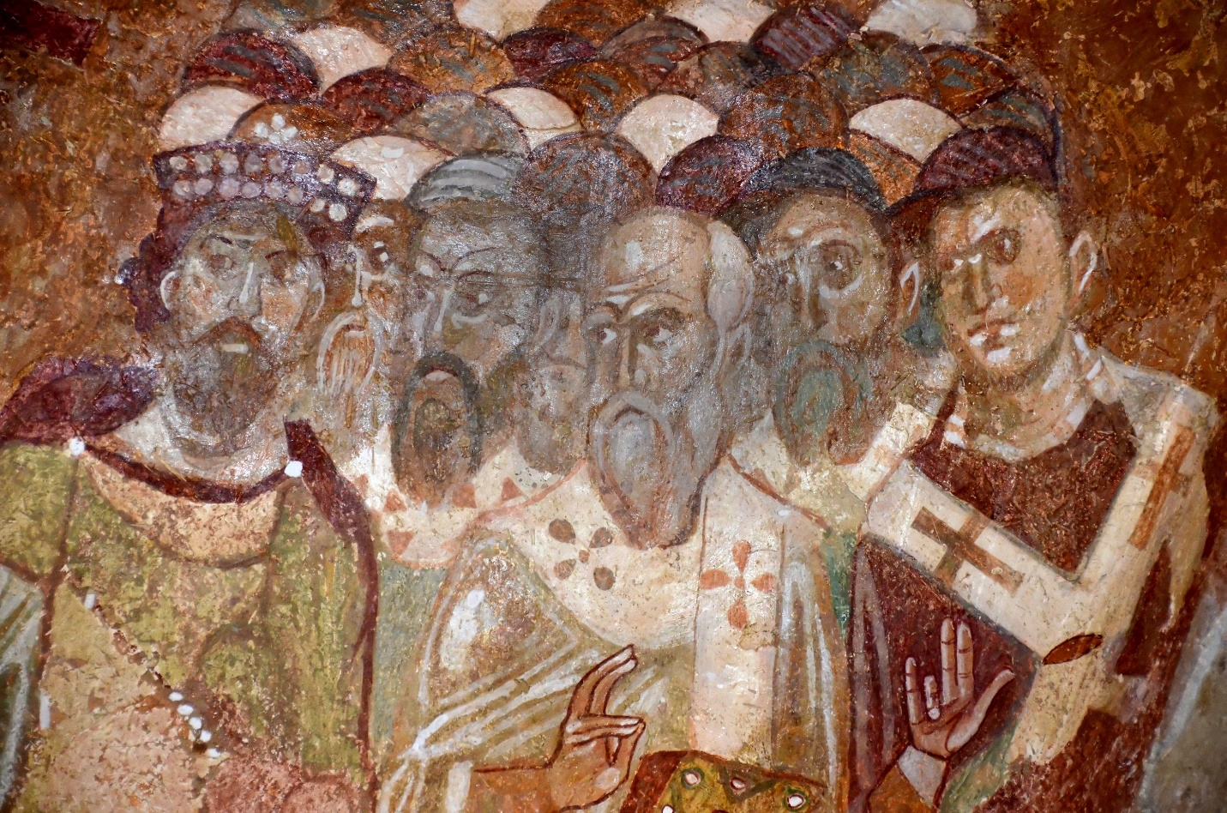
- Stable Leadership: Constantine’s policies brought leadership stability and centralized power, integrating religious leaders into secular governance.
- Lasting Legacy: Constantine's endorsement of Christianity led to the widespread acceptance and growth of the religion throughout the Roman Empire.

Summary:
Before Constantine, Roman emperors worshiped pagan gods, and Christians were persecuted. The night before the Battle of Milvian Bridge in 312 CE, Constantine reportedly saw a cross in the sky and prayed to the Christian God for victory. After his success, Constantine converted to Christianity. In 313 CE, the Edict of Milan granted Christians freedom to worship and hold public office. The Council of Nicaea in 325 CE, led by Constantine, established the Nicene Creed, unifying Christian beliefs. Constantine’s reign brought stability and expanded Christianity’s influence, ensuring its growth as a major religion.

Check-In Questions:
1. What is the Trinity?
- Answer: The Trinity explains the religious association among God, Christ, and the Holy Spirit.

2. When did Constantine become a Christian?
- Answer: Constantine became a Christian after the Battle of Milvian Bridge.

3. What effect did Constantine’s conversion have on the persecution of Christians in the Roman Empire?
- Answer: Persecution based on religion ended, as did the destruction of churches and the burning of scriptures.

Practice Questions:
1. How did the Edict of Milan affect the spread of religion under Constantine? Develop a thesis you could use to write an essay on this question.
- Sample answer: The Edict of Milan was a theological compact between Constantine I and Licinius that granted religious toleration to Christians within the Roman Empire without fear of persecution. It increased the spread of Christianity because it allowed residents of the empire to practice this religion freely.

2. How did the reign of Constantine change politics in the Roman Empire?
- Sample answer: Constantine’s policies resulted in stable leadership and centralized power in the Roman Empire. The church became involved in secular matters at a high level and was given a great deal of authority.

- Dividing the Christian Church

Objective 2: Investigate the causes and effects of the Christian schism.

Essential Question: What were the religious and political causes of the East-West Schism in the Christian Church?

Key Terms:
1. East-West Schism - The division of the Christian Church into Eastern Orthodox and Roman Catholic.
2. Papal Supremacy - The belief that the Pope held authority over all Christians and secular leaders.
3. Caesaropapism - The principle that the Byzantine emperor was both a secular ruler and the leader of the Church.
4. Patriarch - Senior bishop in the Eastern Orthodox Church.
5. Iconoclasm - The rejection and destruction of religious images.

Big Ideas:
- Political Disputes: The rise of the Byzantine Empire led to power struggles between Constantinople and Rome, with contrasting views on church and state roles.
- Theological Differences: Disagreements on religious doctrines, such as the nature of God and Jesus, further deepened the divide.
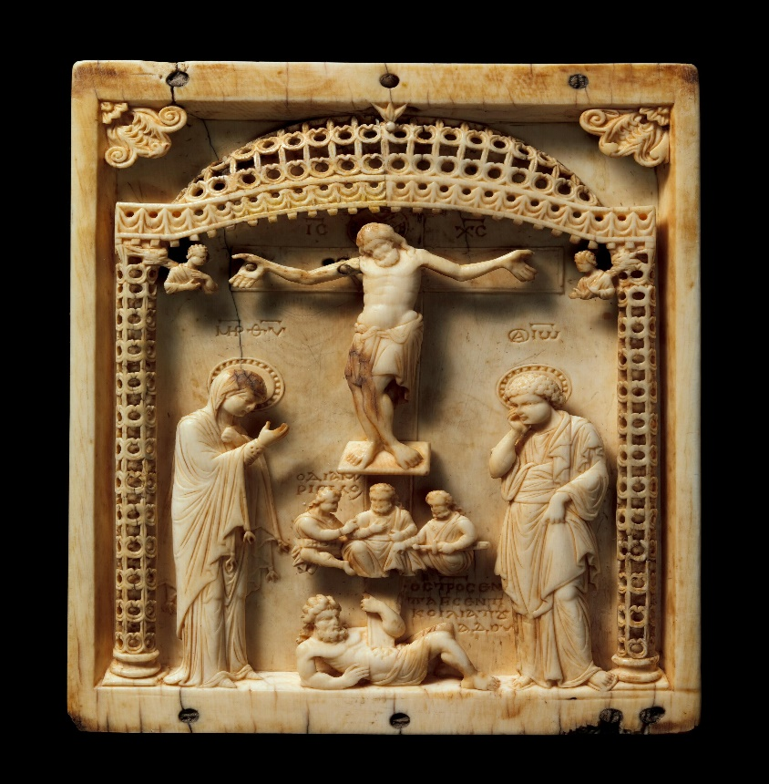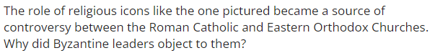
- Impact of Islam: The rise of Islamic empires and their conquest of Christian cities weakened Western religious influence, centralizing power in Constantinople and Rome.
- Cultural Divergence: Differences in language, culture, and governance between the Eastern and Western parts of the former Roman Empire contributed to the schism.
- Legacy of the Schism: The division shaped the development of Western and Eastern Christian traditions, influencing their theological and cultural paths.

Summary:
The East-West Schism occurred in 1054 CE, splitting the Christian Church into Eastern Orthodox and Roman Catholic branches. Political and theological differences fueled the divide. The West emphasized Papal Supremacy, while the East followed Caesaropapism. Disagreements over religious icons and the nature of the Trinity intensified tensions. The rise of Islamic empires further reduced Western influence. The schism was marked by mutual excommunication, which lasted until 1965 when efforts began for reconciliation. This division significantly shaped the distinct paths of the Christian traditions in the East and West.

Check-In Questions:
1. What two churches emerged from the East-West Schism?
- Answer: Eastern Orthodox and Roman Catholic.

2. What is the best way to categorize the causes of the East-West Schism?
- Answer: Causes of the East-West Schism were both political and theological.

3. Why did Eastern Orthodoxy develop?
- Answer: Eastern Orthodoxy was the branch of Christianity that developed in the Byzantine Empire after the fall of the Western Roman Empire.

Practice Questions:
1. Evaluate the causes of the East-West Schism and explain which issue you feel was the most responsible for the outcome.
- Sample answer: The most significant cause of the East-West Schism was the dispute over who should be the leader of the Christian Church. The Byzantine emperor claimed control of the religion due to the concept of caesaropapism, while the Western Church believed that the pope had the ultimate authority over both religious and secular leaders and should therefore be the one making decisions.

2. Explain why papal supremacy and caesaropapism are incompatible solutions to disputes within the Christian Church.
- Sample answer: Supporters of papal supremacy believe that the pope should be God’s most important voice on Earth and have power over secular leaders, while caesaropapists argue that the emperor of the Byzantine Empire is both the head of the government and of the Church.

- Who Contributed to the Byzantine Empire?

Objective 3: Evaluate the significance of key figures in the Byzantine Empire and their contributions to history, including Justinian's Code.

Essential Question: How did key figures contribute to the Byzantine Empire?

Key Terms:
1. Edict of Milan - Legalized Christianity and protected its practitioners.
2. Justinian’s Code - A codification of laws that streamlined the Byzantine legal system.
3. Nika Revolt - A major uprising against Emperor Justinian.
4. Hagia Sophia - A grand church constructed under Justinian, symbolizing the union of church and state.
5. Theodora - Influential wife of Emperor Justinian, known for her support of social reforms.

Big Ideas:
- Constantine’s Influence: Constantine’s conversion to Christianity and the establishment of Constantinople set the stage for the Byzantine Empire’s religious and political landscape.
- Justinian's Reforms: Justinian I’s rule was marked by military conquests, legal reforms (Justinian’s Code), and significant architectural achievements (Hagia Sophia). 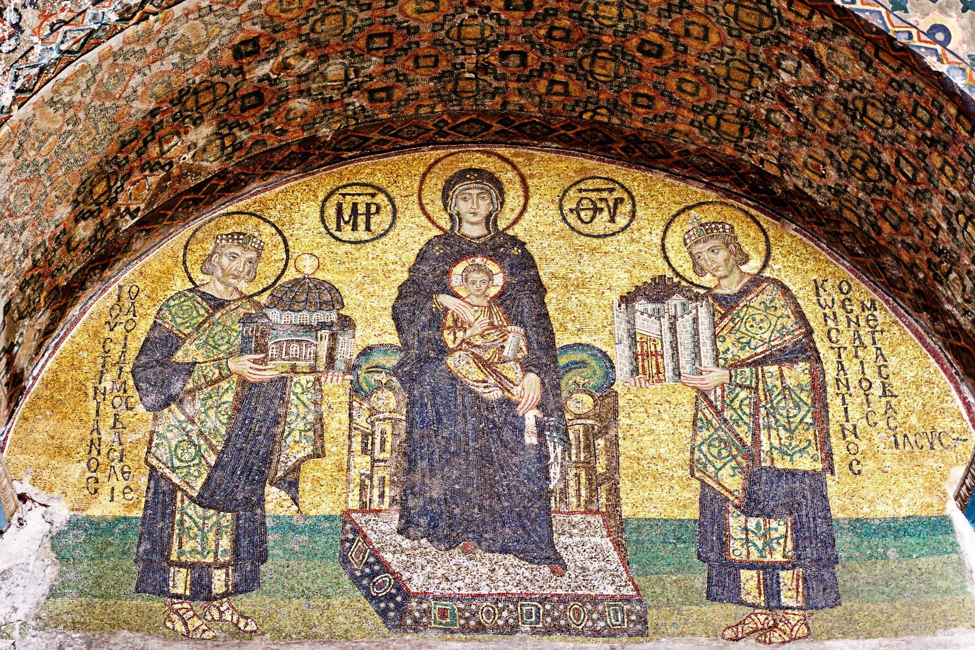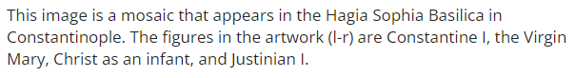
- Theodora’s Impact: Empress Theodora played a crucial role in advocating for women’s rights and social reforms during Justinian’s reign.
- Religious Tensions and Reforms: The Nika Revolt and adjustments in religious policies demonstrated the complexities of ruling a diverse empire.
- Empire's Legacy: The contributions of key figures helped shape the Byzantine Empire’s legal, cultural, and religious identity, influencing the broader medieval world.

Summary:
The Byzantine Empire saw significant contributions from key figures such as Constantine, Justinian I, and Theodora. Constantine's legalization of Christianity through the Edict of Milan and establishment of Constantinople were foundational. Justinian’s reign from 527-565 CE included military conquests, the compilation of Justinian’s Code, and the construction of the Hagia Sophia, which symbolized the empire's grandeur. Empress Theodora supported significant social reforms, particularly for women. Despite challenges like the Nika Revolt, these leaders’ actions had lasting impacts, solidifying the Byzantine Empire’s cultural and religious legacy.

Check-In Questions:
1. Which agreement gave people the right to publicly believe in Christianity with the freedom of not being persecuted?
- Answer: The Edict of Milan.

2. What primary issue caused the Nika Revolt?
- Answer: Taxation.

Practice Questions:
1. Search online for information about social reforms that Theodora promoted and influenced Justinian to pass, benefiting women of lower social classes. How could the same freedoms be utilized by women in society today?
- Sample answer: Theodora worked to help women of lower status in society get jobs that were better than their status in society would allow them to have. In the 21st century, women may appreciate the trials of the women who lived during Theodora’s time period, while working to gain even more privileges and liberties than those before them.

2. Search online for information about the Hagia Sophia and write 1–2 sentences about how it is tied to current events and religion.
- Sample answer: The Hagia Sophia was rebuilt in 532–537 CE. In 2020, the Hagia Sophia became a mosque again, and it will no longer be a museum.

- Fall of the West and Rise of the East

Objective 4: Compare the territorial change in the Roman Empire under the rule of Trajan in 117 CE and the Byzantine Empire under the Justinian Dynasty in 555 CE, explaining the reasons for change by using maps.

Essential Question: What motivated Trajan and Justinian to expand their empires?

Key Terms:
1. Trajan - Roman emperor who expanded the empire to its greatest territorial extent.
2. Justinian - Byzantine emperor known for his conquests and legal reforms.
3. Parthian Empire - Persian empire targeted by Trajan for its strategic location and wealth.
4. Sasanian Empire - Persian empire that Justinian engaged in conflict with to solidify eastern borders.
5. Byzantine Empire - The continuation of the Eastern Roman Empire, with significant cultural and military achievements.

Big Ideas:
- Trajan’s Expansion: Trajan expanded the Roman Empire through military campaigns in Dacia and the Near East, motivated by the desire for resources, strategic defense, and historical prestige. 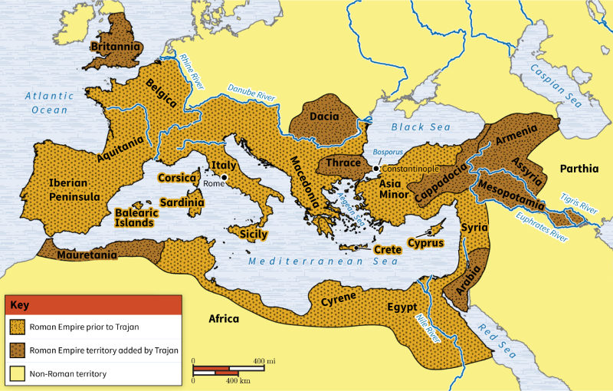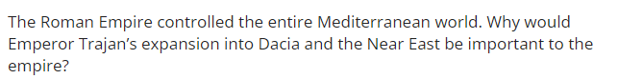
- Justinian’s Conquests: Justinian sought to reclaim former Roman territories in Western Europe and solidify the Byzantine Empire's position, driven by historical legacy and religious motivations. 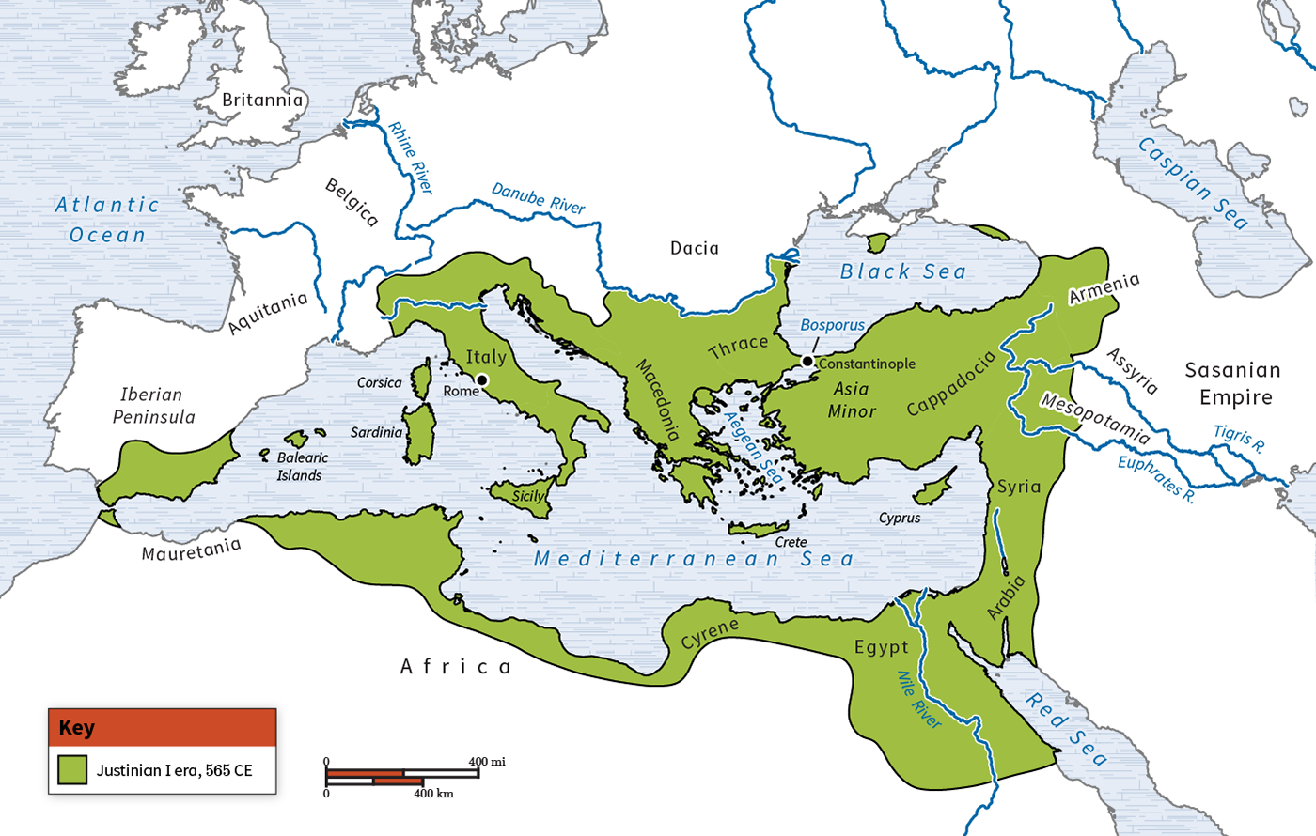
- Economic and Strategic Goals: Both emperors sought economic benefits and strategic advantages through their expansions, aiming to protect their empires and enhance their legacies.
- Historical Significance: The motivations and outcomes of Trajan and Justinian’s expansions illustrate the broader historical trends of conquest, defense, and legacy.
- Impact on Modern Europe: The territorial changes under Trajan and Justinian influenced the formation of modern European borders and the cultural and religious landscape.

Summary:
The Roman Empire reached its greatest territorial extent under Emperor Trajan (98-117 CE) through campaigns in Dacia and the Near East, motivated by strategic defense and resource acquisition. The Byzantine Empire, under Emperor Justinian (527-565 CE), aimed to reclaim former Roman territories and solidify eastern borders, driven by historical prestige and religious unity. Both emperors sought economic and strategic advantages, reflecting broader historical trends. Their expansions shaped the formation of modern European borders and influenced the cultural and religious landscape.

Check-In Questions:
1. What motivated Justinian to expand into Western Europe?
- Answer: Justinian wanted to retake the traditional lands controlled by the Roman Empire.

2. What was a similarity between the Parthian and Sassanid Empires?
- Answer: Both empires were Persian.

Practice Questions:
1. Search online for a map of modern Europe. Compare the borders of modern nations to the territories controlled by Justinian and Trajan. What effect did those historical boundaries have on the creation of modern nations?
- Answer: The borders of some countries match the historical boundaries of the empires. One example of this is the modern country of Italy. The northern border of the country matches the territory controlled by Justinian.

2. Search online for a physical map of Europe, showing important geographic features such as mountains and rivers. Compare these features to the historical maps of Trajan and Justinian, as well as the map of modern European countries. What conclusion can you come to about the effect of geography on a country’s or empire’s borders?
- Sample answer: Geographic boundaries also affect borders of states and empires in Europe. An example of this is the Danube River in southern Romania. This was also the border between Dacia and the Roman Empire before it was invaded by Trajan.

- Unit 4 Lesson 9: Rise of Islam
- Introduction to Islam

Objective 1: Summarize the fundamental beliefs and development of Islam in Mecca using primary sources.

Essential Question: How did the fundamental beliefs of Islam develop Islam in Mecca?

Key Terms:
1. Quran - The holy book of Islam, containing the revelations given to Muhammad.
2. Shahada - The profession of faith, the first pillar of Islam.
3. Salat - The ritual prayer performed five times a day, the second pillar of Islam.
4. Zakat - The practice of almsgiving, the third pillar of Islam.
5. Hajj - The pilgrimage to Mecca, the fifth pillar of Islam.

Big Ideas:
- Origins of Islam: Founded by the Prophet Muhammad in the early seventh century CE, Islam is one of the world’s primary religions, with Mecca being its birthplace. 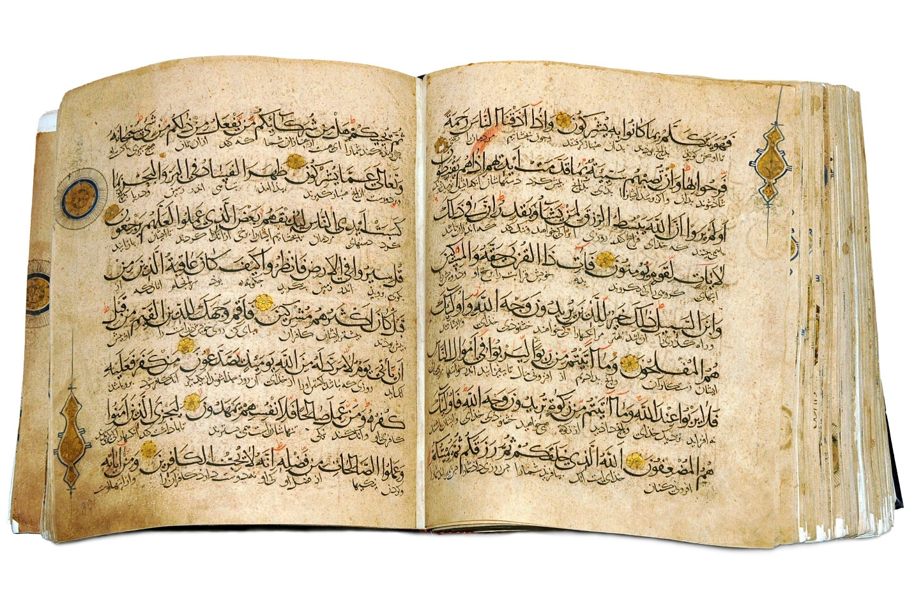
- Revelations: Muhammad received revelations from God, which were transcribed into the Quran, the sacred text that guides all Muslims.
- Five Pillars of Islam: Fundamental beliefs of Islam include the five pillars: profession of faith (shahada), prayer (salat), almsgiving (zakat), fasting (sawm), and pilgrimage (hajj).
- Expansion through Trade and Conquest: Islam spread quickly through military successes and trade, eventually leading to the creation of the Islamic Empire.
- Impact on Society: The beliefs and practices of Islam influenced social, political, and economic systems, expanding monotheism and shaping cultures worldwide.

Summary:
The Prophet Muhammad founded Islam in the early seventh century CE in Mecca, modern-day Saudi Arabia. Muhammad received revelations from God, recorded in the Quran, which became the sacred scripture for Muslims. The fundamental beliefs of Islam are encapsulated in the Five Pillars: shahada, salat, zakat, sawm (fasting during Ramadan), and hajj. These beliefs and practices facilitated Islam’s spread through trade and military conquests. The influence of Islam transformed societies, promoting monotheism, establishing religious laws for trade, and expanding into diverse regions globally.

Check-In Questions:
1. Who is the single most significant person associated with Islam?
- Answer: The Prophet Muhammad was the last prophet sent from Allah, who established the Islam religion. He was also sent revelations from Allah, which were transcribed into the governing document of Islam, the Quran.

2. Why is Mecca important to the development of Islam?
- Answer: Mecca is the birthplace of Islam’s holy prophet, Muhammad. It serves as a site of pilgrimage for all practicing Muslims, and prayer requires the body to be turned toward it. It is sacred.

Practice Questions:
1. Identify the major causes and historical origins of the development of Islam.
- Answer: The Prophet Muhammad founded the religion of Islam in the early seventh century CE in present-day Saudi Arabia. The political, religious, and philosophical traditions of Islam spread predominantly through trade, which was encouraged and governed by the teachings of the religion.

2. The Quran is one of the most important texts for Muslims. It was originally written in Arabic. To read more from the Quran, do a quick internet search to read a version online. Consider how using primary sources, such as a religion’s holy text, helps historians better understand the religion’s beliefs and development. Then, in two to four sentences, summarize your findings.
- Sample answer: The Quran is a sacred text that Muslims follow. It was first transcribed from revelations given to the Prophet Muhammad. It gives insight into the origins and beliefs of the religion of Islam.

- Introduction to Key Individuals

Objective 2: Describe the role of key individuals in the rise and spread of Islam using primary and secondary sources, paying particular attention to the source of the document, its context, and accuracy, and to the usefulness of sources throughout history.

Essential Question: What was the role of key individuals in the early rise and spread of Islam?

Key Terms:
1. Allah - The name that Muslims call God.
2. Quran - The holy book of Islam containing Muhammad’s revelations.
3. Hadith - Written record of Muhammad’s sayings and traditions.
4. Sunni-Shiite Split - The division in Islam over who should lead after Muhammad's death.
5. Caliphs - The political and religious leaders of Muslim territories following Muhammad’s death.

Big Ideas:
- Central Figure: The Prophet Muhammad, regarded as the last prophet, received revelations from Allah, leading to the creation of the Quran, the sacred text of Islam.
- Primary Sources: The Quran and the Hadith are vital primary sources for understanding Muhammad’s teachings and the development of Islam.
- Sunni-Shiite Split: Following Muhammad’s death, disagreement over his successor led to a split in Islam into Sunni and Shiite factions, each supporting different leaders.
- First Caliphs: The first four caliphs (Abu Bakr, Umar, Uthman, and Ali) were key figures who expanded and solidified Islamic rule, spreading the religion geographically and culturally.
- Role of Primary and Secondary Sources: Primary sources like the Quran and Hadith provide direct insight into Islamic beliefs and traditions, while secondary sources offer interpretations and broader contexts.

Summary:
The Prophet Muhammad, the central figure in Islam, received divine revelations recorded in the Quran. Following Muhammad’s death in 632 CE, his followers were divided on who should succeed him, leading to the Sunni-Shiite split. The first four caliphs played crucial roles in expanding and consolidating Islamic rule. Primary sources like the Quran and Hadith are essential for understanding Muhammad’s teachings and Islam's early development, while secondary sources provide additional context and interpretation.

Check-In Questions:
1. Who were the four caliphs of the Aṣḥāb?
- Answer: Abu Bakr (first caliph), Umar b. al-Khattab (second caliph), Uthman b. Affan (third caliph), and Ali b. Abi Talib (fourth caliph).

2. What is the Hadith?
- Answer: The Hadith is a written record of Muhammad’s teachings and traditions.

Practice Questions:
1. The rise and spread of Islam are noted by two primary sources, the Quran and Hadith. Conduct an online search to examine and critique the Quran’s and Hadith’s usefulness in world history. Consider the source of the documents, context, and accuracy. In three to five sentences, describe how these two primary sources are useful in understanding Muhammad’s role in the rise and spread of Islam.
- Sample answer: The Quran and the Hadith are both primary sources linked to Muhammad. They detail his revelations from Allah, his teachings, and his traditions, which all molded the Islam faith. Both sources can be critiqued in that they are very old and have been translated numerous times. This means that what is written today might not be exactly what was written originally. The texts are still useful for understanding the evolution of Islamic beliefs and the guiding principles of the Islamic Empire.

2. Critique the article “The Sunni and Shia Schism: Religion, Islamic Politics, and Why Americans Need to Know the Differences” by James Moore by addressing the following criteria:
- Who wrote the article?
- When was the article written?
- What are the author’s intentions in writing the article?
- Does the author cite and use credible sources?
- Was the article peer-reviewed?
- Does the article include any biased language?
- Sample answer:
- Who wrote the article? James Moore
- When was the article written? 2015
- What are the author’s intentions in writing the article? To inform readers about the differences between Sunni and Shiite Muslims to make informed decisions about Islam.
- Does the author cite and use credible sources? Yes, as it is an academic journal article that was peer-reviewed.
- Was the article peer-reviewed? Yes.
- Does the article include any biased language? The article does contain opinions but includes fact-driven information reviewed by other scholars, making it a credible and useful secondary source.

- The Growth of Islam

Objective 3: Create a timeline identifying the key people and events in the origins of Islam and the growth of the Islamic Empire.

Essential Question: Who were the key people and events in the origins of Islam and growth of the Islamic Empire?

Key Terms:
1. Allah - The god worshipped by Muslims.
2. Quran - The holy book of Islam.
3. Hijra - Muhammad’s migration from Mecca to Medina, marking the beginning of the Muslim era.
4. Sunni-Shiite Split - The division in Islam over leadership after Muhammad’s death.
5. Caliphate - The political-religious system of leadership in Islam.

Big Ideas:
- Foundation of Islam: Muhammad is credited with founding Islam, receiving revelations from Allah, which were transcribed into the Quran.
- Hijra: The migration from Mecca to Medina (622 CE) marked the beginning of the Muslim era, signifying the spread of Islam.
- Caliphs and Expansion: After Muhammad’s death, the first caliphs (Abu Bakr, Umar, Uthman, Ali) continued to spread Islam, leading to significant political and religious expansion.
- Sunni-Shiite Split: Disagreement over leadership after Muhammad’s death resulted in the Sunni-Shiite split, shaping Islamic political dynamics.
- Growth of the Empire: The Islamic Empire expanded through a series of dynasties, with the Umayyad and Abbasid Caliphates playing significant roles in spreading Islam across vast regions.

Summary:
Islam originated with the Prophet Muhammad in Mecca. Key events include Muhammad’s receipt of revelations from Allah (610 CE), the Hijra to Medina (622 CE), and the subsequent spread of Islam by the first caliphs. Muhammad’s death in 632 CE led to the Sunni-Shiite split over leadership. The Islamic Empire expanded significantly under the Umayyad and Abbasid Caliphates, spreading Islam from the Arabian Peninsula to parts of Asia, Africa, and Europe. This growth was marked by various political, social, and religious developments.

Check-In Questions:
1. What were two consequences of Muhammad’s death in 632 CE?
- Answer: Muhammad’s death led to the assumption of power by the first caliph, Abu Bakr. Muhammad's death also marked the beginning of the Sunni-Shiite split in Islam.

2. What event is considered the beginning of the Muslim era, and when did it take place?
- Answer: The event that began the Muslim era was Muhammad’s Hijra in 622 CE when Muhammad and his followers took a journey from Mecca to Medina.

Practice Questions:
1. Create a timeline by identifying key people and events in the origins of Islam.
- Sample answer:
- 570 CE: Muhammad born in Mecca.
- 610 CE: Gabriel visits Muhammad in meditation; Quran is transcribed.
- 613 CE: Muhammad begins preaching his revelations from Allah.
- 622 CE: Muhammad and his followers’ journey from Mecca to Medina, called Hijra.
- 632 CE: Death of Muhammad and transition of power for first caliph; beginning of Sunni-Shiite split in Islam.
- 634 CE: Death of first caliph, Abu Bakr.
- 661 CE: Beginning of first Islamic Dynasty, Umayyad Dynasty, which marked the beginning of the Islamic Empire.
- 1517 CE: Beginning of the Ottoman Empire.

2. Using the timeline you created, explain at least one key person and one key event that contributed to the growth of the Islamic Empire.
- Sample answer: Muhammad was a key person who began Islam and fostered it with his teachings. His journey from Mecca to Medina and his transcription of the Quran helped to spread the religion throughout the Middle East and North Africa.

- Causes and Effects of the Spread of Islam

Objective 4: Summarize the expansion of the Muslim Empires by examining their causes and effects.

Essential Question: What were the causes and effects of the spread of Islam?

Key Terms:
1. Umayyad Caliphate - First Islamic dynasty (661-750 CE) that centralized Islamic power.
2. Abbasid Caliphate - Islamic dynasty (750-1258 CE) that emphasized social and cultural development.
3. Islamic Golden Age - Period of cultural, economic, and scientific flourishing under the Abbasid Caliphate.
4. Arab Invasions - Military expansions that led to the spread of Islam.
5. Sociology - The study of society and social behavior, used to understand the social implications of Islamic expansion.

Big Ideas:
- Expansion through Conquest and Trade: Islam spread rapidly through military conquests and trade routes, extending into Sub-Saharan Africa, South Asia, Western Europe, and Anatolia.
- Umayyad and Abbasid Caliphates: The Umayyad Caliphate centralized Islamic power in Damascus and developed state organization, while the Abbasid Caliphate moved the capital to Baghdad, fostering cultural tolerance and inclusivity. 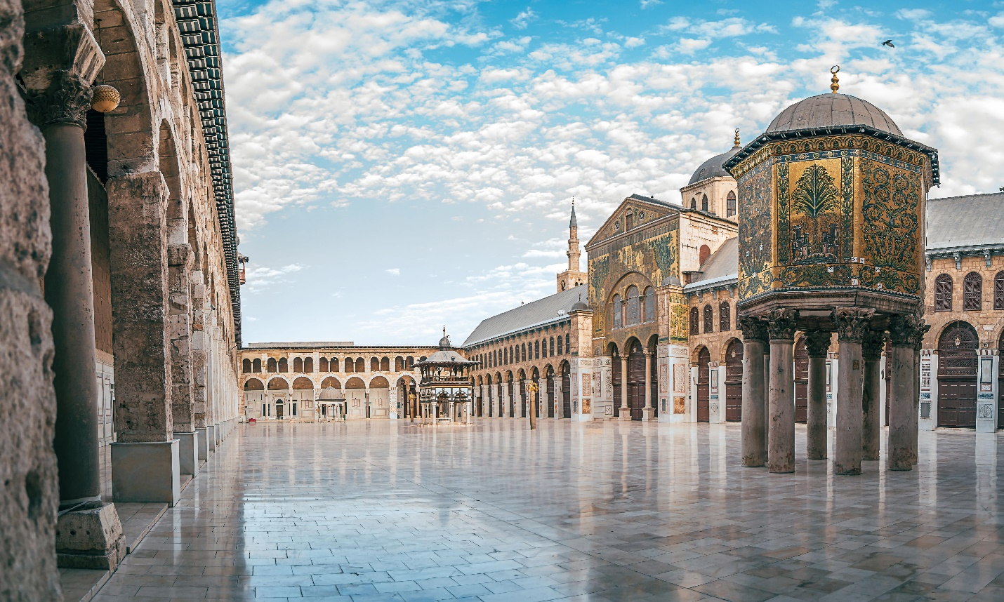
- Cultural Thriving: The Abbasid Caliphate’s era, known as the Islamic Golden Age, saw significant advancements in art, science, and culture.
- Political Shifts: Leadership transitions and military conquests were critical in expanding the Islamic Empire’s influence.
- Research and Credibility: Using credible sources and managing information are crucial for understanding the causes and effects of Islamic expansion.

Summary:
Islam expanded through conquests and trade under the first four caliphs and later the Umayyad and Abbasid Caliphates. The Umayyad Caliphate centralized power and developed a unified Arab identity, while the Abbasid Caliphate promoted cultural and scientific development. The Islamic Golden Age reflected this thriving cultural environment. Arab invasions aimed at resources and strategic military success facilitated the spread of Islamic influence. Understanding the shift in political power and the development of cultural tolerance requires credible research and managing different historical sources.

Check-In Questions:
1. Where did the Umayyad Caliphate expand Islamic power?
- Answer: The Umayyad Caliphate moved the capital to Damascus, expanding Islamic power to Syria.

2. Where did the Abbasid Caliphate expand Islamic power?
- Answer: The Abbasid Caliphate moved the capital to Baghdad, expanding Islamic power to Iraq.

Practice Questions:
1. Summarize the major effects of the development of Islam.
- Sample answer: The first two Islamic dynasties who ruled after the death of the first four caliphs changed the Islamic world politically and socially. The Umayyad Caliphate centralized Islamic power in their new capital of Damascus, and developed a state organization and a united Arab identity. The capital city moved to Baghdad under the more socially-minded Abbasid Caliphate, whose leadership became more inclusive. Art and culture thrived in an era known as the Islamic Golden Age, and academic and religious institutions were established under this caliphate.

2. Use “The Arab Invasions” article by Eamonn Gearon to investigate the causes and effects of the expansion of the Muslim Empire. Then, summarize the causes and effects.
- Sample answer: The main causes of Arab invasions were to gain resources and find military success. For example, Egypt was a prize because of its grain. The effects of the Arab invasions were the expansion of Islamic power and the shifting of culture as new areas of the world came under Islamic rule.

- Unit 4 Lesson 10: Golden Age and Ottoman Empire
- The Golden Age of Islam

Objective 1: Describe the significance of key individuals from the Golden Age of Islam and how they contributed to the religion.

Essential Question: What contributions were made by key individuals during the Golden Age of Islam?

Key Terms:
1. Abbasid Dynasty - A major dynasty that ruled the Islamic Empire during its Golden Age.
2. Caliph - The chief Muslim civil and religious ruler.
3. House of Wisdom - An intellectual center in Baghdad where scholars translated ancient texts.
4. Translation Movement - The process of translating scholarly works from various ancient civilizations into Arabic.
5. Al-Ma'mum - An Abbasid caliph who expanded the House of Wisdom.

Big Ideas:
- Foundation of Learning: The Golden Age of Islam began under the Abbasid Dynasty, particularly with Caliph al-Mansur establishing Baghdad, which became the intellectual center of the world.
- House of Wisdom: Al-Mansur's son, Caliph al-Rashid, founded the House of Wisdom, where scholars translated vast works from ancient civilizations into Arabic. 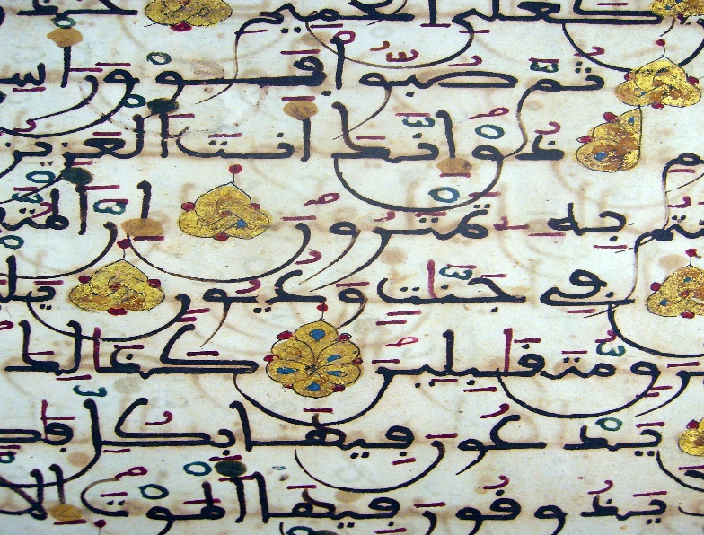
- Translation Movement: This movement preserved and expanded knowledge from Ancient Mesopotamia, Rome, China, India, Persia, Egypt, Greece, and Byzantine civilizations.
- Universality: Scholars from various backgrounds, including Muslim, Jewish, and Christian, collaborated, leading to advances in astronomy, mathematics, science, medicine, law, and philosophy, creating the world's first universal civilization.
- Long-lasting Influence: The knowledge preserved and expanded during the Golden Age of Islam played a crucial role in shaping future civilizations, especially during Europe's Dark Ages.

Summary:
The Golden Age of Islam was marked by significant intellectual and cultural growth under the Abbasid Dynasty. Caliph al-Mansur established Baghdad, and his successor al-Rashid created the House of Wisdom. This center became the heart of the Translation Movement, where scholars from diverse backgrounds worked together to translate and expand upon ancient knowledge. Key individuals like Caliph al-Ma'mum recruited scholars to ensure the preservation and growth of knowledge. These contributions turned the Islamic world into the first universal civilization and greatly influenced global development.

Check-In Questions:
1. Where did the Abbasid Dynasty move its capital?
- Answer: Baghdad.

2. What did al-Rashid build in the new capital?
- Answer: House of Wisdom.

Practice Questions:
1. Why did the translation movement begin?
- Answer: The Abbasids wanted to study ancient texts by translating them into Arabic.

2. How did the Abbasids create the first universal civilization?
- Sample answer: The Abbasids recruited Christian, Jewish, and Arabic scholars to translate ancient texts from Greece, Rome, China, India, and Persia. They spread libraries throughout their empire and encouraged the study of subjects such as math, astronomy, medicine, and philosophy.

- Muslim Contributions Outside Religion

Objective 2: Describe Muslim contributions to art, science, mathematics, and geography during the Golden Age of Islam and their impact on later historical events.

Essential Question: How did Islam influence art, science, mathematics, and geography during its Golden Age?

Key Terms:
1. Calligraphy - The artistic practice of handwriting, developed as a significant art form in Islam.
2. Arabesque - Intricate scrolling plant and floral patterns, developed in Islamic art.
3. Algebra - A field of mathematics greatly influenced by Islamic scholars, including Al-Khwarizmi.
4. Al-Havi - The comprehensive medical encyclopedia written by Al-Razi.
5. Geocentric Latitude - A method for measuring the Earth's roundness, developed by Al-Biruni.

Big Ideas:
- Artistic Innovations: Islamic contributions in art included calligraphy, arabesque, and geometric patterns, which were prominent in manuscripts, architecture, ceramics, and more. 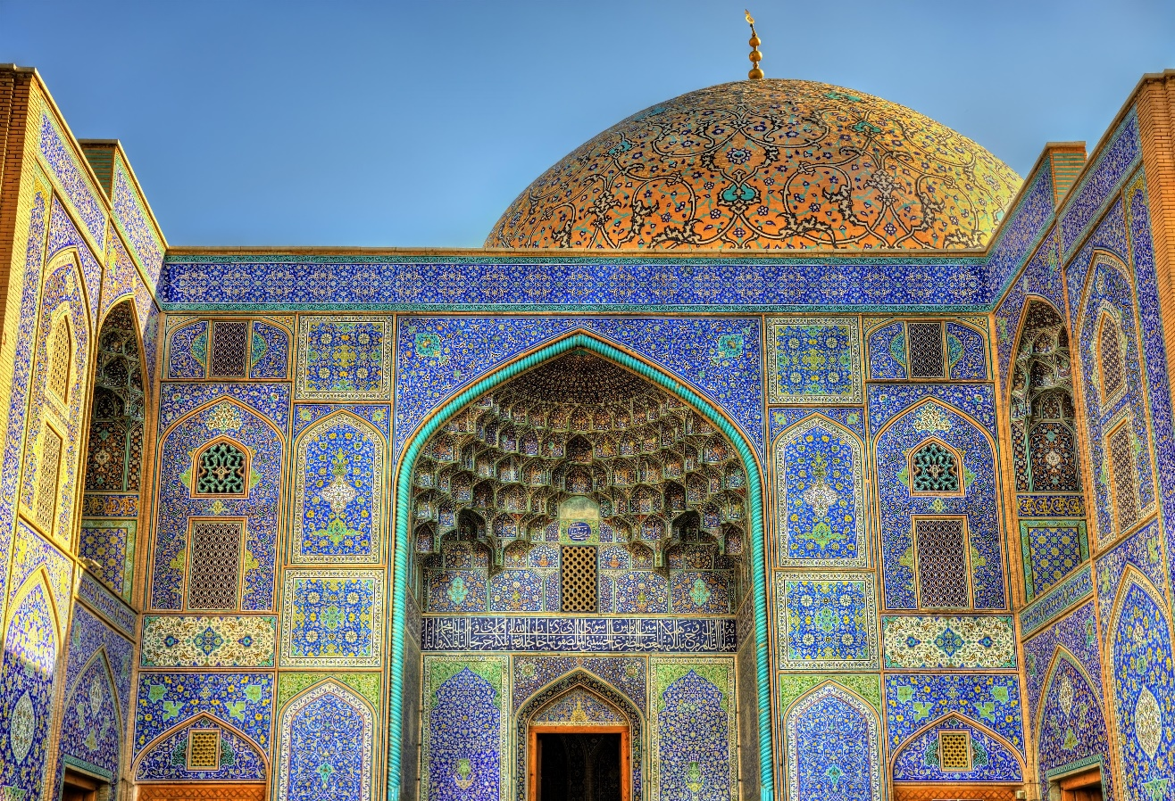
- Mathematical Advancements: Islamic scholars developed Hindu-Arabic numerals, the concept of zero, algebra, geometry, and trigonometry, vital for scientific progress.
- Scientific Contributions: Islamic scholars like Al-Razi and Al-Biruni made significant advances in medicine and geography, with comprehensive works and practical applications that influenced global science.
- Preservation of Knowledge: The use of paper and translations preserved Greek and Latin texts, creating extensive libraries that facilitated the study and spread of knowledge.
- Impact on Later Events: Islamic scientific and mathematical advancements laid the foundation for European developments during the Renaissance and beyond.

Summary:
During the Golden Age of Islam, Muslim scholars made significant contributions across various fields. In art, they developed calligraphy, arabesque, and geometric patterns, which became key elements of Islamic art. Mathematicians introduced Hindu-Arabic numerals, the concept of zero, and advanced algebra, geometry, and trigonometry. Scientists like Al-Razi and Al-Biruni expanded knowledge in medicine and geography. By preserving and translating ancient texts, Islamic scholars built extensive libraries, ensuring the continued study and spread of knowledge. These contributions had a lasting impact on global development, particularly influencing the Renaissance in Europe.

Check-In Questions:
1. What were Muslim contributions in the arts?
- Answer: Calligraphy, arabesque, and geometric designs.

2. What were Muslim contributions in math?
- Answer: The number zero, the numerical system, algebra, geometry, and trigonometry.

Practice Questions:
1. How did historical events impact records from ancient civilizations in Iraq?
- Answer: During the Iraq War, looters from Baghdad destroyed more than 170,000 items, including ancient carvings, manuscripts, and more at the National Museum and National Library of Iraq.

2. Describe some reasons why scholars are upset about the artwork and artifacts that have been removed from Iraq and Baghdad.
- Answer: Artifacts, some 9,000 years old, were taken from the National Museum of Iraq and National Library of Iraq, as well as smaller artifacts from around the country that had been moved to Baghdad for protection. Many manuscripts from the Ottoman Empire were also taken. Scholars expected U.S. forces briefing on the importance of the artifacts to protect them more.

- Islam and its Growth

Objective 3: Analyze the key people and events from the origins of Islam and the growth of the Ottoman Empire using timelines.

Essential Question: How did Islam begin and grow into the Ottoman Empire?

Key Terms:
1. Umayyad Dynasty - The first Islamic dynasty, beginning in 661 CE.
2. Abbasid Dynasty - The dynasty that followed the Umayyads, ruling from 750 CE to 1258 CE.
3. Hijra - Muhammad's migration from Mecca to Medina.
4. Caliph - A successor to Muhammad and leader in the Muslim community.
5. Suleiman I - Ruler of the Ottomans, known for expanding the empire significantly.

Big Ideas:
- Origins of Islam: Islam began in 610 CE when Muhammad received his first revelation from Allah. His teachings led to the rapid spread of the religion. 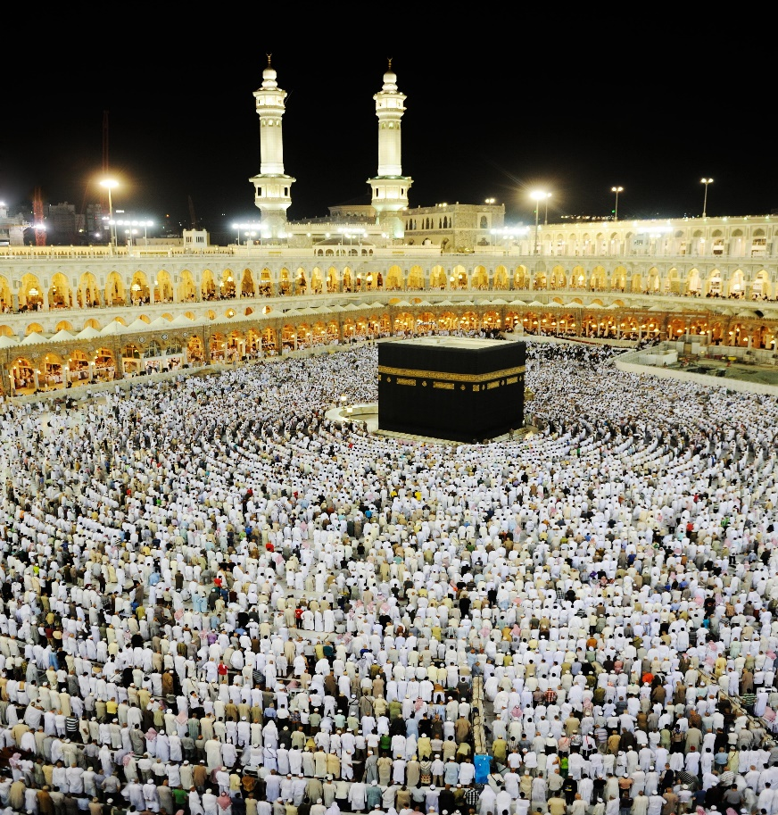
- Early Expansion: After Muhammad's death in 632 CE, leaders like Abu Bakr and the subsequent caliphs expanded Islam beyond the Arabian Peninsula.
- Dynastic Rule: The Umayyad Dynasty saw significant territorial expansion, while the Abbasid Dynasty cultivated intellectual growth and moved the capital to Baghdad.
- Ottoman Empire: The Ottomans began in Anatolia and grew in strength, eventually capturing Constantinople in 1453, marking their dominance.
- Key Contributions: The Ottomans, under leaders like Suleiman I, expanded their territory and influenced the cultural and political landscapes of their regions.

Summary:
Islam began in the seventh century when Muhammad received revelations from Allah. After Muhammad's death, leaders like Abu Bakr expanded the religion. The Umayyad and Abbasid Dynasties played crucial roles in spreading Islam and fostering intellectual growth. The Ottoman Empire emerged in the late 1200s, capturing Constantinople in 1453 and marking the end of the Byzantine Empire. The Ottomans, under rulers like Suleiman I, expanded their territory and influence, shaping the region's cultural and political landscape.

Check-In Questions:
1. When did Muhammad conquer Mecca?
- Answer: Muhammad conquered Mecca in 630.

2. When did the first Islamic dynasty begin?
- Answer: In 661 CE, the Umayyad Dynasty began.

Practice Questions:
1. Why was the victory against Constantinople a turning point in Ottoman rule?
- Sample answer: It ended the Byzantine Empire and marked the beginning of Ottoman rule in the region. 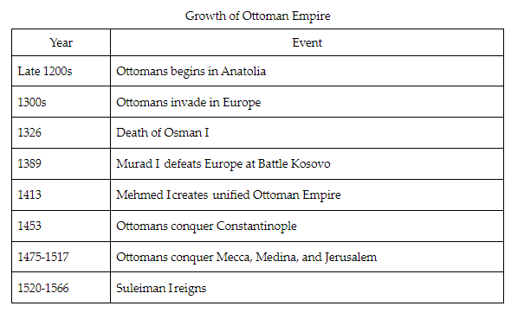

2. Create a timeline comparing the events and key people in the origins of Islam and the growth of the Ottoman Empire.
- Sample answer:
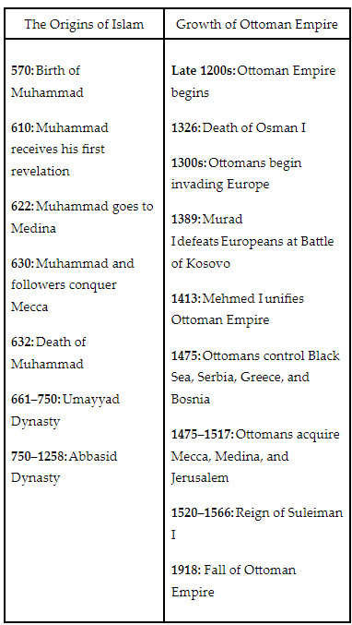

- Exploring Historical Points of View

Objective 4: Summarize the capture of Constantinople in 1453 by the Ottoman Empire, addressing historians’ differing points of view on the event.

Essential Question: How do different historians view the capture of Constantinople in 1453 by the Ottomans?

Key Terms:
1. Historiography - The study of how history is written and understood.
2. Claims - Statements or assertions made by historians based on evidence.
3. Evidence - Information used to support historical claims.
4. Reason - The logical basis for historical arguments.
5. Perspectives - Different viewpoints of historians on historical events.

Big Ideas:
- Varied Perspectives: Historians have different views on the fall of Constantinople, with some attributing it to internal issues within the Byzantine Empire and others to external factors like gunpowder technology.
- Raymond Ibrahim: Considers the fall as Islam’s greatest victory, enabled by gunpowder and previous failed attempts by Arabs.
- Lars Brownsworth: Believes the fall was due to the West's failure to act as one, crippled by the split in Christianity and earlier Crusader plundering.
- Roger Crowley: Attributes the fall to financial weakness within Byzantium, leading to the Ottoman utilization of advanced technology like the cannon built by Orban.
- Historical Impact: The fall of Constantinople had far-reaching effects, including the fleeing of scholars to the West, sparking the Renaissance, and shifting religious centers.
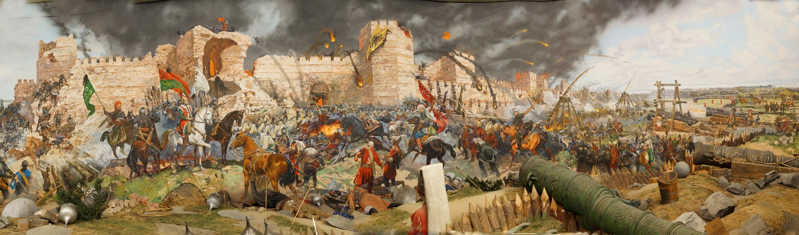
Summary:
The capture of Constantinople in 1453 by the Ottoman Empire is viewed differently by historians. Raymond Ibrahim sees it as Islam’s greatest victory, aided by gunpowder technology. Lars Brownsworth argues the West's disunity due to the split in Christianity weakened Constantinople. Roger Crowley highlights the Byzantine Empire's internal weaknesses and the Ottomans' use of advanced cannons. The fall had significant impacts, including the migration of scholars to the West, contributing to the Renaissance, and shifting the center of Eastern Orthodox Christianity to Russia.

Check-In Questions:
1. Summarize Raymond Ibrahim’s perspective about the fall of Constantinople.
- Answer: The fall was Islam’s greatest victory.

2. What evidence does he provide to support this claim?
- Answer: It was the seat of the Christian Orthodox faith. Muslims failed to attack the city twice before, but after 700 years, they finally did.

Practice Questions:
1. Compare the different claims of Lars Brownsworth and Roger Crowley about the fall of Constantinople.
- Sample answer:
- Lars Brownsworth: Believes Constantinople fell because the West failed to act as one due to the split in Christianity between the East and West.
- Roger Crowley: Attributes the fall to the weakening of the Byzantine Empire from the inside, highlighting the financial issues that led to the loss of engineer Orban’s cannon expertise to the Ottomans.

2. Summarize what evidence Crowley offers to support his claim.
- Sample answer: The leader Constantine had few funds available, and the empire was weak internally. He could not pay the cannon maker, Orban, so he took his business to the rival Ottomans and made cannons for them, which were used to attack Constantinople.

3. Summarize the effects of the rise of the Ottoman Empire.
- Sample answer: As the Ottoman Empire expanded, Byzantine scholars and scientists fled Constantinople for Western Europe, where they helped start the Renaissance. The leadership of the Eastern Orthodox Church left Constantinople for Russia. Constantinople had been the last Christian stronghold in the East. Trade was temporarily disrupted between East and West because Constantinople had been a key location for trade. When it fell in 1453, the trade routes were now in the hands of the Ottoman Turks, and Europeans did not want to trade with them. Chinese gunpowder technology spread across central Asia and into Europe, which the Ottomans used to conquer finally conquer Constantinople. It also prompted the development of guns, cannons, and artillery-based military tactics, such as the work of Hungarian cannon founder Orban.

- Unit 4 Lesson 11: Cooperation and Conflict

- Religion in the Mediterranean

Objective 1: You will describe the beliefs of Christianity and Islam and how historical conflicts arose between them.

Essential Question: What causes conflict between religions?

Key Terms:
1. Christianity: A monotheistic religion believing in Jesus of Nazareth as the messiah.
2. Islam: A monotheistic religion believing in Muhammad as a prophet.
3. Abrahamic: Relating to religions that trace their origins to Abraham.
4. Proselytize: To attempt to convert others to one's religion.
5. Crusades: A series of religious wars initiated by Christians to capture the Holy Land from Muslims.

Big Ideas:
- Shared Origins: Both Christianity and Islam are Abrahamic religions with shared history and origin stories, leading to competition for followers in the same regions.
- Christianity's Rise: Christianity began as a sect of Judaism, with Jesus viewed as the messiah who fulfilled the covenant with God. Christians began proselytizing, contrasting with gnostic religions that required seekers to find truth independently.
- Islam's Spread: Islam emerged from Muhammad’s teachings, viewing him as a prophet. Unlike Christianity, Islam targeted polytheists in conversion efforts. Initially, both religions faced persecution.
- The Crusades: Major religious wars primarily fought over control of Jerusalem. Both Christians and Muslims believed only their religion was true, leading to long-standing conflicts.
- Lasting Conflict: Both religions' beliefs in their exclusive correctness fueled historical and ongoing disputes, sometimes leading to war. 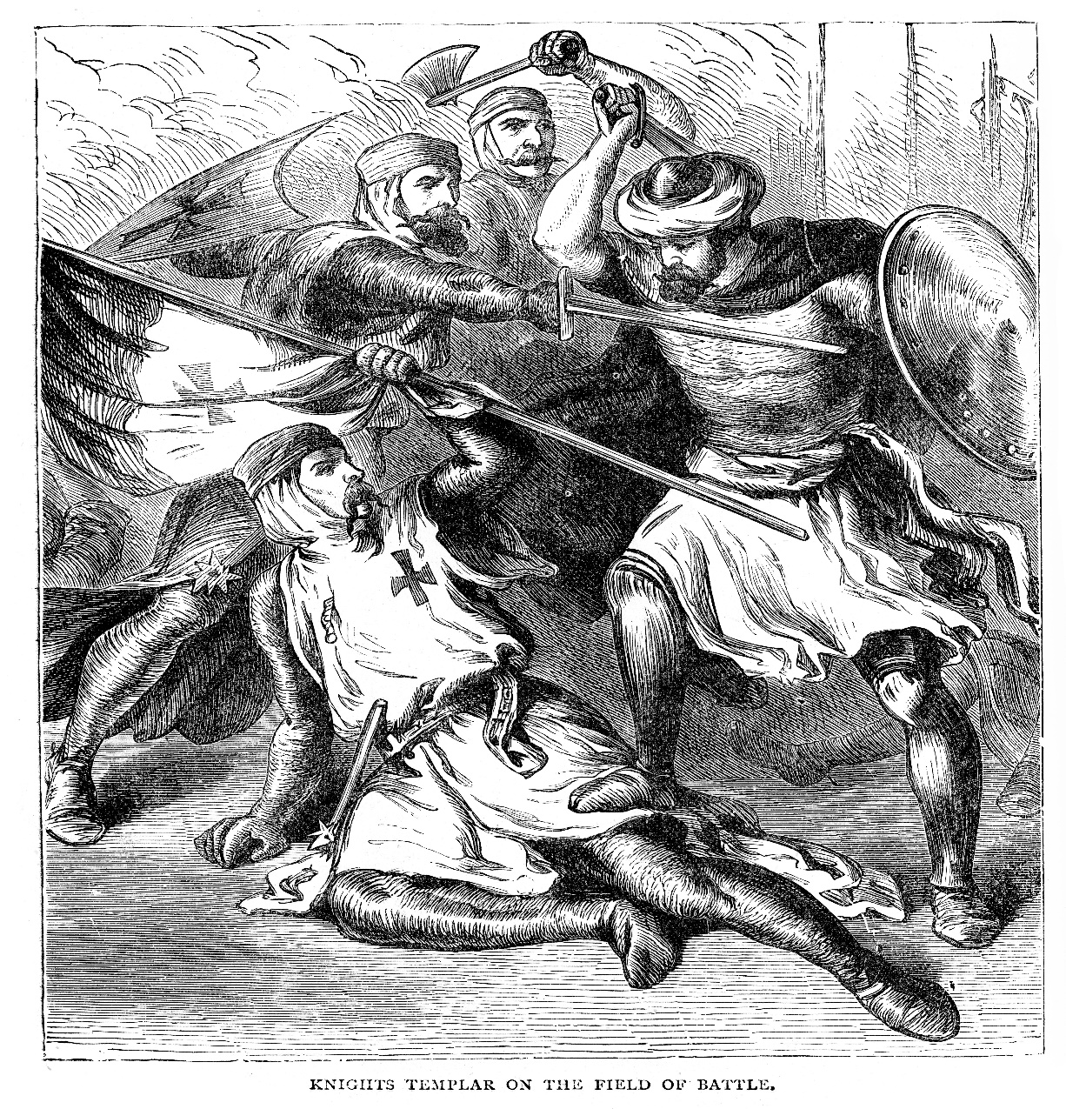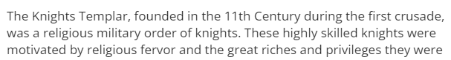

Summary:
Christianity and Islam are two major religions with shared origins in Abrahamic traditions. Both have a history of attempting to convert followers in the same regions, leading to conflicts such as the Crusades. Their differing views on key religious figures and evangelism practices often put them at odds, resulting in significant historical and modern-day tensions.

Check-In Questions:
1. Describe Christianity.
- Answer: Christianity is a monotheistic religion that believes Jesus of Nazareth is the messiah who fulfilled the covenant of Abraham.
2. Describe Islam.
- Answer: Islam is a monotheistic religion believing that Muhammad ibn Abdullah and Jesus of Nazareth continued the teachings of Abraham.

Practice Questions:
1. What caused conflict between Christians and Muslims?
- Answer: Both religions believed the other to be wrong and theirs to be the only correct religion. This belief led to wars as each tried to assert its dominance, especially over Jerusalem.
2. What was the religious motivation for the Crusades?
- Answer: Both Christians and Muslims wanted to control Jerusalem and the Holy Land because they are significant to both religions. The desire to manage these religious areas motivated the Crusades.

- The Rise of the Caliphate

Objective 2: You will describe an example of cooperation and conflict among Muslims and other societies within at least one of the Islamic caliphates.

Essential Question: What was life like for Christians and Jews under Islamic rule?

Key Terms:
1. Caliphate: An Islamic state led by a caliph, a religious leader considered a successor to the prophet Muhammad.
2. Caliphs: Leaders of the Islamic community after Muhammad.
3. Sunni Islam: The largest branch of Islam, believing the community should decide its leader.
4. Shi'a Islam: A branch of Islam believing only Muhammad’s direct descendants should lead.
5. Zoroastrian: A religion of ancient Persia, recognized as one of the conquered populations under the Rashidun Caliphate.

Big Ideas:
- Rashidun Caliphate: The first caliphate after Muhammad, unified the Arabian Peninsula, and spread Islam through conquests.
- Dynastic Empires: The Umayyad and Abbasid dynasties expanded the caliphate and integrated diverse populations, allowing religious and mixed communities to coexist.
- Golden Age of Islam: Under Abbasid rule, scholarship thrived, promoting exchanges between Muslim and non-Muslim scholars, significantly advancing science and culture.
- Fatimid State Religion: The Shi'a Fatimid dynasty introduced a state religion but faced resistance and eventual downfall due to internal fractures and external Crusader attacks.

Summary:
The Islamic caliphates, starting with the Rashidun, expanded Islam's influence through military conquests and diplomacy, integrating diverse religious communities. The Umayyad dynasty introduced dynastic rule, and the Abbasid dynasty led to a golden age of scholarship. The Fatimid Empire introduced a state religion, which ultimately led to internal divisions and vulnerability to external threats.

Check-In Questions:
1. What is a caliph?
- Answer: A caliph is a religious leader in Islam who is considered a successor to the prophet.
2. What regions were conquered by the Umayyad dynasty?
- Answer: The Iberian Peninsula, the northwestern coast of Africa, and territory along the empire’s eastern edge.

Practice Questions:
1. Describe life for non-Muslims under the Umayyad caliphate.
- Answer: Non-Muslims lived under Islamic rule and could hold various jobs, except for specific state positions that had to be held by Muslims.
2. How did the Abbasids promote scholarship during their rule?
- Answer: The Abbasids promoted exchanges between Muslim and non-Muslim scholars, leading to significant advancements in science and culture.

- Expanding an Empire

Objective 3: You will analyze the military expansion of two Islamic empires and the common causes and effects of that expansion.

Essential Question: What was the purpose of conquest for the Islamic empires of the Umayyads and Ottomans?

Key Terms:
1. Jihad: Islamic term meaning struggle; often interpreted as holy war for spreading Islam.
2. Fitnah: Islamic civil war; the first one led to the Umayyad control.
3. Caliphate: The Islamic state ruled by a caliph.
4. Sultan: The ruler of the Ottoman Empire.
5. Janissary: Elite Ottoman military unit loyal to the sultan.

Big Ideas:
- Umayyad Expansion: The Umayyad dynasty expanded Islam through military prowess, creating a vast empire that extended across Europe, Asia, and Africa.
- Arabization: The process under the Umayyads to make Arabic the official language and standardize coinage and bureaucracy.
- Ottoman Conquests: The Ottomans focused on expanding into Europe and continued the tradition of using jihad to spread Islam.
- Janissaries: The Ottoman elite military unit composed mainly of converted Christians loyal to the sultan, playing a crucial role in the empire’s expansion.

Summary:
The Umayyad and Ottoman empires significantly expanded Islamic territory through military conquests. The Umayyads focused on consolidating power and Arabizing their empire, while the Ottomans concentrated on European conquests using elite military units like the janissaries. Both empires faced internal and external challenges that eventually led to their decline.

Check-In Questions:
1. Where was the Umayyad base of power after 750 when they lost control of the empire?
- Answer: The Iberian Peninsula.
2. Which empire did the Ottomans originally target in their conquests?
- Answer: The Byzantine Empire.

Practice Questions:
1. Why did the Umayyads reorganize their provinces with Arabic as the official language?
- Answer: To unify and standardize the administration across their empire.
2. How did the janissary system help the Ottoman Empire?
- Answer: The janissaries were an elite military unit loyal to the sultan, which helped maintain control and expand the empire.

- The Rising Threat of the Islamic Empire

Objective 4: You will compare the responses of Europe, Asia, and North Africa to Islamic expansion in the seventh century.

Essential Question: How did other empires deal with the expansion of the Islamic empire?

Key Terms:
1. Islam: A monotheistic religion based on the teachings of the prophet Muhammad.
2. Sasanian Empire: An ancient Persian empire that faced Islamic conquest.
3. Byzantine Empire: The Eastern Roman Empire, which resisted Islamic expansion.
4. Fratricide: The act of killing one's brother; contributed to the Sasanian Empire’s instability.
5. Levant: The eastern Mediterranean region, significant in the Byzantine-Islamic conflict.

Big Ideas:
- Sasanian Collapse: The Sasanian Empire fell quickly to Islamic conquest due to internal instability and ongoing conflicts with the Byzantine Empire.
- Byzantine Resistance: The Byzantine Empire, despite losing territory, managed to withstand the initial Islamic expansion and maintained its core empire.
- Initial Conquests: The seventh century saw rapid Islamic expansion, challenging the stability of neighboring empires and changing the political landscape of the region.
- Continued Conflict: The capture of significant cities like Jerusalem fueled ongoing conflict and tension between the Byzantine and Islamic empires. 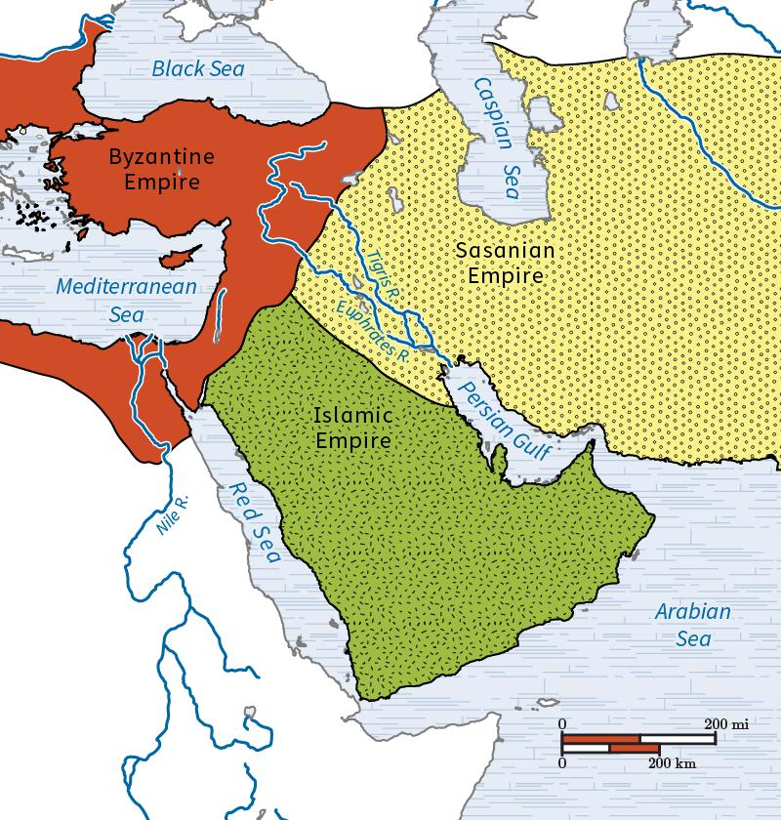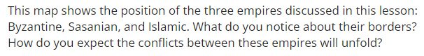

Summary:
The seventh century marked significant Islamic expansion that clashed with the Sasanian and Byzantine empires. The Sasanians crumbled under the pressure due to internal conflicts and weakened defenses, while the Byzantines managed to resist and maintain their empire despite territorial losses. The capture of Jerusalem intensified religious and political conflicts, setting the stage for further historical battles.

Check-In Questions:
1. How long did it take the Islamic empire to conquer the Sasanian Empire?
- Answer: Nearly 20 years.
2. How many times was Constantinople sieged by the Islamic empire?
- Answer: Twice, once in the seventh century, once in the eighth century.

Practice Questions:
1. What was one major reason that the Sasanian Empire fell to conquest so quickly?
- Answer: The Sasanian Empire was unstable due to previous wars and a succession crisis, which left it vulnerable to the Islamic empire.
2. Why was it significant that the Muslims took Jerusalem from the Byzantines?
- Answer: Jerusalem was a religiously significant city, and its capture by another religious group was a major blow to the Christian Byzantine Empire.

- Unit 4 Lesson 12: Trade and Development

- Trade and Development

Objective 1: You will examine maps to determine the impact of Muslim trade routes on societies in Asia, Africa, and Europe.

Essential Question: How did Muslim trade shape the religious landscapes of Asia, Europe, and Africa?

Key Terms:
1. Caliphate: An Islamic state under the leadership of a caliph.
2. Pilgrims: Travelers who journey to a sacred place for religious reasons.
3. Dhimmi: Non-Muslims living in an Islamic state with legal protection.
4. Jizya: A tax levied on non-Muslims by Islamic rulers.
5. Caravansary: An inn with a central courtyard for travelers in the desert regions of Asia or North Africa.

Big Ideas:
- Important Role of Islamic Caliphates: The Islamic caliphates served as key players in the trade routes connecting Europe, Asia, and Africa.
- Trade Practices: Muslim merchants personally negotiated trades and used innovations such as checks and currency exchanges.
- Spread of Islam: Trade facilitated the spread of Islam and Arabic, particularly through conversions for business advantages.
- Cultural Exchange: Trade routes diffused religious beliefs, languages, customs, artistic styles, and inventions across continents. 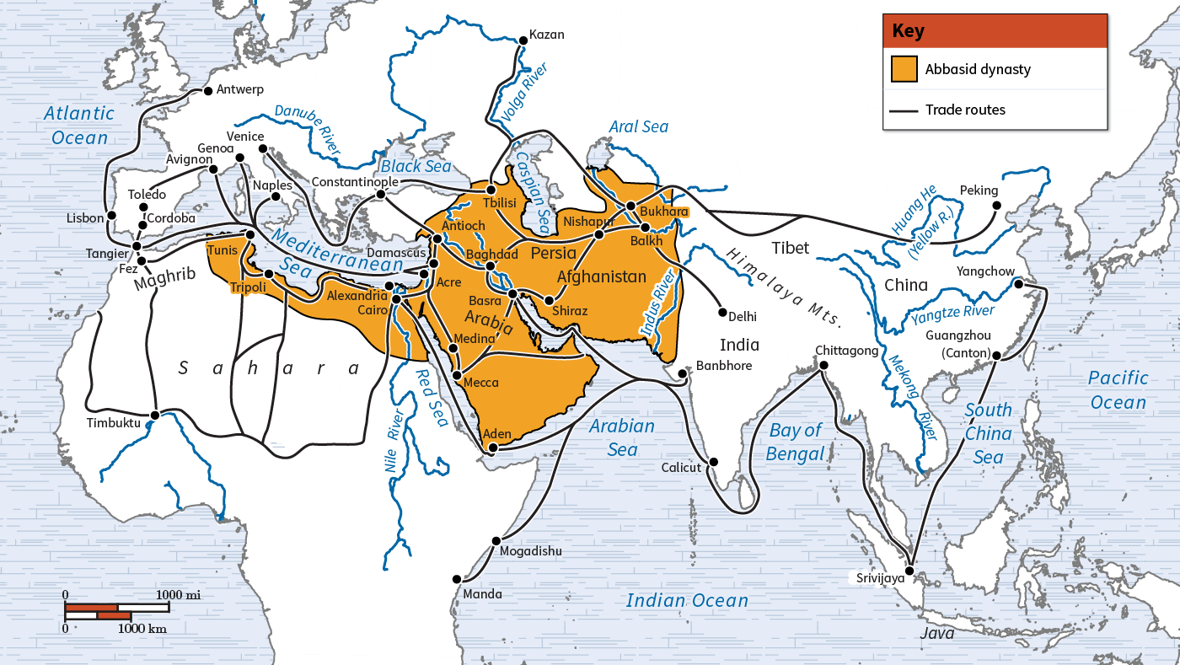

Summary:
Muslim trade routes, spanning Asia, Africa, and Europe, played a significant role in shaping the religious and cultural landscapes of these regions. The direct involvement of Muslim merchants in trade led to the spread of Islam and Arabic language. Trade routes facilitated the exchange of not only goods but also ideas, leading to enriched cultures and innovations across continents.

Check-In Questions:
1. During the medieval period, the spread (diffusion) of which religion is associated strongly with Afro-Eurasian trade routes?
- Answer: Muslim traders helped spread Islam along Afro-Eurasian trade routes.
2. A map illustrating the Silk Road would need to include parts of which continents?
- Answer: The Silk Road connected the continents of Asia, Africa, and Europe.

Practice Questions:
1. If you were asked to draw a map of the spice trade, what key places would you include?
- Answer: A map of the spice trade would include the Indian Ocean, Bay of Bengal, Arabian Sea, India, Red Sea, Cairo, Alexandria, and Mediterranean Sea.
2. What is one way Muslim trade impacted the cultures of places along the routes?
- Answer: Local merchants along the trade route would often convert to Islam to increase business opportunities with Muslim traders and reduce trade taxes.

- A Golden Age of Learning Under the Abbasid Caliphate

Objective 2: You will analyze the economic impact of Muslim trade on Europe.

Essential Question: How did the Islamic Golden Age impact medieval European culture?

Key Terms:
1. The Abbasid Caliphate: An Islamic empire that spanned parts of North Africa, the Middle East, and Central Asia.
2. Marco Polo: A Venetian merchant traveler whose travels are recorded in "The Travels of Marco Polo."
3. Burghs: Commercial districts in medieval European cities.
4. Bazaar: A marketplace in the Islamic world where goods were traded.
5. Kamal: A navigational tool used by sailors to determine latitude.

Big Ideas:
- Abbasid Trade Networks: The Abbasid Caliphate revitalized international trade following the collapse of the Roman Empire's networks.
- Economic Influence: Muslim economic practices such as common currency, exchange rates, and banking influenced European economies.
- Cultural Exchange: Increasing literacy and scholarship under the Abbasid Caliphate led to advancements in science, medicine, and technology, impacting Europe.
- Lifestyle Changes: Introduction of new goods and improved diets due to Muslim trade led to improved living conditions and longer life spans in Europe. 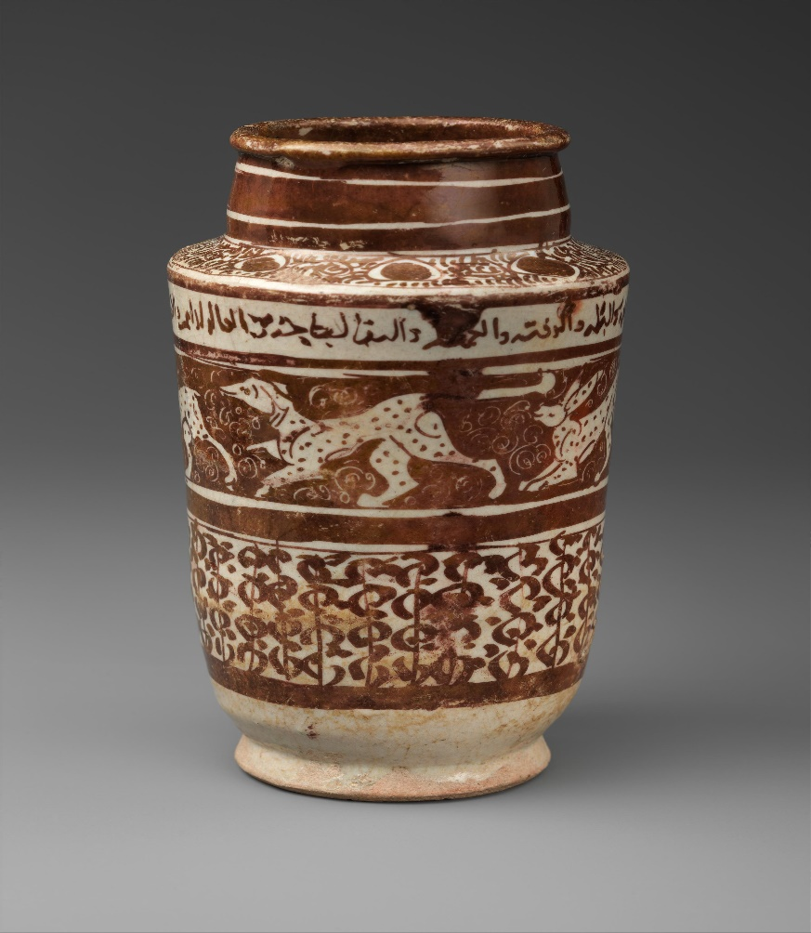

Summary:
During the Islamic Golden Age, the Abbasid Caliphate's trade networks connected Europe, Asia, and Africa, bringing about significant economic and cultural exchanges. The reintroduction of extensive trade brought wealth, innovation, and new products to medieval Europe, shaping its development and leading to the Renaissance.

Check-In Questions:
1. Silk Road trade contributed to the growth of which class of people in Europe?
- Answer: The increase in trade led to the growth of the merchant class.
2. How did Muslim trade impact calculations for business transactions, such as interest rates on loans?
- Answer: The introduction of the Arabic number system and mathematics led to easier accounting measures for calculating interest payments.

Practice Questions:
1. Identify the diffusion and spread of major ideas in technology that occurred in the Islamic Golden Age.
- Answer: Muslim engineers and scholars created many technological innovations. The Abbasid Caliphate funded both innovation and the inscription of knowledge into books. These innovations included navigational tools such as the kamal and Tabula Rogeriana, and books created with paper from their paper mills.

2. Search museum collections online and locate art and artifacts that shed light on the impact of Muslim trade on medieval Europe. What does the evidence you discover tell you about cross-cultural exchange during this period?
- Answer: Sample answer: Potential evidence can be found in museums such as the Metropolitan Museum of Art, the British Museum, and the Art Institute of Chicago. Note Islamic elements in European art and objects and explain the role of trade in the introduction of those elements into Europe.

- The Islamic World

Objective 3: You will describe social, economic, and political changes in Islamic history during the later Middle Ages.

Essential Question: How did Muslim life, economy, and government change during the late Middle Ages?

Key Terms:
1. Shariah: Islamic legal code based on the Quran and Hadith outlining daily life behaviors and legal practices.
2. Dinar: An ancient currency used in the Abbasid Empire.
3. Funduqs: Large-scale commercial institutions that acted as market exchanges and warehouses.
4. Ibn Sina (Avicenna): A Persian doctor who documented medical knowledge in his “Canon on Medicine.”
5. Mamluks: Turkic enslaved military who took control of Egypt and halted the Mongol advance.

Big Ideas:
- Valuation of Scholarship: Islamic society highly valued education, leading to significant advancements in math, science, and medicine. 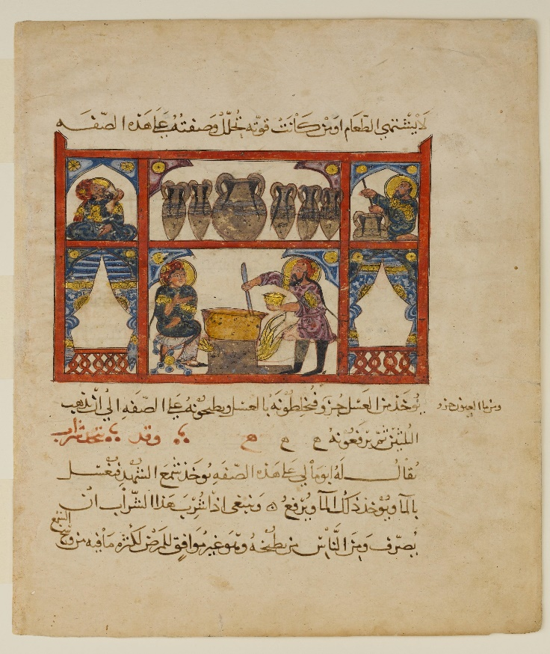
- Business Practices: Muslim merchants developed new business methods such as partnerships, banks, and accounting systems to streamline trade.
- Legal Rights: Islamic women experienced legal rights such as property ownership, remarriage, and initiating divorce, which were progressive compared to their contemporaries.
- Political Changes: Various invasions and conquests, including by the Seljuk Turks and Mongols, fragmented the Muslim Empire, but Islamic culture continued to influence the regions.

Summary:
During the later Middle Ages, the Islamic world experienced significant social, economic, and political changes. Islamic scholarship contributed to advancements in various fields, women had comprehensive legal rights, and new business practices were developed. Despite external military pressures, Islamic culture remained influential across Asia, Africa, and Europe.

Check-In Questions:
1. How did Ibn Sina influence health care?
- Answer: Ibn Sina created an encyclopedia of diseases and treatments other doctors could use as a reference.
2. What law code guides daily behaviors for Muslims?
- Answer: Shariah is the Islamic law code that provides guidelines for daily behaviors.

Practice Questions:
1. Describe a unifying business practice developed by Muslim merchants.
- Answer: To help make trading more efficient, Muslim traders created common accounting methods, banks, and even checks.
2. Muslim scholars developed advancements in math and science building on the knowledge from which society?
- Answer: Muslim scholars used the works of Greek scientists and mathematicians to develop their advancements.

- Faith, Law, and Politics

Objective 4: You will develop a logical argument about how politics and religion have impacted law and government in the Muslim world over time.

Essential Question: To what degree has politics and religion shaped law and government historically in the Muslim World?

Key Terms:
1. Sharia: Islamic law derived from the Quran and Hadith.
2. Theocracy: A form of government where clergy rule in the name of religion.
3. Secular: Non-religious or not connected to religious matters.
4. Umma: The global community of Muslims.
5. Sects: Religious divisions within Islam, such as Sunni and Shi'a.

Big Ideas:
- Integration of Faith and Politics: The early Islamic state combined religious and secular authority, with Muhammad's leadership encompassing both.
- Evolution of Governance: Over time, Islamic states witnessed variations in governance, from theocratic structures to more secular ones, while still maintaining religious influence.
- Modern Examples: Iran and Saudi Arabia exemplify the role of Islam in government with different approaches; Iran has direct clerical control, whereas Saudi Arabia uses religious influence to support monarchical rule.
- Women’s Rights: Islamic law granted women rights such as property ownership, initiating divorce, and protection in court long before such rights were common in other cultures. 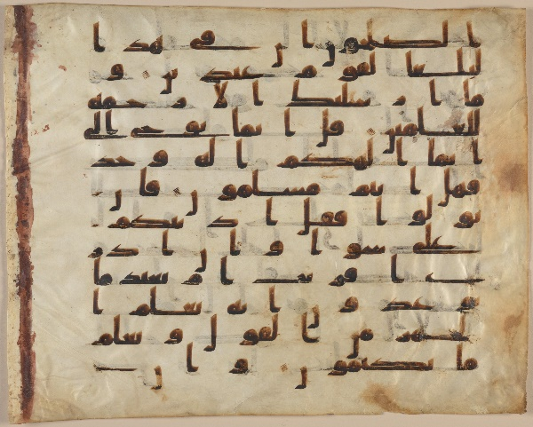

Summary:
Islamic law and politics have been deeply intertwined, evolving from a unified religious-political community under Muhammad to more complex structures. In modern times, examples like Iran and Saudi Arabia show variations in how Islamic principles are applied in governance. Sharia law provided progressive rights for women and continues to impact legal systems in Muslim-majority countries.

Check-In Questions:
1. As the Islamic empire grew, how did the influence of religion on the government change?
- Answer: The influence of religion on the government decreased as the Islamic empire expanded.
2. A country where the religious leader is also the political leader and religion has a significant influence on government policies is likely which type of government?
- Answer: A theocracy.

Practice Questions:
1. Compare and contrast the role of Islam in the governments of Iran and Saudi Arabia. What might account for the differences you note?
- Answer: Religious leaders have considerable direct control over the government in Iran, whereas in Saudi Arabia, religious leaders have significant influence but do not occupy key governmental positions. The differences may be explained by the historical contexts in which these governments emerged.
2. Outline steps you would take to prove or disprove the following statement: “Islamic nations that use sharia law are theocracies.” What questions might guide your research?
- Answer: I would select several Islamic nations using sharia law and gather evidence on how sharia is implemented and enforced, and who enacts laws. Guiding questions: Is the religious leader also the political leader? How aligned are domestic policies to the Quran? Have policies adjusted to modern situations? Do court rulings reflect religious or secular reasoning?

- Unit 4 Lesson 13: Different Religious Societies

- Interactions Between Muslim, Christian, and Jewish Populations 1200-1450 CE

Objective 1: Learn about the ways that Muslim, Christian, and Jewish peoples interacted in Afro-Eurasia during 1200-1450 CE and consider diverse perspectives on historical events to understand potential biases between these groups.

Essential Question: How did Muslim, Christian, and Jewish populations interact with one another during the period 1200–1450 CE?

Key Terms:
1. Perspective: Seeing things from other people's viewpoints.
2. Bias: A preference or inclination, especially one that inhibits impartial judgment.
3. Primary Source: Original materials from the time period being studied.
4. Secondary Source: Analysis or interpretation of primary sources.
5. Dhimmi: Non-Muslims living in an Islamic state with legal protection.

Big Ideas:
- Historical Contexts and Interaction: From 1200 to 1450, Jews, Christians, and Muslims interacted mainly through trade, conquest, and specific laws affecting their relationships and attitudes toward one another.
- Jewish-Christian Interactions: In Spain, Jewish communities lived under Christian rule, often with restrictions, but also had some level of autonomy to govern their own communities.
- Christian-Muslim Interactions: Christians in Muslim territories paid a tax called jizya. The Crusades were significant conflicts where Christians tried to retake the Holy Land from Muslims.
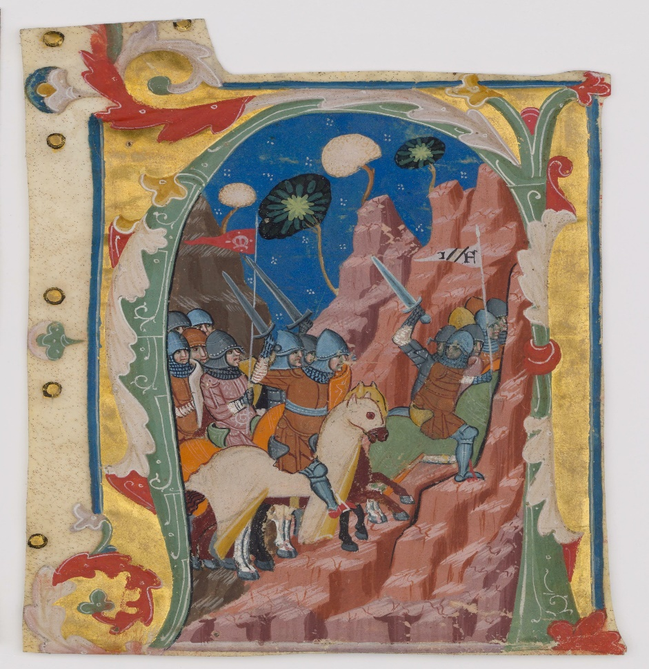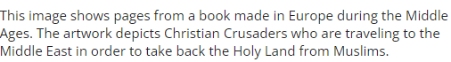
- Muslim-Jewish Interactions: Jews in Muslim territories had legal restrictions but enjoyed more economic freedom, often trading with Muslims.
- Bias and Perspective: Historical documents show varying biases, such as Christian and Muslim leaders using hostile language toward each other during the Crusades.

Summary:
From 1200 to 1450 CE, the interactions between Muslims, Christians, and Jews were complex. These groups often interacted through trade and war while living under laws specific to their religion. Primary sources show that the way people talked about each other back then can reveal biases and help us understand why they acted as they did.

Check-In Questions:
1. In general, what do primary and secondary sources reveal about inter-religious relationships in the Middle Ages between Muslims, Jews, and Christians?
- Answer: Sources show that Jews, Christians, and Muslims tended to lead separate lives from one another during the Middle Ages. Interactions that resulted from conquest tended to have tones of negativity, while economic interactions tended to be more positive.
2. Describe one example of interactions between Muslims and Christians that was a result of conquest.
- Answer: The Christian Crusades were wars initiated by the Pope to retake the Holy Land that was controlled by Muslims.

Practice Questions:
1. What kind of attitude do words in a primary source such as “pagan” or “demon” demonstrate toward people of another religion?
- Answer: These words show that the author views their own religion as superior or more important than the one they are describing. Using the words “pagan” and “demon” shows a negative point of view and indicates bias.

2. When a primary source uses phrases like “the valour of our ancestors” and “our superiority,” what determination can you make about their attitude toward the other group of people?
- Answer: The source likely feels like they are better than the other group. Being superior or having brave ancestors indicates that the author has a biased point of view towards people from other groups.

3. Describe the interactions between Muslim, Christian and Jewish societies in North Africa and Asia.
-Answer: Both Christian and Muslims required Jewish people to follow different laws than they did in the regions that they controlled. However, Jews and Muslims had more equality and respect for one another in economic interactions, often forming trading companies together. As Muslim empires expanded in the Middle East, both Christians and Muslims held biases against each other and fought during the Crusades in the 700s to the 1500s over control of the Holy Land.

- Islam and Christianity in Europe Between 300 and 1500 CE

Objective 2: Compare the growth of Islam and Christianity in Europe between 300 and 1500 CE.

Essential Question: How can Islam and Christianity’s growth in Europe from 300 to 1500 CE be compared?

Key Terms:
1. Holy Roman Empire: A major political entity in medieval Europe.
2. Byzantine Empire: The eastern part of the Roman Empire, centered around Constantinople.
3. East-West Schism: The division of Christianity into Western Catholic and Eastern Orthodox branches.
4. Crusades: Religious wars initiated by European Christians to reclaim the Holy Land from Muslims.
5. Reconquista: The process of Christian kingdoms in Spain reclaiming territory from Islamic rule.

Big Ideas:
- Christianity's Spread Through Rome: Christianity expanded through the Roman Empire and remained strong in Europe even after the Roman Empire's fall, though it split into Catholic and Orthodox branches.
- Islam's Rapid Expansion: Islam quickly spread and became dominant in the Middle East and parts of Europe, creating powerful Islamic states and interconnecting with Christian territories through both conflict and cooperation.
- Religious Conflicts and Cooperation: Significant events like the Crusades and the Reconquista marked the relationships between Christian and Muslim civilizations, with periods of trade and peace coexisting with times of conflict.
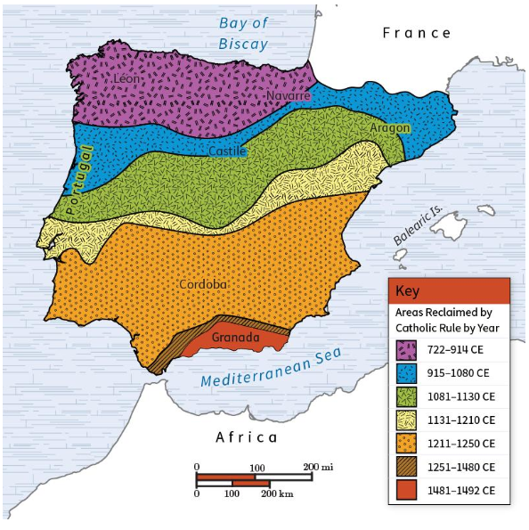
Summary:
Between 300 and 1500 CE, both Islam and Christianity grew significantly but had different paths. Islam spread quickly across the Middle East and parts of Europe, supported by powerful empires, while Christianity spread through the Roman Empire and remained in Europe despite internal splits and conflicts like the Crusades. These interactions ranged from peaceful trade to intense religious wars.

Check-In Questions:
1. What was the Reconquista?
- Answer: The reconquest of Islamic-ruled Spain by Christian rulers.
2. Where and under which empire was the Catholic Church based after the fall of the Roman Empire?
- Answer: The Catholic Church was based in Rome (later Vatican City), in the Holy Roman Empire.

Practice Questions:
1. How did the Crusades begin?
- Answer: The Crusades started following the Byzantine emperor’s call to the pope for help defending against Muslim kingdoms.
2. How did the Spanish kingdom that ruled Spain after the Reconquista treat anyone who wasn’t a Catholic Christian?
- Answer: The Spanish kingdom took extreme efforts to expel or convert anyone who wasn’t a Catholic Christian.

- Introduction to the Growth of Islam and Christianity in the Middle East

Objective 3: Compare the growth of Islam and Christianity in the Middle East between 300 and 1500 CE.

Essential Question: How did the expansion of Islam and Christianity in the Middle East differ between 300 and 1500 CE?

Key Terms:
1. Monotheistic: Belief in one god.
2. Scripture: Sacred writings of a religion.
3. Quran: The holy book of Islam.
4. Prophet: A person regarded as an inspired teacher or proclaimer of the will of God.
5. Caliphate: An Islamic state under the leadership of a caliph, often regarded as a religious successor to Muhammad.

Big Ideas:
- Islam’s Emergence as a Major Religion: Islam began around 600 CE and spread worldwide, becoming a leading religion in the Middle East by 1500 CE, supported by several powerful empires. 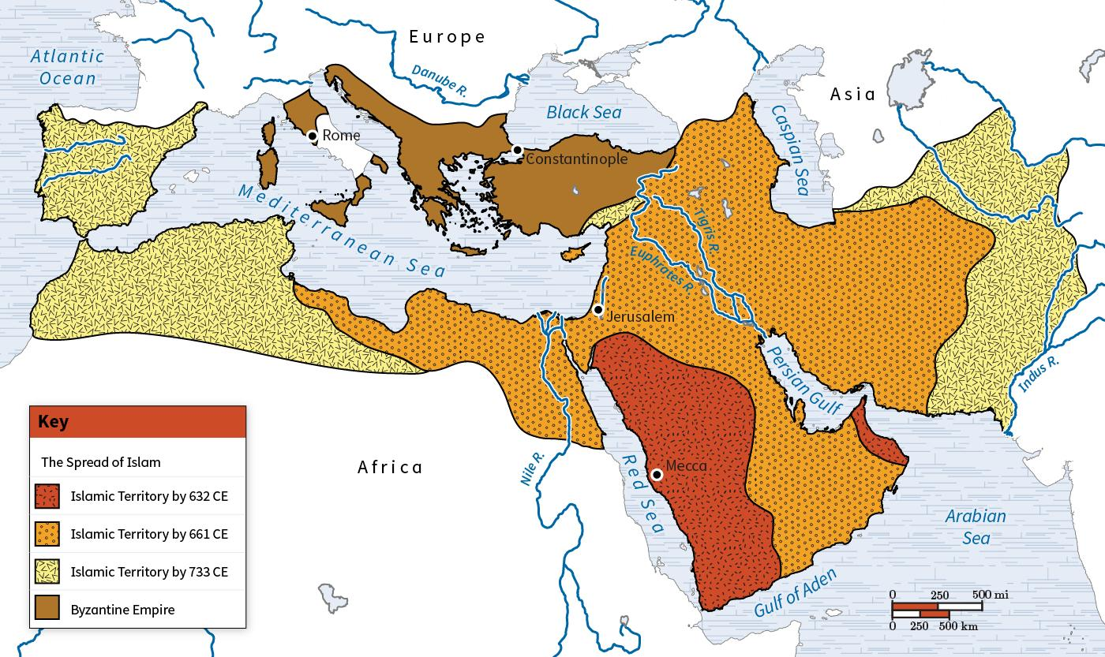
- Christianity’s Continued Influence: Christianity began in the Middle East in the first century CE, expanding beyond the region, significantly influenced by trade routes and the Roman Empire.
- Religious Conflicts: The Crusades were religious wars initiated by European Christians to reclaim the Holy Land from Muslims, leading to long-standing religious conflicts in the area.
- Regional Dominance Shifts: Over time, the center of Christianity moved from the Middle East to Europe, while Islam remained the dominant religion in the Middle East due to its official status in powerful empires.

Summary:
From 300 to 1500 CE, Islam and Christianity expanded significantly but had different trajectories. Islam quickly became dominant in the Middle East and established powerful empires, while Christianity spread beyond its region of origin through Roman influence and trade routes. The Crusades marked significant religious conflicts, and over time, Europe emerged as the center of Christianity, whereas Islam continued to shape the Middle East.

Check-In Questions:
1. Name two things Islam and Christianity have in common.
- Answer: They are both monotheistic religions. They both recognize Jesus and Moses as prophets.

2. What was the East-West Schism?
- Answer: The splitting of Christianity into Western Catholic and Eastern Orthodox branches.

Practice Questions:
1. How did Islam and Christianity spread across the world?
- Answer: They spread through trade routes.

2. How did the Crusades affect the Middle East?
- Answer: The Crusades affected the entire region as crusaders wanted to “claim” the region for Christianity and drive out Islam. Most of the Crusades were unsuccessful, but they were the first of many religious conflicts in the area.

- Exchanges of Knowledge in Christian and Islamic Societies

Objective 4: Describe the impact of exchanges of knowledge between Christian and Islamic societies.

Essential Question: How can we assess, evaluate, and describe the exchanges of knowledge between Christian and Islamic societies?

Key Terms:
1. Roman Empire: One of the largest and most enduring empires in world history, instrumental in spreading Christianity.
2. Middle Ages: The period in European history from the fall of the Roman Empire to the beginning of the Renaissance.
3. Renaissance: The period in Europe characterized by a resurgence in arts, culture, and learning following the Middle Ages.
4. Bookbinding: The process of physically assembling a book from a set of written, printed, or blank pages.
5. Movable type: Printing technology that uses movable characters to reproduce the elements of a document.

Big Ideas:
- Centers of Knowledge: Islamic societies became key centers of knowledge, preserving and expanding upon the knowledge of the Roman Empire and ancient Greece.
- Institutional Learning: Both Christian and Islamic societies developed important educational institutions such as universities and libraries that facilitated the exchange of knowledge.
- Artistic Exchanges: Literature and artistic traditions from Islamic societies influenced the development of similar traditions in Europe, leading to the creation and dissemination of significant works.
- Scientific and Technical Exchanges: Innovations in science and technology, particularly in mathematics, astronomy, and navigation, were developed in Islamic societies and later adopted by Christian Europe, leading to significant advancements. 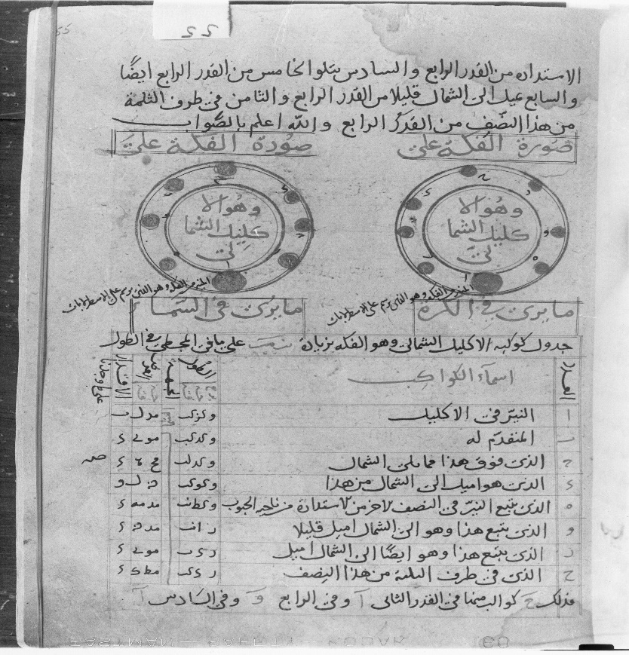

Summary:
From 300 to 1500 CE, Christian and Islamic societies exchanged vast amounts of knowledge, fostering advancements in various fields including science, technology, and the arts. Islamic centers of learning preserved and expanded upon the knowledge of ancient civilizations, which was later reintroduced to Europe, contributing to the Renaissance. Educational institutions in both societies played a significant role in this knowledge exchange, leading to mutual prosperity and growth.

Check-In Questions:
1. What are some examples of literature that were written in Islamic and Christian societies at this time?
- Answer: The One Thousand and One Nights and Gargantua and Pantagruel.
2. What are some examples of knowledge institutions that developed during this time?
- Answer: Universities, libraries, and “bookshop schools”.

Practice Questions:
1. Search online for an institution of knowledge—such as a university or library—that was founded between 300 and 1500 CE. Write a statement about how they present the story of their history on their website. What mention, if any, of exchanges of knowledge between Islamic and Christian societies can you find? Remember to identify a reliable website or resource to answer this question.
- Answer: Sample answer: I chose to investigate the University of Oxford. Its website states that “There is no clear date of foundation, but teaching existed at Oxford in some form in 1096 and developed rapidly from 1167, when Henry II banned English students from attending the University of Paris.” No mention is made of exchanges of knowledge between Islamic and Christian societies. The University of Paris is mentioned, though. The University of Oxford grew after the knowledge across borders was cut down on by Henry II.

2. Search online for an example of an invention that was exchanged between Islamic and Christian societies. Write a statement about the effect of this invention on both societies. Remember to identify a reliable website or resource to answer this question.
- Answer: Sample answer: I chose the example of the astrolabe and read an article by Smithsonian magazine. The astrolabe could “give you the time, your location, your horoscope, and even help you make decisions.” It allowed people to navigate and find directions—such as the direction of Mecca in Islamic societies. In Europe, it was used as an “astrological tool to make decisions ranging from when to go to battle to how to go about bank dealings.”

