- Unit 3 Lesson 1: Early Civilizations
- Early Civilizations: Introduction

Timeline:
Pre-10,000 BCE
• Hunter-Gatherer Societies: Human beings live in small, mobile bands, subsisting by hunting and gathering.

Around 10,000 BCE
• Development of Agriculture: Transition from hunter-gatherer lifestyles to agricultural societies. Domestication of animals like goats and sheep and cultivation of crops like barley and wheat. 
• Permanent Settlements: Establishment of villages due to the need to oversee crops and livestock.

Approximately 3000-2000 BCE
• Formation of River Valley Civilizations: Rise of the first complex societies in key river valleys:
• Mesopotamia (Euphrates and Tigris Rivers)
• Egypt (Nile River)
• Indus Valley (Indus River)
• China (Yellow River)

2000-1000 BCE
• Development of Major Cities: Cities emerge as economic, political, and cultural hubs with busy markets, large temples, and advanced governments.
• Construction of Large Infrastructure: Societies build significant structures like pyramids in Egypt and ziggurats in Mesopotamia.

1600-1100 BCE
• Old, Middle, and New Kingdoms in Egypt: Periods characterized by different political, economic, and cultural developments in ancient Egypt.

1000-500 BCE
• Development of Writing:
• Mesopotamia: Emergence of cuneiform for record-keeping.
• Egypt: Development of hieroglyphics.
• Specialization and Trade: Rise in craft specialization (e.g., weaving, metalworking) and long-distance trade.

550-330 BCE
• Persian Empire: Rise and expansion of the Persian Empire.
• Trade Routes and Cultural Exchange: Establishment of early trade routes contributing to the spread of ideas, technology, and goods.

321-185 BCE
• Mauryan Empire: Formation, expansion, and eventual collapse of the Mauryan Empire in India.

200 BCE-220 CE
• Han Dynasty: Major advancements in science, technology, and trade in China, including the development of the Silk Road.

300-600 CE
• Gupta Empire: Flourishing of arts, science, and trade in India.

618-907 CE
• Tang Dynasty: Period of great cultural and technological progress in China.

Objective 1: Understand how geography influenced the development of early complex civilizations in river valleys.

Essential Question: How does geography impact the development of complex civilizations?

Key Terms:
1. Civilization: A complex human society with cities, governments, and social structure.
2. River Valley: Areas around rivers which provided fertile land for early civilizations.
3. Irrigation: Systems to control water flow for farming.
4. Mesopotamia: One of the earliest known civilizations located in the Tigris-Euphrates river valley.
5. Agriculture: Farming and domestication of animals, allowing for permanent settlements.

Big Ideas:
- Geographic Influence: Early civilizations like Mesopotamia, Egypt, the Indus River Valley, and China developed in river valleys. These areas offered rich soil for farming due to river sediments, but they also faced challenges like unpredictable rainfall and floods.
- Development of Cities: These river valleys became homes to the first cities, serving as centers for economy, politics, and culture. Here, people exchanged goods in markets and participated in governance.
- Irrigation Systems: To manage water resources, communities created irrigation systems. This coordinated effort led to sophisticated governments to organize labor and resources.
- Specialization and Resources: With increased agricultural productivity, not everyone needed to farm. People specialized in different crafts, leading to a more efficient society with the capacity to build large structures like temples and pyramids.
- Interconnected Advances: Writing and government developed together to manage these growing and complex societies. However, political instability could disrupt these systems, leading to economic crises.

- Unit 3 Lesson 2: Human Migration and Society Formation
- What Are Push and Pull Factors?

Objective 1: Use geographic tools to assess the impact of physical geography on human settlement and migration.

Essential Question: How does physical geography, including push and pull factors, affect human settlement and migration?

Key Terms:
1. Climate Map: A map that shows information about the climate of different parts of the world.
2. Deductive Reasoning: Developing a general statement or hypothesis about a topic, then examining sources to come up with a logical conclusion.
3. Homo Sapiens: The primate species to which modern humans belong.
4. Inductive Reasoning: Making broad generalizations about a topic from specific observations.
5. Physical Geography: A branch of geography focused on physical features and processes.

Big Ideas:
  - Geographic Tools: Climate maps, physical maps, and thematic maps help us understand push and pull factors in human migrations.
  - Push and Pull Factors: Push factors in the physical environment, like climate changes and food scarcity, prompt migration, while pull factors such as better climates and ample food supply attract people to new areas. 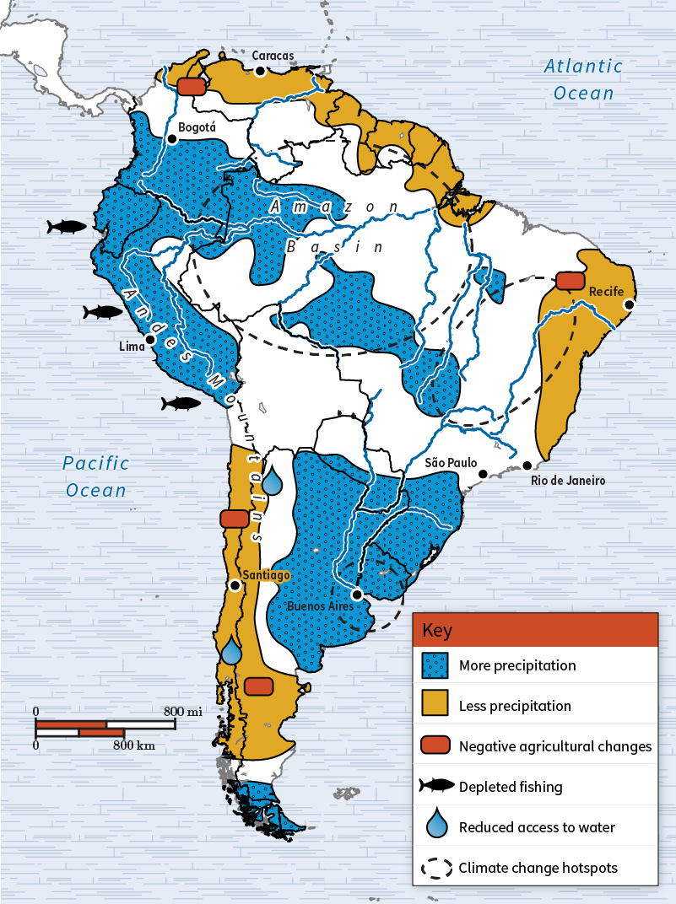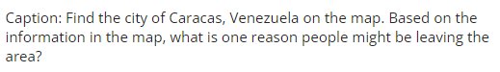
  - Patterns of Migration: Historians and social scientists use reasoning to understand how physical geography influences human migration.

Check-In:
1. What is an example of a geographic tool that could be used to assess patterns of human migration?
- Answer: A thematic map.

2. What information does a climate map provide?
- Answer: A climate map shows information about the climate of different parts of the world.

Practice:
1. How can studying the physical geography of an area help social scientists and others to deduce push and pull factors for human migration?
- Answer: Physical geography can give researchers information about an area’s food supply, water accessibility, and safety from natural events, indicating why people might migrate away or toward it.

2. Analyze the map and decide whether the following statement is true, partly true, or false. Then, explain your reasoning. "From 2015 to 2020, countries in Central America experienced faster population growth than those in South America." 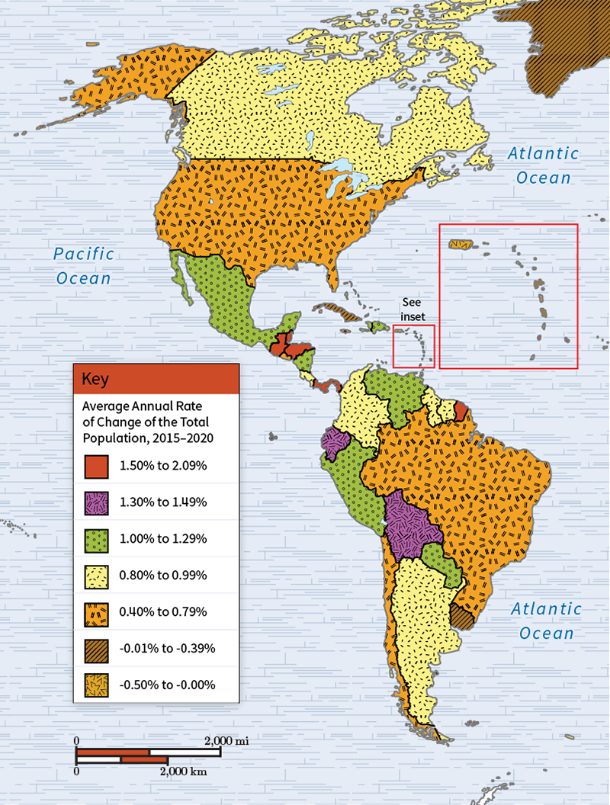

- Answer: This statement is only partly true. Four of the countries with the fastest population growth are in Central America. However, one such country is in South America, and not all Central American countries experienced fast population growth.

- Push and Pull Factors for Early Human Migration

Objective 2: Analyze the role of environmental factors in shaping patterns of human migration, using maps as evidence.

Essential Question: What role does environment play in the migration of early humans?

Key Terms:
1. Bering Strait: The strait separating the Chukchi Peninsula of Russia from the Seward Peninsula of Alaska.
2. Homo Sapiens: The primate species to which modern humans belong.
3. Pull Factor: A positive factor that prompts migration to a location.
4. Push Factor: A negative factor that prompts migration away from a location.

Big Ideas:
  - Environmental Influence: Climate changes, scarcity of resources, and natural disasters could push early humans to move, while better climates and plentiful resources could pull them to new areas. 
  - Migration Patterns: Early humans followed herds and moved to areas with better resources. Understanding modern human migrations helps scholars guess why early humans migrated.
  - Historical Evidence: Maps and archaeological findings provide clues about where early humans migrated and why, indicating the impact of environmental factors.

Check-In:
1. What are push factors?
- Answer: Push factors are negative factors that prompt migration away from a location.

2. What are pull factors?
- Answer: Pull factors are positive factors that prompt migration to a location.

Practice:
1. What pull factors might have caused early humans to migrate toward coastal areas?
- Answer: The abundance of natural resources and moderate climate in most coastal areas were pull factors that caused humans to migrate toward those areas.

2. What push factors might have caused early humans to leave certain places?
- Answer: A negative change in environmental conditions, such as drought or flooding, in the area where they were living might have caused humans to leave in search of a better location.

3. Use the internet to research and locate at least two additional sources that discuss the push and pull factors leading to the migration of early humans. Then, using evidence from your sources, write a paragraph that supports or refutes the argument proposed by the student in the video.
- Sample answer: I disagree with the student in the video. Early humans were hunter-gatherers and might have moved because the herds they were following moved, crossing into North America via the Bering Strait in search of similar environments.

- Neolithic Revolution: Let's Farm

Objective 3: Construct a historical hypothesis to analyze the impact of the domestication of plants and animals on the development of early civilizations.

Essential Question: How did the domestication of plants and animals lead to the development of early civilizations?

Key Terms:
1. Complex Society: A society with a clear social structure, hierarchy, system of government, and developed cultural elements.
2. Cuneiform: An ancient writing system used in Sumer.
3. Domestication: The process of breeding wild plants or animals for food.
4. Fertile Crescent: Area along and around the Tigris and Euphrates rivers, where some of the first agricultural societies developed.
5. Neolithic Revolution: The time around 10,000 BCE when humans began farming and settled permanently.

Big Ideas:
- Neolithic Revolution: People abandoned hunting and gathering to start farming, leading to the domestication of plants and animals. 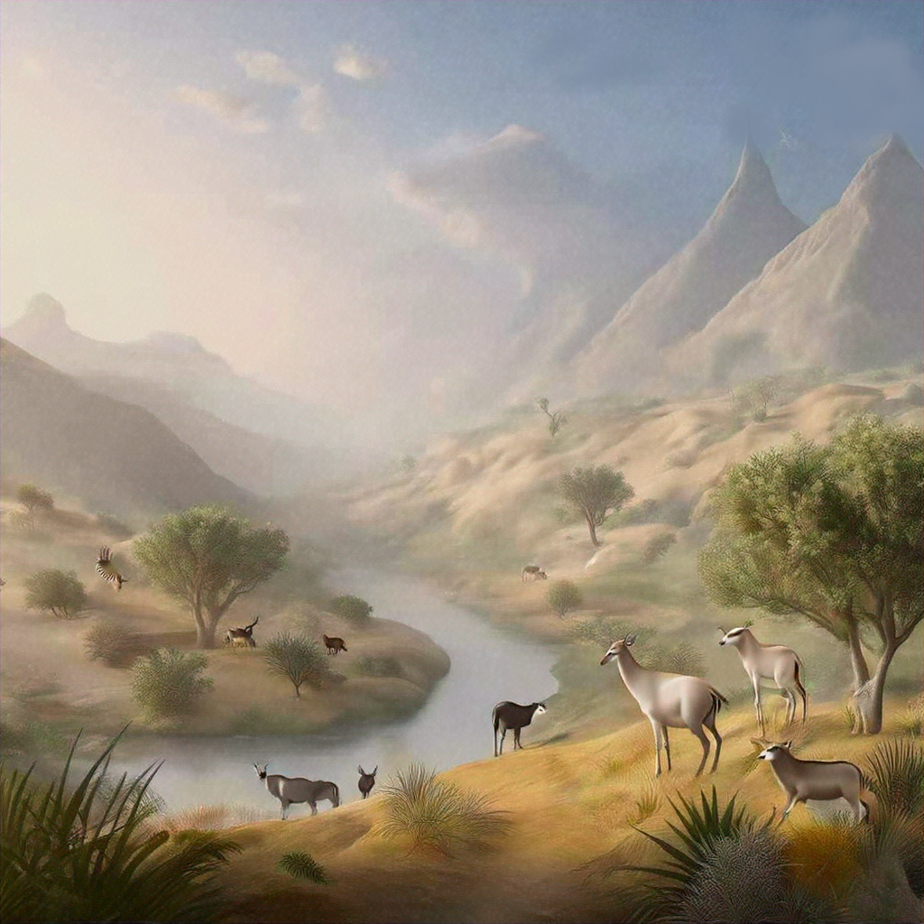
- Permanent Settlements: Farming allowed for stable food supplies and the establishment of permanent settlements, which evolved into complex societies.
- Domestication: By taming plants and animals, societies could support larger populations, build permanent structures, and develop specialization in labor.
- Complex Societies: As settlements grew, so did the need for organized governance, specialized jobs, and written language to manage resources and societal functions.

Check-In:
1. What were domesticated animals used for in early societies?
- Answer: Domesticated animals were used for food, pets, or to help perform labor on farms.

2. What are some examples of early written languages?
- Answer: Examples of early written languages include cuneiform, hieroglyphics, and Chinese symbols and characters.

Practice:
1. Construct a historical hypothesis: How did the domestication of plants and animals lead to permanent settlements?
- Answer: The domestication of plants and animals allowed people to abandon hunting and gathering. Because people had a stable food supply, they could build permanent settlements.

2. Explain the main features of complex societies.
- Answer: Complex societies included large population centers, specialized jobs, organized governments, and written languages to create laws and manage society.

- Cause and Effect: From Hunting and Gathering to Complex Societies

Objective 4: Use a timeline to assess the development of complex civilizations by showing the cause-and-effect relationship of certain events.

Essential Question: What factors led to the development of increasingly complex societies?

Key Terms:
1. Anthropologist: A person who studies the development of human societies and cultures.
2. Archaeologist: A person who studies human history by examining artifacts.
3. Code of Hammurabi: An early legal code from Mesopotamia.
4. Complex Society: A society with a clear social structure, hierarchy, system of government, and developed cultural elements.
5. Cuneiform: An early form of writing that used symbols.

Big Ideas:
- Hunter-Gatherer to Settlements: Early humans lived as hunter-gatherers but eventually formed permanent settlements due to stable food supplies from agriculture. 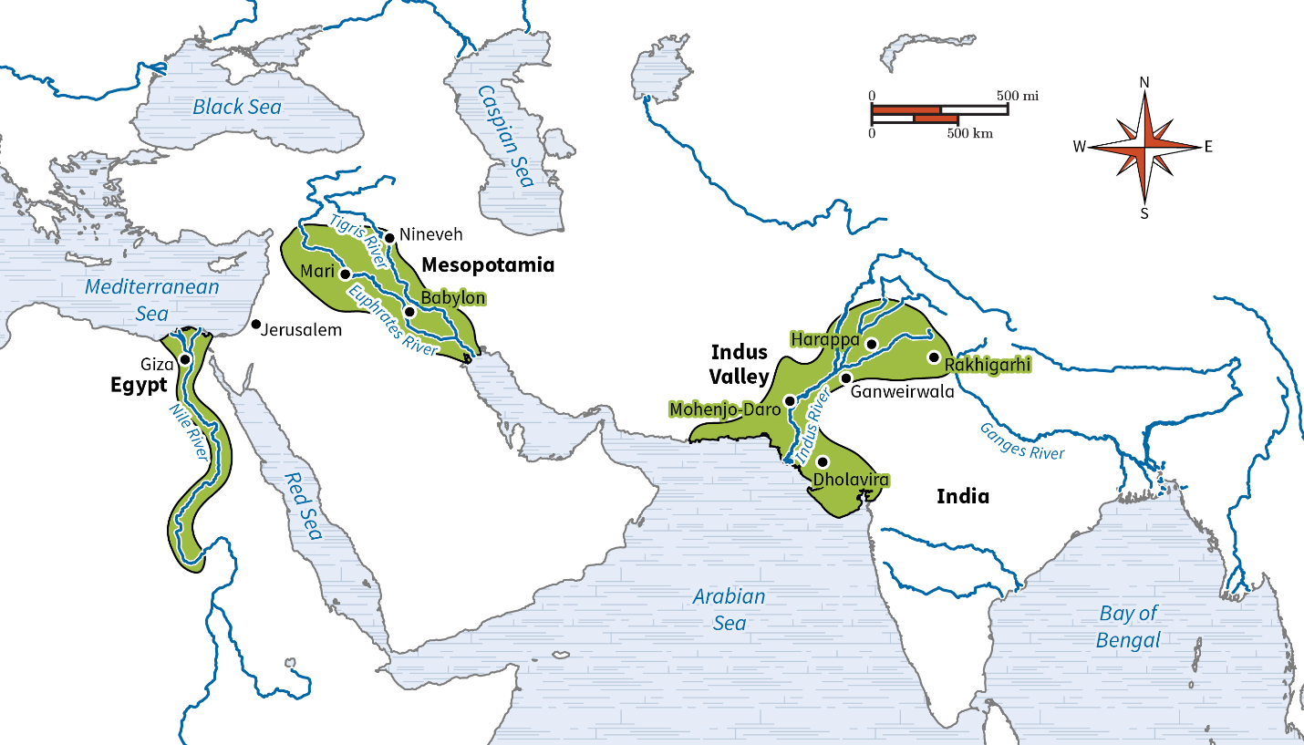
- Domestication and Surplus: Domestication of plants and animals led to food surplus, which required storage solutions like pottery, enabling larger populations and complex societies.
- Development of Governance: As societies grew, governments formed to organize people and resources. Writing systems like cuneiform were developed to manage societies effectively.
- Impact of Specialization: Specialization in jobs and development of writing systems were key features in the evolution of complex societies.

Check-In:
1. What do archaeologists believe pottery was first used for?
- Answer: Food preparation.

2. How can timelines help you make inferences about cause-and-effect relationships of certain events?
- Answer: Timelines can be used to place events in sequence. By examining the sequence of events on a timeline, we can determine cause-and-effect relationships.

Practice:
1. What is one problem early societies experienced that was solved as civilizations became more complex?
- Answer: Early societies needed to store surplus food. Pottery allowed for food storage, which provided food stability, leading to population growth and the development of complex societies.

2. Use a timeline to place the following events in chronological sequence: written language, hunter-gatherer societies, domesticated plants, Code of Hammurabi.
- Answer:
- 20,000 BCE: Hunter-gatherer societies
- 10,000 BCE: Domesticated plants
- 3200 BCE: Written language
- 1750 BCE: Code of Hammurabi

- Unit 3 Lesson 3: River Valley Civilizations
- Trade, Not Conquest

Objective 1: Use charts and maps to trace how the ancient civilizations of the Mediterranean and Southwest Asia led to the foundation of later civilizations.

Essential Question: How did the Minoan and Etruscan civilizations lead to the founding of later classical civilizations?

Key Terms:
1. City-State: A political system where the city leaders make all decisions for their territory without being overruled by a larger government.
2. Aqueduct: A manmade system for moving water.
3. Polytheism: The belief in more than one god.
4. Empire: A system of government with one authority ruling over a large territory.
5. Urban Planning: The intentional development and design of urban areas.

Big Ideas:
- Minoan Contributions:
  - Minoans created independent city-states and advanced urban planning.
  - Their trade routes and engineering skills influenced later Greek city-states.
  - Cultural elements like polytheism, frescoes, and mosaics originated from Minoan society and were incorporated into Greek civilization. 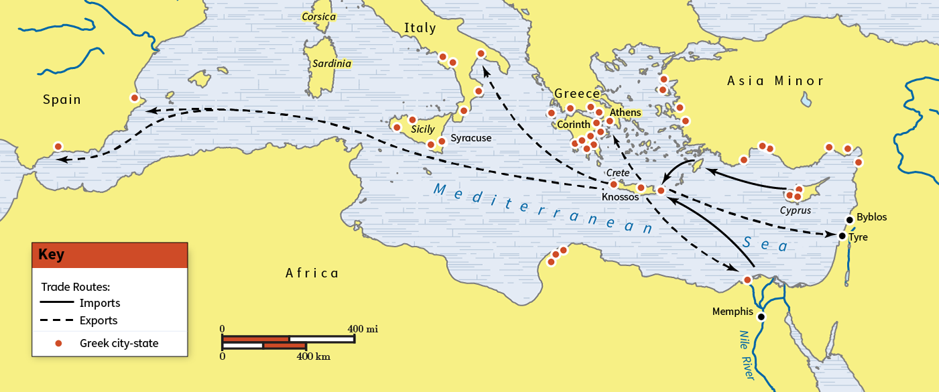

- Etruscan Contributions:
  - Etruscans established leagues of city-states which were precursors to empires.
  - They brought advanced engineering technologies, like aqueducts and city walls, to Rome.
  - Cultural practices such as architectural styles and fighting contests influenced Roman society. 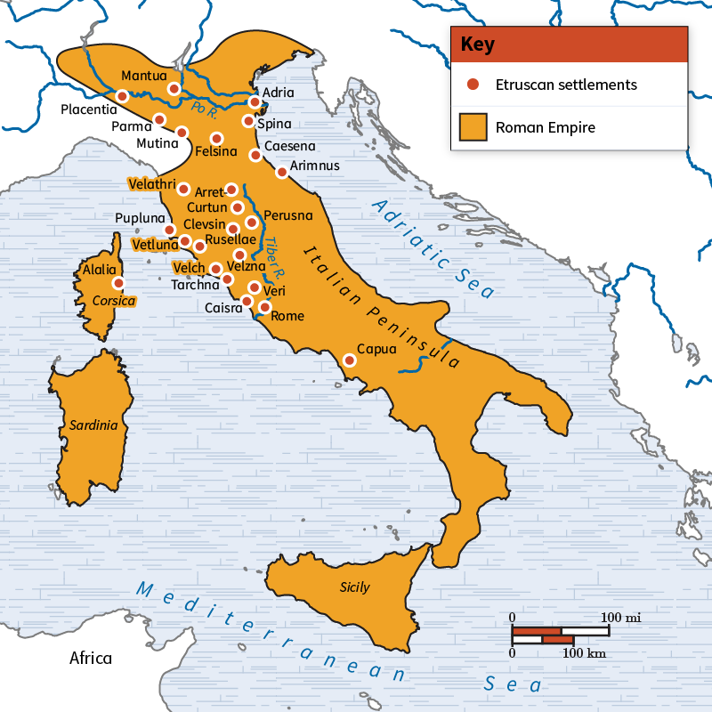

Check-In:
1. Classical Greek civilization can be directly traced back to which previous civilization?
- Answer: The Minoans.

2. Classical Roman civilization can be directly traced back to which previous civilization?
- Answer: The Etruscans.

Practice:
1. Explain how topography played a role in the Greek city-states’ Minoan origins.
- Answer: The rocky and mountainous terrain led to physical isolation, causing the development of independent city-states.

2. Explain how topography played a role in the Roman Empire’s Etruscan origins.
- Answer: The relatively flat and traversable terrain contributed to the unity of Etruscan cities, which later influenced the Roman development of empires.

3. Identify what the Romans did to spread Etruscan architectural style. Give at least one example of a specific Etruscan practice or idea that the Romans used.
- Answer: The Romans adopted and improved on Etruscan architectural elements for their own buildings, such as the “Etruscan atrium” house model.

- Building on the Past

Objective 2: Show how people in river valley civilizations built upon Neolithic technology.

Essential Question: How is river valley civilization technology an extension of Neolithic innovation?

Key Terms:
1. Alloy: A mixture of metals.
2. Domesticate: The practice of taming and breeding animals for work and food.
3. Metallurgy: The process of mining, mixing, and using metals.
4. Nomadic: A lifestyle of continual movement to meet survival needs.
5. Sedentary: A settled, stationary lifestyle.

Big Ideas:
- Neolithic Innovations:
- During the Neolithic period, humans developed stone tools, engaged in hunting and gathering, and started experimenting with farming. 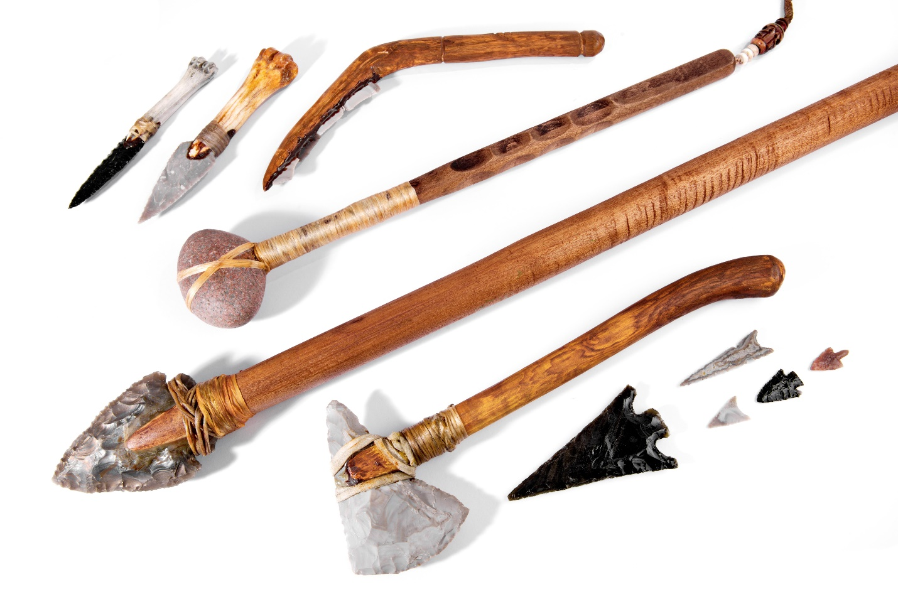

- Advancements in River Valley Civilizations:
- River valley civilizations, such as those in Mesopotamia and Egypt, built upon Neolithic tools and introduced advanced farming methods, like the plow and hoe for agriculture.
- Metals like bronze, created by mixing tin and copper, enabled stronger tools and weapons.
- Innovations in transportation included the transition from simple canoes to wheeled carts.

Check-In:
1. How does the etymology of “Neolithic” relate to the use of technology?
- Answer: The word Neolithic means “New Stone Age” in ancient Greek, reflecting the widespread use of stone for tools.

2. Make a list of five technologies discussed in this reading. Label each one with either river valley civilization or Neolithic period.
- Answer: Stone axe (Neolithic); gold (Neolithic); canoe (Neolithic); bronze (river valley civilizations); plow (river valley civilizations); wheel (river valley civilizations).

Practice:
1. How did river valley civilizations use Neolithic technology for planting crops?
- Answer: River valley inhabitants used Neolithic axes to help clear land where needed.

2. Write down five examples of technology you use in your everyday life. In the same way that river valley civilization societies built upon Neolithic technology, which items on your list are extensions of river valley civilization advancements?
- Answer: Metal knives are an extension of Neolithic cutting tools. Cars are an extension of carts. Steel is an extension of bronze. Books are an extension of early writing. Grocery produce is an extension of settled agriculture.

- The Egyptians and Mesopotamians Master the Environment

Objective 3: Compare ways that Egyptians and Mesopotamians altered their environments to suit their needs using case studies of how changes in the environment can change its capacity to support human activity.

Essential Question: How did Egyptians and Mesopotamians change their environment to suit their needs?

Key Terms:
1. Agrarian: Related to farming.
2. Basin Irrigation: A type of watering system that floods entire fields between canals.
3. Head-Dam: A structure at the beginning of a canal that controls the flow of water.
4. Irrigation: A human-made system of channeling water from a natural source like a river to crops.
5. Silt: The sediment and nutrients that fertilize crops.

Big Ideas:
- Egyptian Water Management:
- Egyptians depended on the annual flooding of the Nile, which deposited nutrient-rich silt on their farmlands. 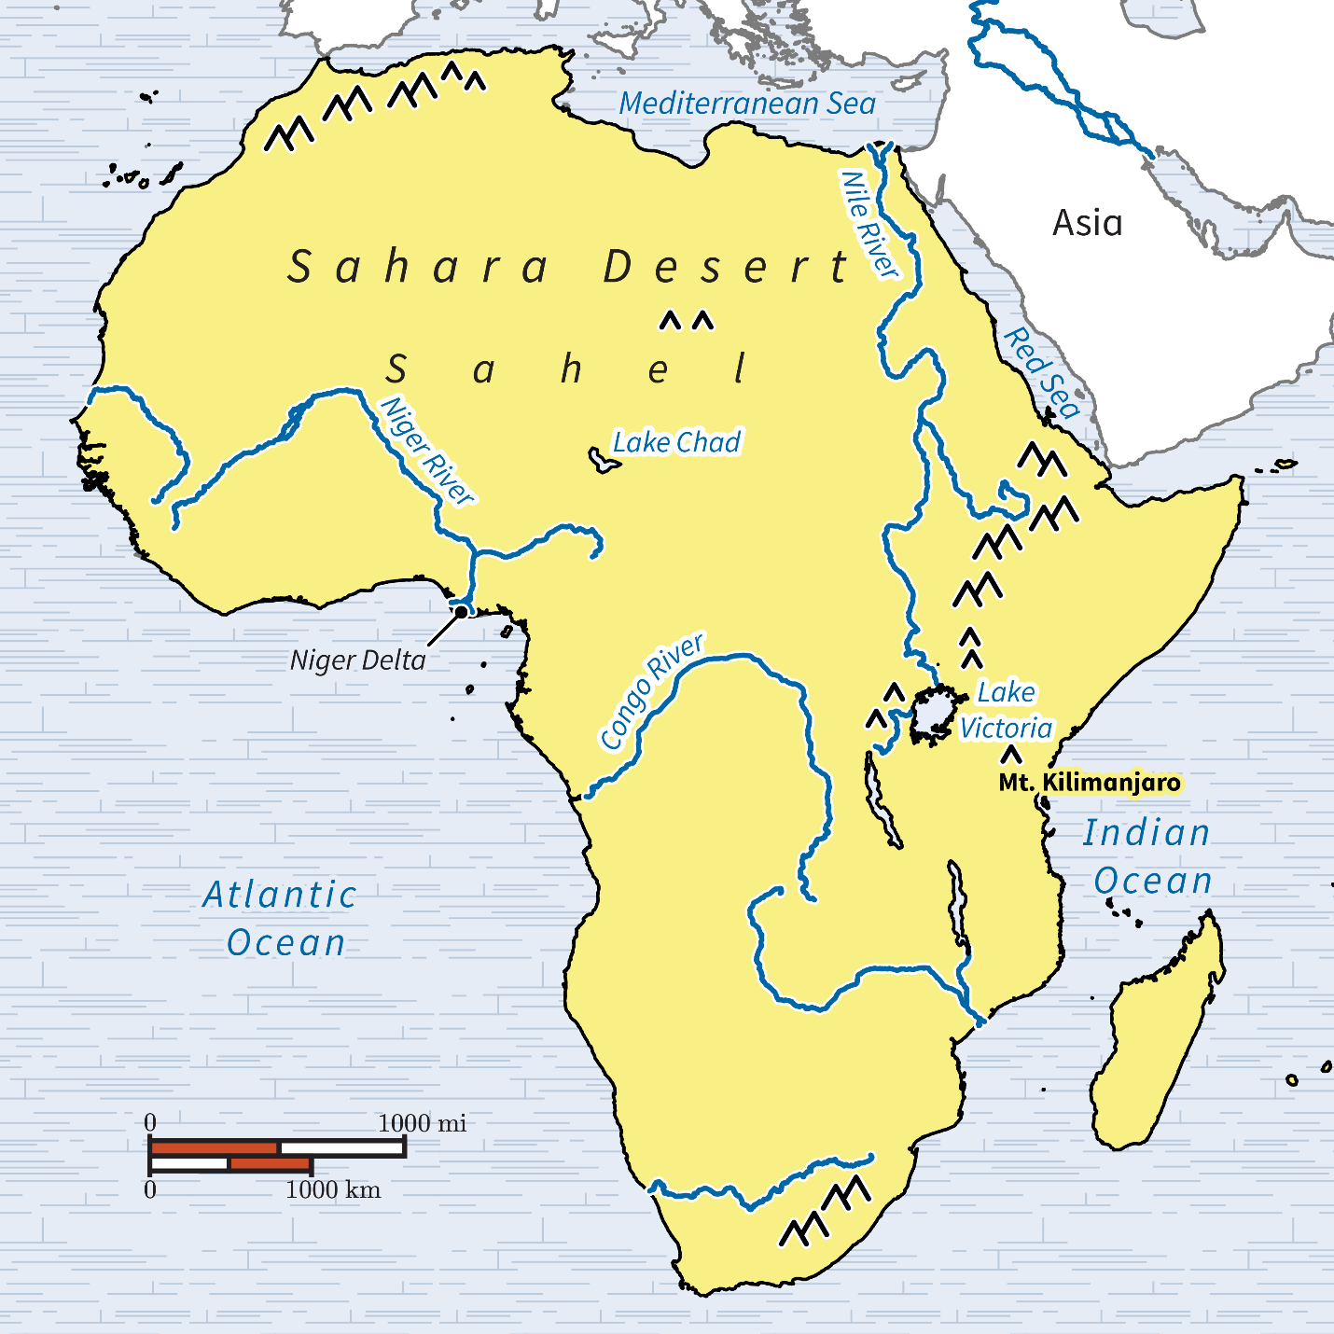
- To maximize agricultural productivity, they developed basin irrigation systems with crisscrossing canals that channeled floodwaters to their crops.

- Mesopotamian Water Management:
- Mesopotamians faced unpredictable floods from the Tigris and Euphrates Rivers.
- They built large scale irrigation systems, including head-dams and canals, to control water flow and reduce flood damage. Regulator-dams inside the canals managed water distribution.

Check-In:
1. Name the main way Egyptians altered their environment to meet their water management needs.
- Answer: The Egyptians mainly used basin irrigation.

2. Name the main way Mesopotamians altered their environment to meet their water management needs.
- Answer: The Mesopotamians mainly used a system of dams to water their crops.

Practice:
1. Explain how the Egyptians changed their environment to meet the water needs of their population.
- Answer: The Egyptians dug a system of crisscrossing canals in order to flood the fields between the canals.

2. Explain how the Mesopotamians changed their environment to meet the water needs of their population.
- Answer: The Mesopotamians used various materials to build dams in order to prevent strong floodwaters from destroying their crops.

- Classic Civilizations with Ancient Roots

Objective 4: Identify how classical civilizations arose from the influences of river valley civilizations.

Essential Question: How did river valley civilization ideas appear in Greek and Roman societies?

Key Terms:
1. Aesthetic: The way things look; valuing beauty above all else.
2. Infrastructure: Basic systems, such as road and building construction, that are necessary for a society to function effectively.
3. Legitimacy: The right of a government or ruler to have power.
4. Polytheistic: Worshipping more than one god.
5. Social Hierarchy: A system that exists within a community where members have unequal power.

Big Ideas:
- Social Hierarchies:
- River valley civilizations established social hierarchies based on territory and accumulation of goods, influencing class structures in classical civilizations.
- Greco-Roman societies had distinct social classes, with privileges for the wealthy and ruling elites.

- Governance and Law:
- River valley civilizations created early forms of government to manage large populations and introduced systems of law, like Hammurabi’s Code.
- Greco-Roman civilizations expanded on these governance systems and legal codes, such as Rome’s Twelve Tables.

- Religion and Legitimacy:
- River valley civilizations practiced polytheistic religions integrated into government and everyday life, legitimizing leadership through divine support.
- Classical civilizations maintained these traditions, with Greek and Roman rulers using religion to reinforce their power and societal norms.

- Architecture and Art:
- Monumental architecture and artistic works were used by river valley civilizations to show devotion to gods and reinforce government authority.
- Greco-Roman civilizations built upon these practices, creating iconic structures like temples and using art for political and religious messages. 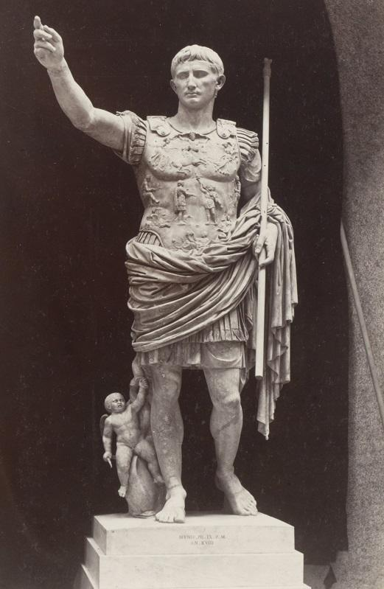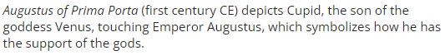

Check-In:
1. Identify two ways that river valley civilizations influenced classical civilizations.
- Answer: River valley civilizations influenced the government systems and the art and architecture of classical civilizations. Governments helped them manage large populations, while art and architecture helped them to legitimize the authority of the government.

2. Describe how classical civilizations expanded upon river valley civilizations’ law codes.
- Answer: Greco-Roman societies built on systems of laws such as Hammurabi’s Code by expanding codified laws to regulate almost every aspect of life.

Practice:
1. Imagine you are a leader of a classical civilization. Think back to the statue of Augustus of Prima Porta. If you were designing a statue of yourself, what other figures or objects would you include and why?
- Answer: My statue would include a spear to symbolize my power as a leader, and a scroll to show that I am wise and well-educated.

2. Why did river valley civilizations first begin to implement large-scale institutions such as government?
- Answer: To organize large populations.

- Unit 3 Lesson 4: Egypt and Mesopotamia
- Ancient Egypt

Objective 1: Construct a timeline of major civilizations in ancient Egypt.

Essential Question: Why was the Nile River Valley a favorable place to settle, and how was ancient Egypt’s location at the crossroads of Africa, the Middle East, and the Mediterranean Sea important in its development?

Key Terms:
1. Dynasty: A series of rulers from the same family.
2. Hieroglyphics: A system of writing using images to represent sounds.
3. Pharaoh: A ruler of ancient Egypt.
4. Polytheistic: Worshipping more than one god.
5. Monotheistic: Worshipping only one god.

Big Ideas:
- Development of Early Egypt:
- Egypt was split into Upper and Lower regions, united by the first pharaoh, Menes.
- The Nile River provided essential resources for agriculture and transportation, aiding the growth of civilization.
- Ancient Egypt was characterized by the construction of pyramids, strong central governments, and dynastic rule.

- Major Time Periods:
- Predynastic Period: Early settlements and initial developments.
- Early Dynastic Period: First pyramid built and strong central governance.
- Old Kingdom: Known for pyramids and long-term prosperity.
- Middle Kingdom: Cultural advancements and reunification efforts.
- New Kingdom: Expansion, military conquests, and famous pharaohs like Hatshepsut and Ramses II.
- Late Period: Regained power but faced external threats.
- Hellenistic and Roman Periods: Influence from Alexander the Great and Rome, leading to major cultural and architectural developments.

Check-In:
1. Where were the first two kingdoms of ancient Egypt established?
- Answer: Upper and Lower Egypt in the Nile Valley.

2. Which conqueror overthrew the Persian Empire and ushered in the Hellenistic period in Egypt?
- Answer: Alexander the Great.

Practice:
1. Construct a timeline in your notebook of the major time periods in ancient Egypt and the civilizations associated with each.
- Answer:
  - Before 3100 BCE: Predynastic Period - Native Egyptian
  - 3100–2686 BCE: Early Dynastic Period - Native Egyptian
  - 2686–2181 BCE: Old Kingdom - Native Egyptian Nubian Libyan
  - 2181–2125 BCE: First Intermediate Period - Native Egyptian
  - 2125–1650 BCE: Middle Kingdom - Native Egyptian Nubian Bedouin
  - 1650–1550 BCE: Second Intermediate Period - Native Egyptian Hyksos
  - 1550–1069 BCE: New Kingdom - Native Egyptian, Nubian, Hittites, Mitannians, Israelites
  - 1069–664 BCE: Third Intermediate Period - Native Egyptian, Nubian, Libyan, Assyrian
  - 664–332 BCE: Late Period - Native Egyptian, Persian, Neo-Assyrian
  - 332–30 BCE: Hellenistic Period - Native Egyptian, Macedonian, Greek
  - 30 BCE–395 CE: Roman Period - Native Egyptian, Roman

2. As you likely noticed, Nubia was a geographic location that was often battled over between Egyptian leaders. Why was this area so important to leaders of Egypt?
- Answer: Nubia contained important resources such as gold, ebony, and ivory.

- Comparing the Old, Middle, and New Kingdoms of Ancient Egypt

Objective 2: Describe similarities and differences among key characteristics of the Old, Middle, and New Kingdoms of Egypt, including the characteristics of theocracies.

Essential Question: How did the geography of Egypt change across the Old, Middle, and New Kingdoms, and how did these physical changes in territory impact the political, economic, and cultural characteristics of each time period?

Key Terms:
1. Absolute Monarchy: A government where the monarch holds unlimited power.
2. Hyksos: A group of non-Egyptian invaders that controlled parts of Egypt for 100 years.
3. Nome: A religious and governmental district used in ancient Egypt.
4. Theocracy: Rule by divine guidance.

Big Ideas:
- Geographic Evolution:
- Old Kingdom: Centered around the Upper Nile Valley, dependent on annual Nile flooding for agriculture.
- Middle Kingdom: Expanded control beyond earlier regions, integrating new oases and settlements.
- New Kingdom: Reached its peak territorial extent, expanding into Nubia, Syria, and Mesopotamia.

- Political Systems:
- Old Kingdom: Centralized under Menes with a theocratic government relying on nomarchs.
- Middle Kingdom: Mentuhotep II unified Egypt and strengthened central authority.
- New Kingdom: Pharaohs maintained absolute power, with significant military expansions and diplomatic relations.

- Economic and Cultural Development:
- Consistent agricultural reliance on the Nile.
- Innovations such as mummification, use of hieroglyphics, and major architectural achievements.
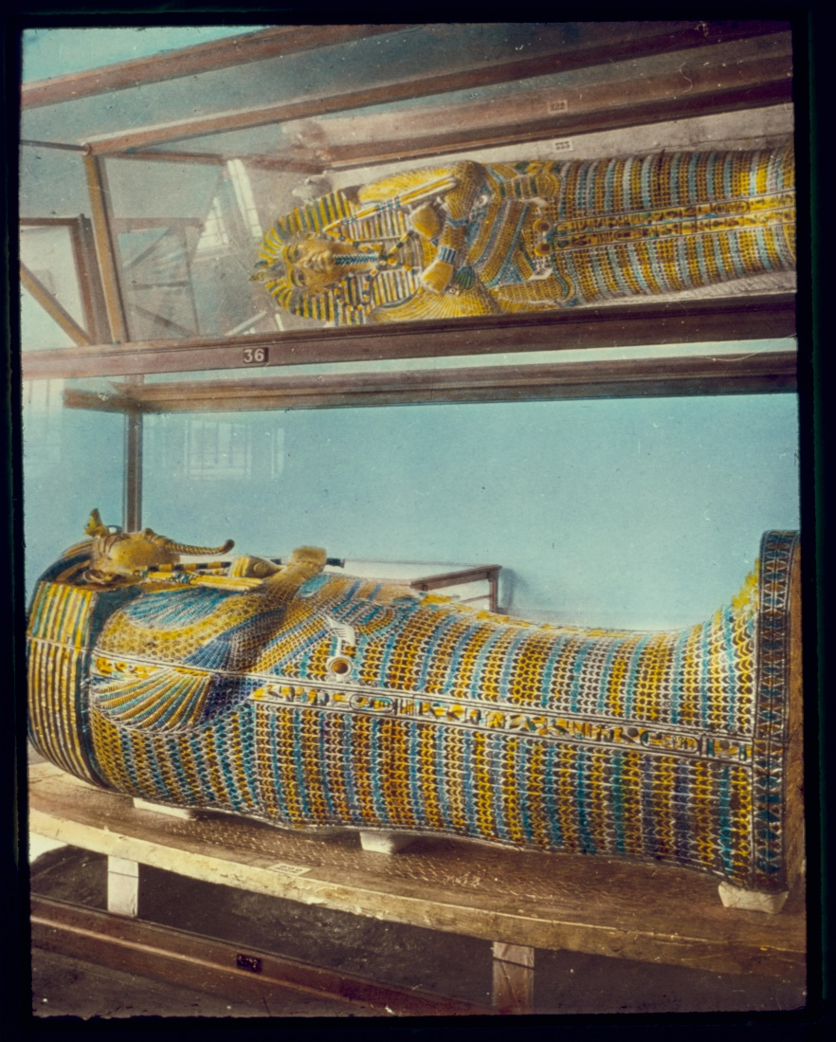
- Religious beliefs remained central, with transitions in practices and influences over time.

Check-In:
1. What body of water played a major role in the development of Egypt across the Old, Middle, and New Kingdoms, and why did it provide a good place to settle?
- Answer: The Nile River provided essential resources for farming, hunting, fishing, travel, and trade.

2. What was a shared characteristic of Egyptian religion throughout most of the Old, Middle, and New Kingdoms?
- Answer: Polytheism, the belief in more than one god.

Practice:
1. Why were materials such as art, jewelry, and other treasures buried in Egyptian tombs?
- Answer: Egyptians believed this world was an extension of the next, and their material possessions would travel with them to the afterlife.

2. Construct a comparison chart in your notebook of the Old, Middle, and New Kingdoms. Include information such as when each occurred, the capital city/cities, and who the important leaders were. Then list some similarities and differences within these time periods.
- Answer:
- Similarities:
- All kingdoms had a pharaoh who was an absolute monarch.
- Religion was very important and mostly polytheistic.
- Building and architecture were significant in all three kingdoms.
- Differences:
- Different viewpoints on religion and the afterlife.
- Different roles held by priests.
- Different capital cities.
- Different viewpoints on writing and how it was used.
- Pyramids mainly in the Old and Middle Kingdoms, not the New.
- Brief monotheistic period in the New Kingdom.
- Different burial places for pharaohs.

- Starting from the Beginning

Objective 3: Construct a timeline of the major civilizations that occupied Mesopotamia during ancient times.

Essential Question: How are societies structured?

Key Terms:
1. Fertile Crescent: An area in the present-day Middle East, where some of the first agricultural societies began to develop.
2. Neolithic Revolution: The gradual adoption of farming practices leading to widespread lifestyle changes.
3. Plural Society: A society incorporating numerous cultures into a single, unified organization.
4. Ziggurat: A temple in ancient Mesopotamia, possibly inspiring early Egyptian pyramids.

Big Ideas:
- Early Civilizations:
- Mesopotamia's Fertile Crescent was critical for early agriculture and settlement development.
- Early villages evolved into city-states such as Uruk and Ur, forming the first Sumerian Kingdom.

- Key Mesopotamian Empires:
- Akkadian Empire (Sargon the Great) established the first known multicultural empire.
- Babylonian Empire (Hammurabi) was known for its legal codes and centralized governance.
- Assyrian Empire expanded Mesopotamian control into modern-day Palestine and Syria.

- Cultural Influences:
- Innovations such as writing (cuneiform), monumental architecture (ziggurats), and legal systems (Hammurabi’s Code).

Check-In:
1. Between what two rivers did much of Mesopotamian society thrive?
- Answer: The Tigris and Euphrates rivers.

2. What type of temples did the Akkadians build?
- Answer: Ziggurats.

Practice:
1. Construct a timeline in your notebook of the major Mesopotamian civilizations and time periods of their reigns.
- Answer:
- 10,000 BCE to 2750 BCE - Early villages and Sumerian Empire
- 2234–2154 BCE - Akkadian Empire
- 2100–2004 BCE - Ur-Namma
- 1792–1750 BCE - Babylonia
- 1595–1395 BCE - The Hittites
- 1365–626 BCE - The Assyrians
- 722–705 BCE - Sargon II
- 626–539 BCE - Neo-Babylonian Empire
- 539–651 CE - Persian Empire/Cyrus the Great/more

2. What made the Fertile Crescent an ideal place for civilizations to thrive?
- Answer: The Fertile Crescent's proximity to numerous bodies of water and its fertile land made it ideal for growing crops.

- Exploring Mesopotamian Culture

Objective 4: Outline some of the key unifying factors of ancient and diverse civilizations.

Essential Question: Do leaders unify groups, or do leaders capitalize on culture?

Key Terms:
1. Cuneiform: The written language of ancient Mesopotamia.
2. Polytheism: A religion with more than one deity.
3. Standing Army: A permanent army with paid soldiers.
4. Treaty: An agreement between two governments.
5. Common Era: The period of time starting with the year one using the Gregorian calendar.

Big Ideas:
- Military Might:
- Leaders like Sargon the Great and Hammurabi used military force to unify and expand their empires.
- Innovation in military technology, such as the composite bow, aided these expansions.

- Citizen Equality:
- Early Mesopotamian societies had nearly equal rights for women, fostering unification and societal stability.

- Religious Practices:
- Religion played a vital unifying role, with Mesopotamian cultures practicing polytheism and engaging in rituals honoring gods.
- Temples (ziggurats) were central to both religious and governmental activities.

- Education and Language:
- Mesopotamia valued education highly, with schools teaching a variety of subjects.
- Written language (cuneiform) enabled the recording of laws, trade contracts, and literature, promoting cultural unity.

- Economic Trade and Job Specialization:
- Specialization in jobs led to economic interdependence and trade, fostering connections between different regions and cultures.
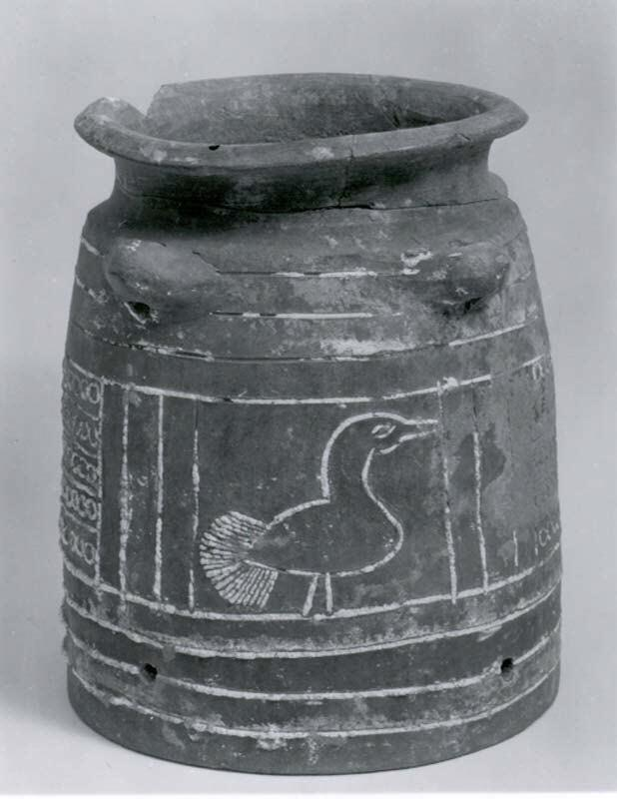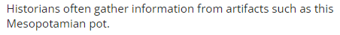

Check-In:
1. How is job specialization a unifying factor for civilizations?
- Answer: Job specialization leads to trade, and trade leads to cultural connections.

2. Why would government leaders have encouraged education among citizens?
- Answer: Education provides common connections to new generations, which lead to united communities.

Practice:
1. Complete further research into historical law codes, looking specifically at Hammurabi, Ur-Nammu, or Lipit-Ishtar. Then, in your notebook, make a Venn diagram about the ancient law code you researched and the modern-day laws of the United States. What is similar, and what is different?
- Answer:
- Similar: It is very common for fines to be implemented when a law is broken.
- Different: Modern laws usually do not outline the consequences.

2. In this lesson, we encounter the first known work of literature, Epic of Gilgamesh. Research a more modern folktale and answer the following question: What are ways in which shared knowledge helps to unify cultures?
- Answer: Shared knowledge creates common history and connection. Most folktales have a moral to the story, so sharing folktales helps to create unified common histories for varied cultures.

- Unit 3 Lesson 5: Social Structure

- Improvements in Farming and Social Organization
Objective 1: Explain how improvements in farming in river valley civilizations impacted social organization.

Essential Question: How did farming change human social organization?
Key Terms:
1. Labor Specialization: Division of roles in society where different people perform different jobs.
2. Neolithic Agricultural Revolution: The time around 10,000 BCE when humans started farming and settled permanently.
3. Nomadic: A lifestyle of constant movement to meet survival needs.
4. Social Class: Division of people based on social and economic power.
5. Social Hierarchy: A system where members of a community have unequal power.

Big Ideas:
- Transition from Nomadic Life: Early humans were hunters and gatherers moving constantly for survival. Around 10,000 BCE, the Neolithic Agricultural Revolution began, and people started farming and settling permanently.
- Permanent Settlements: Farming created surplus food, allowing populations to increase and settle in one area. 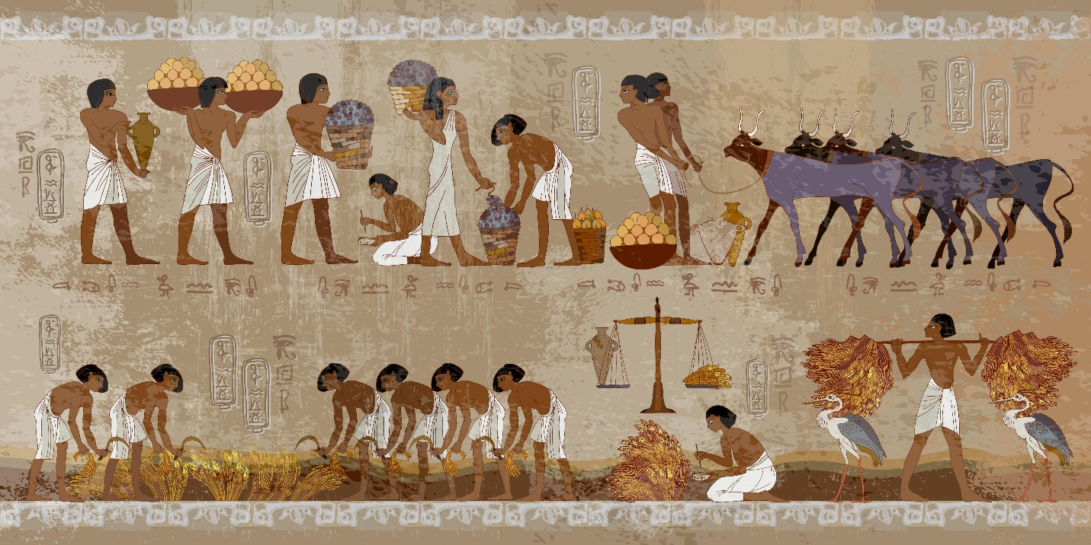

- Labor Specialization: Not everyone needed to farm, so people took on different roles like crafting, trading, and governing.
- Formation of Social Classes: Different roles led to social hierarchies, where some people had more power and resources than others.
- Examples of Civilizations: Mesopotamia, Egypt, the Huang He Valley, Teotihuacan, and Chavín showed how agriculture led to complex social structures.

Check-In Questions:
1. What is a social class?
- Answer: The division of people based on their social and economic power in a society.
2. What can you effectively reason about the effect of the rise of agriculture on early civilizations?
- Answer: The rise of agriculture caused a shift from nomadic lifestyles to permanent settlements and created social classes and hierarchies.

Practice Questions:
1. Compare and contrast Chavín and Egyptian societies.
- Answer: In both societies, there was an elite class with religious officials below them. In Egypt, merchants were above farmers, but in Chavín, it is unclear if merchants or farmers held more power.
2. Do you think the Neolithic Agricultural Revolution was a positive or negative change?
- Answer: Positive if you believe surpluses and population growth led to civilization. Negative if you believe it caused social classes and inequalities.

- Early Patriarchal Societies

Objective 2: Describe the characteristics of a patriarchal society.

Essential Question: What does a patriarchal society look like?

Key Terms:
1. Patriarchal Society: A social system where men hold the most power and restrict women's rights.
2. Patriarchy: A system in which men hold the most power and exclude women.

Big Ideas:
- Patriarchal Characteristics: Early societies like Rome, China, Greece, and North Africa were male-dominated, restricting women's political, economic, and social rights.
- Men’s Control: Men controlled politics, finances, and social roles, excluding women from power.
- Women’s Role: Women's primary roles were domestic, and they had limited education and job training to keep them dependent on men.
- Examples: In Rome, women managed households but had few legal rights. Hatshepsut in Egypt had to act like a male pharaoh to keep her power and was erased from history after her death.
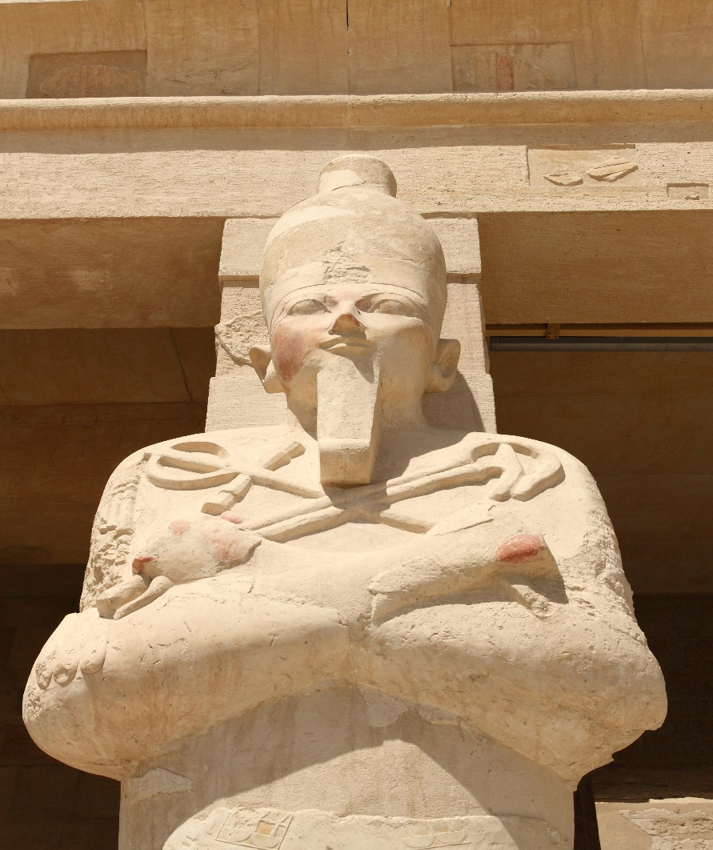

Check-In Questions:
1. What is a patriarchal society?
- Answer: A social system where men hold the most power and restrict women's lives and rights.
2. How were women in the ancient world affected by patriarchy?
- Answer: Women had few legal rights and were forced to depend on men.

Practice Questions:
1. Describe how women in Egypt were affected by patriarchal society using Hatshepsut as an example.
- Answer: Hatshepsut acted like a male ruler to maintain power, but after her death, her patriarchal society tried to erase her from history.
2. How is patriarchy present today?
- Answer: An example is women being paid less for the same jobs as men.

- The Structure and Stratification of Ancient Societies

Objective 3: Compare social structures in ancient Mesopotamia and Egypt.

Essential Question: How are societies structured?

Key Terms:
1. Social Hierarchy: A system where members of a community have unequal power.
2. Social Stratification: Separation of people based on their power and labor specialization.
3. Social Structure: Organization of people based on their social and economic power in a society.

Big Ideas:
- Social Stratification: Separation of people based on power and specialized roles, starting after the Neolithic Agricultural Revolution.
- Social Hierarchy: Rulers were at the top, followed by nobles, priests, merchants, artisans, farmers, and enslaved people.
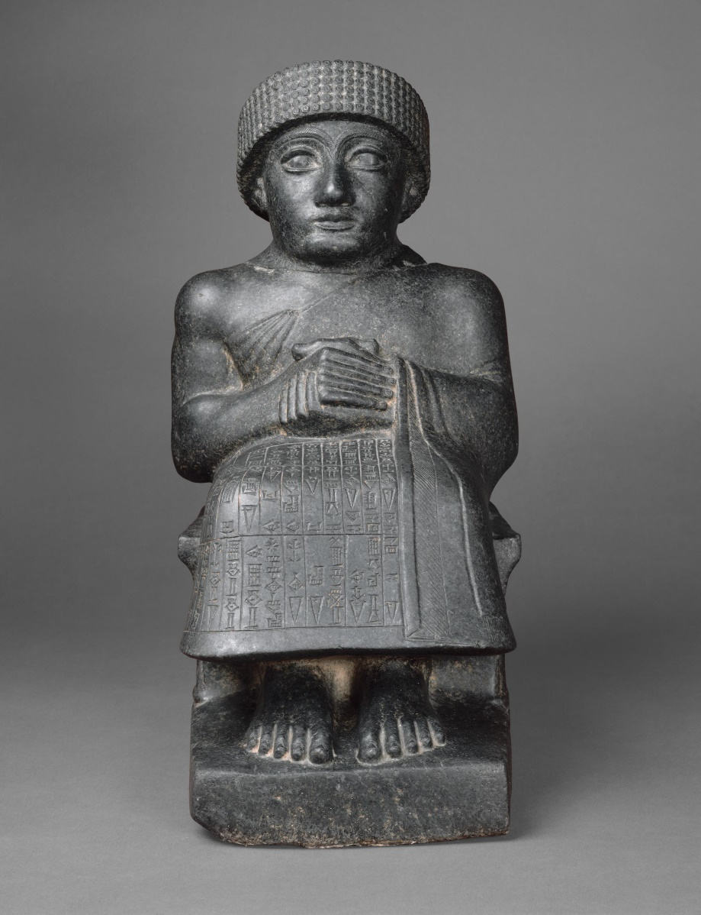
- Mesopotamia: The king, nobles, priests, middle class (soldiers, scribes, merchants), lower class (farmers, builders, artisans), and enslaved people.
- Egypt: Similar to Mesopotamia but with more integration of soldiers and priests in the middle class. Women had more rights in Egypt.
- Marriage and Family: Mesopotamian marriages were arranged, while Egyptian marriages were more private. Similarities included child-rearing and education.

Check-In Questions:
1. Describe the social structure and hierarchy of Mesopotamian society.
- Answer: King and nobles at the top, followed by priests, middle class (soldiers, scribes, merchants), lower class (farmers, builders, artisans), and enslaved people.
2. How can you access and evaluate information?
- Answer: Look for reliable sources like websites ending in .org, .gov, or .edu, written by experts, recent, and with diverse perspectives.
3. How did marriage customs differ between Mesopotamian and ancient Egyptian societies?
- Answer: Mesopotamian marriages were complex rituals with arranged property contracts, while Egyptian marriages were private and property agreements were separate.
4. How was childhood similar and different in ancient Egypt and Mesopotamia compared to today?
- Answer: Similar in play and schooling, but ancient children often started working life earlier.

Practice Questions:
1. Access a reliable source on Egyptian social class. Explain the reliability.
- Answer: Example: Britannica article, reliable due to academic authorship, accuracy, and recent publication.
2. Evaluate the claim that ancient Mesopotamian society was simple.
- Answer: It is inaccurate; I would question the source's expertise and evidence.

- Emerging Historical Perspectives

Objective 4: Compare multiple perspectives on the role of slavery in Mesopotamia and ancient Egypt.

Essential Question: How do different historical perspectives emerge?

Key Terms:
1. Chattel Slavery: The enslaving and owning of human beings and their children; in the system of chattel slavery, people were treated like livestock and families were enslaved for generations.
2. Prisoner of War: A person held prisoner by the enemy during wartime.
3. Slavery: When one human is the legal property of another.

Big Ideas:
  - Complexity of Slavery: Slavery in Mesopotamia and Egypt was more nuanced than previously thought. Enslaved people performed various jobs, including farming, construction, soldiering, and serving as tutors or entertainers.
  - Historical Perspectives: New research shows enslaved people could sometimes gain freedom and even hold valued positions within households.
  - Mesopotamia: Many enslaved were prisoners of war or people who sold themselves to pay debts. They had diverse roles and could buy freedom.
  - Egypt: The term "Hm" meant slave, servant, or laborer, complicating the understanding of slavery. Most enslaved were foreign captives or punished fugitives but could become free through adoption or marriage.
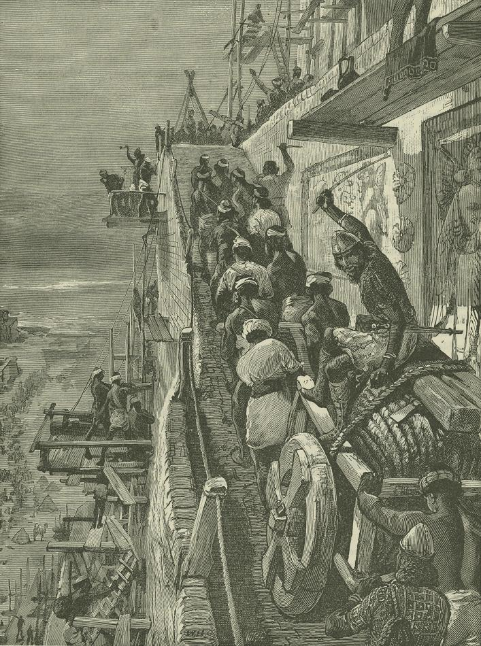

Check-In Questions:
1. What jobs did enslaved people hold in ancient Mesopotamia?
- Answer: Farmers, builders, soldiers, and various skilled roles.
2. What other meanings have historians begun to assign to the Egyptian word "Hm"?
- Answer: Laborer and servant, in addition to slave.

Practice Questions:
1. Compare two different perspectives on Mesopotamian slavery.
- Answer: Some believe benefits came from being part of a household, though others argue they were not treated as equals.
2. Explain an emerging perspective on Egyptian slavery.
- Answer: Translating "Hm" to laborer or servant shows enslaved people had roles similar to those of laborers and servants, but with fewer legal freedoms.

- Unit 3 Lesson 6: Introduction to the Mauryan Empire
- The Mauryan Empire

Objective 1: Identify trends and describe the origins and collapse of the Mauryan Empire using maps.

Essential Question: How can we use maps to identify trends and describe the origins and collapse of the Mauryan Empire?

Key Terms:
1. Alexander the Great: King of Macedonia who ruled over a large area of land from Europe to Asia.
2. Ashoka: The third ruler of the Mauryan Empire.
3. BCE: Shortening of “Before Common Era”; anything before the year 0 is deemed to be before the Common Era.
4. Chandragupta Maurya: First ruler of the Mauryan Empire.
5. Buddhism: A religion that started in India thousands of years ago; it is still practiced by millions of people worldwide.

Big Ideas:
- Origins After Alexander the Great: The Mauryan Empire began around 321 BCE after the death of Alexander the Great created a vacuum of power in the Indian subcontinent. Chandragupta Maurya seized this opportunity to establish the empire.
- Expansion Under Chandragupta and His Successors: Starting from the Punjab region, Chandragupta expanded the empire, which was further enlarged by his son Bindusara and his grandson Ashoka.
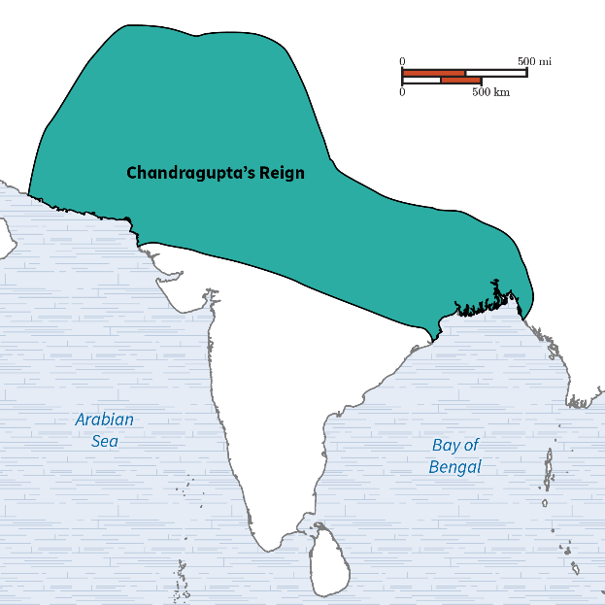
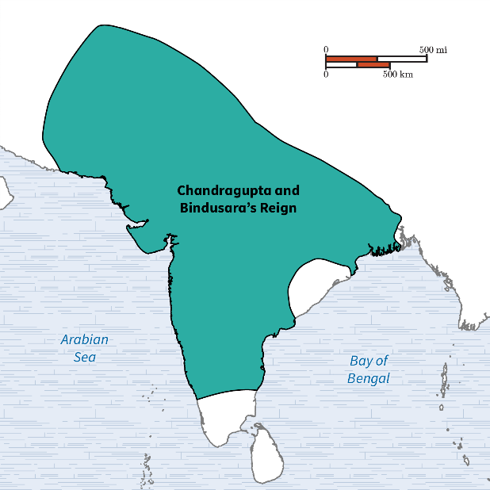
- Ashoka’s Reign and Buddhism: Ashoka, after expanding the empire, adopted Buddhism and promoted peace and learning. He spread Buddhism through edicts carved on stone pillars across the empire.
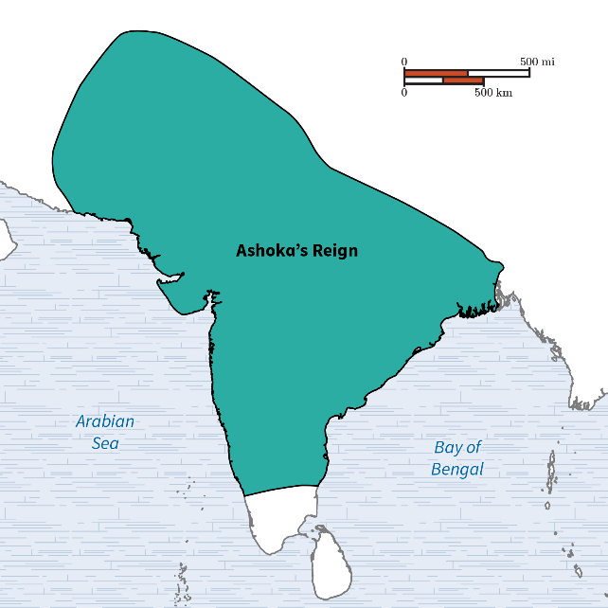
- Decline and Collapse: After Ashoka’s death, weaker kings led to the empire's decline. The final ruler, Brihadratha, was killed by his general, and with no heir to take over, the Mauryan Empire collapsed.
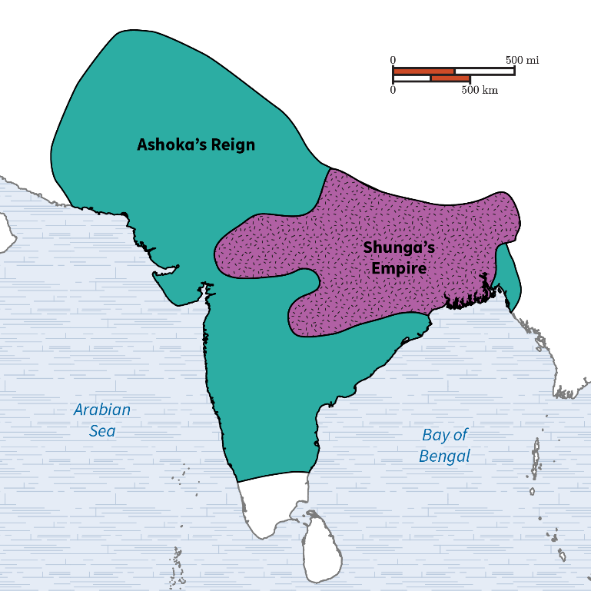

Check-In Questions:
1. After the end of Alexander the Great's reign, the Mauryan Empire began with what ruler?
- Answer: Chandragupta Maurya
2. What trend of the Ashoka rule changed the Mauryan Empire from military rule to peaceful rule?
- Answer: Buddhism

Practice Questions:
1. What caused the Mauryan Empire to collapse?
- Answer: The final Mauryan ruler was killed by his general, and there was no heir, leading to the empire's collapse.
2. What caused the Mauryan Empire to begin?
- Answer: The death of Alexander the Great weakened his empire, allowing Chandragupta Maurya to seize power in the Indian subcontinent.

- The Kushan Empire

Objective 2: Locate the Kushan Empire in South and Central Asia using maps.

Essential Question: How can we use maps to locate the Kushan Empire in South and Central Asia?

Key Terms:
1. Kushan Empire: An empire that controlled land in South and Central Asia in the 1st, 2nd, and 3rd centuries CE.
2. Silk Road: A web of trade routes connecting China with Europe.
3. Amu Darya: A major river in Central Asia.
4. Canal: A human-made way of moving water from one place to another.
5. Arid: Describes a dry climate with little rain.

Big Ideas:
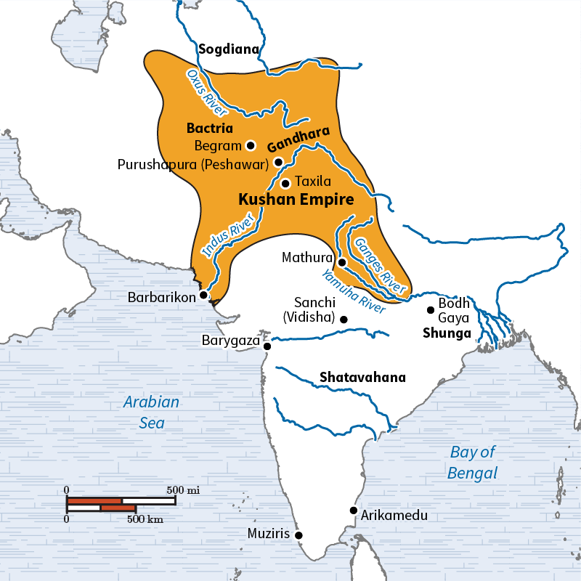

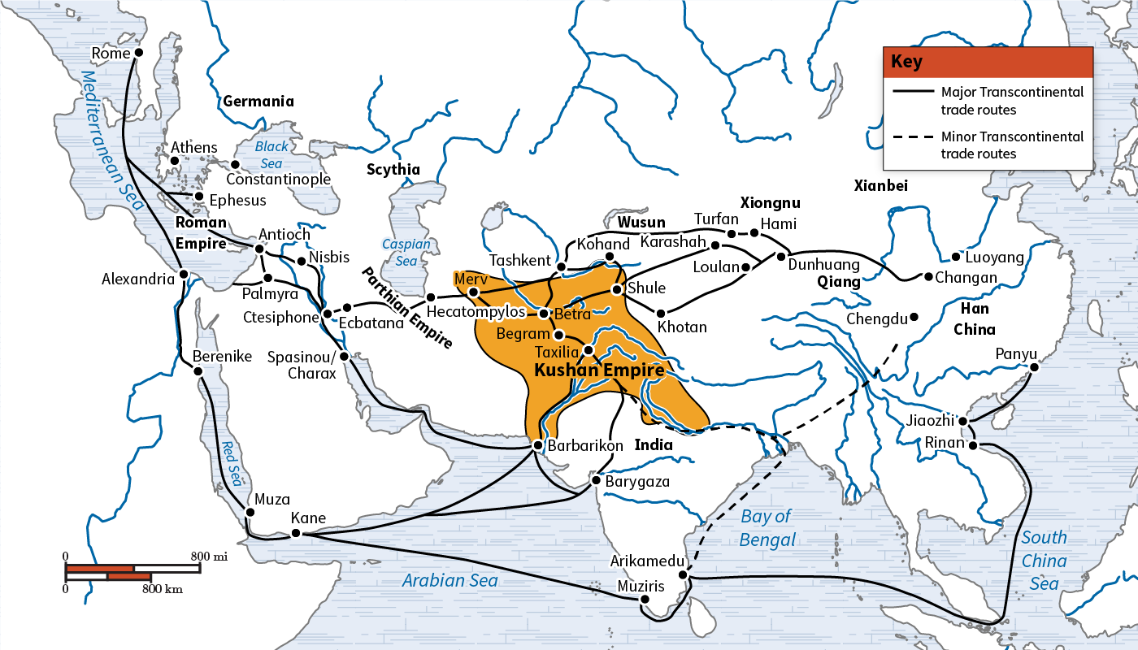
- Geographic Expansion: The Kushan Empire originated in northwestern China and expanded westward to regions like Gandhara. It thrived due to its strategic position in the middle of the Silk Road and proximity to major rivers like the Amu Darya and Syr Darya.
- Trade and Wealth: The empire's location on the Silk Road facilitated extensive trade, bringing wealth. Evidence of this includes gold coins bearing various deities and inscriptions from different cultures.
- Agriculture and Innovation: Though the region was arid, the Kushan people built canals to irrigate their farms, increasing arable land and allowing for significant agricultural production.
- Decline: Over time, as other empires grew stronger, the Kushan Empire weakened and eventually collapsed in the 3rd century CE.

Check-In Questions:
1. Where was the Kushan Empire located?
- Answer: The Kushan Empire was located in South and Central Asia.
2. What trade route ran through the Kushan Empire?
- Answer: The Silk Road

Practice Questions:
1. Why was trade important to the Kushan Empire?
- Answer: Trade brought wealth to the Kushan Empire, allowing it to prosper.
2. Why were canals important to the Kushan Empire?
- Answer: Canals allowed the Kushan Empire to grow more crops in an arid climate.

- The Gupta Empire

Objective 3: Summarize the rise and fall of the Gupta Empire in India using a secondary source.

Essential Question: How can we use a secondary source to summarize the rise and fall of the Gupta Empire?

Key Terms:
1. Gupta Empire: An empire that ruled over much of what is now the country of India from the early 4th to the late 6th centuries CE.
2. Bureaucracy: A type of government in which big decisions are made by employees of the government, rather than by people who are elected.
3. CE: Shortening of “Common Era”; anything after the year 0 is deemed to be in the Common Era.
4. Military: An armed, organized force used to fight wars.
5. Indian Subcontinent: A geographical region in South Asia composed of the modern-day countries of Pakistan, India, and Bangladesh.

Big Ideas:
- Rise of the Gupta Empire: The Gupta Empire started with Chandragupta I in 320 CE and expanded rapidly under his successors, including Samudragupta and Chandragupta II.
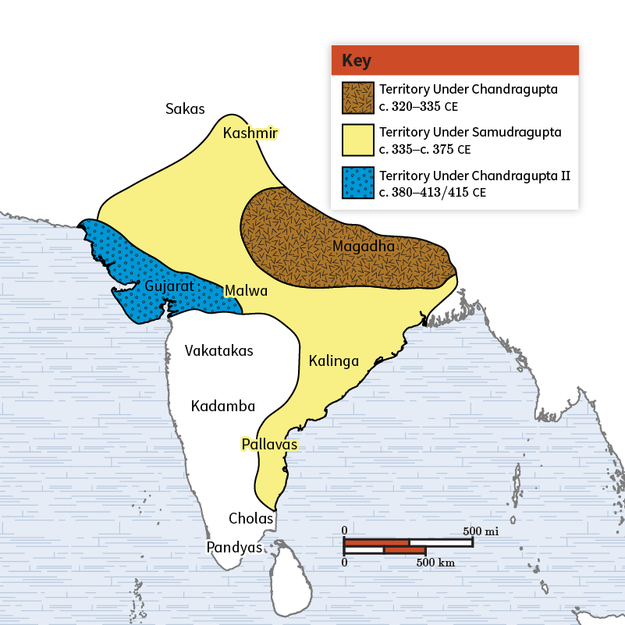
- Golden Age: The Gupta period is often considered a golden age for Indian culture, with significant advancements in literature, science, and art due to relative peace and prosperity.
- Strong Military and Bureaucracy: The Gupta rulers used a strong military and an effective bureaucracy to expand and maintain their empire.
- Decline: The Gupta Empire began to decline due to internal problems and external pressures from groups like the Pushyamitras and the Huns, eventually leading to its collapse.

Check-In Questions:
1. Identify two factors that helped lead to the rise of the Gupta Empire.
- Answer: The Gupta Empire had a strong military and an effective bureaucracy.
2. At its height, the Gupta Empire ruled over which parts of what is now the country of India?
- Answer: The Gupta Empire ruled over parts of what is now northern, central, and western India.
3. Which groups started wars with and partly caused the fall of the Gupta Empire?
- Answer: The Pushyamitras and the Huns

Practice Questions:
1. According to the secondary source, what encouraged advancements in literature, science, and art during the Gupta Empire?
- Answer: An era of relative peace and prosperity and a love of learning encouraged these advancements.
2. According to the secondary source, what caused the Gupta Empire to disintegrate?
- Answer: The Gupta Empire disintegrated due to internal problems and external wars against tribal peoples such as the Huns.

- The Safavid and Mughal Empires

Objective 4: Summarize the extent and development of the Safavid and Mughal Empires using a variety of sources.

Essential Question: How can we use maps to summarize the extent and development of the Safavid and Mughal Empires?

Key Terms:
1. Gunpowder: An explosive used in weapons such as guns and cannons.
2. Gunpowder Empires: A name given to the Safavid, Mughal, and Ottoman Empires as they used gunpowder in their military weaponry.
3. Islam: A monotheistic religion that developed in the Middle East around 600 CE.
4. Safavid Empire: An empire that ruled over land in modern-day Iran, Azerbaijan, Armenia, parts of Russia, Iraq, and Afghanistan.
5. Mughal Empire: An empire that ruled over land in modern-day Pakistan, India, and Bangladesh.

Big Ideas:
- Rise and Influence: Both empires rose to power during the early modern period, relying on strong militaries and gunpowder technology to expand their territories.
- Safavid Empire: Founded by Shah Ismail I in 1501 CE, ruling over parts of what are now Iran and surrounding areas until it collapsed in 1736 CE.
- Mughal Empire: Founded by Bābur in 1526 CE, it ruled over much of the Indian subcontinent until its decline in the 18th century due to internal strife and external invasions.
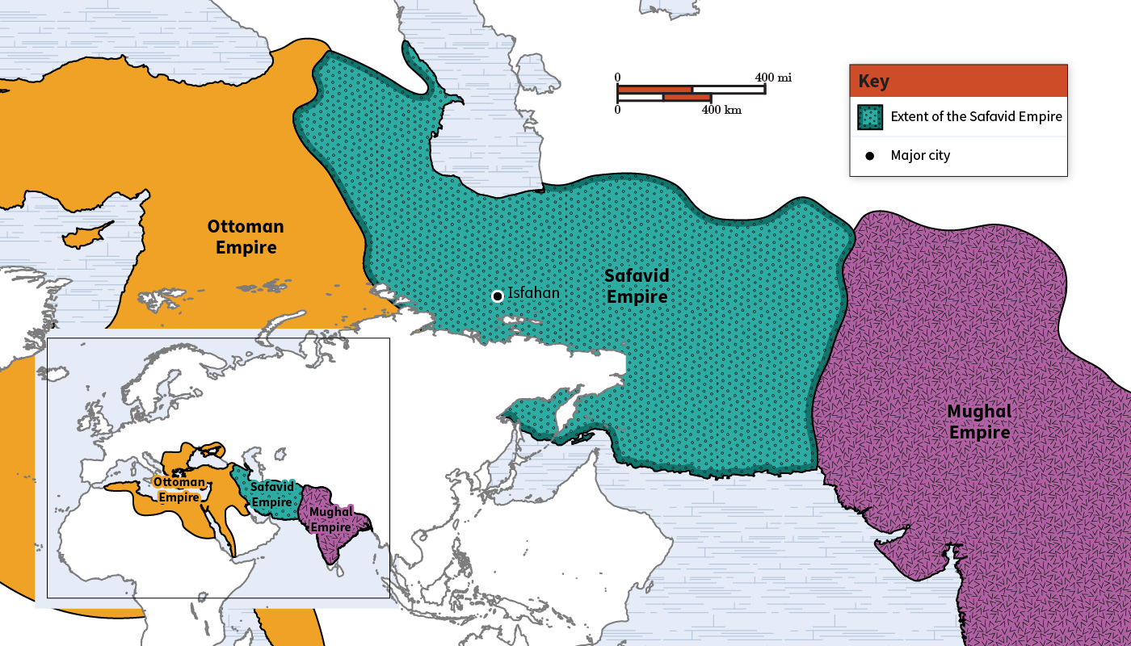
- Religious Influence: Both empires were Islamic, with the Safavid Empire following Shia Islam and the Mughal Empire primarily following Sunni Islam. The Mughals allowed religious diversity in their military.
- Military Technology: Both empires used gunpowder weapons to maintain and expand their territories, known collectively as the “Gunpowder Empires.”

Check-In Questions:
1. What military technology allowed the Safavid and Mughal Empires to gain control over such large areas of land?
- Answer: Gunpowder
2. What was the official religion of both the Safavid and Mughal Empires?
- Answer: Sunni Islam

Practice Questions:
1. At the height of its empire, which land areas did the Safavid Empire control?
- Answer: The Safavid Empire ruled over land in modern-day Iran, Azerbaijan, Armenia, parts of southern Russia, Iraq, and Afghanistan.
2. At the height of its empire, which land areas did the Mughal Empire control?
- Answer: The Mughal Empire ruled over land in modern-day Pakistan, India, and Bangladesh.

- Unit 3 Lesson 7: Dynasties
- The Unification of China

Objective 1: Examine the events that led to the rise and fall of the Zhou and Qin dynasties in China. Analyze the role geography played in their development.

Essential Question: What role did geography play in molding the rise and fall of dynasties in China?

Key Terms:
1. Confucianism: A philosophical system centered on virtue, education, and respect to achieve harmony.
2. Dynasty: Leadership of a country passed on over multiple generations, such as a monarchy or empire.
3. Feudal System: A system of landownership where a central authority grants land to individuals in exchange for tax revenue, crops, and soldiers.
4. Mandate of Heaven: A Chinese philosophy that a morally fair leader is chosen by the universe to be the "Son of Heaven."
5. Legalism: A political system based on appointing qualified individuals rather than those born into positions of leadership.

Big Ideas:
- Geographical Influence: Early Chinese civilizations formed along the Yellow River due to fertile land and the need to control water for agriculture, leading to larger populations and powerful leaders.
- The Shang Dynasty: Established the foundations of Chinese civilization with a feudal system and caste system, creating walled cities for protection.
- The Zhou Dynasty: Replaced the weakened Shang, utilized the Mandate of Heaven to justify rule, expanded irrigation, developed iron tools, centralized beliefs, and built roads.
- The Warring States Period: A time of conflict between states, leading to the development of philosophies like Confucianism, Taoism, and Buddhism.
- The Qin Dynasty: Unified China through military strength, centralized power, and a bureaucracy based on legalism. Began the construction of the Great Wall and created a common language.
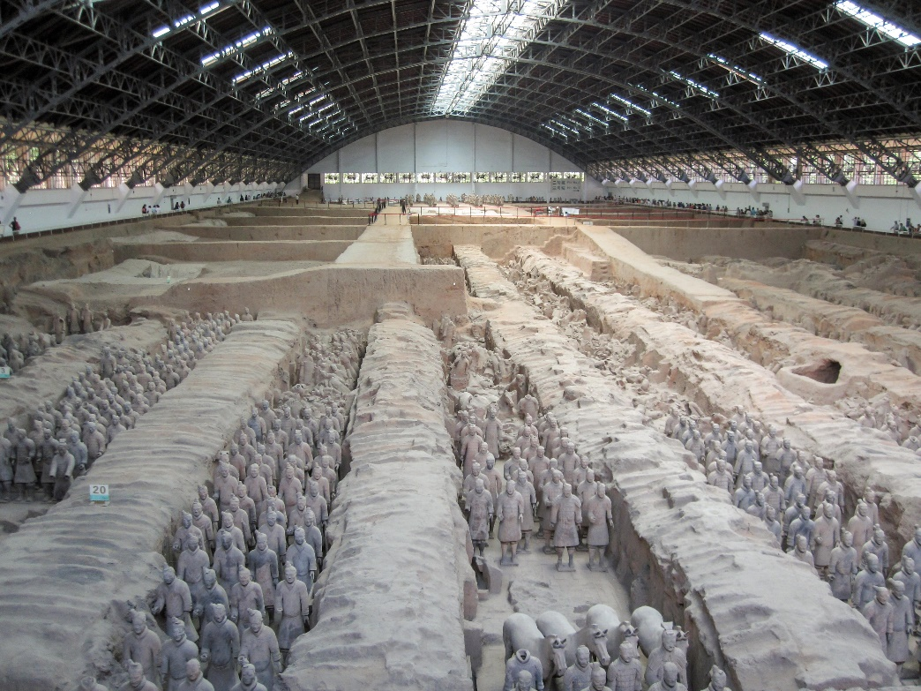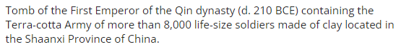

Check-In Questions:
1. Why did the early dynasties form near the Yellow River?
- Answer: The Yellow River provided irrigation for the crops that allowed people to settle in the area and eventually establish city-states.
2. Explain why it was challenging for power to be centralized in ancient China.
- Answer: There were many different city-states with their own leaders competing over resources, especially control of water from rivers.

Practice Questions:
1. Explain the role of geography in the expansion and unification of China.
- Answer: The Zhou dynasty began along the Yellow River because of the fertile ground. They controlled the river flow to irrigate crops, feeding the empire.
2. Describe how the fall of the Zhou dynasty led to the formation of the Qin dynasty.
- Answer: As the Zhou dynasty weakened, city-state rulers fought for territory control. The Qin dynasty took advantage with a powerful military to unify the area.

- The Impact of the Zhou and Qin Dynasties

Objective 2: Use historical information to explain the impact of the Zhou and Qin dynasties on China by analyzing, categorizing, and comparing their achievements in technology, politics, and culture.

Essential Question: How did the Zhou and Qin dynasties’ advancements in technology, politics, and culture impact the development and expansion of China in terms of territory and influence?

Key Terms:
1. Bureaucracy: A system of government with appointed officials making important decisions rather than elected representatives.
2. City-State: An independent city that controls the surrounding area.
3. Crossbow: A bow that shoots horizontally, with a mechanism that shoots projectiles down a wooden groove by releasing a string.
4. Mandate of Heaven: A Chinese philosophy that it is the natural order for a morally fair leader to be chosen by the universe.
5. Standardized: A widely accepted form of measurement or quality; a universally used system.

Big Ideas:
- Zhou Dynasty Achievements: Developed irrigation technology, centralized belief systems, used iron for tools and weapons, created roads, and expanded the writing system.
- Qin Dynasty Reforms: Centralized power by replacing local rulers with loyalists, created a common language and written records, standardized weights, measures, and currency, and expanded the Great Wall.
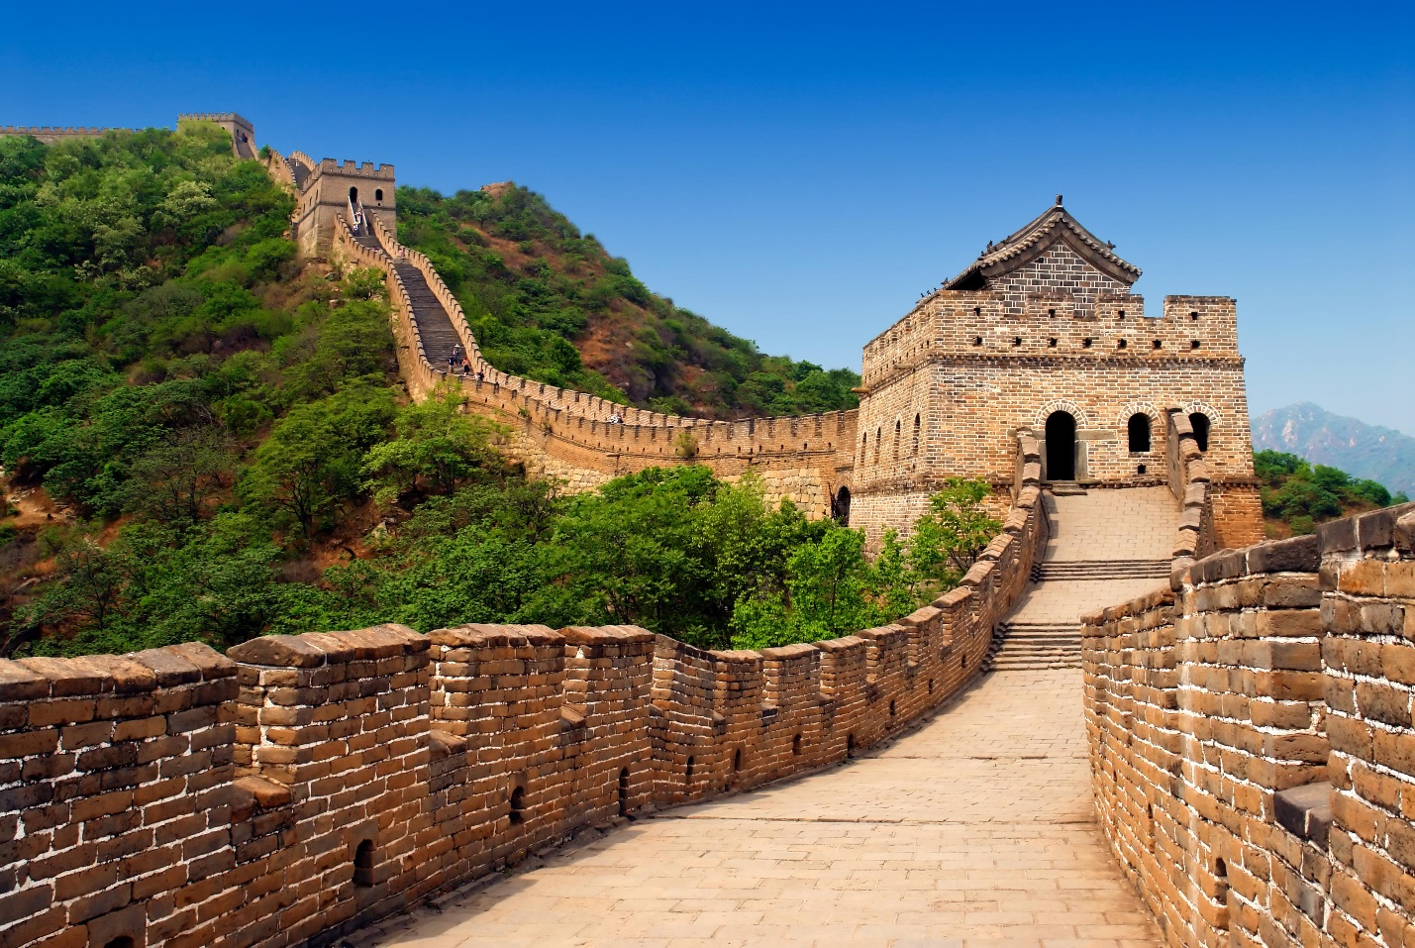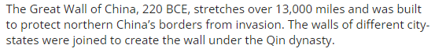
- Cultural Integration: Both dynasties worked towards a unified cultural identity through shared language, religious practices, and government systems.
- Military Advances: Qin dynasty used advanced weaponry like the crossbow and cavalry to expand and protect the empire.
- Philosophical Developments: Confucianism, Taoism, and Buddhism emerged during the Warring States period, focusing on peace, respect, and balance.

Check-In Questions:
1. What is the mandate of heaven?
- Answer: A Chinese philosophy claiming that a morally fair leader is chosen by the universe to be the "Son of Heaven."
2. Describe one philosophy that developed out of the Warring States period.
- Answer: Confucianism emphasizes peace through balance and education. Taoism focuses on harmony in nature. Buddhism aims for inner peace.

Practice Questions:
1. Describe how the development of a written language helped create a Chinese cultural identity.
- Answer: A written language allowed people to record history, laws, and culture, making this information available across regions and generations.
2. Using historical evidence about the Zhou dynasty, explain why it was able to last for 700 years.
- Answer: The Zhou dynasty made advances in language, utilized the mandate of heaven to justify rule, and unified culture by centralizing practices and beliefs.

- Contributions of the Han and Tang Dynasties

Objective 3: Identify contributions in technology, science, and mathematics made by the Han and Tang dynasties and their impact on the development of China and its relationships with other regions.

Essential Question: How did the Han and Tang dynasties lead to the expansion of China’s trade networks and influence throughout Asia and eventually Europe?

Key Terms:
1. Silk Road: A network of trade routes connecting China to Asia, Europe, and North Africa.
2. Bureaucracy: A system of government with appointed officials making important decisions rather than elected representatives.
3. Meritocracy: A system of government based on education or merit.
4. Voucher: A paper that can be exchanged for goods; credit.
5. Junk: A ship from the Han and Tang dynasties in China with sails, a stern rudder for steering, and oars.

Big Ideas:
- Han Dynasty Expansion: Grew territory through military means and the Silk Road, spreading culture, technology, and trade networks.
- Technological and Scientific Advances: Developed paper, the compass, a new plow, the wheelbarrow, and water-powered mills, increasing productivity and trade.
- Tang Dynasty Success: Utilized advancements in transportation, established a meritocracy, built the Grand Canal connecting north and south, and promoted education with movable typeprint.
- Cultural Legacy: Introduced the banking system, credit, standard currency, and gunpowder, influencing global trade and military technology.
- Silk Road Impact: Connected China globally, introducing new cultures, technologies, and facilitating trade, leading to a lasting Chinese influence.
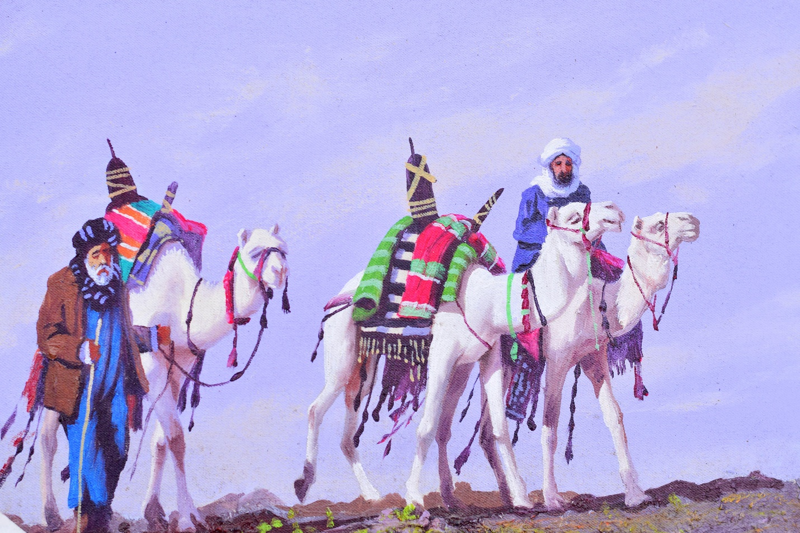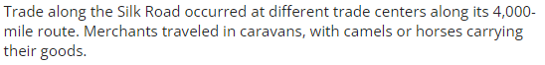

Check-In Questions:
1. What was the Silk Road in Ancient China?
- Answer: A series of trade routes that connected China with the rest of Asia, Europe, and North Africa, introducing China to new cultures, resources, and innovations.
2. Why was the invention of paper so important?
- Answer: Paper allowed more people to become educated because it was easier to produce and lighter than silk, facilitating the recording of laws, sales, taxes, and history.

Practice Questions:
1. Describe the impact of the development of vouchers during the Tang dynasty.
- Answer: Vouchers made it easier for merchants to travel safely without carrying currency, which reduced the risk of theft and streamlined trade.
2. What was one government policy that made the Tang dynasty more successful than the Han dynasty?
- Answer: The Tang dynasty taxed both nobles and farmers, created a standardized coinage for trade, and supported policies that extended the waterway systems, facilitating trade and reducing wealth gaps.
3. Identify how gunpowder diffused from China to Europe.
- Answer: The Mongols adopted it and used it in warfare throughout Asia, eventually introducing it to Europe.

- Emperor Wudi and His Impacts

Objective 4: Analyze the impact of Emperor Wudi’s changes on China and how politics, and culture can be influenced by historical events. Explain how changes in belief systems, economics, and values can steer a country in different directions.

Essential Question: How did Emperor Wudi of China’s Han dynasty impact politics, values, and beliefs beyond his time in power?

Key Terms:
1. Silk Road: A network of trade routes connecting China to Asia, Europe, and North Africa.
2. Bureaucratic: Having an organized division of labor.
3. Conscription: Government-required military or state service.
4. Granary: A place for storing large amounts of grain.
5. Alchemist: A person who mixes or manipulates different materials to create something with healing or mystical powers.

Big Ideas:
- Expansion through Warfare: Emperor Wudi expanded China through military conquest, reaching Korea, Vietnam, and northern India, and extending the Silk Road.
- Economic Policies: Implemented taxes on nobles, controlled currency, and monopolized key industries like salt and iron to fund military endeavors.
- Technological Advancements: Enhanced farming with new plows and horse harnesses, built granaries, and developed the junk for efficient transportation.
- Cultural Integration: Established the Confucian Academy, promoted written records, standardized laws, and created a shared Chinese cultural identity.
- Decline and Legacy: Overextended military campaigns led to financial strain, Wudi’s obsession with alchemy and immortality, and paranoia about assassinations undermined stability. His policies influenced modern governance, trade, and cultural practices.
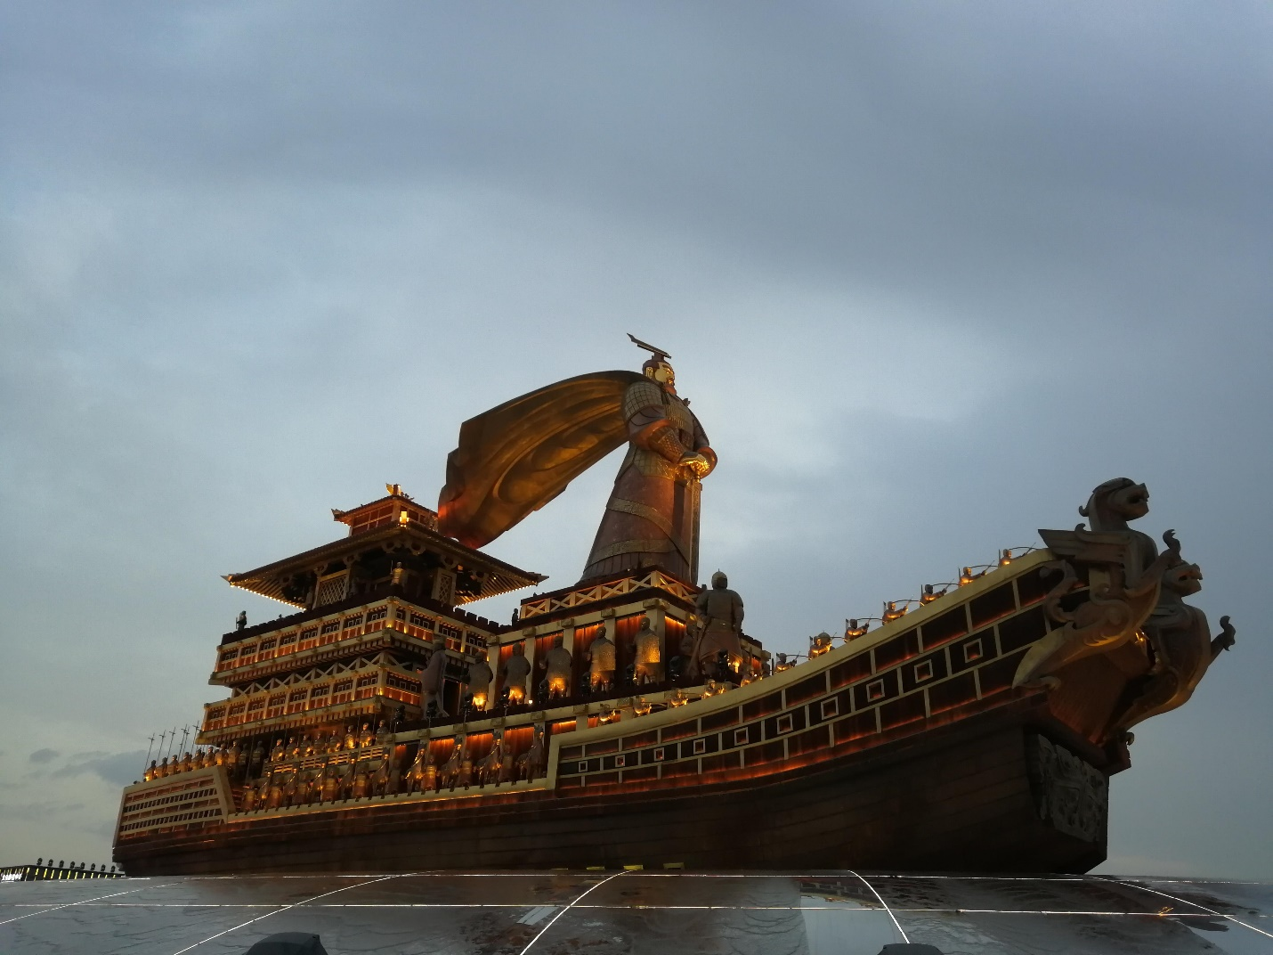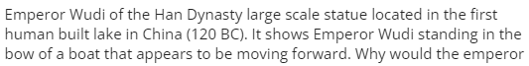
Check-In Questions:
1. List one cause for the decline of Emperor Wudi’s power.
- Answer: His power declined due to growing expenses to fund the military, his superstitions about assassinations, and distractions from his desire to live forever.
2. What was the code of conduct for women?
- Answer: Women were expected to be humble, subservient to their husbands, and caretakers of the family per Confucian hierarchical principles.

Practice Questions:
1. Describe one of Emperor Wudi’s policies that influenced modern-day political systems.
- Answer: The Confucian principle of merit over heredity, where power and influence are earned based on ability rather than family background, influences modern governments.
2. Analyze the impact of the junk’s technological advancements on Chinese trade and how it influenced future travel in other parts of the world.
- Answer: The junk's design allowed for carrying large cargoes over long distances, improving trade efficiency and wealth. Its technology influenced European ship designs, aiding in their exploration and trade expansion.

- Unit 3 Lesson 10: Religion and Belief Systems
- Religious Traditions of the Indian Subcontinent

Objective 1: You will describe the beliefs and traditions of Hinduism and Buddhism and how they spread.

Essential Question: What are the beliefs and traditions of Hinduism and Buddhism?

Key Terms:
1. Hinduism - Eastern religion, originating in India; a diverse set of religious practices that aim to help the soul rejoin Brahman or ultimate reality.
2. Buddhism - Eastern religion, prominent in India and across East and Southeast Asia, that seeks to understand the true sources of suffering and the method to eliminate them, the Four Noble Truths.
3. Brahman - In Hinduism, the ultimate reality, source, and purpose of all spiritual understanding.
4. Buddha - Any “enlightened one,” but generally referring to Prince Siddhartha Gautama, whose teachings are the primary source of Buddhism.
5. Four Noble Truths - In Buddhism, a summary of the causes of suffering and the method of eliminating them.

Big Ideas:
- Hinduism and Buddhism's Roots:
- Both Hinduism and Buddhism originated in the Indian subcontinent. Hinduism is the oldest of the major world religions and began as an oral tradition prior to the 15th century BCE. Buddhism began in the 5th century BCE with Prince Siddhartha Gautama’s journey to understand and end human suffering.

- Hindu Beliefs and Practices:
- Hinduism’s core idea revolves around rejoining the soul with Brahman, the ultimate reality. Practices include serving others, worshipping gods, meditating, and reincarnation, where the soul is reborn until reunited with Brahman. 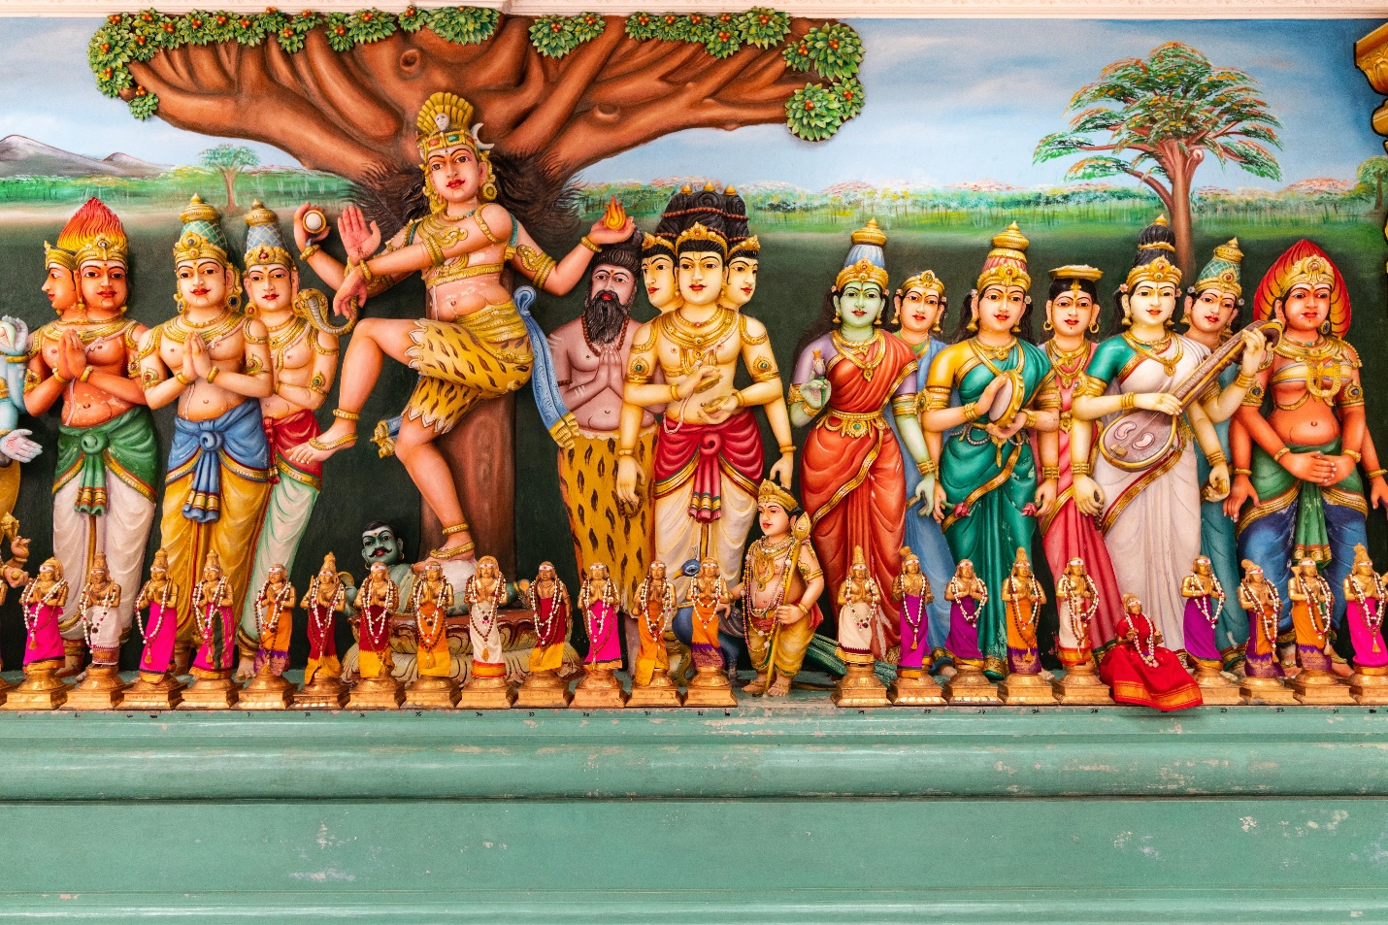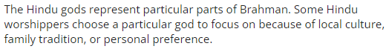

- Buddhist Beliefs and Practices:
- Buddhism focuses on understanding and ending suffering through the Four Noble Truths. These truths explain the causes of suffering and how to eliminate them. Buddhism rejects the caste system, promoting that anyone can achieve enlightenment.

- Spread and Influence:
- Hinduism and Buddhism spread throughout the Indian subcontinent and into other parts of Asia. As they spread, they adapted to local cultures, resulting in various forms of these religions around the world.

Check-In:
1. What are the Vedas?
- Answer: The Vedas are a collection of ancient Hindu scriptures consisting of poetry, stories, directions for religious practices, and philosophical essays.
2. In Hinduism, what is the relationship between the individual and Brahman?
- Answer: The soul of the individual needs to be reunited with Brahman in order to be released from the cycle of reincarnation.
3. Describe how the spread of Hinduism and Buddhism had an influence on other cultures.
- Answer: As the Hindu and Buddhist religions spread into other parts of Asia, they influenced other cultures by resulting in new forms of these religions through the blending of practices.

Practice:
1. Describe the three major components of the Hindu religion.
- Answer: One practice is living a good life in service to others. The second type of practice is worshipping aspects of Brahman that represent parts of reality. The third practice is using meditation to perceive reality.
2. Describe the reason Siddhartha Gautama, who started Buddhism, decided to live without desire but with compassion.
- Answer: He did not want to create suffering for himself or others.
3. Why did the Buddha call his method “the middle path”?
- Answer: He did not find happiness through luxury or physical deprivation, but in between them, through compassion without desire.
4. Why do religions change as they spread?
- Answer: When people learn about a new religion, they may blend it with their own culture.
5. What is one aspect of Hindu tradition that has spread to people who do not necessarily consider themselves Hindus?
- Answer: Yoga is an originally Hindu tradition that has spread throughout the world. Many people practice yoga as a system of physical exercises without necessarily believing in Hindu theology or reincarnation.
6. How does migration influence the spread of religious traditions?
- Answer: As people migrate around the world, they often take their religious traditions with them and pass them on to their children. They may also encourage others to join their religion through preaching and missionary work.

- Asoka Spreads Buddhism

Objective 2: You will explain Asoka’s role in the diffusion of Buddhism throughout Asia.

Essential Question: How did Asoka help Buddhism to spread through Asia?

Key Terms:
1. Asoka chakra - A Buddhist symbol of a wheel with 24 spokes that appears on many monuments erected by Asoka and also on the modern flag of India.
2. Buddha - Any “enlightened one,” but generally referring to Prince Siddhartha Gautama, whose teachings are the primary source of Buddhism.
3. Edict - An official order or rule given by someone with a lot of power.
4. Mauryan Empire - An empire that ruled parts of the Indian subcontinent from 321 to 185 BCE.
5. Stupa - A Buddhist shrine or monument containing relics.

Big Ideas:
- Asoka's Life:
- Asoka was the third ruler of the Mauryan Empire from about 279 to 232 BCE. He was initially warlike but had a dramatic change of heart after the brutal Kalinga War, leading to his conversion to Buddhism.

- Spread of Buddhism:
- After converting to Buddhism, Asoka sent emissaries and missionaries, including his own children, to spread Buddhist teachings. He also built numerous monuments and carved edicts to promote Buddhist principles.

- Asoka's Monuments:
- Asoka created pillars and stupas across his empire. These monuments carried messages of compassion and apologies for past wars, helping to spread Buddhism. 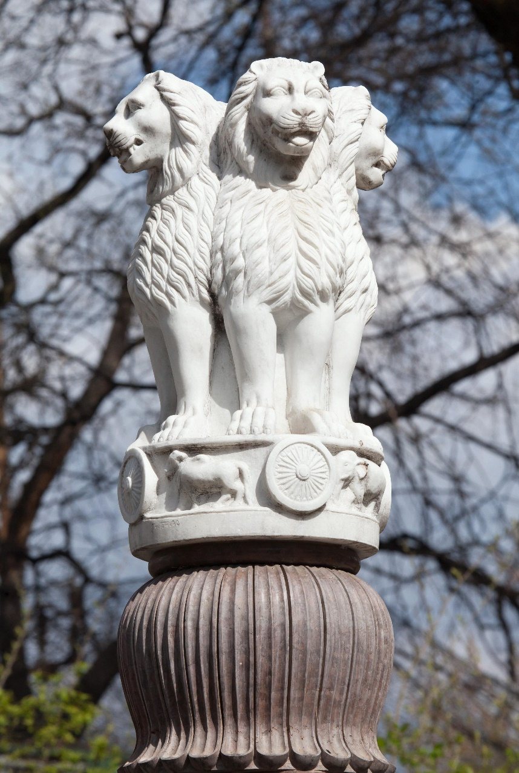

- Modern Influence:
- Symbols from Asoka’s time, such as the Asoka chakra and the Lion capital, continue to be important in modern India, appearing on the national flag and money.

Check-In:
1. Describe how Asoka spread Buddhist teaching throughout the Mauryan Empire.
- Answer: Asoka sent out emissaries and carved edicts into stone monuments about the teachings of the Buddha.
2. In what ways is Asoka’s influence represented in modern India?
- Answer: Images from his monuments, like the Asoka chakra and the Lion capital, appear on Indian money and on the flag of India.

Practice:
1. Describe how the war for Kalinga had an impact on Asoka and on the spread of Buddhism.
- Answer: It is after this war that Asoka changes his ways and starts to build monuments. These monuments apologize for the massacre and spread the teachings of the Buddha throughout the Mauryan Empire.
2. Create a timeline that shows major events from the time the Great Stupa was built until the present day.
- Answer:
- Second century BCE: Great Stupa built by Asoka
- Twelfth century CE: Site was abandoned
- 1818: Site documented by British General Henry Taylor; restoration work begins
- 1919: Restoration work completed
- 1989: Sanchi becomes a UNESCO World Heritage site
3. Describe how the spread of Buddhist teachings influenced the policies of Asoka.
- Answer: Because Buddhism emphasizes nonviolence, Asoka’s encounter with Buddhist teachings made him less warlike. Instead of attempting further conquests, he started to focus on building infrastructure that would benefit the common people, such as wells and rest houses.

- China's Philosophical Religions

Objective 3: You will describe the origins, beliefs, and culture of Confucianism and Taoism using a variety of sources and interpretations.

Essential Question:
What are the origins and beliefs of Confucianism and Taoism?

Key Terms:
1. Confucianism - An Eastern religion and philosophy developed from the writings of Master Kong and concerned with improving society through virtuous living.
2. Taoism (Daoism) - An Eastern religion and philosophy developed from ancient Chinese concepts of balance and harmony with nature.
3. Oracle - A person, often a priest or priestess, through whom a god or gods are believed to send messages or advice.
4. Wu wei - The Taoist concept of acting in alignment with nature in order to accomplish much with little effort.
5. Yin-yang - The Taoist concept of balance where opposites like dark and light, fast and slow, hard and soft, act together to create the living processes of nature.

Big Ideas:
- Confucianism:
- Confucianism is focused on social stability and virtuous behavior. Master Kong (Confucius) emphasized the importance of living a moral and virtuous life to improve society.

- Taoism:
- Taoism is centered around living in harmony with nature. The balance of opposites, symbolized by yin-yang, and the principle of wu wei (effortless action) are key concepts.

- Religions or Philosophies?:
- Both can be seen as religions by some and philosophies by others. The reverence for these ideas has led to temples and rituals, though not necessarily involving worship of gods.

- Impact and Spread:
- Confucianism and Taoism influenced various aspects of Chinese culture and government. They spread to neighboring countries like Korea and Japan, blending with local beliefs.

Check-In:
1. What two things was Master Kong most concerned with?
- Answer: Social stability and virtuous behavior.
2. When did Daoism become a religion?
- Answer: By the fifth century, Daoists began to worship the writer Laozi as a god.

Practice:
1. Describe Master Kong’s teaching about the relationship between rulers and subjects.
- Answer: Master Kong believed that rulers should care for subjects the way a parent cares for children. Subjects should then give the ruler respect and loyalty as a child would give their parent.
2. Explain the Daoist principle of wu wei.
- Answer: Wu wei means “non-doing.” This principle is about action through nonaction or “effortless action." This means acting in cooperation with nature to accomplish more with less effort.

- Achieving Social Stability

Objective 4:
You will analyze the role of Confucianism, Taoism, and Legalism in Chinese civilization and culture. You will evaluate how the resulting social structures have impacted Chinese society.

Essential Question:
How did Confucianism, Daoism, and Legalism impact Chinese society?

Key Terms:
1. Confucianism - An Eastern religion and philosophy developed from the writings of Master Kong and concerned with improving society through virtuous living.
2. Legalism - The doctrine in Chinese philosophy that political order should be established by a strong central government that creates strict laws and standards enforced by rewards and punishments.
3. Mandate of Heaven - The belief in Chinese philosophy that rulers were entitled to keep their power because of their ability to be a successful bridge between heaven, earth, and humanity.
4. Taoism - An Eastern religion and philosophy developed from ancient Chinese concepts of balance and harmony with nature.
5. Warring States period - A period in ancient Chinese history (475–221 BCE) in which several smaller states or kingdoms fought for power and control of what is now the modern country of China.

Big Ideas:
- Warring States Period and Philosophies:
- The sixth to third century BCE saw political instability in China, leading to the development of Confucianism, Daoism, and Legalism as ways to achieve social stability.

- Confucianism:
- Focused on social stability through virtuous behavior and education. Government officials were expected to set a good example for society.

- Daoism:
- Emphasized harmony with nature and wu wei (effortless action). It influenced various aspects of Chinese culture, including traditional medicine.

- Legalism:
- Believed in strict laws and harsh punishments to maintain order. It was used by the Qin dynasty to centralize power and build a strong military.

- Han Dynasty Synthesis:
- The Han dynasty combined the best ideas from these philosophies to create a stable society. They used Confucianism for moral education, Legalism for laws, and Daoism for governing in harmony with nature.

- Mandate of Heaven:
- The belief that rulers could keep their power as long as they provided social stability and acted as a bridge between heaven, earth, and humanity.

Check-In:
1. How was Legalism used in the Qin empire?
- Answer: The Qin empire used Legalist principles to centralize power and impose a set of strict laws with rewards and punishments.
2. What is the mandate of heaven?
- Answer: The mandate of heaven means that rulers are entitled to keep their power because of their ability to create social stability and be a bridge between heaven, earth, and humanity.

Practice:
1. Search online for more descriptions of Emperor Zheng and the Qin dynasty. What aspects of Qin rule, when analyzed, could support the claim that they had lost the mandate of heaven?
- Answer: In the later years of his rule, Emperor Zheng became obsessed with finding a way to become immortal. He died searching for a magical elixir. After his death, the Qin court was overtaken by political infighting. This led to more executions. Revolt soon broke out. This instability and social unrest could indicate that the Qin had lost the mandate of heaven.
2. How can the concept of wu wei be applied to government?
- Answer: By making laws that are in line with natural human dispositions, the government could ensure people would naturally follow the laws. These types of laws would allow the government to practice nonaction because they would not need to enforce the laws.

- Unit 3 Lesson 11: Impacts of Trade
- Traveling the Trade Routes

Objective 1:
You will explain how the Silk Road, Indian Ocean, and other trade routes aided in the transfer of products, ideas, and religions.

Essential Question:
How do trade routes transport more than products?

Key Terms:
1. Crusades - A series of military and religious movements by Europeans seeking to conquer Muslim lands associated with the life of Jesus and expand Christianity.
2. Ortaq system - A trade practice that paired a Mongol elite or government official with a merchant traveling the Silk Road trade route.

Big Idea:
- Reach of the Trade Routes:
- Trade routes like the Silk Road and Indian Ocean connected multiple continents, allowing for the exchange of products, ideas, and religions. Historians use maps, travel accounts, and archaeological finds to understand these connections.
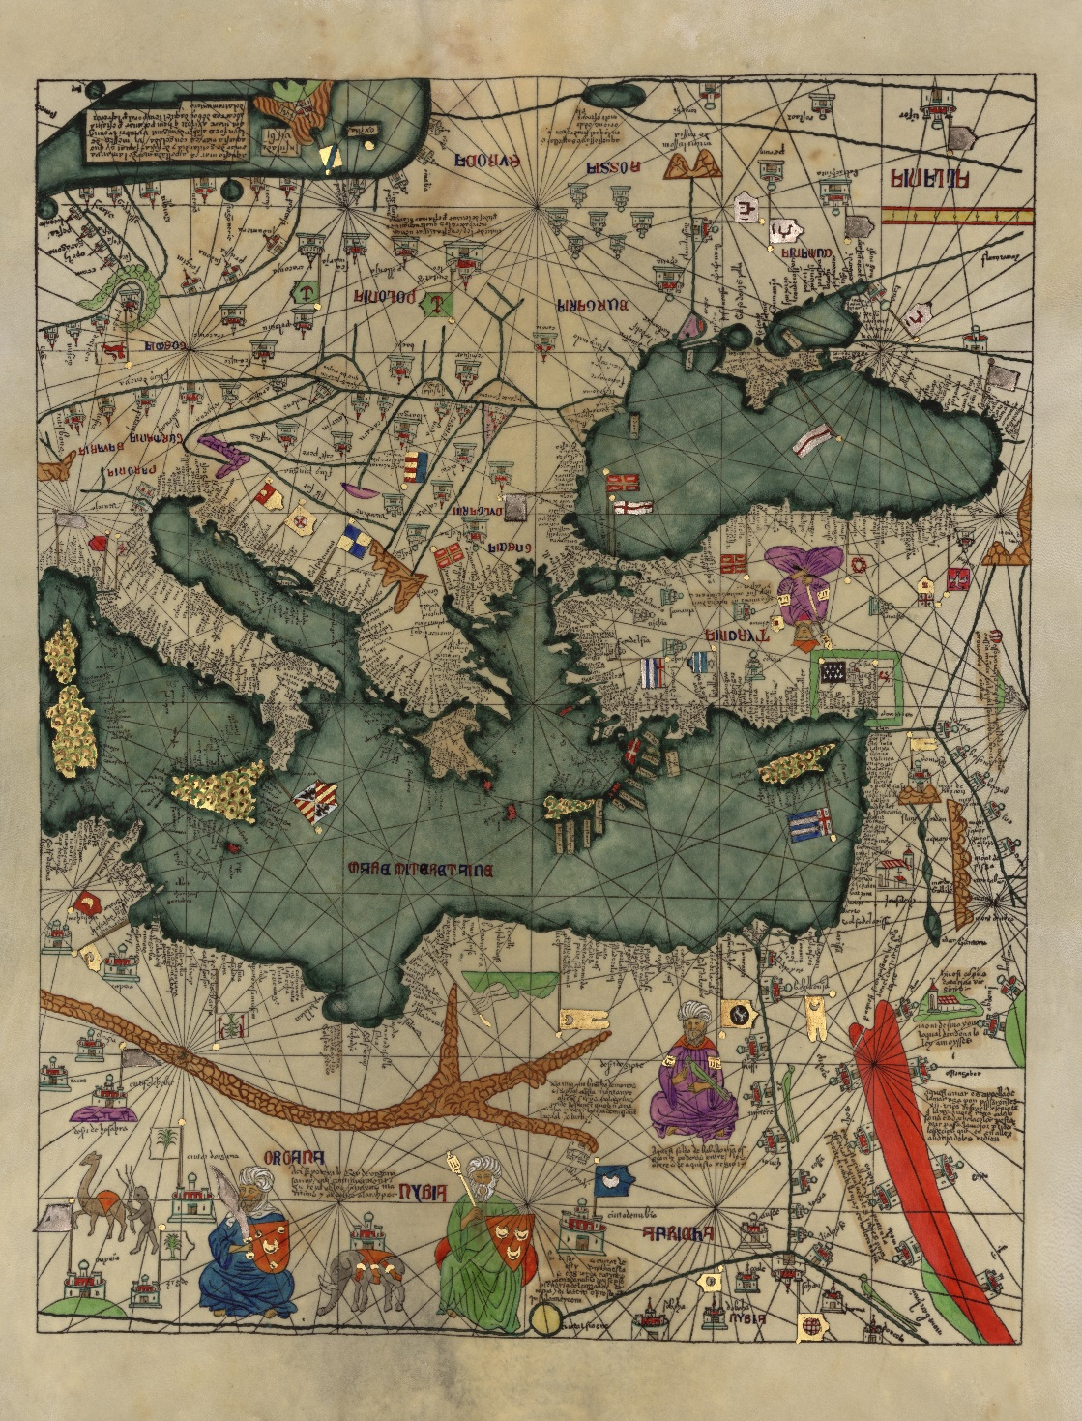
- How Merchants Traveled:
- Merchants faced varying challenges depending on political climates. The Mongol ortaq system facilitated safer trade along the Silk Road by ensuring merchants had protection and logistical support, encouraging cross-cultural interactions.

- Evolution of Routes:
- Trade routes evolved as political climates shifted. New routes emerged when old ones became unsafe or inaccessible, such as when the Song Dynasty turned to the Indian Ocean route after losing access to the Silk Road.

- Transfer of Products and Ideas:
- Trade facilitated the exchange of not only goods but also ideas and religions. Even during conflicts like the Crusades, trade continued as merchants from different cultures interacted, spreading their beliefs.

Check-In:
1. In what ways did the Mongols promote trade?
- Answer: They promoted trade through the ortaq system, which paired Mongol elites and government officials with merchants, making the trade route safer and encouraging cross-cultural interaction.
2. In what ways did conflict encourage the use of new trade routes for the Song dynasty?
- Answer: Conflict forced the Song Dynasty to seek new trade routes when old paths became dangerous or inaccessible, such as shifting focus to the Indian Ocean after losing control of Northern territories.

Practice:
1. Search online for archaeological evidence and artifacts found on either the Silk Road or the Indian Ocean. What does archaeological evidence tell us about the trade routes and about how historians and archaeologists use and manage this information to form conclusions?
- Sample answer: Archaeological evidence, such as tombstones and graves of Sumatran kings, shows that Islam was practiced in the Philippines as early as the 13th century. Historians use such evidence to confirm the presence of cultural exchange on trade routes.
2. Search online to locate maps of the Silk Road and Indian Ocean trade routes. Identify some geographical regions discussed in the lesson and explain how ideas and faiths were able to spread so easily across distances and cultural barriers.
- Sample answer: The Indian Ocean borders Asia, Africa, and the Middle East, enabling easy travel between these regions. This facilitated the spread of ideas and faiths, such as Islam spreading through interactions between Muslim traders and local communities.

- Trade Between Ocean and Land

Objective 2:
You will analyze how trade along the Silk Road and Indian Ocean routes influenced the cultural exchange, economies, and politics of early civilizations.

Essential Question:
How did trade along the Silk Road and Indian Ocean routes affect the economies and shape the cultures of ancient and medieval societies?

Key Terms:
1. Black Death - A pandemic that swept through Asia, Africa, and Europe between 1346–1353, killing between 75 million and 200 million people; also known as the bubonic plague.

Big Idea:
- Effect of Trade on Ancient Economies and Policy:
- Trade routes like the Silk Road and Indian Ocean routes created wealth and power for civilizations, such as the Roman Empire, which gained luxury goods like pearls. Increased wealth resulted in more demand for exotic products and policies that supported trade expansion. 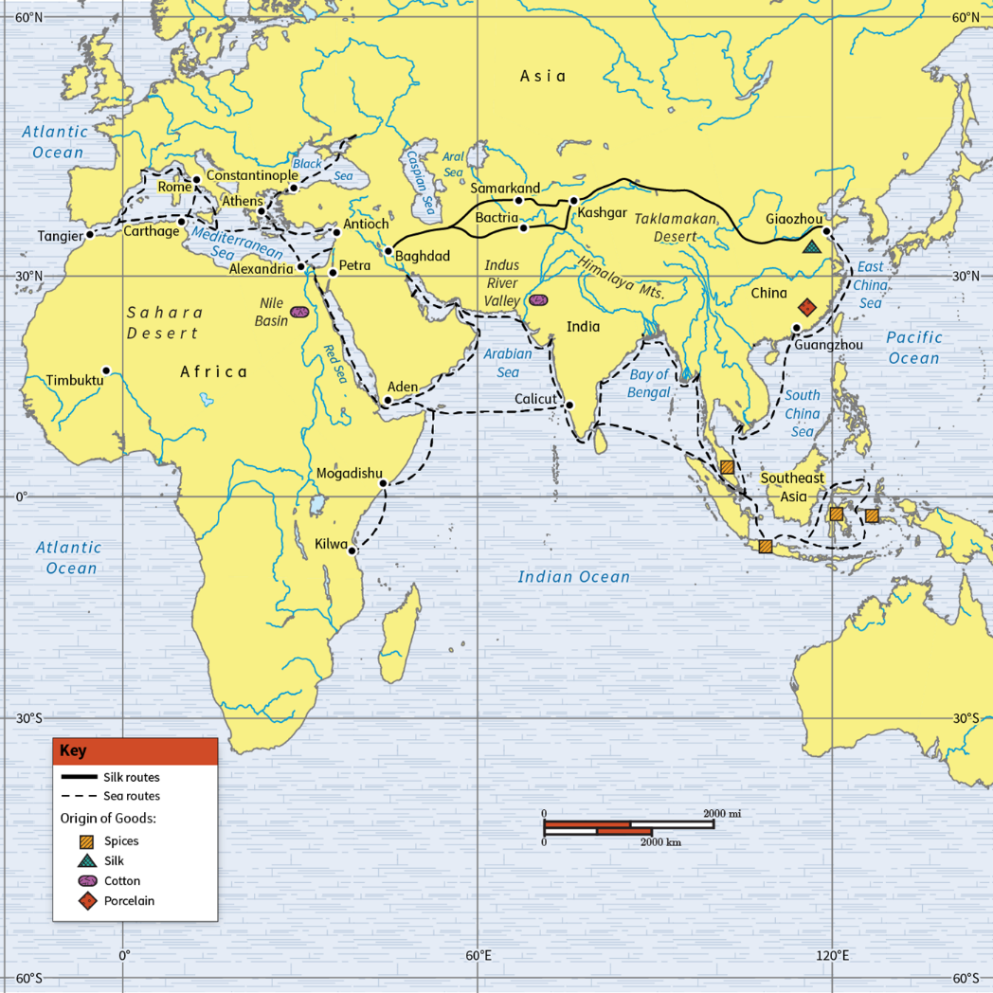

- Cause and Effect Along the Routes:
- Roman expansionism was driven by the desire for luxury goods available through trade. Trade routes brought wealth but also brought dangers, such as the spread of the Black Death, which decimated populations like in Venice.

- Transfer of Culture:
- Religious and cultural ideas were spread along trade routes. Buddhism spread through the Silk Road via Kushan kings and Sogdian merchants, while Islam spread through Muslim traders along the maritime Silk Roads.

Check-In:
1. Analyze how cause and effect can be seen along the trade route.
- Answer: Romans expanded their territory to access luxury trade goods, which in turn fueled more expansion and trade. The Silk Road's stability under the Mongols facilitated the spread of the Black Death.
2. What are some of the negative consequences of utilizing the trade routes?
- Answer: Diseases like the Black Death spread along trade routes, leading to significant population losses and economic disruption. Trade interactions sometimes led to conflicts or wars between civilizations.

Practice:
1. Analyze and provide an example of the long- and short-term effects of trade that occurred on the Silk Road and Indian Ocean trade routes.
- Sample answer: Long-term, Islam remains a major religion in Southeast Asia due to historic trade. Short-term, Mongol interactions with China introduced them to Buddhism, leading to its spread in their territories.
2. Analyze and provide an example of why religions spread along the trade routes of the Silk Road and Indian Ocean.
- Sample answer: Muslims spread Islam through trade interactions across the Indian Ocean. As merchants settled and integrated into new communities, their cultural and religious practices, like Islam, spread.

- Impact of Trade on Ideas

Objective 3:
You will analyze the impact trade routes had on African, Asian, and European religions, philosophies, and political beliefs.

Essential Question:
How did trade routes impact religions, philosophies, and politics globally?

Key Terms:
1. Indian Ocean trade network - A series of sailing routes across the Indian Ocean that connected Asia, Africa, and the Middle East.
2. Silk Road - An ancient network of trade routes that connected China to the Mediterranean Sea and allowed for widespread cultural interaction.
3. Spice Routes - The maritime (sea) trade routes related to the Silk Road, where spices were primarily traded.
4. Trans-Saharan trade route - The trade routes of northern Africa that were known for trading gold, salt, and other goods.

Big Idea:
- Silk Road:
- Connected the Roman and Chinese empires, facilitating the trade of luxury goods and the exchange of religious and philosophical ideas like Buddhism and Greco-Roman thought. Trade brought wealth, leading to government interest in maintaining routes for economic benefits.

- Spice Routes:
- Maritime routes connected Europe and Asia, spreading spices and also religious and philosophical ideas. High spice prices led European governments to search for alternative routes, inspiring developments in navigation and eventually leading to global exploration and colonization.
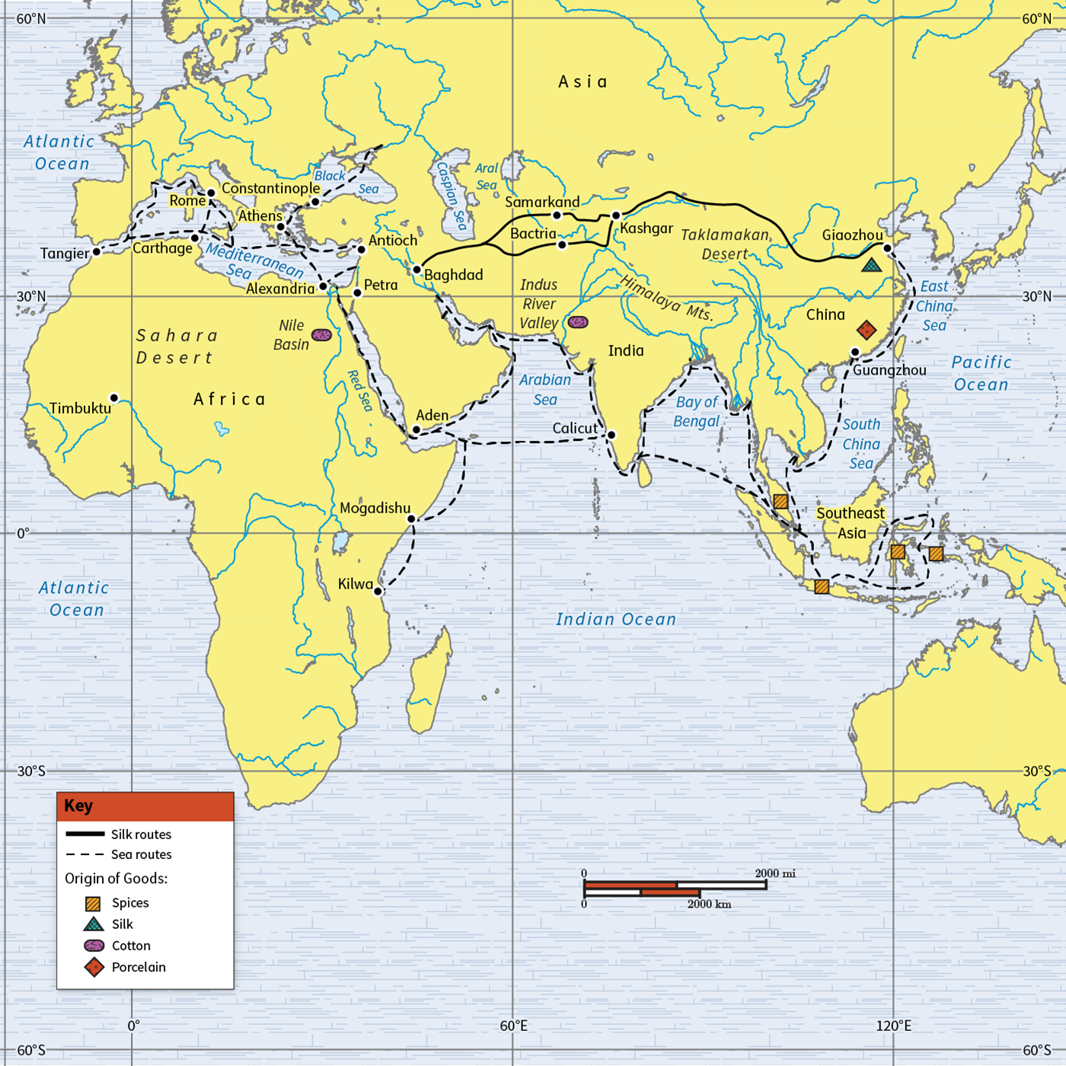
- Trans-Saharan Trade:
- Connected North and West Africa, spreading Islam and enhancing political power in African cities like Mali and Songhai. Trade in gold, cloth, and salt increased wealth and led to the rise of prosperous empires.

- Indian Ocean Trade Network:
- Connected East Africa, Asia, and the Middle East. Favorable winds and currents facilitated trade, spreading goods and religions like Islam. Political leaders supported trade by building ports and harbors, enhancing economic development and cultural interactions.

Check-In:
1. What were the Spice Routes?
- Answer: The Spice Routes were the maritime trade routes related to the Silk Road, where spices were primarily traded.
2. What philosophies were spread along the Silk Road trade routes?
- Answer: Greco-Roman philosophies, as well as Confucianism and Daoism, were spread along the Silk Road.

Practice:
1. Analyze how the impact of trade along the Spice Routes and Indian Ocean trade can be compared. Focus on how religious and political beliefs were impacted.
- Sample answer: Both were maritime trade routes that involved Africa, Asia, and the Middle East. Both spread Islam through trade interactions with merchants. Also, both inspired governments to become more involved in trade. Chinese and European governments became proponents of the political belief that trade could expand political influence.
2. How did Trans-Saharan trade impact religion in Africa?
- Sample answer: Trans-Saharan trade led to the spread of Islam in Africa as Muslim merchants interacted with local populations, converting the upper classes first before the religion spread more widely.

- Development of Trade Routes

Objective 4:
You will explain the development of land-based and sea-based trade routes, highlighting specializations and relationships between societies.

Essential Question:
How do trade routes develop?

Key Terms:
1. Indian Ocean trade network - A series of sailing routes across the Indian Ocean that connected Asia, Africa, and the Middle East.
2. Pax Romana - Latin for “Roman peace,” a period of stability for the Roman Empire lasting 200 years.
3. Silk Road - An ancient network of trade routes that connected China to the Mediterranean Sea and allowed for widespread cultural interaction.
4. Trans-Saharan trade network - The trade routes of northern Africa that were known for trading gold, salt, and other goods.

Big Idea:
- The Silk Road and Environmental Literacy:
- The Silk Road connected China and Rome across challenging environmental barriers, facilitated by the stability and infrastructure improvements of the Han and Roman empires. Increased economic stability and demand for goods led to the development of this extensive trade network.

- Impact of Silk Road Trade Routes:
- The Silk Road fostered peaceful relations and specialization in certain products. China focused on silk production, while Europe traded gold and silver. Traders specialized in shorter, more profitable routes to transport goods.

- Trans-Saharan Trade:
- Challenges like crossing the Sahara Desert were tackled with oases and camels. After the fall of the western Roman Empire, North African traders connected West Africa's gold and salt with Mediterranean markets, growing wealthy through trade.

- Indian Ocean Trade Network:
- Favorable monsoon winds facilitated maritime trade between Asia, Africa, and the Middle East. Political leaders supported trade by building ports and harbors, spreading goods, religions, and cultures. Relationships between trading regions remained positive due to mutual benefits.

Check-In:
1. What did North African traders specialize in?
- Answer: They specialized in horses and iron weapons.
2. What made transporting goods easier on the Indian Ocean trade network?
- Answer: Favorable currents and monsoon winds made it easy to transport goods across the Indian Ocean.

Practice:
1. How did the environment impact the development of the Silk Road trade network?
- Sample answer: Mountains, deserts, and rivers provided obstacles for traders. Trade was only possible when the Chinese and Roman empires grew in power. Then they could build roads, bridges, and other infrastructure for easier trade.
2. Use environmental literacy skills to explain why the Trans-Saharan trade route was organized around oases.
- Answer: It would be difficult for traders to get goods across the desert on foot and without water for the entire journey. Oases provided rest and water for traders.

- Unit 3 Lesson 12: Early Asian Societal Structures
- The Emergence of Caste and Gender Systems in Early India

Objective 1: You will explain the origins of social class and gender structures in early India and their impact on the civilizations of South Asia.

Essential Question: Why did social class and gender structures emerge in early India?

Key Terms:
1. Arranged marriage - A marriage agreed upon by the families of the bride and groom, who usually have little to no say in this matter.
2. Aryans - A group of Indo-European speaking people who invaded northern India during the second millennium BCE.
3. Brahmins - Priests and other religious officials who were part of the highest level in the caste system.
4. Caste system - A class structure determined by birth and occupation.
5. Dalit - The modern term given to those who were considered "untouchable" or "unseeable" in the caste system.

Big Ideas:
• The Aryans and Social Structure: The Aryans, who invaded India around 2000-1500 BCE, set up a social structure to control the region. They integrated with Dravidian-speaking societies, creating a blend of cultures. The Vedas, religious texts created around 1500 BCE, describe the world's oldest religion and societal rules, from which much of Aryan culture can be learned.

• The Caste System: Society was divided into four main varnas: Brahmins (priests), Kshatriyas (warriors/leaders), Vaishyas (commoners like farmers), and Shudras (servants). Those considered impure, called "untouchables" or Dalits, fell outside this system. Over time, this social structure became rigid and hereditary, leading to strict social stability and order.
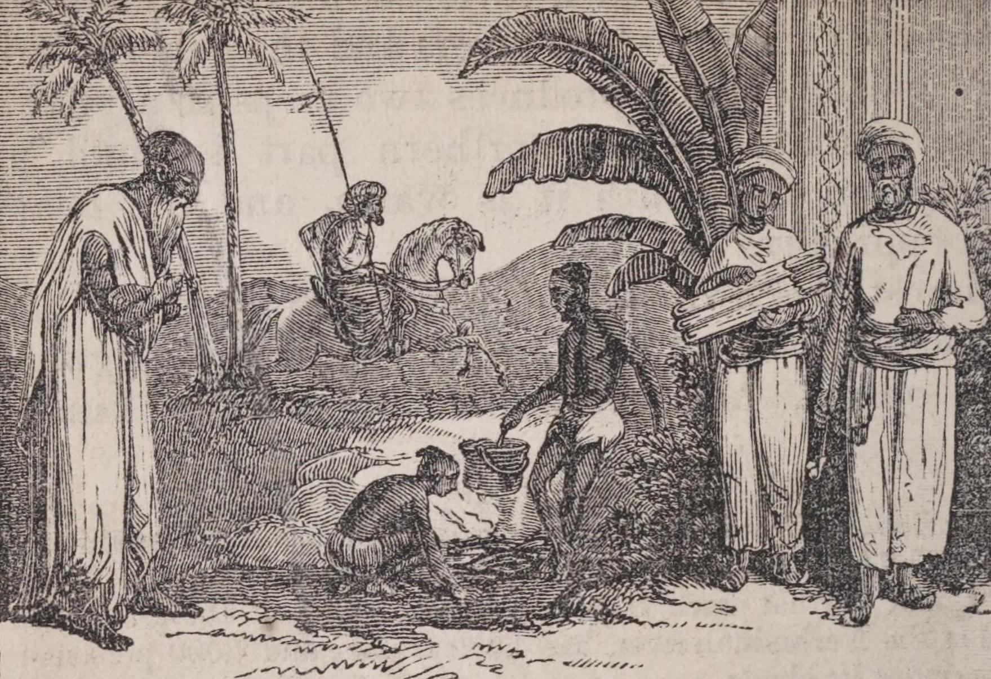
• Impact on Women: Initially, Aryan women had considerable privileges, but as the caste system became strict, women's rights were increasingly restricted. Practices like arranged marriages, dowries, and purdah (seclusion and veiling) began. The social status of women rapidly declined in the late Vedic Period, leading to practices such as sati where widows were burned on their husbands' funeral pyres.

Check-In:
1. Who introduced a rigid system of social order to the Indian subcontinent?
- Answer: The Aryans introduced a rigid system of social order.
2. What was the practice of cremating widows alive on their dead husbands’ funeral pyres known as?
- Answer: Sati.

Practice:
1. The Mánusmriti addressed the types of foods that could be eaten by members of certain castes and which were considered to be pure or impure. Search online for a menu from a traditional Indian restaurant and recipes for preparing specific dishes. Select two to three items from the menu. Use this information to determine which castes in the Vedic period could have eaten the dishes you selected from the menu and which dishes would have been considered to be pure or impure. What kind of evidence did you find?
- Sample answer:
- Soups such as dal (lentil soup) – pure because it is vegetarian; cooked in water, so it can only be eaten by members from one’s own caste.
- Any beef dish – considered impure; eaten by Dalits because no one else would consume it.
- Spinach dishes like saag paneer – spinach cooked in oil is considered pure because it is vegetarian; if cooked by a Brahmin, it may be eaten by members of any caste.
- Fried pastries such as Gulab Jamun (fried balls of dough sweetened with syrup) – pure because it is a grain dish; it is allowed to be eaten by all castes.
- Leftovers taken home – both pure and impure but can only be eaten by the lower castes.
2. What if our society used the Vedic caste system? Conduct additional research from various sources to learn more about the types of jobs that were part of each caste in early India. Apply this evidence to the following jobs held today in our society. In early India, which caste would have been assigned to the person holding each of these jobs? Briefly explain why this person would be categorized into that caste.
- Sample answer:
- The President of the United States – Kshatriyas included both warriors and important political leaders.
- Plumber – Dalits were considered “untouchable” because they dealt with human waste.
- Computer software designer – Vaishyas included artisans who created specific consumer goods.
- Television evangelist – Brahmins included religious leaders.
- Cook at a fast-food restaurant – Shudras included people in low-paying jobs that often required little to no professional skills.

- A Structured Society in Ancient China

Objective 2: You will recognize the different social classes found in early China.

Essential Question: How did the different social classes found in ancient China contribute to and shape that society?

Key Terms:
1. Analects - A written collection of Confucius’s sayings.
2. Shi - An upper class of warriors, nobles, and scholars that made up the gentry of ancient Chinese society.
3. Nong - Ancient Chinese social class made up of peasant farmers.
4. Gong - An ancient Chinese social class made up of artisans and craftspeople.
5. Shang - Merchants and traders who made up the lowest social class level in ancient China.

Big Ideas:
• Confucianism and Social Order: Confucius promoted social order through his teachings, which were later compiled into the Analects. His ideas led to a structured society where everyone had specific roles and responsibilities.

• Social Classes in Ancient China: Ancient Chinese society was stratified into five main classes: Emperor and royal family, Shi (nobles and scholars), Nong (farmers), Gong (artisans), and Shang (merchants). Slaves were not considered part of this social structure. Each class contributed to society in different ways. The emperor and royal family ruled, the Shi class governed and protected, the Nong class produced food, the Gong class created goods, and the Shang class traded and facilitated commerce.
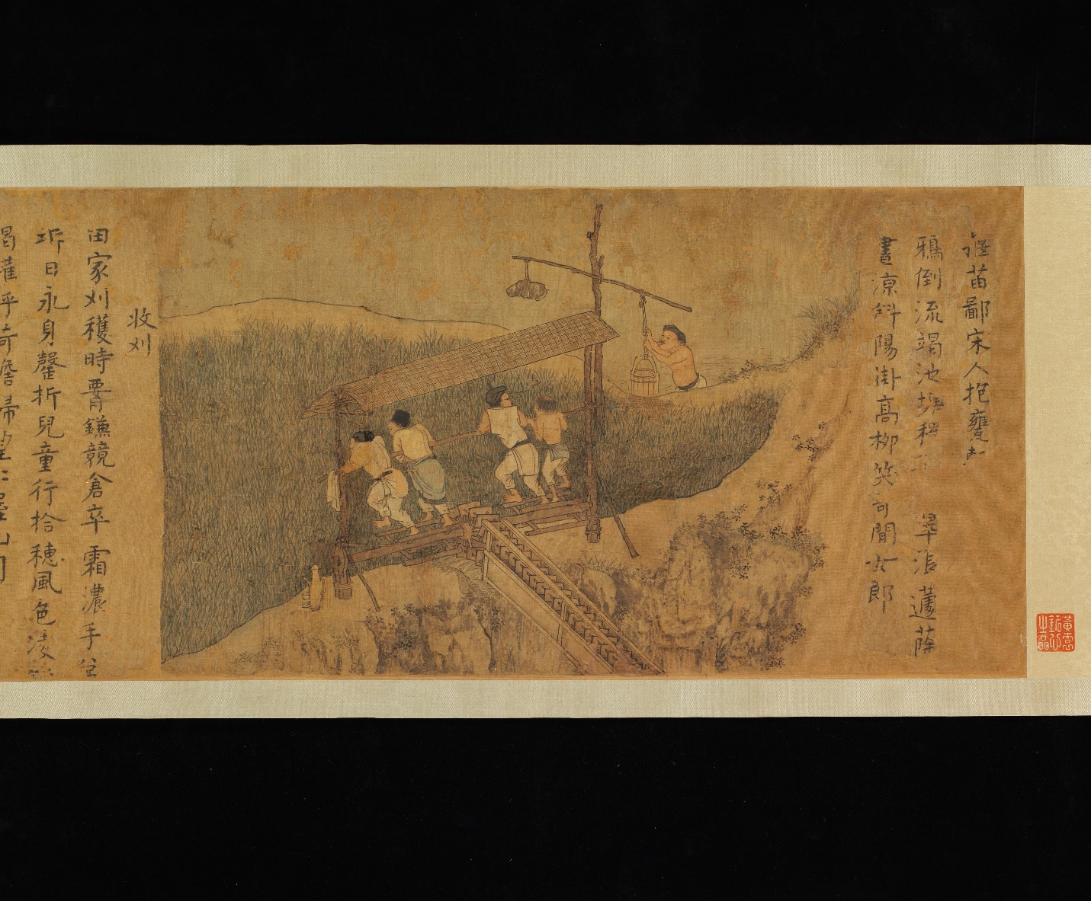
• Roles and Functions: Every class had specific roles, from governance to production and trade, which ensured a balanced and functioning society. Confucianism's emphasis on education ensured that government officials were well-prepared to lead.

Check-In:
1. What was the name given to the written collection of Confucius’s teachings compiled by his students?
- Answer: The Analects.
2. Which social class was the least-respected in ancient China?
- Answer: Shang (merchants and traders).

Practice:
1. Identify the five levels of the social class system in ancient China. Place the highest social level at the top level and label the other four levels in descending order. Write a brief statement next to each social class that explains their roles and functions in Chinese society.
- Sample answer:
- Emperor – Responsible for protecting his people; set good examples for his subjects.
- Shi – Gentry class made up of warriors, lower-ranking nobles, and civil service scholars; allowed to wear silk and drive chariots during war; symbolized by the double-edged Jian.
- Nong – Peasant farmers; largest class system in ancient China; respected because they were hard workers; required to wear blue or black hemp instead of silk.
- Gong – Artisans and craftspeople; designed functional and luxury goods from bronze and jade; did not own land; engaged in silk production.
- Shang – Merchants, traders, and bankers; held in low esteem because they did not produce goods with their own labor; only profited off the work done by other members of society.
2. Social groups in ancient China were expected to wear clothing made from specific materials. Silk clothing was limited to the emperor and members of the Shi class. Members of the Nong were required to wear dark-colored tunics made from hemp. List the five social groups that were found in ancient China. Select several groups of professions from our modern society and assign at least one profession to each of the five Chinese social classes. Next to the group(s) listed at each class level, determine what types of clothing members should wear when performing their jobs.
- Sample answer:
- Emperor
- President, CEO
- Dark suits, formal attire
- Shi
- Actors, athletes, musicians
- High fashion, unique and personal attire
- Nong
- Office workers
- Office casual attire
- Gong
- Factory workers
- Jeans, work shirts, and boots
- Shang
- Stockbrokers
- Suits, formal attire

- Chinese Philosophies and Religions Shape Gender Roles and Government in Ancient China

Objective 3: You will analyze the connection between gender roles, religion, and government in early China by understanding how people’s perspectives are related to their experiences across time and space.

Essential Question: How were the various philosophies and religions that spread throughout ancient China connected to the ideas associated with traditional gender roles and government in that empire?

Key Terms:
1. Confucianism - A system of ideas developed in ancient China that focused on worldly goals such as maintaining social order and good government.
2. Daoism (Taoism) - An ancient Chinese philosophy developed by Laozi that emphasized living in harmony with nature.
3. Buddhism - A widespread Asian philosophy or religion that was developed by Siddharta Gautama in India between the sixth and fourth centuries BCE.
4. Legalism - An ancient Chinese philosophy calling for strict discipline and enforcement of harsh laws to maintain order.
5. Yin and yang - The idea that the universe reflected a delicate balance between two opposite forces.

Big Ideas:
• Belief Systems and Social Customs: Confucianism, Daoism, and Legalism formed the spiritual pillars of ancient Chinese society. Each played a role in shaping customs, traditions, and government. Confucianism emphasized social order through respect, hierarchy, and education. Daoism stressed harmony with nature and personal behavior. Legalism focused on authoritarian control and strict laws.

• Impact on Government: Confucianism promoted the idea of leaders setting good examples for their subjects. Education was considered vital for rulers and officials. Daoism suggested a more passive approach, encouraging leaders to avoid showiness and favoritism to maintain peace. Legalism justified harsh punishments and strict laws to maintain order, as seen during the Qin dynasty.
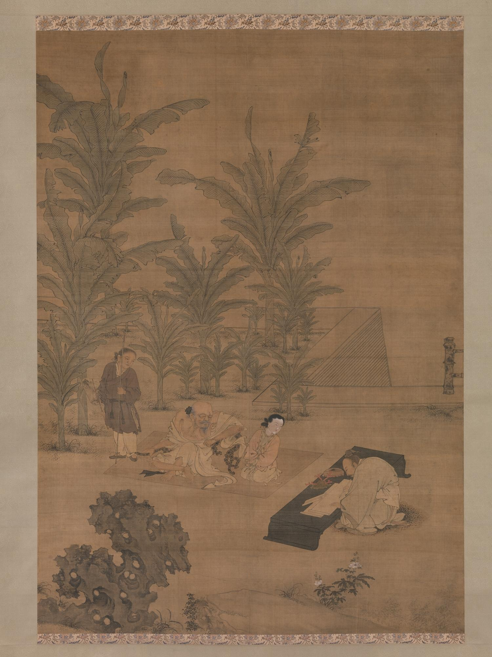
• Gender Roles and Philosophies: Yin and yang represented the balance of female and male forces, with yin being passive and receptive (female) and yang being active and dominant (male). This justified the subjugation of women. Confucian doctrines, such as the Three Obediences and Four Virtues, defined women's roles and behaviors, reinforcing their subservient status.

Check-In:
1. Which Chinese philosophy did Shi Huangdi enforce to maintain order within his empire?
- Answer: Legalism.
2. What concepts were used by Confucians and Daoists to provide a framework for bringing balance into people’s lives?
- Answer: Yin and yang.

Practice:
1. Categorize the terms from the word bank by placing them next to the Chinese belief system with which they are most closely associated.

Word Bank
- Strict penalties for light crimes
- Promises of eternal happiness
- Withdrawal from political struggles
- Superior–subordinate relationships
- Rulers set good examples for their subjects
- Living in harmony with nature
- Strength is a ruler’s greatest virtue
- Introduced to China from India

- Belief System: Key Ideas
- Confucianism
- Superior–subordinate relationships
- Rulers set good examples for their subjects
- Daoism
- Withdrawal from political struggles
- Living in harmony with nature
- Legalism
- Strict penalties for light crimes
- Strength is a ruler’s greatest virtue
- Buddhism
- Promises of eternal happiness
- Introduced to China from India
2. Confucian scholars regulated Chinese society by compiling various codes of behavior that promoted balance and order. Create a code of five behaviors that a student should follow to create balance and order at school.
- Sample answer: Getting to class on time, completing assignments, having materials ready to use, walking in an orderly manner in the hallways, not talking out of turn in a classroom, being respectful to the instructor and to other students.

- The Mandate of Heaven and the Dynastic Cycle: Implications on Chinese Government and Society

Objective 4: You will assess how the evolution of Chinese government shaped social status and gender roles.

Essential Question: How were social status and gender roles in early China shaped as government evolved over time?

Key Terms:
1. Mandate of Heaven - The Chinese belief that emperors and dynasties are able to rule as long as they have the blessing of the gods.
2. Dynastic cycle - A four-phase cycle that traced the rise and fall of Chinese dynasties according to the Mandate of Heaven.
3. Oracle bones - Charred animal bones or tortoise shells that Chinese spiritual leaders inscribed with symbols to communicate with the gods and predict the future.
4. Qin dynasty - The imperial Chinese dynasty that lasted from 221 to 206 BCE under the rule of Emperor Shi Huangdi.
5. Han dynasty - The imperial Chinese dynasty established by Liu Bang that lasted from 202 BCE to 220 CE.

Big Ideas:
• Mandate of Heaven and Dynastic Cycle: The Mandate of Heaven justified the rise and fall of dynasties in China. A dynasty's power was seen as granted by the gods, which could be revoked if the dynasty became corrupt or ineffective. Dynasties went through a four-phase cycle: strong ruler consolidates power, power passed to heirs, dynasty becomes corrupt, and a new ruler claims the Mandate of Heaven.
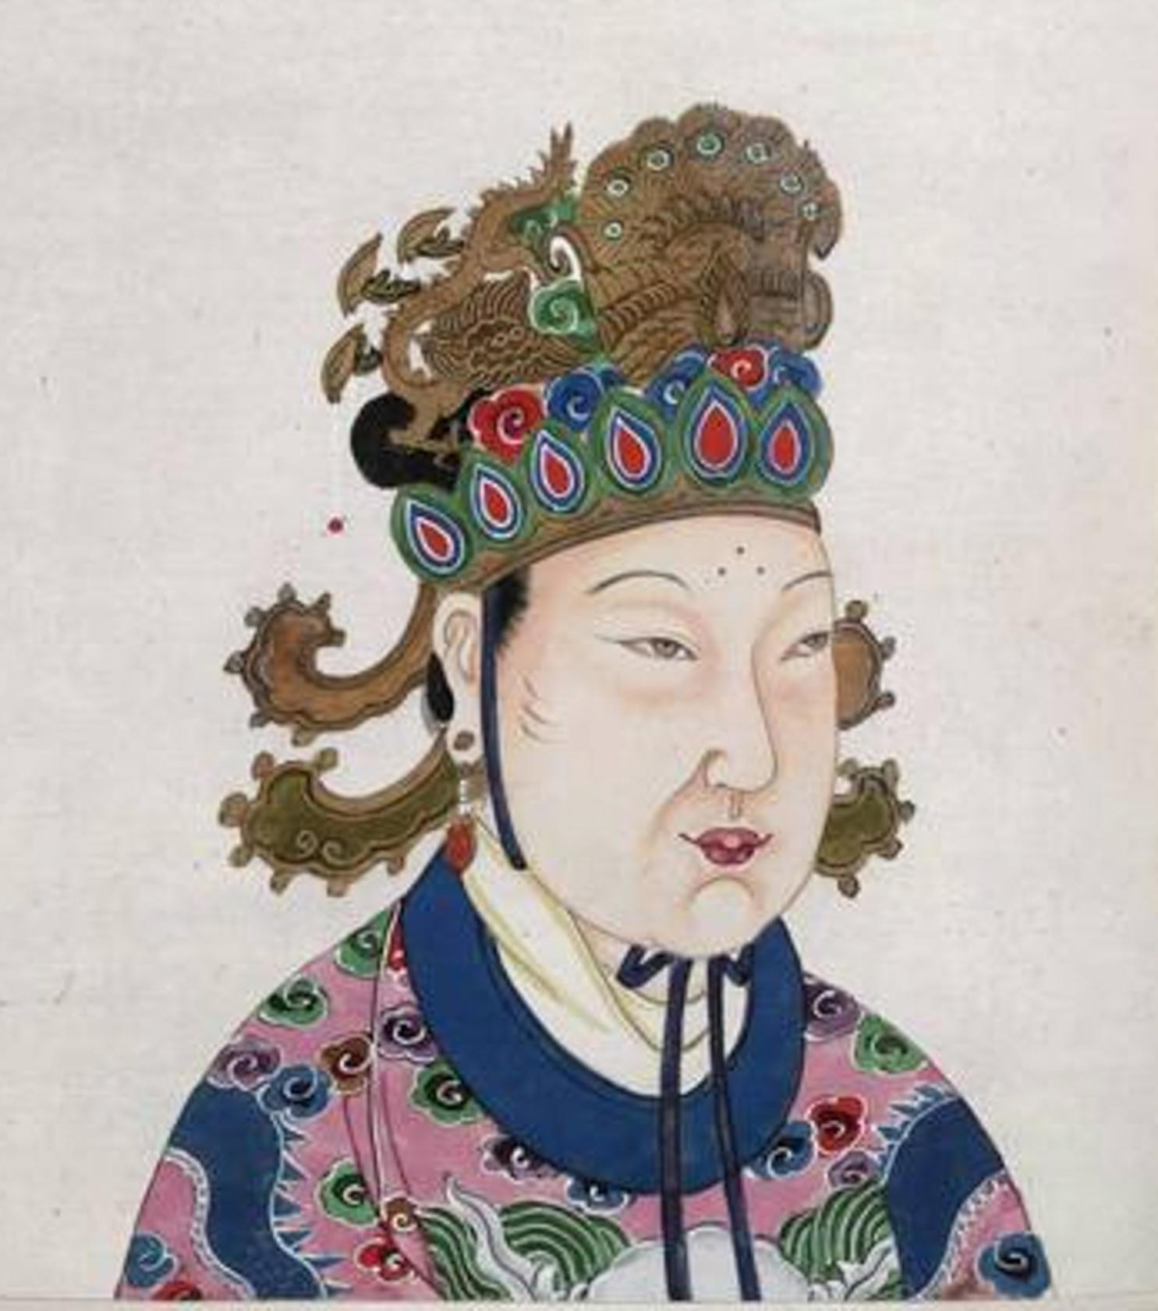
• Impacts on Social Structure: Social status was influenced by the dynastic cycle. The ruling class and aristocracy held power during stable periods, while lower classes, including peasants and slaves, played crucial roles in society. Oracle bones were used during the Shang dynasty to communicate with the gods, indicating a divinely influenced governance system.

• Evolution of Government and Society: Different belief systems influenced governance. Confucianism introduced hierarchical relationships and education for rulers. Daoism recommended a peaceful, nature-based approach. Legalism enforced strict rules and punishments. As these philosophies developed, they shaped gender roles and social expectations, such as the subservient role of women under Confucianism.

Check-In:
1. What were the charred, cracked animal remnants used by Shang priests to interpret messages from the gods known as?
- Answer: Oracle bones.
2. Who was the only woman to serve as a Chinese emperor?
- Answer: Wu Zhao, also known as Wu Zetian.

Practice:
1. Wu Zhao was the only woman to serve as emperor during the various dynastic cycles in early China. Access online information to learn about her rule. After reading several short biographical entries of Wu Zhao, evaluate why Tang historians portrayed her so negatively in their writings.
- Sample answer: Historians and other male officials in Tang China dismissed her as a woman. While she exiled her sons so she could rule in her own right and was said to have carried out assassinations of family members who challenged her rule, she also helped restore the former Han system of uniform government by rebuilding bureaucracy and enlarging the civil service system to recruit talented officials.
2. Read the following passage from the memorial that Qin Prime Minister Li Shi wrote to Emperor Shi Huangdi: “Your servant suggests that all books in the imperial archives, save the memoirs of the Qin, be burned. All persons in the empire, except members of the Academy of Learned Scholars, in possession of [Confucian classics] should take them to

