2-Variable Equations & Inequalities
Formula Sheet
Name | Definition | Formula
Slope-Intercept Form of a Linear Equation | The slope-intercept form is a way of writing an equation in a form that identifies the slope and y-intercept. | 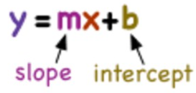  For example: $$y=2x+4$$
Standard Form of a Linear Equation | The standard form is the typical form that a linear equation is represented. This form makes the elimination and other methods simpler. | $$Ax+By=C$$  For example: $$8x+6y=8$$
Quadratic Equation | A quadratic equation is a two-degree polynomial that creates a parabola when graphed. It can be written in a standard form. | $$ax^{2}+bx+c=0$$  When represented in a system: $$y=ax^{2}+bx+c$$
Intercepts | The x- and y-intercepts of a graph can be found where a line crosses the x- and y axes. | 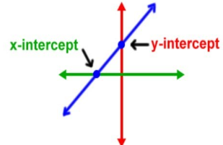  The x-intercept is where the line crosses the x-axis.  The y-intercept is where the line crosses the y-axis.
Inequality Symbols | Two expressions can be compared in an inequality, which is a mathematical statement that uses symbols. | 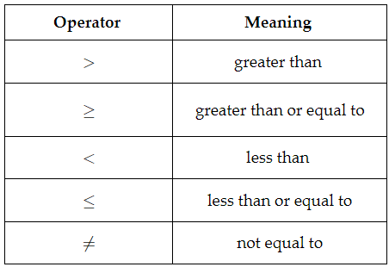
Graphs of Linear Inequalities | Depending on the inequality symbol used will determine what the graph of a linear inequality looks like. | Inequality Symbol Boundary Line Shading  > dashed line shade above  ≥ solid line shade above  < dashed line shade below  ≤ solid line shade below  - Dashed line: points on the line are NOT included in the solution set  - Solid line: points on the line are included in the solution set
Solutions of Systems of Equations | Systems of equations can have one, zero, or infinite solutions. | Solutions Graphed Features  One Solution Lines will intersect at a shared point of intersection.  Infinite Solution The system creates the exact same line, making the graph look like it is just one line.  None or Zero Solutions The system creates parallel lines (same slope, different intercepts) that never cross.
Solutions of Systems of Inequalities | The solution to a system of inequalities is defined by the overlapping shaded regions of their solution sets when graphed. All points within the overlapping area on a graph must satisfy both equations in a system of inequalities, in other words, this region shows their shared solutions. | For example, the two inequalities overlap in the shaded purple region. This region represents the solution set for the system.  