Additional Problems: 1-Variable Equations and Inequalities

**Solving Linear Inequalities**

1. Click on this [link](https://www.geogebra.org/m/ns2xr6na) and practice graphing at least five inequalities. Take a screenshot of the one you are most proud of and upload it here.
2. Select the correct graph of x > 2
   1. 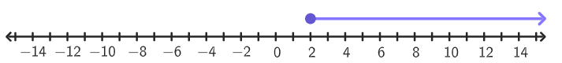
   2. 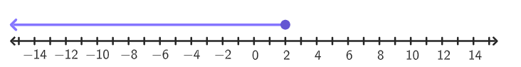
   3. 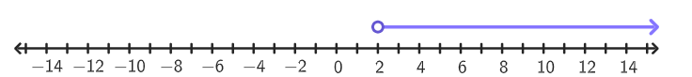
   4. 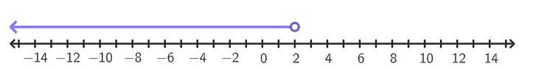
3. Select the correct graph of x ≥ 4
   1. 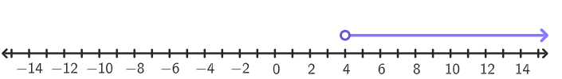
   2. 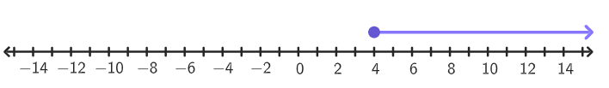
   3. 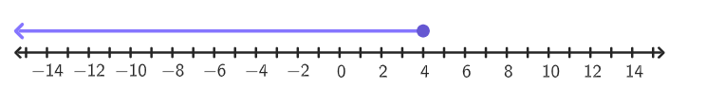
   4. 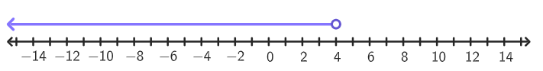
4. What inequality does the number line graph?

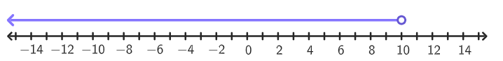

* 1. x < 10
  2. x > 10
  3. x ≥ 10
  4. x ≤ 10

1. What inequality does the number line graph?

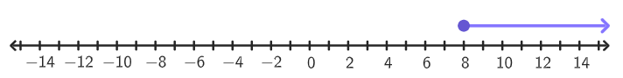

* 1. x < 8
  2. x > 8
  3. x ≥ 8
  4. x ≤ 8

1. What inequality does the number line graph?

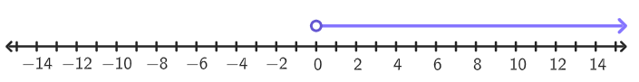

* 1. x < 0
  2. x > 0
  3. x ≥ 0
  4. x ≤ 0

1. What property of inequality justifies the steps shown in the following solution process?

2/5x ≤ -10

5/2 (2/5) x ≤ -10 (5/2)

X ≤ -25

* 1. Addition Property of Inequality
  2. Division Property of Inequality
  3. Multiplication Property of Inequality
  4. Subtraction Property of Inequality

1. Solve the inequality $\frac{3}{7}$  x ≥ 15
2. Solve the inequality $\frac{2}{3}$ y < 8
3. Solve the inequality $\frac{5}{6}$ ≤ 30