Algebra 1 Unit Test Guide

Bivariate Datasets Unit Test

Item | Lesson Coverage | Objective | Mathematical Practice Standard | Assessment Item
1 | Lesson 2: Two-Way Frequency Tables | In this lesson, you will distinguish the differences between numerical and categorical data. | Model with mathematics. | Dog Breed Height Weight Length  Dachshund 8 in. 12 lb. 14 in.  Basset Hound 12 in. 40 lb. 24 in.  Great Dane 40 in. 150 lb. 45 in.  Kyle includes this table in their report on the dogs they walk. They want to add another example of categorical data. Which of the following options would be suitable?  Correct Answer: color
2 | Lesson 2: Two-Way Frequency Tables | In this section, you will use two-way frequency tables to compare, organize, and interpret data. | Model with mathematics. | Favorite Snack Third Graders Fourth Graders Total  Salty 35 ? 43  Sweet ? 42 57  Total 50 50 100  Review the two-way frequency table. What are the missing values?  Correct Answer:  Salty: 8, Sweet: 15
3 | Lesson 3: Relative Frequencies | In this section, you will use two-way frequency tables to obtain and interpret relative frequency tables. | Model with mathematics. | Play winter sports Does not play winter sports Total  Colorado 103 35 138  Nebraska 54 95 149  Total 157 130 287  Based on the two-way frequency table, what is the marginal relative frequency of people who play winter sports? Round your answer to the nearest whole percentage.  Correct Answer: 55
4 | Lesson 3: Relative Frequencies | In this section, you will use two-way frequency tables to calculate and interpret conditional relative frequency. | Model with mathematics. | Sprinkles Jelly Beans Total  Vanilla 102 73 175  Chocolate 65 125 190  Total 167 198 365  You have gathered your grade’s votes for favorite ice cream flavor and topping. Then you organized the data into a two-way frequency table. Interpret the table to generate a two-way table of conditional relative frequencies for students who prefer sprinkles or jelly beans, given they prefer chocolate or vanilla. Round your answers to the nearest whole percentage.  Sprinkles (%) Jelly Beans (%)  Vanilla ? % ? %  Chocolate 34 66  Correct Answer: Sprinkles 58%, Jelly Beans 42%
5 | Lesson 3: Relative Frequencies | In this section, you will interpret conditional relative frequencies to determine whether variables or categories are the result of association and not causation. | Model with mathematics. | GPA Above 3.0 GPA Below 3.0 Total  Involved in Extracurricular Activities 68 12 80  Not Involved in Extracurricular Activities 22 38 60  Total 90 50 140  A group of ninth-grade math teachers collected the data in the table about the grades of students who are involved in extracurricular activities compared to the grades of students who are not involved in extracurricular activities. What percentage of students who are involved in extracurricular activities have a GPA above 3.0?  Of the students that are involved in extracurricular activities, ____% have a GPA above 3.0.  Correct Answer: 85%
6 | Lesson 4: Relationships Between Two Numerical Variables | In this section, you will distinguish between linear and nonlinear relationships in scatterplots. | Model with mathematics. | Data Set A: (0, 0), (1, −1), (2, 12), (3, 7), (4, −4), (5, 5)  Data Set B: (0, 1), (3, 4), (6, 8), (9, 16), (12, 64)  Data Set C: (0, 4), (1, 6), (2, 8), (3, 10), (4, 12)  Data Set D: (0, −4), (1, −6), (2, −8), (3, −10), (4, −12)  Create a scatterplot for each of the data sets shown. Distinguish which set of data represents a negative linear relationship.  Correct Answer: Data Set D  Bivariate Datasets Unit Test Item #6 | Desmos  Bivariate Datasets Unit Test Item #6 (Data Set A) - GeoGebra  Bivariate Datasets Unit Test Item #6 (Data Set B) - GeoGebra  Bivariate Datasets Unit Test Item #6 (Data Set C) - GeoGebra  Bivariate Datasets Unit Test Item #6 (Data Set D) - GeoGebra
7 | Lesson 4: Relationships Between Two Numerical Variables | In this section, you will use data, models, and scatterplots that model nonlinear relationships to analyze situations. | Model with mathematics. | 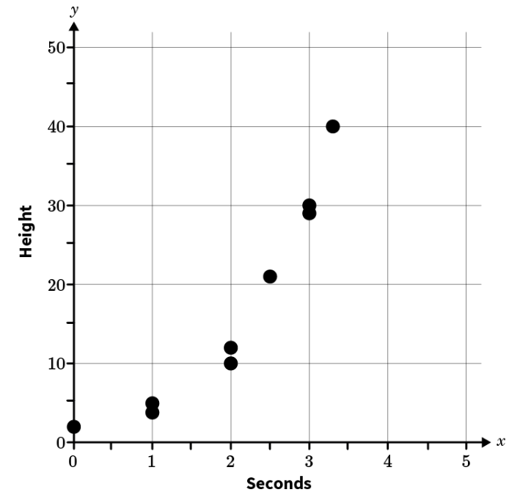  A scientist is studying the longitudinal growth of plant cells with a microscope. They record the height in microns of the plant’s growth after x seconds. What is the height in microns of the plant cells after 2.5 seconds?  Option #1: 21  Option #2: 12  Option #3: 10  Option #4: 29  After 2.5 seconds, the plant is approximately Option #____ microns high.  Correct Answer: 1  Bivariate Datasets Unit Test Item #7 | Desmos  Bivariate Datasets Unit Test Item #7 - GeoGebra
8 | Lesson 5: Linear Models | In this section, you will use technology to determine the least squares regression line from a given dataset. | Model with mathematics. | x y  -5 3  -4 4  -3 7  -2 7.5  -1 2.5  Use a spreadsheet calculator to determine the least squares regression line for the points in the table. Round to the nearest hundredth if necessary.  Correct Answer: $y=0.25x+5.55$  Bivariate Datasets Unit Test Item #8 | Desmos  Least Squares Regression Line – GeoGebra: move the points around to match the table and identify the LSRL
9 | Lesson 5: Linear Models | In this section, you will interpret the slope and y-intercept of linear models in the context of the data. | Model with mathematics. | X (Months) Y (Miles on Car)  3 38,250  4 40,000  5 41,800  6 43,250  7 45,000  8 47,000  Gianna recently bought a used car. She keeps track of the number of miles she drives each month. The table displays the number of miles on her car after the given number of months. If the slope of the line of best fit is 1,727, which of the following options is the correct interpretation of the slope?  Option #1: Gianna drives 1,727 miles every 3 months.  Option #2: Gianna drives 1,727 miles every month.  Option #3: Gianna drove 1,727 miles over 8 months.  Option #____ is the correct option.  Correct Answer: Option #2
10 | Lesson 5: Linear Models | In this section, you will use linear models to make predictions. | Model with mathematics. | Charles wants to go on a fishing trip. The price of the excursion varies based on the length of the trip. The line of best fit for these data is $y=50x+75$, where the price of the trip is based on the number of hours of the trip. What prediction can be made about the length of his trip based on the line of best fit?  Correct Answer: Charles can take a 6-hour trip for less than $400.  Bivariate Datasets Unit Test Item #10 | Desmos  Bivariate Datasets Unit Test Item #10 - GeoGebra
11 | Lesson 6: Residuals | In this section, you will graph residuals between data and corresponding linear models. | Model with mathematics. | Age Weight Line of Best Fit: $y=5.5x+16$ Residual  8 61 ? 1  What is the value of y given the table?  Correct Answer: 60
12 | Lesson 6: Residuals | In this section, you will use residual plots to determine the reliability of linear models and the accuracy of predictions made by using them. | Model with mathematics. | 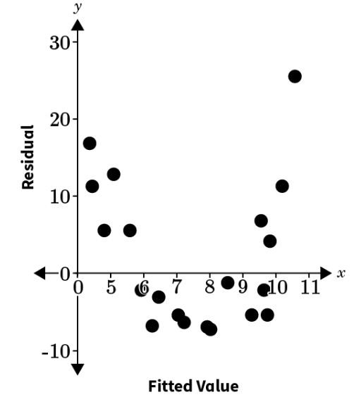  Determine the reliability of the linear model given this residual plot.  Correct Answer: The given residual plot clearly has a pattern. Therefore, the linear model is not reliable and will not provide accurate predictions for the original data.
13 | Lesson 6: Residuals | In this section, you will connect shapes of scatter plots to shapes of corresponding residual plots. | Model with mathematics. | 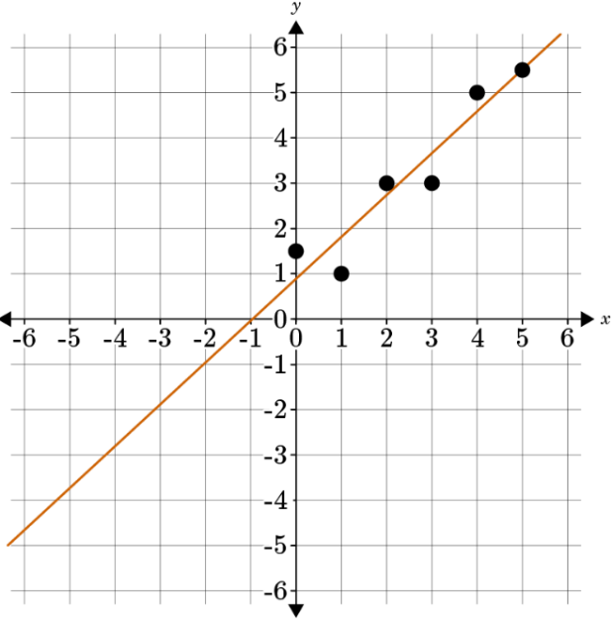  To create a residual plot based on the given scatterplot, how many values would be located below the residual=0 line?  Correct Answer: 2  Bivariate Datasets Unit Test Item #13 | Desmos
14 | Lesson 7: Correlation Coefficient | In this section, you will use technology to determine the correlation coefficient (r  -value) for a dataset. | Model with mathematics. | x y  2.3 19  3.1 28  4.5 33  6.6 85  Find the correlation coefficient of the following table using technology (such as GeoGebra). Round your answer to the nearest hundredth.  Correct Answer: 0.95  Bivariate Datasets Unit Test Item #14 | Desmos  Bivariate Datasets Unit Test Item #14 - GeoGebra
15 | Lesson 7: Correlation Coefficient | In this section, you will interpret what the correlation coefficient of a data set means in terms of its strength and direction on the coordinate plane. | Model with mathematics. | List the following correlation coefficients in order from strongest to weakest.  - 0.86359210  - 0.87000015  - 0.24156379  - 0.49215631  Correct Answer: 0.87000015, 0.86359210, 0.49215631, and 0.24156379
16 | Lesson 8: Correlation Between Variables | In this section, you will estimate the correlation coefficients (r  -values) of scatterplots in a variety of forms. | Model with mathematics. | 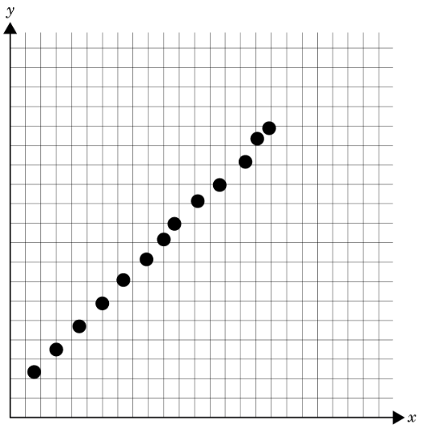  Based on the data, which of the following choices would be the best estimated correlation coefficient?  Correct Answer: 1
17 | Lesson 8: Correlation Between Variables | In this section, you will pair residual analysis and the correlation coefficient (r-value) of a dataset to determine whether the linear model (line of best fit) is appropriate. | Model with mathematics. | 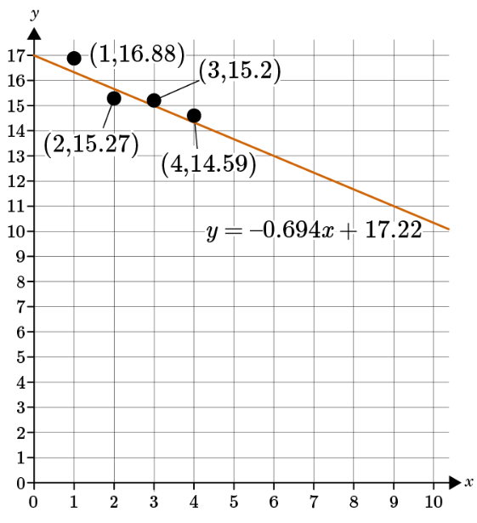  Find the residual of the data point (2, 15.27). Round the answer to the nearest thousandths.  Correct Answer: The residual of the data point is -0.562.  Bivariate Datasets Unit Test Item #17 | Desmos
18 | Lesson 9: Correlation, not Causation | In this section, you will explain why correlation in a dataset does not necessarily imply causation. | Model with mathematics. | A social sciences researcher is studying data from a survey she collected. She notices that there is a correlation between height and the number of salads consumed. Can the researcher conclude that being tall causes participants to eat more salads?  Correct Answer: No
19 | Lesson 11: Analyzing a Dataset | In this section, you will recognize various datasets that represent linear functions, quadratic functions, and exponential functions. | Model with mathematics. | Which type of function is $f\left(x\right)=3x-2+2x^{2}$?  Correct Answer: quadratic function  Bivariate Datasets Unit Test Item #19 | Desmos  Bivariate Datasets Unit Test Item #19 - GeoGebra
20 | Lesson 11: Analyzing a Dataset | In this section, you will create models of datasets that represent linear functions, quadratic functions, and exponential functions. | Model with mathematics. | x-values y-values  0 5  1 35  2 245  3 1715  4 12005  5 84035  Given the following xy-chart, create a function model. Does this illustrate a linear function, an exponential function, or a quadratic function to represent the dataset  Correct Answer: $f\left(x\right)=5{\left(7\right)}^{x}$ and an exponential function  Bivariate Datasets Unit Test Item #20 | Desmos  Bivariate Datasets Unit Test Item #20 - GeoGebra
21 | Lesson 3: Relative Frequencies | In this section, you will interpret conditional relative frequencies to determine whether variables or categories are the result of association and not causation. | Model with mathematics. | Purchases More than 2 Pairs per Year Purchases 2 Pairs or Less per Year Total  Run More than 5 Miles Per Week 42 28 70  Run Less than 5 Miles Per Week 15 32 47  A running shoe company is collecting data on long-distance runners. The company’s research analyst asked runners how many pairs of running shoes they purchase each year and how many miles they run each week, on average. The results are summarized in the table. Determine if there is an association between the number of miles an individual runs per week and how many pairs of running shoes they purchase per year. Create a conditional relative frequency table of the data. Use your table to support your reasoning. Explain your reasoning in 3–5 sentences.  Correct Answer:  Purchases More than 2 Pairs per Year Purchases 2 Pairs or Less per Year Total  Run More than 5 Miles Per Week 60% 40% 100%  Run Less than 5 Miles Per Week 32% 68% 100%  - Of the survey respondents who run more than five miles per week, 60% purchase more than two pairs of shoes per year and 40% purchase two pairs or less.  - Of the survey respondents who run less than five miles per week, 32% purchase more than two pairs of shoes per year and 68% purchase two pairs or less.  - The frequency table shows a noticeable difference between how many shoes are purchased given the number of miles per week a person runs. Therefore, there is a strong association between the number of miles a person runs per week and how many pairs of running shoes they purchase per year.
22 | Lesson 7: Correlation Coefficient | In this section, you will interpret what the correlation coefficient of a data set means in terms of its strength and direction on the coordinate plane. | Model with mathematics. | Correlation coefficients are an effective tool for determining if the results of a survey or project are strong or weak. In 3–5 sentences, create a situation where you would want to see the correlation between two variables. Would you want a strong or weak correlation? What would it mean if you had a negative correlation? What would it mean if you had a positive correlation?  Correct Answer: Student answers will vary depending on the situation they create, such as: Consumer spending for the first three quarters of the year was consistent. During the fourth quarter, however, spending increased drastically due to the holiday season. There is a strong correlation between holiday celebrations and the amount of money spent. If there was a negative correlation, it would mean spending was down. If there was a positive correlation, it would mean spending was up.
23 | Lesson 8: Correlation Between Variables | In this section, you will pair residual analysis and the correlation coefficient (r-value) of a dataset to determine whether the linear model (line of best fit) is appropriate. | Model with mathematics. | Jazmin used a graphing calculator to graph a given dataset. She found that the trend line of her data is $y=-0.694x+17.22$and that the correlation coefficient is $-0.9153.$ What conclusion should Jazmin make about the appropriateness of the linear model she found?  Correct Answer: The given trend line is an appropriate representation of the data since approximately half of the data points are above and half are below the trend line. The correlation coefficient is close to -1, accurately representing the negative trend in the data. Also, the point with the largest residual is (2,15.27), which has a residual of –0.562, which means that the least accurately represented point is 0.562 units below the trend line. Thus, the distribution of the points around the trend line, small residuals, and correlation coefficient close to -1 indicates that the trend line accurately represents the dataset.
24 | Lesson 11: Analyzing a Dataset | In this section, you will recognize various datasets that represent linear functions, quadratic functions, and exponential functions. | Model with mathematics. | In 1-2 sentences, explain which type of function best models the data in the table? How do you know?  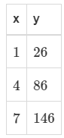  Correct Answer: This is a linear function, and I know this because there is a constant first difference between consecutive values of y.

