Algebra 1 Unit Test Guide

Univariate Datasets Unit Test

Item | Lesson Coverage | Objective | Mathematical Practice Standard | Assessment Item
1 | Lesson 2: Describing Distributions | In this section, you will formulate questions about datasets that could be answered by describing the shape, center, and spread of the data, and datasets that are displayed with dot plot models. | Model with mathematics. | 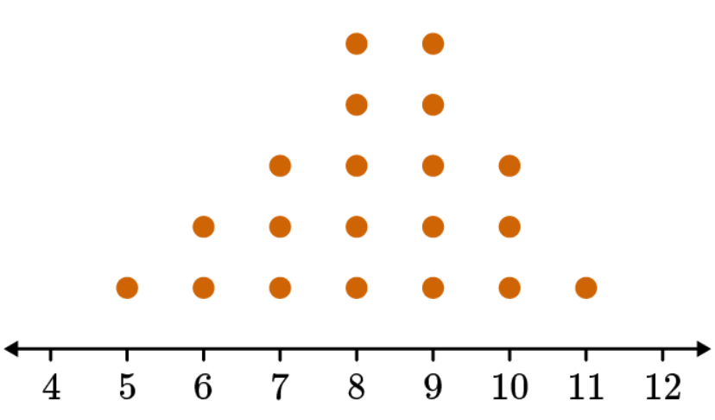  What is the mean of the dataset shown in the dot plot?  Correct Answer: 8.2  Univariate Datasets Unit Test Item #1 | Desmos  Univariate Datasets Unit Test Item #1 - GeoGebra
2 | Lesson 2: Describing Distributions | In this section, you will formulate questions about datasets that could be answered by describing the shape, center, and spread of the data, and that are displayed with histogram models. | Model with mathematics. | 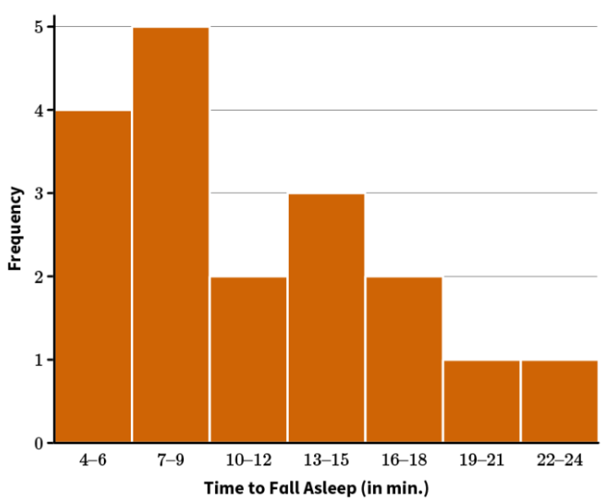  How many total people participated in this survey?  Correct Answer: 18
3 | Lesson 2: Describing Distributions | In this section, you will formulate questions about datasets that could be answered by describing the shape, center, and spread of the data, and that are displayed with box plot models. | Model with mathematics. | Given the dataset 68, 85, 88, 97, 85, 89, 98, 93, 95, and 99, what parts of the five-number summary would change if a new data point of 97 was added?  Correct Answer: the median  Univariate Datasets Unit Test Item #3 | Desmos  Univariate Datasets Unit Test Item #3 - GeoGebra
4 | Lesson 3: Centers of Distributions | In this section, you will compare the means and medians of symmetrical data by using dot plots. | Model with mathematics. | 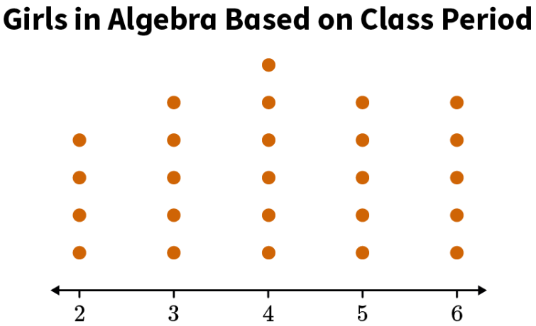  What is the median of the data?  Correct Answer: 4  Univariate Datasets Unit Test Item #4 | Desmos  Univariate Datasets Unit Test Item #4 - GeoGebra
5 | Lesson 3: Centers of Distributions | In this section, you will compare the means and medians of skewed data represented in a dot plot. | Model with mathematics. | 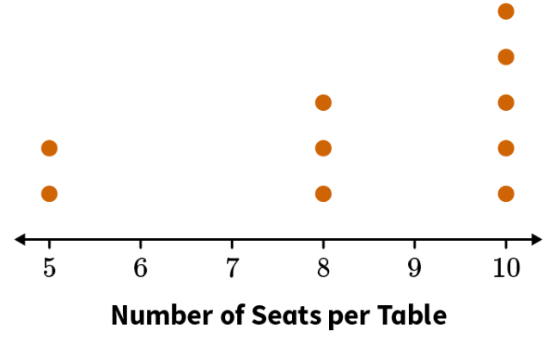  Hortencia made the dot plot to help her plan for her quinceañera. Find the mean and median number of seats per table to show that the mean and median are different in this skewed dataset. Round your answer to the nearest whole number, if necessary.  Correct Answer: The mean number of seats is 8.4, and the median number of seats is 9.  Univariate Datasets Unit Test Item #5 | Desmos  Univariate Datasets Unit Test Item #5 - GeoGebra
6 | Lesson 3: Centers of Distributions | In this section, you will explain how the shape of distribution determines the most appropriate measure of center. | Model with mathematics. | 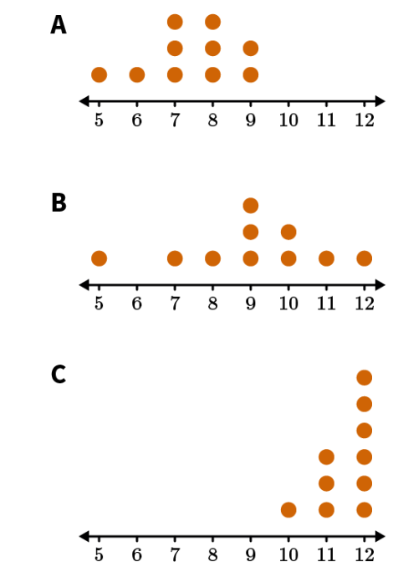  The median is the best measure of center for which data set?  Correct Answer: data set C because the distribution is skewed
7 | Lesson 4: Estimations of Centers | In this section, you will estimate the mean and median of data distributions. | Model with mathematics. | 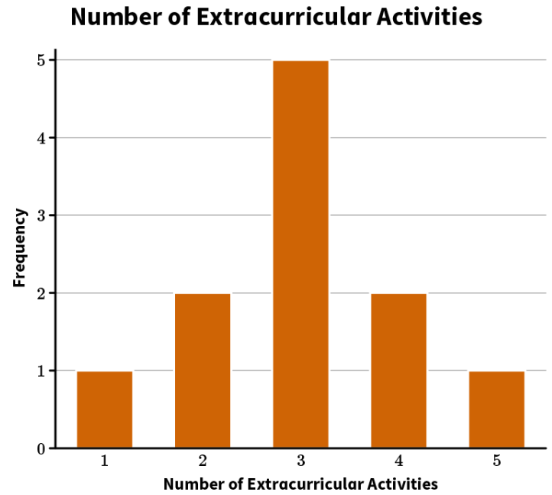  Which of the following options is true about the relationship between the mean and median of the data in the graph?  Option #1: The mean is greater than the median.  Option #2: The mean is less than the median.  Option #3: The mean is equal to the median.  Correct Answer: Option #3 is the true statement.  Univariate Datasets Unit Test Item #7 | Desmos  Univariate Datasets Unit Test Item #7 - GeoGebra
8 | Lesson 4: Estimations of Centers | In this section, you will explain mean as a balance point when both mean and median are not good descriptors. | Model with mathematics. | 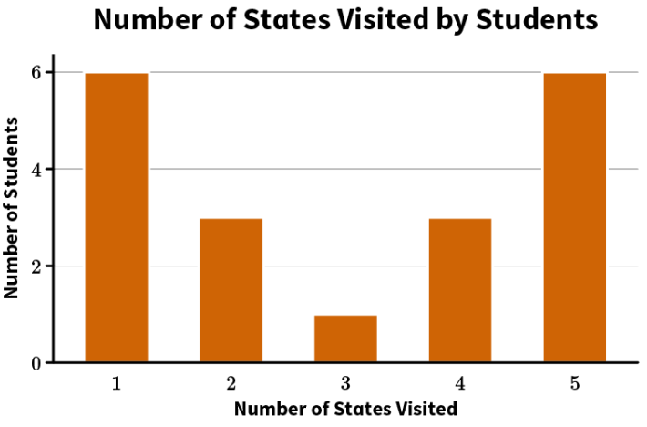  Use the mean to find the balancing point of the given dataset in the graph.  Correct Answer: The balancing point of the dataset is 3.  Univariate Datasets Unit Test Item #8 | Desmos  Univariate Datasets Unit Test Item #8 - GeoGebra
9 | Lesson 5: Deviation from the Mean | In this section, you will calculate the deviations from the mean for symmetric datasets that have the same mean. | Model with mathematics. | Calculate the average deviation from the mean for the following dataset: {23, 24, 26, 27, 28, 30, 31}. Round your answer to the nearest hundredth.  Correct Answer: The average deviation from the mean is 2.29.  Univariate Datasets Unit Test Item #9 | Desmos
10 | Lesson 5: Deviation from the Mean | In this section, you will compare deviations, interpreting larger deviations as greater spread or variability and smaller deviations as smaller spread or variability. | Model with mathematics. | Graph 1  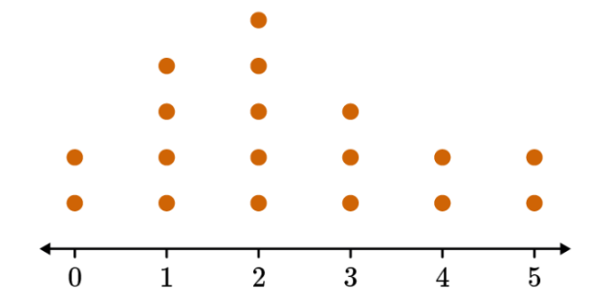  Graph 2  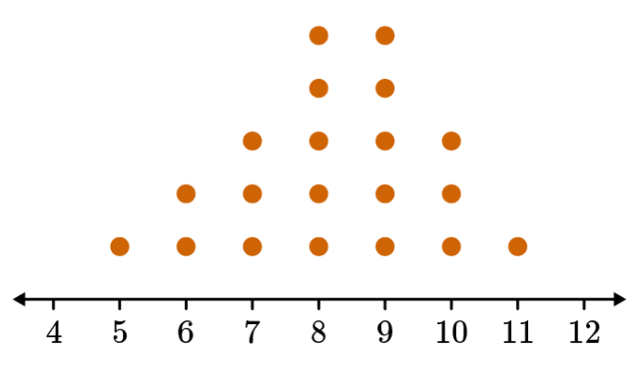  Which of the two graphs has a larger standard deviation?  Correct Answer: The second graph has a larger standard deviation.  Univariate Datasets Unit Test Item #10 | Desmos  Univariate Datasets Unit Test Item #10 - GeoGebra
11 | Lesson 6: Standard Deviation | In this section, you will calculate the standard deviation of symmetric datasets. | Model with mathematics | Minutes the Bus Came Late -1 0 1 2 3  Number of days 1 2 4 2 1  Addie’s bus pickup time is 8:00. The table shows the minutes before and after 8:00 the bus arrived at the stop for the last 10 days. Negative values represent minutes before 8:00. Calculate the standard deviation for the number of minutes the bus arrived before or after 8:00. Round your answer to the nearest tenth.  Correct Answer: The standard deviation is 1.10.  Univariate Datasets Unit Test Item #11 | Desmos  Univariate Datasets Unit Test Item #11 - GeoGebra
12 | Lesson 6: Standard Deviation | In this section, you will interpret the standard deviation as a measure of the spread of variability for a symmetric data set that represents the typical distance from a data point. | Model with mathematics | Dataset Mean Standard Deviation  1 78 1.23  2 87 1.42  3 83 1.19  Which dataset has the least variability?  Correct Answer: Dataset 3 has the lowest variability.
13 | Lesson 6: Standard Deviation | In this section, you will use standard deviation to compare the relative variability of distributions. | Model with mathematics | Use the standard deviation to compare the variability of the datasets. Round to the nearest hundredths.  Dataset A: 4, 5, 6, 12, 13  Dataset B: 4, 5, 7, 9, 10  Correct Answer: The standard deviation of Dataset A is 3.74. The standard deviation of Dataset B is 2.28. The standard deviation of Dataset A is larger than that of Dataset B, so Dataset A has more variability  Univariate Datasets Unit Test Item #13 | Desmos  Univariate Datasets Unit Test Item #13 - GeoGebra
14 | Lesson 7: Interquartile Range | In this section, you will construct box plots by calculating five-number summaries and interquartile ranges for skewed datasets and identify any outliers. | Model with mathematics. | Calculate the values for the 5-number summary of the skewed dataset 5, 6, 6, 7, 7, 8, 8, 8, 9, 9, 14, 16.  Correct Answer:  The minimum value = 5.  The maximum value = 16.  The median = 8.  Quartile 1 = 6.5.  Quartile 3 = 9.  Univariate Datasets Unit Test Item #14 | Desmos  Univariate Datasets Unit Test #14 - GeoGebra
15 | Lesson 7: Interquartile Range | In this section, you will interpret the interquartile range as a way to describe the variability for skewed datasets. | Model with mathematics. | The consistency of a drink machine is being tested. The machine dispenses the following ounces of water in five different trials: 12, 11, 10, 11, 14. What is the IQR of the dispensing trials?  Correct Answer: The IQR is 2.5.  Univariate Datasets Unit Test Item #15 | Desmos  Univariate Datasets Unit Test Item #15 - GeoGebra
16 | Lesson 8: Comparing Distributions | In this section, you will compare two or more related symmetric distributions. | Use appropriate tools strategically. | 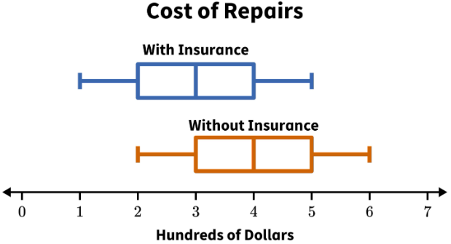  These box plots summarize the cost of repairs at a car shop. Which statement best compares the distributions?  Correct Answer: Cars without insurance were more likely to have a higher repair cost.
17 | Lesson 8: Comparing Distributions | In this section, you will compare two or more related skewed distributions. | Use appropriate tools strategically. | 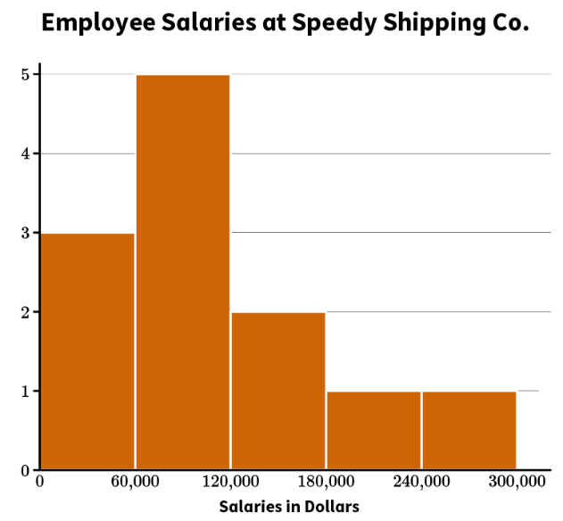  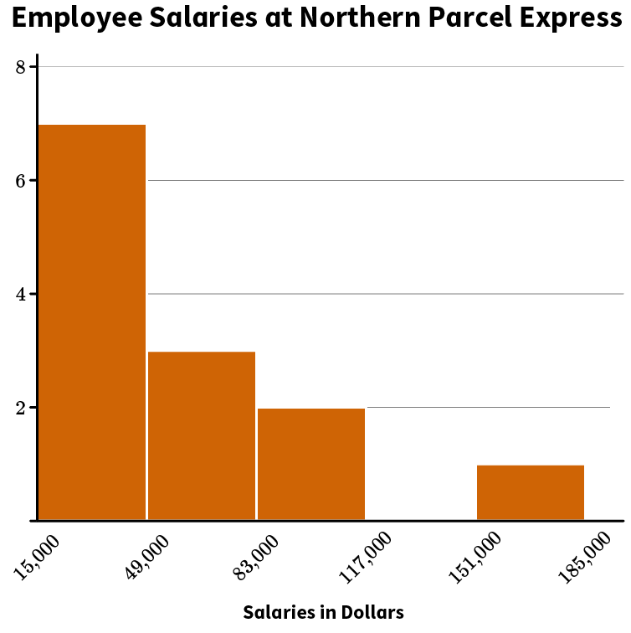  An auditor published the salaries of each employee from the CEO to the interns at Speedy Shipping Co. and at Northern Parcel Express. The salaries are summarized in histograms. Which statement best compares the median salaries at the two companies?  Correct Answer: Speedy Shipping Co. has the greater median salary because the overall salaries are higher, and the data is not as far skewed to the right as Northern Parcel Express.  Univariate Datasets Unit Test Item #17 | Desmos
18 | Lesson 2: Describing Distributions | In this section, you will formulate questions about datasets that could be answered by describing the shape, center, and spread of the data, and that are displayed with histogram models. | Model with mathematics. | Grades Frequency  50–64 2  65-74 4  75-80 1  81-85 5  85-94 8  95-100 6  The table represents the data in a histogram. In 1–2 sentences, describe the shape of the data, find the mode, and find the range of the data.  Correct Answer: Students should find that the data are skewed right, the mode is 85–94, and the range is 50 (50 = 100 − 50).  Univariate Datasets Unit Test Item #18 | Desmos
19 | Lesson 2: Describing Distributions | In this section, you will formulate questions about datasets that could be answered by describing the shape, center, and spread of the data, and that are displayed with box plot models. | Model with mathematics. | The following dataset represents the number of eggs laid in the chicken coop each day for the past week.  5, 8, 0, 3, 2, 7, 4  In 3–5 sentences, find the five-number summary, create a box plot, and describe the distribution of data using the box plot and explain what the distribution means.  Correct Answer: Students should find that the data in order are: 0, 2, 3, 4, 5, 7, 8. The minimum of the dataset is 0. The maximum of the dataset is 8. The median of the dataset is 4. Q1 is 2, and Q3 is 7. The distribution is symmetrical, meaning it is evenly spread around the median.  Univariate Datasets Unit Test Item #19 | Desmos  Univariate Datasets Unit Test Item #19 - GeoGebra
20 | Lesson 3: Centers of Distributions | In this section, you will explain how the shape of distribution determines the most appropriate measure of center. | Model with mathematics. | 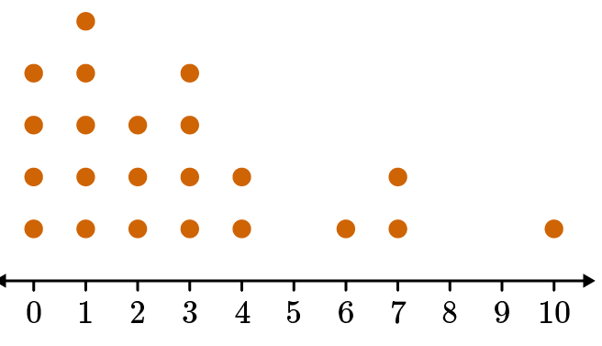  You are trying to find the average number of siblings that your classmates have. In 3–5 sentences, explain whether the distribution of the data you gathered is symmetrical or skewed and if the mean or median would be the most appropriate center. Also calculate and state the mean and median in your response. Finally, state the best measure of center for the number of siblings.  Correct Answer: The student should explain that the dataset distribution is skewed to the right; therefore, the median would be the most appropriate measure of center. Using the data, the student will find that the mean is 2.8 and the median is 2. The median shows that the average number of siblings per classmate is 2.  Univariate Datasets Unit Test Item #20 | Desmos  Univariate Datasets Unit Test Item #20 - GeoGebra
21 | Lesson 8: Comparing Distributions | In this section, you will compare two or more related symmetric distributions. | Use appropriate tools strategically. | 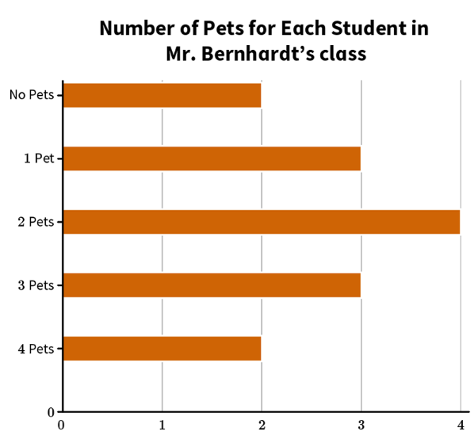  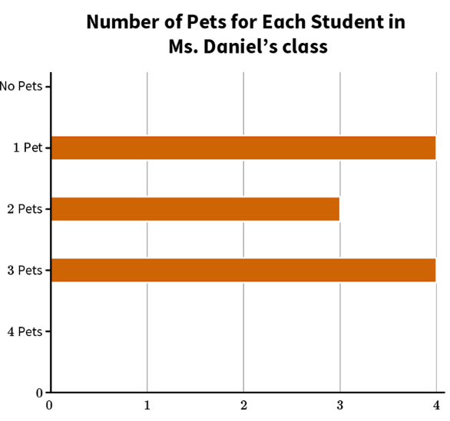  Compare the graphs showing the number of pets each student in Mr. Bernhardt’s and Ms. Daniel’s classes has. In 3–5 sentences, state whether the distributions are symmetric and provide at least two similarities and two differences.  Correct Answer: Student responses should state that the distributions are symmetric for both Mr. Bernhardt’s class and Ms. Daniel’s class. Both classes have the same median value, the same average value, and are measuring the same idea. They are different because the datasets have different maximum values, different minimum values, and different values for the mode.  Univariate Datasets Unit Test Item #21 | Desmos  Univariate Datasets Unit Test Item #21 - GeoGebra
22 | Lesson 8: Comparing Distributions | In this section, you will compare two or more related skewed distributions. | Use appropriate tools strategically. | 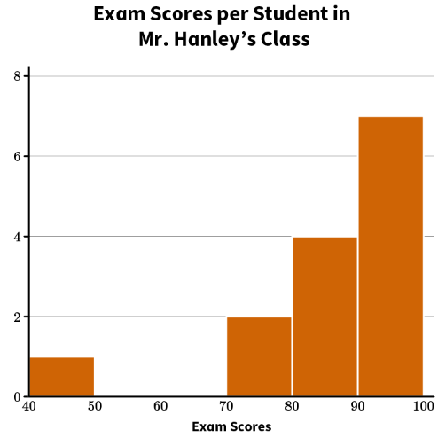  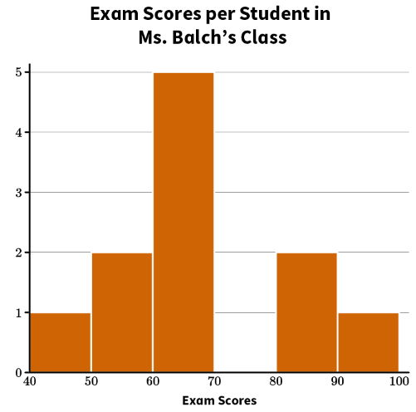  Mr. Hanley and Ms. Balch gave an identical Algebra final exam to their classes. The histograms show the distribution of the scores for each class. In 3–5 sentences, compare the histograms and explain which class you think performed better on the exam. Use information from the histograms such as data skew as well as median scores for both classes to justify your response.  Correct Answer: Student answers should explain that the histogram for Mr. Hanley’s class reveals a distribution of scores that is skewed to the left with a median score between 90 percent and 100 percent. By comparison, Ms. Balch’s score distribution is nearly symmetrical, but is marginally skewed to the right. The median score for Ms. Balch’s class is between 60 percent and 70 percent, meaning that half of her class scored at or below this. Because of the higher median score and more favorable skew toward higher scores, Mr. Hanley’s class performed better on the exam.  Univariate Datasets Unit Test Item #22 | Desmos

