Algebra 1 Unit Test Guide

Function Analysis Unit Test

Item | Lesson Coverage | Objective | Mathematical Practice Standard | Assessment Item
1 | Lesson 2: Piecewise Linear Functions | In this section, you will graph piecewise linear functions given equations. | Model with mathematics. | 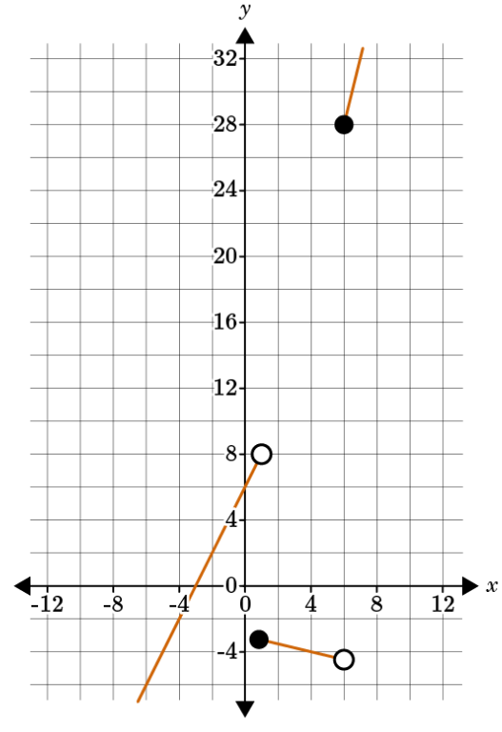  Is this the correct graph for the piecewise function:  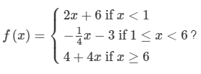  Correct Answer: 1 for yes  Function Analysis Unit Test Item #1 | Desmos  Function Analysis Unit Test Item #1 - GeoGebra
2 | Lesson 2: Piecewise Linear Functions | In this section, you will write equations of piecewise linear functions from graphs. | Model with mathematics. | 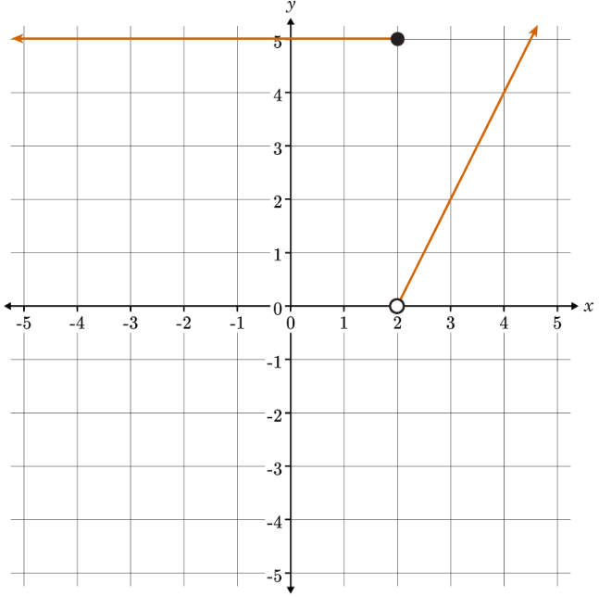  What is the piecewise function for the graph?  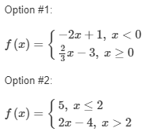  Correct Answer: Option #2  Function Analysis Unit Test Item #2 | Desmos  Function Analysis Unit Test Item #2 - GeoGebra
3 | Lesson 3: Quadratic Functions in Vertex Form | In this section, you will graph quadratics given in vertex form. | Model with mathematics. | 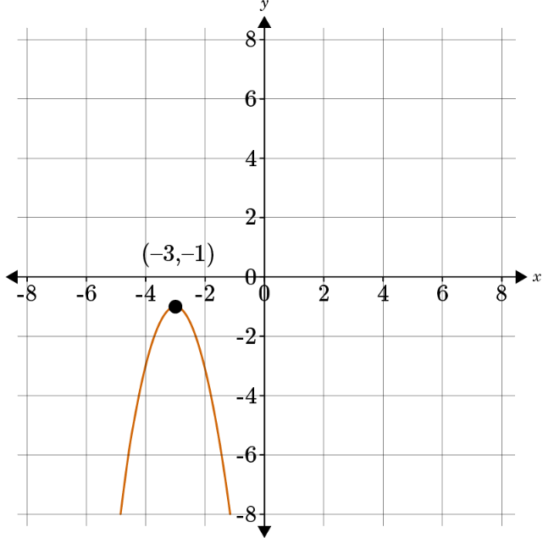  What is the vertex form of the graphed equation?  $$y=-2{\left(x- ? \right)}^{2}+?$$  Correct Answer: -3, -1  Function Analysis Unit Test Item #3 | Desmos  Function Analysis Unit Test Item #3 - GeoGebra
4 | Lesson 3: Quadratic Functions in Vertex Form | In this section, you will write equations of quadratics in vertex form given a graph. | Model with mathematics. | 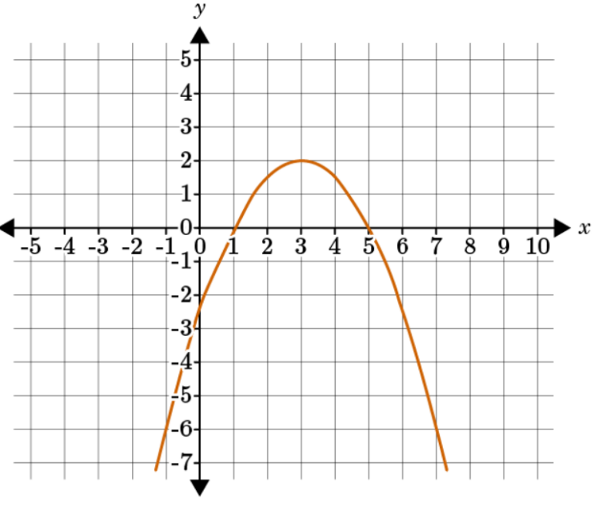  Use the graph to write the equation of the quadratic function in vertex form.  $y=-\frac{1}{2}{\left(x- ?\right)}^{2}+ ?$  Correct Answer: 3, 2  Function Analysis Unit Test Item #4 | Desmos  Function Analysis Unit Test Item #4 - GeoGebra
5 | Lesson 4: Quadratic Functions in Standard Form | In this section, you will graph quadratic functions given in standard form. | Model with mathematics. | A soccer ball is kicked from the ground at an upward velocity of 25 feet per second. This situation can be represented by the function $f\left(x\right)=-16x^{2}+25x$. Graph the function. Identify the x-intercept(s) and interpret its meaning.  Correct Answer: (1.563, 0) The soccer ball will return to the ground 1.563 seconds after it has been kicked.  Function Analysis Unit Test Item #5 | Desmos  Function Analysis Unit Test Item #5 - GeoGebra
6 | Lesson 4: Quadratic Functions in Standard Form | In this section, you will write quadratic equations in standard form given a graph. | Model with mathematics. | 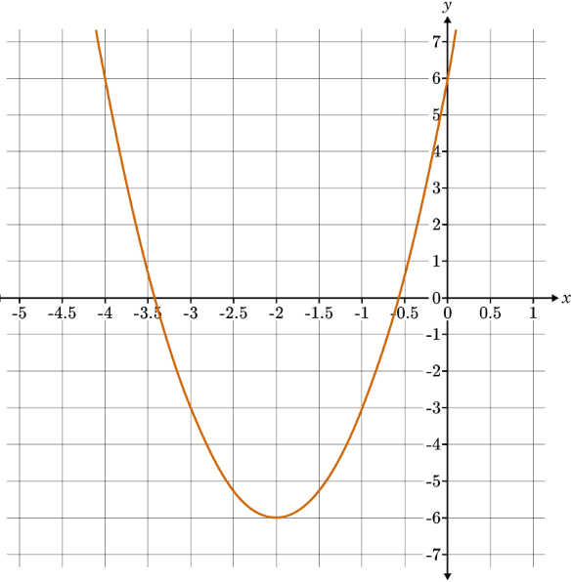  Determine the value of the constant term of the quadratic function in standard form, given its graph.  The value of c in the standard form of the quadratic function $y=ax^{2}+bx+c$ is ____.  Correct Answer: 6  Function Analysis Unit Test Item #6 | Desmos  Function Analysis Unit Test Item #6 - GeoGebra
7 | Lesson 5: Exponential Functions | In this section, you will graph exponential functions given equations. | Model with mathematics. | The function $y=4{\left(6\right)}^{x}$models the number of people who have watched a video after t days. Graph the function to determine how many people initially watched the video by finding the y-intercept.  Correct Answer: 4 people  Function Analysis Unit Test Item #7 | Desmos  Function Analysis Unit Test Item #7 - GeoGebra
8 | Lesson 5: Exponential Functions | In this section, you will write equations for exponential functions given a graph. | Model with mathematics. | 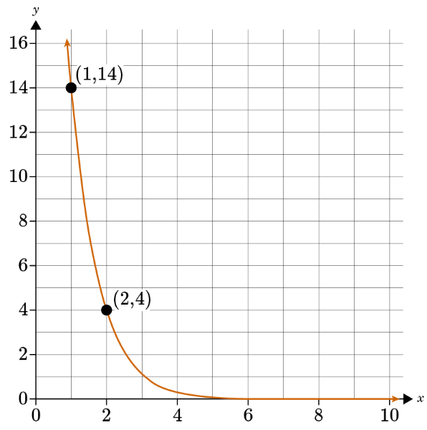  Given the graph of the exponential equation, which option is the correct exponential equation for the graph?  Option #1: $y=7{\left(\frac{1}{2}\right)}^{x}$  Option #2: $y=49{\left(\frac{2}{7}\right)}^{x}$  Option #3: $y=7{\left(\frac{2}{7}\right)}^{x}$  Option #4: $y=49{\left(\frac{7}{2}\right)}^{x}$  Correct Answer: Option #2 is the correct equation for the graph.  Function Analysis Unit Test Item #8 | Desmos  Function Analysis Unit Test #8 - GeoGebra
9 | Lesson 6: Square Root Functions | In this section, you will graph square root functions given equations. | Model with mathematics. | Graph the square root functions $f\left(x\right)=\sqrt{x-2}$ and $g\left(x\right)=\sqrt{2-x}$. Which function has a y-intercept? Enter the correct option number.  Option 1: $f\left(x\right)$  Option 2: $g\left(x\right)$  Option 3: both $f\left(x\right) and g\left(x\right)$  Correct Answer: Option 2  Function Analysis Unit Test Item #9 | Desmos  Function Analysis Unit Test Item #9 - GeoGebra
10 | Lesson 6: Square Root Functions | In this section, you will identify key features of square root functions from graphs and compare with related quadratic functions. | Model with mathematics. | What are the coordinates of the minimum point for the square root function that relates to the quadratic function $f\left(x\right)=\frac{1}{2}{\left(x-11\right)}^{2}+4$  Correct Answer: (4, 11)  Function Analysis Unit Test Item #10 | Desmos  Function Analysis Unit Test Item #10 - GeoGebra
11 | Lesson 7: Cube Root Functions | In this section, you will graph cube root functions given equations. | Model with mathematics. | Does the graph of the function $y=3\sqrt[3]{\left(x-1\right)}$ show that the function is increasing or decreasing?  Option 1: increasing  Option 2: decreasing  Correct Answer: Option 1  Function Analysis Unit Test Item #11 | Desmos  Function Analysis Unit Test Item #11 - GeoGebra
12 | Lesson 7: Cube Root Functions | In this section, you will identify key features from the graph of a cube root function and compare them to the features of the graph of a square root function. | Model with mathematics. | 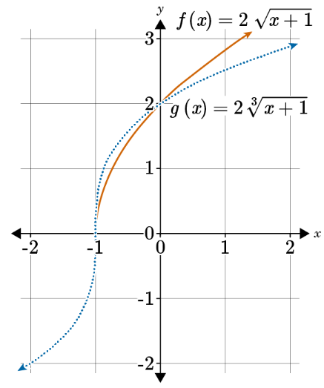  Compare the graphs of $f\left(x\right)=2\sqrt{\left(x+1\right)}$ and $g\left(x\right)=2\sqrt[3]{\left(x+1\right)}$. What is the y-intercept of both graphs?  Correct Answer: 2  Function Analysis Unit Test Item #12 | Desmos  Function Analysis Unit Test Item #12 - GeoGebra
13 | Lesson 8: Comparing Shapes of Functions | In this section, you will compare the shapes of linear, quadratic, exponential, and cubic functions. | Model with mathematics. | $$x$$ $$f(x)$$ $$g(x)$$  -2 -1 3  -1 $$\frac{3}{4}$$ $$\frac{3}{4}$$  0 1 0  1 $$1\frac{3}{4}$$ $$\frac{3}{4}$$  2 3 3  Compare the functions $f\left(x\right)$ and $g\left(x\right)$. When is $f\left(x\right)$ greater than $g\left(x\right)$?  $f\left(x\right)$ is greater than $g\left(x\right)$ when _____$<x<$_____.  Correct Answer: -1, 2  Function Analysis Unit Test Item #13 | Desmos  Function Analysis Unit Tet Item #13 - GeoGebra
14 | Lesson 8: Comparing Shapes of Functions | In this lesson, you will compare the shapes of square root and cube root graphs. | Model with mathematics. | 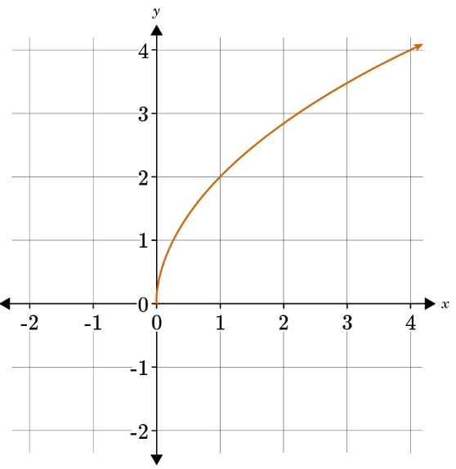  Select the option that matches the graph.  Option #1: The graph of the function matches $f\left(x\right)=2\sqrt[3]{x}$  Option #2: The graph of the function matches $f\left(x\right)=2\sqrt{x}$  Correct Answer: Option #2  Function Analysis Unit Test Item #14 | Desmos  Function Analysis Unit Test Item #14 - GeoGebra
15 | Lesson 9: Average Rate of Change | In this lesson, you will calculate the average rate of change between two points using a variety of functions. | Model with mathematics. | Use the formula $\frac{f\left(b\right)-f\left(a\right)}{b-a}$ to calculate the average rate of change over the interval [-2, -1] given the function table for $y=3^{x+2}$. Express your answer as an integer.  $$x$$ $$f(x)$$  -3 $$\frac{1}{3}$$  -2 1  -1 3  0 9  Correct Answer: 2  Function Analysis Unit Test Item #15 | Desmos  Function Analysis Unit Test Item #15 - GeoGebra
16 | Lesson 9: Average Rate of Change | In this lesson, you will describe function graphs in terms of average rates of change. | Model with mathematics. | 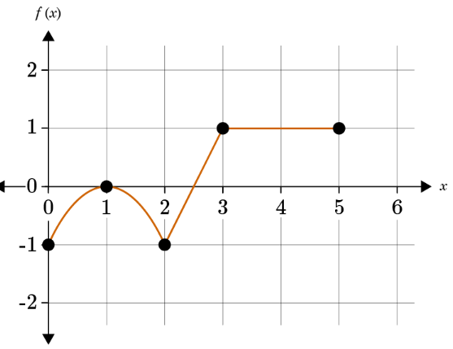  Describe the behavior of the function by determining over which interval the function has a negative average rate of change.  The average rate of change is negative over the interval [____, ____].  Correct Answer: [1,2]
17 | Lesson 10: Comparing Average Rates of Change | In this section, you will compare estimated average rates of change of quadratic and exponential functions. | Model with mathematics. | 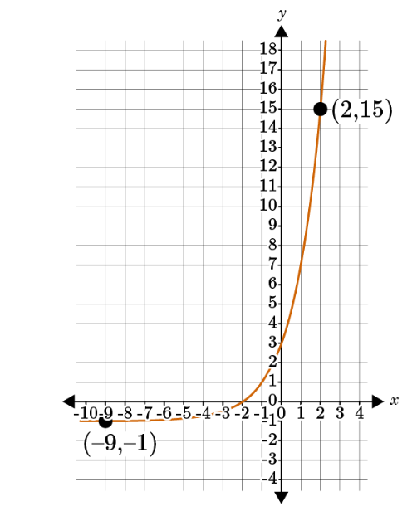  Compare the estimated average rates of change of the exponential function pictured above and the quadratic function $f\left(x\right)=x^{2}-20$ over the interval [-9,2].  Correct Answer: The magnitude of the estimated average rate of change of the exponential function over the interval [-9,2] is less than the magnitude of the estimated average rate of change of f(x) over the interval [-9,2].  Function Analysis Unit Test Item #17 | Desmos  Function Analysis Unit Test Item #17 - GeoGebra
18 | Lesson 10: Comparing Average Rates of Change | In this lesson, you will compare estimated average rates of change of square root and cube root functions. | Model with mathematics. | $$x$$ $p\left(x\right)=√x$-5 $$q\left(x\right)=5\sqrt[3]{x-1}$$  0 -5 -5  1 -4 0  9 -2 10  Compare the estimated average rates of change for the function $p\left(x\right)=\sqrt{x}-5$ and $q\left(x\right)=5\sqrt[3]{\left(x-1\right)}$ over the interval [0.1, 8.9].  Correct Answer: The estimated average rate of change of $q\left(x\right)$ is greater than the estimated average rate of change of $p\left(x\right)$ over [0.1, 8.9].  Function Analysis Unit Test Item #18 | Desmos  Function Analysis Unit Test Item #18 - GeoGebra
19 | Lesson 8: Comparing Shapes of Functions | In this section, you will compare the shapes of linear, quadratic, exponential, and cubic functions. | Model with mathematics. | Graph and compare the shapes and key features of the functions $f\left(x\right)={\left(x+2\right)}^{2}$ and $g\left(x\right)=2x+4$ . In 3–5 sentences, explain how the two functions are similar and how they are different.  Correct Answer:  The student should explain that the function $f\left(x\right)={\left(x+2\right)}^{2}$ is U-shaped while the function $g\left(x\right)=2x+4$ is a straight line. The two graphs have the same domain, which is all real numbers. However, the two graphs have a different range. The range of the linear function is all real numbers. The range of the quadratic function is $y≥0$ . Also, the quadratic function has a minimum at (-2, 0), but the linear function does not have a minimum. Also, (-2,0) is the x-intercept for the linear equation. $f\left(x\right)={\left(x+2\right)}^{2}$ and $g\left(x\right)=2x+4$ have the same y-intercept, (0,4).  Function Analysis Unit Test Item #19 | Desmos  Function Analysis Unit Test Item #19 - GeoGebra
20 | Lesson 8: Comparing Shapes of Functions | In this lesson, you will compare the shapes of square root and cube root graphs. | Model with mathematics. | Compare the square root and cube root functions by completing the following:  A) Complete an input-output table for the functions $f\left(x\right)=\sqrt{x}$ and $g\left(x\right)=\sqrt[3]{x}$ . You do not need to submit the tables.  B) Graph the functions by plotting the points from the input-output table. You do not need to submit the graphs.  C) In 3–5 sentences, discuss the similarities and differences between the graphs of the functions.  Correct Answer:  A) (For reference) The following is a sample input-output table for both functions.  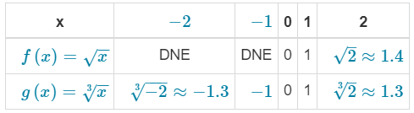  B) (For reference) The following are the plotted points and graphs of both functions.  $$f\left(x\right)=\sqrt{x}$$  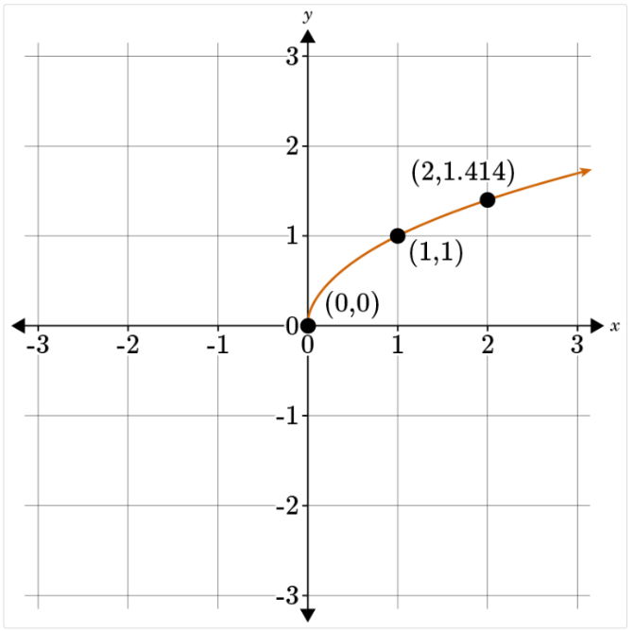  $$g\left(x\right)=\sqrt[3]{x}$$  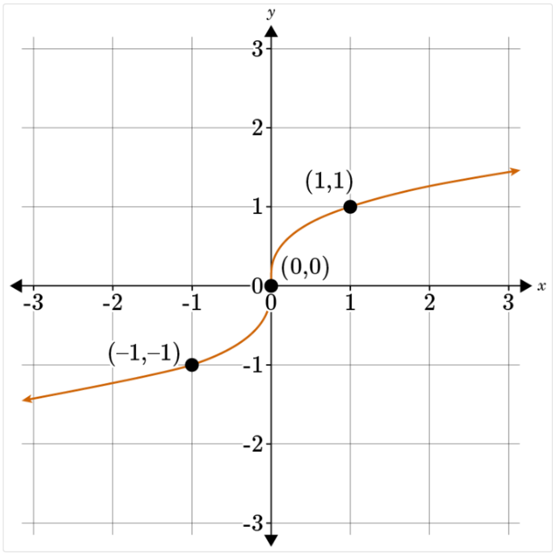  C) Students should note the similarities and differences. Sample answers include the following: The square root function, $f\left(x\right)$ , is not defined for negative values of $x$.  - The cube root function, $g\left(x\right)$ , is greater than $f\left(x\right)$ on the interval from 0 to 1.  - The graphs intersect at the points (0, 0) and (1, 1).  - After the intersection at $x=1$ , the square root function, $f\left(x\right)$ , is greater than $g\left(x\right)$.  - Both graphs are smooth curves.  - Both functions are increasing.  - $g\left(x\right)$ curves up for $x<0$ and curves down for $x>0$ . $f\left(x\right)$ curves down for $x>0$ .  Function Analysis Unit Test Item #20 | Desmos  Function Analysis Unit Test Item #20 - GeoGebra
21 | Lesso 9: Average Rate of Change | In this lesson, you will calculate the average rate of change between two points using a variety of functions. | Model with mathematics. | Time (hours) 0 4 7 9 12  Distance (miles) 0 248 449 565 757  The Diaz family went on a road trip for vacation. The table includes a cumulative chart of the time they traveled compared to the distance they drove. Over which interval was their average speed the fastest: [0, 4], [4, 7], [7, 9], or [9, 12]? Explain your reasoning in 1–2 sentences.  Correct Answer:  - Over the first interval [0, 4], the average rate of change is:  $\frac{248-0}{4-0}=62$ miles per hour.  - Over the second interval [4,7], the average rate of change is: $\frac{449-248}{7-4}=67$ miles per hour.  - Over the third interval [7, 9], the average rate of change is: $\frac{565-449}{9-7}=58$ miles per hour.  - Over the fourth interval [9, 12], the average rate of change is: $\frac{757-565}{12-9}=64$ miles per hour.  - The family averaged the fastest speed of 67 miles per hour during the second interval of the trip [4, 7].
22 | Lesson 9: Average Rate of Change | In this lesson, you will describe function graphs in terms of average rates of change. | Model with mathematics. | 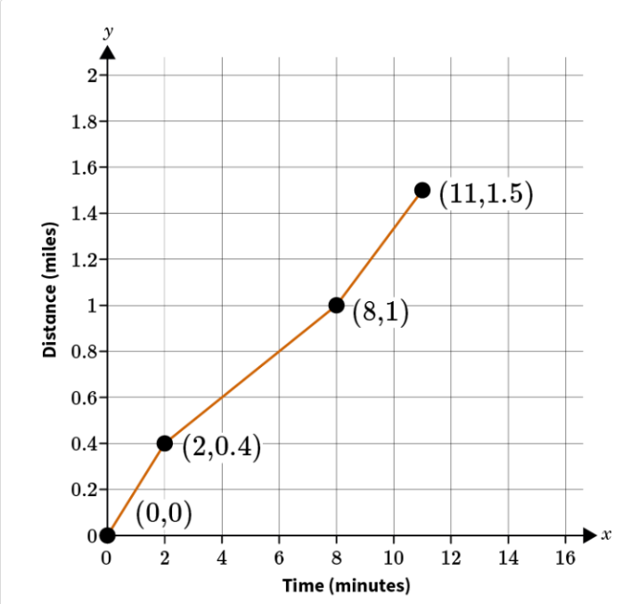  Riley is training to run a 5-mile race. The graph represents the distance (miles) she ran with respect to time (minutes) in her first training run. Over which time interval did she run the fastest, [0, 8] or [2, 11]? Justify your answer in 1–2 sentences.  Correct Answer:  - The average rate of change over the interval $\left[0, 8\right]=\frac{1-0}{8-0}=0.125$ miles per minute.  - The average rate of change over the interval $\left[2, 11\right]=\frac{1.5-0.4}{11-2}≈0.122$ miles per minute.  - Riley ran the fastest over the interval [0, 8].

