Algebra 1 Unit Test Guide

Solving Problems with Functions

Item | Lesson Coverage | Objective | Mathematical Practice Standard | Assessment Item
1 | Lesson 2: The Usefulness of Graphs | In this section, you will show how equations can be solved by creating functions with the expressions and finding their intersection(s) to reveal the solution(s). | Model with mathematics. | To show how to solve the equation, create two functions and find their intersection points. What two functions can be used to solve the following equation, and what is their solution set?  $$10-x^{2}=x+4$$  Correct Answer: $f\left(x\right)=10-x^{2}, g\left(x\right)=x+4, \left\{-3, 2\right\}$  Solving Problems with Functions Unit Test Item #1 | Desmos  Solving Problems with Functions Unit Test Item #1 - GeoGebra
2 | Lesson 2: The Usefulness of Graphs | In this section, you will use function graphs to solve equations with a constant on one side. | Model with mathematics. | What function should be graphed in order to solve the equation $9x-6=-8$?  Correct Answer: $f\left(x\right)=9x+2$
3 | Lesson 2: The Usefulness of Graphs | In this section, you will use function graphs to solve equations with algebraic expressions on both sides. | Model with mathematics. | 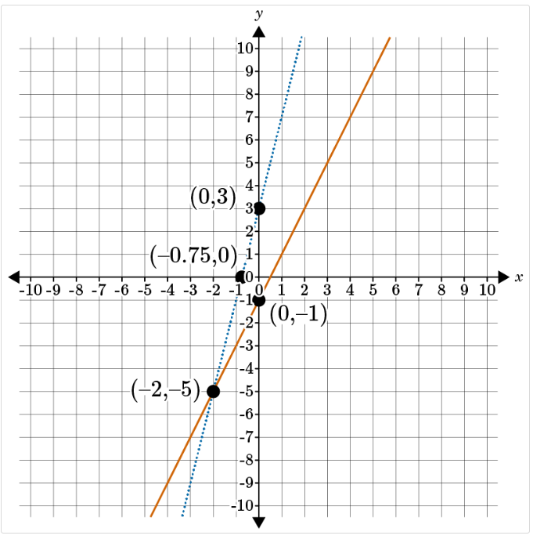  What is the solution to the equation $2x-1=4x+3$?  Correct Answer: -2  Solving Problems with Functions Unit Test Item #3 | Desmos  Solving Problems with Functions Unit Test Item #3 - GeoGebra
4 | Lesson 3: Linear Functions in Context | In this section, you will create linear function equations and graphs from real-life situations. | Make sense of problems and persevere while solving them. | You are traveling home from work. You are decreasing the distance as you walk home. Your house is 41 blocks away, and you walk 3 blocks per minute. Create a linear equation that represents the situation. How many minutes will it take, to the nearest minute, to get home?  Correct Answer: $y=41-3x$; 14 minutes  Solving Problems with Functions Unit Test Item #4 | Desmos  Solving Problems with Functions Unit Test Item #4 - GeoGebra
5 | Lesson 3: Linear Functions in Context | In this section, you will interpret graphs of linear functions in context. | Model with mathematics. | 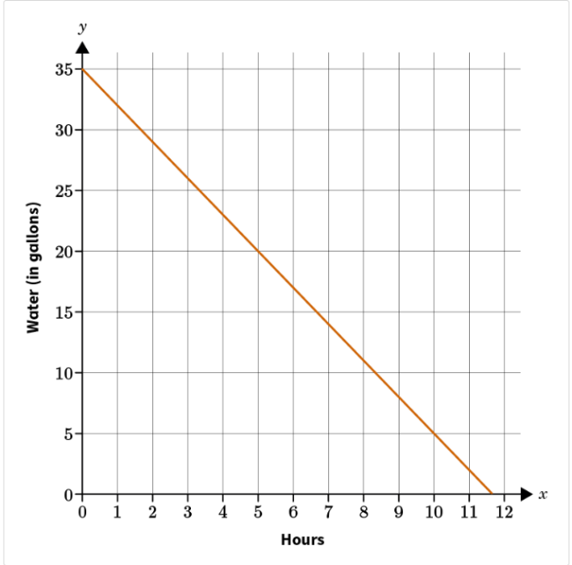  A water tank is being slowly emptied to remove it and replace it with another one. The graph shows the declining water level of gallons in hours. Approximately how long will it take for the water tank to be emptied?  Correct Answer: 11.7 hours  Solving Problems with Functions Unit Test Item #5 | Desmos  Solving Problems with Functions Unit Test Item #5 - GeoGebra
6 | Lesson 3: Linear Functions in Context | In this section, you will use linear function graphs to solve real-world problems. | Model with mathematics. | 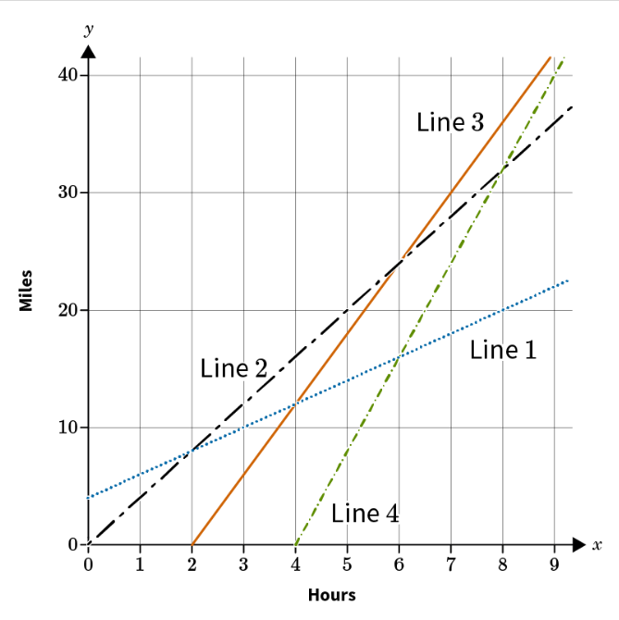  Brandi and her daughter, Ella, are training for a hiking challenge. Because Brandi hikes at a slower pace than her daughter, she begins the practice hike two hours earlier. If Brandi averages a pace of 4 mph, the linear equation $y=4x$can be used to model her distance, y, in miles with respect to her time, x, in hours. If Ella averages a pace of 6 mph and begins two hours after her mom, the linear equation $y=6x-12$can be used to model her distance, y, in miles with respect to time, x, in hours. The graph of which two lines can be used to find the time and distance when Ella catches up with her mother?  Option #1: Line 1 and Line 2  Option #2: Line 2 and Line 3  Option #3: Line 3 and Line 4  Option #4: Line 1 and Line 4  Correct Answer: The lines in option #2 can be used to determine when Ella catches up with her mother.  Solving Problems with Functions Unit Test Item #6 | Desmos  Solving Problems with Functions Unit Test Item #6 - GeoGebra
7 | Lesson 4: Piecewise Linear Functions in Context | In this section, you will create piecewise linear function equations and graphs. | Make sense of problems and persevere in solving them. | 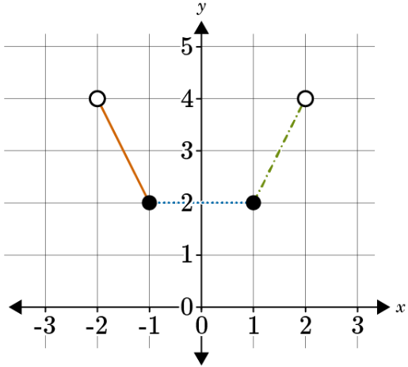  Which option represents the piecewise function of the graph?  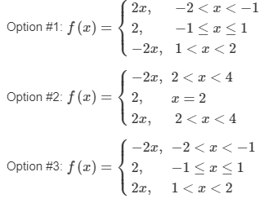  Correct Answer: Option #3 is the correct equation for the piecewise graph.  Solving Problems with Functions Unit Test Item #7 | Desmos  Solving Problems with Functions Unit Test Item #7 - GeoGebra
8 | Lesson 4: Piecewise Linear Functions in Context | In this section, you will interpret the graphs of piecewise linear functions through their contextual meaning. | Model with Mathematics. | 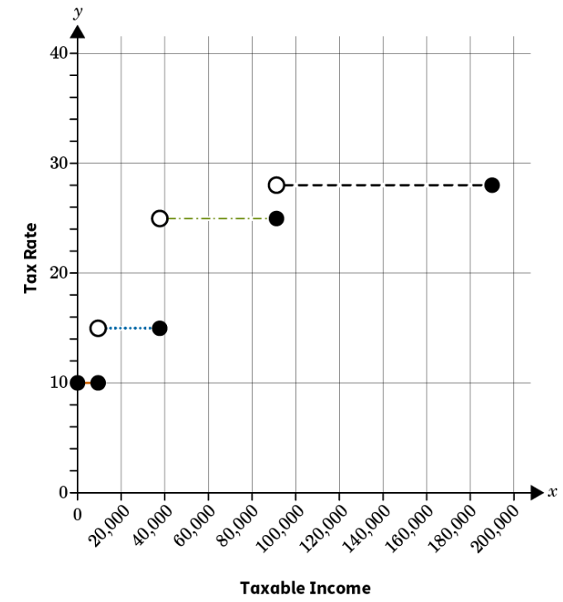  A family has $98,150 of taxable income. The top tax rate on the graph is for taxable income over $91,150. What is the tax rate for the $7,000 they earned over $91,150?  The tax rate for the $7,000 of taxable income earned over $91,150 is ____%.  Correct Answer: 28%  Solving Problems with Functions Unit Test Item #8 | Desmos  Solving Problems with Functions Unit Test Item #8 - GeoGebra
9 | Lesson 4: Piecewise Linear Functions in Context | In this section, you will use piecewise linear function graphs to solve real-world problems. | Model with Mathematics. | 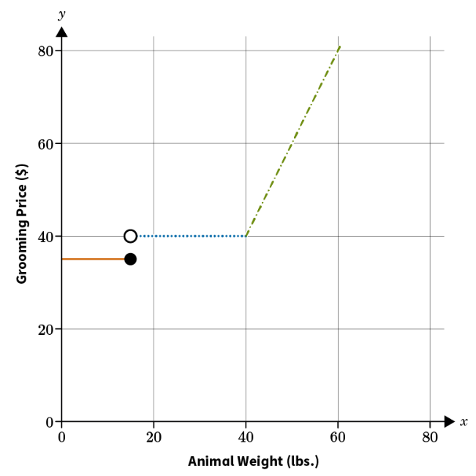  Jamal has a 20-pound dog and a 45-pound dog. How much would it cost for him to have both dogs groomed?  The total cost to have both dogs groomed is $____.  Correct Answer: 90  Solving Problems with Functions Unit Test Item #9 | Desmos  Solving Problems with Functions Unit Test Item #9 - GeoGebra
10 | Lesson 5: Exponential Functions in Context | In this section, you will create exponential functions and graphs in the context of real-world problems. | Make sense of problems and persevere in solving them. | A radioactive substance decays at a rate of 6% each year. If the initial amount of the substance was 600 grams, create an exponential function to model the decay of the substance. Which of the following options correctly models the decay?  Option #1: $f\left(x\right)=600{\left(0.06\right)}^{x}$  Option #2: $f\left(x\right)=600{\left(1.06\right)}^{x}$  Option #3: $f\left(x\right)=600{\left(0.6\right)}^{x}$  Option #4:$f\left(x\right)=600{\left(0.94\right)}^{x}$  Correct Answer: Option #4  Solving Problems with Functions Unit Test Item #10 | Desmos  Solving Functions with Problems Unit Test Item #10 - GeoGebra
11 | Lesson 5: Exponential Functions in Context | In this section, you will interpret graphs of exponential functions describing a specific context. | Model with mathematics. | 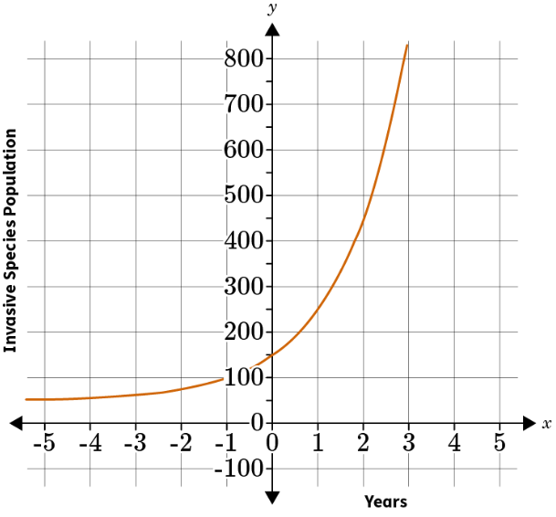  Two college roommates are studying an invasive species at the local park. What was the size of the population when they began recording data on the invasive species? (Round to the nearest tens.)  When they began recording their data, the population of the invasive species was ____.  Correct Answer: 150  Solving Problems with Functions Unit Test Item #11 | Desmos  Solving Problems with Functions Unit Test Item #11 - GeoGebra
12 | Lesson 5: Exponential Functions in Context | In this section, you will use graphs of exponential functions to solve word problems. | Model with mathematics. | 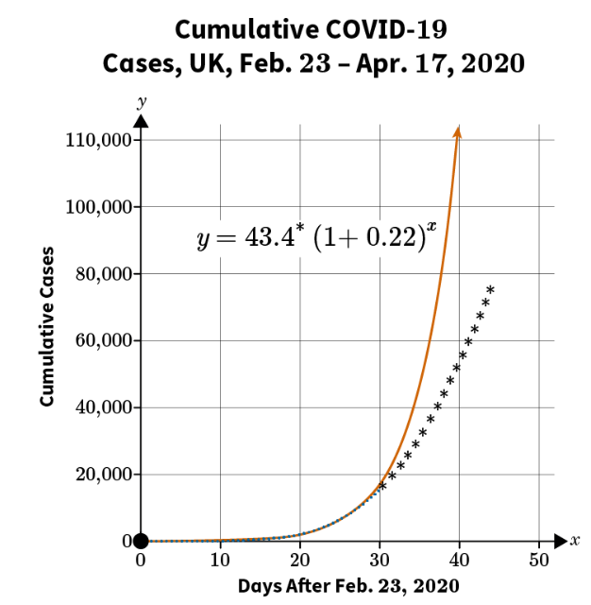  The graph shows the total number of COVID-19 cases in the UK from February 23 to April 17 in 2020. Each value in the x-axis shows days since COVID cases started to be measured in the UK, with “day 1” representing February 23. The y-axis shows the total number of cases per day. Which of the following correctly uses the graph to determine the best estimate for the number of COVID-19 cases in the UK on day 22?  Correct Answer: 3,500 cases  Solving Problems with Functions Unit Test Item #12 | Desmos  Solving Problems with Functions Unit Test Item #12 - GeoGebra
13 | Lesson 6: Quadratic Functions in Context | In this section, you will create quadratic function equations and graphs in the context of solving real-world problems. | Make sense of problems and persevere in solving them. | When calculating the effect of Earth’s gravitational pull on a launched projectile, the expression $-16t^{2}$ is used to represent that the projectile falls at a rate of 16 feet per second squared. If a toy rocket is launched vertically upward from the ground at an initial velocity of 132 feet per second, what will be its maximum height? Round to the nearest hundredth.  Correct Answer: 272.25 feet  Solving Problems with Functions Unit Test Item #13 | Desmos  Solving Problems with Functions Unit Test Item #13 - GeoGebra
14 | Lesson 6: Quadratic Functions in Context | In this section, you will interpret graphs of quadratic functions and their contextual meaning. | Reason abstractly and quantitatively. | While hiking, Julia kicked a small rock off a ledge that was meters above a crevasse. Use GeoGebra to graph the situation using the formula $y=-4.9t^{2}+9$. Use the graph to determine when the rock will hit the bottom of the crevasse, 2 meters below ground level. Round your answer to the nearest tenth of a second.  The rock will hit the bottom of the crevasse in ____ seconds.  Correct Answer: 1.5  Solving Problems with Functions Unit Test Item #14 | Desmos  Solving Problems with Functions Unit Test Item #14 - GeoGebra
15 | Lesson 6: Quadratic Functions in Context | In this section, you will use quadratic function graphs to solve contextual problems. | Model with mathematics. | 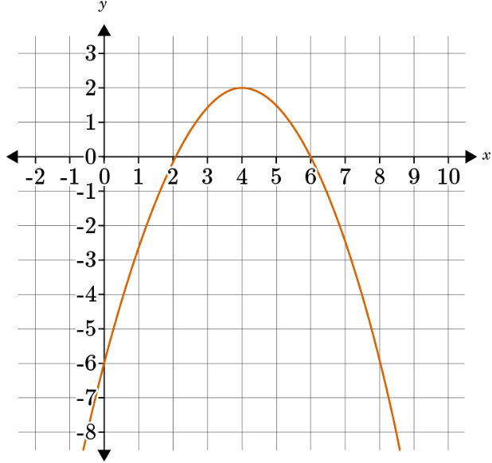  A sports analyst graphed the trajectory of a soccer ball that was kicked by a goalkeeper. In the graph, x is the ball’s distance from the goalpost, and y is the height of the ball in meters. What is the maximum height that the kicked ball reached?  The maximum height of the kicked ball was ____ meters.  Correct Answer: 2
16 | Lesson 7: Multiple Function Types in Context | In this section, you will compare function equations and graphs in related contexts to one another. | Model with mathematics. | Function 1: $f\left(x\right)=\frac{3}{2}x+5$  Function 2:  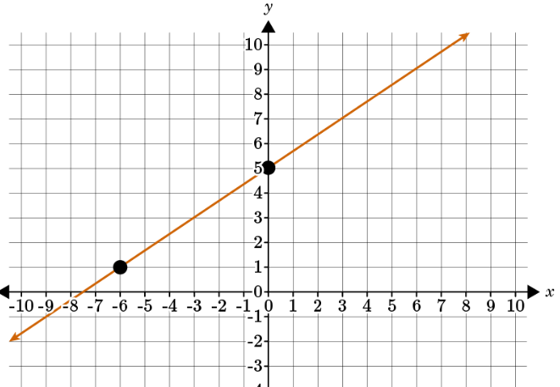  Which function has the greater rate of change?  Type 1 for Function 1.  Type 2 for Function 2.  Correct Answer: 1
17 | Lesson 7: Multiple Function Types in Context | In this section, you will interpret contextual graphs of different functions on the same axes. | Model with mathematics. | Salim purchased a new car for $21,000, and it depreciates in value each year. The function $y=21,000{\left(1-0.15\right)}^{x}$ represents the depreciation. He also purchases a motorcycle, which depreciates each year as well. Its depreciation is represented by the function $y=14,000{\left(1-0.09\right)}^{x}$. Graph these two functions using GeoGebra.  Which statement best describes when the motorcycle will be worth $7,000?  Statement #1: The motorcycle will have a value of $7,000 after roughly 7.3 years. Statement #2: The motorcycle will have a value of $7,000 after roughly 6.7 years.  Correct Answer: Statement #1  Solving Problems with Functions Unit Test Item #17 and #18 | Desmos  Solving Problems with Functions Unit Test Item #17 - GeoGebra
18 | Lesson 7: Multiple Function Types in Context | In this section, you will interpret contextual graphs of different functions on the same axes. | Model with mathematics. | Salim purchased a new car for $21,000, and it depreciates in value each year. The function $y=21,000{\left(1-0.15\right)}^{x}$ represents the depreciation. He also purchases a motorcycle, which depreciates each year as well. Its depreciation is represented by the function $y=14,000{\left(1-0.09\right)}^{x}$. Graph these two functions using GeoGebra.  Which statement best describes when the car will be worth $4,000?  Statement #1: The car will have a value of $4,000 after roughly 10.2 years.  Statement #2: The car will have a value of $4,000 after roughly 13.3 years.  Correct Answer: Statement #1  Solving Problems with Functions Unit Test Item #17 and #18 | Desmos  Solving Problems with Functions unit Test Item #18 - GeoGebra
19 | Lesson 7: Multiple Function Types in Context | In this section, you will use multiple function graphs to solve real-world problems. | Model with mathematics. | 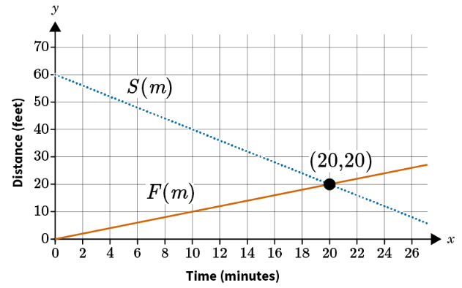  Silvio is meeting his friend Fernando at a café. In the graph, $S\left(m\right)$ represents Silvio’s path and $F\left(m\right)$ represents Fernando’s path to the café. How long will it take for both of them to arrive at the café?  Correct Answer: 20 minutes  Solving Problems with Functions Unit Test Item #19 | Desmos  Solving Problems with Functions Unit Test Item #19 - GeoGebra
20 | Lesson 8: Combining Function Types in Context | In this section, you will use pieces of different functions to represent and describe the behavior of a real-life scenario. | Model with mathematics. | 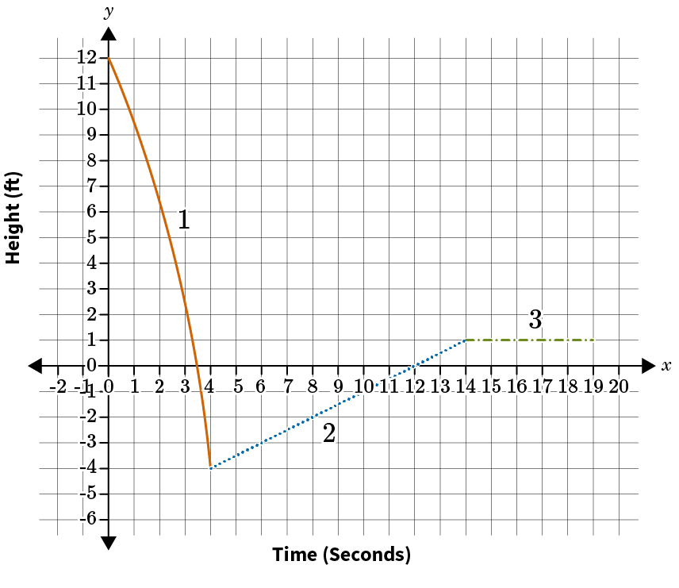  What scenario can be represented by the graph?  Correct Answer: A child slides down a water slide into a pool, swims at a constant rate to the edge of the pool, then exits the pool to grab their towel.
21 | Lesson 8: Combining Function Types in Context | In this section, you will combine functions to create new functions to represent situations. | Model with mathematics. | The heart rate of a person can be modeled by the function $r\left(a\right)=211-0.64a$ where $a$is the person's age in years and $r\left(a\right)$ is heartbeats per minute. The life span in minutes of a person is modeled by the function $s\left(a\right)=525,600a$.  Explain what $\left(r∙s\right)\left(a\right)$ represents.  Correct Answer: the total number of heartbeats in a lifetime of a person who is $a$years old
22 | Lesson 7: Multiple Function Types in Context | In this section, you will use multiple function graphs to solve real-world problems. | Model with mathematics. | 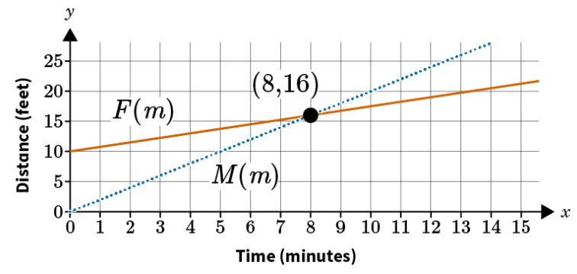  Francesca is meeting Mercedes at a store. The line labeled $F\left(m\right)$ shows the path Francesca will take, and the line labeled $M\left(m\right)$ represents the path of Mercedes. How long will it take for them to arrive at the store?  Correct Answer: The intersection point is (8,16), meaning it took 8 minutes for both people to arrive at the store.  Solving Problems with Functions Unit Test Item #22 | Desmos  Solving Problems with Functions Unit Test Item #22 - GeoGebra
23 | Lesson 8: Combining Function Types in Context | In this section, you will use pieces of different functions to represent and describe the behavior of a real-life scenario. | Model with mathematics. | In 1–2 sentences, describe what types of function can be used to describe each part of the following situation. You jumped from a high ledge into a pool of water, then swam to the other side of the pool and climbed up a ladder at a constant rate to get out of the pool. Compare your height around the surface of the pool water to the time.  Correct Answer:  The initial fall would be represented by a quadratic function. The swim across the pool would be represented by a constant function because there is no height change. Climbing the ladder would be represented by a linear function due to the constant rate and height change.
24 | Lesson 8: Combining Function Types in Context | In this section, you will use pieces of different functions to represent and describe the behavior of a real-life scenario. | Model with mathematics. | A rocket is shot straight up into the air. If $f\left(t\right)$ represents the height in feet of the rocket at time, $t$, seconds and $g\left(t\right)$ is a constant function that represents the height of a platform, what situation can be described by $\left(f+g\right)\left(t\right)$? Include a description of the domain of $\left(f+g\right)\left(t\right)$.  Correct Answer:  The function $\left(f+g\right)\left(t\right)$ is the height in feet at time, $t$, seconds of the rocket shot off the platform. The domain of the function is the set of all real numbers, $t$, such that $t≥0$. Students may also describe an upper bound on $t$corresponding to the time when the rocket is no longer in the air.

