Quadratic Equations
Formula Sheet
Name | Definition | Formula
Order of Operations | You need to know the order of operations to solve equations. To remember the order of operations, use the acronym PEMDAS. | P Parentheses  E Exponents  MD Multiplication and Division (left-to-right)  AS Addition and Subtraction (left-to-right)  Within each level, evaluate left to right.
Quadratic Equation | Any equation containing one term in which the unknown variable is squared and no term in which it is raised to a higher power. | Standard Form: $$ax^{2}+bx+c=0$$, where $$a≠0$$  Vertex Form: $$y=a{\left(x−h\right)}^{2}+k$$  Factored Form: a form in which a quadratic equation is expressed as a product of two algebraic expressions  - $$\left(x±a\right)\left(x±b\right)=0$$  - Other forms of factors are $$x$$, $$\left(ax±b\right)$$ , and $$\left(ax±b\right)$$  - where $$a$$and $$b$$are constants
Perfect Squares | A number obtained from squaring an integer (multiplying a number by itself). | $$n^{}$$ $$n^{2}$$  0 0  1 1  2 4  3 9  4 16  5 25  6 36  7 49  8 64  9 81  10 100  11 121  12 144
Zero Product Property | A property stating that if the product of two expressions or quantities is equal to zero, then at least one of the expressions or quantities is equal to zero. | If $$a⋅b=0$$then $$a=0$$, $$b=0$$, or both $$a$$and $$b$$ar zero.
Solutions of Quadratic Equations | Quadratic equations contain a variable that is squared. The result of having a squared variable is that every quadratic equation has either zero, one, or two solutions. | Once you have rewritten the quadratic equation into a form in which one side is only a squared variable and the other side is only a numeric expression then:  - If the numeric expression is less than zero, there are no solutions.  - If the numeric expression is equal to zero, there is one solution.  - If the numeric expression is greater than zero, there are two solutions.
Perfect Square Trinomial | A trinomial that follows a specific pattern and can be written as a square of a binomial. | 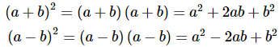  - The first and last terms of the trinomial $$\left(a^{2}−b^{2}\right)$$ are positive perfect squares.  - The middle term ($$2ab$$ or $$−2ab$$) is twice the product of $$a$$and $$b$$.
Difference of Two Squares | If there are only two terms that are perfect squares, and they are separated by a minus sign, it can be written as a difference of two squares. | $$a^{2}−b^{2}=\left(a+b\right)\left(a−b\right)$$
Completing the Square | Completing the square is a method of factoring. The process makes an expression into a perfect square trinomial and can be used to solve a quadratic equation. | Starting from the standard form of a quadratic equation, $$ax^{2}+bx+c=0$$, follow these steps:  - Move the constant term, $$c$$, to the right side of equation: $$ax^{2}+bx=−c$$  - Divide the coefficient of the middle term, $$b$$, by 2, then square the quotient: $${\left(\frac{b}{2}\right)}^{2}$$  - Add the number to both sides of the equation: $$ax^{2}+bx+{\left(\frac{b}{2}\right)}^{2}=−c+{\left(\frac{b}{2}\right)}^{2}$$  - Simplify and factor.
Quadratic Formula | A formula that gives the solutions of any quadratic equation in standard form. | $$x=\frac{−b±\sqrt{b^{2}−4ac}}{2a}$$  where $$a$$, $$b$$, and $$c$$are from the standard form of a quadratic equation: $$ax^{2}+bx+c=0$$
Discriminant of a Parabola | In the quadratic formula, $$b^{2}−4ac$$ is known as the discriminant of a parabola. The discriminant is used to determine what type of solutions a quadratic equation has. | 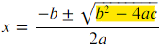  - If $$b^{2}−4ac$$ is positive, then there are two solutions  - If $$b^{2}−4ac$$ is zero, then there is one solution  - If $$b^{2}−4ac$$ is negative, then there are no solutions
Key Features of a Parabola | When you pot points using a quadratic equation, the graph is a parabola. It is shaped like an upward or downward U.  There are four key parts of a parabola: the axis of symmetry, the vertex, the zero(s), and the y-intercept. | 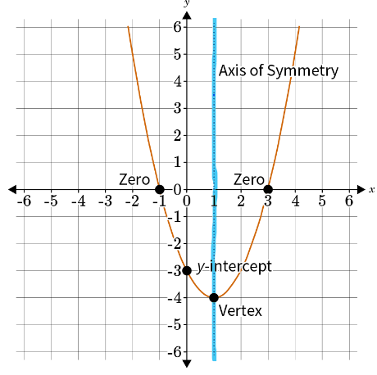
Vertex Form of a Quadratic Equation | When a quadratic equation is in vertex form, the axis of symmetry and vertex are easily identifiable. | - Axis of Symmetry: $$x=h$$  - Vertex: $$\left(h,k\right)$$

