Rational Expressions & Equations
Formula Sheet
Name | Definition | Formula
Commutative Property | A property of algebra that states that the order in which algebraic terms are added or multiplied together does not affect the sum or product of those terms. | Addition: $$a+b=b+a$$  Multiplication: $$ab=ba$$
Distributive Property | A property of algebra states that multiplying the sum of two or more addends by a number will give the same result as multiplying each addend individually by the number and then adding the products together. | $$a\left(b+c\right)=ab+ac$$
Polynomial Identity | A polynomial equation that is always true for any value of the variables. | Common Polynomial Identities:  $${\left(a+b\right)}^{2}=a^{2}+2ab+b^{2}$$  $${\left(a−b\right)}^{2}=a^{2}−2ab+b^{2}$$  $$\left(a−b\right)\left(a+b\right)=a^{2}−b^{2}$$  $$a^{3}+a^{3}=\left(a+b\right)\left(a^{2}−ab+b^{2}\right)$$  $$a^{3}−a^{3}=\left(a−b\right)\left(a^{2}+ab+b^{2}\right)$$
Rational Expression | An expression that is the ratio of two polynomials. | 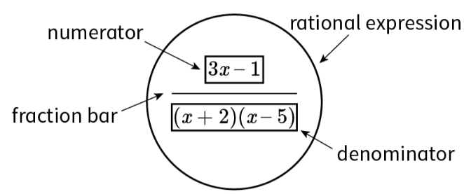
Keep, Flip, Change | “Keep, Flip, Change” is a mnemonic device to follow when changing a division problem into a multiplication problem. | 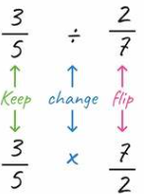
Quadratic Formula | The quadratic formula is a general formula for finding the solution to a quadratic equation. | $$x=\frac{−b±\sqrt{b^{2}−4ac}}{2a}$$  where a, b, and c are the coefficients and constant of the terms in a quadratic equation$$ax^{2}+bx+c$$.
Zero Product Property of Multiplication | The Zero Product Property holds that if the product of two or more factors is zero, then at least one factor must be zero. | If $$ab=0$$, then $$a=0, b=0,$$or both $$a$$and $$b$$equal to zero.
Multiplication Property of Equality | Multiplication Property of Equality says that you can multiply both sides of an equation by a non-zero quantity without changing the solutions to the equation. | If $$a=b$$then $$a⋅c=b⋅c$$

