Polynomial Functions & Graphs
Formula Sheet
Name | Definition | Formula
Zero Product Property | The Zero Product Property holds that if the product of two or more factors is zero, then at least one factor must be zero. | If $$ab=0$$, then $$a=0$$, $$b=0$$, or both $$a$$and $$b$$equal to zero.
Polynomial Identities | A polynomial equation that is always true for any value of the variables. | Common Polynomial Identities:  $${\left(a+b\right)}^{2}=a^{2}+2ab+b^{2}$$  $${\left(a−b\right)}^{2}=a^{2}−2ab+b^{2}$$  $$\left(a−b\right)\left(a+b\right)=a^{2}−b^{2}$$  $$a^{3}+a^{3}=\left(a+b\right)\left(a^{2}−ab+b^{2}\right)$$  $$a^{3}−a^{3}=\left(a−b\right)\left(a^{2}+ab+b^{2}\right)$$
The Factor Theorem | The Factor Theorem links factors and zeros of polynomials. | If $$c$$is a zero of a polynomial, then $$x−c$$is a factor of that polynomial.
Odd Multiplicity and Graph Behavior | If a factor is raised to an odd exponent, the graph will cross the x-axis. | 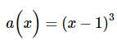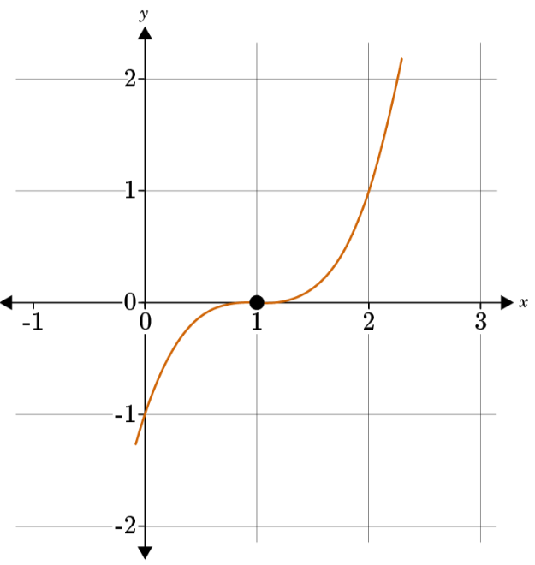
Even Multiplicity and Graph Behavior | If a factor is raised to an even exponent, the graph will touch the x-axis and turn back to the direction it came from. | 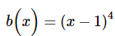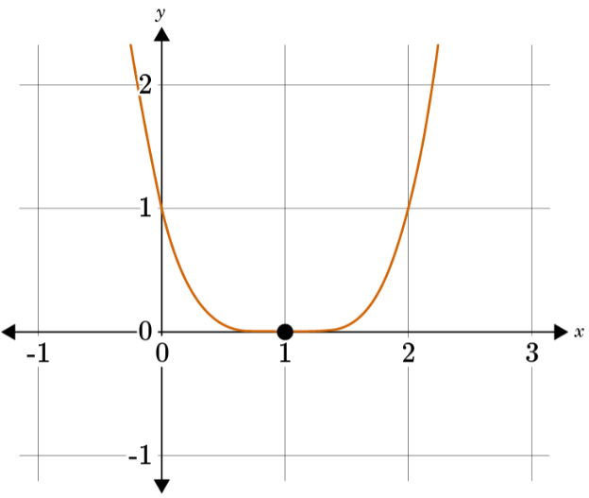
Quadratic Formula | The quadratic formula is a general formula for finding the roots of a quadratic equation. | $$x=\frac{−b±\sqrt{b^{2}−4ac}}{2a}$$  where a, b, and c are the coefficients and constant of the terms in a quadratic equation $$ax^{2}+bx+c$$
Relative Extrema | The degree of a polynomial relates to the number of relative extrema that the graph of a polynomial will have. | 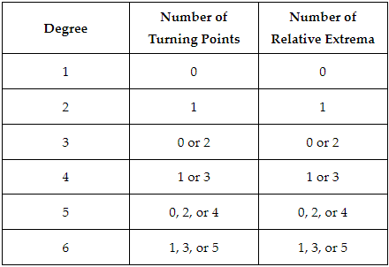
The Division Algorithm | The remainder is represented by adding it to the product of the quotient and divisor. | $$p\left(x\right)=d\left(x\right)⋅q\left(x\right)+r\left(x\right)$$  where  - $$p\left(x\right)$$ = polynomial  - $$d\left(x\right)$$ = divisor  - $$q\left(x\right)$$ = quotient  - $$r\left(x\right)$$ = remainder
The Remainder Theorem | The Remainder Theorem states that the remainder of dividing a polynomial by a factor is the value of the polynomial at that factor. | The value of a function, $$f\left(x\right)$$, at a given value, $$x−a$$, then divide the polynomial by $$f\left(x\right)$$ by the linear function $$x−a$$.
Single Motion Projectile | The formula that models the motion of an object where $$s\left(t\right)$$ is height and $$t$$is time. | $$s\left(t\right)=\frac{1}{2}gt^{2}+v_{0}t+s_{0}$$  where  - $$g$$is the gravitational constant ($$g=−32 \frac{ft}{s^{2}}$$ or $$g=−9.8 \frac{m}{s^{2}}$$)  - $$v_{0}$$ = initial velocity  - $$s_{0}$$ = initial height

