Polynomials
Formula Sheet
Name | Definition | Formula
Standard Form of a Quadratic Polynomial | The general form of a quadratic, or 2nd degree, polynomial where A, B, and C are real numbers. | $$Ax^{2}+Bx+C$$  As a sequence: $$a_{n}=an^{2}+bn+c$$ where $$a≠0$$.
Standard Form of a Cubic Polynomial | The general form of a cubic, or 3rd degree, polynomial where A, B, C, and D are real numbers. | $$An^{3}+Bn^{2}+Cn+D$$
1st Difference | The set of numbers that is the difference between each term and its predecessor in a sequence. | $$a_{\left(n+1\right)}−a_{n}$$  $$a_{n}=$$ term number  $$a_{n+1}=$$consecutive term number
Constant Difference of a Polynomial | For an $$n^{th}$$degree polynomial, the $$n^{th}$$ differences are a constant value. | 2nd degree polynomial $$→$$ 2nd differences are constant  3rd degree polynomial $$→$$ 3rd differences are constant  4th degree polynomial $$→$$ 4th differences are constant  $$n^{th}$$degree polynomial $$→$$ $$n^{th}$$ differences are constant
Standard Form of a Polynomial | The standard form of a polynomial contains all terms that have exponents less than or equal to the degree of the polynomial, with undetermined coefficients. | $$An^{k}+Bn^{k−1}+Cn^{k−2}+…$$  $$k=$$degree of the polynomial
Leading Coefficient | The coefficient of the highest degree term can be determined from the constant differences. | $$A=\frac{d}{k!}$$  $$A=$$leading coefficient  $$k=$$degree of the polynomial  $$d=$$$$k^{th}$$ difference
Product Rule of Exponents | A rule stating that when multiplying same bases, add the exponents. | $$b^{m}⋅b^{n}=b^{m+n}$$  b is the base, m and n are exponents
Quotient Rule of Exponents | A rule stating that when dividing same bases, subtract the exponents. | $$\frac{b^{m}}{b^{n}}=b^{m−n}$$  b is the base, m and n are exponents
Distributive Property | A property of multiplication where each term of a sum inside a pair of parentheses gets multiplied by another term outside the parentheses. | 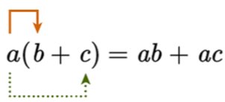
Commutative Property | A property of algebra that states that the order in which algebraic terms are added together does not affect the sum of those terms. | Addition: $$a+b=b+c$$  Multiplication: $$ab=ba$$
Polynomial Identities | A polynomial equation that is always true for any value of the variables. | Common Polynomial Identities:  $${\left(x+a\right)}^{2}=x^{2}+2ax+a^{2}$$  $$\left(x+a\right)\left(x+b\right)=x^{2}+\left(a+b\right)x+ab$$  $$x^{2}−a^{2}=\left(x+a\right)\left(x−a\right)$$  $$x^{2}+a^{2}={\left(x+a\right)}^{2}−2xa$$  $$x^{3}−a^{3}=\left(x−a\right)\left(x^{2}+ax+a^{2}\right)$$  $$x^{3}+a^{3}=\left(x+a\right)\left(x^{2}−ax+a^{2}\right)$$  $$x^{4}−a^{4}=\left(x^{2}−a^{2}\right)\left(x^{2}+a^{2}\right)$$
Mersenne Prime | A prime number that is one less than some power of 2. | $$p=2^{n}−1$$  where p is a prime value and n is a prime number
Pythagorean Triple / Pythagorean Theorem | A set of three positive integers such that the squares of the first two integers add up to the square of the third. | $$a^{2}+b^{2}=c^{2}$$  also written as  $$c^{2}=a^{2}+b^{2}$$  where a, b, and c are a Pythagorean triple
Pythagorean Triple Polynomial Identity | The polynomial identity that fits the pattern of the Pythagorean theorem, $$c^{2}=a^{2}+b^{2}$$. | $${\left(x^{2}+y^{2}\right)}^{2}={\left(x^{2}−y^{2}\right)}^{2}+{\left(2xy\right)}^{2}$$  - $$c=x^{2}+y^{2}$$  - $$a=x^{2}−y^{2}$$  - $$b=2xy$$
Pascal’s Triangle | An arrangement of numbers in increasing rows such that the first and last numbers in each row are 1, and the numbers in between equal the sum of the two numbers above them.  The numbers in each row correspond to the coefficients of a binomial expansion. | 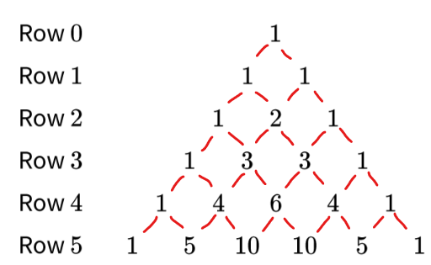
Binomial Theorem | A theorem that describes the full expansion of a binomial raised to a higher power. | $${\left(a+b\right)}^{n}=\sum_{k=0}^{n}{\frac{n!}{\left(n−k\right)!k!}a^{n−k}}b^{k}$$  - $$\frac{n!}{\left(n−k\right)!k!}$$ computes the coefficient  - n is the power of the binomial  - The exponents of a will decrease from n to 0  - The exponents of b will increase from 0 to n
Binomial Theorem: Combination | The Binomial Theorem restated as combinations, $${}_{n}C_{k}$$. The coefficient of each term in a binomial expansion, $$\frac{n!}{\left(n−k\right)!k!}$$, is equal to the number of possible combinations of $$k$$items out of a total $$n$$items. | where n is the degree of the binomial expression

