World History Beginnings to Present B

**Unit 2 : Contact, Imperialism and Colonization**

**Unit Summary:** From the late 15th - early 20th century, European powers (and later, the U.S. and Japan) expanded throughout the world. Technology helped aid their exploration. All sought wealth, power, and glory. They strongly influenced the societies they came across. In many cases, they conquered them. But, this process was varied. The newcomers went after different goals and used different tactics. In some areas, trade was most crucial. In others, direct conquest was most crucial.

In the same way, the objects of this expansion reacted in a variety of ways. Some collaborated, some resisted, and some worked with the newcomers on a fairly equal basis. Both sides absorbed ideas from the other, as well as technology and material goods.

**Unit Timeline:** This timeline provides *some* events included in this unit’s learning. The goal is for this timeline to assist understanding chronologically.

* 801–1492 CE – the Reconquista
* 1096–1271 CE – the Crusades
* 1179 - Pope banned the trade of firearms with non-Christians
* 1200 CE - Reformation of the Church
* 1271 - Marco Polo journeyed to China
* 1405 to 1433 – Zhu Di ordered seven elaborate ocean treks
* 1450–1650 – Old Imperialism
* 1492 - Columbus sailed west searching for a route to India
* 1492–1600 - Indigenous population in the Americas dropped by 90%
* 1494 - Treaty of Tordesillas
* 1525–1866 - 12.5 million enslaved peoples forcibly migrated to the Americas
* 1568–1570 – Jaga Invasion
* 1571 - Catholic Church accepted enslaved peoples as tax payment
* 1603–1867 - Tokugawa shogunate military government founded
* 1622 – King Pedro ll was put in power
* 1640–1890 – Bight of Benin
* 1644–1912 – Qing dynasty ruled China
* 1655-1709 - Civil war in Kongo
* 1700–1900 – Age of Globalization
* 1721 – Russia became an official empire
* 1757 – Battle of Plassey
* 1786 – Gulf Stream was charted
* 1789 - Olaudah Equiano published his autobiography
* 1807 - Great Britain banned international slave trade
* 1808 – U.S. made the importation of new enslaved people illegal
* 1825 – Brazil earned its independence
* 1826 - nearly all Latin American colonies achieved independence from Spain
* 1828 – Red Jacket denied request of missionaries to come speak
* 1836 – exploitation of enslaved people outlawed in Angola
* 1838 – Battle of Blood River
* 1840 – First Opium War
* 1842 – Treaty of Nanking
* 1850 – Taiping Rebellion
* 1856 – Russia lost the Crimean War and signed the Treaty of Paris
* 1856-1860 – Second Opium War
* 1857 – Sepoy Rebellion and Indian revolt
* 1860s – Russification period
* 1861 – Edict Emancipation abolished serfdom
* 1865 – U.S. made slavery illegal
* 1868–1912 – Meji Restoration
* 1870–1871 - Franco-Prussian War
* 1879 - Zululand invaded by British
* 1879 – Anglo-Zulu War
* 1880–1914 – New Imperialism
* 1881 – Tsar Alexander ll assassinated
* 1882 – Salt Act
* 1884 – Berlin Conference
* 1888 – Brazil made slavery illegal
* 1888 – Zulu Revolt
* 1890s – Boxer Rebellion
* 1894–1895 - First Sino-Japanese War
* 1895-1920 – Somaliland Rebellion
* 1900-1904 – Mahdi Revolt
* 1901-1909 –Roosevelt used “Big stick” diplomacy
* 1904 - Monroe Doctrine
* 1906 – Portuguese developed a system of direct taxation
* 1909-1913 – Taft used dollar diplomacy
* 1911 – Xinhai Revolution
* 1918 – Egba Revolt
* 1919 – Rowlatt Acts Passed and Amristar Massacre
* 1930 – Salt March

**Lesson 2 – Contact, Imperialism, and Colonization Introduction**

**Objective 1:** Describe the goods and resources traded along the Silk Roads.

**Essential Question:** In what ways did the exchange of goods and ideas impact ways of life in Europe, Africa, and Asia?

**Big Ideas**:

Silk Roads:

* + connected civilizations and societies
  + enabled trades between Asia, Europe, and Africa
  + helped disperse rare and unusual goods and commodities
  + furthered cultural exchange
  + increased movement
  + grew the commercial economy
  + expanded a desire for unique natural resources

**Objective 2:** Identify the technological innovations that led to European exploration. Do this by comparing their uses and effects.

**Essential Question:** How did technological innovations allow European countries to begin an age of exploration?

**Big Ideas:** Starting at the end of the 15th - early 18th century, Europe emerged as a global power by:

* making innovative navigational and shipbuilding technologies
* better trading with Africa and Asia
* tools that helped them sail to the Americas

**Objective 3:** Explore how astronomical ideas developed during the scientific revolution. Review how these ideas challenged the Roman Catholic Church. Look at their impact on our understanding of the universe.

**Essential Question:** How did the ideas of the scientific revolution affect our understanding of the world?

**Big Ideas:** Before the scientific revolution, Europe’s beliefs about the universe were based on ancient Greek writings and the Bible. This changed when mathematicians and astronomers created new tools.

* These tools were used to:
  + understand the Earth’s place in the solar system
  + track the movement of planets
* The findings of these scientists:
  + challenged the authority of the Roman Catholic Church
  + changed Europe’s understanding of the world

**Objective 4:** Use maps to show how major ocean currents and wind patterns changed the major routes of the Portuguese and Spanish explorers of the 15th and 16th centuries.

**Essential Question:** How did scientific reasoning and knowledge about wind and ocean currents make the Age of Exploration possible?

**Big Ideas:** European merchants sought new and faster ways to get goods from distant lands. They did this due to ongoing conflicts making land routes less safe.

They turned to the water. Maritime advances:

* + provided different ways to travel
  + enabled recording more accurate information about ocean trips
  + allowed charting ocean currents and prevailing wind patterns
  + allowed explorers to travel to distant lands and return home

**Keywords**:

* **age of exploration –** the period in history between the 15th - 18th centuries when European explorers traveled the world using new maritime technologies
* **scientific revolution –** period of time in European early modern history that saw major developments in chemistry, astronomy, mathematics, physics, and biology

**Quick Check**

Q 1: Which of the following allowed pastoral communities to greatly expand their range?

* **the horse**
* paper money
* iron smelting
* the compass

Q 2: Identify a technology that allowed ships to sail into the wind

* magnetic compass
* **lateen sail**
* square rigging
* astrolabe

Q 3: Which European explorer was the first to use new technologies, such as the caravel and astrolabe, to sail around Africa to Asia?

* Amerigo Vespucci
* Christopher Columbus
* **Bartolomeu Dias**
* Prince Henry

Q 4: How did Galileo investigate and prove the model of heliocentrism correct?

* He improved on the sextant and quadrant to determine the movements of planets.
* **He used the telescope to make observations about the solar system.**
* He only used mathematical calculations to prove the model of heliocentrism correct.
* He used biblical teachings to prove the model of heliocentrism correct.

Q 5: Which of the following best shows how the Gulf Stream influenced the major routes of the Spanish explorers during the Age of Exploration?

* The Gulf Stream helped transport enslaved people from Africa to plantations in the Americas.
* **They used the Gulf Stream to speed up the journey between Mexico and Spain.**
* The Gulf Stream caused ships to slow down in a zone of calm winds.
* Explorers used the Gulf Stream to circumvent the southern cape of Africa.

**Lesson 3 – Religious Motivations**

**Objective 1:** Identify religious reasons that led to European exploration. Address the role cause and effect played.

**Essential Question:** What religious reasons led to European exploration?

**Big Ideas**: Religion played a big role in European exploration. The religious history of Europe helped motivate European nations and kingdoms. This led to explorations.

Iberian religious history shaped how religious conversion and colonization were handled.

**Objective 2:**  Analyze the intentional spread of Christianity through migration worldwide. Identify cause-and-effect relationships and connections between events over time.

**Essential Question:** How did Christianity migrate worldwide?

**Big Ideas:** The spread of Christianity was a crucial historical event. It was influenced by many events. The intentional spread of Christianity to the Americas and worldwide was done through colonization and migration.

**Objective 3:** You will analyze the connection between the growth of the Spanish Empire and the spread of Catholicism.

**Essential Question:** What are the connections between the growth of the Spanish Empire and the spread of Catholicism from Europe?

**Big Ideas:** The spread of Catholicism was impacted by:

* + The setup of the Spanish Empire
  + The religious history of Spain
  + The turbulent religious and political past of Spain
  + Missions

Indigenous populations would either adopt Catholicism peacefully or face violence.

**Keywords**:

* **Crusades –** a series of military and religious movements by Europeans seeking to conquer Muslim lands associated with the life of Jesus, expand Christianity, and suppress heresy in Europe
* **Spanish Reconquista –** a series of conflicts that occurred between Muslims from North Africa and Christians in the Iberian Peninsula
* **sect** – a religious, political, or cultural subgroup

**Quick Check**

Q 1: Identify the religious motivations that led to European exploration. What was the cause/effect each motivation contributed to European exploration?

* The Crusades showcased how Christian missionaries peacefully spread their religion to foreign peoples. This would later influence Christian rulers during the age of exploration.
* Muslim conquests into Iberia and hostile Christian missionaries were two of the most important motivators. These hostile missionaries would wage war against Indigenous populations in the New World.
* Missionaries were sent to convert Muslims through violent means during the Reconquista. The Reconquista was a successful experiment in using missionaries against a “hostile” religion.
* **Violent conversion rooted in the Reconquista and Crusades, coupled with charitable causes from Christian missions, were both important motivators during European exploration.**

Q 2: Use the table below to answer the question. Analyze the table to identify the cause-and-effect relationships involved in the spread of Christianity over time.

* 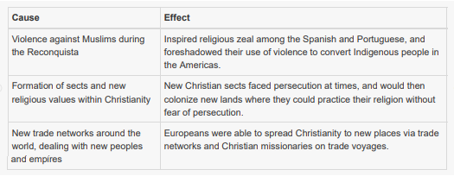
* 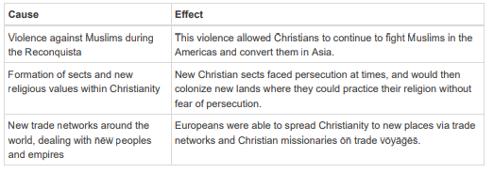
* 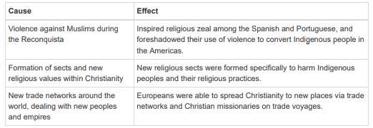
* 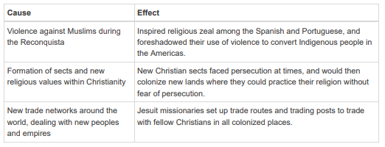

Q 3: Why did Puritan Christians migrate from Europe to the Americas?

* **They faced persecution by the church.**
* They migrated for trade and commerce.
* They wanted to establish reductions in North America.
* They accidentally discovered it while sailing to China.

Q 4: Use the maps to answer the question. Analyze the maps to identify the connection between the growth of the Spanish Empire and the spread of Catholicism.

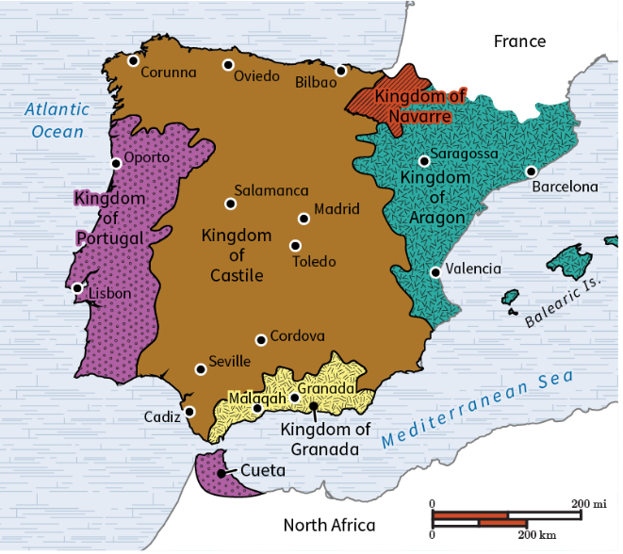 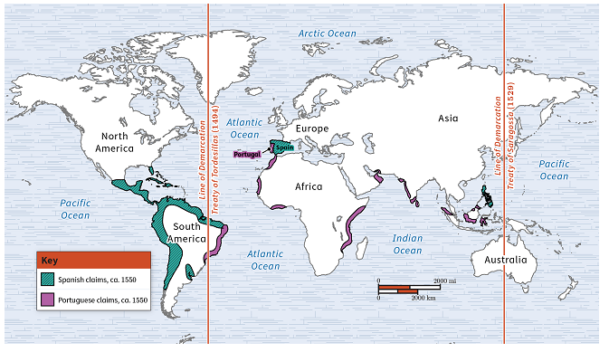

* After Spain merged the kingdoms of Castile and Portugal, it was able to use Castile as a
* launching point to spread Christianity to North America.After Spain merged the kingdoms of Granada and Portugal, it was able to use Portugal as
* a launching point to spread Christianity to the Americas.After Spain merged the kingdoms of Aragon and Navarre, it was able to use Navarre as a
* launching point to spread Christianity to the Americas.**After Spain merged the kingdoms of Aragon and Castile, it acquired Granada and was able to use it as a launching point to spread Christianity to the Americas.**

Q 5: Use the table to answer the question. Analyze the table to determine which statement about the spread of Catholicism is true.

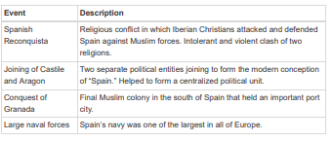

* **The conquest of Granada helped to free up a major port city so that the Spanish could use their large navy to colonize the Americas and beyond.**
* Spain’s large navy conquered Portugal, which allowed Spain to sail overseas to spread Catholicism to different regions.
* The joining of Aragon and Castile allowed the Spanish to colonize Portugal and use its navy to sail to the New World.
* The Spanish Reconquista united the territories and religions of Spain, which allowed Spain to spread Catholicism more easily.

**Lesson 4 – Empires and Imperialism**

**Objective 1:** Evaluate how the Spanish and Portuguese built their empires.

**Essential Question:** How did the Spanish and Portuguese build their empires?

**Big Ideas**: In the late 15th and early 16th centuries, European countries explored more. Some, like Spain and Portugal, did more than explore.

They made empires and became more powerful. At times, their empires included new colonies in lands they conquered. Other times, they built their empires on new trade connections.

**Objective 2:** Analyze the key similarities and differences in how Europeans expanded to the Western and Eastern Hemispheres.

**Essential Question:** What were the key similarities and differences in European expansion to the Western and Eastern Hemispheres?

**Big Ideas:** Europeans explored the world in the late 15th century. They moved into new areas in the Western and Eastern Hemispheres. The Portuguese and the Spanish looked for trading prospects. They created new colonies in both hemispheres. They sometimes used similar methods to expand.

**Objective 3:** Summarize factors that spurred and aided European imperialism.

**Essential Question:** Why did Europeans colonize?

**Big Ideas:** Historians have divided imperialism into two types.

1. Old imperialism:
   * the colonies of European countries
   * 1450-1650
   * spurred by desire for gold and glory for the colonizing country
   * included the want to convert Indigenous peoples to Christianity
2. New imperialism:
   * 1880-1914
   * spurred by economic factors like the desire for raw materials
   * Industrial Revolution grew demand for produced goods

The growth of nationalism spurred European powers to scramble for control of colonies. This was especially true in Africa.

This form of imperialism took on an increasingly oppressive attitude with the practice of social Darwinism. New technologies were developed, such as medical and military technologies. These enabled colonizers to gain control of territories.

**Objective 4:** Differentiate between direct and indirect imperial rule. Use graphs and/or diagrams to inform decisions.

**Essential Question:** Why does imperial rule hurt colonized countries?

**Big Ideas:** During the imperial era, European powers needed to keep control of their colonies. They had a vested economic interest in keeping the peace.

They ruled their colonies in two ways:

1. Taking complete control.
   1. Trying to get local people to assimilate to its culture
   2. Hoping this would make them follow laws and accept foreign rule
2. Using local administrators.
   1. Appointing local people to rule according to its conditions
   2. Keeping control by appearing to not be in control

**Keywords**:

* **mercantilism** – a country’s wealth is measured by the amount of gold or silver it has. Colonies exist to provide wealth to the controlling country
* **imperialism** – the practice of one group of people establishing control over another in a foreign land

**Quick Check**

Q 1: When historians investigate how the Spanish and Portuguese built their empires, they notice

* **many similarities between how the two countries engaged in this process.**
* the Spanish and Portuguese did not follow advice from the Catholic Church when they began exploring.
* there are no similarities between these countries’ empire-building efforts.
* neither country was successful in building empires in the age of exploration.

Q 2: Queen Isabella and King Ferdinand paid for exploration to cross the Atlantic Ocean because they wanted to

* **find a new route to trade with Asian nations.**
* show that they could use Portuguese sailing technologies.
* conquer the Caribbean Islands.
* build on existing trade relationships in the Western Hemisphere.

Q 3: Which statement **best** analyzes a key difference between European expansion in the Western and Eastern Hemispheres?

* In the Eastern Hemisphere, Europeans focused on conquering as many local people as they could, while in the Western Hemisphere Europeans peacefully traded with local people
* Europeans did not set up any colonies in the Eastern Hemisphere, but Europeans did set up colonies in the Western Hemisphere.
* **In the Eastern Hemisphere, Europeans were able to set up trade relationships with different peoples, but in the Western Hemisphere, Europeans focused on conquering different peoples.**
* The Roman Catholic Church told European nations they could explore the Eastern Hemisphere but only parts of the Western Hemisphere.

Q 4: Which statement correctly summarizes a motivation for imperialism?

* Malaria medication motivated Europeans to conquer Africa.
* Social Darwinism motivated Europeans to make the colonized peoples their equals.
* **Europeans were motivated by a desire to “civilize” Indigenous peoples.**
* Military technology inspired Europeans to conquer parts of Africa.

Q 5: How can you differentiate between direct and indirect imperial rule?

* **Direct rule occurs when a colony is directly ruled by foreign powers, while indirect rule occurs when local people administrate on behalf of foreign powers.**
* Direct rule’s main goal is maintaining control of a colony, while indirect rule’s main goal is assimilation.
* Direct rule occurs when a colony maintains control of its government, while indirect rule occurs when foreign powers control the government.
* Direct rule has a negative impact on local people, while indirect rule maintains local people’s power.

**Lesson 5 – Slave Trade**

**Objective 1:** Explore the role that trade played in the advance of the transatlantic trade. Look at the development of the Middle Passage.

**Essential Question:** How do economic systems develop?

**Big Ideas**: The transatlantic trade network aided trade between Africa, Europe, and the Americas. This trade network began as colonies in the Americas grew.

With mercantilism, colonies grew a country’s wealth. Raw materials needed to be sent across the Atlantic Ocean. The Middle Passage of the transatlantic trade network connected the Americas and Africa by trade.

Enslaved people were transported under horrible conditions through the Middle Passage.

**Objective 2:** Explore how colonial plantations influenced the growth of the African slave trade. Explore viewpoints involving African slave trade.

**Essential Question:** How did the spread of colonial plantations impact the African slave trade. How did they impact the lives of the enslaved?

**Big Ideas:** Following European colonial expansion in the Americas, plantations for sugar, tobacco, rice, and indigo were set up. The work to harvest the crops was labor heavy.

Due to the plantations not having enough local labor:

* Enslaved Africans were transported to the Americas by the African slave trade.
* They were sold to plantation owners to provide labor.

Responses to slavery differed among groups.

**Objective 3:** Evaluate evidence used to support the theory: increased European demand for enslaved Africans contributed to the rise of warfare within West Africa.

**Essential Question:** How did European globalization and the demand for enslaved Africans intensify warfare within West Africa?

**Big Ideas:** Since the 1400s in Africa, a practice of enslaving and selling enemies of war and other displaced peoples developed. But this practice was much smaller in scope in the 1400s.

As European interest grew, not only the Portuguese wanted to capitalize on the market. Other nations, like the Dutch Republic, began to trade firearms for enslaved peoples. The demand grew for firearms in Africa and for enslaved peoples in the Americas.

Each side of the trade had to ensure they could offer what the other wanted. This is the crux of historians’ argument: European globalization and the demand for enslaved Africans increased warfare within West Africa.

**Objective 4:** Explore and describe the process of enslavement, its effect on captive people, and its impact on the creation of an African diaspora.

**Essential Question:** What do primary sources tell us about the cultural influence of the forced migration of captive Africans to the Americas?

**Big Ideas:** Between 1525-1866, 12.5 million enslaved peoples were forcibly migrated to the Americas. The experiences of individuals who endured enslavement and a lifetime of forced labor differ from each other in details and circumstances. The emotional and physical toll on these enslaved peoples in the African diaspora is clear in all primary sources.

**Keywords**:

* **cash crop** – a crop, such as sugar, that is grown for profit and production, rather than food
* **transatlantic trade network** – a trade network across the Atlantic Ocean. It transported goods between Africa, Europe, and the Americas
* **diaspora** – a mass migration of people from their homeland

**Quick Check**

Q 1: Which statement investigates the origin of the transatlantic trade network?

* The transatlantic trade network originated with the growth of nationalism, as countries amassed colonies as a symbol of power.
* **The transatlantic trade network originated with the growth of mercantilism and the need to transport goods across the Atlantic Ocean.**
* The transatlantic trade network originated as a response to power imbalances between the colonies and their mother countries.
* The transatlantic trade network originated with the increased demand for enslaved labor in the Americas

Q 2: Use the text excerpt to answer the question.

Some historians believe that the expansion of slavery was linked to profits planters made from growing cash crops such as tobacco, rice, indigo, and sugar. By the 18th century the sugar islands in the Caribbean served as a major market place for enslaved people. The sugar crop and enslaved harvesting the crop were a major income source for these plantation owners.

Which of the following accurately investigates the reasons why the African slave trade spread to the Caribbeans?

* African slave traders exported enslaved people to the Caribbean in exchange for more fertile plantation land.
* The demand for rice rose during the 17th century, which increased the demand of enslaved people.
* The demand to colonize newly conquered lands in Portugal and Britain prompted landowners to purchase enslaved people.
* **The growing demand for sugar encouraged plantation owners to purchase enslaved people to increase their profits.**

Q 3: Imagine you investigated the African slave trade. Which of the following would provide the best definition of African slave trade?

* the sale and transportation of enslaved people from the Caribbeans to Brazil to harvest sugar
* **the sale and exportation of enslaved people from Africa to harvest cash crops for profit**
* the trade of enslaved people to Africa for use in intensive labor projects
* the route enslaved people took to gain better work and living conditions

Q 4: While investigating the increased warfare in West Africa between the 16th and 18th centuries, what do many historians argue is the key factor in increasing warfare at large?

* varying local currencies, such as nzimbu shells
* **the European firearms sale-enslavement cycle**
* dangerous environments along the Bight of Benin
* wars of succession

Q 5: Investigate the influence of the forced migration of captive Africans to the New World with regard to culture and commerce. How did forced migration directly lend to creating a new culture?

* **The forced migration of enslaved Africans led to the creation of an African diaspora.**
* The creation of new culture was limited, as enslaved Africans did not want to adopt Christianity and aspects of European culture.
* A new culture emerged that completely abandoned traditional African culture.
* Europeans expected enslaved Africans to use proper English and Christianity to earn respect, contributing to the creation of a new culture.

**Lesson 6 – Global Impact**

**Objective 1:** Analyze the short- and long-term effects of European exploration of the Americas on the Indigenous population.

**Essential Question:** What were the long- and short- term effects of European exploration on the Indigenous peoples of the Americas?

**Big Ideas**: Beginning in the mid-15th century, European explorers from Portugal, the Netherlands, Spain, England, and France interacted with the Indigenous peoples of the Americas.

Each country had many reasons for being in the New World. They all had effects on the Indigenous populations.

**Objective 2:** Assess the consequences of European efforts to convert the Indigenous peoples of the Americas to Christianity. Use primary and/or secondary sources.

**Essential Question:** What were the consequences of European interactions with Indigenous peoples?

**Big Ideas:** In 1492 Christopher Columbus accidentally came across a chain of islands. The islands were in the Caribbean Sea.

Worlds clashed as Columbus and his crew learned that the islands were home to many Indigenous peoples and goods. News of this “new world” quickly spread in Europe. It incited a rush of Europeans to explore the lands.

The Europeans:

* + held an Eurocentric mindset
  + saw themselves as superior beings
  + tried to press their religion on the Indigenous peoples

**Objective 3:** Explain how the influx of silver from the New World to the Old World led to the Commercial Revolution in Europe. Include economic, political, and social factors.

**Essential Question:** How did the Commercial Revolution add to the consequences of European global expansion?

**Big Ideas:** The promises of material riches and cities of gold spurred European explorers to settle in the New World.

* + Spain, England, and Portugal were some of the largest colonizers.
  + They exploited the peoples and resources of the New World.
  + The Spanish Empire was arguably the most exploitative.
  + The discovery of a mountain made of silver in the small town of Potosí, in present-day Bolivia, created lots of wealth for Spain.
  + Spanish settlers brutally enslaved local Indigenous people and Africans to mine the silver.
  + This silver enriched Spain and Europe and led to the Commercial Revolution.

**Objective 4:** Analyze the shifts of people due to the Columbian Exchange. Use political, social, religious, and economic characteristics of different historical time periods.

**Essential Question:** What were the consequences of the Columbian Exchange on different groups?

**Big Ideas:** In 1492 Christopher Columbus accidentally came across a chain of islands. These are now known as the Caribbean Islands.

Columbus was looking for a different sea route to trading markets in Asia. Instead, he made contact with Indigenous people in the Caribbean. The discovery of this “New World,” or how Europeans interpreted their discovery, changed the course of history.

It uprooted many populations in the world. For the first time in history, global trade started.

**Keywords**:

* **Commercial Revolution** – a period of change during the 16th and 17th centuries. In this time higher levels of global trade and wealth flowed into European nations. It resulted in the creation of new economic and political systems
* **Columbian Exchange** – the exchange of plants, animals, and diseases between the Americans and Eurasia after the arrival of Christopher Columbus
* **Eurocentric** – the focus on European history and beliefs while excluding other world views or beliefs

**Quick Check**

Q 1: Identify two causes of European exploration in the Americas.

* **gold, land**
* large animals, medicine
* forests, opportunity to form new governments
* food, clean water

Q 2: What was one effect that European exploration had on the Indigenous peoples of the Americas?

* **decreased population**
* increased land
* increased wealth
* immunity to smallpox

Q 3: Assess the consequences of European attempts to convert Indigenous peoples to Christianity. Which consequence most likely resulted from sacred Indigenous religions being banned by Europeans?

* the preservation of Indigenous myths and history
* **the loss of Indigenous religious texts**
* Christianity becoming a minor religion in South America
* conquistadors immersing themselves in the cultures of local populations

Q 4: Which of the following explains a result of the Commercial Revolution in Europe?

* Spain experienced long-term wealth and economic power.
* New World commodities were banned from Old World markets.
* **The influx of silver caused inflation in European economies.**
* Global trade and exchange decreased.

Q 5: An analysis of the long-term impacts of the Columbian Exchange on Indigenous North American populations would show that.

* **Indigenous cultures faced the threat of extinction.**
* productive and thriving trade agreements were formed.
* Old World goods became widely accessible to Indigenous populations.
* Indigenous groups resisted European invasion of their homelands.

**Lesson 7 – Perspectives Portfolio**

**Objective 1:** Analyze the impact of perspectives missing from historians’ accounts of the age of globalization.

**Essential Question:** How does a historian’s perspective change the way they tell history?

**Big Ideas**: Victors usually write history. Historians often write about who won battles and wars. We might have ideas about how the other side felt. But we do not hear from them often.

**Objective 2:** Assess and understand the difference between validity, credibility, and reliability of primary sources from the Age of Globalization. Identify the difference between facts, opinions, and propaganda.

**Essential Question:** What can looking at validity, credibility, and reliability tell historians about primary sources?

**Big Ideas:** Primary sources are common. Some are more exciting to look at. Others may be long and hard to understand.

Primary sources may have a point of view or a bias. Look at every source with an objective eye.

**Keywords**:

* **propaganda** – the biased or misleading information that is promoted by a particular political ideology. It has the intent to persuade
* **primary source** – a historical record created by a person who experienced something first hand

**Lesson 8 – Spanish, Portuguese, and British**

**Objective 1:** Identify the crucial components of the Spanish and Portuguese overseas empires in the 19th century. Highlight elements of continuity and change.

**Essential Question:** What components of empires change or remain constant over time?

**Big Ideas**: Change and continuity over time is a big theme in world history.

The Spanish and Portuguese colonies in the Americas were defined by their social caste system.

* + This system was based on the race of colonists.
  + There was a long history of racism and classism in these colonies.
  + At first this was an asset to rulers.
  + Later it became a major weakness, as lower social classes became unhappy.

Both economies made money. But the changing economic, social, and political landscapes of these colonies led to their downfall.

**Objective 2:** Analyze the strengths and weaknesses of Spanish and Portuguese colonial rule in the 19th century. Use a range of quantitative and qualitative sources.

**Essential Question:** How can the strengths and weaknesses of colonial rule be determined?

**Big Ideas:**

* + Spain and Portugal:
    - mined resources from Africa and Latin America
    - became rich through mercantilism
    - exploited Indigenous people which led to consequences as unrest grew
    - declined by the end of the 19th century
      * as independence movements and conflicts with other European powers weakened them

**Objective 3:** Assess the short-term and long-term economic effects of British rule on Indian society.

**Essential Question:** How are the economies of colonized nations affected by colonization?

**Big Ideas:**

British colonialism had a lasting impact on the areas it colonized.

* + India’s economy was affected in the short- and long-term by colonization.
  + India was kept from building its own industry by:
    - the commercialization of agriculture
    - the tax revenue system
  + The development of India was stunted by British economic policies.
  + This impacted the quality of education and healthcare in the country.

It was not until the end of British rule that India was able to build up its industry. This put it at a disadvantage compared to other nations.

**Objective 4:** Analyze the reasons for the British victory in the Zulu Wars. You will do this through many perspectives among historians.

**Essential Question:** Why did the British win the Zulu Wars?

**Big Ideas:** The British tried to gain more control of South Africa during the Zulu Wars. Perspectives on this war have shifted. As historians found more evidence, they have created new arguments.

Prior perspectives came from negative assumptions about the strength of African military forces. Now historians believe that the Zulu military was a strong rival. Other historians credited British policies for lasting British control.

**Keywords**:

* **land revenue system** – the system of taxation set up by the British in India to tax farmers
* **Zulu Wars** – a series of conflicts between the British and the Zulu throughout the 19th century

**Quick Check**

Q 1: Which statement identifies a way that an important component of the Portuguese Empire changed over time?

* The Portuguese were no longer the strongest military power by the 19th century
* The Portuguese government attempted to put less of a focus on the social caste system.
* **The slave trade eventually stopped, as it was no longer profitable for Portugal.**
* The Portuguese gained territory in Asia by the 19th century.

Q 2: Read this quote:

“Before Spanish arrival there is estimated to be about 60 million people in the Americas. After Spanish arrival this population shrank to about 6 million people.”

Using evidence from the quotation, which statement correctly analyzes the effectiveness of Spanish colonial rule?

* Colonial rule was strengthened by indigenous population decreases because it meant they could focus less on the unpopular social caste system.
* Colonial rule was weakened by decreases in the indigenous population because it led to more resistance to Spanish colonial rule.
* **Colonial rule was strengthened by decreases in the indigenous population because it meant they would face less resistance from colonial populations.**
* Colonial rule was weakened by decreases in the indigenous population because there were fewer people to work in the colonies.

Q 3: How did Spanish conflicts on the Iberian Peninsula weaken the Spanish colonies?

* **The Spanish were unable to focus resources on governing the colonies.**
* The Spanish had to stop using the mercantile system.
* The Spanish were betrayed by the British joining independence movements.
* The Spanish were unable to maintain a presence in their military forts.

Q 4: Which quote from this section assesses a long term impact of British rule.

* **“Since the majority of India’s labor force was devoted to growing cash crops as raw materials for British industry, Indian industry remained underdeveloped through the end of British rule”**
* “...Poor farmers were oppressed by these high taxes. Meanwhile, political administrators received huge payoffs from them.”
* "Markets were restructured to suit industrial British interests, leading to high levels of unemployment in the handicrafts industry.”
* "Railroads connected economic centers across India.”

Q 5: Read this quote from the section: “In 1879 colonial authorities divided Zulu lands into 13 territories.” How could historians analyze this as a reason for lasting British victory in the Zulu Wars?

* **Dividing the Zulu lands separated their societies and economies**
* Dividing Zulu lands led to a single chief being appointed by the British to rule.
* Dividing Zulu lands destroyed the productivity of their agriculture.
* Dividing Zulu land led to British victory at the Battle of Kambula.

**Lesson 9 – Imperialism in Asia**

**Objective 1:** Draw conclusions about the role of war in building the German and Japanese nation-states.

**Essential Question:** How can we draw conclusions about the role of war in building the German and Japanese nation-states? How can we also highlight different interpretations of these events?

**Big Ideas**:

* + A state is an independent government that rules over an area with clear boundaries.
  + A nation is a group of people who see themselves as belonging together because of a shared history, culture, or language.
  + A nation-state occurs when those two things are combined. This results in a group of people with something in common forming their own government. This can be difficult to achieve. In history, nation-states have been rare.

To understand nation-states, we will look at:

1. Germany under leadership of Otto von Bismarck.
2. Japan during the Meiji Restoration.

**Objective 2:** Identify the reasons Japan defeated China in the First Sino-Japanese War.

**Essential Question:** How did Japan defeat China during the First Sino-Japanese War?

**Big Ideas:** The First Sino-Japanese War took place from 1894-1895.

* The war was fought because both China and Japan wanted to take over Korea.
* China had used Korea’s resources for its own benefit.
* In the late 1800s, Japan began industrializing.
* Japan needed a lot of coal and iron. Korea had lots of both. Japan wanted to take control of Korea and its resources.

The First Sino-Japanese War showed that Japan was an imperialist power. It showed that China’s power was weakening. China could not defend its interests against imperialist powers.

**Objective 3:** Use cause and effect to explain the outcomes of the Opium Wars.

**Essential Question:** How can we use cause and effect to explain the growing influence of Western powers on China? Looking at the Opium Wars through the Boxer Rebellion?

**Big Ideas:** The influence of Western powers on China began in the late 18th century. During this time, China was ruled by the Qing dynasty. This dynasty ruled from 1644-1912.

At this time:

* + Great Britain bought lots of tea from China
  + China was not interested in buying Great Britain’s products
  + Great Britain was losing money

The situation changed once the British Empire took over India.

A three-way trade started. The British bought tea from China. Then, it sold China opium and cotton taken from India.

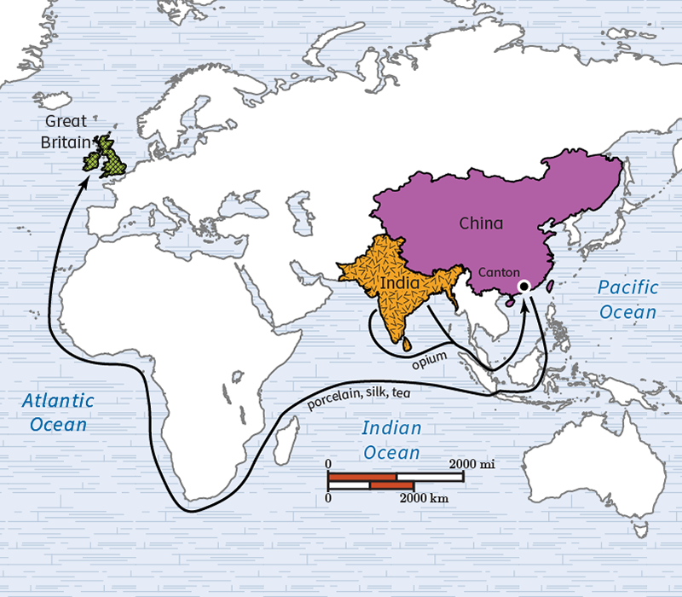

The effect of this trade system was cruel. People in China became addicted to opium.

As a result, China began to fight back.

**Objective 4:** Use timelines to analyze the effects of the Treaty of Nanking on the Qing Dynasty.

**Essential Question:** How did the Treaty of Nanking affect the Qing dynasty?

**Big Ideas:**

The Qing dynasty:

* China’s last imperial dynasty
* 1644-1912
* increased its geographical territory
* grew its population
* began a national economy
* fell due to western imperialist powers
* forced to sign the Treaty of Nanking

This Treaty made the Qing dynasty give up lots of power.

The Qing dynasty was forced to give up more power in treaties with western imperialist powers. Rebellions and wars plagued the country. After the Xinhai Revolution, the Qing dynasty fell.

**Keywords**:

* **opium –** a drug created from a type of poppy; known for being an addictive narcotic
* **imperialism** – the practice of one group of people establishing control over another in a foreign land

**Quick Check**

Q 1: Draw a conclusion about the role of war in uniting Germany.

* The Franco-Prussian War convinced Otto von Bismarck that his cause of uniting Germany was correct.
* The Franco-Prussian War convinced German and French states to unite under one nation-state.
* The Franco-Prussian War did not convince German states to unite under one nation-state.
* **The Franco-Prussian War convinced German states to unite under one nation-state.**

Q 2: How were the Korean people affected by Japanese imperialism?

* The Korean people were treated nicely by the Japanese empire.
* Korea was never invaded by Japan.
* The Korean people were not affected by Japanese imperialism.
* **The Korean people were treated harshly by the Japanese empire.**

Q 3: Identify the reason Japan defeated China in the First Sino-Japanese War.

* **Identify the reasons Japan defeated China in the First Sino-Japanese War.**
* China’s military was industrialized and had more advanced technology, but Japan’s military was much larger. Because of this, Japan was able to overwhelm China during the First Sino-Japanese War.
* Japan’s military was supported by Western imperialist powers. Because of this, Japan was able to overwhelm China during the First Sino-Japanese War.
* Japan is a smaller country than China. Japan defeated China during the First Sino-Japanese War because China had more territory to defend.

Q 4: Explain the outcome of the Opium Wars.

* **The outcome of the Opium Wars were rebellions, such as the Boxer Rebellion. These rebellions were put down by Western powers.**
* The outcome of the Opium Wars were rebellions, such as the Boxer Rebellion. These gained Western support.
* The outcome of the Opium Wars were rebellions, such as the Opium Rebellion. These rebellions were put down by Western powers.
* The outcome of the Opium Wars were rebellions, such as the Boxer Rebellion. These rebellions succeeded.

Q 5: Use the timeline to answer the question.

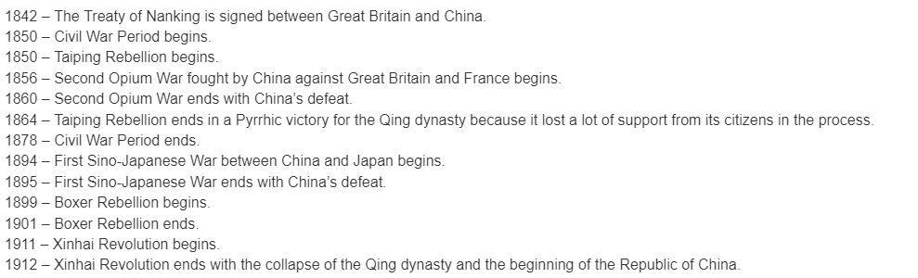

Analyze the effect of the Treaty of Nanking on the Qing Dynasty using the timeline. What happened to the Qing Dynasty after the Treaty of Nanking?

* **The Qing dynasty faced rebellions and wars after the Treaty of Nanking. This led to its collapse.**
* The Qing dynasty faced invasion from Eastern imperialist powers after the Treaty of Nanking. This led to its collapse.
* The Qing dynasty did not face anything terrible after the Treaty of Nanking, which made it smug. This led to its collapse.
* The Qing dynasty faced rebellions and wars after the Treaty of Nanking. These did not lead to its collapse, however.

**Lesson 10 – Russia and the U.S.**

**Objective 1:** Distinguish between the short and long-term causes of Russification.

**Essential Question:** What were the short-term and long-term causes of Russification? What were its effects on colonization?

**Big Ideas**:

During the era of Russification:

* + many ethnic minorities were forced to change their cultures and beliefs
  + policies forced non-Russian identities to adopt Russian culture and beliefs

**Objective 2:** Explain the causes that liberated Russian serfs. Explain the long-term effects of such freedoms.

**Essential Question:** Why were Russian serfs liberated?

**Big Ideas:**

Serfdom

* + a term used to describe the social status of peasants in a society that links peasants to their landlords
  + was started to ensure there was always labor available to landowners
  + common during the Middle Ages in Europe
  + used in Russia past the Middle Ages

**Objective 3:** Summarize the U.S.’s foreign policy goals in the Caribbean. Look at different perspectives.

**Essential Question:** How did the U.S.’s foreign policy in the Caribbean impact colonization?

**Big Ideas:**

* + The Caribbean played a big role in the imperial development of the U.S.
  + This was in the late 1800s - early 1900s
  + The U.S.’s involvement in the Caribbean has been highly criticized

**Objective 4:** Compare the goals of dollar diplomacy and “big stick” diplomacy.

**Essential Question:** How were the goals of dollar diplomacy similar and/or different from “big stick” diplomacy?

**Big Ideas:**

The Age of Imperialism:

* + Was during the 19th and 20th centuries
  + U.S. changed its foreign policy
  + switched from “big stick” diplomacy to dollar diplomacy
  + impacted U.S. presence in Latin America
  + saw change in leadership from Roosevelt to Taft in the U.S.

**Keywords**:

* **feudalism –** a social system in which people would work or fight for nobles/landowners in return for protection and use of the land
* **Russification** – a period of time and policies in which non-Russian identities were forced to adopt Russian culture and beliefs

**Quick Check**

Q 1: Which of the following tables accurately distinguishes the short-term causes and long-term causes of Russification policies?

* 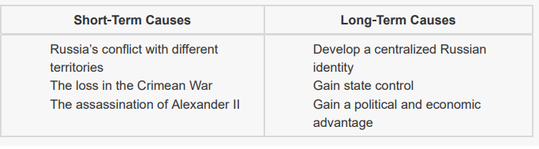
* 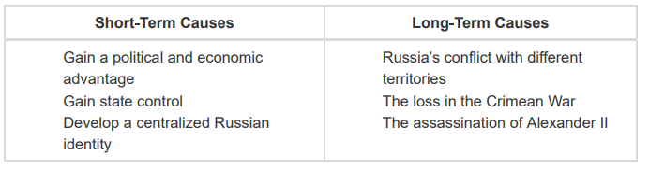
* 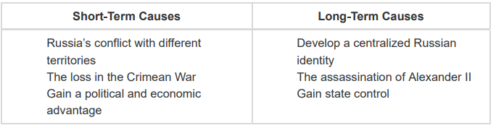
* 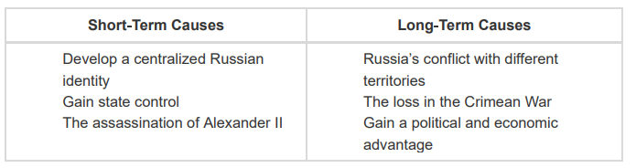

Q 2: Which statement best explains the causes leading to the emancipation of Russia’s serfs?

* The Edict Emancipation of 1861 marked the end of the Crimean War, which was fought over serfdom in Russia.
* **Alexander II saw serfdom as inhumane, and the military loss in the Crimean War prompted Alexander II to enact social reform, which led to the emancipation of Russia’s serfs.**
* The mounting pressure of public opinion that said serfdom and the Crimean War were inhuman prompted Alexander II to modernize and develop Russia.
* The Edict Emancipation of 1861 established the feudal system, and Alexander II saw the feudal system as inhumane, which established the freedom of serfs.

Q 3: Which statement **best** explains the effects of the emancipation over time?

* The emancipation boosted social reform and economic development, and it helped Russia strengthen its long-term weaknesses.
* The emancipation was successful in abolishing serfdom, but it led to significant conflict and war because of opposition from the people.
* The emancipation increased economic development, but it failed to abolish feudal serfdom in Russia.
* **The emancipation boosted social reform and economic development, but it failed to address Russia’s long-term weaknesses.**

Q 4: Which statement best summarizes the U.S. foreign policy goals from the perspective of peacemaking?

* U.S. foreign policy in the Caribbean intended to retreat military forces to establish peace in the U.S.
* The U.S. foreign policy in the Caribbean intended to establish the U.S. as an imperial government in Latin American.
* **The U.S. foreign policy in the Caribbean intended to provide stability and peace in an unstable region.**
* U.S. foreign policy in the Caribbean intended to overthrow threats to U.S. citizens living in Latin America.

Q 5: Which of the following charts **best** compares the goals of “big stick” diplomacy and dollar diplomacy?

* 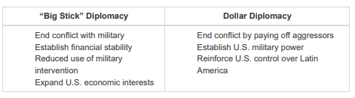
* 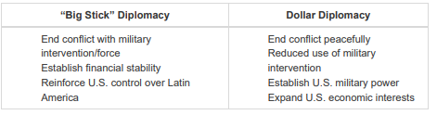
* 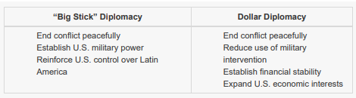
* 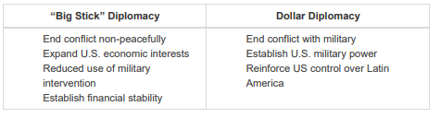

**Lesson 11 – Impacts and Responses**

**Objective 1:** Compare China’s and Japan’s response to imperialism. Pay extra attention to the experience of people affected by the Treaties of Nanjing and Kanagawa.

**Essential Question:** How did Japan’s and China’s response to imperialism differ?

**Big Ideas**: The West was always interested in trading with the East. This is especially true of China and Japan. Some Western nations traded for years before both China and Japan shut their borders to the West.

In the 19th century, an interest in the East was renewed. It was renewed in Europe, Britain, and the U.S.

* + Through imperialism they controlled trade and resources.
  + Even Japan and China were subject to imperialism.
  + Imperialism impacted each nation in diverse ways.
  + China’s state, economics, and society suffered due to Western imperialism.
  + Japan grew into a modern industrialized nation.

**Objective 2:** Describe outcomes of African resistance to imperial rule.

**Essential Question:** Why were some African resistance movements to European imperialism more successful than others?

**Big Ideas:** The Western world was changed by the Industrial Revolution.

Imperialism was caused by:

* + capitalism
  + a desire to be the most powerful nation
  + greed
  + a false but strong feeling of racial and national superiority

The 19th and early-20th centuries were the “Age of Imperialism.” The Western world colonized and dominated the people and resources of every continent. This included Africa.

The people of the African continent resisted the imperial powers that invaded their homelands. Some resistance movements were more successful than others. In the end, only two nations remained free of colonial and imperial rule. These were Ethiopia and Liberia.

**Objective 3:** Explore the effect of the Amritsar Massacre on Indian nationalism.

**Essential Question:** What were the effects of the Amritsar Massacre on Indian nationalism and the British colonization of India?

**Big Ideas:** As WW1 was ending, so was Britain’s rule of India. From the 15th -20th century, Britain had colonized and imposed its rule on nearly all continents.

Britain used trade and economics to gain the trust of the indigenous people. Then, Britain claimed the regions as its own.

The people in these British colonies suffered:

* + loss of their rights
  + loss of land
  + loss of economics
  + violent massacres

These abuses became the catalyst for resistance movements.

This was the case in India where the Amritsar Massacre reshaped Indian nationalism. It led to India’s independence from Britain.

**Objective 4:** Use relevant and diverse sources to describe the British response to the Salt March.

**Essential Question:** How did acts of civil disobedience by colonized peoples undermine the power and authority of colonizers?

**Big Ideas:** In 1882, Britain implemented the Salt Act.

* The act forbade Indian citizens from collecting or selling salt.
* It forced them to buy it only from the British.
* British rulers levied a heavy tax on salt.
* The poor in India were impacted the most.

Over 40 years later Gandhi took a stand. He and thousands of other Indians marched to the coast at Dandi to oppose the law.

**Keywords**:

* **Berlin Conference of 1884** – the conference that formalized the scramble for African colonies by various European nations in the late-19th and early-20th centuries. It led to the partition of Africa between these imperial powers
* **Gold Coast** – the name given to a collection of western African colonies ruled by British, Portuguese, Dutch, Swedish and Danish colonizers. It is present-day Ghana
* **open door policy** – a statement issued in 1899 by the U.S. to China declaring that the U.S. had the same equal protection and privileges as other countries trading with China
* **Salt Act** – a law the British implemented in India that heavily taxed salt. It kept native Indians from manufacturing or selling the mineral

**Quick Check**

Q 1: Which of the following statements best compares the experiences of China and Japan under imperialism?

* Japan and China had to cede land to the Americans.
* Both China and Japan were able to learn a lot from Western nation.
* Both Japan and China were forced to carry the cost of shipwrecked sailors
* **Both China and Japan were forced to sign unequal treaties.**

Q 2: How did being open to learning from the West help Japan’s experience with American imperialism?

* **Japan was able to build a strong nation-state and modernize their entire nation.**
* Japan was able to help China improve during imperialism.
* Japan convinced the U.S. to return all the land it was forced to cede under the Treaty of Kanagawa.
* Japan was able to balance learning with isolationism.

Q 3: Which of the following **best** describes why Ethiopia’s resistance to Italian imperialism was successful?

* Ethiopia was never colonized because it arranged a mutually beneficial relationship with the Italians.
* **European alliances gave Ethiopia time and resources to build up its military and Infrastructure.**
* Ethiopia relied on the Zulu nation in its conflict with Italy because Cetshwayo and Menelik were allies.
* Ethiopia was only valued by Italy to keep other Europeans from taking over more valuable African land.

Q 4: If you investigate the Amristar Massacre, what effect will you find it had on British colonial rule in India?

* Indians had more violent uprisings against the British in retaliation for the massacre.
* Indians demanded Indian equality in government representation to rule jointly with the British.
* **Indians began demanding India’s independence from British rule.**
* Indians felt that Britain began to rule India in more violent ways in retaliation for the massacre.

Q 5: Which of the following statements **best** describes the British response to the Salt March?

* **The British responded to the Salt March by maintaining full political and economic control in India.**
* The British responded to the Salt March by refusing to jail those who participated in acts of civil disobedience.
* The British responded to the Salt March by only jailing those who committed acts of violence.
* The British responded to the Salt March by jailing the protestors and ending the salt tax.