American Government

**Unit 5: Civics and Political Participation**

**Unit Summary:** In this unit you will explore the basis for Civics and Political Participation in the U.S.. The balance between the government and the governed is important. This requires the people to interact with their government. This is done in the form of civic obligation, participation, duties, virtue, and competencies.

The interaction between the people and government takes place at the local, state, and federal levels. This unit will help you examine your own role in democracy. The people and the government have specific roles and responsibilities that help to maintain a functioning society.

Political participation can be shown in many ways. Political party affiliation, geographical factors, political socialization, and media influence all play a role in participation from citizens. The U.S. political process allows for the continued involvement from the people. People have the option to take part in political processes from start to finish. This process—and the people who are part of it—has evolved over time.

**Lesson 2 – Obligations and Responsibilities**

**Objective 1:** Explain some of the responsibilities that are required of U.S. citizens.

**Big Ideas**: Being a U.S. citizen comes with responsibilities. Among these responsibilities are respecting the rule of law, paying taxes, serving on juries, serving as witnesses in trials, and serving in the military if drafted.

Rule of law is the idea that all people in society are bound by the law. This includes citizens as well and government officials.

Paying taxes is an important civic obligation.

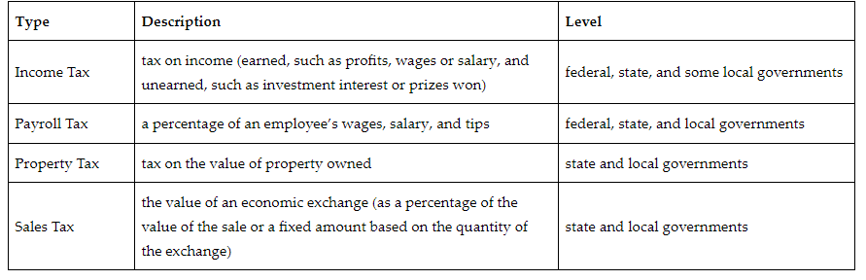

Juries allow citizens to participate in the judicial process. Juries serve as a check on the judicial process. There are two different types of juries that a person can serve on: grand juries and trial juries.

Grand juries determine if there is enough evidence to warrant a trial. Trial juries determine the outcome of cases.

Being a witness at a trial is an important thing to do. Typically, a person is called to be a witness if they have vital information that will help the jury make the right decision. When a person is called to be a witness in a trial, they often get a subpoena.

U.S. citizens can also serve in the military. Sometimes there are not enough people in the military. In this case, Congress can use the draft to force people to serve under penalty of law.

**Objective 2:** Explain what civic responsibility means and the importance of civic responsibilities.

**Big Ideas** Being a U.S. citizen is both a great privilege and a great responsibility. As a U.S. citizen, individuals are expected to exercise civic responsibility. Civil responsibility refers to attitudes, behaviors, and duties one demonstrates and/or performs to support a democratic society, community, and nation. Civic responsibility is acting in a manner that promotes the local community and nation. Civic obligations are non-voluntary duties. These are responsibilities a U.S. citizen automatically accepts as a native-born citizen. They are required by law.

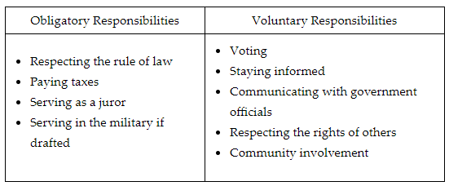

Voter eligibility is determined by both state and federal law. There are some differences between the states. Generally, a person must be a U.S. citizen and 18 to vote.

Before you can vote, you typically are required to register. This usually involves filling out a form and mailing it to the proper official. The purpose of voter registration is to prevent voter fraud in elections.

**Objective 3:** Explain the importance of civic virtue in a democratic society.

**Big Ideas:** For a democratic society to function, there must be a level of civic virtue among its citizens. Civic virtue requires people to put the needs of the community above their own needs.

Natural rights are the rights given to all humans and are not dependent on the laws, customs, or beliefs of any culture or government.

**Keywords**:

* **conscription** – the process by which a government raises a military force by requiring people to serve under penalty of law
* **criminal trial** – a trial where the government has brought charges against a person that accuses them of breaking a law
* **grand jury** – a jury used to determine if there is enough evidence to charge a person with a crime
* **subpoena** – an order issued by a court that commands a person named on the subpoena to appear and testify
* **trial jury** – a jury used in both criminal and civil cases to decide who wins
* **civic responsibility** – an action U.S. citizens perform to support a democratic society
* **civic virtue** – a set of standard moral behaviors for citizens to uphold by putting community needs ahead of individual needs

**Quick Check**

Question 1: Which of the following is the **best** explanation of why it is important to serve as a juror?

* **Juries serve as a check on the judicial process.**
* Juries determine whether a trial will be civil or criminal.
* Juries present evidence to determine a person’s guilt in a criminal trial.
* Juries decide who will receive a subpoena.

Question 2: Which of the following **best** describes the difference between a grand jury and a trial jury?

* Grand juries determine the outcome of cases.
* Trial juries determine if there is enough evidence to warrant a trial. Grand juries only decide criminal cases.
* Trial juries only decide civil cases. Grand juries only decide civil cases. Trial juries only decide criminal cases.
* **Grand juries determine if there is enough evidence to warrant a trial. Trial juries determine the outcome of cases.**

Question 3: Which of the following **best** explains civic responsibility?

* Acting in a manner to emphasize one’s own rights.
* Acting in a manner that impedes other’s rights.
* Acting in a manner that focuses only on local community issues.
* **Acting in a manner that promotes the local community and nation.**

Question 4: Which of the following **best** explains the purpose of voter registration?

* It helps to increase voter participation.
* It helps citizens become informed about issues.
* It helps citizens to communicate with government officials.
* **It helps to prevent voter fraud in elections.**

Question 5: Which of the following statements **best** explains the importance of civic virtue in a democratic society?

* Civic virtue requires people to have the same or similar religious beliefs within the community.
* **Civic virtue requires people to put the needs of the community above their own needs.**
* Civic virtue requires people to never question the decisions made by government officials.
* Civic virtue requires people to sign a social contract to uphold the common good of society.

**Lesson 3 – Civic Behavior**

**Objective 1:** Explain the importance of civic competencies including civil discussions, evaluating issues and government leaders/candidates, and placing societal needs above personal interests.

**Big Ideas**: For the framework of American government to operate well, citizens must practice and demonstrate civic skills or competencies that support American democracy.

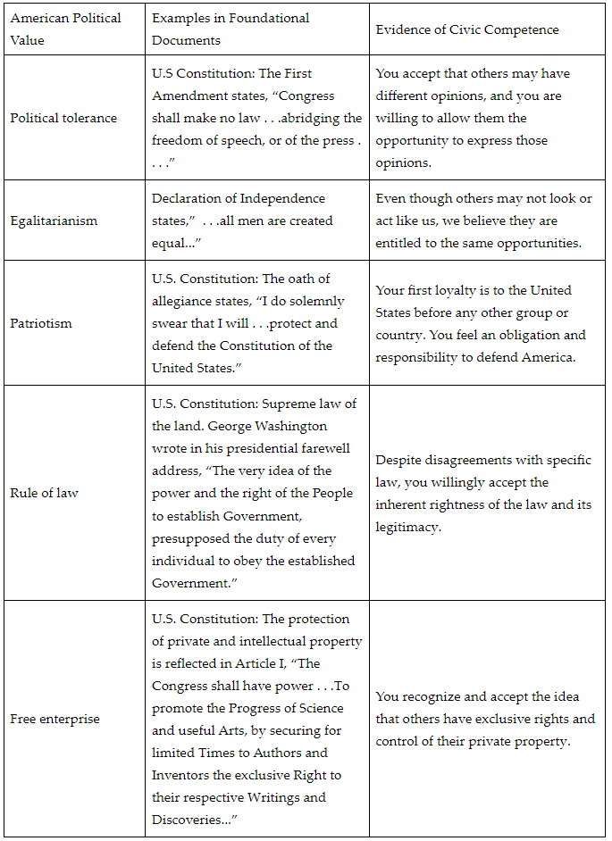

The following chart illustrates the relationship between civic competencies and civic dispositions.

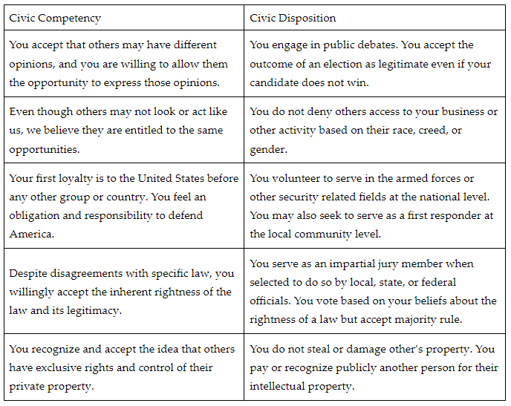

**Objective 2:** Explain civil society, how civil society institutions contribute to the public good, and how individuals can become involved in civil society institutions.

**Big Ideas:** Civil society is one of three spheres that comprise the environment of a society.

Civil society brings together people of shared interests and concerns. Often these civil society organizations interact with parts of the other environmental arenas to address interests and concerns through various forms of governance.

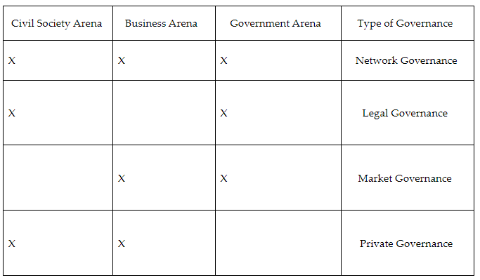

Civil society institutions may interact with the governmental sphere through legal governance. Legal governance seeks to address the needs and interests of the civil society institution by harnessing existing laws or applying pressure to create new laws. Often, this takes the form of interest groups that are non-profit, public-sector organizations seeking to address members’ needs and issues.

Civil society interacts with the business sphere through private governance. Private governance does not involve the government or laws. Private governance involves a partnership between community, national, or international businesses addressing civil society concerns.

Civil society institutions can also interact with government and business spheres simultaneously through network governance. Network governance addresses economic concerns of a local and national civil society institution by seeking laws that govern business practices.

**Objective 3:** Identify ways you can get involved in government at the local, state, national, and global levels.

**Big Ideas:** Even if you are not 18, you can still be involved in politics. This can start with volunteering to support a candidate’s campaign by passing out campaign literature, getting signatures on petitions, or working on the campaign’s community activities. You can support campaigns by sharing your enthusiasm for a candidate or their positions on issues by sharing these messages informally with others.

**Getting Involved at the State Level**

Every state has legislators that represent you in the state capitol. One way to get involved at the state level is to contact your state representative to share your views on issues that matter to you. Although you may not be eligible to vote, your voice is important feedback to legislators as they consider legislation that personally affects you.

**National and Global Involvement**

Like communication with your state representatives, you can write or call and express your view on issues that concern you. At the national level there are often unique opportunities that will help you join others as part of a national communication. These include national protests and joining national organizations. By joining with others in protests and organizations at the national level, you create an amplified message.

**Keywords**:

* **civic competence** – knowledgeable in the social and political aspects of a democratic government in order to fully participate in civic life
* **civic disposition** – being active in democratic practices while respecting the thoughts and beliefs of others
* **egalitarianism** – the equal nature of people within American society
* **free enterprise** – the idea that people have the freedom to pursue their own economic goals without government interference
* **civil society** – a civil society creates institutions dedicated to furthering the public good, or benefits to society, by working with government and business interests
* **constituent services** – offices or staff members who are affiliated with state and federal elected officials to help voters in their districts and states address problems and concerns they may have with matters related to public policy

**Quick Check**

Question 1: Read the following excerpt from the Fourteenth Amendment:

“All persons born or naturalized in the U.S. and subject to the jurisdiction thereof, are citizens of the U.S. and of the State wherein they reside. No State shall make or enforce any law which shall abridge the privileges or immunities of citizens of the U.S.; nor shall any State deprive any person of life, liberty, or property, without due process of law . . . .”

Explain how one could support this through a civic disposition.

* A person volunteers to serve in the armed forces or other security related fields at the national level. They may also seek to serve as a first responder at the local community level.
* A person serves as an impartial jury member when selected to do so by local, state, or federal officials. A person votes based on your beliefs about the rightness of a law, but accepts majority rule.
* A person engages in public debates. A person accepts the outcome of an election as legitimate even if your candidate does not win.
* **A person does not deny others access to your business or other activity based on their race, creed, or gender.**

Question 2: A person recognizes that there is a high incidence of police shootings involving minorities and organizes with others from the community to lobby the state government to successfully change the training requirements for new police officers. Explain how civil society and institutions in this case are contributing to the public good.

* **Civil society institutions interact with the governmental sphere through legal governance.**
* Civil society institutions did not interact with governmental and business spheres.
* Governmental and business spheres interact through market governance.
* Civil society institutions interact with the business sphere through private governance.

Question 3: Organizers at the state and local level identify that air pollution is responsible for higher incidences of lung cancer. The air pollution is traced to factories that employ a substantial number of state residents. Organizers, unable to coordinate a reduction in the industry’s pollution generation, ask state legislators for help. In the end, state legislators provide tax incentives for the company to retrofit their factories with green technology and reduce pollution emissions. Explain how civil society and institutions in this case are contributing to the public good.

* Civil society institutions interact with the governmental sphere through legal governance.
* **Civil society institutions interact with governmental and business spheres through network governance.**
* Civil society institutions interact with the business sphere through private governance.
* Governmental and business spheres interact through market governance.

Question 4: Identify which of the following actions would be **most** appropriate for becoming involved with government at the local level.

* You are strongly against the national law that would require people to have a driver’s license to vote. You join in a national march on Washington, D.C.
* **You agree with a candidate’s position on issues. You volunteer to pass out campaign literature to support the candidate.**
* You are 18 and feel your ideas about governance are strong enough to support your candidacy for Congress.
* You join a national organization online and subscribe to the email newsletter.

Question 5: Identify which of the following actions would be most appropriate for becoming involved with government at the state level.

* You agree with a candidate’s position on issues. You volunteer to pass out campaign literature to support the candidate.
* **You see that the state legislature is considering lowering the age of drivers. You disagree with this and create a social media page to show your research about this.**
* Despite being under 18 years of age, you feel your ideas about governance are strong enough to support your candidacy for Congress.
* You learn that the state legislature is considering reducing funding in the state public schools. You decide to run for class president.

**Lesson 4 – Election Process**

**Objective 1:** Look at the ways in which elections in the U.S. take place.

**Big Ideas**: In the U.S., there are hundreds of thousands of elected offices at local, state, and national levels.

Elections are open to eligible voters. Elections are held on a regular and predictable schedule. In the U.S. A typical election cycle is every two years. They are held on even-numbered years. The presidential election cycle is every four years. In between presidential elections there is a midterm election. There are special elections held under various circumstances in the odd-numbered years in between.

**Majority Versus Plurality**

There are two ways to win an election. One is by a majority of votes. The second is by a plurality of votes. An election that a candidate must win by a majority must receive more than half of the votes. In many cases, a majority vote occurs in an election where there are only two viable candidates.

In an election that a candidate must win by a plurality of votes, the winner must get more votes than the other candidates. Plurality votes often happen when there are three or more candidates.

**Primary Elections and General Elections**

Many democracies have an added round of elections, called a primary election, before the general election. These primaries are used to select the candidates who will later run for office. Primary elections are in part a way for political parties to gauge the popularity of candidates. Primary elections also serve as another democratic check on who ends up in powerful leadership roles. If a candidate does not win a political party’s primary, they will not be that party’s candidate. They are then barred from running in the general election.

**The Presidential Election Process**

**Presidential Nominations**

Starting early in February of a presidential election year, the major political parties in each state conduct either a primary election or a caucus. These are opportunities for people to select whom they would like as their party’s candidate. They are conducted state-by-state over many months.

In a state with a presidential preference primary election system, voters choose their nominee. The votes are protected and counted by government officials. Most states hold primary elections to vote for their nominees. In states with a caucus, voters attend a scheduled meeting on election night in a public gathering area. At these meetings, people publicly express their support through a series of “aye” and “nay” votes. Between each vote, surrogates for a candidate try to convince supporters of an opponent to switch sides. This process repeats until a final vote is tallied, and a caucus selects its candidate. Caucuses across the state are added up, and delegates are distributed proportional to the overall vote.

Potential candidates campaign in states to collect delegates. They compete to win a plurality of the vote in each state. Delegates for each person running for the nomination will then be formally counted in each party’s national convention in late summer. Whoever wins most of the delegates becomes the candidate of that party.

**Electoral College**

After each major political party has selected its candidate, the general election occurs. The presidential election is not decided by a national popular vote. It is decided by the outcome of the Electoral College.

This is an additional institution whose only function is to select the president. Presidential compete for a majority of electors. Each state gets a number of electors equal to its representation in Congress. Each state legislature decides how to allocate its electors.

All states but two allocate their electors on a winner-take-all rule. Whichever candidate wins a majority of a state’s votes is awarded all that state’s electors.

Winner-take-all affects the strategy of presidential campaigns. Candidates spend most of their money and time campaigning in battleground states. They largely ignore safe states.

Winner-take-all allocation of electors can warp the outcome of presidential elections. Since candidates are competing for electors and not the national popular vote, it is possible to have a result in which a presidential candidate loses the popular vote, but still wins the election because they won most electors.

**Local Elections**

Local elections often take place at the same time as state and national elections. This is so people can vote for their representatives at all levels at once.

**Partisan**

Officials in local elections have the choice between conducting partisan or nonpartisan elections. In a partisan election, voters choose a ballot for one political party when they enter a polling place. The voter will only see candidates from their selected party.

**Nonpartisan**

In a nonpartisan election, voters get a ballot with all candidates running for office.

**Objective 2:** Identify the major similarities and differences between election procedures at the national, state, local, and tribal levels of government.

**Big Ideas: Federal Elections**

At the federal level, American citizens elect the president, vice president, and members of Congress. Federal elections always occur on the first Tuesday after the first Monday in November in even-numbered years.

Presidential elections are four years. Presidents and vice presidents are the only two positions chosen by a national electorate. Both are chosen through the Electoral College. The Electoral College has 538 electors. These electors are divided among the 50 states plus the District of Columbia based on population. A simple majority (270) is needed to win the election. If no candidate reaches 270, then a simple majority vote in the U.S. House of Representatives selects the president. A simple majority vote in the U.S. Senate selects the vice president.

Members of the House serve two-year terms. Elections occur every two years, either on the same day as the presidential election or during what is called a midterm election. Members of the Senate serve six-year terms. Election dates are staggered so that only one-third of the Senate is up for election every two years. Each member of the House represents those who live in their district. Senators represent those who live in their state.

**State and Local Elections**

For all elections at the state and local levels, procedures and laws can vary if they do not violate the “one person, one vote” rule in the Constitution. State and local election officials oversee election procedures and voter registration.

State elections include those for state legislatures and the positions of governor and other statewide elected positions. These can vary by state. New Hampshire and Vermont have two-year terms for statewide offices and hold elections every even-numbered year. The remaining 48 states have four-year terms for statewide offices. Of those, 34 hold their elections on the same day as the federal midterm elections. Nine hold their elections on the same day as presidential elections. Five states hold their elections in odd-numbered years. Members of state legislatures serve either two- or four-year terms.

Local elections vary due to the length of terms and the variety of offices. These positions can include mayor, city council members, county boards of supervisors, school boards, sheriffs, local judges, or members of water or park districts, among others. Many elections at the local level are nonpartisan elections. This means that candidates do not campaign or appear on a ballot with a political party affiliation.

**Elections for Indigenous Nations**

Tribal elections occur regularly within the 574 Indigenous nations that are recognized by the federal government. Indigenous nations have sovereignty. This means that they can create laws. They can determine how to represent their people. As each Indigenous nation is unique, so too are their electoral procedures.

Most Indigenous nations rely on a constitution that outlines term limits for elected positions and when elections occur. Leadership positions vary, with examples such as tribal chair, secretary, or treasurer. Some Indigenous nations require that their citizens live on the reservation to participate in the election. Others also allow nonresidents to vote. Indigenous nations contribute to local and regional economies and interact with federal, state, and local governments, making representation of Indigenous people essential within the governing process.

**Objective 3:** Critique the impact that election processes have on voter participation and engagement.

**Big Ideas:** Elections in the U.S. are winner take all.

In a winner-take-all election, the winner is the candidate who receives the plurality of the votes among what can sometimes be a large field of candidates. This is different than a proportional electoral system where political parties win seats in proportion to the percentage of votes cast. Winner-take-all elections encourage a two-party system within the U.S. because candidates outside the two major parties (Democrats and Republicans) have difficulty gaining traction with voters during a campaign. The winner-take-all system makes it more difficult for a third political party to gain traction. The winner-take-all system ensures that the will of the majority is represented. Those in the minority might not have their views represented by their elected official.

Voters need substantive information about candidates and public policies to make informed decisions about choices during an election. However, not all media coverage provides substantive information, as stories often focus on the horse race of the campaign or personal scandals involving the candidates. Public opinion polling is plentiful during a campaign, but polls can be inaccurate, and the media might use them to incorrectly predict an election outcome.

**Keywords**:

* **battleground states** – states where the outcome in a presidential election is much more competitive and either candidate has a reasonable chance of winning
* **caucus** – a method of choosing a nominee in which voters attend a scheduled meeting in a public place on election night and publicly express their support for a candidate through a series of “aye” and “nay” votes
* **delegate** – a person sent by a state to represent its residents in the national convention
* **national convention** – an event held in late summer in a presidential election year by each major political party to formally announce its presidential candidate
* **nonpartisan election** – an election in which voters get a ballot with all candidates running for office, regardless of their political party affiliation
* **partisan election** – an election in which voters choose a ballot for one political party when they enter a polling place
* **winner-take-all** – a system that awards all electoral votes to the winner
* **one person, one vote** – the ideal that citizens have equal representation when voting
* **plurality voting** – an electoral system in which a candidate wins office by receiving the highest number of votes

**Quick Check**

Question 1: Which of the following illustrates elections in the U.S.?

* There are 7,000 elected members in the federal government.
* **There are hundreds of thousands of elections at local, state, and national levels in the U.S.**
* Most local governments do not have elected officials.
* While all states elect their governors, there are not any states that elect other state executives.

Question 2: How many electors in the Electoral College will a state with 14 members of the House of Representatives and two members of the Senate have?

* 14
* 17
* 2
* **16**

Question 3: Which of these statements **best** explains the job of state and local election officials?

* To nominate candidates for the general election.
* **To oversee election procedures and voter registration.**
* To determine the procedures and date of Indigenous nation elections.
* To determine the date of federal elections.

Question 4: What is the purpose of a general election?

* To nominate a candidate for an elected position.
* **To select who will hold an elected position.**
* To determine who is eligible to vote.
* To determine the length of a governor’s term in office.

Question 5: Which statement **best** critiques the winner-take-all electoral process?

* The winner-take-all process allows political parties to win seats in proportion to the percentage of votes cast.
* **The winner-take-all system makes it more difficult for a third political party to gain traction.**
* A winner-take-all system tends to depress voter turnout.
* The winner-take-all system discourages the two-party system in the U.S..

**Lesson 5 – Electoral System**

**Objective 1:** Analyze the foundations of the U.S. electoral system and how it has shaped the U.S. political system.

**Big Ideas**: The president is elected every 4 years. The members of the House of Representatives are elected every 2 years. One-third of the Senate comes up for election also every 2 years. Senators serve 6-year terms. Their terms are staggered based on the years they were elected.

The U.S. holds a national general election every 2 years. The elections without a presidential candidate on the ballot are known as “midterm” elections. Every state has its own legislature with representatives and a chief executive called a governor who are elected in the same way.

**Presidential Elections**

A candidate first must win the nomination of their party. Voters in each state from each political party choose their nominee. For each state, the candidates are assigned a number of delegates based on the results.

**Party Conventions**

Where do these delegates go? They gather at each party’s national convention. At the convention, the delegates enter the names of candidates onto a nomination ballot. Then they vote for the candidate they think will have the best chance of winning.

The first time they vote, each delegate is told who to vote for. They either vote for the person who won their state’s primary election. Or they vote as they have been assigned to vote by the party organization. If no one receives a majority on the first ballot, the delegates can vote for anyone after that.

Before the convention, the presumptive nominee will normally choose a vice presidential “running mate.”

**The General Election**

Once the nominees for each party are determined, the general election cycle begins. Between August and the end of October, the nominees campaign. Nominees often ignore states or locations where they are very likely to win or very likely to lose.

The nominees appear in campaign advertisements. They debate each other on national television. They engage in other activities designed to connect with voters and increase their appeal. Finally, on the first Tuesday following the first Monday in November, the public goes to the polls and votes. The new president takes office on January 20 of the year after the election.

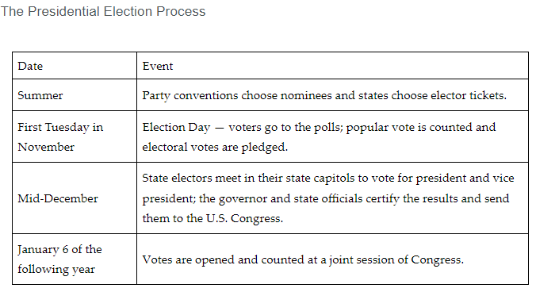

**Objective 2:** Illustrate the process of the Electoral College.

**Big Ideas:**

The U.S. uses a unique method to elect its president. Citizens’ presidential votes do not go directly to the candidate. Instead, they vote for members of the Electoral College. These members cast the “real” presidential votes.

The use of the Electoral College has caused controversy. Politicians and voters often consider it undemocratic. That is because the nominee who wins the election may not receive the most popular votes.

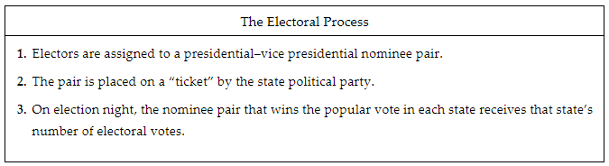

There is the potential for a tie vote. There is also a chance that no one gets the majority. When a nominee fails to get a majority of electoral votes, it triggers a contingent election. This happens in the House of Representatives. A contingent procedure requires each state’s representatives to vote as a single unit (by state). The winner is the candidate who gets a majority of state delegation votes.

**Objective 3:** Explain the role and importance of campaigns, primaries, and caucuses in general elections.

**Big Ideas:**

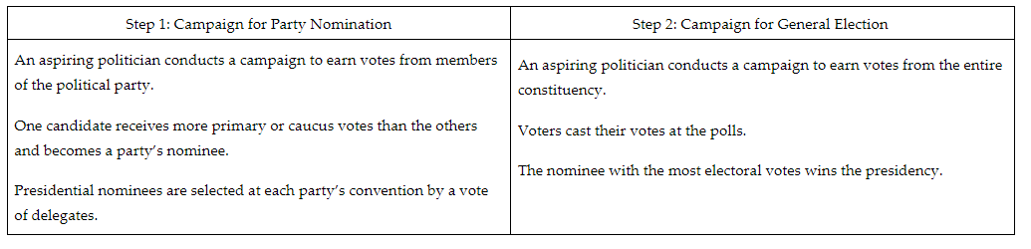

**Primary Elections**

Primaries may be closed, semi-closed, or open:

* A closed primary is one in which only registered members of a party may vote. Republicans and Democrats have separate primaries and neither may vote in the other’s primary.
* A semi-closed primary excludes voters from the opposing major party (Republican or Democratic) but allows independents and third-party voters to cast ballots.
* An open primary is available to any registered voter in the state, without respect to party affiliation. The only restriction is that one may not vote in more than one primary in any given election cycle.

The purpose of a primary is to assign delegates from each state to the national party convention.

**Caucuses**

A few states keep their caucus-based election systems. In a caucus, voters meet to debate the nomination.

* Voters meet in a school, church, convention hall, or other public meeting place with those of their same party affiliation.
* Voters discuss which candidates are worthy of support and stand a good chance of winning.
* Voters use the process of elimination to choose a candidate.

The goal is to collect delegates for their party’s national convention. A presidential candidate is not officially the nominee until delegates vote at the party convention. Superdelegates are those that are not pledged to a candidate and may vote for whomever they choose at the convention. The state’s political party organizations control allocation of delegates.

In the general election, all constituents vote. The type of position determines who votes:

* Presidential election: All eligible voters in the country vote.
* U.S. Senate election: All eligible voters in the state vote.
* U.S. House of Representatives: All eligible voters in a district vote.
* State-level representatives, state senate, or other state and local elections: All eligible voters in a precinct, district, or city vote.

**Keywords**:

* **apportionment** – the method of assigning U.S. House districts to each state based on population

**convention** – a gathering of party delegates to decide their nominees for president and vice president

* **gerrymandering** – creating U.S. House districts that favor one political party over the other, usually by employing unusual or convoluted shapes and boundaries
* **nominee** – a person chosen to represent a political party at a general election
* **Electoral College** – the system used to elect the president of the U.S.
* **popular vote** – the aggregate total of all individual votes cast for each nominee
* **superdelegate** – a designation used by the Democratic Party to indicate a convention delegate who is not pledged to vote for a certain candidate

**Quick Check**

Question 1: Analyze the strategy that a candidate might use when running for president in the general election. What should their first goal be?

* To choose the correct states in which to campaign during the general election.
* To choose a good running mate.
* To become a delegate to the national convention.
* **To win their party’s nomination at the national convention.**

Question 2: Which of the following illustrates the Electoral College process?

* 1. Electors carefully choose a presidential and vice presidential nominee pair. 2. The pair is placed on the ballot by the state political party. 3. The nominee pair that wins the state receives its number of electoral votes.
* 1. Electors are assigned to a presidential–vice presidential nominee pair. 2. The pair is placed on a ticket by the state political party. 3. The nominee pair that wins the electoral votes receives that number of popular votes.
* 1. Electors carefully choose a presidential and vice presidential nominee pair. 2. Each state needs a certain number of voters to vote on Election Day. 3. The nominee who wins the popular vote receives the state’s electoral votes.
* **1. Electors are assigned to a presidential–vice presidential nominee pair. 2. The pair is placed on a ticket by the state political party. 3. The nominee pair that wins the popular vote in each state receives that state’s electoral votes.**

Question 3: What event triggers a contingent election for president?

* One of the nominees switches to a different political party.
* **One of the nominees fails to receive a majority of electoral votes.**
* One of the nominees drops out of the race before Election Day.
* One of the nominees doesn’t win their state electoral votes.

Question 4: Which of the following **best** explains the role of superdelegates?

* They only vote in caucuses.
* **They are not pledged to a candidate and may vote for whomever they choose at the convention.**
* They are pledged to a candidate but are allowed to change their vote at the convention.
* They only vote in closed primaries.

Question 5: What is the purpose of a presidential primary?

* To determine the best candidate through discussion and the process of elimination.
* **To assign delegates from each state to the national party convention.**
* To persuade voters to select a presidential candidate.
* To assign presidential electors from each state.

**Lesson 6 – Political Parties**

**Objective 1:** Analyze three primary source documents to determine the role of parties in American politics and analyze how voter turnout impacts elections. This lesson will include excerpts from three documents: George Washington’s Farewell Address, Theodore’s Roosevelt's speech “The New Nationalism,” and one of Barack Obama’s campaign speeches.

**Big Ideas**:

**Washington and Roosevelt on Political Parties**

Political parties have a long history in the U.S.. They have been criticized by many key figures for dividing America. Both Washington and Roosevelt were concerned about preserving unity, the threat of division to American liberty, and the role of what Roosevelt termed “special interests” in undermining American democracy. Special interests are an example of the spirit of party. They could twist economic policy to their benefit and enrich themselves at the expense of others.

Both saw self-interest as part of human nature, leading to the spirit of party and special interests. Washington feared this would lead to disunity and conflict in the U.S.. Roosevelt was concerned with economic inequality leading to political inequality. Both men would likely have concerns about modern political parties. They would also have concerns about how modern partisan debate often focuses on attacking the motives of one's opponent and arguments over the distribution of wealth.

**Obama and Voter Turnout in 2008**

Voter turnout can also have a major impact on the results of an election. Many historians believe that Barack Obama won the 2008 presidential election in part because of a high voter turnout.

Obama used the slogan “Yes We Can” to rally voters to show up on election day and cast their votes.

As a result of Obama’s efforts, the 2008 election saw high voter turnout. At the time, a record 131 million people voted in the election.

**Objective 2:** Evaluate how diversity has influenced political parties and led to changes in American party politics.

**Big Ideas:** Political parties are often made up of diverse groups. These groups come together because they share key beliefs about the purpose of government. Political parties try to be as diverse as possible. This increases their percentage of voters. With a higher percentage of the voting public, the party is more likely to win elections.

Over the past 25 years, the demographics of the U.S. has changed. America has become older, better educated, and more diverse. The following chart demonstrates the changing natures of the parties as of 2016.

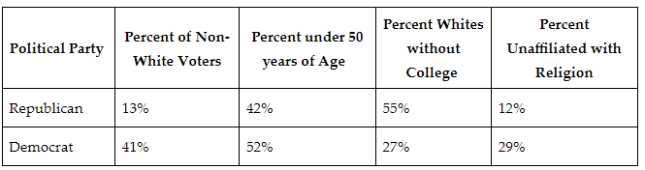

In recent presidential elections, each party wins in large sections of the country. The following chart reflects these trends.

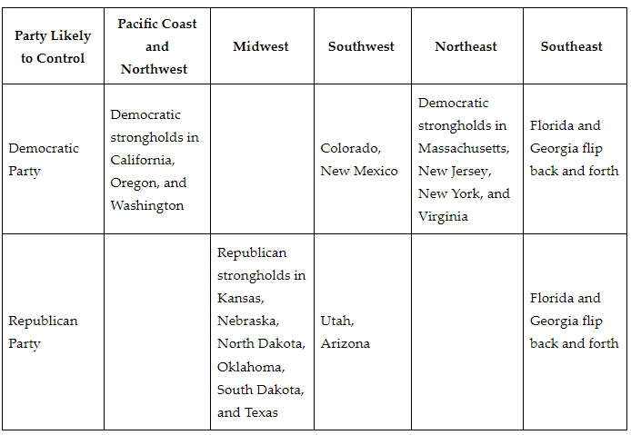

**Objective 3:**  Assess the role political parties play in administering government at the local, state, and national levels.

**Big Ideas:** Political parties use resources and strategies to administer government at the national, state, and local levels. The most common ways political parties administer government is by developing the following:

* coalitions
* agendas
* party platforms

Democrats and Republicans compete to become the elected party. The highest-level political parties compete for is the presidency. The political party that becomes the elected party controls the executive branch. Controlling the executive branch allows a political party:

1. Determine military action.
2. Guide policies at all three levels of government.

The president creates an agenda that outlines the political party’s platform with policies the party would like Congress to pass. Once Congress passes the legislation, the executive branch executes the policies. Political parties dictate laws and policies that are implemented at the national level.

At the local level, mayors are the most influential. Political parties at the local level influence the type of policies a mayor implements. A mayor often implements policies its party member’s support.

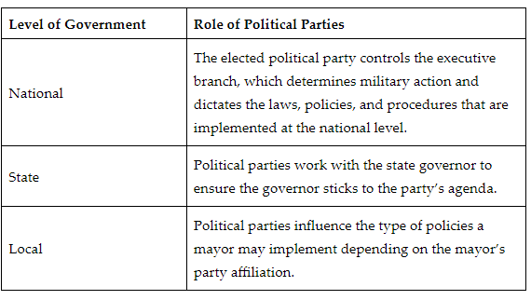

**Objective 4:** Describe the ways in which diverse individuals influence interest groups and political parties.

**Big Ideas**: A diverse population typically has characteristics that differ from most others in a particular area.

Diversity in politics and interest groups is not always all about race, gender, or ethnicity. It is also about lived experiences, skills, and backgrounds. It is imperative that interest groups and political parties understand that diverse populations are valuable. By listening to, and aligning with, interest groups that represent diversity in all its forms, politicians have a better chance of reaching the entire population. Diverse populations influence interest groups by advocating for policy and change.

**Keywords**:

* **Progressive Era** – a period in the U.S. that saw significant political, social, and economic reforms aimed at reducing the power of corporations and putting government to work on behalf of American workers
* **special interest group** – a group of people, a company, or an industry that works to impactlegislation and public policy in their favor on one or more shared concerns or topics
* **spirit of party** – the favoring of your segment of the community and those like you over the public good
* **party platform** – the ideas and beliefs that a party stands for and wishes to enact
* **coalition** – a political group formed to complete particular legislation
* **gridlock** – difficulty moving the legislative process forward
* **plank** – a section of a political party platform that addresses a specific issue
* **political efficacy** – the trust people have in their ability to influence and understand political issues and to create change in the government

**Quick Check**

Question 1: Which statement draws correct conclusions about the relationship between Washington’s spirit of party and Roosevelt’s special interests?

* Special interests cause the spirit of party.
* Special interests and the spirit of party are good for democracy.
* Special interests and the spirit of party are unrelated.
* **Special interests are an example of the spirit of party.**

Question 2: Which statement **best** evaluates the way in which diverse stakeholders influence political outcomes within the Republican Party?

* Republican voters are more likely to be non-White and supportive of issues related to discrimination against people of color.
* Republican voters are likely to be college educated.
* **Republican voters are more likely to be affiliated with organized religion and supportive of individual liberty connected to religion.**
* Republican voters are more likely to be younger and supportive of issues related to youth.

Question 3: Which of the following assesses the role political parties play in administering government at the national level?

* Political parties use a strategy called gridlock to create a plank at the national level.
* **Political parties dictate laws and policies that are implemented at the national level.**
* Political parties use a strategy called gridlock to create laws and policies at the national level.
* Political parties determine the number of U.S. representatives at the national level.

Question 4: Which of the following assesses the role political parties play in administering government at the local level?

* **Political parties at the local level influence the type of policies a mayor implements.**
* Political parties at the local level create the agenda items the mayor will implement.
* Political parties at the local level determine the number of congressional votes in Congress.
* Political parties influence the number of representative seats the mayor has in Congress.

Question 5: Which of the following **best** describes how a diverse population influences an interest group?

* Diverse populations influence interest groups by adding them to the ballot.
* Diverse populations influence interest groups by marching in Washington, D.C. or in a state capital city.
* **Diverse populations influence interest groups by advocating for policy and change.**
* Diverse populations influence interest groups by donating money.

**Lessons 7-8 Funding Campaigns Discussion**

**Lesson 9 – Minority Rights**

**Objective 1:** Assess how reapportionment, redistricting, and gerrymandering can influence or impact minority rights.

**Big Ideas**:

**Reapportionment**

The U.S. is divided into 435 congressional districts. Each district has a member of the House of Representatives. These districts are redrawn every 10 years. They are redrawn by each state’s legislature based on changes in population. Drawing new boundaries is meant to ensure all citizens are fairly represented. The party in power might use the redrawing process to give itself an advantage. Minority rights are frequently impacted by this process. Minority voters may gain or lose congressional representation based on population changes.

**Redistricting**

Redistricting is the process of redrawing districts. When redistricting, state legislatures may try to weaken the influence of minority groups by packing and cracking. Packing refers to grouping large numbers from the opposing political party in a few districts. Other voters of the same party are “cracked,” broken up across several districts. This way, their votes do not wield much influence in any election. Redistricting could disenfranchise minority voters by making their votes less influential.

**Gerrymandering**

Gerrymandering is done to manipulate the boundaries of election districts, giving an unfair advantage to one party over the other.

**Objective 2:** Explain how different groups of people fought for and achieved suffrage in the U.S..

**Big Ideas: The Fifteenth Amendment**

This amendment granted Black men the right to vote. But many Black men were denied this right. This was due to discriminatory practices and laws, and the threat of violence. Literacy tests were given to those who tried to register to vote. White people often did not have to take these literacy tests. Black people were often unfairly disqualified based on the administrator’s interpretation of their answers.

Voters in the South were required to pay poll taxes to vote. Black families could often not afford these taxes. This prevented them from voting. Meanwhile, impoverished white people were offered exemptions from paying these taxes.

**The Nineteenth Amendment**

Women first officially called for the right to vote at the Seneca Falls Convention (1848). During this convention, women’s rights advocates issued the Declaration of Sentiments. This declaration stated that women deserve the same civil rights as men. Known as suffragettes, women worked tirelessly to earn their right to vote. In 1920, the Nineteenth Amendment was ratified. This gave giving the right to vote.

**Indigenous Americans**

In 1924, Congress passed the Indian Citizenship Act. This act gave citizenship to Indigenous Americans. But states would still limit the voting rights of Indigenous Americans for decades. Indigenous Americans in all states had the right to vote by 1962. Indigenous Americans faced literacy tests and poll taxes. The goals of these were to prevent them from voting.

The Voting Rights Act of 1965 protected the rights of all citizens to vote by banning discriminatory practices like literacy tests. This law offered protection to groups that had been marginalized from voting.

**Objective 3:**  Analyze the impact of expanding suffrage throughout American history.

**Big Ideas:** Many events have occurred in the history of voting rights in the U.S.:

* 1788 U.S. Constitution
* 1870 Fifteenth Amendment - expanded suffrage to Black men. Black men were able to access jobs, housing, and education during the era of Reconstruction.
* 1920 Nineteenth Amendment - Women were granted equal rights as citizens of the country. This effectively doubled suffrage rights in the U.S., impacting legislation significantly.
* 1924 Snyder Act - gave Indigenous Americans U.S. citizenship. It opened up the opportunity for voting rights.
* 1964 Twenty-fourth Amendment - ratified in 1964. It worked in tandem with the Voting Rights Act to undo the impact of the disenfranchisement of Black Americans. It prohibited discriminatory laws. It expanded voting rights of minority populations.
* 1965 Voting Rights Act of 1965 - The passage of the Voting Rights Act of 1965 finally allowed Black Americans to vote without the restrictions of poll taxes, literacy tests, and laws that had been passed in southern states.
* 1971 Twenty-sixth Amendment - lowered the voting age from 21 to 18.

**Keywords**:

* **census** – an official count of the population and its demographics
* **congressional districts** – states are divided into congressional districts based on the number of members they are assigned in the House of Representatives. Each congressional district elects one member to the House of Representatives.
* **cracking** – a gerrymandering method used to divide a cluster of voters who support the same political party into several districts
* **gerrymander** – to manipulate the boundaries of election districts to gain an unfair electoral advantage
* **packing** – a gerrymandering method where like-minded voters are grouped to support a political party in one voting district to reduce their influence in surrounding districts
* **reapportionment** – a gain or loss of congressional seats as a result of population changes
* **redistricting** – a process in which state and local governments redraw their districts because of the population changes that occur over the course of a decade
* **poll tax**– the money that some citizens had to pay in order to vote
* **Snyder Act** – the act granting citizenship to Indigenous Americans

**Quick Check**

Question 1: Which assesses how minority rights could be negatively impacted by redistricting?

* Redistricting could put voters into districts outside of their own states.
* Redistricting could take away the ability of minority voters to participate in elections.
* **Redistricting could disenfranchise minority voters by making their votes less influential.**
* Redistricting could give more power to some minority voters while taking away power from others.

Question 2: How can reapportionment impact minority rights?

* Minority voters may be grouped into one district based on changes to the population.
* **Minority voters may gain or lose congressional representation based on population changes.**
* Minority voters may have less influence based on the new boundaries of congressional districts.
* Minority voters may be less likely to vote based on changes to congressional representation.

Question 3: Which explains how suffrage was granted to Black men in the U.S.?

* Through the Voting Rights Act of 1965.
* Through the U.S. Constitution.
* **Through a constitutional amendment.**
* Through a convention.

Question 4: Which statement **best** analyzes the historical impact of the Twenty-Fourth Amendment for Americans?

* **The Twenty-Fourth Amendment prohibited discriminatory laws, expanding the voting rights of minority populations.**
* The Twenty-Fourth Amendment gave citizenship to Indigenous Americans, allowing them the right to vote.
* The Twenty-Fourth Amendment gave suffrage rights to Black women, expanding the voting population.
* The Twenty-Fourth Amendment allowed women to vote, doubling the voting population of the U.S..

Question 5: What was the historical impact of the Snyder Act?

* **The Snyder Act gave Indigenous Americans U.S. citizenship, opening up the opportunity for voting rights.**
* The Snyder Act affirmed suffrage for Black men, protecting their ability to vote.
* The Snyder Act gave women the right to vote, doubling the country’s voting population.
* The Snyder Act required the payment of poll taxes, limiting who was able to vote.

**Lesson 10 – Political Participation**

**Objective 1:** Analyze expansion of the Constitution as it relates to citizenship and political participation.

**Big Ideas**: In each country there are laws that determine who is a citizen and what rights the citizens of that country have. In the U.S., the Constitution is that document. Rights that are given to people living in the U.S. can vary depending on the type of citizenship. Natural born citizens are born in the U.S.. Naturalized citizens are born in a foreign country and gain legal citizenship. These rights have evolved.

The Fourteenth Amendment defines citizenship in the U.S. for those who are born or naturalized in the U.S.. Prior to this amendment, Black Americans were not considered U.S. citizens. The Fourteenth Amendment gave citizenship to anyone born or naturalized within the U.S., including Black Americans.

Voting has evolved with the additions of the Fifteenth, Nineteenth, and Twenty-sixth Amendments. Originally, only White men who owned land could vote. Now any U.S. citizen can vote. The Fifteenth Amendment allowed for all men to vote regardless of race or previous servitude. The Nineteenth Amendment addressed women’s suffrage. The Twenty-sixth Amendment lowered the voting age from 21 to 18.

**Objective 2:** Evaluate how changing demographics have impacted political outcomes throughout history.

**Big Ideas:** Political outcomes have been affected by changing demographics. A greater portion of the population given the right to vote over the years. With a more diverse group of voters, political outcomes are less likely to be made by a single group of voters as they had been in the early years of the U.S.

Voters can vote for candidates and policies that are geared toward their own beliefs. This further affects political outcomes.

Active citizenship can be influenced by laws that are passed. It can also be influenced by social issues. Over time, there has been a shift in participation based on lack of equality and civil rights issues that can either deter people from participating or encourage it.

**Objective 3:** Evaluate the factors that have influenced active citizenship and participation throughout American history.

**Big Ideas:** Being an active citizen means that you are participating in the democratic process by knowing your rights and exercising them. It is demonstrated by getting involved in the community and participating in nondemocratic activities. Being a citizen means you have rights. Being an active citizen means using the rights and fulfilling civic responsibilities.

Citizens are defined by their rights and freedoms based on naturalization or birth rights. Active citizens are defined by their actions and use their freedoms to actively participate in politics, community interests, and human rights.

Even after redefining citizenship and rights given to the newly freed Black population, states still limited their citizenship regarding voting, employment, housing, and all other areas in the form of Jim Crow laws. Black Americans faced limitations on the street they could live on, where they could shop, what type of job they could have, and being in the same room as a white person. These discriminatory laws encouraged Black groups to take the role of active citizenship seriously. More Black people began to run for public office and push for legislative changes.

Equal opportunity in the workforce, education, and even the military was not a given. Full equality took a lot of petitioning, protesting, and assembly for Black Americans. Issues regarding discrimination were prevalent well into the 1960s. Activists such as Dr. Martin Luther King Jr. were motivated to use their right to freedom of speech to encourage others to speak out and become active citizens.

**Objective 4:** Analyze a few of the critical historical figures and groups whose contributions influenced political structures and decision making today.

**Big Ideas**: James Madison is known as the “Father of the Constitution”. This is for his contributions to the formation of the new government. His goal was to unify the country. Madison argued for a strong central government with expanded powers. He is the main author of the Virginia Plan. Madison wrote the Virginia Plan. This plan served as the basis of debate over representation in Congress at the Constitutional Convention. The Virginia Plan gave the federal government power over the states, incorporated a bicameral legislature, and stressed the need for three branches of government.

Madison’s Virginia Plan was not favored by small states. They feared that large states like Virginia would have too much representation. One example of compromise at the convention was Roger Sherman’s Connecticut Compromise. The Connecticut Compromise allowed each state to be proportionally represented by population in the House of Representatives. It gave each state an equal number of votes in the Senate.  This bicameral legislature is still in use today.

**Keywords**:

* **enfranchise**– the granting of a right or privilege; commonly referring to the right to vote
* **literacy tests** – a test given to assess a person’s ability to read and write; used as a tool in the Jim Crow era to restrict voting among Black Americans
* **natural born citizen** – someone who at birth is considered to be a U.S. citizen
* **naturalized citizen** – a person who is born in a foreign country and completes all the steps required by law to become a citizen
* **poll taxes** – money that some citizens had to pay in order to vote
* **constitutional republic** – a system of government in which particular principles are embodied in a constitution (document) that establishes separate branches, and the public has the ability to influence those who hold power through regular elections

**Quick Check**

Question 1: Which **best** analyzes how U.S. citizenship in regard to political participation has evolved over time?

* Originally, men of any race could vote, while now any U.S. citizen can vote.
* Originally, all men who were born or naturalized in the U.S. could vote as long as they had lived in the country for two years, while now any citizen born in the U.S. can vote.
* **Originally, only White men who owned land could vote, while now any U.S. citizen can vote.**
* Originally, men who were 18 years of age or older could vote, while now, any citizen born in the U.S. can vote at 18.

Question 2: What is the difference between natural born citizens and naturalized citizens in the U.S.?

* Natural born citizens must go through a legal process to become a citizen, and naturalized citizens are those people who have lived in the country a specific amount of time.
* Natural born citizens are born in the U.S., and naturalized citizens are any person who is born in a foreign country who wants to be a citizen.
* Natural born citizens must have parents who were born in the U.S., and naturalized citizens gain legal citizenship after being born in a foreign country.
* **Natural born citizens are born in the U.S., and naturalized citizens are born in a foreign country and gain legal citizenship.**
* The right to vote was guaranteed when Congress included the right to vote for women in the Fifteenth Amendment after the Civil War.

Question 3: What **best** evaluates the connection between demographic changes over time and political outcomes in the U.S.?

* The inclusion of all men being able to vote in elections.
* **The addition of amendments to the Constitution giving more people the right to vote.**
* The targeting of underrepresented voters by candidates during elections to gain more votes.
* The limiting of polling locations, language-specific material, and mail ballots for specific voters.

Question 4: What **best** evaluates how underrepresented populations during the civil rights movement exercised their active citizenship options?

* Resorting to discrimination and violence.
* Passing legislation to help their cause.
* Attending any school or business of their choice.
* **Peacefully protesting and assembling.**

Question 5: Which of the following statements **best** analyzes how James Madison contributed to the U.S. political structures and decision making today?

* Madison was the first U.S. president and supported a strong executive.
* Madison wrote the Connecticut Compromise, which served as the basis of debate over representation in Congress at the Constitutional Convention.
* **Madison wrote the Virginia Plan, which served as the basis of debate over representation in Congress at the Constitutional Convention.**
* Madison’s theory on the separation of powers and checks and balances inspired two important components of the U.S. government.

**Lesson 11 – The Governed and the Government**

**Objective 1:** Examine the responsibility that citizens have toward the government and the responsibility that the government has toward citizens.

**Big Ideas**: Every government expects certain responsibilities of their citizens.

**Obeying the Law**

One of the chief responsibilities that citizens have is to obey the law. This is critical in a democratic society. Governmental power comes from the people.

**Paying Taxes**

Another responsibility of citizens is to pay taxes. Taxes are vital to the effective functioning of society. There are different types of taxes.

* Income tax is what people pay on the income that they earn. This is the main way the federal government uses to finance its operations. People pay different percentages of income tax based on their personal situations and how much money they make. Many states and some cities also rely on income tax for their operations.
* Payroll tax is different. Every person’s paycheck is reduced by the same percentage before they receive it. This tax is what funds Social Security and Medicare.
* Sales tax is the tax that is paid on the purchase price of goods and services. There is not a national sales tax.
* Property tax is the tax that a person pays on the value of the property they own. Property tax is a big source of revenue for local governments and schools.

**Serving on Juries**

Jury service ensures that the judicial system is accountable to the people. There are two main types of juries: grand juries and trial juries.

**Serving in the Military**

The U.S. government has the authority to compel citizens to serve in the military whenever Congress passes a law that requires it. This is known as a military draft.

**Responsibilities of the Government**

As partners with citizens in maintaining an orderly society, elected officials in the government also have responsibilities.

**Protecting Natural Rights**

A government must protect people’s natural rights, and as a result, they maintain services such as the schools, police forces, and the military.

One of the major responsibilities of the national government in the U.S. is defense. To defend the country, the national government has created the various branches of the military:

* Air Force
* Army
* Coast Guard
* Marine Corps
* Navy
* Space Force

The Constitution allocates to states what is known as reserved power. The easiest way to understand reserved to power is to assume that state and local governments can engage in any activity they wish unless there is some sort of rule against it, or it has been assigned to the national government.

One way that state and local governments protect people's natural rights is police power. The police power refers to the power to protect the public peace, safety, and welfare. You see this in action when local governments pass health and safety codes.

One of the main responsibilities of most local governments is public education. Public education helps to ensure the continuation of democratic government. This is because educated citizens can participate politically and to hold their government accountable.

**Objective 2:** Look at the impact of citizen involvement in society, specifically paying taxes, serving on a jury, and registering for the draft.

**Big Ideas:** The political system in the U.S. is based on citizen participation. Without citizen participation the system will not work. The government will not be able to provide necessary services. The government’s actions will not be checked. Citizen involvement strengthens government services and sometimes limits its power.

There are many ways citizens can participate in the political process in the U.S.. These include: voting, paying taxes, serving on juries, and registering for military service. These forms of participation contribute to a government that is “of the people, by the people, and for the people.”

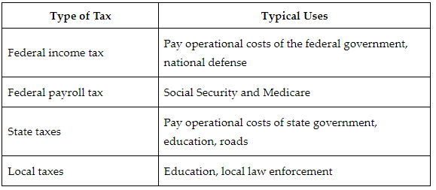

**Serving on a Jury**

Jury service ensures that the judicial system is accountable to the people. There are different types of juries on which a citizen may serve.

The purpose of a grand jury ensures that the government possesses enough evidence to warrant a trial. Grand juries do not determine whether a person is guilty or not.

Trial juries are groups of citizens who hear the evidence presented by the prosecution and the defense. After a judge explains how the law applies to the situation, they determine if the state has enough proof of the crime. For the state to secure a conviction, a jury must be convinced beyond a reasonable doubt that the defendant committed the crime. This is because often the penalty of a criminal conviction results in loss of freedom. The trial jury is there to keep a check on the judicial system.

There are also trial juries in civil cases. A civil case is where two or more people have a dispute. In this situation, while one may be accused of violating the law, the penalty would only be financial. In civil cases, the trial jury listens to the evidence and the instructions from the judge and then renders a decision. Again, the trial jury serves as an important check on the judicial system.

**Serving in the Military**

Currently, the military is made of people who volunteer. People apply voluntarily to work as a member of the military. They are not forced to sign up.

There are times in which volunteers cannot staff the military adequately to meet a threat. In those situations, Congress can order conscription. This is called the draft. All males must register for the draft at 18.

**Objective 3:** Look at the responsibility of the government to the citizens and the responsibility of the citizens to the government.

**Big Ideas:** Both government and citizens have obligations to each other that must be met for society to function.

**National Government**

The national government’s powers are known as delegated powers. The national government only has the power to do those things that it has been assigned to do in the Constitution or that can be reasonably inferred from the text of the Constitution. The national government takes on four basic tasks:

1. fiscal policy: taxing, spending money, and borrowing money
2. monetary policy: setting the value of and printing money
3. regulating commerce: making rules about sales within and between states
4. defense policy: protecting the country against attacks

**State Government**

State governments have reserved powers. This means that states can typically do whatever they would like to do unless there's a specific rule against it. There is no exhaustive list of reserved powers. Most states will spend their resources doing the following:

* building roads
* operating educational institutions
* exercising the police power

The police power is the power to protect the public peace, health, safety, and welfare. States exercise the police power when they pass laws that make certain actions a crime. They also exercise the police power when they pass laws that create new rules, such as regulations for food safety or construction. For most people in the U.S., the police power is also exercised by city governments.

**The Obligations of Citizens**

The government has obligations to citizens, such as protecting their natural rights. Citizens also have obligations to the government and to each other.

1. Obeying the law.
2. Pay taxes. Tax money finances important government functions.
3. Vote in elections.
4. Serve on a jury. Jury service allows citizens to participate in the judicial process and check the power of judicial officers, like judges.
5. Serve in the military. There are times in which volunteers cannot staff the military adequately to meet a threat. In those situations, Congress can order the draft. To facilitate this, all males, both citizens and noncitizens, must register for the draft at age 18.

**Keywords**:

* **grand jury** – a jury that determines if there is enough evidence to warrant a criminal trial
* **natural rights** – the rights, such as life, liberty, and property, that are considered inalienable
* **police power** – the power to protect the public peace, safety, and welfare
* **rule of law** – the idea that all people and institutions are required to follow the law regardless of their status in society
* **trial jury** – the jury that determines if a criminal defendant is guilty in a criminal case or which side wins in a civil case
* **reserved power** – the powers that are kept by the states; these are protected by the Tenth Amendment
* **draft** – compulsory recruitment for military service
* **income tax** – a tax paid on money earned
* **payroll tax** – a tax paid on wages and salaries but not on investment income
* **property tax** – a tax paid on the value of property
* **sales tax** – a tax paid on the value of goods and services purchased
* **trial jury** – a group of 12 people selected from the public to give a verdict in a legal case
* **delegated powers** – the powers that are assigned to the national government based on the language in the Constitution

**Quick Check**

Question 1: Which of the following is an accurate analysis of the fundamental obligations that a government must fulfill with regard to its citizens?

* A government must ensure that citizens can only be convicted of a crime by a fair and impartial jury, and as a result, they require jury duty.
* A government must ensure that citizens are only tried for crimes after review by a grand jury, and as a result, they use grand juries to review all crimes.
* **A government must protect people’s natural rights, and as a result, they maintain services such as the schools, police forces, and the military.**
* A government must promote the physical wellbeing of its citizens, and as a result, they charge taxes.

Question 2: Which of the following statements is the **most** accurate assessment of the impact of citizen involvement on society?

* **Citizen involvement strengthens government services and sometimes limits its power.**
* Citizen involvement strengthens government services and always increases its power.
* Citizen involvement strengthens government services and has no impact on its power.
* Citizen involvement strengthens government services and always limits its power.

Question 3: Which of the following **best** explains the impact the jury service has on the judicial system?

* **Jury service ensures that the judicial system is accountable to the people.**
* Juries are the primary way that judges are selected for a particular case.
* Juries are the primary way by which evidence is presented during the trial.
* Jury service ensures that the decisions made by the judge in a criminal case are accurate.

Question 4: Based on current law, which of the following groups are required to register for the draft?

* All persons over the age of 21.
* All citizens over 18, both men and women.
* All immigrants over the age of 21.
* **All males over 18, both citizens and immigrants.**

Question 5: Which of the following accurately evaluates the relationship between government and citizens?

* Citizens have obligations to government, such as obeying the law, but government obligations to citizens are minimal.
* **Both government and citizens have obligations to each other that must be fulfilled in order for society to function.**
* Government has obligations only to those citizens who pay the taxes that government needs to operate.
* Government has obligations to citizens, but citizens have no meaningful way in which to participate in government.

**Lesson 12 – Activism and Participation**

**Objective 1:** Evaluate a variety of ways in which citizens participate in the political process.

**Big Ideas**: In a democratic society there are many ways a person can participate politically. These include being active in political parties, being active in an interest group, participating in social movements, talking about politics, voting, and contributing to political campaigns.

Citizen participation is important in the U.S.. If citizens do not participate, it is hard for the government to address their issues and concerns.

There are a many ways citizens can be involved in their political party. These can include holding party offices, such as party chairperson or precinct captain, and volunteering at party events. American political parties tend to be open. As an active member of a political party, you can directly interact with policyholders. They may tend to be more receptive to your views on public policy than they are with average citizens.

**Special Interest Groups**

Special interest groups are groups of individuals organized to impact public policy. The key distinction between special interest groups and political parties is that special interest groups do not run candidates for public office. One of the main ways that special interest groups attempt to achieve their policy goals is by lobbying government officials.

**Lobbying** means trying to persuade government officials that your views on public policy are correct. Special interest groups hire lobbyists. These lobbyists then form relationships with government officials to influence them. While this may seem corrupt, it is simply another way in which citizens are trying to impact the political process. A common misconception about lobbyists is that they lie and try to deceive politicians. This is not true. The best thing for lobbyists to do is to be truthful and build a long-lasting relationship with policymakers.

**Electioneering**

Special interest groups will attempt to influence the outcome of elections. This is called electioneering. The most common way to engaged in electioneering is by making campaign contributions. This should not be confused with running candidates for office. Special interest groups do not run candidates for office. They do not nominate people for public office. Most of the campaign contributions that special interest groups make to candidates for public office will be made through political action committees (PACs).

Special interest groups also try to influence public opinion. If public opinion can be shifted toward supporting the issues that the group cares about, then public officials are more likely to also agree with the group. Public officials typically will not act in a manner that is contrary to public opinion if they want to be reelected. The way that special interest groups will attempt to influence public opinion is by advertising and engaging in protests and demonstrations that are designed to secure positive media coverage that highlights the specific issue the interest group cares about.

**Social Movements**

Citizens may also be involved in social movements. A social movement is defined as a broad-based movement of individuals trying to shape or change public policy. Coalitions of groups tend to work toward a similar goal. Collective action usually makes more of an impact than individual action.

**Talking About Politics**

Citizens can share their views with other individuals. This participation is protected by the First Amendment of the Constitution, which provides that citizens have a right to free speech, free press, and free assembly. By sharing your views, you are helping to shape public opinion.

**Individual Contributions to Campaigns**

Running for office in the U.S. is an expensive proposition. Candidates are always in need of campaign contributions. While there are limitations on contributions that are given directly to candidates, there are no limitations on money that is spent independently of an individual candidate’s campaign. Money generated by citizen activism can be very effective in changing electoral outcomes.

**Voting**

Voting is the formal way citizens make known their preferences. The candidates that they vote for represent distinct policy positions. By voting for a candidate who promises to pursue a particular course of action, you are showing support for the issues that candidate supports.

**Objective 2:** Evaluate ways in which citizen activism impacts the political agenda.

**Big Ideas:** Citizen activism can have an impact on the political agenda. There are many ways this can take place. One would be political demonstrations. What the group wants is to get on television so that they can use this medium to impact public opinion. The public will then pressure policy makers to create public policy that is sympathetic to the views of the group. In this way, citizen activism has shaped public opinion. Public opinion then impacts public policy. Skilled group organizers will select locations and times for demonstrations that will allow the media ready access.

**Objective 3:** Evaluate how citizens support the policy-making process through political participation.

**Big Ideas:** Citizen activism can make a big impact on public policy. But unorganized, underfunded groups are rarely impactful. Citizens who work with others, maximize the use of existing institutions, and develop financial resources are more likely to achieve their goals. This is true even if the group is small.

**Linkage Institutions**

Policy-making institutions are institutions that craft public policy. They are Congress, the president, the bureaucracy, and the judiciary. Public policy is something that you must comply with or there will be bad consequences if you do not.

The four main linkage institutions are elections, political parties, interest groups, and the media. These institutions provide information to citizens about government actions, policies, and programs and/or provide information to the government about citizen preferences, wants, and desires. Some also facilitate citizen involvement in the political process. Effective participation is almost always through linkage institutions.

**Elections**

The first linkage institution is elections. Citizens can inform the government of their policy preferences with their votes. Candidates for public office make known their stances on a variety of issues.

Political parties also serve as a way for citizens to express their points of view to the government. This is mainly done through the construction of a party platform. A party platform is a statement of beliefs and policy preferences of the members of a particular political party.

An interest group is an organization of people that tries to influence public policy. At first, this may seem very similar to a political party. But interest groups do not run candidates for office. Interest groups function as a linkage institution by providing information to citizens about governmental actions. Many interest groups will also provide information to citizens about how members of Congress vote on legislation that is of concern to the group.

**Objective 4:** Identify methods used by stakeholders to influence public policy and political action.

**Big Ideas:**

**Congress**

Logrolling is a common practice in Congress. It is used to influence public policy. Logrolling occurs when members of Congress work together to support each other’s bills by exchanging positive votes on their legislation.

Congress also uses party structure. Since Congress is organized by political party affiliation, party leaders use their position to persuade members to vote with the party. Voting along party lines can help members of Congress obtain support during elections and favorable assignments within committees.

Congress has the power to appropriate funding for government. This power allows Congress to have influence over the public policy that is enforced by the executive. Congress has the power to designate the amount of money disbursed. By controlling the amount of money that executive agencies receive, Congress can influence the actions these agencies take.

**Outside Influences**

Individuals can help guide lawmakers and executives by voting. At a state level, individuals have the power to decide public policy by voting on a referendum. A referendum is a process in which a state legislature or city council writes and submits a proposed law to the voters for their approval.

If people oppose a particular policy, they will often protest. Individuals can also provide support through fundraising and donating.

Like individuals, a special interest group tries to influence the legislative process. These kinds of groups often use money to help influence public policy and action. By fundraising for a candidate or a cause, they can obtain the support needed for their interest.

Special interest groups can also use the power of information to lobby the government for a particular law or rule. Lobbying is the organized process of influencing legislation or policy. This information can help convince members of Congress and the executive to favorably enact and enforce laws.

Finally, members of the media are stakeholders who use their platform to influence public policy and political action. Through the stories they present and the content they use, the media can direct the public’s attention. This role as gatekeeper can help deter or obtain support for a particular policy or change. While the media is meant to remain unbiased, the information they present and the language they use often affects the public’s view of government policies.

**Keywords**:

* **electioneering** – the process of trying to influence elections
* **initiative petition** – a process by which citizens can make public policy by circulating a petition, gaining an appropriate number of signatures, and then forcing a vote on a specific question or proposition
* **political action committee** – an organization that facilitates special interest group contributions to candidates
* **primary election** – an election used to determine who will represent each political party at the general election
* **referendum** – a general vote by citizens on a single political question
* **special interest group** – a group of people, a company, or an industry that works to impact legislation and public policy in their favor on one or more shared concerns or topics
* **hard money** – the contributions made directly to a candidate
* **linkage institution** – a social structure connecting the people to the central authorities or government
* **special interest group** – a group of people, a company, or an industry that works to impact legislation and public policy in their favor on one or more shared concerns or topics

**Quick Check**

Question 1: Which of the following is a fair evaluation of the methods of participation?

* Small group action is always more effective than large group action.
* **Collective action usually makes more of an impact than individual action.**
* Social movements have yet to produce lasting change in society.
* Campaign contributions are the only form of effective action.

Question 2: Which of the following is an accurate evaluation of the impact of money generated by citizen activism?

* Money generated by citizen activism can be very effective in deciding which demonstrations receive coverage.
* Money generated by citizen activism can be very effective in controlling the news cycle.
* **Money generated by citizen activism can be very effective in changing electoral outcomes.**
* Money generated by citizen activism can be very effective in changing how members of Congress vote.

Question 3: Which of the following is an accurate evaluation of citizens’ support of civil institutions through political participation?

* Effective participation is only through interest groups.
* Effective participation is most often with a large group of citizens.
* **Effective participation is almost always through linkage institutions.**
* Effective participation is primarily through the media.

Question 4: Which statement **best** describes the function of interest groups?

* Interest groups fund political parties and media outlets to advance their agenda.
* **Interest groups attempt to influence public policy in Congress and the bureaucracy.**
* Interest groups are the primary way in which people acquire political information.
* Interest groups nominate and fund candidates for public office during elections.

Question 5: Identify one method used by individuals to influence public policy.

* **Voting for the representatives who best represent their needs.**
* Making an advertisement for their public policy.
* Voting for a national referendum to establish national public policy.
* Funding research to inform government about a political action or policy.

**Lesson 13 – Policy Issue Portfolio**

**Lesson 14 – Influence and Bias**

**Objective 1:** Analyze the influence of private and public institutions on shaping public policy and political opinions.

**Big Ideas**: The relationship that exists among the private sector, members of Congress, and executive bureaucrats to develop policy is often referred to as an iron triangle. An iron triangle describes three interactions that influence public policy:

* + Interest groups provide pertinent information to executive agencies in exchange for favorable regulation.
  + Executive bureaucrats and members of Congress interact to form legislation and rules.
  + Members of Congress create bills that support an interest group in exchange for information or campaign funding.

Funding is an important part of the iron triangle. Executive agencies will ask interest groups to use their leverage with members of Congress to gain additional funding. Since Congress oversees the allocation of funds, they can sometimes be persuaded to provide more funds to a particular agency. The leverage that some interest groups may have often relies on the campaign funding they can provide to members of Congress. Private institutions provide information and funding to support legislation that matches their goals.

**Objective 2:** Analyze different forms of political communication to identify bias.

**Big Ideas:** We often fail to realize the extent to which one-sided information is present all around us. Politicians use bias in many ways to get support.

When reading an argument or information, it is important to identify the author or publisher. Information written or published by someone who will directly benefit can be one-sided information. The type of language used can also create bias. Some words that have a positive or negative connotation can be used to sway readers' opinions. Including or omitting information can show preference towards one argument.

Bias can be used in political communication to get the support of individuals. An example is President Andrew Jackson’s 1830 message to Congress. The purpose of this message was to inform Congress on the progress and status of the removal of Indigenous groups west of the Mississippi River. The policy known as Indian removal began under President Jackson and was supported by many.

Here is how President Jackson begins his message:

“It gives me pleasure to announce to Congress that the benevolent policy of the Government, steadily pursued for nearly thirty years, in relation to the removal of the Indians beyond the white settlements is approaching to a happy consummation.”

Here, the president uses words and phrases like benevolent and happy consummation to imply that the actions taken by the government are positive. But the topic of the speech is the forceful removal of Indigenous groups from their long-time home. President Jackson uses positive words to describe the government’s policy, giving a one-sided and positive account of the government's actions.

**Objective 3:** Analyze the influence of bias on shaping public opinion.

**Big Ideas:** Public opinion, or the general view of the people, is a key component of a democratic government. A democratic government emphasizes that power is in the hands of the people and that they can voice their preferences. Public opinion represents the voice of many. It is an important part of the political process. It helps candidates get elected and influences government officials. This ultimately determines public policy.

Individuals have different opinions formed by a variety of factors. A key factor that shapes public opinion is one’s social environment. People are likely to share the opinion of those who surround them. They are influenced by their coworkers, friends, and family. Public opinion is also influenced by outside sources. These sources include the government and the media. These sources will often provide biased information to try to move public opinion toward their goal.

Digital and social media tend to target specific readers and viewers. By gathering information of what individuals look for and read, companies can make suggestions on what individuals would like. This information is often shared with companies or interest groups to target specific individuals. These groups can place advertisements that can help gather support for an action. These actions can further people’s confirmation bias.

**Keywords**:

* **interest group** – a well-organized group of people with a shared identifying interest that attempts to influence the legislative process
* **iron triangle** – a figurative relationship among Congress, bureaucracy, and interest groups
* **lobbying**– the organized process of influencing legislation or policy
* political action committee (PAC) – a private group that raises and distributes funds for use in election campaigns
* **concision bias** – the sharing of information that is easy to understand and beneficial while omitting other difficult information
* **confirmation bias** – the tendency to look for and interpret information to support one’s views
* **coverage bias** – the spotlighting of what people should know and the focusing of their attention on certain topics
* **selective exposure** – the theory that people tend to look for information that aligns with their views and ideology

**Quick Check**

Question 1: Which of the following **best** describes the influence private institutions have in framing public policy?

* Private institutions work with state and local officials to hold rallies and town halls.
* Private institutions endorse candidates who support their policy agenda.
* **Private institutions provide information and funding to support legislation that matches their goals.**
* Private institutions invite experts to a congressional hearing to discuss the benefits of a policy.

Question 2: Which of the following accurately describes a relationship that is illustrated by the iron triangle?

* Members of Congress help fund interest groups to make legislation and regulation.
* **Members of Congress create bills that support an interest group in exchange for campaign funding.**
* Executive agencies provide funds to members of Congress in exchange for favorable legislation.
* Executive agencies provide favorable regulation to interest groups in exchange for campaign funding.

Question 3: Which of the following accurately analyzes President Jackson’s use of bias in his 1830 message to Congress?

* President Jackson describes how the Indian Removal Policy can bring negative effects for the U.S. government.
* President Jackson uses the same words to describe the government, its people, and Indigenous Americans, ensuring everyone is treated equally.
* **President Jackson uses positive words to describe the government’s policy, giving a one-sided and positive account of the government's actions.**
* President Jackson compares the removal of Indigenous Americans to European immigrants in order for people to understand the negative effects of the policy.

Question 4: Which of the following **best** analyzes how interest groups use bias to frame public opinion?

* Interest groups can use coverage bias to influence the opinion of voters by attracting or diverting attention.
* Interest groups can create a party platform that will gather the support of party members and the public.
* Interest groups can draft legislation that is beneficial to the public and reflects public opinion.
* **Interest groups can use focus groups to determine what phrases to use to obtain a favorable response from the public.**

Question 5: What is a bias that results from being exposed to likeminded information that agrees with one's views?

* focus group
* selective exposure
* **confirmation bias**
* coverage bias

**Lesson 15 – Political Opinion**

**Objective 1:** Identify the social demographics that influence individuals’ political opinions.

**Big Ideas**: The way people are influenced politically directly affects the way they will think politically.

Political socialization is strongest when people are young and with their family. This socialization will last long into adulthood because it is so strong.

As people grow, they become socialized by their peers. Once they leave school, they continue to be politically socialized by their work environment, their religion, their friends, their income, and the region where they live.

Many other demographic variables influence one’s political opinions. In this table are data that show the trends in political party affiliation for different groups:

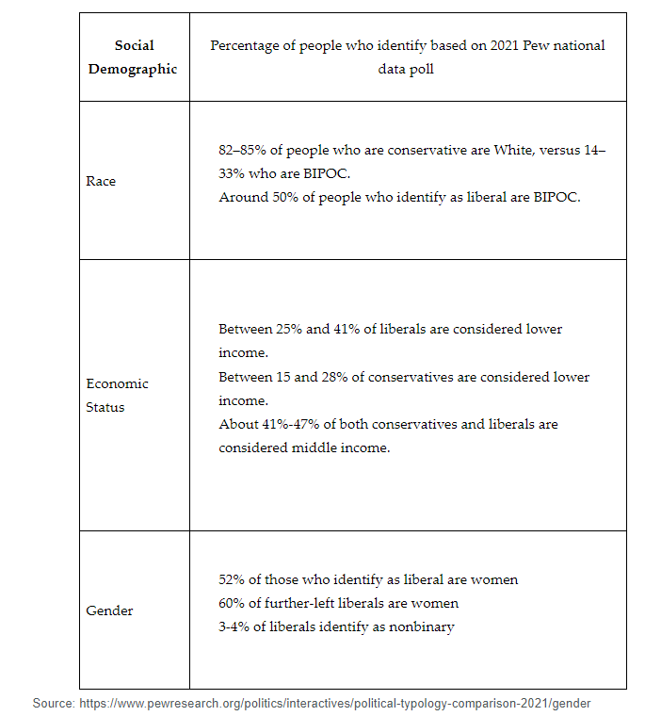

**Objective 2:** Analyze how political opinions are influenced by demographics and intersectionality.

**Big Ideas:** Many factors contribute to political identity. These include party preference, ideological perspective, and how someone votes. American citizens can be categorized by many demographic attributes. Key demographic attributes include:

* gender
* race
* age
* socioeconomic class
* religion
* geographic region of residence

Understanding how these demographic factors work together can show patterns among voter registration, turnout, and candidate selection during elections.

Demographics are a more important reference for Americans’ opinions than ideology. Demographics are defined as the statistical data relating to the population and specific groups within it. Political scientists rely on demographics when studying political behavior such as voting. Understanding how demographic attributes intersect best describes how people form their political opinions.

Americans often view politics according to the groups to which they belong. Intersectionality looks at the interconnected nature of identity categorizations within individuals and groups.

Latino voters are a good example of intersectionality. As the largest minority group in the U.S., Latino voters are the fastest-growing voting bloc. Latino voters have diversity within the demographic category. This is because they represent many Latin American nations. Many Latino voters support the Democratic Party. But Cuban Americans tend to support the Republican Party.

**Objective 3:** Evaluate the ways in which stratification influences political outcomes.

**Big Ideas:** Political scientists can better predict political outcomes if they understand how people are stratified.

People don’t develop their political identities from one influence. It is important to remember that many factors influence their ideology.

A person’s age usually influences their political ideology. When a person is young, they are guided by their family’s political ideology. This stratification allows political scientists to understand why young people form the ideologies they do.

Another way to reason effectively and evaluate the ways in which stratification influences political outcomes is by looking at a person’s race and ethnic background.

**Keywords**:

* **cross-cutting cleavage** – a division in society that occurs when people are part of opposing political or social demographics
* **political ideology** – a system of beliefs, ideas, or values that serve as the foundation of how a government should function and as a guide for policy initiatives
* **political socialization** – the process that every individual undergoes to form their political beliefs
* **intersectionality** – the interconnected nature of identity categorizations within individuals and groups
* **stratification –** the arrangement of something into different groups

**Quick Check**

Question 1: Identify the factor that **most** influences an individual’s political opinion when they are a young child.

* Religion
* School
* Peers
* **Family**

Question 2: Identify a time when peers are most influential in a person’s political socialization.

* When a person goes back to school as an adult.
* When a person works from home.
* **When a person is in high school.**
* When a person is retired.

Question 3: Which statement **best** analyzes the role of demographics in determining political opinions?

* Gender is the most important demographic when forming political opinions.
* Race is the most important demographic when forming political opinions.
* **Understanding how demographic attributes intersect best describes how people form their political opinions.**
* Young voters support Democrats while older voters support Republicans

Question 4: Which of the following statements **best** describes Latino voters?

* Latino voters only support Democratic candidates.
* Latino voters represent a shrinking proportion of the electorate.
* The Latino voting bloc is homogenous.
* **Latino voters represent the fastest-growing voting bloc in the U.S**

Question 5: Evaluate the importance of stratification on political outcomes.

* Political campaigns would appeal to a broader base of people if they used stratification.
* **Political scientists can better predict political outcomes if they understand how people are stratified.**
* Government leaders would be able to please all Americans when making collective policy decisions if they understood stratification.
* Political scientists could assist government to pass laws that would please the country as a whole if they used stratification.