American Government

**Unit 4: Civil Rights and Liberties**

**Unit Summary:** In this unit you will discover how events after the Civil War put this country and its government on a long path to greater freedom and equality for all Americans. The path was bumpy, and laden with costly setbacks. Destructive failures restricted Americans’ basic rights and denied them access to the full American dream for 100 years after the Civil War. Changes for the better did occur over time. The U.S. today is a freer and more equitable place to live. This is a direct result of the struggles of Americans who refused to accept inequality.

**Lesson 2 – Constitutional Rights**

**Objective 1:** Describe how the federal government has limited powers due to embedded stipulations present in the U.S. Constitution, including habeas corpus rights, prohibitions on bills of attainder, and ex post facto laws.

**Big Ideas**: The federal government is limited in this aspect to protect the individual rights and liberties of the American citizens. When the Constitution was being written, consideration was given to the people and safeguards were put in place to ensure that the federal government was not left unregulated, and the rights of the people could not be infringed.

The need to limit powers within the federal government is designed to protect the rights of the people. Habeas corpus allows an individual the right to appear before a judge/jury. The prohibition of bills of attainder and ex post facto laws further protect individual liberties and limits federal power by restricting the inclusion of singling out individuals and retroactive laws.

**Objective 2:** Analyze the events that led to the addition of the Fourteenth Amendment to the U.S. Constitution.

**Big Ideas** The events that led to the ratification of the Fourteenth Amendment centered around the limitation of freedoms placed on people who had been enslaved. After the Civil War, the states in the South held constitutional conventions that would decide on certain state laws. The newly passed laws in each of the southern states focused on restricting the rights of African Americans.

One such law was vagrancy laws. These were set up to require people to have and keep a permanent residence. Anyone in violation could be arrested and forced into labor. Separate court systems were used for African Americans. In these courts, harsher punishments were given. Whipping, hiring the accused out, and even death were punishments that they might receive for minor offenses.

Unfair treatment and violation of rights played a huge role in what was included in the amendment and cases brought before a court in the years following. The Fourteenth Amendment is cited in the most litigations of any of the amendments. It is the basis for many famous landmark Supreme Court cases.

Equal protection and the promise of life, liberty, and property have become cornerstones of what it means to be truly free. *Plessy v. Ferguson* focused on the equal protection clause in the Fourteenth Amendment.

**Four Clauses of the Fourteenth Amendment**

1. The citizenship clause was largely ineffective, aside from establishing the definition of a citizen and determining that those held as slaves were now free and citizens of the U.S. as well as the state they resided in. Controversy surrounded the definition of citizenship and what rights were guaranteed in the states. There was also little to no enforcement within the states with regard to citizenship for people who had been enslaved.
2. The penalty clause outlines the consequences if voting rights had been violated. This portion of the amendment was not upheld until the 1970s, which made it difficult for legal voters to exercise their rights. This clause limited the state’s ability to make or enforce a law that would diminish rights of the citizens.
3. The due process clause reiterated that each individual was entitled to life, liberty, and property. This clause states that people should not be deprived of these rights without the proper procedures and rules being followed. This clause holds the states accountable. It requires that they abide by the Supreme Court’s decision to uphold minimal standards about civil liberties. Within this clause, the incorporation doctrine was introduced. This required the states to incorporate portions of the Bill of Rights in state legislation.
4. The final clause is the equal protection clause. In this clause anyone who was born or naturalized in the U.S. should receive equal protection under the law. This clause also places limitations on the states and their ability to infringe upon the rights of any citizen.

**Objective 3:** Analyze the importance of key Supreme Court decisions that affected the Due Process Clause found within the Fifth and Fourteenth Amendments.

**Big Ideas:** The Due Process Clauses of the Fifth and Fourteenth Amendments both protect civil liberties. The Fifth Amendment gives protection from the federal government, and the Fourteenth Amendment includes protection in the states.

Since these amendments, there have been many Supreme Court cases about procedural due process. The meaning of due process has changed over time because of Supreme Court cases. The U.S. has multiple tests for determining whether due process has been provided.

For each case brought to the Supreme Court, there are tests used to decide if a violation has taken place. If there is a violation, the test shows how the rights have been violated. The three tests that are used include the rational basis test, the intermediate scrutiny test, and the strict scrutiny test. The rational basis test is used to see if restrictions have been put in individual liberties. Both the intermediate and strict scrutiny tests are used in cases involving discrimination. The strict scrutiny test being the highest standard of review.

**Keywords**:

* **bill of attainder** –a legislative act inflicting punishment without a judicial trial
* **ex post facto law** –a law retroactively increasing a punishment for a criminal act or altering the definition of a crime
* **habeas corpus** –an order to bring an arrested person before a judge
* **black codes** –laws passed by southern states, designed to replace the social controls of slavery following the end of the Civil War
* **citizenship clause** –clause of the Fourteenth Amendment that defines citizenship
* **due process clause (Fourteenth Amendment)**– one of two due process clauses in the Constitution. The one in the Fourteenth Amendment allows for selective incorporation.
* **equal protection clause –** a clause in the Fourteenth Amendment that requires states to treat citizens equally; does not apply to the national government or private business
* **incorporation doctrine** – found within the due process clause where certain items in the Bill of Rights must be included by the states
* **penalty clause**– a clause in the Fourteenth Amendment that provides for a reduction in the number of U.S. Representatives that a state is entitled to if it discriminates against Black voters
* **Fifth Amendment Due Process Clause** – a clause that protects individual civil liberties against the national government and requires suspect classifications (race, religion, national origin, and alienage) to be treated equally by the national government
* **substantive due process** – gets to the idea of fairness and that there are limits to the power of the government to encroach into an individual’s life

**Quick Check**

Question 1: Which of the statements best describes the rights of individuals stated in the Constitution under the protection of habeas corpus?

* A punishment will not be implemented without a trial.
* A jury trial is required for individuals who have been arrested or accused.
* A law cannot be made to punish crimes retroactively or increase punishments.
* **An individual who has been arrested has the right to be brought before a judge.**

Question 2: Analyze why the addition of the Fourteenth Amendment was necessary.

* to clarify for the Supreme Court what rights people who had been enslaved were entitled to
* to give the states more power so the federal government could not limit the states’ authority
* to further explain the rights granted in the Thirteenth Amendment, which guaranteed freedom to people who had been enslaved
* **to limit the powers held by the states, prevent unjust treatment, and ensure equal rights for all citizens**

Question 3: Plessy v. Ferguson was a landmark Supreme Court Case that focused on which Fourteenth Amendment clause?

* penalty clause
* due process clause
* citizenship clause
* **equal protection clause**

Question 4: Analyze the meaning of substantive due process.

* It allows for the taking of property by the government and being provided compensation.
* **Substantive due process centers on the idea of fairness limiting the power of the government.**
* Substantive due process is a group determined by the court to have been discriminated against in the past.
* It focuses on the procedural process that must be followed in the legal system.

Question 5: What process is described as the requirement of following predetermined procedure prior to depriving an individual of life, liberty, and property?

* civil liberties
* **procedural due process**
* suspect classification
* substantive due process

**Lesson 3 – Freedom of Speech**

**Objective 1:** Explain how free speech is necessary to maintain a democratic system of government.

**Big Ideas**: The freedom of speech protected by the First Amendment is key to a democratic system of government. Without freedom of speech, a democratic society cannot exist.

Freedom of speech:

* ensures people have access to information
* promotes public debate
* protects controversial viewpoints

Freedom of speech allows people and groups to challenge the dominant beliefs in a society. The right to freedom of speech allowed those participating in the civil rights movement to challenge the ideas that supported racial discrimination.

Freedom of speech promotes healthy public debate. Freedom of speech allows people to hear a variety of viewpoints.

Using the process of selective incorporation, the Supreme Court forced states to abide by individuals’ freedom of speech. It did this through its decision in *Gitlow v. New York*. Selective incorporation required that the right to freedom of speech be protected by state governments.

**Objective 2:** Analyze the effect several important Supreme Court decisions have had on the freedom of expression found in the First Amendment to the U.S. Constitution.

**Big Ideas:** The First Amendment to the Constitution includes the freedoms of speech and press. Over time Supreme Court decisions have expanded these rights to include the freedom of expression.

***Gitlow v. New York***

* In 1919, Benjamin Gitlow called for strikes to promote socialism. He was convicted of violating New York’s criminal anarchy law.
* Gitlow appealed his conviction. He claimed his freedom of speech was violated.
* In earlier Supreme Court decisions, the court had ruled that the freedom of speech was not protected against state government actions.

**Decision**

* The Supreme Court created the concept of selective incorporation.
* Based on the equal protection clause of the Fourteenth Amendment, the court ruled that state governments must also abide by the freedom of speech.

**Significance**

* This was the first of many cases in which the Supreme Court gradually applied the Bill of Rights to state governments.
* Forcing states to protect the freedom of speech expanded the freedom of expression. The Supreme Court effectively reasoned that individuals would have more Bill of Rights protections if they were protected against state and local governments as well as the national government.
* Selective incorporation has expanded the freedom of expression by forcing states to protect the freedom of speech.

**Objective 3:** Explain the meaning and purpose of the establishment and Free Exercise Clauses and how Supreme Court decisions have affected these clauses.

**Big Ideas:** The Free Exercise Clause states that “Congress shall make no law prohibiting the free exercise” of religion. The purpose of this clause is to protect people’s right to believe in the religion (or no religion) of their choice. The clause was also designed to protect the practice of religion. The clause prevents the government from creating an official government religion. It is when people act on their religious belief that conflicts with governments can arise.

***Engel v. Vitale***

* In the early 1960s, public school students in New York were required to recite a short prayer at the beginning of each school day.
* Several families and organizations claimed this policy violated the establishment clause.

**Decision**

* The Supreme Court ruled that the prayer did violate the establishment clause.
* The court reasoned that the prayer violated the “wall of separation between church and state.”
* The court reasoned that governments should not be involved in creating any prayer.

**Significance**

* As a result of this decision, government-organized prayer in public schools was ruled to be unconstitutional.

***Lemon v. Kurtzman***

* Rhode Island and Pennsylvania used government funds to support religious-based schools.
* Funding included support for textbooks and teachers’ salaries.
* These laws were challenged by individuals and groups who believed they violated the establishment clause.

**Decision**

* The Supreme Court ruled that the funding (by Rhode Island and Pennsylvania) of religious-based schools was unconstitutional.
* Created the “Lemon Test.”
* To be constitutional, a law involving government with religion must pass a three-part test.

1. The law must have a secular purpose.
2. The law must neither promote nor inhibit religion.
3. The law cannot create “excessive government entanglement with religion.”

**Significance**

* This decision is still used today to determine whether government involvement with religion is constitutional.

**Keywords**:

* **selective incorporation** – the process by which the Supreme Court has applied portions of the Bill of Rights to the states on a case-by-case basis via the Fourteenth Amendment due process and equal protection clauses
* **symbolic speech** – utilizing symbols to communicate messages
* **flag desecration** – the act when someone purposefully destroys or damages a flag
* freedom of expression – the right to express thoughts and communicate those thoughts to others
* **establishment clause** – a clause in the First Amendment that prohibits the national government and, through selective incorporation, state government promoting a specific religion or religion in general
* **Free Exercise Clause** – a clause in the First Amendment that prohibits the national government and, through selective incorporation, state government from unduly interfering with an individual’s practice of religion
* **Lemon test** – the three-part test used by the Supreme Court to determine if a government’s involvement with religion is constitutional

**Quick Check**

Question 1: Which of the following correctly explains how selective incorporation contributed to the right to freedom of speech in the U.S.?

* Selective incorporation required that states restrict speech that is controversial and unpopular.
* Selective incorporation required the national government to protect the right to freedom of speech.
* **Selective incorporation required that the right to freedom of speech be protected by state governments.**
* Selective incorporation protected speech that creates a clear and present danger.

Question 2: Which of the following correctly explains how the freedom of speech contributed to the success of the civil rights movement?

* **The right to freedom of speech allowed those participating in the civil rights movement to challenge the ideas that supported racial discrimination.**
* The right to freedom of speech allowed participants to avoid punishment when they broke laws they believed to be unjust.
* The right to freedom of speech allowed the opponents of the civil rights movement to physically attack the participants in the movement.
* The right to freedom of speech prevented law enforcement from physically harming the participants in the civil rights movement.

Question 3: Which of the following correctly analyzes the effect the Supreme Court’s use of selective incorporation has had on the freedom of expression?

* **Selective incorporation has expanded the freedom of expression by forcing states to protect the freedom of speech.**
* Selective incorporation has gradually reduced freedom of expression by allowing states to ignore certain freedoms found in the Bill of Rights.
* Selective incorporation had no effect on the freedom of expression as states have always had to protect the freedom of speech.
* Selective incorporation has limited the freedom of expression by only requiring the national government to abide by the freedom of speech.

Question 4: Which of the following correctly explains the purpose of the establishment clause of the First Amendment?

* The clause was designed to prevent the government from interfering with an individual’s religious belief.
* **The clause was designed to prevent the government from creating an official government religion.**
* The clause was designed to increase an individual’s freedom of expression.
* The clause was designed to protect the publication of dissenting viewpoints.

Question 5: Which of the following parts of the First Amendment is most closely associated with the phrase “separation of church and state”?

* the free exercise clause
* the freedom of the press
* the freedom of speech
* **the establishment clause**

**Lesson 4 – Freedom of Press and Religion**

**Objective 1:** Assess how freedom of the press has changed over time because of U.S. Supreme Court decisions.

**Big Ideas**: Supreme Court decisions have consistently protected and expanded the freedom of the press.

***Near v. Minnesota***

Local government officials in Minnesota tried to silence a local newspaper. This was because it printed scandalous material relating to an elected official. The claims printed by the newspaper included connections between organized crime and elected officials.

The ruling handed down in favor of the newspaper. It determined that efforts by the government to stop the publication of sensitive materials was unconstitutional unless the censorship efforts were related to matters of war or national security. The effect of this case was to expand and protect the rights of newspapers to practice freedom of the press.

***New York Times v. Sullivan***

In this case, Alabama Montgomery Public Safety Commissioner, L.B. Sullivan, sued the New York Times for libel. The piece in question was a full-page advertisement that was run in the New York Times and paid for by Reverend Martin Luther King, Jr.. The ad did have minor inaccuracies.

In a unanimous ruling, the Supreme Court sided with the New York Times. The decision stated that in the case of libel, if the person being written about is a public official, they must be able to prove actual malice to get a ruling against a newspaper.

***New York Times v. The U.S.***

This case examined if the New York Times violated the conditions of prior restraint when they published the Pentagon Papers. The Supreme Court ruled once again in the favor of the New York Times by saying that prior restraint can be suspended or not used if the public has a valid interest in knowing the information presented.

**Objective 2:** Analyze how the 1971 Supreme Court ruling in the case *Lemon v. Kurtzman* clarified the meaning of the First Amendment.

**Big Ideas:** The *Lemon v. Kurtzman* case set the standard for what it meant for government to violate the Establishment Clause.

In 1968, a statute was passed in Pennsylvania that allowed for the state to supplement teacher salaries and provide for materials taught in non-public, religious schools, as long as the classes and pay were used for secular classes. Civil rights activist and social worker Alton Lemon sued. They claimed that the use of tax dollars for any purpose in a non-public, religious school violated the Establishment Clause of the First Amendment.

**Supreme Court Ruling**

In an 8-1 ruling, the Supreme Court found that the state of Pennsylvania did violate the Establishment Clause of the First Amendment. This meant that Pennsylvania had violated the idea of the separation of church and state.

The legacy of the case is known as the Lemon test. The Lemon test a three-pronged test used to determine if legislation violates the separation of church and state.

The three prongs are:

1. The law must have a secular legislative purpose.
2. The primary effect of the law must neither advance nor inhibit religion.
3. The law must not result in “excessive government entanglement with religion.”

This test is used today to determine if there is government entanglement with religion or if the Establishment Clause is being violated.

**Objective 3:** Describe the issues and limitations of the First Amendment’s protection of religious liberty and freedom of expression as determined by Supreme Court decisions, as well as an examination of the government’s reasons for these limitations.

**Big Ideas:**

**Freedom of Religion and Its Limitations**

As stated in the First Amendment of the Constitution, the government of the U.S. will not prohibit the free exercise of religion.

The Supreme Court has ruled on this issue several times. It has decided there are limits to the Free Exercise Clause of the First Amendment especially to protect other members of society.

*Wisconsin v. Yoder*

The state of Wisconsin sought to force Amish families to send their children to school to the state-established minimum age of sixteen. Amish families found this law to be abusive to their religious freedoms. Agreeing with the Amish families, the Supreme Court ruled unanimously that the Wisconsin law violated the Free Exercise Clause.

*Goldman v. Weinberger* (1986).

The Court ruled 5-4 that a Jewish air force officer could not wear his religious headgear as it violated military standards of dress. The Court held that the military was held to a higher standard than the civilian population. They found that it was necessary for obedience, unity, and commitment for certain traditions to be put aside, even if that meant a violation of the Free Exercise Clause of the First Amendment.

**Freedom of Expression and Its Limitations**

Freedom of speech is a cherished right within the U.S..

***Schenck v. U.S.***

Charles Schenck distributed pamphlets to young men who would be drafted to fight in WWI. He urged them to disobey the draft through peaceful demonstrations. Schenk was arrested and charged with violating the Espionage Act of 1917. This act prohibited anyone from interfering with the war effort. Schenk claimed that he was simply practicing his freedom of expression. The Supreme Court ruled that one cannot hide under the banner of the First Amendment if they are advocating for others to break the law.

*Brandenburg v. Ohio* (1969)

Clarence Brandenburg, a leader of a local Ku Klux Klan chapter who delivered a speech at a rally, was charged with breaking an Ohio law that prohibited speech that advocated for crime and other violent actions. At heart, in the case, was the question of whether hate speech was illegal. The Supreme Court would rule in this case in favor of Brandenburg, saying that incendiary speech, or hate speech, was legal as long as it did not incite, advocate, or direct lawless action.

**Government Justification for Limiting a Citizen's Rights**

As long as a citizen is breaking no laws, is acting on their own accord, and is not directing others to violence, the government will allow the action. If any of these previous categories are violated, then the government seems likely to limit a citizen’s right. This is a strong comparison for consideration when weighing personal freedom versus the greater good.

**Keywords**:

* **libel** – the printing or promoting of false information about a person or organization
* **prior restraint** – the ability of the U.S. government to withhold or prevent media from printing information that is sensitive to the security of the U.S.
* **slander** – the defamation of a person’s character in print or media by tarnishing their image or reputation
* **Establishment Clause** – the clause in the First Amendment that prohibits the national government, and through selective incorporation, state government, from promoting a specific religion or religion in general
* **Lemon test** –the test created as a result of *Lemon v. Kurtzman* to determine if the government is violating the Establishment Clause
* **Free Exercise Clause** – the clause in the First Amendment that prohibits the national government, and through selective incorporation, state government from unduly interfering with an individual's practice of religion
* **incendiary speech** – the type of speech that causes a strong reaction and can lead to lawless action

**Quick Check**

Question 1: Which statement **best** assesses how Supreme Court decisions have impacted freedom of the press?

* Supreme Court decisions have failed to make consistent decisions regarding freedom of the press.
* Supreme Court decisions have consistently limited freedom of the press.
* **Supreme Court decisions have consistently protected and expanded the freedom of the press.**
* Supreme Court decisions have determined that prior restraint is unconstitutional.

Question 2: How has one specific Supreme Court ruling expanded freedom of speech by limiting a public official’s ability to press for libel?

* *Near v. Minnesota* determined that libel is allowed if it serves the interest of the public.
* *Adams v. Jefferson* determined that pursuing charges of libel is unconstitutional.
* ***New York Times v. Sullivan* determined that actual malice must be proven to pursue charges of libel in the case of a public official.**
* *New York Times v. U.S.* determined that libel is allowed in certain instances.

Question 3: Which statement **best** analyzes how Lemon v. Kurtzman clarified the meaning of the First Amendment?

* **It set the standard for what it meant for government to violate the Establishment Clause.**
* It decided that the Establishment Clause enabled the government to give funding to all religious organizations equally.
* It determined that the Establishment Clause was not violated if funding was used for secular purposes.
* It introduced the idea that religion should be separate from government.

Question 4: Which of the following **best** describes why the Supreme Court might limit the freedoms stated in the First Amendment?

* to censor hate speech
* to prevent the incitement of violence
* to preserve the freedom of religion
* **to protect other members of society**

Question 5: In which situation might freedom of religion be limited?

* A church holds a meeting on public property with the proper permits.
* A person takes a personal day from work due to a religious holiday.
* **A person breaks a policy of their employer to participate in a religious ceremony.**
* A public school provides meal alternatives for students who do not eat meat for religious reasons.

**Lesson 5 – Rights of Citizens in Court**

**Objective 1:** Evaluate the importance of the Sixth Amendment, including the impact of the *Gideon v. Wainwright* case on the right to counsel.

**Big Ideas**: The Sixth Amendment provides protections for citizens in a court of law. The interpretation of this amendment has changed overtime. As a result of legal challenges, today it guarantees all citizens, regardless of income, the right to counsel.

*Gideon v. Wainwright* extended the **right to legal counsel**. Clarence Gideon was accused of breaking and entering in Florida. He requested that the court appoint him legal counsel since he could not afford one. He was found guilty and petitioned the decision. He argued that he was denied his constitutional rights by not being granted legal counsel. The State of Florida denied his petition.

He then petitioned the U.S. Supreme Court. The court decided that the Sixth Amendment guarantees counsel for all citizens because of the Fourteenth Amendment’s Due Process Clause. Right to counsel became a fundamental Constitutional right. If an individual cannot afford a lawyer, one will be appointed to them.

The **right to a speedy tria**l requires that defendants are tried quickly when accused of a crime. This prevents the accused from remaining in jail for years if they are in fact innocent. It also allows them to defend themselves before issues arise such as a witness’s death or their fading memory of the charges and the events surrounding them.

**Trials must be public**. This prevents trials from being held in secret. With the public involved, officials are held accountable to the state and national laws as well as to the rights guaranteed within the Constitution. This also allows the public to come forward if they have any information on the case, and it increases confidence in the legal system.

**Trial by jury** further involves the public in the justice system. Trial by jury ensures that members of the public decide the guilt of the accused, not a single judge. Jurors are usually selected from the local community by both prosecution and defense lawyers to keep the jury impartial.

**Objective 2:** Analyze the protections offered by the Fifth Amendment to defendants in criminal prosecutions, as well as key Supreme Court decisions involving these protections.

**Big Ideas:**

The Fifth Amendment includes the following protections:

1. grand jury protection
2. protection against double jeopardy
3. the right against self-incrimination
4. the right to due process
5. the takings clause

***Miranda v. Arizona (1966)***

In March 1963, Ernesto Miranda was arrested. He was taken to the police station and questioned by police officers. A written confession was obtained from Miranda. At the trial, the police officers admitted that they had not informed Miranda of his right to have an attorney present during the interrogation. Miranda was found guilty.

He appealed to the Supreme Court of Arizona. The court held that because Miranda did not ask for a lawyer, his Fifth Amendment rights were not violated. The case was appealed to the Supreme Court.

The Supreme Court ruled with a 5–4 majority that Miranda’s Fifth Amendment rights had been violated. The decision said it was required for a defendant to be warned they have the right to remain silent during questioning. They also had to be warned that anything said could be used against them in a court of law. The court further stated that the police are required to inform a defendant that they have the right to an attorney and, if one could not be afforded, an attorney would be appointed. This has become known as the Miranda rights.

**Objective 3:** Analyze the protections offered by the Sixth Amendment to defendants in criminal prosecutions, as well as key Supreme Court decisions involving these protections.

**Big Ideas:**

**The Protections Offered by the Sixth Amendment**

* the right to a speedy trial
* the right to a public trial
* the right to an impartial jury
* the right to be informed of pending charges
* the right to confront and to cross-examine adverse witnesses
* the right to compel favorable witnesses to testify at trial through the subpoena power of the judiciary
* the right to legal counsel

***JEB v. Alabama ex rel. T. B. (1994)***

An Alabama mother, referred to as T.B., was seeking child support from the defendant and father, referred to as JEB. In this case, the state of Alabama was acting on behalf of the mother. During jury selection, the state of Alabama used its peremptory challenges to reject nine of the ten men in the jury pool. An attorney might utilize peremptory challenges to remove a potential juror who exhibits prejudice or bias.

This case was awarded in favor of the mother. The father appealed. He said that the use of peremptory challenges by Alabama excluded the male jurors and violated his right to a fair and impartial jury. The case made its way to the Supreme Court. The Supreme Court held that peremptory challenges on the basis of gender were a violation of JEB’s right to a fair trial and the Sixth Amendment.

**Keywords**:

* **Sixth Amendment –** the sixth addition to the Bill of Rights that outlines the rights of citizens in court
* **adversary method** – an approach to legal cases that requires the opposing sides to bring out pertinent information, cross-examine witnesses, and present evidence to an impartial judge or jury to render a verdict
* **double jeopardy** – being tried twice for the same crime
* **due process** – fair treatment through the normal judicial system
* **eminent domain** – the right of the government to take personal property for public use after providing due process and just compensation
* **self-incrimination** – the act of implicating oneself in a crime or exposing oneself to criminal prosecution
* **peremptory challenge** - an objection by either the prosecutor or defense attorney to a proposed juror, made without needing to give a reason
* **prejudicial** - harmful to someone or something, detrimental
* **subpoena** - a writ ordering a person to attend a court

**Quick Check**

Question 1: Assess the meaning of the Sixth Amendment.

* The Sixth Amendment guarantees the right to free speech.
* The Sixth Amendment does not require legal counsel.
* The Sixth Amendment protects against self-incrimination.
* **The Sixth Amendment provides protections for citizens in a court of law.**

Question 2: How does trial by jury ensure due process for citizens in court?

* It ensures that all people have access to legal counsel.
* It protects citizens from self-incrimination.
* **It ensures that members of the public decide the guilt of the accused, not a single judge.**
* It ensures that the accused is given a speedy trial.

Question 3: Analyze the case of *Miranda v. Arizona* (1966). Which of the following is the most likely reason the justices ruled as they did?

* Miranda was not warned of his right to a phone call.
* Miranda was not warned of his right to cross-examine witnesses.
* Miranda was not warned of his right to the takings clause.
* **Miranda was not warned of his right to remain silent.**

Question 4: The Supreme Court case of *JEB v. Alabama ex rel. T.B*. involved a child support dispute in which prosecutors used peremptory challenges to reject most of the men in the jury pool. Analyze the case of *JEB v. Alabama ex rel. T.B.* (1994). Which of the following is the **most likely** reason the justices ruled as they did?

* **Peremptory challenges on the basis of gender were a violation of the Sixth Amendment.**
* The attorneys used secret trial proceedings.
* The attorneys used the Confrontation Clause.
* Peremptory challenges on the basis of race were a violation of the Sixth Amendment.

Question 5: Why might an attorney utilize peremptory challenges?

* **to remove a potential juror who exhibits prejudice or bias**
* to remove a potential juror based on gender
* to remove a potential juror based on race
* to remove a potential juror based on their residence in the community

**Lesson 6 – Protections**

**Objective 1:** Explain the Fourth Amendment’s protections against unreasonable searches and seizures, including key Supreme Court decisions.

**Big Ideas**: The Fourth Amendment places limitations on the government and those acting on their behalf. It protects citizens. This amendment does not forbid search and seizure. It requires that it is done under certain circumstances and following certain procedures.

The two main protections against unreasonable searches and seizures are search warrants and probable cause. A search warrant is a document that is issued by a judge that allows an officer to conduct a search when there is probable cause. Law enforcement must have a search warrant and/or probable cause to search a person’s property.

*Weeks v. U.S.* (1914) was one of the earliest Supreme Court cases to address search and seizure. In this case, police officers did not have a search warrant or probable cause. But they entered Mr. Weeks’s home and took some items. They later used the items they found to find him guilty in court. The Supreme Court used what we now call the exclusionary rule. The exclusionary rule does not allow evidence collected in violation of the Constitution to be used in court. The Court found that Mr. Weeks’s constitutional rights were violated.

**Objective 2:** Analyze the meaning and importance of the Eighth Amendment’s protections against cruel and unusual punishments, including key related Supreme Court decisions.

**Big Ideas:** The Eighth Amendment protects life, liberty, and property. It does this by not allowing excessive bail, fines, and cruel and unusual punishment.

**Key Supreme Court Decisions**

Atkins v. Virginia (2002). The court said that it was unconstitutional to sentence an individual with intellectual disabilities to death. This is considered cruel and unusual punishment. These individuals have a lessened ability to understand the severity of their crimes.

Roper v. Simmons (2005). This case began back in 1993 when Christopher Simmons was sentenced to death for first-degree murder when he was 17. In 2002 the Missouri Supreme Court postponed the execution. They wanted to wait until the Atkins v. Virginia case was decided. Public opinion toward the death penalty had changed. The Supreme Court decided that the death penalty for juveniles was cruel and unusual punishment.

**Objective 3:**  Analyze how the Supreme Court attempts to balance the needs of society with the rights of individuals.

**Big Ideas:** The Bill of Rights protects individuals accused of crimes and provides checks against a powerful government. These protections are not absolute. There are many exceptions that the Supreme Court has identified. When the court makes decisions, it tries to balance the needs of the individual with the needs of society.

**Example: The Miranda Warning**

Not every state’s Miranda Warning is identical because states have the authority to craft the specific language for their law enforcement. Most people are familiar with these commonly used lines:

“You have the right to remain silent. Anything you say can and will be used against you in a court of law. You have a right to an attorney. If you cannot afford an attorney, one will be appointed for you.”

There are exceptions to the Miranda rule. One exception is a routine traffic stop. Police officers may question the driver of the car before informing the person of their rights. Another example is the "public safety" exception. Imagine that an officer sees a person on a live surveillance camera threatening other people with a weapon. The officer apprehends the person but cannot find the weapon. The officer can ask, "Where's the weapon?" before giving the person the Miranda Warning. This is because an unattended weapon poses a great danger to the public.

**Keywords**:

* **probable cause** – the belief by a reasonable person that it is more likely than not that a crime has been or is being committed
* **reasonable suspicion** – there is reasonable cause to suspect that a rule has been broken
* **search warrant** – an order issued by a judge that allows a search to take place
* **exclusionary rule** – the rule requiring that evidence obtained in violation of the Fourth Amendment be excluded at trial
* **capital crime** – a crime punishable by the death penalty
* **civil liberty** – a basic natural right such as life, liberty, and property, and protection against arbitrary governmental action
* **good faith exception** – an exception to the requirement for a warrant

**Quick Check**

Question 1: Which of the following statements explains the Fourth Amendment’s protections against unreasonable searches and seizures?

* **Law enforcement must have a search warrant and/or probable cause to search a person’s property.**
* School officials must obtain a search warrant before conducting random drug testing.
* Law enforcement must have reasonable suspicion to search a person’s house.
* School officials must have probable cause to search a student’s locker.

Question 2: What is the exclusionary rule?

* The exclusionary rule allows schools to conduct random drug testing.
* The exclusionary rule states that law enforcement officials do not need search warrants to conduct a search.
* **The exclusionary rule does not allow evidence collected in violation of the Constitution to be used in court.**
* The exclusionary rule states that school officials do not need probable cause to conduct a search

Question 3: Why are the Eighth Amendment's protections against cruel and unusual punishment important?

* **The Eighth Amendment protects life, liberty, and property by not allowing excessive bail, fines, and cruel and unusual punishment.**
* The Eighth Amendment protects life by making the death penalty unconstitutional.
* The Eighth Amendment protects juveniles, which are people who are younger than 16.
* The Eighth Amendment serves as a deterrent for future crimes.

Question 4: Why are individuals with intellectual disabilities not allowed to be sentenced to death?

* *Roper v. Simmons* found this sentencing to be unconstitutional.
* Individuals with intellectual disabilities are only allowed to be sentenced to death for homicide.
* **It is considered cruel and unusual, because by the nature of their diagnosis, these individuals have a lessened ability to understand the severity of their crimes.**
* They are not over the age of 18, so they cannot understand the severity of their crimes.

Question 5: Which of the following summarizes the analysis used by the Supreme Court in cases regarding the rights of criminal defendants?

* The rights of criminal defendants are minimal according to the Bill of Rights.
* The rights of criminal defendants must be balanced with the interests of the victim of the crime.
* **The rights of criminal defendants must be balanced with the competing interests of society.**
* The rights of criminal defendants are absolute according to the Bill of Rights.

**Lesson 7 – Protective Rights**

**Objective 1:** Analyze rulings of U.S. Supreme Court cases that involve the rights of individuals and groups.

**Big Ideas**:

**Supreme Court Cases Involving Civil Rights in Education**

There are Supreme Court cases that have played a key role in how civil rights have evolved in education.

***Brown v. Board of Education of Topeka***

Oliver Brown filed a case against the Board of Education in Topeka. He claimed that segregated schools were a violation of the Fourteenth Amendment. This was because Black children were not given equal quality education as children in White schools.

The Court voted unanimously to desegregate not only schools, but also all public establishments and services.

***Grutter v. Bollinger***

Barbara Grutter, a White student, was applying to the University of Michigan Law School. She was rejected from the school despite a high GPA and a high score on her LSATs. Grutter filed a suit against the university. She claimed that their use of racial preferences among student admissions was a violation of the Fourteenth Amendment.

The Court ruled in favor of the University of Michigan. The Court cited that the use of race in college admission was used to promote a compelling state interest such as college diversity. The Court also found that the University of Michigan law still did a highly individualized review of each applicant. They found that no student was rejected or accepted entirely on race.

**Supreme Court Cases Involving Civil Rights in Society**

The Supreme Court Justices often rule on cases involving civil rights. These caseshave a lasting impact on how groups of people are treated in society.

***Obergefell v. Hodges***

The Supreme Court Justices decided whether the Fourteenth Amendment requires a state to provide a marriage license to two people of the same sex. In 2015, same-sex filed a suit against their states for refusing to recognize same-sex marriage as legitimate.

The Supreme Court ruled in favor of same-sex marriage. They argued that state laws that exclude same-sex couples from having the right to marry are a violation of fundamental rights, protected under the Fourteenth Amendment.

***Hernandez v. Texas***

Pete Hernandez was convicted of murdering Joe Espinoza. The grand jury that indicted Hernandez was an all-White jury. Hernandez claimed that people of Mexican descent were excluded from serving on the jury, since no Mexican American served as a juror in Jackson County for over 25 years.

The Supreme Court ruled that Mexican Americans are protected under the Fourteenth Amendment. Prior to this ruling, Mexicans were classified as “White.” The Court ruled that the Fourteenth Amendment also guaranteed protection based on class. Understanding that Mexican Americans experienced discrimination, the Court stated that there was a pattern of discrimination against Mexican Americans, thus, extending protection to this group and preventing discrimination.

**Supreme Court Cases Involving Civil Liberties**

***Baker v. Carr***

This case argued that a 1901 Tennessee law to redraw district lines for voting was not updated to provide an equal representation of the state. This case established that the unequal voting powers among district lines was a violation of the Fourteenth Amendment.

This case provided a precedent that has significantly affected voting. After the ruling, states were required to redistrict their lines in a way that was equitable and represented the people. The goal was to prevent unequal voting power among county lines. Following this decision, states were then required to redraw their voting lines. They had to align with the decision of *Baker v. Carr*. Consequently, *Baker v. Carr’s* impact changed political representation within the nation.

***Tinker v. Des Moines Independent Community School District***

In Des Moines, Iowa, a 16-year-old student planned a meeting with other students to show their opposition to the Vietnam war. They would wear black armbands to symbolically express their stance. Before the students could wear the armbands, the administration heard about the students’ plan to meet. They decided to send any students wearing armbands home.

The students filed a lawsuit against the school district for violating their First Amendment right. The Supreme Court decided that the students’ Fourteenth Amendment rights were violated. The court stated that students’ freedom of expression is protected. The court stated that they do not lose their First Amendment rights when they step onto school property. The *Tinker v. Des Moines* case determined that the school district could not prove that the armbands disrupted or “materially and substantially interfered” with other students’ ability to learn.

**Objective 2:** Explain how the Fourteenth Amendment protects individuals through the equal protection and due process clauses.

**Big Ideas:** The Fourteenth Amendment defines citizenship and provides due process of law. It plays an integral role in ensuring civil rights to the people. The due process clause ensures that people have the right to a fair trial.

As a result of the Civil War, the Fourteenth Amendment extended civil rights and protections to freed enslaved people.

The Fourteenth Amendment allowed for integration within schools. It ensured that quality education was being provided to all students regardless of race.

**Equal Protection Clause**

The equal protection clause is the first clause under the Fourteenth Amendment. It states that the government cannot deny individuals equal protection under the law. In Virginia in 1958, Mildred Jeter, a Black woman, and Richard Loving, a White man, wanted to get married. They could not because of Virginia’s law that prohibited interracial marriage.

The two went to D.C. to get married. They then went back to Virginia and were charged with violating Virginia’s law. The two were subjected to one year in prison. The Supreme Court of Appeals in Virginia defended this position stating that the purpose of the law was to “preserve racial integrity” of Virginia residents. Therefore, the couples’ constitutional rights were not violated.

The Supreme Court found that the ability to marry someone from another race is protected under the equal protection clause.

The Court ruled unanimously, stating that the “freedom to marry, or not to marry a person of another race resides with the individual, and cannot be infringed by the state.” The ruling in Loving v. Virginia overturned similar laws in 16 other states.

**Objective 3:**  Explain the need for the Thirteenth, Fourteenth, and Fifteenth Amendments following the Civil War and their effectiveness.

**Big Ideas:**

**Reconstruction Amendments**

The Fourteenth Amendment provides U.S. citizenship to all born in the U.S.. In this amendment is the equal protection clause and the due process clause. These two clauses served to further ensure civil rights to freed enslaved people by providing equal protection to all people. This amendment has been used to expand rights on issues like segregated schools, same-sex marriages, and for those who are incarcerated.

Section 1 of the Fifteenth Amendment provides voting rights to Black American men. Despite this, Black and White women were still not given voting rights.

Nearly a century after the end of the Civil War, Black Americans were still fighting for equality in the nation in relation to work discrimination, voting rights for Black women, and voting accessibility.

The Thirteenth, Fourteenth, and Fifteenth Amendments were added to the Constitution after the Union won the Civil War. They ultimately abolished slavery within the whole country.

**Keywords**:

* **Fourteenth Amendment** – the section of the U.S. Constitution that protects individual civil liberties against state laws
* **civil liberty** – a basic natural right such as life, liberty, property, and protection against arbitrary governmental action
* **civil right** – a right that requires equal treatment for groups in society by the government
* **anti-miscegenation law** – a segregation law that banned interracial marriages
* **due process clause** – a part of the Fourteenth Amendment of the U.S. Constitution that says the state must recognize the legal rights of individuals
* **equal protection clause** – a part of the Fourteenth Amendment of the U.S. Constitution that says the government cannot deny individuals equal protection under the law
* **slave codes** – the laws that were based on the concept that enslaved persons were property

**Quick Check**

Question 1: Use the passage to answer the question.

Semaj and Kevin wanted to wear all green in support of saving the environment. Their teacher, who also happens to own a gas company grew angry when finding out about these plans. He gave them lunch detention after hearing about their plans.

Analyze the scenario and decide whose Fourteenth Amendment right is violated.

* Nobody’s Fourteenth Amendment rights were violated in this scenario.
* **This scenario represents a violation of Semaj and Kevin’s Fourteenth Amendment rights.**
* This scenario represents a violation of the administration’s Fourteenth Amendment rights.
* This scenario represents a violation of the teacher’s Fourteenth Amendment rights.

Question 2: Which statement explains why the Fourteenth Amendment was included in the U.S Constitution?

* **As a result of the Civil War, the Fourteenth Amendment extended civil rights and protections to freed enslaved people.**
* As a result of the Civil War, the Fourteenth Amendment provided rights to children to fight in the war.
* As a result of the Civil War, the Founding Fathers extended civil rights to freed enslaved people.
* As a result of the Civil War, the Fourteenth Amendment extended civil rights and protections to women across the nation.

Question 3: What was the constitutional basis for overturning the Virginia statute in *Loving v. Virginia*?

* The Supreme Court found that the ability to marry someone from another state is protected under the equal protection clause.
* **The Supreme Court found that the ability to marry someone from another race is protected under the equal protection clause.**
* The Supreme Court found that the ability to marry someone who is more than ten years older than you is protected under the equal protection clause.
* The Supreme Court found that the ability to marry someone who makes less than $30,000 is protected under the equal protection clause.

Question 4: Which statement explains why the Thirteenth, Fourteenth, and Fifteenth Amendments were added to the Constitution?

* a rebellion led by former enslaved people
* the Revolutionary War, ultimately freeing colonists from the British Monarchy
* **the Union winning the Civil War, ultimately abolishing slavery within the whole country**
* the Confederate South winning the Civil War

Question 5: Why did Northern states fight against having enslaved people counted as full citizens?

* Northern states viewed enslaved people as property, thus they believed that enslaved people should not be counted as full citizens.
* **The South would benefit greatly from having a high population for high political power in the House of Representatives**
* Northern states fought to have enslaved people counted as full citizens.
* Northern states knew that they would politically benefit if their population was lower than Southern states.

**Lesson 8 – Voting Rights**

**Objective 1:** Explain the changes to the Constitution that expanded the right to vote to several groups of people in the U.S..

**Big Ideas**: Voting rights in the U.S. expanded after the Civil War. These constitutional changes impacted many demographic groups. They dramatically expanded the electorate.

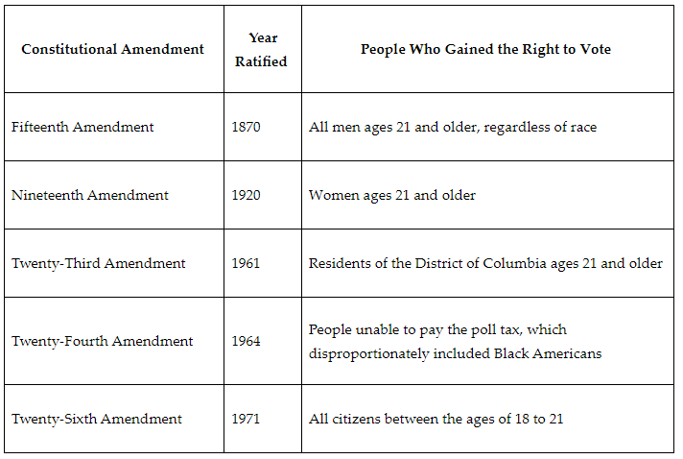

After the Civil War, even though the Thirteenth Amendment ended slavery and the Fourteenth Amendment promised equal protection, not many states protected Black Americans' right to vote. Congress proposed the Fifteenth Amendment because Congress wanted to prevent states from denying citizens the right to vote based on race.

**Objective 2:** Explain key historical events from the Women’s Suffrage Movement that impacted the U.S. Constitution.

**Big Ideas:** In the mid-nineteenth century, the right to vote for men began expanding in the U.S.. Women’s rights leaders met and began to demand that this right be extended to women. This meant building national organizations, making legal challenges, holding protests, and convincing the nation to honor their national service.

After their attempts to gain the vote were not successful, the Women’s Suffrage Movement strategy changed.

They increasingly focused on getting state legislatures to change state laws rather than constitutional legal challenges. This led to a string of successes. By 1912, nine states had passed laws to protect the right to vote for women. More would do so before the Nineteenth Amendment was ratified. The right to vote was secured through changing state laws that created momentum to add an amendment to the Constitution.

**Objective 3:** Connect the Voting Rights Act of 1965 to the Black American suffrage laws that triggered a federal response to protect voting rights.

**Big Ideas:** In 1964, because of voting restrictions still in place from the Jim Crow era, only about 2% of the eligible Black population in Selma, Alabama, were registered to vote. Dr. Martin Luther King Jr. decided to organize a march. The march would begin in Selma and proceed for several days to the capital of Montgomery. The goal was to demand that Jim Crow laws that suppressed Black voter registration be changed.

In response to the Selma to Montgomery march, Congress passed the Voting Rights Act. It had several important provisions to protect voting rights. First, it prohibited the use of literacy tests by states to register for elections. Second, it allowed the federal government to send monitors into states to ensure that eligible voters could register to vote.

The impact on voter registration was immediate among Black voters. In a year, voter registration increased across the South.

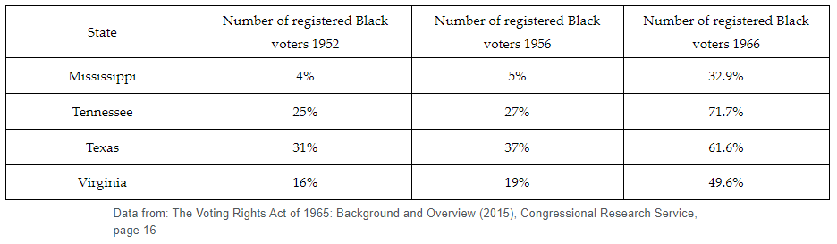

**Keywords**:

* **freedman** – a person liberated from slavery in the Civil War period
* **suffrage** – the right to vote in public elections
* **franchise** – the right to vote
* **poll tax** – a fixed sum tax levied on individuals
* **abridge** – to limit or reduce
* **enfranchise** – the granting of a right or privilege; commonly referring to the right to vote
* **temperance** – the refusal to drink alcohol
* **Underground Railroad** – a network to help enslaved peoples escape to free states
* **black codes** – the laws passed by southern states, designed to replace the social controls of slavery following the end of the Civil War
* **Jim Crow laws** – the laws that legalized the separation of people based on race in areas of school, public places, and transportation

**Quick Check**

Question 1: Which statement **best** explains the Twenty-Third Amendment’s changes to voting rights in the District of Columbia?

* **Citizens residing in the District can vote for a presidential candidate.**
* Citizens in the District can be eligible for the military draft.
* Citizens residing in the District can elect members of Congress.
* Citizens residing in the District can elect a local government.

Question 2: What did the Fifteenth Amendment prohibit governments from using to prevent someone from voting?

* **race**
* property
* gender
* age

Question 3: Which statement **best** explains how women achieved voting rights changes in the Constitution?

* The right to vote was secured through the Declaration of Sentiments, which declared that all women and men were equal.
* **The right to vote was secured through changing state laws that created momentum to add an amendment to the Constitution.**
* The right to vote was secured when women won voter registration challenges under the Fourteenth Amendment.
* The right to vote was guaranteed when Congress included the right to vote for women in the Fifteenth Amendment after the Civil War.

Question 4: How does the Voting Rights Act of 1965 connect to Black suffrage laws passed after the Civil War?

* **The Voting Rights Act of 1965 prohibits the use of literacy tests by states.**
* The Voting Rights Act prohibits a state from preventing someone from voting because of their race.
* The Voting Rights Act guarantees equal protection under the laws.
* The Voting Rights Act prevents states from using the black codes developed after the Civil War.

Question 5: What was the purpose of the Selma to Montgomery march in 1965?

* to demand a constitutional amendment to prohibit states from using race to prevent a person from voting
* **to demand that Jim Crow laws that suppressed Black voter registration be changed**
* to demand that Congress pass a civil rights law ending segregation in public places
* to demand an amendment to guarantee equal protection under the laws

**Lesson 9 – African American Civil Rights**

**Objective 1:** Describe the key events and influential people involved in the civil rights movement for Black Americans.

**Big Ideas**:

**Key Events**

|  |  |
| --- | --- |
| **Event** | **Description** |
| Executive Order 8802 | Allowed Black Americans to participate in the defense industry |
| Double V Campaign | Acknowledged that Black Americans thought fighting for freedom and democracy overseas contradicted the racial discrimination they experienced in the U.S. |
| Montgomery Bus Boycott | Ended segregation on city busses in Montgomery, Alabama |
| March on Washington for Jobs and Freedom | An organized march to apply pressure on politicians for equal civil and economic rights for Black Americans |
| Civil Rights Act | A law passed prohibiting discrimination on the basis of race, color, religion, sex, or natural origin |
| Voting Rights Act | A law to enforce the Fifteenth Amendment of the Constitution by prohibiting discriminatory voting practices |

**Influential People**

|  |  |
| --- | --- |
| **Key Figure** | **Description** |
| A. Philip Randolf | Organized a march on Washington to force President Franklin Delano Roosevelt to allow Black Americans to participate in the defense industry |
| Rosa Parks | Refused to give up her seat for a White American on a Montgomery, Alabama bus initiating a yearlong boycott that led to the end of segregation of public transportation in Alabama |
| Martin Luther King Jr. | Led the Montgomery Bus Boycott and gave a speech during the March on Washington for Jobs and Freedom that applied political pressure to pass the Civil Rights Act of 11964 and Voting Rights Act of 1965 |

**Objective 2:** Describe how the Thirteenth, Fourteenth, and Fifteenth Amendments extended civil rights to Black Americans and the implications of each amendment on Black Americans’ civil rights.

**Big Ideas:**

The following chart summarizes the achievements of the Reconstruction Amendments, and their limitations.

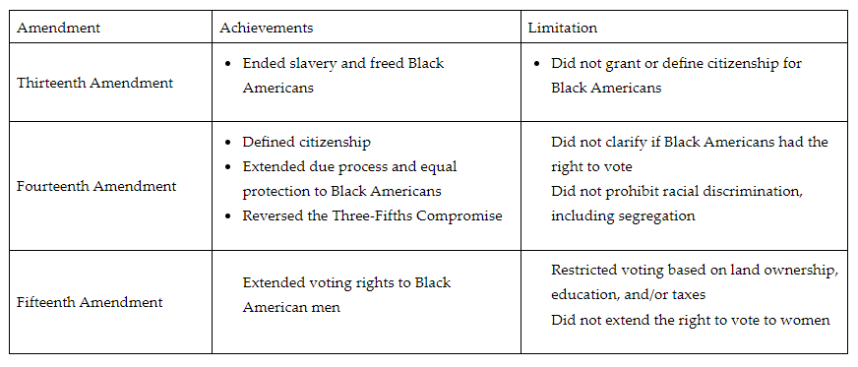

**Objective 3:** Analyze the rulings of the U.S. Supreme Court cases *Brown v. Board of Education* and *Plessy v. Ferguson* and the impact they had on individual freedoms and equal protections.

**Big Ideas:**

In 1896 and 1954, two key court cases became landmark cases in the fight for Black Americans’ individual freedoms and equal protections. These two court cases, *Plessy v. Ferguson* and *Brown v. Board of Education of Topeka*, were landmark cases for opposite reasons.

*Plessy v. Ferguson* created a law that separated Black Americans from White Americans. *Brown v. Board of Education* ended that segregation.

**Separate but Equal**

In 1896, *Plessy v. Ferguson* codified into law the separate but equal doctrine. Black Americans were legally segregated from their White American counterparts.

The Supreme Court argued in *Plessy v. Ferguson* that separate but equal did not necessitate racial inferiority on the part of Black Americans. As a result, Black Americans’ equality and freedoms suffered under the separate but equal doctrine. The segregated public provisions and facilities were not equal in standard or quality. Legal segregation, or apartheid, would not end in the U.S. until the civil rights movement in the 1950s and 1960s.

**The Ruling and Impact of *Plessy v. Ferguson***

In 1896, Plessy agreed to help challenge Louisiana’s Separate Car Act. After Plessy was arrested, his lawyers argued in court that the Separate Car Act violated the Thirteenth Amendment and Fourteenth Amendment protections. Their argument failed, and after a series of appeals, the case made it to the Supreme Court.

The Supreme Court decided 7 to 1 that the Louisiana law did not violate the Constitution. According to the court, the Thirteenth Amendment did provide sufficient protections against laws that restricted citizens based on race.

It was argued that segregation did not violate the equal protections clause of the amendment. As long as the segregated facilities were equal, then separating the races on account of race was constitutional.

**The Ruling and Impact of *Brown v. Board of Education***

By 1951, the National Association for the Advancement of Colored People (NAACP) challenged Topeka's segregated schools. With the help of the NAACP, three Black American families tried to enroll their children in exclusively White schools. The enrollment for the children was rejected. After years of appeals and litigation, the Supreme Court heard the case.

*Brown v. Board of Education* directly challenged the separate but equal doctrine established in *Plessy v. Ferguson*. The Supreme Court decided unanimously to end the separate but equal doctrine. According to the court, the segregation of public schools violated the equal protections clause of the Fourteenth Amendment.

What mattered to the court was the psychological impact that legally sanctioned segregation had on Black Americans. The court argued that segregation led to the feeling of inferiority on the part of Black Americans in comparison to White Americans.

**Challenges Presented and Overcome**

After the *Plessy v. Ferguson* decision, Black Americans’ individual freedoms stagnated. *Brown v. Board* ended a legal regime in the U.S. that lasted more than half a century.

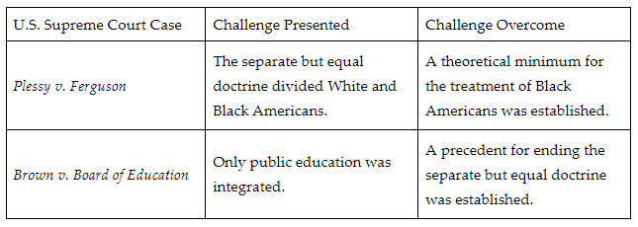

**Objective 4:** Develop a logical argument to support how the concept of judicial restraint was reflected in the Supreme Court’s decision of *Plessy v. Ferguson* and the concept of judicial activism was reflected in the Supreme Court’s decision of *Brown v. Board of Education*

**Big Ideas:** The U.S. Supreme Court is the highest court in the country. According to the U.S. Constitution, the Supreme Court provides the final verdict on all constitutional disputes. The Supreme Court interprets the Constitution to make a decision. When the court makes a decision, it can set a precedent or uphold an existing precedent.

The Supreme Court does have some restrictions when ruling on cases. These restrictions are called judicial restraint and judicial activism.

**Judicial restraint** is the idea that the Supreme Court justices should only rule on cases based on the constitutionality of the law or legal precedence. They also should only overturn laws that are deemed unconstitutional.

The *Plessy v. Ferguson* decision is supported by judicial restraint. This decision created the separate but equal doctrine, which segregated White and Black Americans’ public accommodations. Race-based segregation laws were already in existence when this case was decided. The Supreme Court did not interpret the law to produce a favorable outcome or challenge the elected branches of government.

**Judicial activism** is the ruling on laws based on political or personal views. These views lead to a preferred or desired outcome regardless of how the law is written.

Judicial activism supports the *Brown v. Board of Education* decision because the court interpreted the law to produce a favorable outcome. Until 1954, the separate but equal doctrine had existed unchallenged. To challenge the doctrine, the Supreme Court needed to disregard the actions of the elected branches of government and precedent to decide the case.

**Keywords**:

* **Civil Rights Act of 1964**– a law prohibiting discrimination on the basis of race, color, religion, sex, or national origin
* **civil rights movement** – a movement from 1954 to 1968 that sought equal status for Black Americans
* **due process of law** – the fair treatment of a citizen through the normal judicial system
* **separate but equal** – a legal doctrine that permitted racial segregation in public facilities and services as long as the standard and quality of the segregated facilities and services were equivalent
* **Jim Crow laws** – the laws that legalized the separation of people based on race in areas of schools, public places, and transportation
* ***Brown v. Board of Education of Topeka*** – a landmark Supreme Court case which rejected the doctrine of separate but equal and led to a policy of integration
* **Thirteenth Amendment** – the addition to the Constitution that ended slavery
* **judicial activism** – the ruling on laws based on political or personal views that lead to a preferred or desired outcome regardless of the law that is written
* **judicial restraint** – the idea that judges should not rule on matters of the constitutionality of the actions of the executive or legislative branch because those matters should be decided by the voting public
* **legislative intent** – the goals of the legislators at the time of a bill’s passage
* **plain meaning rule** – an interpretation of the law that uses ordinary language when language is unclear

**Quick Check**

Question 1: Which of the following tables accurately describes the key events in the fight for Black American civil rights in chronological order?

* 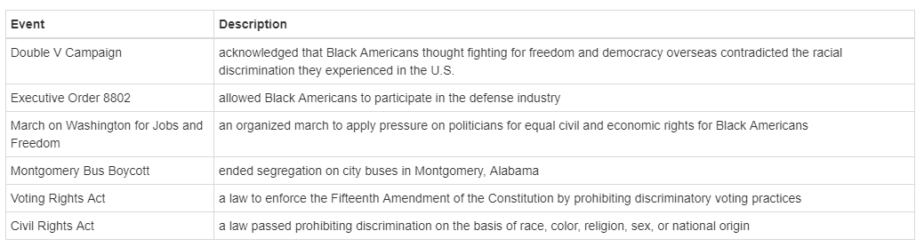
* 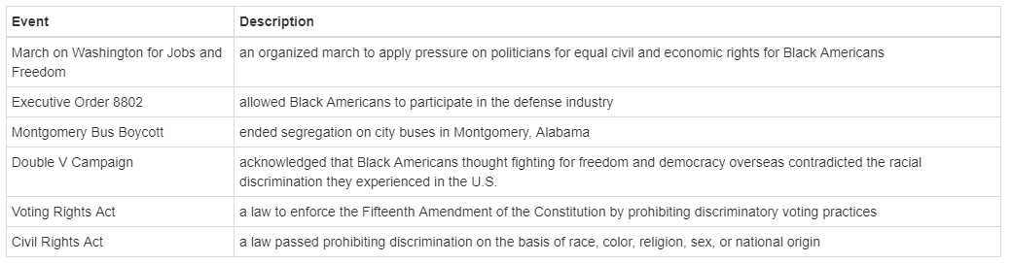
* 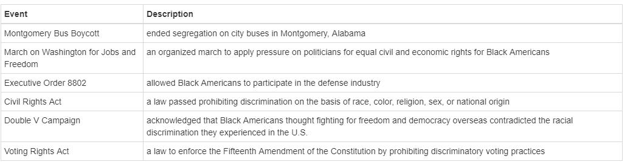
* 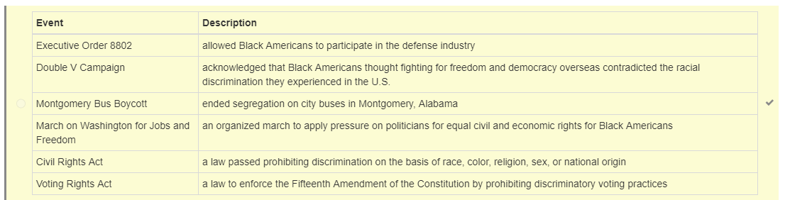

Question 2: Which of the following charts **best** describes the key figures that influenced and contributed to civil rights for Black Americans?

* 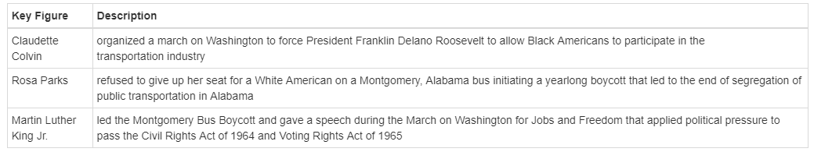
* 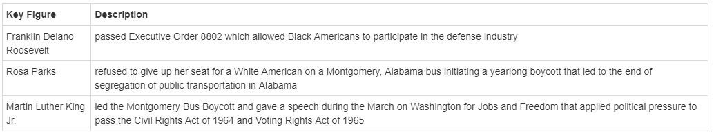
* 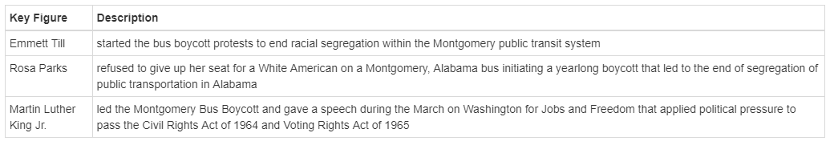
* 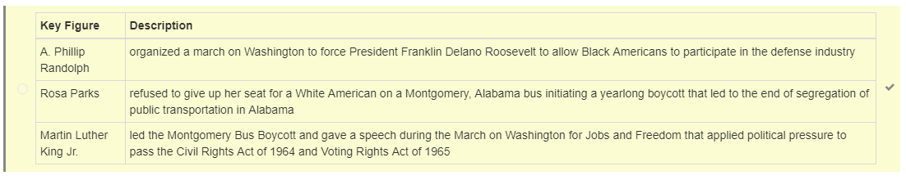

Question 3: Which of the following **best** describes how the Fourteenth Amendment extended and limited civil rights to Black Americans?

* **The Fourteenth Amendment defined citizenship in the U.S., made all citizens equal before the law, and guaranteed due process to all citizens; however, it did not extend voting rights to Black Americans or prevent the separate but equal doctrine.**
* The Fourteenth Amendment defined citizenship, prevented the separate but equal doctrine, and abolished slavery; however, it did not reverse the Three-Fifths Compromise or extend voting rights to Black Americans.
* The Fourteenth Amendment defined citizenship in the U.S., granted voting rights for Black American men, and guaranteed due process; however, it did not abolish slavery or prevent the separate but equal doctrine.
* The Fourteenth Amendment defined citizenship in the U.S., abolished slavery, and guaranteed due process to all citizens; however, it did not extend or prevent the separate but equal doctrine.

Question 4: Which of the following **best** analyzes the ruling *Plessy v. Ferguson* had on individual freedoms and equal protections?

* ***Plessy v. Ferguson* established the separate but equal doctrine that segregated Black Americans in public spaces.**
* *Plessy v. Ferguson* ended segregation between White and Black Americans with the separate but equal doctrine.
* *Plessy v. Ferguson* applied the separate but equal doctrine only to public transportation across the U.S.
* *Plessy v. Ferguson* established segregation in public transportation based on the constitutionality of the Louisiana Separate Car Act.

Question 5: Which of the following develops a logical argument about how judicial restraint supports the Supreme Court’s *Plessy v. Ferguson* decision?

* Judicial restraint supports the *Plessy v. Ferguson* decision because the decision invalidated the separate but equal doctrine.
* Judicial restraint supports the *Plessy v. Ferguson* decision because the decision challenged the legislative intent of the equal protections clause.
* Judicial restraint supports the *Plessy v. Ferguson* decision because the decision challenged the actions of the legislative and judicial branches.
* **Judicial restraint supports the *Plessy v. Ferguson* decision because the Supreme Court did not challenge the actions of the executive or legislative branches.**

**Lesson 10 – Marginalized Group’s Rights**

**Objective 1:** Analyze the protections and limitations of the Civil Rights Act of 1964.

**Big Ideas**: **Promises of the Civil Rights Act of 1964**

The act banned discrimination based on race, color, gender, religion, and national origin. It mandated equality in voting rights, education, public accommodations, housing, and employment. It gave federal agencies power to take action against racial discrimination. It was not limited to protections for Black Americans.

The Civil Rights Act of 1964 has the following provisions:

* Title I: Voting – prohibits unequal requirements for voter registration applications, such as a literacy test.
* Title II: Public Accommodations – outlaws discrimination based on color, race, religion, or national origin in restaurants, theaters, hotels, as well as all other public accommodations involved in interstate commerce such as buses and trains. In so doing, it overturned the doctrine of “separate but equal” established in the case of Plessy v. Ferguson.
* Title III: Public Property – prohibits state and local governments from denying access to public property and facilities based on color, race, religion, or national origin.
* Title IV: Public Schools – provided the basis for the desegregation of public schools.
* Title V: Future Expansion – provided for the expansion of the Civil Rights Commission.
* Title VI: Government Agencies – prohibits discrimination by government agencies (such as schools and colleges) that receive federal funds. The penalty for doing so is the loss of funding.
* Title VII: Employment – prohibits discrimination in the workplace based on race, color, religion, sex, or national origin for public and private sector employers with 15 or more employees.
* Title VIII: requires analysis of voter registration and voting data in specific areas that had a history of disenfranchisement of Black Americans.
* Titles IX and XI: Enforcement – moved civil rights cases from state to federal courts.

**Work Still to Be Done**

Despite the Civil Rights Act of 1964, work is still needed to ensure equality. The principles it established now inform the debate about a much wider range of issues. Social justice and civil rights advocates believe many aspects of American society are still discriminatory and need to be changed. Some of these include:

* The data on race-based policing and race-based incarceration show wide disparities between White and Black Americans in arrests, convictions, and length of prison sentences.
* Legal cases in a number of states center on the question of whether private companies can use religious beliefs as a justification for establishing policies that impact employees’ health-care access.
* Schools continue to be unofficially segregated due to the scarcity of affordable housing in many areas of the country.
* 29 states today deny people access to public services because of their sexual orientation or gender identities.
* Health care, prenatal care, and early childhood education are more difficult for people of color to access.
* Fair housing and environmental justice remain issues unaddressed by current legislation.

**Objective 2:** Identify ways the federal government has extended and protected the civil rights of marginalized groups.

**Big Ideas:** Title IX requires all schools that receive federal funding to provide fair and equal treatment of the sexes in all areas.

Section 504 prohibits discrimination against qualified individuals with disabilities. Institutions that receive federal funding must provide appropriate educational services to students with disabilities under Section 504.

The Americans with Disabilities Act (ADA) prohibits discrimination against individuals with disabilities. The ADA’s purpose is to guarantee equal opportunity for individuals with disabilities in public accommodations, employment, transportation, telecommunications, and all levels of government services.

*Reed v. Reed* was a 1971 Supreme Court case that addressed the equal protection clause of the Fourteenth Amendment. The equal protection clause prohibits states from making or enforcing any law that infringes on the rights of citizens of the U.S..

Represented in the *Reed v. Reed* case were a mother and father, who were separated. Their teenage son had died and did not have a legal will indicating his wishes regarding what to do with his property after death. Both the mother and father wanted to be appointed executor with the power to make decisions about the young man’s property. The couple’s Idaho residency subjected them to a state statue indicating that “males must be preferred to females”. Mrs. Reed challenged Idaho’s ruling to make Mr. Reed the executor and the case made its way to the U.S. Supreme Court.

The Supreme Court ruled that to give one gender preference over another was a violation of the Fourteenth Amendment and the equal protection clause. The court ruled that the Idaho state law was unconstitutional because it was discriminatory based on sex. *Reed v. Reed* led to the revision or removal of hundreds of state and federal laws that previously had been discriminatory based on sex.

In *Obergefell v. Hodges*, Obergefell represented the group of same-sex couples, while Hodges, the Ohio Department of Health director, represented the states. The equal protection clause and the due process clause of the 14th Amendment of the U.S. Constitution protect the right to marriage. The court held that state bans on same-sex marriage were unconstitutional. The court further held that states must recognize same-sex marriages legally performed in other jurisdictions.

**Objective 3:** Explain the changes in American culture as a result of federal immigration policies.

**Big Ideas:**

* The Immigration and Nationality Act of 1965 changed U.S. immigration policy.
* It got rid of the National Origins Formula and created a preference system to identify people that would get priority legal immigration status.
  + The National Origins Formula had set immigration policy based on a system of quotas that restricted immigration based on existing population already residing in our nation.
  + The formula favored immigration of people from western and northern Europe by using the 1890 census to determine national quotas.
* The Immigration and Nationality Act gave priority to immigrants who had family in the U.S., skills that were needed, or were fleeing danger.
* No cap was placed on visas extended to immediate family members of U.S. citizens.
* It allowed more immigrants from Africa and Asia to come to the U.S.
* The law limited entry to 20,000 immigrants per country, with a total of only 120,000 people annually immigrating from the western hemisphere.
* The need for temporary workers in the U.S. exceeded the 20,000 cap.
* Looking for work to feed their families, Mexican workers entered the country without legal immigration or work visa status.
* Prejudice against undocumented workers began. Illegal alien is a derogatory term used by anti-immigration supporters. Today, the term undocumented noncitizen is preferred.

**Immigration Reform and Control Act of 1986**

* IRCA is a law that says employers can't hire workers who don't have permission to work in the U.S.
* IRCA lets some workers who came to the U.S. before 1982 become legal residents.
* IRCA was signed by President Reagan and aimed to stop illegal immigration.
* IRCA made a system to check workers' legal status and gave more money to Border Patrol.
* Some people liked IRCA because they wanted to control immigration. Some people didn't like IRCA because they thought it would be unfair and harmful to workers.

**Deferred Action for Childhood Arrivals**

* DACA is a rule made by President Obama in 2012 to protect some immigrant youth from being sent away from the U.S. These youth are often called DREAMers.
* DACA helps people who came to the U.S. as children and feel like Americans, but don't have legal papers to stay here.
* DACA gives young undocumented noncitizens protection from deportation as well as a permit to work in the U.S.
* DACA was stopped by President Trump in 2017, but the Supreme Court said it can continue in 2020.
* Current policy on DACA is the result of executive order.
* President Biden tried to restore DACA in 2021, but a judge in Texas said it has to end.
* It is up to Congress to make a new law for a more permanent solution for the civil rights of the DREAMers.

**Keywords**:

* **disenfranchisement** – the state of being deprived of a right or privilege, especially the right to vote
* **literacy test** – a test given to assess a person’s ability to read and write; used as a tool in the Jim Crow era to restrict voting among Black Americans
* **lynching** – the act of putting a person to death (often by hanging) by mob action without legal approval or permission
* **due process clause** – the portion of the Fourteenth Amendment that states no person shall be denied life, liberty, or property and that all individuals shall be treated fairly and given the opportunity to have legal matters resolved according to established rules and principles
* **equal protection clause** – the portion of the Fourteenth Amendment that states the government must treat an individual in the same manner as others in similar conditions and circumstances and that it may not deny people equal protection of its laws or rights
* **marginalized** – to treat a person, group, or concept as insignificant or peripheral
* **asylum** – the protection granted by a nation to someone who has left their native country as a political refugee fleeing an oppressive government
* **deportation** – the removal from a country of a person who is not a citizen
* **visa** – a conditional travel document issued by the traveler's country of citizenship to any person seeking entry into another country or territory

**Quick Check**

Question 1: Analyze the provisions guaranteed by the Civil Rights Act of 1964. Which provision invalidated the “separate but equal doctrine” of *Plessy v. Ferguson*?

* **Title II: Public Accommodations**
* Title III: Public Property
* Title IV: Public Schools
* Title VI: Government Agencies

Question 2: Think about the examples of how the federal government took actions to extend or protect the civil rights of marginalized groups. Identify the action that is matched with the correct marginalized group.

* The Twenty-sixth Amendment protects women’s rights.
* An executive order creates the ADA.
* **A Supreme Court ruling protects LGBTQ+ rights in *Obergefell v. Hodges.***
* A Supreme Court ruling creates Title IX to protect the rights of female college students.

Question 3: Which of the following is the foundation of modern civil rights law?

* Section 504
* Title IX
* **the Civil Rights Act of 1964**
* the Americans with Disabilities Act

Question 4: Which of these **best** explains why the 1924 Immigration Act favored immigrants from northern and western Europe?

* **The act used the 1890 census to determine national quotas.**
* The act required all immigrants to be Protestants.
* The act required all immigrants to be fluent in English.
* The act used the 1920 census to determine national quotas.

Question 5: Current policy on Deferred Action for Childhood Arrivals (DACA) is the result of what type of federal action?

* constitutional amendment
* **executive order**
* act of Congress
* presidential veto

**Lesson 11 – Civil Rights Issues**

**Objective 1:** Critique governmental policies resulting in inequalities at the local, state, and national levels.

**Big Ideas**: To balance social order with the American ideals of freedom and democracy, political leaders purposely created policies to limit equality. Many inequalities result from the American laws for protecting personal property. This is supported by the U.S. Constitution. It is further upheld by state and local laws.

**Critiquing the National Policy on Property Rights (1787–1965)**

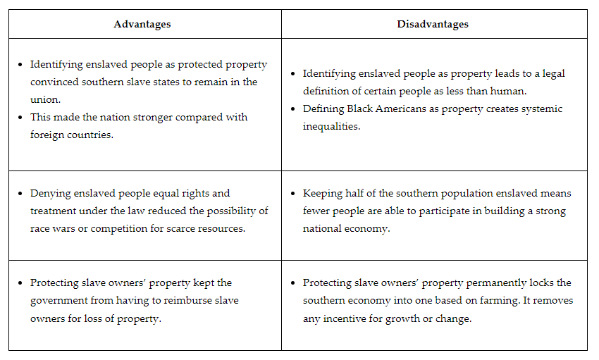

**Critiquing the National Policy on Voting Rights (1787–1870)**

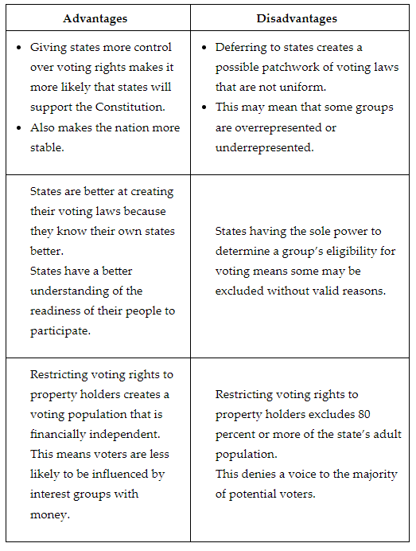

**Objective 2:** Explain the effect the civil rights movement (1954–1968) had on the interpretation of the U.S. Constitution.

**Big Ideas:** With a Union victory in the Civil War, the enslavement of Black Americans ended. To protect the civil rights of the newly freed, formerly enslaved people, Congress passed, and the individual states ratified, the Thirteenth Amendment, the Fourteenth Amendment, and the Fifteenth Amendment. The amendments officially ended slavery. They extended the rights of citizenship. They granted the right to vote to all Black males in the U.S..

In 1896 in the Supreme Court case *Plessy v. Ferguson*, the U.S. adopted a legal policy of segregation. Under segregation, Black Americans officially had the rights of citizenship granted by these amendments. But they were not allowed to share public or private facilities with White Americans.

With *Plessy v. Ferguson*, a legal doctrine of separate but equal characterized Black American life. These separate facilities were often not equal in quality to White facilities. This facility inequality was paired with a persistent unequal application of the law based on race. The civil rights movement was an effort to address these inequalities.

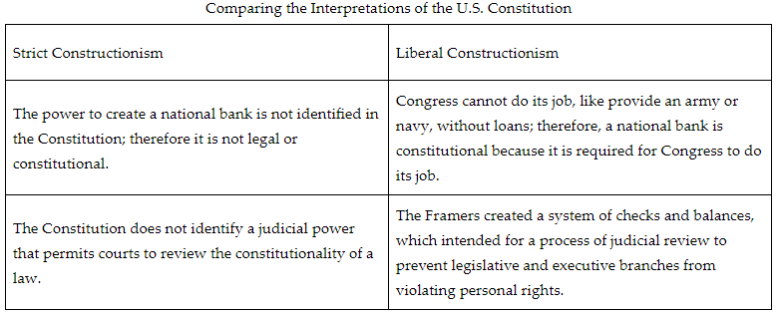

One example where an emerging social issue has used a liberal constructionism approach to fill in the gaps is the civil rights movement. The Constitution does not identify a citizen’s right to an equal education. During the strict constructionism era after *Plessy v. Ferguson*, the Supreme Court would not hear or decide on cases involving education. This was because it was not explicitly addressed in the Constitution. *Plessy v. Ferguson* used strict constructionism by refraining from attempting to decipher the intent behind the Fourteenth Amendment.

But, lawyers for the civil rights movement presented arguments that the right to an equal education was a fundamental right guaranteed by the Constitution. The Supreme Court agreed and applied liberal constructionist arguments in *Brown v. Board of Education of Topeka*.

The Constitution does not identify the right to vote as a federally protected right. For most of the U.S.’ history, states had broad powers to legislate voting rights. This led to abuses involving gerrymandering and poll tax levies to restrict Black Americans’ voting rights. Once again adopting a liberal constructionist approach in response to the civil rights movement, the Supreme Court ruled in cases *Reynolds v. Sims* and *Harper v. Virginia Board of Elections* that all persons are entitled to an equal right to vote. They also ruled that states cannot restrict these rights despite their power to regulate elections.

The Supreme Court redefined the traditional rights of personal property. With the civil rights era, the Supreme Court limited the discretion that individuals and corporations had for administering their property. In Heart of *Atlanta Motel v. U.S*., the Supreme Court ruled that discrimination by restaurants, hotels, and other businesses is illegal. They also ruled that Congress has the right to legislate on this due to its power of regulating interstate commerce.

**Objective 3:** Describe how social movements, political parties, and interest groups attempted to reconcile American political ideals with public policy.

**Big Ideas:** The Republican party led the nation’s efforts to extend these values and ideals. They did this by passing the laws of the Thirteenth, Fourteenth, and Fifteenth Amendments, granting Black males the rights of American citizenship including the right to vote. The Republican party also put forward presidential candidates who supported expanding Black Americans’ civil rights. But, the Republican party would not sustain this leadership in reconciling American ideals with public policy.

Black leaders organized formal interest groups. Interest groups litigated unfair laws in the Supreme Court.

The NAACP would:

* successfully reverse segregation through the Supreme Court case *Brown v. Board of Education of Topeka.*
* organize the 1963 March on Washington for Jobs and Freedom.
* lobby Congress to pass the Civil Rights Act of 1964 and the Voting Rights Act of 1965.

**Keywords**:

* **disenfranchisement** – the state of being deprived of a right or privilege, especially the right to vote
* **coverture** – the legal definition of marriage as one person
* **redline** – a de facto segregation housing policy in which real estate could not be sold or financed to Black families within specific neighborhood boundaries
* **gerrymandering** – manipulating the boundaries of election districts to gain an unfair electoral advantage
* **liberal constructionism** – the legal interpretation of the Constitution that uses the text to discover hidden intentions of the founders
* **poll tax** – the money that some citizens had to pay in order to vote
* **segregation** – an imposed physical separation of people
* **strict constructionism** – the legal interpretation of the Constitution that uses the text only to determine founders’ intent
* **Jim Crow laws** – the laws that legalized the separation of people based on race in areas of school, public places, and transportation
* **lobbying** – an attempt to influence legislation to promote specific interests
* **Reconstruction** – the efforts to rebuild the South and encourage their submission to the laws of the North to reform the Union of states

**Quick Check**

Question 1: Critique the following constitutional provision protecting the property of slave owners. What would be an advantage of this policy?

“Representatives and direct Taxes shall be apportioned among the several States which may be included within this Union, according to their respective Numbers, which shall be determined by adding to the whole Number of free Persons, including those bound to Service for a Term of Years, and excluding Indians not taxed, three fifths of all other Persons.”

* The national government assesses taxation on an equal basis, regardless of state population size.
* States retain the power to decide what taxes will be paid to the federal government, thus increasing state autonomy.
* Taxes are divided on an equal basis regardless of race, ensuring taxation is fair
* **Identifying enslaved people as property ensures that Southern slave states remain part of the Union.**

Question 2: Read the following excerpt from *Plessy v. Ferguson.*

“The object of the [Fourteenth] amendment was undoubtedly to enforce the absolute equality of the two races before the law, but in the nature of things it could not have been intended to abolish distinctions based upon color, or to enforce social, as distinguished from political equality, or a commingling of the two races upon terms unsatisfactory to either. Laws permitting, and even requiring, their separation in places where they are liable to be brought into contact do not necessarily imply the inferiority of either race to the other, and have been generally, if not universally, recognized as within the competency of the state legislatures in the exercise of their police power. The most common instance of this is connected with the establishment of separate schools for white and colored children, which has been held to be a valid exercise of the legislative power even by courts of States where the political rights of the colored race have been longest and most earnestly enforced . . . .”

Explain how this decision legally interpreted the Constitution prior to the civil rights movement.

* The decision used liberal constructionism by citing the precedent of separate educational facilities are inherently unequal.
* The decision used strict constructionism by explaining the federal power to legislate education within state borders.
* **The decision used strict constructionism by refraining from attempting to decipher the intent behind the Fourteenth Amendment.**
* The decision used liberal constructionism by interpreting the amendment’s author’s intent to explain the Fourteenth Amendment.

Question 3: Explain the origin of the civil rights movement as it relates to constitutional interpretation.

* It originated with the lack of a constitutional amendment that granted formerly enslaved people the right to vote.
* **It originated with the legal definition of private property leading to discriminatory treatment against Black Americans.**
* It originated with states not following such federal laws as the Civil Rights Acts of 1964 and the Voting Rights Act of 1965.
* It originated with individuals, corporations, and states not following constitutional amendments and prescribing equal treatment for education and private property.

Question 4: Describe the political strategy used to eliminate discrepancies between Black Americans and American ideals by ratifying the Thirteenth, Fourteenth, and Fifteenth Amendments.

* litigating laws in the Supreme Court
* **writing and passing laws**
* demonstrating in large groups
* political alliances with party leaders

Question 5: Read the following excerpt from *Brown v. Board of Education of Topeka*:

“We conclude that in the field of public education the doctrine of ‘separate but equal’ has no place. Separate educational facilities are inherently unequal. Therefore, we hold that the plaintiffs and others similarly situated for whom the actions have been brought are, by reason of the segregation complained of, deprived of the equal protection of the laws guaranteed by the Fourteenth Amendment . . . ..”

Describe the political strategy used to eliminate discrepancies between Black Americans and American ideals through this court case.

* Interest groups create political alliances with parties.
* **Interest groups litigated unfair laws in the Supreme Court.**
* Social movements demonstrated in large groups.
* Congress wrote and passed laws addressing unfairness.

**Lesson 12 - Citizenship**

**Objective 1:** Explain the historical changes in the meaning of citizenship in the U.S. from the early republic through the passage of the Fourteenth Amendment, the impact on Black Americans, and the expansion of suffrage.

**Big Ideas**: The Constitution did not clearly define U.S. citizenship. In the early republic, Congress recognized various forms of citizenship. They recognized citizenship through birth, citizenship through parents, and naturalized citizenship. Both state and country citizenship were recognized.

The Fourteenth Amendment uses the jus soli rule. Anyone born in the U.S. automatically becomes a citizen. They are entitled to all the privileges and immunities of citizenship. The Fourteenth Amendment guaranteed citizenship to everyone born in the U.S., including Black people. The Dred Scott decision previously had said that Black people could not be U.S. citizens.

**Objective 2:** Summarize legal protections and rights available to citizens and noncitizens under the U.S. Constitution.

**Big Ideas:** U.S. citizenship is based on several factors, including constitutional and legislative acts. The. According to the Fourteenth amendment, any person born in the U.S. is automatically a U.S. citizen. This was affirmed by the U.S. Supreme Court in *U.S. v. Wong Kim Ark* (1898). The Court ruled that anyone born in the U.S. had full U.S. citizenship. They ruled it could not be taken away because of a person’s race or an act of Congress.

Congress has also passed laws that affect citizenship. According to U.S. law, any person born from a U.S. citizen while abroad is also a U.S. citizen. Congress also created a process for naturalization of immigrants in the U.S.. Any resident noncitizen may apply for citizenship after residing in the U.S. for five years.

Once citizenship is established, it may only be forfeited in two circumstances:

1. A citizen may voluntarily surrender U.S. citizenship.
2. A citizen convicted of treason would have their citizenship stripped from them.

There are two major categories for noncitizens. People in both noncitizen groups may reside in the U.S., but under different terms.

1. temporary residents - these are foreign nationals who have a special visa that allows them to remain in the U.S. for an extended period. They may remain in the U.S. for the time on the visa. They can live in the U.S. with their spouses and children.
2. permanent residents - may remain in the U.S.. They have green card status. This means they can remain in the U.S. to live and work permanently.

**Rights and Responsibilities**

Both citizens and noncitizens share important responsibilities in the U.S. They both should obey the laws, pay taxes, stay informed about local and national issues, and uphold the Constitution.

Citizens may need to serve on a jury or perform military service during a national emergency. Citizens have the right to vote in American elections. Citizens may run for federal office and hold U.S. passports.

The Bill of Rights expressly refers to the rights of the people, not to the rights of citizens. In 1945, the meaning of this language was litigated in *Bridges v. Wixon*. The Supreme Court ruled that the First and Fifth Amendments did not distinguish between citizens and noncitizens. Thus, both citizens and noncitizens are entitled to all the rights available in the Bill of Rights.

**Objective 3:** Contrast the differences in citizens’ abilities to engage in political participation in authoritarian and democratic systems of government.

**Big Ideas:**

**Democratic Governments and Elections**

In a democratic system of government, elections are a primary way for citizens to influence government actions. This forces the government for the people. Elections in democracies happen on a predictable schedule. They are held reasonably frequently. Citizens generally have unimpeded access to the polls. The government also makes efforts to protect the integrity of the election process.

A democracy is a government of and by the people. It is important that individual rights are respected and protected. This fact is true even when those freedoms are expressing criticism or calling for change. When a political party or politician does not do a good job, a democratic government protects the people’s right to choose new leaders, support new laws, or bring about change in other ways.

**Authoritarian Governments and Elections**

In an authoritarian system of government, leaders limit political participation. Their goal is to reduce the possibility of an uprising that might threaten their power. Authoritarian governments do not hold free and fair elections. Some authoritarian countries do not hold elections. Some modern authoritarian governments do conduct pseudo-elections. These types of elections operate through a system controlled by the authoritarian government. These governments can then engineer a winning outcome that appears to have some legitimacy to citizens and the outside world.

When authoritarian governments weaken legislative bodies there are consequences. Doing so threatens the civil and human rights of a nation’s citizens. Through legislative action, corrupt politicians can strike down laws. They can also roll back protections. They may even break down the people and institutions that made it possible to elect them.

**Freedom of Expression in Democratic and Authoritarian Government Systems**

Authoritarian governments harshly punish speech that is critical of the government and its leaders; democratic governments do not.

**Democratic Governments and Free Expression**

Under a democratic government, individuals can speak freely about the government and its officials. Individuals can organize and attend nonviolent protests of government actions or policies. News organizations, polling organizations, and scientific journals are allowed to collect data and publish stories. This includes material that is highly critical of the government and its leaders.

When people are free to point out mistakes or corruption in all corners of society, the likelihood that those problems will be fixed increases. Democratic countries then benefit from improvements in policy, technology, health care, and other areas across society.

**Authoritarian Governments and Free Expression**

Authoritarian governments strictly limit speech that is critical of the government or its leaders. If authoritarian leaders do not respond harshly to public criticism, the public perception may shift against them.

In this environment, individuals who want to organize to protest or to speak out against government actions must weigh the risks to their personal safety or to family members and friends. The threat of harm reduces the number of citizens willing to participate.

A free press is also heavily restricted. News media companies in these countries are often owned or heavily controlled and monitored by the state. Journalists who try to publish stories critical of government activities or officials are often punished with imprisonment or death.

**Objective 4:** Explain dual citizenship and how tribal sovereignty provides Indigenous Americans with dual citizenship.

**Big Ideas:**

**The Role of Dual Citizenship in the U.S.**

The U.S. permits a naturalized citizen to hold citizenship in both the U.S. and their country of birth. This status is called dual citizenship.

A U.S. citizen with dual citizenship can:

* vote in all elections
* work without a visa
* live permanently in the U.S.

The dual citizen has the same responsibilities as other citizens. These include:

* paying taxes
* serving in the military
* serving on juries when summoned

A dual citizen could lose their U.S. citizenship if the country of their other citizenship declares war against the U.S.. Dual citizens may be required to pay taxes in both countries. They may not be eligible for specific jobs that require a security clearance.

**Indigenous Americans and Dual Citizenship**

The U.S. considers Indigenous Americans domestically sovereign. Tribal sovereignty refers to geographic areas solely controlled by Indigenous Americans.

Tribal sovereignty does not equal dual citizenship. The U.S. does not recognize Indigenous lands as separate and sovereign nations. The U.S. considers them domestically dependent nations. The federal government recognizes Indigenous Americans as U.S. citizens first and tribal citizens second. This is like state residents. Indigenous Americans under tribal sovereignty are not dual citizens. This is because tribal lands are like states with the power to govern and tax within their borders.

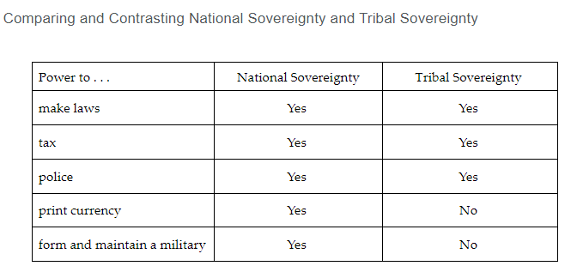

**Keywords**:

* **diversity jurisdiction** – a method used to allow federal courts the authority to hear civil cases involving parties who are citizens of two different states
* **jus sanguinis** – the principle that anyone born of a citizen also obtains citizenship regardless of where the person is born
* **jus soli** – the principle of birthright citizenship
* **naturalization** – the process someone who is born outside the U.S. uses to voluntarily become a citizen of the U.S.
* **literacy test** – a test given to assess a person’s ability to read and write; used as a tool in the Jim Crow era to restrict voting among Black Americans
* **permanent resident** – a person granted the right to live in the U.S. indefinitely
* **poll tax** – a sum of money that some citizens had to pay in order to vote
* **temporary resident** – a foreign national granted the right to stay in a country for a certain length of time without full citizenship
* **dual citizenship** – a person who is considered a citizen of two countries simultaneously
* **naturalized citizen** – a person who is born in one country and completes all the steps required by law to become a citizen of another country
* **tribal sovereignty** – the geographic areas that are solely governed by Indigenous Americans in which tribal governments have autonomy in lawmaking, establishing public services, and imposing taxes

**Quick Check**

Question 1: Which of the following explains how citizenship was expanded to Black people?

* Congress passed the Naturalization Act of 1790.
* **Congress passed the Fourteenth Amendment**
* The Founders placed the Diversity of Jurisdiction Clause in the Constitution.
* The Supreme Court issued the Dred Scott ruling.

Question 2: Which of the following correctly summarizes why noncitizens are protected by the Bill of Rights?

* Noncitizens may have permanent residency that grants them the same constitutional rights as citizens.
* Noncitizens are considered citizens under the language of the Fourteenth Amendment and have the same rights as citizens.
* **Noncitizens are considered “people” within the language of the Constitution and are therefore entitled to the same constitutional protections as citizens.**
* Noncitizens may have green cards that grant them the same constitutional rights as citizens.

Question 3: Which of the following examples accurately contrasts political participation in democratic and authoritarian systems of government?

* **Authoritarian governments harshly punish speech that is critical of the government and its leaders; democratic governments do not.**
* Democratic governments do not tolerate nonviolent forms of protest; authoritarian governments do.
* Democratic governments rarely hold elections; authoritarian governments hold regular elections.
* Free speech has no effect on the function of society in democratic systems; authoritarian governments’ limits on free speech make their societies work better.

Question 4: Which of the following **best** explains dual citizenship in the U.S.?

* **The U.S. permits dual citizenship for naturalized citizens from other countries.**
* The U.S. does not permit a dual citizen to pay taxes, serve on juries, or serve in the military in the U.S.
* The U.S. does not permit dual citizenship for natural born citizens of the U.S.
* The U.S. permits a dual citizen to leave and join their birth country’s military to fight in wars against the U.S.

Question 5: Which of the following **best** explains the relationship between tribal sovereignty and dual citizenship?

* Indigenous Americans under tribal sovereignty are dual citizens because they might be asked to serve in both the U.S. military and the tribal military.
* Indigenous Americans under tribal sovereignty are not dual citizens because they have international passports issued by the tribe.
* **Indigenous Americans under tribal sovereignty are not dual citizens because tribal lands are like states with the power to govern and tax within their borders.**
* Indigenous Americans under tribal sovereignty are dual citizens because they might be asked to use separate currencies with the U.S. and with the tribe.

**Lesson 13 - Noncitizens**

**Objective 1:** Categorize noncitizen residents of the U.S., including permanent residents, nonpermanent residents, refugees, and undocumented migrants.

**Big Ideas**:

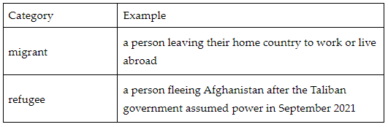

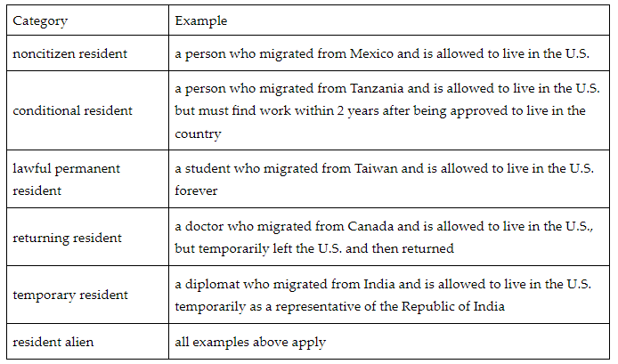

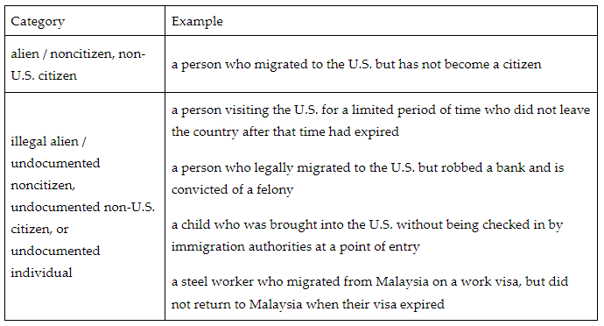

**Objective 2:** Identify the ways in which a person can become a citizen of the U.S. including the citizenship naturalization process.

**Big Ideas:** Citizenship is being a member of a country through birth, relationship, or process. Most people are born as a citizen of their country and grow up into their society. Some countries require people born there to go through a process to attain citizenship. A few countries prevent people born into certain minority ethnic groups, religions, social groups, or parental political associations from becoming citizens.

When people migrate to another country, that country may allow them to become citizens. They do this through a citizenship naturalization process.

The U.S. has two paths to citizenship.

1. **birthright citizen** - The U.S. Constitution gives all people born in the U.S. citizenship. If someone is born in a city, state, or territory of the U.S., they become a birthright U.S. citizen.
2. **naturalized citizen** - To become a naturalized citizen, a migrant must go through the process of naturalization. To begin this process, they must meet the following criteria:
   * be a lawful permanent resident.
   * have lived continuously in the U.S. for 5 years.
   * have not committed any felonies.
   * apply for citizenship to the U.S. Citizenship and Immigration Services (USCIS).

**Objective 3:** Explain knowledge and skills needed to pass the U.S. Naturalization Test.

**Big Ideas:**

**Step 1: Becoming a Lawful Permanent Resident**

A migrant is required to be a lawful permanent resident. A lawful permanent resident is a migrant who has been given permission to live in the U.S. permanently. The migrant must meet eligibility requirements. Once they fulfill the requirements, the migrant will be awarded a green card / permanent resident card. The green card will provide proof that the migrant can live and work in the U.S. permanently.

**Step 2: Applying for Citizenship**

Being a lawful permanent resident does not automatically make a migrant eligible to apply for citizenship. Most migrants must be a lawful permanent resident for 5 years before being eligible to apply for citizenship. Once this requirement is met, other requirements must be fulfilled.

These requirements are:

* Must be at least 18 years old when submitting Form N-400, Application for Naturalization
* Must show lawful admittance as a permanent resident of the U.S. for at least 5 years
* Must demonstrate continuous residence in the U.S. for at least 5 years immediately before the filing date of Form N-400
* Must show physical presence in the U.S. for at least 30 months out of the 5 years immediately before the filing date of Form N-400
* Must show having lived for at least 3 months in a state or USCIS district having jurisdiction over one’s place of residence.
* Must show to be a person of good moral character and have been a person of good moral character for at least 5 years immediately before the filing date of Form N-400
* Must demonstrate an attachment to the principles and ideals of the U.S. Constitution
* Must be able to read, write, and speak basic English
* Must have knowledge and understanding of the fundamentals of the history, principles, and form of government of the U.S. (civics)
* Must take the Oath of Allegiance to the U.S.

**Step 2, Continued: Educational Requirements**

They must be able to read, write, and speak basic English. They also must demonstrate an understanding of American history and government. To provide proof of these skills, the migrant will be invited to complete a face-to-face interview. They will also complete an English literacy and/or a U.S. history and government test.

**Keywords**:

* **alien** – an outdated term for a person without U.S. citizenship or nationality (may include a stateless person); term is no longer used by the U.S. government
* **conditional resident** – a noncitizen granted permanent resident status under certain conditions that only the U.S. government can remove
* **deportable noncitizen** – a noncitizen who has been admitted into the U.S., broken the law, and is now subject to any grounds of removal specified in the Immigration and Nationality Act
* **lawful permanent resident** – a migrant not a citizen of the U.S. who is a lawfully recorded permanent resident
* **migrant** – a person who leaves their country of origin to seek residence in another country
* **noncitizen resident** – a person who does not have U.S. citizenship or nationality
* **refugee** – a migrant who fears their government will harm them due to their race, religion, nationality, social group, or political opinion
* **temporary resident** – a noncitizen who is seeking to become a temporary resident of the U.S. for a specific purpose and period of time
* **undocumented noncitizen** – a noncitizen convicted of a felony, who entered the U.S. unlawfully, and/or whose period of stay in the U.S. has expired
* **birthright citizen** – a person who is born to parents who are citizens of a country or who is born within that country
* **Oath of Allegiance** – an oath of loyalty that every applicant for U.S. citizenship must make publicly prior to becoming a U.S. citizen
* **green card / permanent resident card** – a document that proves that a noncitizen is allowed to live and work permanently in the U.S.

**Quick Check**

Question 1: What is another term for an illegal alien in the U.S.?

* a temporary resident
* **an undocumented non-U.S. citizen**
* a returning resident
* a lawful permanent resident

Question 2: Which example **best** identifies a birthright citizen of the U.S.?

* **a child born in the U.S. to undocumented parents**
* a migrant who is a lawful permanent resident of the U.S.
* a person who was born in another country to citizens of that country, but who has lived continuously in the U.S. for more than 5 years
* a child born in another country to a permanent resident of that country

Question 3: Which document makes birthright citizenship possible?

* Oath of Allegiance
* the Magna Carta
* U.S. Citizenship and Immigration Service
* **the U.S. Constitution**

Question 4: Which requirement indicates that an applicant for naturalization should have a clean criminal record?

* being a good person
* having good values
* **having a good moral character**
* having good morale

Question 5: Which example fulfills the educational requirements to apply for naturalization?

* must have an elementary level of education
* **demonstrate an understanding of American history and government and must be able to read, write, and speak basic English**
* must be able to memorize and recite the Oath of Allegiance to the U.S.
* must be able to only read and write basic English