American Government

**Unit 2: Foundations and Constitution**

**Unit Summary:** This unit explores the foundations of the American system of government. It does this through looking at the creation of the U.S. Constitution. This unit also covers the unique constitutional design. This includes a focus on historical influences and key concepts associated with the distribution, exercise, and limitations of power of the federal government.

**Unit Timeline:** This timeline provides *some* events included in this unit’s learning. The goal is to assist understanding chronologically.

* 1215 – Magna Carta Signed
* 1607 – Virginia Colony founded
* 1626 – New York Colony founded
* 1630 – Massachusetts Bay Colony founded
* 1632 – Maryland Colony founded
* 1633 – Connecticut Colony founded
* 1636 – Rhode Island Colony founded
* 1638 – New Hampshire Colony founded
* 1638 – Delaware Colony founded
* 1663 – North Carolina Colony founded
* 1663 – South Carolina Colony founded
* 1663 – Roy Charter granted by King Charles ll
* 1664 – New Jersey Colony founded
* 1681 – Pennsylvania Colony founded
* 1689 – English Bill of Rights
* 1732 – Georgia Colony founded
* 1774 – Continental Congress
* 1775 – American Revolution began
* 1776 – Declaration of Independence
* 1777 – Continental Congress
* 1781-1789 – Articles of Confederation
* 1786-1787 – Shay’s Rebellion
* 1787 – U.S. Constitution
* 1789-1870 – Laissez-Faire Era
* 1790-1930 – dual federalism
* 1819 – *McCullock v. Maryland*
* 1820 - Missouri Compromise
* 1824 – *Gibbons v. Ogden*
* 1848 – Seneca Falls Convention
* 1850 – Compromise of 1850
* 1854 – Kansas-Nebraska Act
* 1870-1932 – Progressive Era
* 1884 – Declaration of Sentiments
* 1920 – *Missouri v. Holland*
* 1924 – Indian Citizenship Act
* 1929-1930s – Great Depression
* 1930s-1980s – cooperative federalism
* 1932-1949 – New Deal Era
* 1935 – Social Security Created
* 1946-Present – Post-World War ll Era
* 1954 – *Brown v. Board of Education*
* 1958 – *Cooper v. Aaron*
* 1963 – Equal Pay Act
* 1965 –Medicare and Medicaid created
* 1996 – Welfare Reform Act
* 1980s-present – new federalism

**Lesson 2 – Political Precedence**

**Objective 1:** Assess how the Code of Hammurabi contributed to United States political thought.

**Big Ideas**: The Code of Hammurabi was a series of rules used in ancient Mesopotamia. This code was one of the first written codes to be followed by a civilization. The U.S. looked to this code when considering how to structure its government.

The Code of Hammurabi contributed to U.S. political thought as an example of how uniform written rules could promote a flourishing society. Using that inspiration, the Founders created a uniform set of rules called the U.S. Constitution. In it, they set up a framework for the rules of behavior expected from everyone living in the U.S.

The Constitution is the foundational document upon which all laws in the U.S. are based.

**Objective 2:** Assess the contributions of English constitutional history to United States political thought, including the Magna Carta, the English Bill of Rights, and English common law.

**Big Ideas:**

**Limited Government and the Magna Carta (1215)**

The Magna Carta was revised several times in the next century, but the basic tenet of king and people sharing governmental rule remained the same throughout each revision. This was the birth of the idea of limited government in England.

**The English Bill of Rights (1689)**

Like the Magna Carta, this document contributed to creating a limited government. It set limitations on what the government could control. It also set what freedoms the people of England had that the government could not control.

It included the right not to be taxed without parliamentary representation. It also included the right of freedom of speech in Parliament, the right to bear arms, and the right to free elections.

**U.S Political Thought**

The Framers used English governmental structure as a foundation of their political thought. The English ideas of limited government appear in the founding documents of the U.S. such as the Constitution and the Bill of Rights.

Many of the same rights in the English Bill of Rights are in the U.S. Bill of Rights. These freedoms and protections in the U.S. documents are direct descendants of their English counterparts.

**Objective 3:** Investigate the contributions of religion to United States political thought, including Judaism and Christianity.

**Big Ideas:**

**African Religions**

Enslaved African people were brought to the American colonies against their will. Each person came with their own religious beliefs. Some enslaved people held on to some of their traditions and religious practices in America if it was allowed by their owners. Sometimes enslaved people would practice their religion secretly so that their traditions could remain. Unfortunately, most enslaved people were not allowed to practice their religions, and their religions were lost.

Many slaveholders were Christian. They taught a version of Christianity to enslaved people that helped the slaveholders keep control over them.

**Puritan Thought Informs the Constitution**

A group of people known as the Puritans brought the Protestant religion from England to America. As a religious minority, some Puritans were mistreated in England for their faith.

Some of the Puritan beliefs were hard work, education, and a nonreligious government. The Puritans believed that a government should work for the good of the people. They also thought a government should not be run by one person. Many of these beliefs were put in the Constitution.

**Jewish People and the Hope of Religious Tolerance**

Jews came to the American colonies, where they were able to openly practice their religion. When George Washington became president, the members of the Hebrew congregation in Newport wrote him a letter. The letter told him how happy they were this country was built on religious tolerance.

**The Great Awakening**

The Great Awakening was a Protestant revival during the early to mid-1700s.

It gave rise to many new Protestant denominations. The rise of Protestantism reduced the influence of the Anglican and Catholic churches in North America. This break with the faiths of England and Europe contributed to a new sense of identity among the colonists. Many people began to think of themselves as American rather than English or European. This shift helped fuel a rising independence movement in the colonies.

**The Second Great Awakening**

The Second Great Awakening was a Protestant revival in the early 1800s. This revival brought an increased awareness of social problems and possible solutions. It gave rise to many free Black churches. It also contributed to the rise of social reform movements like the abolition, temperance, and women's rights movements.

**Religion and the Constitution**

The framers thought that keeping religion out of the U.S. Constitution was a good way to make sure that one religion would never be considered more important than another.

The Bill of Rights states that Congress cannot prohibit the practice of religion.

**Objective 4:** Cite examples of self-government in colonial America.

**Big Ideas:** Each colony used a form of self-government. Self-government is when the people elect government officials.

Eight colonies were Royal colonies governed by the King of England. The King appointed the governor and advisors.

Three were Proprietary colonies that were governed by individuals or families appointed by the King. These leaders appointed their own officials and created their own laws for the colonies.

The remaining two were Corporate colonies. They elected their own officials and created their own laws. The Connecticut Colony is known for establishing the first written democratic Constitution.

As the colonies ruled independently and created their own laws, America declared its independence from England. A new document, the Constitution, was created and incorporated input from each of the thirteen colonies.

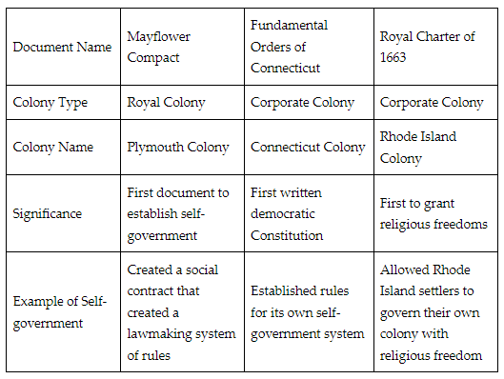

**Keywords**:

* **Code of Hammurabi** – a series of rules and laws that were used uniformly in ancient Mesopotamia
* **English common law –** English law originating from judicial decisions based on custom and precedent
* **constitutional monarchy –** a government in which a monarch (for example a king or queen) shares power with a constitutionally organized government
* **constitutional democracy** – a government whose power is limited by a constitution
* **monarchy** – a government that is run solely by a king, queen, or emperor, usually based on heredity
* **African religions –** a broad term acknowledging the many different religious beliefs enslaved people brought to the United States
* **Great Awakening –** a Protestant revival during the early to mid-1700s that reduced the influence of the Anglican and Catholic Churches and contributed to the rise of the colonial independence movement
* **Second Great Awakening** – a Protestant revival during the early 1900s that contributed to the rise of social reform movements such as the abolition and temperance movements
* **lord proprietor –** a person appointed to oversee the business of a proprietary colony on behalf of a higher sovereign
* **corporate colony** – the land granted to inhabitants as a corporate body

**Quick Check**

Question 1: Which of these statements **best** assesses the contributions of the Code of Hammurabi to U.S. political thought?

* The Code of Hammurabi contributed to U.S. political thought because the philosophers of England, France, and East Asia used it in all of their political writing.
* The Code of Hammurabi contributed to U.S. political thought because Hammurabi was the first leader of the U.S. and he brought his code with him.
* The Code of Hammurabi contributed to U.S. political thought because the Supreme Court still uses this code today to rule on cases.
* **The Code of Hammurabi contributed to U.S. political thought as an example of how uniform written rules could promote a flourishing society.**

Question 2: Which statement **best** assesses the connection between English governmental structure and U.S. political thought?

* The Framers wanted the U.S. government to be exactly like the English government.
* The Framers thought a constitutional monarchy would be the best form of government.
* **The Framers used English governmental structure as a foundation of their political thought.**
* The Framers copied the Magna Carta word for word when creating the U.S. government.

Question 3: How did the framers ensure people the freedom to practice their religion in the U.S. Constitution?

* Article I states that Congress has the power to tax.
* Article VI, Clause 3 states that people don’t have to take a religious test.
* Article II states that the president must be 35 years old.
* **The Bill of Rights states that Congress cannot prohibit the practice of religion.**

Question 4: Which of the following **best** cites an example of self-government?

* A royal colony is an example of self-government because it granted land to families and allowed religious freedom.
* A proprietary colony is an example of self-government because a king governs the colony by direct monarchial rule.
* **A corporate colony is an example of self-government because the people elect their own government officials.**
* A corporate colony is an example of self-government because a lord proprietor elects their own government officials.

Question 5: What colony is known for establishing the first written democratic Constitution?

* Massachusetts Bay Colony
* **Connecticut Colony**
* Virginia Colony
* Rhode Island Colony

**Lesson 3 – Political Philosophy**

**Objective 1:** Analyze the impact of Montesquieu and Rousseau on the founders of the new U.S. government.

**Big Ideas**:

**Montesquieu**

Montesquieu, is well known for his book The Spirit of the Laws. It discussed the importance of political liberty. This would be achieved if there was a separation of powers.

Montesquieu is given credit for creating the term separation of powers. Separation of powers prevents concentration of governmental power into one person or institution.

The influence of Montesquieu and the idea of separation of powers is clear in the federal government design created by the framers of the U.S. Constitution.

**Rousseau**

Rousseau felt that people were free, good, and happy.

Rousseau published The Social Contract in 1762. In it he described a civil society that was based on a social contract. This is the idea that people in society give up some individual freedoms to the government in exchange for the government protecting their natural rights. This supports the idea of popular sovereignty. Popular sovereignty is when authority of the government is given by the people.

Rousseau supported the idea that all people would work toward a common interest by creating laws that were good for all. These ideas can be seen in the Declaration of Independence as the colonists sought to establish a new government for the people by the people. Rousseau’s influence can also be seen in the preamble. The first line begins with the, “We the People of the United States, in order to form a more perfect union…”.

**Objective 2:** Analyze the impact of Locke and Hobbes on the foundation of the United States government.

**Big Ideas:**

**John Locke and Thomas Hobbes**

Locke wrote that the people’s natural rights of “life, liberty and estate” would be protected by the government. These natural rights are held by all and not dependent on a government. This government operated under the consent of those governed and ensured the natural rights of the citizens. The Declaration of Independence was influenced by the concept of natural rights.

The influence of Hobbes in the Declaration statement is also evident through the idea that man has been guaranteed the right of life. For Hobbes, this right was important because protection of self was imperative.

Locke wrote that laws should apply to everyone. He said everyone’s life held value. The value for human life was illustrated in the 8th Amendment. This amendment prohibits cruel and unusual punishment. It should also be noted that during this time, those who would be included “equal” in the eyes of the government were White males.

Locke believed in the idea that people entered into a contract to work together for the common good. This social contract is an agreement among members of a society to give up some individual freedoms to the government in exchange for the government protecting their natural rights.

**Objective 3:** Summarize the main ideas of the Declaration of Independence that were influenced by the Enlightenment Period.

**Big Ideas:** The Enlightenment philosophers wrote of the social contract and natural rights.

Locke’s version of the social contract inspired the American Revolution and the Declaration of Independence.

The Declaration lists the grievances against the British monarchy. By violating the rights of the colonists, the king had violated the social contract. The revolutionaries then had the right to break the social contract and make their own government. The American Revolution was social contract theory in action.

**Objective 4:** Analyze how the founding of the nation was influenced by the different perspectives of individuals and groups who influenced the political developments of the time.

**Big Ideas:** Many political leaders at the time were involved in drafting both the Articles of Confederation and the Constitution. The Articles of Confederation was the first document to describe the framework for the newly formed U.S.. Each leader had different viewpoints on how the government should be arranged and how power should be distributed.

These leaders agreed that government should be responsible for protecting the natural rights and liberties of the citizens. They could not agree on how the new government would be held responsible for protecting these natural rights.

Those that wanted to create a new government under the Constitution were called Federalists. Federalists wanted to create a national government that would be stronger and more influential than it was under the Articles of Confederation. Opponents to this system were called Anti-Federalists. Anti-Federalists wanted to keep the system under the Articles of Confederation. In this system states held most of the power and influence.

Mostly, the Framers did not discuss the morality of slavery. Instead, they discussed how it affected the representation of states at the national level. Many of the northern states wanted to end slavery. The southern states would not agree. The result was the Three-Fifths Compromise.

**Keywords**:

* **separation of powers –** the division of responsibilities between different branches of government to help keep one branch from becoming more powerful than another
* **social contract –** an agreement among members of a society to give up some individual freedoms to the government in exchange for the government protecting their natural rights
* **natural right –** a right that is not dependent on the laws of government and is inalienable
* **three-fifths compromise –** an agreement between the northern and southern states that three out of every five enslaved people would be counted to determine taxation and representation in the House of Representatives
* **tyranny** – a cruel, harsh, and unfair government in which one person or a small group of people holds power

**Quick Check**

Question 1: After analyzing the influence of philosophers on the American Framers of the U.S. Constitution, choose which of the following is given credit for the idea of separation of powers for government.

* Hobbes
* Washington
* **Montesquieu**
* Rousseau

Question 2: After analyzing how the U.S. Bill of Rights implemented Locke’s thoughts, select the U.S. amendment that supports his idea of protecting human life.

* **Eighth Amendment**
* Third Amendment
* Fourteenth Amendment
* Second Amendment

Question 3: Summarize how the Declaration of Independence embodies social contract theory in action.

* The Declaration of Independence describes how the United States government is arranged.
* The Declaration of Independence lists the how the monarchy protected the people.
* The Declaration of Independence was the first U.S. Constitution.
* **The Declaration of Independence lists all of the ways that the colonists felt their liberties had been violated by the king.**

Question 4: Analyze the Declaration of Independence. How was this document influenced by John Locke?

* **It is based on the concept of natural rights and social contract theory.**
* It is based on the Rights of Englishmen.
* It is based on separation of powers.
* It is based on a list of grievances colonists had toward the King of England.

Question 5: What was the first document to describe the framework for the newly formed U.S.?

* **the Articles of Confederation**
* the Constitution
* the concept of natural rights
* the Declaration of Independence

**Lesson 4 – Limited and Unlimited Government**

**Objective 1:** Synthesize the impact diverse government structures have on society and human rights.

**Big Ideas**: 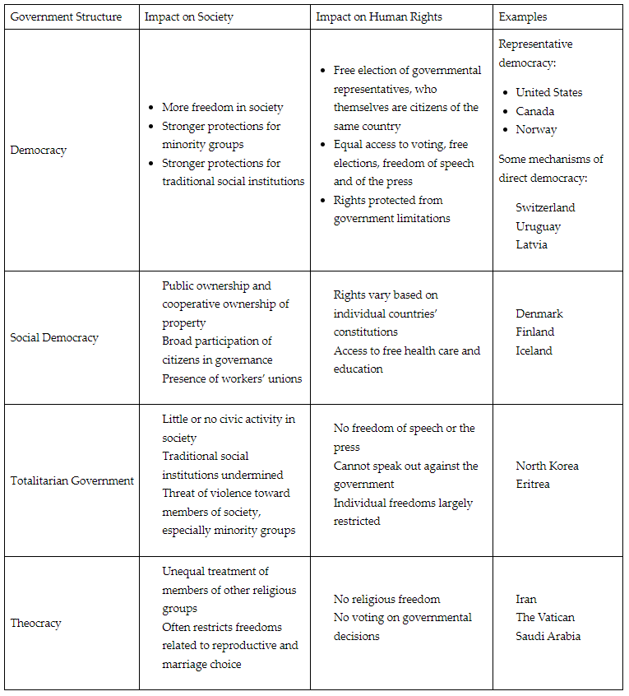

**Objective 2:** Compare the influence of authoritarian and democratic governments on people, groups, and society.

**Big Ideas:** A democracy is a government run by the people. Democracies provide for limits of government over its people.

Democracies

* Emphasize individualism.
* Give citizens access to free and fair elections.
* Grant people civil liberties, like the right to free speech or the right to assemble.
* Enable a robust civil society in which the people can influence their government officials directly or through political parties and interest groups (pluralism).
* Have checks on abuses of power built into government systems.

Unlike democracies, authoritarian governments hold power without input from citizens. These governments are often run by one or a few individuals.

Authoritarian governments:

* Incorporate rule by law.
* Reject the idea of pluralism.
* Restrict civil society.
* Lack civil liberties.

People who live under authoritarian governments lack freedom of speech and freedom of assembly rights. Those who voice opposition to these governments may face imprisonment or death.

**Objective 3:** Explain natural law and natural rights as they were used in the foundation of our government and how governmental power is limited by natural law.

**Big Ideas:** Natural law and natural rights exist independent of human law and cannot be given or taken away.

Within natural law, the Framers reasoned that there are rights that must be protected. The main natural rights that they found were life, liberty, and property.

John Locke’s theory of a social contract was very prominent in the thinking of the Framers of the American system of government. Locke believed humans organized to create governments, and in this organization, they had an unwritten agreement. They gave up some of their unlimited freedom from a state of nature so that the government could protect their natural rights. This social contract was the basis of the Declaration of Independence and the Constitution.

**Objective 4:** Explain limits on government, including the rule of law, and how these limits affect laws.

**Big Ideas:**

**The Rule of Law**

The Rule of Law is the idea that everyone must follow the same laws. These laws should be public and equally enforced. They should follow the founding principles of our government.

The Framers wanted everyone in a democracy to be equally accountable. This is a crucial limit on government that prevents one person or group from seizing total control.

**Federalism**

The American government has a federal system.

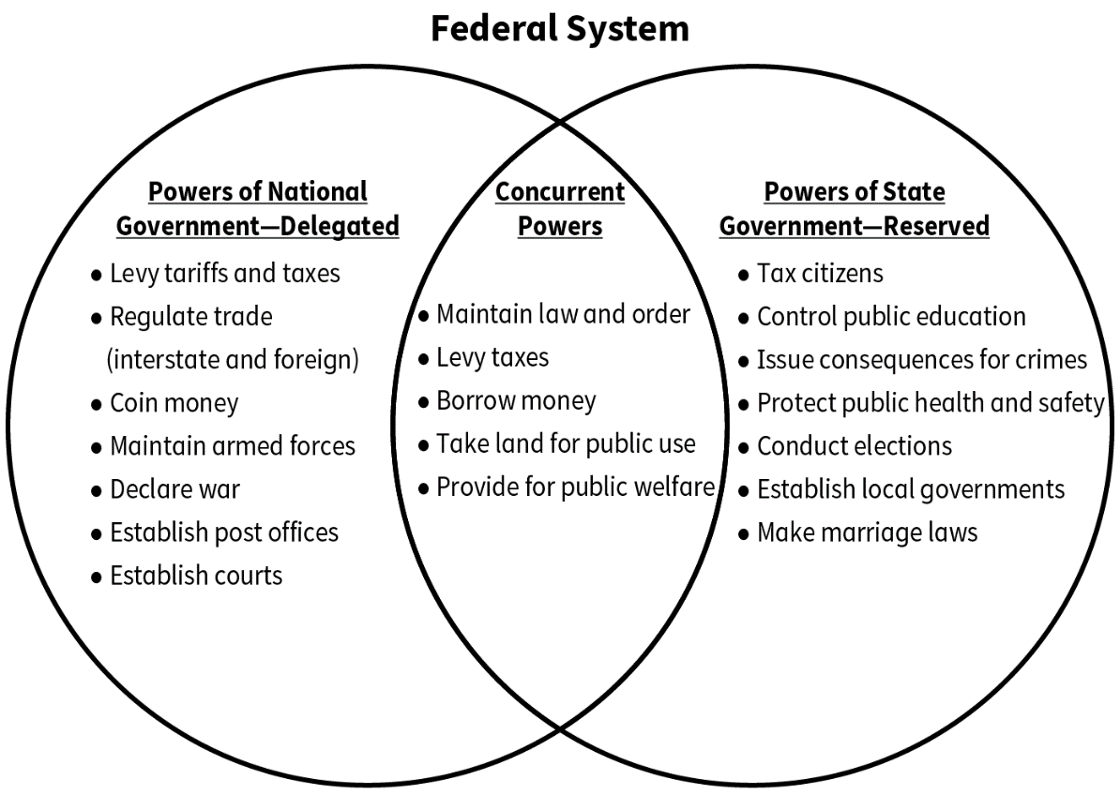

This system serves to limit the power of all levels of government by holding them accountable to each other.

**The Effect of Limited Government on Laws**

The Constitution identifies the judicial branch as the governing body that protects people from unjust laws. If the national government or a state government passes a law outside their power or violates individual rights, people can challenge those laws through the court system.

If a law or act is not in accordance with the protections of the U.S. Constitution, the judicial branch could then declare the law unconstitutional.

**Keywords**:

* **democracy –** a government run by the people
* **direct democracy –** a government that allows citizens to vote on important matters
* **representative democracy –** a government in which people elect representatives to make decisions for them
* **social democracy –** a democratic form of government that has socialist and capitalist characteristics
* **theocracy –** a government run by a religious leader
* **totalitarian government –** a government in which a leader tries to control all aspects of public and private life
* **authoritarian government –**a government that controls virtually everything about a country other than possibly a social organization such as a religion; it is not limited by a constitution, the rule of law, or elections, and typically, it would be run by one or a few individuals
* **civil society –** a civil society creates institutions dedicated to furthering the public goods or benefits to the society by working with government and business interests
* **concurrent powers –** the powers that are shared by the national and state governments
* **delegated powers –** the powers given to the federal government by the Constitution
* **emergency powers –** the additional powers that can be exercised by the executive or legislative branch during a declared state of emergency
* **enumerated powers** – the powers granted to the federal government by the Constitution
* **reserved powers** – the powers that are kept by the states; these are protected by the Tenth Amendment

**Quick Check**

Question 1: Use the text excerpt to synthesize and answer the question.

Democracies and social democracies differ significantly from totalitarian and theocratic structures of government. In totalitarian structures, rulers have unlimited power, and this power is vested in one leader or a group of people who are not elected. Their citizens do not participate in the activities of government. Under theocracies, the government’s laws are based on religious laws, and the leader is typically part of the clergy.

Which of the following synthesizes the impact of diverse government structures on society and human rights?

* Government structures that offer strong protections for human rights create oppressive societies because of stronger government regulation, whereas government structures that offer weak protections for human rights allow more freedom.
* Government structures that offer strong protections for human rights create weaker social institutions and less freedom in society whereas government structures that offer weak protections for human rights create free societies.
* Government structures, whether they offer strong or weak protections for human rights, are not connected to how society functions; societies are shaped by culture and the economy, not by government decisions.
* **Government structures that offer strong protections for human rights create stronger social institutions and more freedom in society whereas government structures that offer weak protections for human rights create unequal societies.**

Question 2: Which of the following statements **best** compares the influence of democratic and authoritarian systems of government on civil society?

* Democracies give unlimited power to the executive over civil society, while authoritarian governments concentrate more power in legislative bodies.
* Democracies put many restrictions on the press, while authoritarian governments enable a free press to thrive.
* Democracies reject the idea of pluralism, while authoritarian governments give the people the ability to influence government officials directly or through political parties and interest groups.
* **Democracies enable a strong civil society in which the people are able to influence their government, while authoritarian governments constrain civil society.**

Question 3: Individualism is **best** defined as which of the following?

* freedom is restricted in favor of the collective good
* a process that punishes government officials for misconduct
* the idea that many interests ought to be free to complete for influence over the government and its policies
* **freedom for individuals is superior to collective or state control**

Question 4: Which of the following best explains natural law and natural rights?

* laws and rights created as part of regular laws by governments in order to ensure peace
* **laws and rights that exist independent of human law and cannot be given or taken away**
* laws and rights created by governments to limit the powers of government and to protect freedom
* laws and rights created by governments to help protect the freedom of the people and to keep them safe

Question 5: Which of following explains what happens if the judicial branch finds that a law does not meet the criteria of the rule of law?

* **The judicial branch declares the law unconstitutional.**
* The judicial branch writes a new law to correct the issue.
* The judicial branch has no power to fix the problem, since it has no law-making powers.
* The judicial branch writes a request to the legislative branch to have it changed.

**L**

**Lesson 5 – Limits to Government Power**

**Objective 1:** Explain how popular sovereignty limits government power and the significance of popular sovereignty in the foundation of the American government system.

**Big Ideas**: Popular sovereignty is the idea that the people hold ultimate authority over their own government.

The idea of popular sovereignty and limited government was present in colonies. The state constitutions were founded on varying degrees of Rousseau’s idea of a social contract. It was understood that the governor and the state legislatures were accountable to the people. Each time foundational documents were written, this carried over.

When the Constitution was written, the preamble started with “We the People.” This was on purpose. The Founders wanted the contract between the citizens of the U.S. and the U.S. government to be clear. It is by the people and for the people. The government only has the power assigned to it by the people.

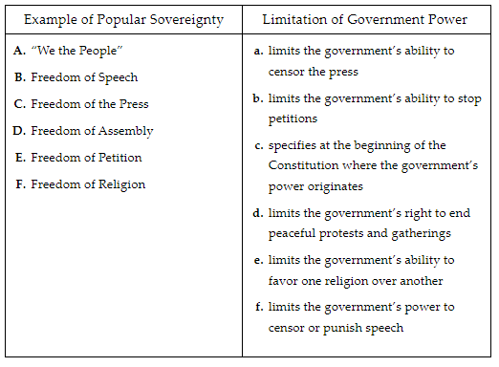

**Objective 2:** Explain how the powers of government are limited by the social contract theory.

**Big Ideas:** Social contract theory limits the power of government in two major ways.

1. The government is required to protect people’s natural rights. Because governments must protect these rights, their power is limited. Without this requirement, governments could use violence against their people. They could imprison people without reason.
2. Because of popular sovereignty, governments get their power from the people. This idea limits the power of government. If power comes from the people, it means that the people can limit the power they give to their government. The idea of popular sovereignty directly puts a limit on absolute authority.

**Objective 3:** Compare the concepts of republic and democracy and how each can limit the power of government.

**Big Ideas:**

**How Democracies Can Limit the Powers of Government**

In its purest form, a democracy represents the will of the majority of citizens. In this pure form, there is little or no limit on what the government can do. On the other hand, if you look at the ways in which democracy is used at the state level in the U.S., there are ways that this type of democracy limits the power of government.

Voters can propose legislation into law through initiatives and referendums. This limits the government’s power to completely control law making. Recall allows voters to remove elected officials from office. This can limit government power by removing elected officials who are not doing what a majority of the voters want them to do.

**How Republics Can Limit the Powers of Government**

Republics can limit the power of government through the constitutions. Republics are created by constitutions, which outline what a government can and cannot do. Constitutions also describe the rights of citizens that the government must protect. By being forced to protect these rights, the government is limited in what it can do.

**Keywords**:

* **nullify** – to cancel or to make legally void
* **sovereignty** – independent, autonomous authority
* **popular sovereignty** – the authority of the government is given by the consent of the people
* **natural rights** – the rights that are not dependent on the laws of government and are inalienable
* **tyranny of the majority** – a situation in which in democracies the majority of voters can pass laws and limit the rights of a minority of voters

**Quick Check**

Question 1: Which of the following **best** explains how governmental authority is limited by popular sovereignty?

* Governmental authority is subject to veto of the people.
* **Governmental authority is limited by the consent of the people.**
* Governmental authority cannot enforce laws without consent.
* Governmental authority is limited by congressional decree.

Question 2: Which of the following is the **best** example of a historical precedent for popular sovereignty?

* The rule of the king was accepted by all the colonists because he was beloved.
* Rousseau wrote that the people should be accountable to their government.
* **State constitutions restricted the power of the governor and the state legislature.**
* Thomas Jefferson wrote about the undisputed authority of the king in the preamble.

Question 3: Which of the following concepts, related to social contract theory, **best** explains the source of government power?

* natural rights
* **popular sovereignty**
* divine right of kings
* limited government

Question 4: Which of the following explains how a republic can limit the power of government?

* Republics use elected representatives to make the laws.
* Republics limit the powers of government by being direct or pure democracies.
* Republics allow their citizens to vote for their representatives.
* **Republics are created by constitutions, which outline what a government can and cannot do.**

Question 5: Which of the following identifies the process that allows voters to vote proposed legislation into law?

* recall
* representative democracy
* a republic
* **referendum**

**Lesson 6 – Founding Fathers and Documents**

**Objective 1:** Analyze the factors that led to the American Revolution.

**Big Ideas**:

**Taxation Without Representation**

From 1756 - 1763, Great Britain fought a war with France. It is commonly called the Seven Years’ War. This war was expensive. To cover the cost, the British government taxed the colonies. They believed the colonies should be required to help pay for part of their own defense.

The new taxes were included in laws. This legislation was unpopular in the U.S.. Many colonists believed that the British government lacked the right to tax the colonies. They thought this because colonists had no representation in British Parliament.

**New Ideas**

During the Enlightenment, many influential ideas emerged that impacted the U.S. political system.

Social contract theory, and the concept of natural rights, served as the philosophical foundation of the Declaration of Independence. The Declaration of Independence was the pronouncement by the U.S. colonies that formally declared them to be independent of Great Britain.

**Practice with Self-Government**

Salutary neglect was a time when the British government let the colonies run their own affairs.

During this time, the colonies learned the lessons of self-government. When the British government began to impose more rules and regulations in the colonies, many resented this. They had come to believe that they had the right to self-government. They did not like being told what to do by a government so removed from their experiences.

**A Fading Allegiance**

Settlers came from all over Europe and other parts of the world to the U.S. to make money and pursue what they believed would be a better life.

Those settlers who emigrated from countries other than Great Britain felt no loyalty to the British crown.

When anger about taxes rose and colonial leaders adopted Enlightenment ideas about government, this diverse group of settlers did not cling to a common British identity.

These factors came together to lead colonists to declare their independence.

**Objective 2:** Analyze how the Articles of Confederation and the U.S. Constitution provided different approaches to the geographic distribution of power.

**Big Ideas:**

**Articles of Confederation**

The Articles of Confederation was the first U.S. constitution. This document created a weak national government. The American leaders worried a strong national government would lead to another king with dictatorial powers. After the Revolutionary War, political power was distributed equally to all states.

**Problems with the Articles of Confederation**

1. Each state, regardless of size, had an equal vote in Congress. This created a problem because small geographic states with fewer people had just as much power as large geographic states with more people.
2. States had the sole power to tax within their own borders. This created a problem because the national government would not have the resources to address the entire country.
3. Changes to the Articles or government required unanimous consent. This created a problem. It was unlikely 13 equal states would agree.

**Proposals to Address Problems of the Articles of Confederation**

In 1787, representatives met in Philadelphia to address the issues above.

One of the primary debates was how to solve the geographic distribution of power.

One proposal, the Virginia Plan, called for larger geographic states with more White men to have more votes in Congress. Smaller geographic states feared being overpowered in Congress. In response, another proposal, the New Jersey Plan, called for all states to have one vote. The following chart indicates how some states benefited from each geographic distribution of power.

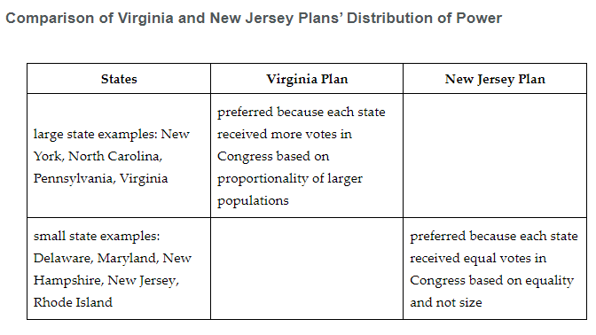

**Resolving the Constitutional Debate**

The representatives discarded the Articles of Confederation in favor of the U.S. Constitution. They created two compromises to resolve the debate over geographic distributions of power.

The Great Compromise resolved the debate between large and small states. It created a bicameral Congress. The House of Representatives would be based on a state’s population. The Senate would be based on state equality.

Also, amendment approval would be based on a majority vote.

The Three-fifths Compromise addressed the conflict over counting enslaved people. Under the compromise, enslaved people would be counted as three-fifths of a person. Enslaved people would not be counted as equal to a White person. But 60% of the southern states’ enslaved populations would count toward representative power in the House of Representatives.

**Objective 3:** Assess the impact of the Declaration of Independence on U.S. political thought at the time it was written, as well as how it impacted political thought over time.

**Big Ideas:** The Declaration of Independence has impacted U.S. political thought from the time of its first draft to now. The document’s exclusions and inclusions of people have shaped U.S. political thought and actions.

**The Declaration of Independence**

The Declaration of Independence states certain truths that are “self-evident.” Life, liberty, and happiness are among these truths for all men. The document goes on to say that people have to consent to be governed. It also says that when the government is not serving the people properly, the people have the right to dissolve the government as they no longer consent to be governed.

The Declaration of Independence is also the first formal document that shaped American political thought. Through this document, people in the American colonies, as well as in Europe, understood that Jefferson was talking about white, land-owning men. No other word but “men” is included in the text.

**Slavery and the Declaration of Independence**

In the first draft of the Declaration of Independence, Jefferson blamed King George III of England for supporting slavery and the slave trade in the colonies. Jefferson held enslaved people at this time. Some of the representatives to the Continental Congress were slaveholders too. When Jefferson presented the document to them, they argued against keeping this clause and demanded it be removed from the final draft. They didn’t believe that enslaved people had the same “self-evident” rights that white men had.

There were northern, non-slave-owning delegates at the Continental Congress too. Some of them did not want slavery to continue in the colonies. But they allowed the removal of the clause to keep the colonies united against the British.

Frederick Douglass, in a speech he made in 1852 regarding the meaning of the Fourth of July to an enslaved person, pointed out the hypocritical nature of the Declaration of Independence and of celebrating the 4th of July. He specifically argued,

...What, to the American slave, is your Fourth of July? I answer: a day that reveals to him, more than all other days in the year, the gross injustice and cruelty to which he is the constant victim. To him, your celebration is a sham; your boasted liberty, an unholy license; your national greatness, swelling vanity; your sounds of rejoicing are empty and heartless; your denunciations of tyrants, brass fronted impudence; your shouts of liberty and equality, hollow mockery; your prayers and hymns, your sermons and thanksgivings, with all your religious parade, and solemnity, are, to him, mere bombast, fraud, deception, impiety, and hypocrisy—a thin veil to cover up crimes which would disgrace a nation of savages. There is not a nation on the earth guilty of practices, more shocking and bloody, than are the people of these United States, at this very hour.

Frederick Douglass believed that the Founders did not write the Declaration of Independence for those who were enslaved. He believed that political thought disregarding enslaved people continued in the nation because of documents like the Declaration of Independence. He said that the Declaration of Independence does not apply to enslaved persons, and it allows the U.S. to ignore slavery.

**“Self-Evident” Truths Have Expanded Over Time**

Amendments have been added to the Constitution over time. In each example, the expansion of “self-evident” truths seem to include more people.

* The 13th Amendment ended slavery in the U.S.
* The 14th Amendment gave citizenship to former enslaved people.
* The 15th Amendment gave former enslaved men the right to vote. Each of these amendments secured more rights for Black Americans.
* The 19th Amendment gave women the right to vote.

Through the passage of several congressional acts, “self-evident” truths grew as well. First, in 1924, Indigenous Americans were granted citizenship through the Indian Citizenship Act. Then, in 1964, the Civil Rights Act was passed.

**Objective 4:** Cite examples from the Declaration of Independence, Articles of Confederation, and The Federalist Papers that illustrate the ideals of liberty and equality.

**Big Ideas:**

**The Declaration of Independence**

“We hold these truths to be self-evident, that all men are created equal, that they are endowed by their Creator with certain unalienable Rights, that among these are Life, Liberty and the pursuit of Happiness.”

With these words, Jefferson claimed that American colonists are equal to English subjects, that liberty is a right that should be allowed to the American colonists, and that they should be freed from English rule.

**The Articles of Confederation**

Once the Revolutionary War was won, the new states had to decide on a governing document. They wrote the Articles of Confederation, which gave the 13 states equal power.

Article IX states,

“...The United States in congress assembled shall have authority to appoint one of their number to preside, provided that no person be allowed to serve in the office of president more than one year in any term of three years...”

**The Federalist Papers**

During this time, there were two factions promoting and arguing the Constitution. The Federalists Papers supported the Constitution. The Anti-Federalists argued against the Constitution.

In Federalist Paper, No. 10, James Madison argued that factions are a result of liberty.

In Federalist Paper, No. 51, Madison wrote,

“In order to lay a due foundation for that separate and distinct exercise of the different powers of government, which to a certain extent is admitted on all hands to be essential to the preservation of liberty, it is evident that each department should have a will of its own.

**Keywords**:

* **salutary neglect –** the unofficial policy in the seventeenth century that allowed the American colonies to have their own form of government as long as they remained profitable and loyal to the British
* **social contract –** an agreement among members of a society to give up some individual freedoms to the government in exchange for the government protecting their natural rights
* **Three-fifths Compromise** – an agreement between the northern and southern states that three out of every five enslaved people would be counted to determine taxation and representation in the House of Representatives
* **Virginia Plan –** a proposal made during the Constitution Convention calling for a bicameral legislative branch with membership in both houses based on a state’s population
* **Great Compromise –** a compromise accepted during the Constitutional Convention that developed the framework for the U.S. Congress; also known as the Connecticut Compromise
* **Articles of Confederation (1777) –** the first governing document of the United States following the Declaration of Independence
* **Declaration of Independence (1776) –** the pronouncement by the American colonies formally declaring themselves independent of Great Britain

**Quick Check**

Question 1: Which of the following statements is the **best** analysis of the attitude of Great Britain toward the colonies at the end of the Seven Years’ War?

* The colonies should be allowed to govern themselves.
* The colonies should be able to renegotiate their social contract with the British government.
* The citizens of the colonies should be given natural rights.
* **The colonies should be required to help pay for part of their own defense.**

Question 2: Analyze the Articles of Confederation’s geographic distribution of power. Which state would prefer this distribution of power?

* Virginia
* **New Jersey**
* Pennsylvania
* New York

Question 3: What was a problem with the Articles of Confederation’s geographic distribution of power?

* **Each state regardless of size had the same power in Congress.**
* Changes to the Articles of Confederation could be made merely by a simple majority.
* The larger geographic states, such as Virginia, had more power
* Federal taxes were apportioned to each state based on their size.

Question 4: What assessment did Frederick Douglass give the Declaration of Independence?

* He said that the Declaration of Independence applies to Indigenous Americans.
* **He said the Declaration of Independence does not apply to enslaved persons, and it allows the U.S. to ignore slavery.**
* He said that the Declaration of Independence applies equally to women as to men.
* He said the Declaration of Independence applies to all men who live in the U.S.

Question 5: Cite the words in the Declaration of Independence that ensure the liberty and equality of all men.

* **“...that all men are created equal...and are...endowed with...liberty...”**
* “...The United States in congress assembled shall have authority to appoint one of their number to preside...”
* “...it is evident that each department should have a will of its own.”
* “they have full Power to levy War...establish Commerce, and to do... things which Independent States may of right do...

**Lesson 7 – Forming the Republic**

**Objective 1:** Identify and explain the strengths and weaknesses of the Articles of Confederation and why it failed as a governing document.

**Big Ideas**:

**Powers of Federal Government**

Under the Articles of Confederation, the states were unified loosely under a unicameral legislature. This new government was able to unify the 13 states and make some decisions that affected all the states, including the following:

* handle foreign issues, including declaring war, making peace, and signing treaties with other countries
* handle all Indigenous American affairs
* manage the postal service
* create coin money
* pass laws that affected all 13 states
* appoint military officers and foreign ambassadors

**Limits on Federal Powers**

The Articles of Confederation caused many weaknesses in the government. These outweighed the strengths of its powers.

* The federal government could not collect taxes. There was never enough money.
* The federal government had limited ability to enforce laws.
* Laws required approval of 9 of the 13 states, which proved to be difficult.
* Amendments required all 13 states to agree, which was difficult to accomplish.
* There was no power to regulate foreign trade with the states or trade between the states.
* There was no judicial branch to handle disputes.
* There was no executive branch to enforce laws or coordinate the work of government.

The federal government was not working under the Articles of Confederation. Leaders decided to meet in Philadelphia to revise the Articles and strengthen the federal government. They ended up restructuring the government into the system we have today under the U.S. Constitution.

**Objective 2:** Analyze the degree to which the Articles of Confederation and the U.S. Constitution reflect the ideals of the Declaration of Independence.

**Big Ideas:**

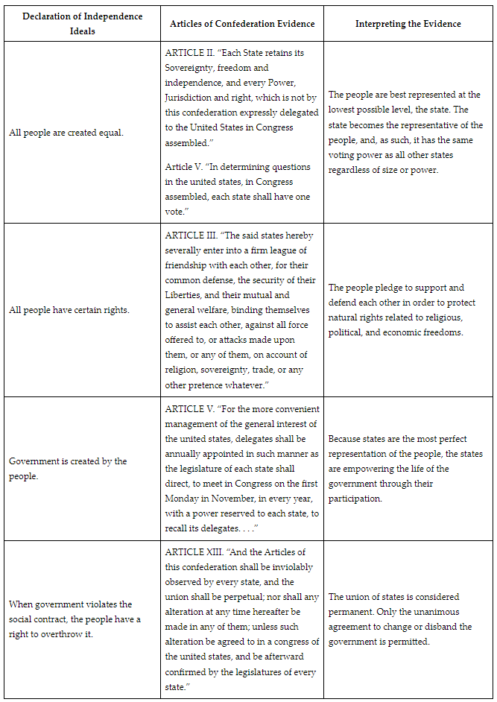

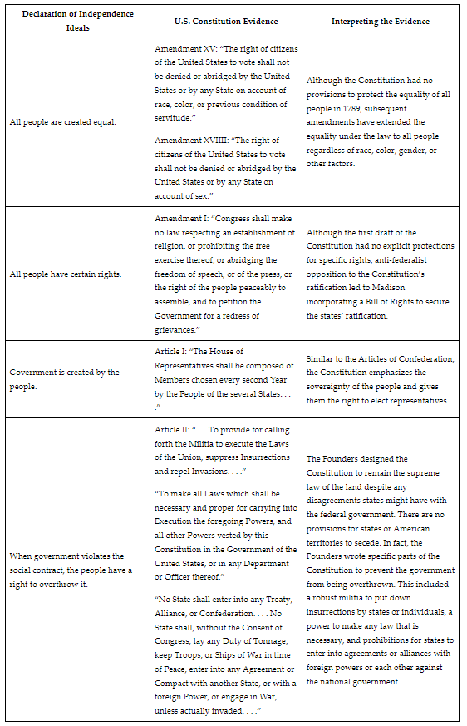

**Objective 3:** Analyze the effects of different perspectives of individuals and groups in the foundational years of the republic that led to the formation of different political factions.

**Big Ideas:**

Two different political perspectives emerged in the early years of the republic. The first was the Federalist Party led by Alexander Hamilton. The second was the Republican Party led by Thomas Jefferson. Each viewed human nature, the economy, foreign relations, and government in different ways.

**Perspectives on Human Nature**

Hamilton and the Federalists had a negative view of human nature. They thought people were selfish and short-sighted. Federalists thought a better government would be guided by enlightened leaders who would guide the masses with wisdom.

Jefferson and the Republicans held a positive view of human nature. Jefferson believed that people would make the right choices for their country if they were informed.

**Perspectives on the Economy**

Hamilton and the Federalists believed a strong national economy should look like Great Britain’s. This included businesses, trade, factories, and a strong national bank.

Republicans saw the national economy’s strength in the average farmer.

**Perspectives on Foreign Relations**

Hamilton respected the power of Great Britain. He believed America would be stronger if it allied with them. Hamilton distrusted France because of the chaos of the French Revolution.

Jefferson and the Republicans considered France to be a kindred nation seeking the enlargement and protection of citizens’ rights. Jefferson also viewed Great Britain’s emphasis on banking, manufacturing, and trade as problematic to personal freedoms.

**Perspectives on the Role of Government**

Federalists emphasized the role of elites guiding the masses. They believed the national government would have to be stronger than the state governments. They felt state governments would seek to maximize their self-interest, just like people. Thus, a strong national government could rein in the unruly states and maintain order. The Federalists advocated for a strong national military and a national banking system.

Jefferson and the Republicans believed a strong national government would threaten citizens’ rights. Republicans trusted and relied on the power of the common person to make the decisions for government.

Jefferson advocated for strong state governments to keep the power of the national government in balance.

**Objective 4:** Analyze the relationship between people and government in establishing a government whose focus is to act in the best interest of the people.

**Big Ideas:**

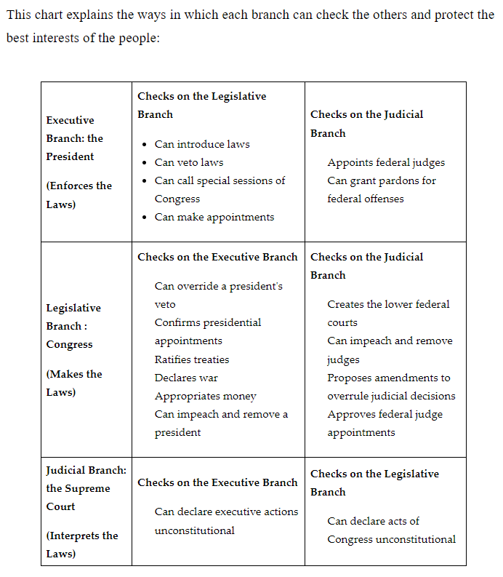

**Keywords**:

* **Articles of Confederation (AOC) –** the first constitution of the United States
* **Continental Congress –** a group of representatives who worked together to lead the 13 colonies through the revolutionary period in the 1770s
* **loose constructionism –** the legal interpretation of the U.S. Constitution that goes beyond the text and allows for a broader definition of the Framers’ intent
* **strict constructionism –** the legal interpretation of the U.S. Constitution that uses the text only to determine the Framers’ intent
* **checks and balances –** a constitutional principle that allows each branch of the government to check one another to prevent any one branch from becoming too powerful

**Quick Check**

Question 1: Identify the reason for the failure of the Articles of Confederation.

* It had a Bill of Rights.
* The government had the power to declare war.
* The leaders could not get the states to send delegates to the Continental Congress.
* **The government could not enforce the laws on the individual states.**

Question 2: Analyze the following principle of the Articles of Confederation: “Delegates to the Congress are appointed by the state legislatures who also have the power to recall those delegates.” What Declaration of Independence ideal does this reflect?

* **Governments are created by the people.**
* All people are created equal.
* All people have certain rights.
* When government violates the social contract, the people have a right to overthrow it.

Question 3: Analyze the perspective of Alexander Hamilton and the Federalists. What would be a policy aligned with their perspective?

* a weak national bank
* an economy based on farming
* **a strong national bank**
* a strong voice of the people in government

Question 4: What statement **best** analyzes the relationship between the people and the government?

* The government exists because the people elect the leaders, which gives them control.
* **The citizens hold their government accountable by voting, which encourages the government to serve the interests of the people.**
* The government exists to rule over the people, which creates a civil society.
* The government exists because the founding fathers created it, which helps the people stay organized.

Question 5: How does the division of powers in the government help the branches to focus on the best interests of the people?

* **No one branch has all the power, which keeps the people’s rights intact.**
* It gives the people more opportunity to interact with the government.
* All branches work on the same tasks to ensure the people’s rights are protected.
* The branches are able to focus on specific tasks that are aligned to the rights of the people.

**Lesson 8 – Key Ideas in the Constitution**

**Objective 1:** Analyze key points of the different parts of the U.S. Constitution, as emphasized by text structure, and how in the Constitution the Continental Congress addresses the goals written in the Preamble.

**Big Ideas**:

The Preamble Sets the Purpose of the Document

This is the Preamble to the U.S. Constitution:

We the People of the United States, in Order to form a more perfect Union, establish Justice, insure domestic tranquility, provide for the common defense, promote the general Welfare, and secure the Blessings of Liberty to ourselves and our Posterity, do ordain and establish this Constitution for the United States of America.

The Preamble lists things the Framers felt the Constitution must do to make a more perfect union. The rest of the U.S. Constitution explains how the new government of the U.S. will achieve these specific goals.

The Preamble sets forth the idea of establishing justice in this new country.

The Preamble declares that the U.S. Constitution should ensure domestic tranquility. The Preamble sets out the goal that this new country will strive for a peaceful existence on its soil.

The Preamble also asserts that providing for a common defense is an key. The Framers clearly delineated this because of controversy about how soldiers would get paid under the Articles of Confederation.

Promoting the general welfare is another key reason that the U.S. Constitution was written. General welfare is a broad concept that depends on the federal government assisting all Americans to live a better life. This goal is addressed in many articles in the body of the document as well as in the Bill of Rights.

Finally, the Preamble states that this Constitution should secure the blessings of liberty. The Framers wanted to broadly clarify that individuals and states would still have rights under this national government.

**The Seven Articles Create the Structure and Processes of the U.S. Government**

The second section contains seven articles. Each article sets up the structure of the government and the process for making changes to the Constitution.

Article I describes the legislative branch. This article sets up the roles and terms of Congress and the House of Representatives. It also sets up the powers of those within this branch. It also discusses powers that are expressly denied to Congress and expressly denied to the states.

Article II creates the executive branch. It gives the qualifications for and the election process of the president. It clarifies the role of president and the powers held.

Article III established the judicial branch of government. It sets up the Supreme Court and the federal system. It sets the rules for what will be heard in a federal court.

Article lV establishes the power of state governments. It discusses the relationships between states and the federal government.

Article V explains the amendment process.

Article VI sets the Constitution as the supreme law of the land.

Article VII explains the ratification process. Nine of the thirteen states’ conventions were required to vote to ratify the Constitution for it to become law.

**The Amendments Allow for Changes to Be Made**

The first 10 amendments to the U.S. Constitution are the Bill of Rights. These set forth the individual rights of the people. The Bill of Rights was passed with the ratification of the Constitution to ensure the blessings of liberty.

A total of 27 amendments have been added to the Constitution since its ratification.

**Objective 2:** Analyze the reasons our government relies on a system of checks and balances.

**Big Ideas:**

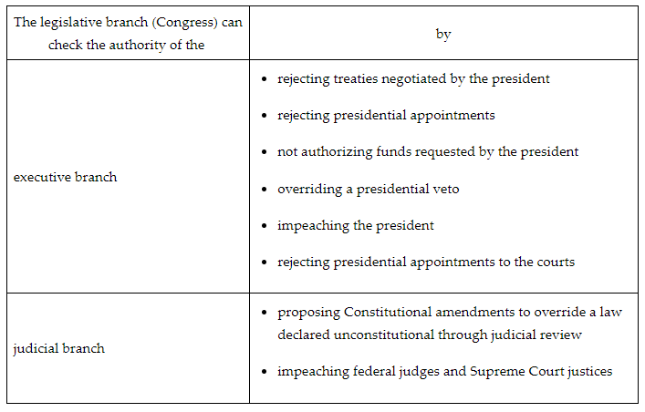

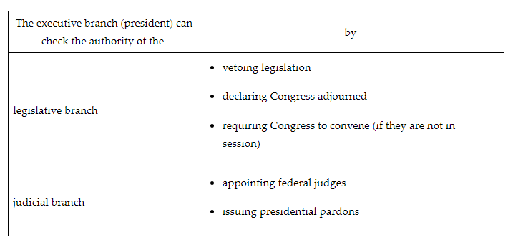

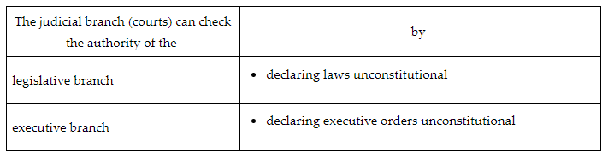

Advantages and Disadvantages of Checks and Balances

The ability of each branch to check the others can slow the act of governing. In addition, our federal system relies on collaboration and compromise to get business done. Party loyalty and political polarization often cause gridlock, leaving the needs of the American people unmet. It is also possible for one branch to abuse its power over the other branches. For example, Congress may choose to impeach a president when there is little supporting evidence.

Our system of checks and balances has ensured power is limited. It does this by blocking one person or one branch from abusing power. Each branch must rely on the others to accomplish their goals to serve the needs of the nation. The system of checks and balances allows one branch to push back against another. The separation of powers has assigned responsibilities and duties best suited to each specific branch so that it may concentrate on its unique role in governing for the American people.

**Objective 3:** Describe federalism and how the U.S. system of federalism has been affected by the supremacy clause.

**Big Ideas:** Federalism divides government power between the national and state governments.

The Constitution gives the national government delegated powers. The 10th Amendment leaves reserved powers to the states. Powers that can be exercised by both the national and state governments are concurrent powers.

In our system of federalism, sometimes there are conflicts between the national and state governments. If both levels of government believe they have the constitutional power to regulate an aspect of public policy, often the Supreme Court is required to resolve this type of dispute.

In most cases, if the national and state governments both have valid constitutional authority, the Supreme Court will rule in favor of the national government. This is due to the supremacy clause. This constitutional clause states that the Constitution and laws of the national government are superior to state constitutions and state laws.

The Supreme Court has ruled that when the national and state governments are using valid constitutional powers, the national government’s actions are superior to state government actions. The supremacy clause has gradually given the national government increasing power over the states.

**Objective 4:** Explain how the U.S. Constitution addressed the weaknesses of the Articles of Confederation in relation to trade, monetary policy, and taxation.

**Big Ideas:**

**Trade**

The Articles of Confederation gave no power to Congress to regulate trade between the states or with foreign nations. Congress asked states to give them power over trade, but the states refused. The states were fearful of giving Congress too much power. This lack of authority in commerce led to inequalities in trade and left them unprotected.

The Constitution gave Congress the authority to regulate trade among the states and foreign nations. This created a uniform system that created equity and organization.

**Policy**

Each state had the ability to print their own currency. With different currencies in the states, there were issues that arose. The Framers found that this was not a sustainable system.

Under the Constitution, Congress is given the sole power to coin and print money in the U.S.. The U.S. was able to use a single form of currency that was coined and regulated by Congress. This uniform currency allowed for all states to utilize the same currency. It also eliminated the issue of devaluation, as Congress could regulate the amount of money printed.

**Taxation**

Congress was not given the authority to levy taxes under the Articles of Confederation. The Framers had hoped to avoid taxation without representation by requiring Congress to ask for money from the states. The states were under no obligation to comply or pay. The government needed taxes to pay off debts from the Revolution, fund military efforts, and provide other services. The new nation found that there were no funds available.

The only solution to the lack of taxation came with the Constitution. Congress was given the power to levy taxes. Taxes were used to repay war debts as well as generate the money needed for military efforts. Services that needed in the new nation could also be funded with taxes. Congress was not required to ask the states for money, but it could tax individuals directly through the new powers written in the Constitution.

The failures of the Articles of Confederation were addressed when the Framers of the Constitution allowed for a stronger central government. The addition of the judicial and executive branches allowed for checks and balances. This combatted the fear of any one branch being more powerful than the others. Congress now had authority and contributed to a more powerful system of government that had the authority to tax, raise and support an army, regulate interstate and international commerce, and develop a uniform monetary system.

**Keywords**:

* **domestic –** relating to or existing inside a particular country
* **Preamble –** the introduction to the Constitution that explains the purpose of the document
* **political gridlock –** a stalemate that occurs when the government is unable to act or pass laws because rival parties control different branches of government and are unable to compromise
* **checks and balances –** a system in which one institution of government can check or counteract another institution
* **commerce clause –** a clause in the Constitution that gives Congress the power to regulate interstate and foreign trade
* **concurrent powers –** the powers that are shared by the national and state governments
* **delegated powers –** the powers given to the national government by the Constitution
* **commerce clause –** a clause in the Constitution that gives Congress the power to regulate interstate and foreign trade

**Quick Check**

Question 1: Analyze why Article III achieves the goal in the Preamble of establishing justice.

* Article III establishes the role of the president.
* Article III establishes the time and manner of elections.
* **Article III establishes the judicial branch of government.**
* Article III establishes the process of impeachment.

Question 2: Use the table to answer the question. Analyze the table. Which of the following is an example of the legislative branch checking the power of the executive branch?

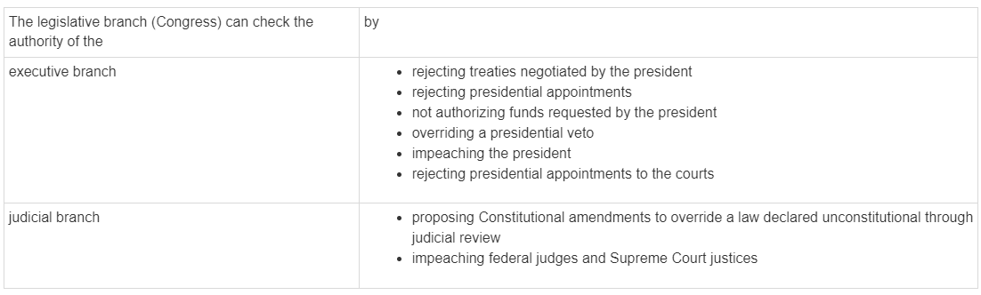

* Congress impeaches a federal judge.
* Congress issues pardons to convicted felons.
* **Congress overrides a presidential veto of a bill passed by Congress.**
* Congress refuses to abide by a Supreme Court decision.

Question 3: Which of the following describes the concept of federalism?

* Federalism describes the requirement to desegregate schools.
* Federalism divides the powers between Congress and the Senate.
* Federalism describes the requirement for the separation of church and state.
* **Federalism divides government power between national and state governments.**

Question 4: Which explains the monetary policy weakness in the Articles of Confederation?

* **The states had the authority to create and print their own currency.**
* The states were required to use the same currency.
* The states were given options of what currency they could use.
* The states were given options of what currency they could use.

Question 5: How did the commerce clause of the Constitution address the weaknesses created by the Articles of Confederation in trade?

* It gave Congress the authority to regulate trade only among the states.
* **It gave Congress the authority to regulate trade among the states and foreign nations.**
* It gave Congress the authority to regulate trade only among foreign nations.
* It gave Congress little authority to regulate trade among the states and foreign nations.

**Lesson 9 – Foundational Economic Thought**

**Objective 1:** Critique the impact of capitalism on the U.S. political system and political thought.

**Big Ideas**:

The economy is a major factor that affects how people vote. This directly impacts political policy.

The government and political policy impact the economy by providing a legal framework, maintaining competition, providing public goods and services, and stabilizing the economy. They do this with the best interest of the people in mind. The economy in turn can impact political thought and policies. This can take the form of changes to tax policy, changes in government spending, and maintaining competition in the market. Politics and economy go hand in hand and often influence each other.

Politics have allowed for free trade with capitalism. But they have stepped in from time to time to regulate aspects of the economy or provide relief to boost the economy. Limited government influences on regulation as opposed to total control has allowed the U.S. to maintain the system of a capitalist free market economy, where freedom of choice and rights for businesses reigns. The creation of regulatory legislation to keep up with technology that is being introduced can be seen as overstepping the government in a free market economy.

The Industrial Revolution impacted politics as it led to the rise of the U.S. as a global economic power. Legislation was passed for labor regulation. Political theories were changed due to the increase in economic and social power. Government policies were changed to help regulate trade. High tariffs were implemented for foreign trade to discourage competition for U.S. markets.

The economic geography change in the U.S. during the nineteenth century was caused by the railroad expansion. People flocked to the U.S., and cities flourished. A massive increase of people and goods was seen across the country. There was a conflict in politics regarding traditional culture and modern progress.

In 1929, the U.S. experienced the most severe economic crisis in its history. The stock market crashed, sending the country into a Great Depression. Unemployment was at an all-time high and people could not afford everyday items.

After the Great Depression, the New Deal, introduced by President Franklin D. Roosevelt, worked to revitalize the U.S. economy. This legislation was a method of political policy used to influence the economy. The federally funded infrastructure and improvement projects were meant to create jobs and profits for businesses. Many of the programs introduced with the New Deal in the 1930s are still in operation today.

**Objective 2:** Explore how the tax base contributes to maintaining the public good.

**Big Ideas:** Tax revenue is spent to improve the lives of everyone by supporting and maintaining public welfare, infrastructure, and fund public services, such as schools and emergency services.

Local and state governments spend tax revenue funds on good and services. These are put in place to help maintain the public good.

Public education receives approximately one quarter of tax revenue. Those funds are used to pay for elementary and secondary public schools, as well as public universities and colleges.

Another quarter of spending goes toward public welfare programs like Medicaid, Temporary Assistance for Needy Families, and Supplemental Security Income payments. Public welfare spending would also supplement health departments, hospitals, and other health care facilities or programs.

Money is spent to fund the government when electing leaders and employing government workers. Other public service programs include water and sewage, criminal justice, fire protection, and natural resources. Additionally, public parks, buildings such as public libraries, museums and community centers are funded for societal use and accessibility.

**Objective 3:** Predict how society would be different if the public good was left up to the private sector.

**Big Ideas:** One idea for making public good funding fairer is to make them private goods. This would entail making them rivalrous and excludable.

Just as in the case of other private goods, goods with higher quality will be scarcer and thus cost more money. In the case of education, a lower-income household will pay for an education at the lower level of quality. As a result, education might develop into tiers of quality based on price.

Another example would be public safety. Making public safety a private good would once again potentially create tiers of quality for public safety. More affluent neighborhoods in a city or state would have better roads. Less affluent neighborhoods would have poorer-quality roads and worse public safety.

**Objective 4:** Draw a timeline detailing government involvement in the economy throughout U.S. history.

**Big Ideas:**

|  |  |  |
| --- | --- | --- |
| **Dates** | **Era** | **Notes** |
| 1789-1870 | Laissez-faire Era | * Laissez-faire is an economic doctrine in which the government does not generally interfere with the economy. Exceptions to this included protecting and expanding interstate commerce and removing state barriers to trade. * America was seeking to establish its economic power. By protecting interstate commerce, America was stronger than Europe. * America witnessed the expansion of the middle class. The middle class balanced the interests of the rich and the very poor, preventing the emergence of radical economic ideas. |
| 1870-1932 | Progressive Era | * After the Civil War America witnessed the rapid expansion of powerful concentrations of wealth in a small number of people. Commonly referred to as robber-barons, these people sought to eliminate competition through monopolies and trusts. * The American government expanded economic involvement. They did this by establishing laws to prevent monopolies and to protect the consumer and the environment. * Important laws, such as the Interstate Commerce Act (1887) and the Sherman Antitrust Act (1890), prevented the establishment of unfair economic practices by large companies. * The government set up regulatory agencies. Agencies like the Food and Drug Administration (FDA) and the Federal Trade Commission (FTC), to assist in this government oversight. |
| 1932-1946 | New Deal Era | * The Great Depression created an economic national emergency. * In response to this emergency, President Franklin D. Roosevelt and Congress passed a series of laws called New Deal legislation. * These laws expanded government involvement in the economy in the areas of banking and social welfare. * The president and Congress created the Federal Deposit Insurance Corporation (FDIC). To create a social safety net, the president and Congress passed the Social Security Act, the National Labor Relations Act (NLRA), and the Works Progress Administration. |
| 1946-Present | Post-World War ll Era | * After WWll, America increased its defense spending instead of decreasing it as it had done previously after wars. * The government sought to expand the social net of the New Deal to people of color, women, and the elderly. * Under the economic programs of the Great Society, President Lyndon Johnson and Congress created laws, like the Equal Pay Act of 1963 and the Age Discrimination in Employment Act (1967). The Great Society programs included the Food Stamp Act (1964) and Medicaid and Medicare in 1965. * Government involvement in the economy after WWII is one of several actions that contributed in going from an annual budget surplus in 1930 changing to a budget deficit in 2022. |

**Keywords**:

* **capitalism –** a system of social organization where there is a free market with a limited role of government
* **Great Depression –** a period of severe economic downturn beginning in 1929 and lasting through the 1930s, leading to high levels of unemployment and poverty in America and the world
* **Industrial Revolution** – the period marked by transition from an agrarian economy to one based in manufacturing
* **gross pay –** the amount employees earn before taxes, benefits, and other payroll deductions are withheld from their wages
* **nonexcludable –** the goods that society ensures are accessible to everyone
* **free-rider problem –** the cost of public goods that is distributed throughout society in the form of taxation but isn’t paid equally by everyone who uses these resources
* **guns versus butter –** the economic tension resulting from competing demands of creating a strong national defense or addressing domestic needs
* **laissez-faire economy –** an economy in which government does not interfere

**Quick Check**

Question 1: What answer **best** critiques the relationship between the economy and politics with the influence of technology in the U.S.?

* **The creation of regulatory legislation to keep up with technology that is being introduced can be seen as overstepping the government in a free market economy.**
* The elimination of technological advances to certain business industries for fair trade can be considered a conflict of interest by political officials.
* The rejection of any new technologies that might interfere with the stability of the economy can be considered unwanted government interference in the market economy.
* The addition of assistance to businesses that need additional support with technology can be seen as unfair in a free market economy, which should be void of government interference.

Question 2: What was the cause of the economic geography change in the U.S. during the nineteenth century?

* the demand for more cotton
* the increased population
* the end of the Civil War
* **the expansion of the railroads**

Question 3: Which of the following statements **best** explores the connection between property taxes and local government spending?

* Most property taxes are collected at the national level and spent at the local level.
* Most property taxes are collected at the local level and spent at the national level.
* Most local governments rely on income tax, not property tax, for revenue.
* **Most local government spending is funded by property taxes.**

Question 4: Which statement **best** predicts the likely outcome of privatizing the public good of policing?

* Crime would decrease in an area as a whole, not just in specific neighborhoods.
* **An area’s more affluent neighborhoods would be better protected.**
* All people regardless of which neighborhood they live in would have access to the same level of protection.
* Crime would be equally distributed throughout all neighborhoods of a city, county, or state.

Question 5: Use the timeline to answer the question.



In drawing the timeline of government involvement in the American economy, which era is the correct label for the first part?

* **Laissez-Faire Era**
* New Deal Era
* Progressive Era
* Post-World War II Era

**Lesson 10 – Three-fifths Compromise Portfolio**

**Lesson 11 – Bill of Rights**

**Objective 1:** Compare and contrast the Declaration of Independence with the Bill of Rights to identify the similarities and differences between the two documents.

**Big Ideas**: Thomas Jefferson wrote the Declaration of Independence in 1776 to address the English government’s abuses of the social contract and of the American colonists’ natural rights. The adoption of the Bill of Rights later in 1791 reflected a similar concern about natural rights, but went further to establish a governmental framework to protect these rights.

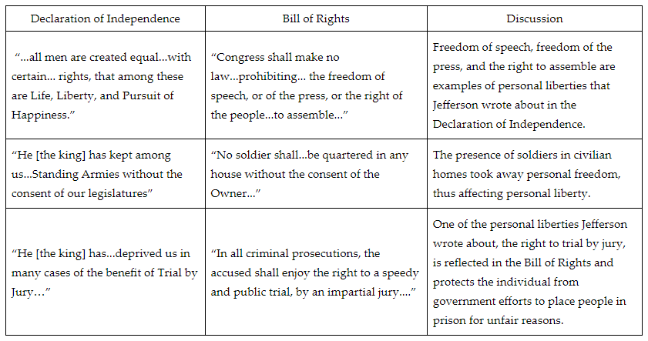

The Bill of Rights differed from the Declaration of Independence in two major ways. First, the Bill of Rights helped establish a framework for the new American government. The Bill of Rights not only protected personal liberties, but it also divided power between the national government and the state governments.

Second, the Bill of Rights supported the legitimacy of the new American government. James Madison wrote the Bill of Rights after publishing the United States Constitution in response to critics who argued that the Constitution gave the national government too much power.

**Objective 2:** Summarize the rights of each amendment in the U.S. Bill of Rights and how they apply to current issues.

**Big Ideas:**

The Bill of Rights emphasizes protection of individual rights that the king had denied American colonists, but it also provides a framework for government.

Below is a list of the first 10 amendments.

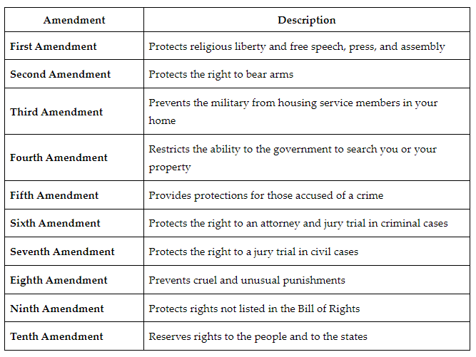

Society must balance the personal rights of individuals with public safety.

In the case of the First Amendment, unlimited free speech might lead to inciting a crowd and possible injury or property damage. Additionally, free speech may involve social media and symbolic speech. Although students using social media may say or write words or use symbols that inflame emotions among other students, the U.S. Supreme Court has decided that schools cannot restrict student speech.

Similarly, society has sought to balance the personal freedom of firearm ownership with public safety. Recent Supreme Court cases involving New York City and Chicago focused on the disproportionate restrictions people of color have experienced involving private firearm ownership.

Fearing another catastrophic terrorist attack after September 11, 2001, President George Bush authorized the use of enhanced interrogation techniques to enable the American military to prevent possible further terrorist attacks. Critics argued that these interrogation techniques were torture and violated the Eighth Amendment. In a recent announcement, the Supreme Court decided to hear evidence on whether the details of a suspected terrorist’s interrogation will be made public and available for potential trials.

The tension over the distribution of power among the national government, state governments, and individuals is reflected in recent court cases involving the Ninth and Tenth Amendments. The Constitution does not enumerate such things as marriage licensing and voter registration for a specific level of government. Therefore, they remain reserved powers. Reserved powers are powers assigned for the states exclusively. Despite the fact these remain the purview of state decision-making, both individuals and the federal government have brought lawsuits alleging that restrictions on marriage and voter registration constitute violations of civil rights.

**Objective 3:** Explain how the Bill of Rights limits the government’s ability to pass laws or act on criminal activity.

**Big Ideas:** The Bill of Rights restricts the government’s power to pass laws affecting personal freedoms. It also restricts the government’s power to act when someone is accused of a crime.

* The Fourth Amendment protects people from unreasonable searches.
* The Fifth Amendment protects people accused of a crime by requiring a grand jury, prohibiting trials for the same crime twice, preventing self-incrimination, and prohibiting the taking of private property without compensation.
* The Sixth Amendment protects people accused of a crime by requiring a speedy and public trial, requiring an impartial jury, identifying the specific crime committed, making witness testimony public, and providing a lawyer for the accused.

Like the restrictions on governmental lawmaking, the Supreme Court cases are another source of information for illustrating how the Bill of Rights limits governmental actions. The Supreme Court has supported the rights of the accused over the government’s power to take action. For example, in *Miranda v. Arizona*, the U.S. Supreme Court ruled that suspects must be advised of their right to remain silent and their right to an attorney. This decision limited the government’s restrictions on a defendant’s access to a lawyer.

**Objective 4:** Examine why the addition of the Bill of Rights was necessary for the ratification of the U.S. Constitution.

**Big Ideas:** When the Philadelphia Convention submitted its final product for ratification, two sides emerged surrounding the ratification of the Constitution. They were known as the Federalists and the Anti-Federalists.

The Federalists supported the ratification of the Constitution, but were not in favor or including a bill of rights.

The Anti-Federalists were opposed to the ratification of the Constitution. They were far more trusting of state governments. Among the Anti-Federalists' many objections was the lack of a bill of rights that would protect the rights and liberties of the people.

**Using the Bill of Rights as a Political Bargaining Chip**

The Federalists offered the concession that should the Constitution be ratified, a bill of rights would be drafted and submitted for ratification. James Madison was the chief architect of what would become the Bill of Rights. Twelve amendments were submitted to the states in 1789. Ten of those twelve were approved in 1791 and became the Bill of Rights.

It should be noted that the Bill of Rights originally only restricted the national government. It would take more than 100 years for parts of the Bill of Rights to be made applicable to the states. Even today, there are a few parts of the Bill of Rights that do not apply to the states. However, states are covered by their own bills of rights in their state constitutions.

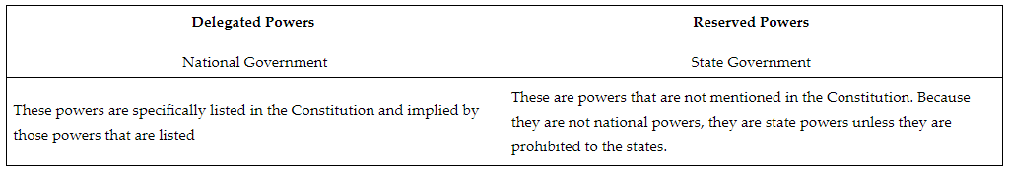

**Keywords**:

* **natural rights** – rights that are not dependent on the laws of government and are inalienable
* **social contract** – an agreement among members of a society to give up some individual freedoms to the government in exchange for the government’s protection of their natural rights
* **Miranda warning** – the rights notification given by police that came from a U.S. Supreme Court case that ruled that suspects must be advised of their right to remain silent and their right to an attorney
* **reserved powers –** the powers reserved for the states exclusively
* **U.S. Bill of Rights** – the first 10 amendments of the Constitution which limit the power that the U.S. government has over the U.S. people
* **U.S. Constitution** – the framework of American government complete with rights, powers, and responsibilities of the individual and of the state and national levels of government
* **Supreme Court** – the highest court in the federal court system that determines if laws and executive actions are constitutional when they are challenged
* **amendment** – a change or addition to the Constitution

**Quick Check**

Question 1: Which statement **best** compares and contrasts the Bill of Rights with the Declaration of Independence?

* The Bill of Rights and the Declaration of Independence both sought to establish fair and even divisions of power within government.
* **The Bill of Rights emphasizes protection of individual rights that the king had denied American colonists, but it also provides a framework for government.**
* The Bill of Rights emphasizes the freedom of religion because the king had denied colonists the right to worship freely.
* The Bill of Rights emphasizes the rights of those accused of crimes because the king often jailed political enemies without a trial.

Question 2: Summarize the rights contained in the First Amendment.

* The part of the Bill of Rights that protects the individual’s right to a jury trial in civil matters.
* **the part of the Bill of Rights that protects religious liberty and freedom of expression such as speech.**
* The part of the Bill of Rights that protects privacy and property by prohibiting the placement of soldiers in private homes.
* The part of the Bill of Rights that protects people from unreasonable searches.

Question 3: Summarize the rights contained in the Sixth Amendment.

* The part of the Bill of Rights that protects people accused of a crime by requiring a grand jury, prohibiting trials for the same crime twice, preventing self-incrimination, and prohibiting the taking of private property without compensation.
* The part of the Bill of Rights that protects religious liberty and freedom of expression such as speech .
* **The part of the Bill of Rights that protects people accused of a crime by requiring a speedy and public trial, requiring an impartial jury, identifying the specific crime committed, making witness testimony public, and providing a lawyer for the accused.**
* The part of the Bill of Rights that protects the individual and state rights to own weapons for the purpose of creating militias.

Question 4: Explain how the First Amendment limits the power of the government to pass laws.

* **Congress can pass no law respecting or restricting religion, or laws limiting freedoms of speech, assembly, the press, or to petition the government.**
* Congress can pass no law infringing the people’s right to own firearms for the purpose of creating a militia.
* Congress can pass no law creating unreasonable searches.
* Congress can pass no law permitting the taking of private property without compensation.

Question 5: Which of the following is an accurate discussion of why a bill of rights for the national government might not be necessary?

* A lengthy list of rights were already protected by each state.
* A lengthy list of rights were already protected by the Constitution.
* The national government has only reserved powers.
* **The national government has only delegated powers.**

**Lesson 12 - Amendments**

**Objective 1:** Explain how the First Amendment protects freedom of expression, including free speech, a free press, the right to peaceful assembly, and the right to petition the government.

**Big Ideas**: Many would agree that the First Amendment contains some of the most important protections for individual liberty in the U.S., including religious liberty and the right to express your opinions.

Freedom of expression is divided into several components: individual speech, the press, peaceful assembly, and petition to the government. Generally speaking, the U.S. Supreme Court is incredibly skeptical of restrictions on expression, believing that a healthy political system is dependent on the expression and exchange of a wide range of viewpoints.

As a general rule, the First Amendment allows people to say anything they wish. However, like all the rights and liberties specified in the Bill of Rights, the right to free speech is not absolute. Most forms of expression are acceptable as long as they do not encourage violence.

**Expression: Press**

Like the way the First Amendment protects a person's right to say virtually anything, the First Amendment also protects the right of people to publish virtually anything they wish. As with free speech, there are a few limits on free press. These limits are similar to the limits on free speech: no protection exists for sedition or obscenity; regulation of commercial publications is allowed; and the press is prohibited from presenting a clear and present danger.

**Prior Restraint**

Prior restraint is a form of censorship where the government prohibits the publication of things that it finds objectionable. For example, the government would have to allow the publication of an article that is critical of involvement in war. As a rule, prior restraint is not permitted. There is a small exception for national security or obscenity.

**Expression: Assembly**

Also protected by the First Amendment is the right to peaceably assemble. The most common limits on the right to assemble are "time, place, and manner" restrictions, as ruled by the Supreme Court in Cox v. New Hampshire. For example, a city might allow demonstrations in a city park during daylight hours but prohibit them during the night. Also, it may generally allow parades but prohibit them on major roads during rush hour. Governments can require permits for parades and demonstrations in public parks. It should be noted that these restrictions must be content or viewpoint neutral.

**Expression: Petition**

The First Amendment states that you have the right "to petition the Government for a redress of grievances." The right to petition is your right to communicate your preferences to governmental officials without fear of retaliation. It also allows for citizens to voice their concerns about current policy with which they may disagree.

**Objective 2:** Consider the powers of the national and state governments and explain the function of the Tenth Amendment.

**Big Ideas:**

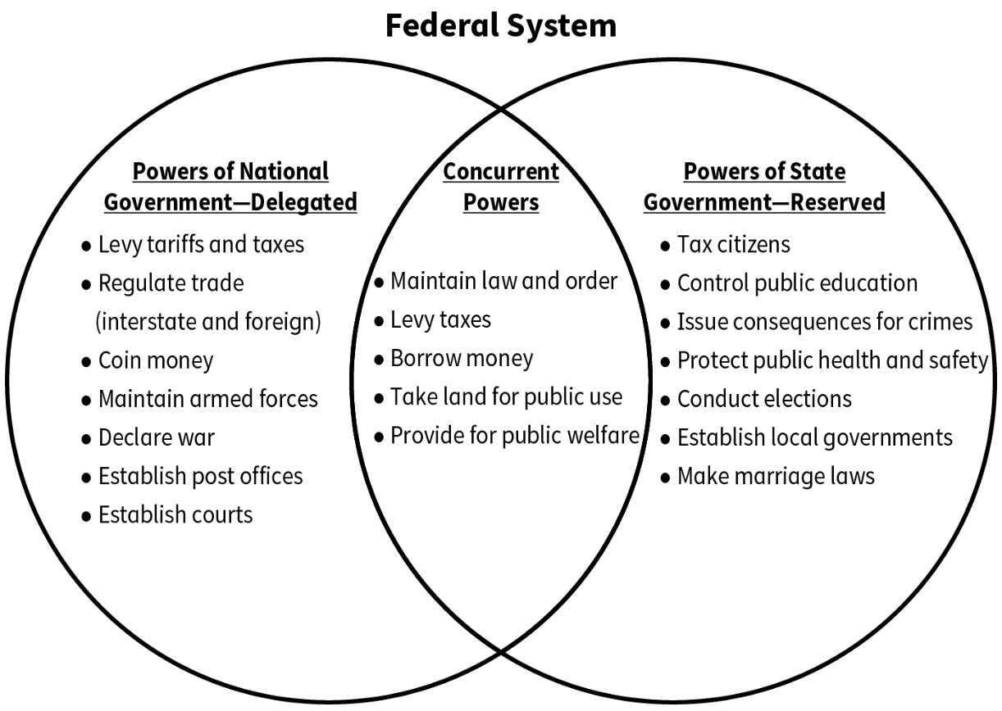

The Tenth Amendment was added to the Constitution to protect the reserved powers of the states. It states:

"The powers not delegated to the United States by the Constitution, nor prohibited by it to the States, are reserved to the States respectively, or to the people."

The Tenth Amendment helps to ensure that the division of power between the national government and the states that was set forth in the original text of the Constitution remains intact. It acts primarily as a reminder of the constitutional division of power between the national government and the states. If the national government exceeds its authority, it is not only violating the Tenth Amendment but the original text of the Constitution. The overwhelming bulk of decisions made by the Supreme Court that might seem to be based on the Tenth Amendment are based on the original text of the Constitution.

**Objective 3:** Assess how the power of the national government has increased by looking at the Eleventh through Twenty-Seventh Amendments to the Constitution.

**Big Ideas:**

The Fourteenth Amendment is one of the two constitutional amendments that have increased the power of the national government.

Section 1 of the Fourteenth Amendment contains two clauses that have increased the power of the national government over the states in the area of civil liberties and civil rights. Civil liberties deal with restrictions on arbitrary and capricious governmental action. Civil rights refer to the requirement for equal treatment of groups in society.

The Supreme Court has interpreted this clause to allow for selective incorporation. Selective incorporation is the process by which parts of the Bill of Rights have been applied to the states.

Originally, the Bill of Rights only restricted the national government. Each state had its own bill of rights that restricted state actions. Consequently, the degree to which civil liberties (such as free speech) were protected varied by state. With selective incorporation, the national government—through the decisions of the Supreme Court—can establish minimum standards for civil liberties with which all states must comply.

The Sixteenth Amendment is another amendment that has increased the power of the national government.

Originally, the national government derived most of its income from the sale of public lands and the tariff, which is a tax on imports. These sources provided limited income, which was sufficient for the limited functions of the national government at the time. The Sixteenth Amendment gave the national government an additional source of funding.

**Keywords**:

* **commercial speech** – a form of expression that relates to business activities
* **defamation** – a form of expression that damages someone's reputation
* **fighting words –** a form of expression intended to provoke violence from another person
* **hate speech –** a form of expression that displays disdain for a particular group based on race, gender, gender expression, sexual orientation, or some other characteristic
* **libel –** a form of defamation that is in print, such as in a book, newspaper, or on a website
* **obscenity –** a form of expression that is sexual in nature and considered by most individuals to be lewd or inappropriate
* **petition** – a form of expression that involves communicating preferences to government officials
* **prior restraint –** a form of censorship where the government prohibits the publication of things that it finds objectionable
* **sedition** – a form of expression that encourages the violent overthrow of a government
* **slander –** a form of defamation that is spoken, such as gossip or spreading rumors
* **symbolic speech –** a form of expression that uses symbols to communicate instead of words
* **concurrent powers** – the powers that are shared by the states and the national government
* **delegated powers** – the powers that are assigned to the national government of the United States
* **expressed powers –** the powers that are assigned to the national government of the United States and explicitly mentioned in the U.S. Constitution
* **due process clause –** a part of the Fourteenth Amendment of the Constitution that says the state must recognize the legal rights of individuals and treat them fairly
* **fiscal federalism –** the process by which the national government gives state and local governments grants while specifying conditions with which those state and local governments must comply
* **selective incorporation –** the process by which parts of the Bill of Rights have been applied to the states

**Quick Check**

Question 1: Which of the following statements **best** explains how the provisions of the First Amendment protect expression?

* The First Amendment does little to protect people’s viewpoints, especially those of minority groups seeking social justice.
* Expression can be limited if it is offensive to a large number of people.
* **Most forms of expression are acceptable as long as they do not encourage violence.**
* Only expression that is supportive of the government is permitted.

Question 2: Which of the following **best** describes a governmental action that would be considered a violation of the First Amendment?

* The government requires groups to obtain a permit before having a parade.
* The government prosecutes an individual who advocates violence toward the government.
* The government prosecutes a person who verbally provoked another person to violence.
* **The government prohibits the publication of an article that is critical of involvement in a war.**

Question 3: Which of the following statements **best** explains how the Tenth Amendment limits the power of the national government?

* The Tenth Amendment authorizes the national government to give grants of money to the states.
* **The Tenth Amendment protects the reserved powers of the states.**
* The Tenth Amendment allows the states to exercise the police power.
* The Tenth Amendment provides for governmental power to be divided between the national government and the states.

Question 4: Which of the following **best** describes the nature of delegated powers?

* The national government may do anything as long as a majority of the people agree.
* The national government may exercise any power as long as there is no rule against it.
* **The national government is limited to only those functions that is has been assigned in the Constitution.**
* The national government has the ability to veto or stop any action of a state government that it opposes.

Question 5: Assess which of the following amendments has had the greatest impact on increasing civil rights.

* Twenty-Seventh
* Twenty-First
* **Fourteenth**
* Twelfth

**Lesson 13 – Ratification and Application**

**Objective 1:** Make an argument for or against the ratification of the U.S. Constitution using evidence.

**Big Ideas**:

**An Argument for Ratification: Reducing the Impact of Factions**

One of Madison’s chief concerns was factions. He defined a faction as a group of people who are pursuing their own self-interest.

Madison said that a small faction can be controlled by a republic. He thought a republic was better than a direct democracy. This is because the elected officials are in a better position to determine what is best for the country compared to regular citizens who might be motivated by selfish interests.

Madison continued in Federalist, no. 10 to describe how to deal with a faction that represents a majority of the people. He argued that the best thing to do is to prevent such a situation. This can be accomplished by increasing the size of the country so that there are greater ranges of interests represented. In such a situation, it is far less likely that any one faction would represent a majority of the people. Madison noted that factions can best be controlled by having a large republic.

**Brutus I and the Anti-Federalist Opposition**

On the opposite side of the debate were the Anti-Federalists. After the start of The Federalist Papers, another series of articles was published. These articles are sometimes referred to as The Anti-Federalist Papers.

One of their concerns, among many, was the size of the new country. They believed it would be difficult to effectively govern such a big country. They believed a single large republic would make it difficult if not impossible to represent the views of the citizens.

The Anti-Federalists were concerned about the power vested in the new national government. The Constitution contained two clauses that were of particular concern to them. One was the Necessary and Proper Clause. The second was the Supremacy Clause.

The Necessary and Proper Cause allows Congress to make laws that are “necessary and proper” to carry into effect expressed powers. Powers derived from this clause are known as implied. The Anti-Federalists were concerned that this clause would be used to justify an increase in the power of the national government.

The Supremacy Clause states that the national government is superior to state governments. It also states that national laws are superior to state laws. Again, the concern was that this would be used as a justification for increasing the power of the national government.

**Objective 2:** Assess how the rights of individuals and minority groups can conflict and why balance between the two is important to American government.

**Big Ideas:** Of all of the purposes of government, its most fundamental purpose is to protect people. This protection can take the form of protecting people from each other.

For example, a government makes rules that regulate how individuals treat one another, such as laws against theft and unfair business practices. Governments also pass laws that prohibit discrimination based on a certain characteristic, such as race or gender.

Most people in the U.S. support the idea of majority rule. This is to say that the will or preferences of the majority of the population should be reflected in public policy, such as laws and regulations. However, if taken to the extreme, there would not be anything to stop a majority from oppressing a minority group or individuals with minority viewpoints.

The U.S. provides the opportunity for the majority to rule while at the same time providing protection for minority views. The U.S. usually allows majority rule but attempts to protect the rights of individuals and minority groups through the judicial and political processes. The U.S. is classified as a liberal democracy.

The will of the majority is reflected in laws and regulations that are made by the government. There are also protections for civil liberties and civil rights. Civil liberties protect individuals against arbitrary governmental action. In the U.S. this is primarily accomplished through the Bill of the Rights. The Bill of Rights contains important protections for things such as religious liberty, expression, and rights for people accused of a crime. The U.S. Constitution also protects minority rights by insisting on equality. The court will overturn governmental actions that are discriminatory.

**Objective 3:** Explain how the division of power between the national and state governments has changed over time.

**Big Ideas:**

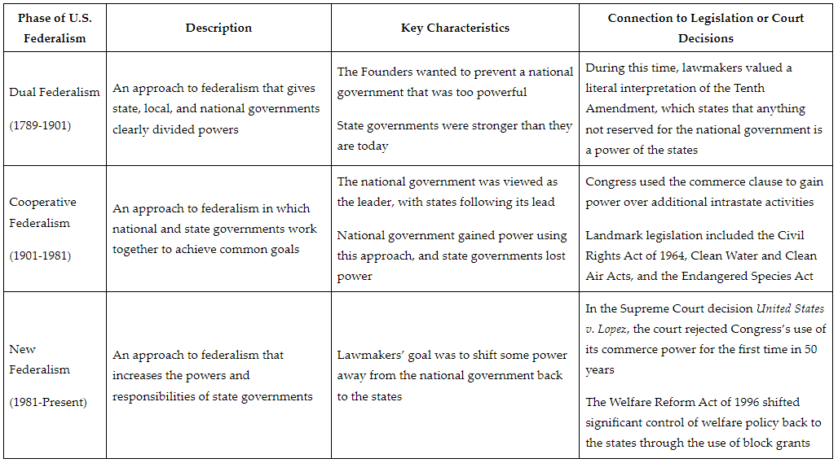

**Objective 4:** Take a critical look at separation of powers, checks and balances, and how those concepts impact current events.

**Big Ideas:** A founding principle of the Constitution is checks and balances. Checks and balances is the idea that each branch of government should be able to block the actions of other branches.

In the U.S., the president can counteract Congress by vetoing laws. The president can check the judiciary by nominating judges and exercising discretion as to how they implement judicial decisions. Congress can check the executive by overriding a veto, impeaching and removing members of the executive branch, and controlling the executive branch's budget. Also, the Senate must approve important presidential appointments to the executive branch. Congress can check the judiciary with its powers to structure the federal judiciary, set jurisdiction of federal courts, and impeach and remove judges. The Senate also must approve presidential appointments to the judiciary. The judiciary can check both the president and Congress by ruling on the constitutionality of their actions.

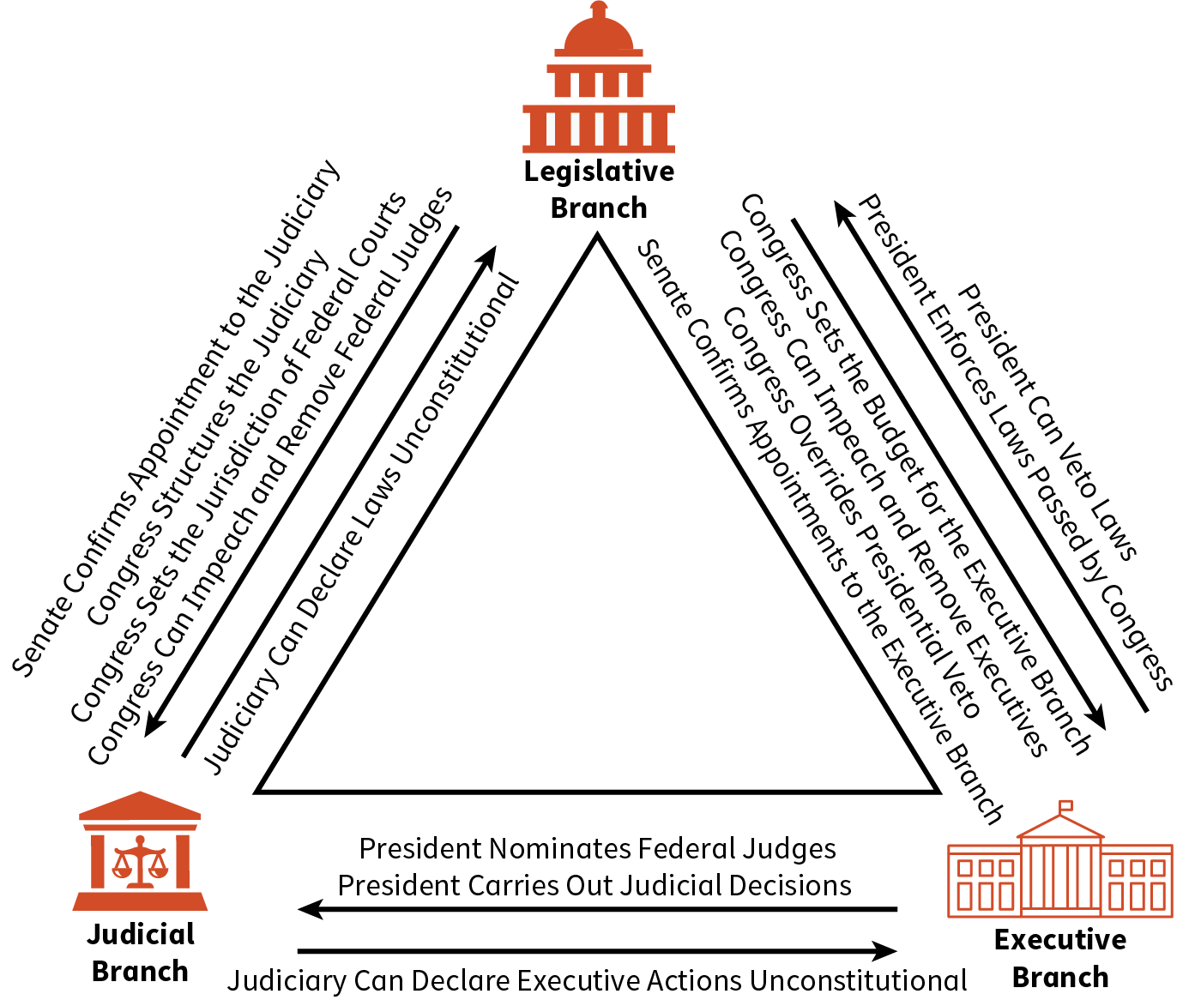

The reason the Framers of the Constitution chose to base the Constitution, in part, on a presidential system of government with checks and balances, was their desire to prevent tyranny. It was believed that too much power concentrated in the hands of a single institution would lead to a tyrannical government that would abuse the rights of the people. But, Presidential systems of government are more likely to lead to divided government.

**Keywords**:

* **expressed powers** – those powers that are explicitly stated in the Constitution
* **faction** – a group of people who are pursuing their own self-interest
* **implied powers** – the powers derived from the Necessary and Proper Clause
* **compelling government interest** – an interest relating to some type of critical governmental function or purpose
* **liberal democracy** – a type of political system that allows majority views to govern while at the same time protecting minority views and minority groups
* **majority rule** – the idea that the views of the majority of the population should be used as the basis for laws
* **social cleavages** – a major division in the society, such as race, ethnicity, or gender
* **categorical grants** – federal government money given to states with which states have little flexibility in how the money will be spent
* **commerce clause** – gives congress the power to regulate interstate and foreign trade
* **Tenth Amendment** – the part of the Constitution that stated the powers not given to the national government, nor denied to the states, were left to the states
* **divided government** – a situation that occurs when one political party controls the presidency and another party controls one or both houses of Congress

**Quick Check**

Question 1: Which of the following **best** summarizes the logic used by the Anti-Federalists to argue against a single large republic?

* A single large republic will best represent and protect the interests of the states.
* A single large republic will make controlling factions easier.
* A single large republic will make direct citizen participation easier.
* **A single large republic will make it difficult if not impossible to represent the views of the citizens.**

Question 2: Which of the following represents Madison’s views on factions?

* Factions can best be controlled through direct democracy.
* Factions can best be controlled by remaining as 13 separate countries.
* **Factions can best be controlled by having a large republic.**
* Factions can best be controlled by direct citizen participation in policy making.

Question 3: Which of the following statements **best** assesses how the U.S. attempts to balance the interests of the majority with the rights of individuals and minority groups?

* **The U.S. usually allows majority rule but attempts to protect the rights of individuals and minority groups through the judicial and political processes.**
* Individual and minority groups are not guaranteed any rights in the U.S.
* Minority groups have been guaranteed equality but are not tolerated when their viewpoints do not match the majority.
* The U.S. allows individuals to express themselves unless their viewpoints are offensive to the majority.

Question 4: Which of the following **best** explains the major source of state government power during the period of dual federalism?

* The use of categorical grants by the federal government.
* The Supreme Court’s decision in United States v. Lopez.
* The commerce power given to Congress by the Constitution.
* **The reserved powers given to states by the Tenth Amendment.**

Question 5: Which of the following is an accurate critique of presidential systems of government?

* Presidential systems of government are more likely to result in a high concentration of power in a single branch.
* Presidential systems of government are undemocratic because the legislature selects the head of the executive branch.
* In presidential systems of government, there is no way for the court system to stop an action of the president.
* **Presidential systems of government are more likely to lead to divided government.**