American Government B

**Unit 2: Forms of Government**

**Unit Summary:** This unit looks at the types of governments within the U.S. at the national, state, local, and tribal levels. This unit also covers the various systems of government found in other countries and compares them to the governing system in the U.S.

A major feature of the U.S. government is federalism. Federalism represents the political authority between the national government and the states. Americans are citizens of both the U.S. and the state they live in.

The Framers of the U.S. Constitution believed that a federalist system of government would strengthen the national government. They also thought it would protect the rights and liberties of individual citizens. Federalism provides checks and balances among the national, state, and local governments. Federalism also needs cooperation in employing public policies.

The U.S. relies on a presidential system. Other democratic countries rely on a parliamentary system. Other key systems of government include an authoritarian or totalitarian regime. This is where power is clustered through a leader, small group of people, or single political party. Communism is where property is publicly owned, and citizens get compensated based on their needs and skills. Socialism encourages cooperation instead of competition with citizens. A social democracy is a democratic form of government that has socialist and capitalist traits.

**Unit Timeline:** This timeline provides *some* events included in this unit’s learning. The goal is to assist understanding chronologically.

* 1778 - United States signed a treaty with the Delaware Nation
* 1781-1789 - Articles of Confederation
* 1788 - United States when the Constitution was ratified
* 1789 – Treaty of Tellico
* 1830 - Congress passed the Indian Removal Act
* 1838 - U.S. Army began the forcible removal of the Cherokee Nation – Trail of Tears
* 1861-1865 - Confederate States of America
* 1881 - *A Century of Dishonor* published
* 1901 - The idea of a city/town commission started in Galveston, Texas
* 1924 - Indian Citizenship Act of 1924
* 1975 - Indian Self-Determination and Education Assistance Act
* December 26, 1991 - former Soviet Union experienced a revolution of sorts that brought about a change in the government
* 1996 - Proposition 209 amended the state’s constitution to ban the use of affirmative action in California.
* 2000 - George W. Bush was elected president
* 2003 - Iraq was invaded by the U.S.
* 2020 - George Floyd was murdered by police officers in the process of being arrested
* January 6, 2021 - riot at the U.S. Capitol

**Lesson 2 – Local Government**

**Objective 1:** Describe how local governments receive their power under the Tenth Amendment as well as describe the structure of local governments.

**Big Ideas**: The 10th Amendment to the U.S. Constitution was written to reinforce the concept of federalism in the new country. By its words, the states can create local governments. The 10th Amendment states:

“The powers not delegated to the United States by the Constitution, nor prohibited by it to the States, are reserved to the States respectively, or to the people.”

Because the Constitution gives states this power, they can set up their local governments in any way they choose. Thus, in the U.S., local governments are structured differently in each state. But they always aim to perform the functions necessary to create a peaceful and prosperous existence for every resident.

The organization of a county varies from state to state. Sometimes the organization is based on population. Counties are called boroughs or parishes in some states. Also, the presence of counties will vary from state to state.

Counties are sometimes look like boxes on state political maps. Counties are responsible for many functions, like:

* Issuing driver’s licenses.
* Keeping legal records of births, deaths, and other vital statistics.
* Running county, state, and national elections.
* Enforcing laws.
* Collecting some taxes.
* Controlling communicable diseases.

Counties are divided into townships or municipalities in different states. These units of government are structured differently in each state. Both townships and municipalities are smaller local units and are sometimes called cities, towns, and villages.

Townships and municipalities provide direct services to residents. Some of these services include providing:

* Maintenance of parks and recreational facilities.
* Police and fire departments.
* Public housing.
* Emergency medical services.
* Courts.
* Public transportation.
* Public works, such as water.

Consider the most common forms of municipal government in the table below.

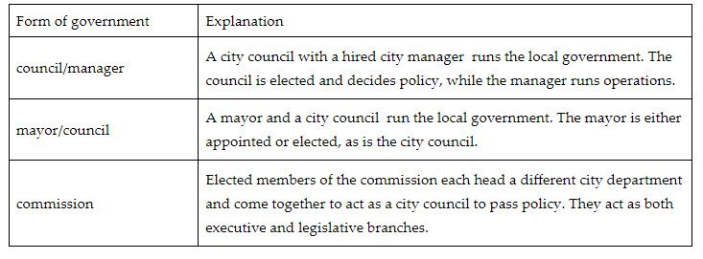

**Objective 2:** Identify policy concerns at the state level.

**Big Ideas:** States bear more of the burden of addressing policy concerns. This is because state government is closer to the people and can better understand their concerns sooner than the federal government can. Policy concerns that states routinely identify include keeping a healthy infrastructure, monitoring economic activity, and addressing environmental issues.

**Maintaining infrastructure**

* Having well-maintained roads, bridges, and transportation structures in place lets residents travel to and from work.
* Planning cities and towns well, attracts more residents to live there and contribute money to the state in property taxes.
* Local governments are responsible for funding kindergarten through high school.
* Maintaining all other parts of the state’s infrastructure will allow states to earn the money to spend on higher educational institutions.

**Positive Economic Activity**

* States work to increase business activity through policies about labor, market activity, and taxes.
* The more people living in a state, the more money the state makes.
* States create labor policies about their workers.
* States develop policies that attract businesses, like offering property tax breaks.
* Most states charge sales taxes on goods and services bought. Sales tax is the most common way for states to make money.

**Environmental Policy**

* More people will live in a state with a healthy environment.
* States use zoning policies to create neighborhoods.
* Policies that promote one type of energy over another can provide jobs for the labor force and can dictate if a state will be more rural or more urban.
* Land use policies can increase the price of land in a state and attract more wealth.

**Objective 3:** Analyze the powers and roles of city council members, including the mayor.

**Big Ideas:** The elected mayor and the elected city council have key roles in setting and executing local governmental policy, overseeing municipal operations, and managing local budgets. Each participant in this form of government has different powers. But the government works best when they use their powers together.

**Powers and Responsibilities of a Mayor**

A mayor is an elected official. The mayor needs to be aware of the needs and wants of those residents when making decisions.

The mayor must also work with the legislative body. It is the mayor’s job to strike the balance of satisfying the needs of residents as well as those of the legislative body.

**Role of City Council Members**

If a city or town chooses to govern by city council, the residents of that locale will elect those city council members. Each city and town in the U.S. has a different number of members on its city council.

Council members can be elected in many ways. In some municipalities, residents in each district elect their council members. In other cities, voters from the whole municipality elect members at large. Both types of elections occur during the same election cycle.

The city council is the lawmaking body of the city or town. Its members write and pass laws and ordinances that will help govern the area.

City council members must work with the mayor to achieve their legislative goals. Even though they have power to pass any law they want within their jurisdiction, they need to keep a balance between what their constituents want and what the mayor wants.

**Different Approaches to the Mayor-City Council Model**

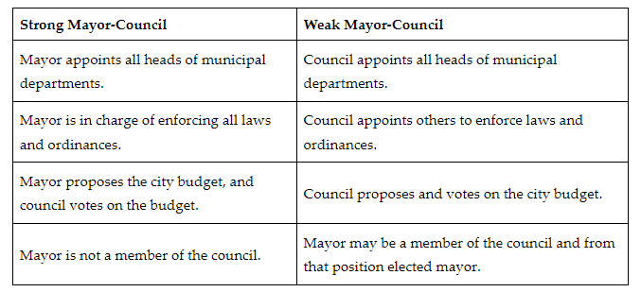

**Objective 4:** Analyze the relationship between different types of local governments.

**Big Ideas:** By state constitution, city and town charter, or local ordinances, cities and towns consist of an executive and a legislative branch to create and enforce laws. Each city and town has a unique way of organizing its government to best suit its needs.

As the nation grew and changed, so did the local areas where people lived. As cities and towns grew, the residents found ways to structure their governments that most suited their needs. In some areas, electing people to serve in the executive branch made sense. In others, electing both the executive and legislative branches was better. And, in many, the appointment, and not the election, of governmental officials seemed to be the best way to structure the town government.

**Council-Manager Form of Government Allows for Continuity**

In the council-manager form of local government, the council is often made up of elected officials. These officials can be elected from the district in which they live, or they can be elected at large. These elected officials meet together and vote on laws and ordinances that will govern the town.

A city/town manager is appointed by the members of the council. This person oversees the day-to-day management of each department that allows the city/town to function. There can also be an elected mayor, but that mayor would only have the same voting power as the members of the council. The manager is usually appointed for the same term as the council.

**City Commission Provides a More Centralized Government**

The idea of a city/town commission started in Galveston, Texas in 1901. The city had been devastated by a hurricane. The residents did not feel that the council was working together to rebuild the city. So, they developed the idea of a commission of elected members to create a unified plan of action.

In a commission, the executive and legislative branches come together to form a centralized government. Usually, a commission is made up of 5-7 members. It has both executive and legislative powers. As legislators, commissioners pass laws and ordinances that help the functioning of the city/town. As executives, each member heads a department of the town and manages that department. One person is usually given the title of chairperson, so there is someone to lead the meetings. That person has the same voting power as the other members.

**Keywords**:

* **federalism**– the system of government in which a national government shares some responsibilities and powers with the state governments but is ultimately seen as the supreme law
* **municipality** – provides the governance of a local area, smaller than a county; examples include cities, towns, and villages
* **constituent** – a person who resides within an elected official’s state or district
* **excise tax** – a tax on specific items that are purchased, most commonly tobacco, alcohol, and gasoline
* **infrastructure** – the public works that include transportation systems (roads, bridges, railroads, airports) and water systems essential for economic activity
* **at large** – elected as a whole

**Quick Check**

Question 1: Describe the structure of government that the Tenth Amendment allows.

* The Tenth Amendment allows states to have more power over taxes than the federal government does.
* **The Tenth Amendment allows states to make decisions about how they will be governed, such as by creating local governments.**
* The Tenth Amendment acknowledges that the federal government has all the control over states and local governments.
* The Tenth Amendment states that local governments must contain townships within each state’s boundaries.

Question 2: Which of the following describes a difference between counties and municipalities?

* Counties can have mayors head them, while municipalities run national elections.
* Counties are specialized boards, while municipalities serve a larger portion of the state.
* Counties collect state taxes, while municipalities collect federal taxes.
* **Counties serve a larger portion of the state than municipalities do.**

Question 3: Identify a policy that states use to attract businesses.

* a high property tax policy on businesses
* **a low minimum wage policy**
* strict land-use policies
* a high minimum wage policy

Question 4: Analyze the difference between the roles of mayor and city council members.

* The mayor is the legislator, and the city council is the judiciary.
* The mayor is the executive, and the city council members are the department heads.
* **The mayor is the executive, and city council members are legislators.**
* The mayor is the legislator, and city council is the executive branch.

Question 5: Analyze the difference between the commission form of local government and the council-manager form of local government.

* **In the former, the same people have equal voice on executive and legislative issues; in the latter, different people decide executive and legislative issues.**
* In the former, different people decide executive and legislative issues, while in the latter, the same people have equal voice on executive and legislative issues.
* In the former, the manager is the head executive, and in the latter, the mayor is the head executive.
* In the former, the commissioners are from England, and in the latter, the council is chosen by the governor.

**Lesson 3 – Levels of Government**

**Objective 1:** Identify the services provided by different levels of government.

**Big Ideas**: The U.S. government is a large and complex organization. Due to this complexity, the Framers of the Constitution opted for a federal system of government. This is a system with three levels of management and control: local, state, and national.

This system allows services to be delivered by different levels of government based on the need for the services. This creates a hierarchy of services. Local governments manage city- or town-level issues, state governments manage state affairs, and the federal government manages national affairs.

Local government is the most immediate form of government. The types of services supplied by local government are often municipal in purpose. Examples are trash collection or utility maintenance. Local government keeps people functioning, safe, and provided for on a day-to-day basis.

State government is the next tier in the government hierarchy. State governments oversee areas like school curriculum, the rules for and printing of driver's licenses, state police forces, and the enforcement of state laws.

Bureaucracies in the national government include executive cabinet departments. Each of these bureaucracies carries out policy initiatives as dictated by the president. The goal is to best serve citizens on a massive scale. A service provided by the national government is the Department of Defense. The U.S. military exists to protect the American people and serve in their defense should the call arise.

**Objective 2:** Compare the executive, legislative, and judicial branches of the federal and state governments.

**Big Ideas:**

**Similarities in Federal and State Governments**

Both levels have three branches of government: executive, legislative, and judicial. Each has its own specific powers laid out by either the federal or a state’s constitution. At each level, the branches provide checks and balances on each other to ensure that no one branch grows too powerful.

Both have an elected leader who heads the executive branch. In the federal government, this is called a president. States use the term governor for their elected leader of the executive branch. Within the executive branch, both levels of government have department leaders appointed to execute the laws and advise the head of state. At the federal level, the president appoints agency leaders and the Senate approves them. At the state level, the people directly elects these leaders. In both governments, the head of the executive branch can veto laws.

Both governments have a legislative branch that writes laws. The legislative branch also approves a budget and controls spending.

The judicial branch consists of lower courts and a Supreme Court. The vast majority of trials are held in the district courts. People appeal decisions to appellate courts. This top-level court’s main purpose is to interpret and uphold the Constitution and to protect it from abuse from unjust laws or overreach by the executive branch.

**Differences in Federal and State Governments**

One major difference is the reach. State governments must manage the affairs of the individual states. The federal government is then in charge of the whole country. The federal government can resolve disputes between different states.

The federal government alone can trade with foreign countries, print money, and declare war. State governments oversee marriage licenses and shoulder most of the burden for maintaining state school systems.

The executive branch oversees enforcing laws. At state levels, a governor heads this. At the federal level, the president of the U.S. heads the executive branch. The president enforces laws written by the legislative branch.

The legislative branch oversees writing laws. At the state level, legislators are elected by citizens within individual states, and they write laws specific to the state they serve. At the federal level, members of Congress come from all 50 states and write laws that apply to the whole country.

The judicial branch is tasked with interpreting laws. All sections of the judicial branch work in a hierarchy of jurisdiction, which determines who oversees certain legal questions, with the Supreme Court of the U.S. being the definitive last court of appeal for making rulings on the law.

**Objective 3:** Create a graphic organizer that compares and contrasts the structures and functions of local, state, and federal governments.

**Big Ideas:**

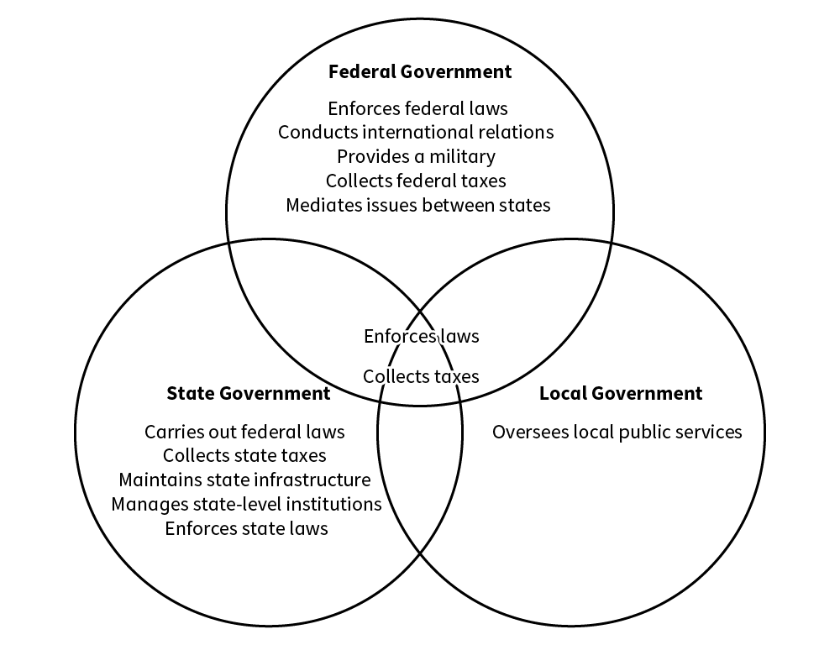

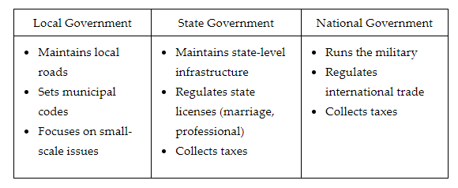

**Objective 4:** Critique the relationship between state and local governments.

**Big Ideas:**

**State Governments and Their Relationship to Local Governments**

The broad power of state governments can lead to issues with local governments. For example, a state government is responsible for funding the public education of that state. But, some districts will get more funding than others.

There can also be issues as some portions of the state populated or made up of the minority political party or a minority ethnic group can feel ignored by their state government. These people would still have the support of their local governments but can be underfunded by state governments.

**Local Governments and Their Relationship to State Governments**

The presence of large metropolitan areas within a state can cause a power struggle over resources, implementation of laws, and the idea of who carries out what services.

Large cities can often hold uneven voting sway over the rest of the state. They can seem to hold the state hostage with their action or inaction.

Depending on the size of state and local governments, certain gaps can exist in services for citizens. When a local government gets so large as to be bogged down by bureaucracies, the nimble nature of local government can fail.

**Keywords**:

* **bureaucracy –** the group of departments, agencies, and commissions that make up the executive branch
* **Department of Defense –** the department that protects the nation and organizes the military
* **veto –** a rejection of a proposal, such as a bill
* **checks and balances –** the power and the ability given to each of the three branches of government to check the others to ensure that no one branch obtains excessive, unchecked power
* **proxy** – in place of

**Quick Check**

Question 1: Identify a service that would be fulfilled by a local government.

* Managing state-wide higher education services.
* resolving disputes between two states.
* **Filling potholes in a community.**
* Defending the border from invasions.

Question 2: Compare how state governments and federal governments structure their different branches.

* States have a judicial branch and a legislative branch, but there is only an executive branch at the federal level.
* **State and federal governments have the same three branches of government, but they differ in size and scope.**
* States have an executive branch, a legislative branch, and a judicial branch, but they have little power compared to the federal government.
* States have an executive branch and a legislative branch, but the federal government alone has a judicial branch.

Question 3: In creating a Venn diagram to compare levels of government, what information can you convey?

* The relationship between different types of local government.
* **The similarities and differences between the different levels of government.**
* The conflicting relationship between state governments and the federal government.
* The power of the executive branch as compared to the different levels of government.

Question 4: Local governments would solely be in charge of which of the following services?

* **Trash collection**
* Enforcing laws
* Civil service pensions
* Military spending

Question 5: How might you critique the relationship between state and local governments?

* The relationship between state and local governments is faulty as there is little interaction between them.
* **State and local governments can come into conflict over who is responsible for which services.**
* State and local governments can provide too many services for customers to utilize.
* The relationship between state and local governments can be hyper-polarized.

**Lesson 4 – Tribal Government**

**Objective 1:** Examine the interaction between tribal governments and national, state, and local governments.

**Big Ideas**: Under the U.S. Constitution, Indigenous American tribes were treated as independent entities. Due to this, they were not taxed but engaged in commerce. They also had passports to travel in the country. Because they were independent entities, the government created treaties with them to obtain their land.

The Constitution also allowed Congress to regulate. Indigenous Americans were not considered citizens of the U.S., even though they were born in the country. Citizenship would be acquired through treaties and legislation. The Indian Citizenship Act of 1924 made all Indigenous Americans U.S. citizens.

The primary agency responsible for interacting with groups of Indigenous Americans is the Bureau of Indian Affairs (BIA).

Rather than exercising the paternalism of the past and trying to change Indigenous Americans, the BIA tries to promote the welfare of the people they serve.

One of the main ways the BIA works with Indigenous Americans is in the areas of economic development. Another area in which the BIA works with Indigenous Americans is gaming. Gaming is the business of gambling and casinos. This is an area in which national, state, and tribal governments interact. According to the National Congress of American Indians, gaming has enhanced tribal self-government. It also revitalized Indigenous communities and provided a range of social services, like health and education.

**State Governments and Indigenous American Tribes**

Tribal gaming operations make about $30 billion a year. This revenue has allowed many tribes to provide a range of social services to their members. Before a tribe engages in large-scale gaming operations, it must enter a compact with the state. This can become complex when states have multiple tribes.

Tribal governments have sovereignty over Indigenous Americans who are on tribal land. Therefore, the state government has no authority over tribal members on tribal land, unless the tribe gives the state this authority. But, the tribes do not have authority over people who are not Indigenous Americans.

Tribes can, if they want, authorize state officials to enforce state law on tribal members on tribal land.

While states do not have authority over tribal land and the Indigenous Americans within those boundaries, they do have authority over Indigenous Americans when they are not on tribal land. Tribal members are also citizens of the states where they live. They are entitled to all the rights and benefits. But, states do have authority over non-tribal members who are on tribal land. This can lead to complex legal situations.

**Local Governments of Indigenous American Tribes**

Tribal governments provide local services like:

* Fire protection
* Ambulance service
* Hospitals
* Law enforcement
* Education
* Water

In many areas, tribal governments provide services to tribe members and non-tribal members. This is possible through cross-deputization agreements. Cross-deputization allows one law enforcement agency to “deputize” members of another law enforcement agency. When this occurs, it gives the law enforcement agency, such as the county sheriff, full authority over the other law enforcement agency.

In rural areas of the country, access to health care is limited. Often, these facilities operated by the Indian Health Service are limited to tribal members.

**Objective 2:** Examine how the U.S. government treated Indigenous Americans with respect to the treaty obligations it had with them.

**Big Ideas:** In 1778 the U.S. signed a treaty with the Delaware Nation. The Treaty of Fort Pitt said that there would be peace between the two. But, in 1782, members of the Pennsylvania militia attacked the village of the Delaware. They incorrectly believed that the tribe had attacked white settlers. The result of this was another treaty where the Delaware gave up more of their land. This behavior typified U.S. policy toward Indigenous Americans.

The treatment of Indigenous Americans by the U.S. government is typified by their interactions with the Cherokee Nation. In 1789, the U.S. and the Cherokee Nation entered into the Treaty of Tellico. Among its many provisions was a guarantee to Cherokee territorial integrity.

The policy of negotiating with Indigenous American tribes as sovereign nations began to change in the early 1800s. Jackson believed that the states had a right to govern the people inside their borders. To Jackson, this included both U.S. citizens and members of Indigenous American tribes.

Jackson, like many White Americans of the time, saw Indigenous Americans as “savages.” Using this term reflected the belief that the various cultures of the Indigenous Americans were inferior to that of the dominant European culture of White Americans.

The growing want of White Americans to occupy Cherokee land put political pressure on the government to act. In 1830, Congress passed the Indian Removal Act. This Act allowed the president to negotiate with the Indigenous American tribes. The goal was to have them cede land in the eastern parts of the U.S., in exchange granting them land in the west.

Jackson spoke to Congress about Indigenous Americans after passage of the Indian Removal Act. He argued that the government was justified in giving western land in exchange for their historical territory.

To put pressure on the Cherokees to accept resettlement, Jackson cut off payments to the Cherokees that the U.S. was obligated to pay under the terms of previous treaties. Further, the final negotiations between the U.S. and the Cherokees were never approved by the Cherokee National Council or principal chief John Ross. Even so, in 1838 the U.S. Army began the forcible removal of the Cherokee Nation. Thus began the Trail of Tears.

**Keywords**:

* **Bureau of Indian Affairs (BIA)** – the primary agency responsible for policies related to Indigenous Americans
* **Indian Citizenship Act of 1924** – the act that granted citizenship to all Indigenous people who had not already become citizens
* **Indigenous Americans** – the first inhabitants of the Americas, prior to European explorers’ travels
* **A Century of Dishonor** – a book that highlights the treatment of several Indigenous American tribes at the hands of the United States government
* **Indian Removal Act** – a law passed by Congress designed to move Indigenous Americans from the areas in the eastern United States to the West
* **Trail of Tears** – the dangerous and deadly journey of the Cherokees from their traditional lands to present day Oklahoma
* **Treaty of Tellico** – an agreement between the U.S. government and the Cherokee Nation that gave Cherokee land to the U.S. government

**Quick Check**

Question 1: Which of the following **best** describes the change over time in the relationship between Indigenous tribal governments and the U.S. government?

* **Initially dominated by the U.S. government, their relationship is now more oriented toward equality.**
* Initially dominated by sovereign Indigenous tribes, their relationship is now more oriented toward equality.
* Initially characterized by equality, their relationship is now more oriented toward Indigenous tribal governments.
* Initially characterized by equality, their relationship is now more oriented toward the U.S. government.

Question 2: Which of the following statements **best** describes why interactions between tribal governments and local governments are often complicated?

* State governments have eliminated the authority of local governments.
* **Tribal land often crosses local and state government boundaries.**
* The national government eliminated the authority of local governments.
* Tribal land was dissolved and incorporated into local counties.

Question 3: How did most Indigenous Americans acquire U.S. citizenship?

* Through state and local law.
* Through state law and federal law.
* Through treaties and state law.
* **Through treaties and federal law.**

Question 4: Which of the following statements is the best critique of the U.S. government’s engagement in treaties with Indigenous Americans?

* The U.S. government engaged unfairly with Indigenous Americans, because Indigenous Americans were forbidden from adopting customs of White Americans.
* The U.S. government engaged fairly with Indigenous Americans because they fulfilled the promises made in treaties.
* **The U.S. government engaged unfairly with Indigenous Americans because the U.S. government continuously broke the terms of treaties they entered into with Indigenous Americans.**
* The U.S. government engaged fairly with Indigenous Americans because Indigenous Americans willingly relocated to new areas to avoid contact with White Americans.

Question 5: Use the excerpt to answer the question. “And is it supposed that the wandering savage has a stronger attachment to his home than the settled, civilized Christian? Is it more afflicting to him to leave the graves of his fathers than it is to our brothers and children? Rightly considered, the policy of the General Government toward the red man is not only liberal, but generous. He is unwilling to submit to the laws of the States and mingle with their population.” President Jackson’s sentiments expressed in the above text are most closely aligned with which of the following documents?

* **Indian Removal Act.**
* Treaty of Tellico
* U.S. Constitution
* *A Century of Dishonor*

**Lesson 5 – Roles of Local and State Governments**

**Objective 1** Explain how local and state governments fund their activities with various forms of taxes and fees.

**Big Ideas:** **State and Local Taxes**

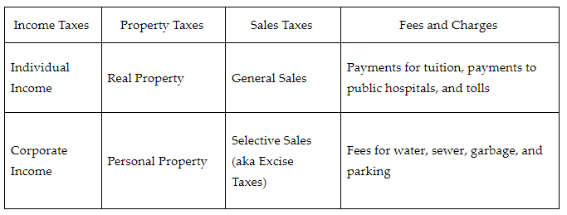

**Objective 2:** Describe various types of local ordinances and the local government process of annexation.

**Big Ideas:** Laws made by local governments are called ordinances. Many ordinances address issues that deal with the day-to-day lives of people living in a city or town. Annexation is the process used by local governments to expand the physical size of their town or city.

**Common Issues of Local Government Ordinances**

**Zoning Issues**

Zoning ordinances regulate how land in several parts of a city or town can be used. Most divide a city or town into areas that can be used for residential housing and other parts that can be used for businesses. Some divide residential areas based on the types of buildings allowed.

**Business Issues**

Many cities or towns will require businesses to have a license to operate in their town. Towns also may use ordinances to restrict the types of businesses they would allow.

**Tax Issues**

Most local governments collect property taxes and some cities or towns have sales taxes. Many local governments also charge user fees for services such as water, sewer, garbage collection, and parking.

**Law Enforcement Issues**

Local ordinances can outline public safety laws within a city’s or town’s boundaries. Ordinances might involve things like speed limits and noise and pet-related regulations.

**Objective 3:** Assess how the process of initiative can affect the rights of individuals.

**Big Ideas:** California has used the initiative process most. When an initiative is placed on the ballot, it is called a proposition. Each proposition is given a number. Look at two different California propositions to assess the effect that initiative can have on individual rights.

Proposition 209 amended the state’s constitution to ban the use of affirmative action.

The proposition was passed, with 54.5% of the vote.

Proposition 16 would have removed the ban.

The proposition did not pass.

56% of voters voted against the proposition.

The process of initiative can impact individual rights. Proposition 209 limited the rights of underrepresented groups by banning the use of affirmative action. Proposition 16, while not being accepted, shows the potential positive impact of the process of initiative

**Objective 4:** Analyze the effect that government can have on the communities it serves.

**Big Ideas:** Governments can help their communities by improving public health and safety. They can improve public education and provide wanted services. Some local governments have not always had a positive impact on their whole community.

**Improvements in Public Health**

Government officials can gather data on the resources in their area. They can work to create public-private partnerships with those resources. By creating partnerships, they will increase their community’s access to these resources.

**Educational Opportunities**

Local governments often provide public schools. Government can improve local education by knowing the skills needed in the job market. Preparing residents to be successful employees has a positive impact on their community.

**Improve Community Services**

Community services include water, sewer, garbage, and leisure opportunities. Governments can ask their community how services could be improved. They can also see what other new services people want. It is key to get this data from the public so a local government can provide the types of services that will be most supported by the community.

**Government Neglect**

There have been examples of local governments that have not had a positive impact on their entire community. Due to racial and ethnic prejudice and discrimination, some local governments have neglected parts of their community. This has led to inequalities in public health, public safety, educational opportunities, and the services provided in some communities.

**Keywords**:

* **corporate income tax –** the taxes paid by corporations on the annual profits they earn
* **general sales tax –** the taxes paid based on the gross receipts of businesses
* **gross receipts –** the amount of money equal to the number of products sold by a business multiplied by the price of those products
* **hospitality tax –** the taxes paid on payments made to hotels and restaurants
* **individual income tax –** the taxes that private individuals and businesses (non-corporations) pay based on their annual income
* **selective sales tax (excise tax) –** the taxes collected on specific purchases such as alcohol, tobacco, and gasoline
* **voluntary annexation** – a right that allows landowners outside a city or town to voluntarily become part of a town or city
* **zoning ordinances** – the local laws that regulate how land in various parts of a town or city can be used
* **affirmative action** – the policies and practices that aim to eliminate discrimination among applicants and include underrepresented groups and individuals within organizations; applies to employment practices, college admission processes, and the awarding of government contracts
* **referendum –** the ability for voters to accept or repeal legislative action

**Quick Check**

Question 1: Which of the following correctly explains how local government user fees can help pay for government functions?

* **User fees are charged for government services and can help fund those services.**
* User fees are property taxes that are paid on things such as automobiles that can be used to fund the construction of roads and bridges.
* User fees are taxes paid based on an individual’s wages and can help fund all government functions.
* User fees are sales taxes charged on products that are used by certain individuals and can help fund certain government services.

Question 2: Which of the following **best** describes the purpose of zoning ordinances?

* **Zoning ordinances are used by local government to regulate how land can be used within their city/town limits.**
* Zoning ordinances are used by local government to enforce public safety issues such as speed limits.
* Zoning ordinances are used by local governments to regulate what people have to pay for things such as property taxes in a particular town or city.
* Zoning ordinances are used by local governments to require someone to obtain a license in order to sell goods or services in a town/city.

Question 3: Assume that citizens of your state wanted to use the initiative process to expand individual rights. Which of the following possible initiatives would directly increase individual rights?

* **An initiative that would guarantee all people equal access to housing.**
* an initiative that would increase the use of wind energy in the state.
* an initiative that would raise property taxes throughout the state.
* an initiative that would increase new road construction in the state.

Question 4: Analyze which of the following government actions would have a direct impact on improving both public safety and increasing recreational opportunities in a community.

* Creating a community garden.
* Increasing the number of people on town council from three to five.
* **The construction of sidewalks.**
* Improving a town’s water and sewer facilities.

Question 5: A town is having trouble getting members of its community and those passing through it to abide by their speed limits. Analyze which of the following would be the most direct way for the town to improve its speed-limit enforcement.

* **The town could hire more law enforcement officers to enforce the town’s speed limits.**
* The town could hire crossing guards to protect pedestrians from speeders at important intersections in the town.
* The town could have its police officers go into the public schools to talk to students about the importance of following the town’s speed limits.
* The town could build sidewalks to improve the safety of citizens who walk on the streets of the town.

**Lesson 6 – Forms of Government**

**Objective 1:** Evaluate different forms of government and their functions and structures.

**Big Ideas**:

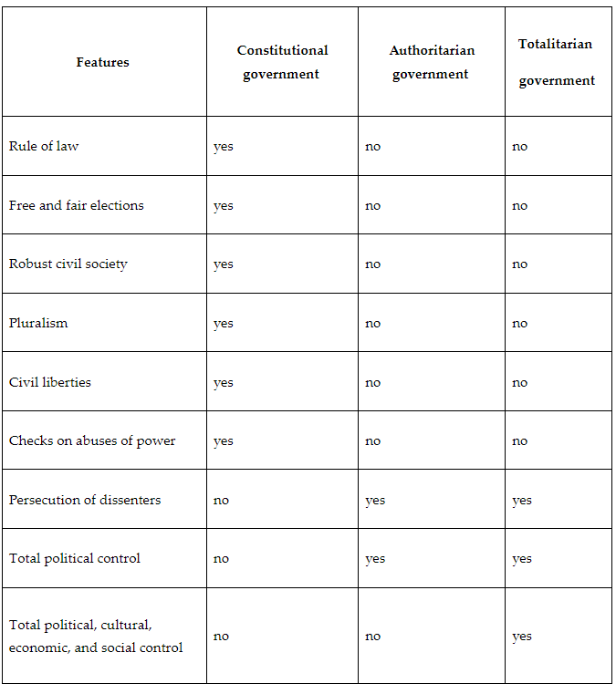

**Objective 2:** Compare different forms of government with the U.S. government.

**Big Ideas:** The U.S. government operates as a constitutional democracy. This means the people hold the power and the power of government is limited by a constitution.

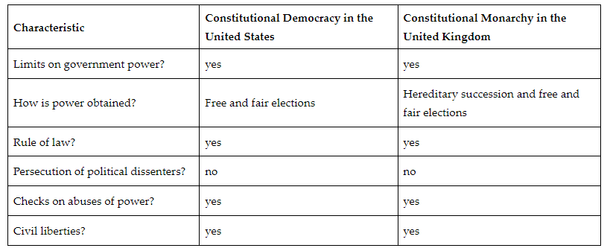

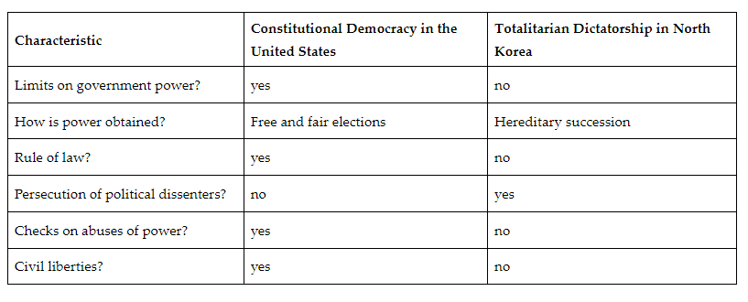

**Objective 3:** Compare the influence of authoritarian and democratic governments on people, groups, and society.

**Big Ideas:** A democracy is a government run by the people. Democracies provide for limits of government over its people.

* Democracies
  + Emphasize individualism.
  + Give citizens access to free and fair elections.
  + Grant people civil liberties, like the right to free speech or the right to assemble.
  + Enable a robust civil society in which the people can influence their government officials directly or through political parties and interest groups (pluralism).
  + Have checks on abuses of power built into government systems.

Unlike democracies, authoritarian governments hold power without input from citizens. These governments are often run by one or a few individuals.

Authoritarian governments:

* Incorporate rule by law.
* Reject the idea of pluralism.
* Restrict civil society.
* Lack civil liberties.

People who live under authoritarian governments lack freedom of speech and freedom of assembly rights. Those who voice opposition to these governments may face imprisonment or death.

**Keywords**:

* **constitutional democracy –** a government where the power of government is limited by a constitution
* **constitutional government –** a government that has a constitution designed to limit the government by specifying its structure, powers, and limits on its powers
* **constitutional monarchy –** a government in which a monarch (for example, a king or queen) shares power with a constitutionally organized government
* **direct democracy –** a government in which all citizens vote on all important matters
* **rule by law –** the idea that government does not apply the law equally, and leaders are above the law
* **rule of law –** the restriction of the arbitrary use of government power based on well-defined and established laws
* **sovereign –** having the power to rule
* **totalitarian government –** a government in which a leader tries to control all aspects of public and private life
* **bicameral legislature –** a two chamber body that requires each chamber to perform separate functions and then reconcile differences in order to produce legislation
* **dictatorship –** a government that is run by one powerful leader who rules and controls people using force and intimidation
* **federal system of government –** a national government that shares some responsibilities and powers with the state governments, but is ultimately seen as the supreme law
* **republic** – a government in which people elect representatives to make decisions for them

**Quick Check**

Question 1: Which of the following statements **best** evaluates the function of a constitution in a constitutional form of government?

* It is designed to limit the government by giving all power to only one person.
* It is designed to limit the people by specifying the structure, powers, and limits on elections.
* **It is designed to limit the government by specifying the structure and limits on the powers of the government..**
* It is designed to limit the government by giving total control to the people.

Question 2: Compare the characteristics of the United States government with North Korea’s government. Which set of characteristics is correctly matched with both governments?

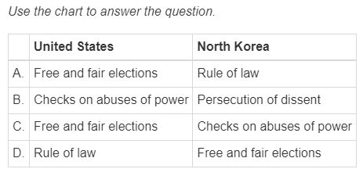

* A
* C
* D
* **B**

Question 3: How does the government of the United Kingdom compare to the government of the United States?

* **Both have elected leaders and a bicameral legislature, but only the United Kingdom has a monarch.**
* Both have a monarch and elected leaders, but only the United States has a bicameral legislature.
* Both have elected leaders and a bicameral legislature, but only the United States has a monarch.
* Both have a monarch and elected leaders, but only the United Kingdom has a bicameral legislature.

Question 4: Which of the following statements **best** compares the influence of democratic and authoritarian systems of government on civil society?

* Democracies put many restrictions on the press, while authoritarian governments enable a free press to thrive.
* Democracies reject the idea of pluralism, while authoritarian governments give the people the ability to influence government officials directly or through political parties and interest groups.
* Democracies give unlimited power to the executive over civil society, while authoritarian governments concentrate more power in legislative bodies.
* **Democracies enable a strong civil society in which the people are able to influence their government, while authoritarian governments constrain civil society.**

Question 5: Which of the following is a characteristic of a democracy?

* **A free press.**
* Persecution of political dissenters
* Rejection of pluralism.
* Rule by law

**Lesson 7 – Comparing Systems of Government**

**Objective 1:** Compare the presidential system of the U.S. and the parliamentary system of the United Kingdom.

**Big Ideas**:

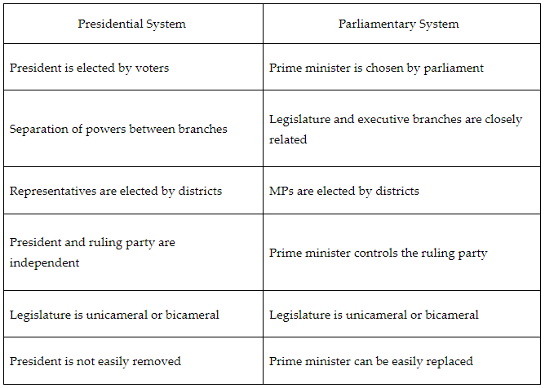

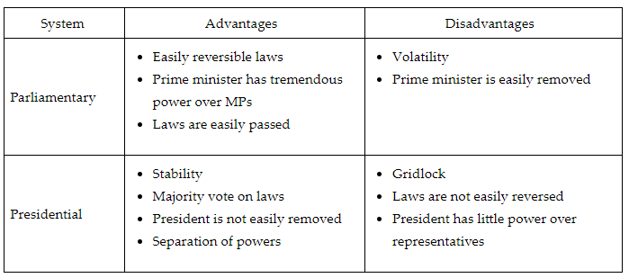

**Objective 2:** Compare the differences between unitary, federal, and confederal governments.

**Big Ideas:**

Advantages of unitary government:

* Allows for the creation of uniform national policies. This creates a situation in which people are treated equally throughout the country, regardless of where they live.
* Reduces the amount of duplication of services provided by the government. This means national, state, and local governments do not need to each provide services.
* Reduces conflict between levels of government. This creates a situation that is more stable. It also creates more national unity.

Disadvantages of unitary government:

* The central government might not be as aware of local conditions or issues.
* Uniform policies might not account for unique characteristics and problems faced at the local or state level.
* Unitary governments may be slower in addressing local issues.
* Shares power between a national government and local and state governments.

Advantages of a federal government:

* Creates a degree of national unity, while allowing state and local governments to solve their unique problems.
* Allows local elected officials to be held accountable by local voters.
* Allows the national government to focus on national and international issues, while allowing state and local governments to focus on more local issues.
* Allows more power at the local and state level. This increases the ability of people to participate in policy making.

Disadvantages of a federal government:

* Can lead to a duplication of government services.
* Allows for people in different parts of a country to be treated unequally. Different parts of a country will have different public services and different methods of law enforcement and will spend different amounts of money on their peoples’ welfare.
* Can lead to an increased conflict between different levels of government.
* Can lead to states passing laws that oppose the country’s foreign policy.

Advantages of a confederal government:

* Strong local and state governments prevent the national government from becoming too powerful.
* Gives states the flexibility to cooperate with other states when it is beneficial, but at the same time keep their independence.
* Gives local and state voters more input into policy making.
* Officials are more aware of the unique qualities and problems that face their communities.

Disadvantages of a confederal government:

* A weak central government might not be able raise needed taxes.
* A weak central government might not be able to defend its country against a foreign nation.
* A weak central government might not be able to defend its country against an internal threat.
* People will be treated differently by government depending on where they live.
* A confederal government might lack unity.

**Objective 3:** Compare the systems of communism and socialism.

**Big Ideas:** Similarities

* Evolved out of an opposition to capitalism.
* Have government ownership and control of economic resources.
* Produce goods and services to meet the needs of society.
* Drastically reduce the economic class differences between people.
* Require people to work based on their abilities.

Differences

|  |  |
| --- | --- |
| Communist System | Socialist System |
| all people are provided goods and services to meet their basic needs | people are given goods and services based on their contribution to society |
| individuals do not own private property | individuals do own private property |
| the goal is to eliminate economic differences between people | the goal is to reduce, not eliminate, the economic differences between people |
| religious freedom is eliminated | religious freedom tends to be allowed |

**Keywords**:

* **bicameral** – a two-house legislature
* **gridlock** – the difficulty of moving the legislative process forward
* **separation of powers** – the division of responsibilities between different branches of government in order to help keep one branch from becoming more powerful than another
* **unicameral** – a one-house legislature
* **uniform national policy** – a public policy that applies to all governments and people throughout the country
* **unitary government** – a system of government where there is one central authority or power over regional governments
* **confederal government** – a type of government with a weak central government and strong state and local governments
* **capitalism** – a system of social organization where there is a free market with a limited role of government
* **communism** – a form of government in which property is publicly owned and citizens get compensated based on their needs and skills
* **socialism** – a government in which the people own the means of production and distribution of services and products as a community, with a central government for management

**Quick Check**

Question 1: Which statement **best** compares the presidential and parliamentary systems?

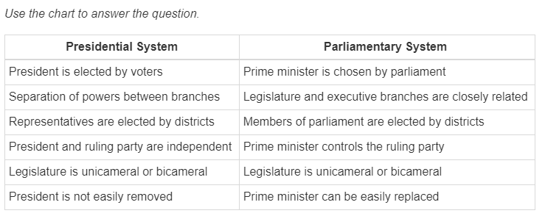

* A presidential system and parliamentary system both rely on swift action and powerful executives to get laws passed. The main difference between the two forms of government is how stable the government is to pass laws.
* A presidential system and parliamentary system both have executives that are difficult to remove, and the legislatures are powerful branches of government. The main difference between the two forms of government is the separation of powers between the legislative and executive branches.
* A presidential system and parliamentary system both have separate and distinct powers between branches of government and a bicameral legislature. The main difference between the two forms of government is how much power is vested in the legislative and executive branches.
* **A presidential system and parliamentary system are both democratic systems that rely on the election of their representatives. The main difference between the two forms of government is the power held in the legislative and executive branches.**

Question 2: Which of the following tables accurately lists the advantages of parliamentary and presidential systems of government?

* 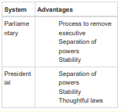
* 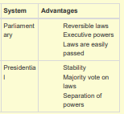
* 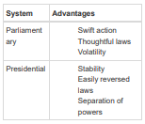
* 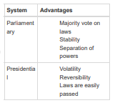

Question 3: When comparing the unitary, confederal, and federal systems of government, which of the following is an advantage most associated with unitary governments?

* State and local officials making policies that suit the unique problems and characteristics of their state or town.
* State and local voters having more input into government policy making.
* State and local governments being able to limit the power of the national government.
* **A government being able to create uniform national policies.**

Question 4: Compare the systems of communism and socialism and identify a similarity between the two systems.

* In both systems Robert Owen is credited with their development.
* **In both systems the central government owns a significant amount of a country’s economic resources.**
* In both systems people are compensated based on their needs.
* In both systems the goal is to completely eliminate economic class distinctions.

Question 5: Which of the following is correct concerning a communist system of government?

* Communist systems allow private individuals to make economic decisions.
* Communist systems pay people based on their contributions to society.
* Countries such as Denmark, Norway, and Sweden are modern examples of communist systems.
* **The concept of communism was developed by Karl Marx and Friedrich Engels.**

**Lesson 8 – Politics and Government**

**Objective 1:** Classify political philosophies with forms of government.

**Big Ideas**: Political philosophy is a study of governments, including their structures and how they function.

When individuals are asked what kind of government exists in America the response is usually a democracy. But, this isn’t 100% correct.

In a democracy members of society can make policy decisions for the whole society. In America, the citizens elect others to make policy decisions. This type of government is called a representative democracy or a republic. This is important as in a representative democracy citizens have to trust elected officials to make the best decisions for them.

People might say is that the U.S. has a federal system of government. This is true. A federal system of government has two levels or layers. The power between the upper and lower levels is shared and divided. The U.S. has a national government that is on the top level and the state governments are on the bottom level. Other nations that have a federal system include Mexico, Germany, and India.

Federalism is contrasted with a unitary system of government. In a unitary system there is one central authority over regional governments. Examples include France, South Korea, and Greece.

In the federal system of the U.S., the national and state governments make one form of government. This is often called a constitutional republic. A constitutional republic is a system of government where particular principles are embodied in a constitution. The constitution sets up separate branches such as the legislative, the executive, and the judiciary. In a constitutional republic, the public has the ability to influence those who hold power through regular elections. The fact that the public can influence the government gives us another concept about government called pluralism. Pluralism is the idea that everyone should be able to compete for influence over the government. Influence over the government is not restricted to a particular group or class of people.

**Alternative Structures of Government**

The colonies were part of the British system of government, which was a monarchy. A monarchy is where the ruler or rulers have power by divine right. Divine right means that God gave them with the power to rule over others. Today, England has a parliamentary system. The parliament selects the executive, called a prime minister in England. Canada, Italy, and Japan also have parliamentary systems. These systems of government, except for a monarchy, have something in common. The people can influence their government. The people also can participate in the marketplace with limited government control. This description references capitalism. Capitalism is a system of social organization where there is a free market and government has a limited role. Capitalist countries tend to be freer and wealthier than those that practice communism.

Communism is a system of social organization where the government is in control of the means of production. China, Cuba, Laos, and Vietnam are examples of communist countries. The term socialism is often used verses communism. Although these terms are similar, socialism is a system of social organization where the means of production are held by the members of society. The results are divided equally among its members. Countries that are referred to as communist like China, Cuba, and Vietnam are also referred to as socialist.

There are three other forms of government that offer a contrast to the freer forms of government mentioned earlier.

First is an aristocracy. An aristocracy is like a monarchy. It where nobles or aristocrats rule based on their status in society. Monarchs had divine right, whereas aristocrats have status that is recognized by society. Another form of government with no involvement by the people is an authoritarian government. An authoritarian government does not allow political participation. Examples of authoritarian governments include the Philippines, Jordon, and Cambodia. A totalitarian government is a system of government where the control of all aspects of society are held by an individual or small group. Today, the Taliban rule in Afghanistan and Kim Jong Un’s government in North Korea would both be examples of totalitarian governments.

**Objective 2:** identify triggers of political change for specific governments.

**Big Ideas:** Triggers of Political Change

When people are unhappy, they are going to bring their unhappiness to bear on the government. Of course, in the U.S. and other representative democracies, the voice of the people is welcomed and encouraged. In countries like Cuba or North Korea these expressions of unhappiness are not welcomed.

The discontent of the people in most cases is driven by economics. If people do not have money to buy the things they need, they will most likely bring their complaints to the government. The unrest is not always about economics. Sometimes, it is about civil rights. These conflicts can involve race, ethnicity, religion, sex, sexual orientation, or even class. The triggers are usually brought about internally; but, other triggers can come from outside of the country.

The Taliban lost control of Afghanistan after the U.S. invaded the country. This invasion brought a change in the government of Afghanistan, which lasted until President Biden pulled American troops out of the country. Today, the Taliban has regained control of the country. Iraq was invaded by the U.S. in March of 2003, and the government was replaced. Today, Iraq is a federal parliamentary republic.

**Keywords**:

* **Special Economic Zone** – a zone on the Chinese coast where the Chinese government allowed foreign companies to set up factories
* **aristocracy** – a form of government where nobles or aristocrats rule based on their status in society
* **authoritarian government** – a government that controls virtually everything about a country other than possibly a social organization such as a religion; it is not limited by a constitution, the rule of law, or elections and typically it would be run by one or a few individuals
* **pluralism –** the idea that many interests ought to be free to compete for influence over the government and its policies
* **majority rule –** the idea that when there is an election or decision to be made, the individuals who are counted on the side of the numerical majority are winners and have the legitimacy to rule over those in the minority, as well as those in the majority

**Quick Check**

Question 1: Classify which system of government has a central authority that makes all the decisions for and is in complete control of the nation?

* Capitalism.
* Democracy.
* **Totalitarian.**
* Republic.

Question 2: Which type of government requires the ruler or rulers to have divine rights?

* **A monarchy.**
* A unitary government.
* A democracy.
* A republic.

Question 3: Identify triggers of political change for specific governments.

* Political change.
* **Elections, revolutions, and war.**
* Legitimacy.
* Majority rule.

Question 4: Classify the term that **best** describes acceptance of those in power as rightfully fit to lead and exercise authority over others?

* Political change.
* Trigger.
* Majority rule.
* **Legitimacy.**

Question 5: Assess which term **best** represents the idea that when there is an election or decision to be made those who are in the numerical majority are legitimate?

* Trigger.
* **Majority Rule.**
* Political Change.
* Legitimacy.

**Lesson 9 – Citizens Role**

**Objective 1:** Evaluate the rights and roles of citizens in different systems of government.

**Big Ideas**:

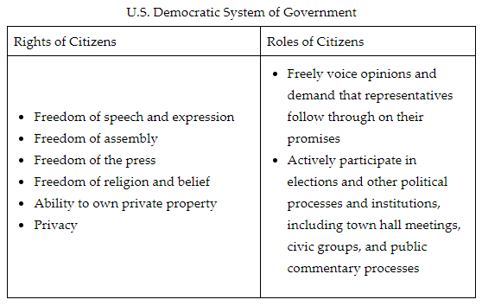

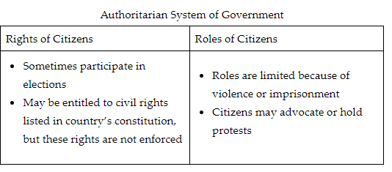

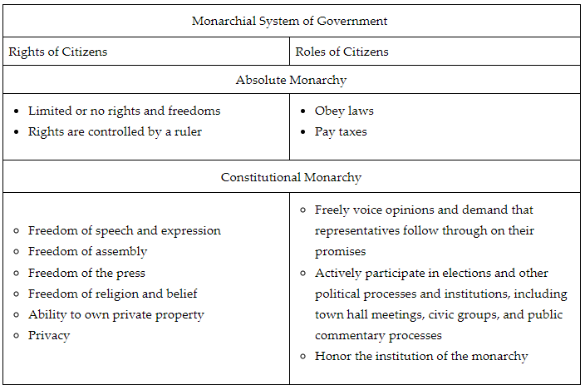

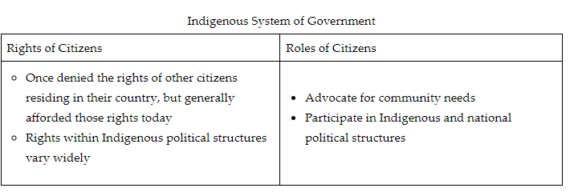

**Objective 2:** Synthesize the impact diverse government structures have on society and human rights.

**Big Ideas:** 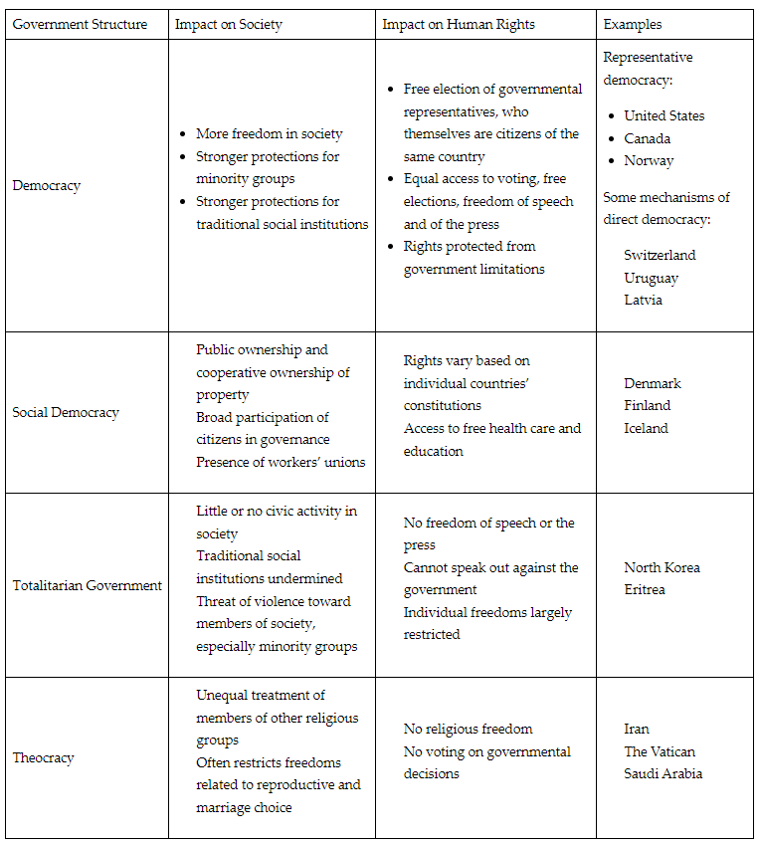

**Objective 3:** Apprise the civic responsibilities of citizens in the U.S..

**Big Ideas:** Being a U.S. citizen comes with many benefits and responsibilities. The importance of these civic responsibilities is to ensure that citizens uphold specific values outlined in the Constitution and Bill of Rights. Through civic engagement, citizens develop knowledge, skills, and a strong voice to cultivate change. The goal is to ensure responsible citizenship. Responsible citizens are active participants in their communities and government to maintain a strong democracy.

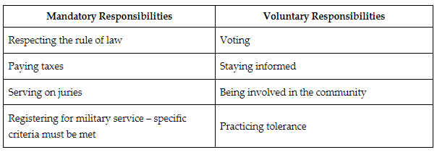

**Objective 4:** Distinguish between how individuals and government interact in the U.S. versus the relationship between individuals and the government in other countries.

**Big Ideas:** The U.S. has a two-party system of government. In this system, government officials typically come from the Republican or Democratic Party. In many other democracies, there are more than two viable political parties. This allows people in other countries to vote for multiple parties and have an impact on the outcome of elections. Systems with more than two viable political parties are called multi-party systems.

American federalism gives state and local governments more power than they often have in other democracies. This means that their local and state governments are going to have the biggest effect on their lives. Due to this, Americans are more likely to feel a closer connection to their local and state governments than to the national government. Other democracies tend to be more unitary governments, with most power left to the national government. This leads to individuals in those countries feeling a closer connection to their national government.

Compared to most other democracies, the U.S. is a large country. This also contributes to the stronger connections individuals have with their local and state governments. In other smaller democracies, people feel a closer connection to their national government because there is not as much physical separation as in the U.S.

The U.S. uses a presidential system of government. Most other democracies are a form of a parliamentary system. In a presidential democracy, the executive branch is separate from and equal to the legislative branch. This can lead to divided government in which the president can be of one major party, while Congress can be controlled by the other major party. This can lead to gridlock. In a parliamentary system, the executive branch is part of and is selected by the legislative branch. This means that the chief executive (usually a prime minister) has the support of the majority in the legislature. This is called unified government, and it makes gridlock unlikely. In the U.S. individuals might feel that their government is less effective in solving problems due to gridlock. The lack of gridlock in other democracies might give their people more confidence in their government’s ability to solve problems.

The U.S. is a representative democracy. This type of government can also be called a republic. In a republic, citizens can elect their representatives. Republics also have constitutions that protect the rights of all people. In authoritarian governments, people do not have input into who becomes government officials. These governments also do not protect people’s rights. This causes the relationship between individuals and government to be different in the U.S. than it would be in authoritarian governments like Russia, China, and North Korea.

Because voters in the U.S. elect representatives, people in the U.S. are more likely to feel that their participation in their government is meaningful. People under the control of an authoritarian government would not feel this way.

**Keywords**:

* **democratic system of government** – a government based on officials selected through free and fair elections; constitutional limitations on government actions; individual freedom of thought and action
* **monarchy –** a government that is run solely by a king, queen, or emperor, usually based on heredity
* **theocracy –** a government run by a religious leader
* **totalitarian government –** a government in which a leader tries to control all aspects of public and private life
* **naturalized citizen –** a person who is born in a foreign country and completes all the steps required by law to become a citizen
* **Selective Service Act** – an act that requires military service; also known as the military draft
* **divided government – a** situation that occurs when one political party controls the presidency and anther party controls one or both houses of Congress
* **gridlock –** difficulty moving the legislative process forward
* **multi-party system –** a system in which there are more than two viable political parties
* **parliamentary system** – a system of government where the executive leader is selected from the legislature
* **presidential system –** a system of government where the legislative and executive branches are separate and the people select the executive

**Quick Check**

Question 1: Which of the following evaluates the rights and roles of citizens in a democratic system of government?

* Citizens have many rights, including freedoms of speech and assembly, privacy, and the right to vote, but they play limited roles in their countries’ governance. Their rights don’t enable them to participate in civic activities or communicate with their elected officials.
* **Citizens have many rights, including freedoms of speech and assembly, privacy, and the right to vote. This enables them to play large roles in democratic systems because they can participate in elections, seek to influence elected officials, and participate in civic activities..**
* Citizens of democratic systems’ rights and roles differ widely from country to country. Sometimes citizens have many rights but play limited roles. In other cases, citizens play large roles in governance but have few individual rights.
* Citizens of democracies are losing fundamental rights, including freedoms of speech and assembly, privacy, and the right to vote. However, this does not impact their ability to play important roles in the governance of their countries.

Question 2: Use the text excerpt to synthesize and answer the question. Democracies and social democracies differ significantly from totalitarian and theocratic structures of government. In totalitarian structures, rulers have unlimited power, and this power is vested in one leader or a group of people who are not elected. Their citizens do not participate in the activities of government. Under theocracies, the government’s laws are based on religious laws, and the leader is typically part of the clergy. Which of the following synthesizes the impact of diverse government structures on society and human rights?

* Government structures that offer strong protections for human rights create oppressive societies because of stronger government regulation, whereas government structures that offer weak protections for human rights allow more freedom.
* **Government structures that offer strong protections for human rights create stronger social institutions and more freedom in society whereas government structures that offer weak protections for human rights create unequal societies.**
* Government structures that offer strong protections for human rights create weaker social institutions and less freedom in society whereas government structures that offer weak protections for human rights create free societies.
* Government structures, whether they offer strong or weak protections for human rights, are not connected to how society functions; societies are shaped by culture and the economy, not by government decisions.

Question 3:

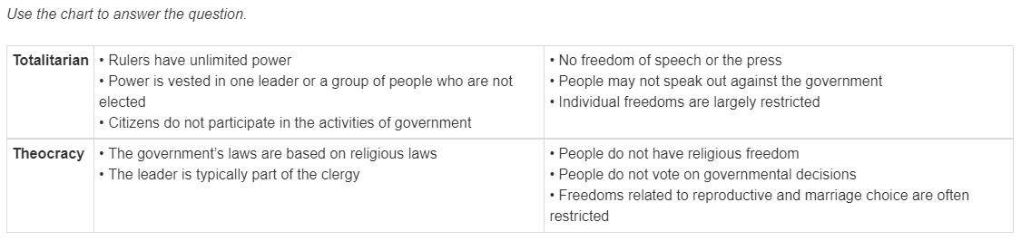

Analyze the chart to synthesize how totalitarian and theocratic government structures impact human rights and societies similarly.

* Both totalitarian and theocratic government structures increase protections for human rights but limit individual liberties for members of their societies.
* **Both totalitarian and theocratic government structures restrict the individual liberties of their citizens and neither prioritizes human rights protections for citizens.**
* Both totalitarian and theocratic government structures are religious in nature and they marginalize members of religious minorities in their societies.
* Both totalitarian and theocratic government structures focus on restricting freedoms related to reproductive and marriage choice.

Question 4: Which of the following activities apprises the voluntary civic responsibilities of citizens?

* **Voting in an election.**
* Obeying the law.
* Paying taxes.
* Becoming a naturalized citizen.

Question 5: Which of the following accurately differentiates the relationship between people and the government in the U.S., compared to the relationship between people and the government in other countries?

* Because the U.S. gives most of the power to the national government, people in the U.S. feel more connected to their national governments than people in other democracies.
* **Because of the way federalism is practiced in the U.S. compared to other democracies, people in the U.S. might feel more connected to their regional governments (local and state) than people in other democracies.**
* Because the U.S., like other democracies, practices a unitary form of government, people in the U.S. and other democracies feel more connected to their regional governments than their national government.
* Because regional governments in other democracies give their regional governments more power than they have in the U.S., people in other democracies feel more connected to these regional governments than people in the U.S.