Math 8 B Unit Test Guide

Scatter Plots & Data Analysis Unit Test

Item | Lesson Coverage | Objective | Lesson Page | Assessment Item
1 | Lesson 2: Scatter Plots | Construct scatter plots for bivariate measurement data. | p. 1-5 | Use the table to answer the question.  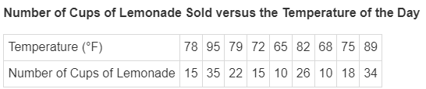  Jeremiah had a lemonade stand. The table shows how much lemonade he sold versus the temperature of the day.  Which scatterplot represents the data?  Answer:  Number of Cups of Lemonade Sold vs. Temperature  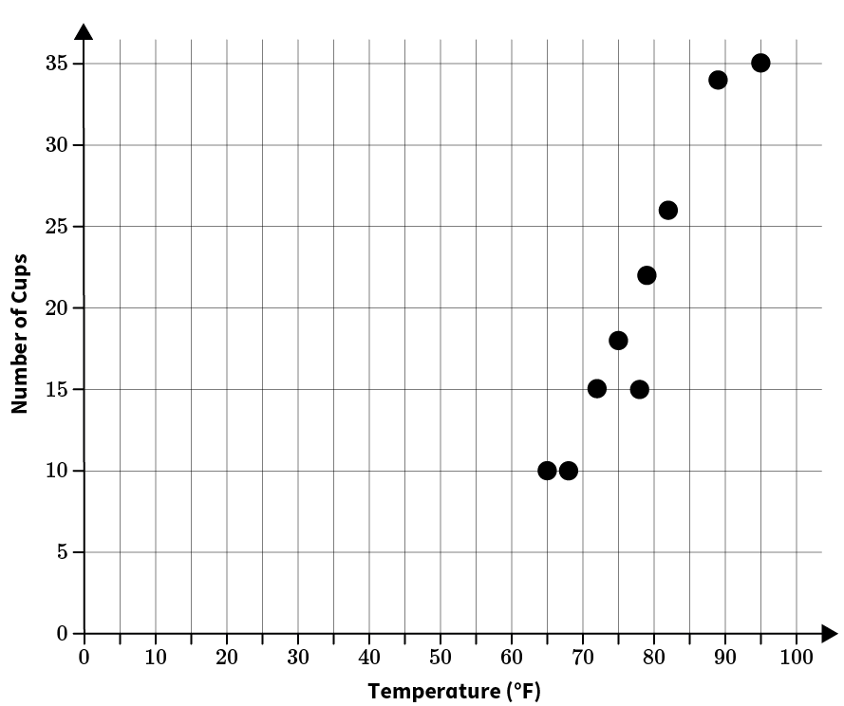  Scatter Plots & Data Analysis Unit Test Item #1 | Desmos
2 | Lesson 5: Correlation | Interpret scatter plots for bivariate measurement data by describing patterns of positive, negative, no association, and patterns of linear and nonlinear association. | p. 1-9 | Use the image to answer the question.  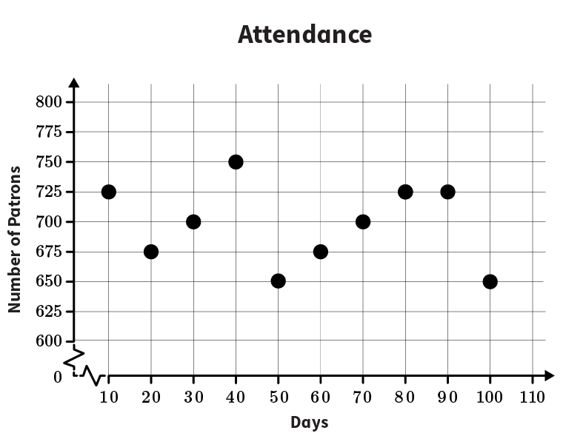  A petting zoo graphed the average attendance of patrons every 10 days over a 100 day period of time. Interpret the scatterplot to determine what type of association the scatterplot shows.  Answer: The graph is non-linear.
3 | Lesson 5: Correlation | Determine whether or not data plotted on a scatter plot have a linear association. | p. 10-14 | Interpret the scatterplot to determine what type of association the scatterplot shows.  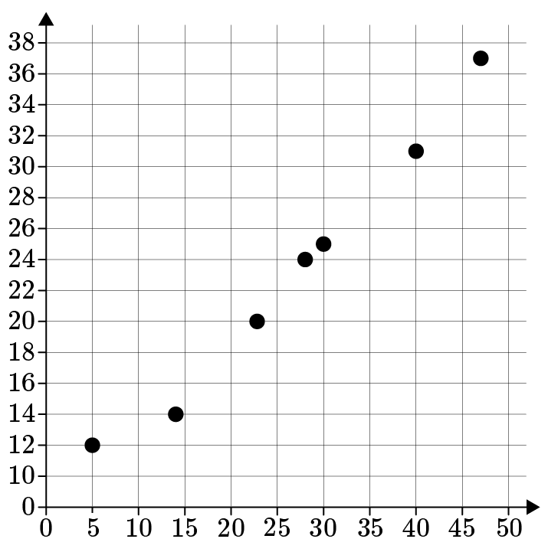  Answer: linear association
4 | Lesson 5: Correlation | Determine whether or not data plotted on a scatter plot have a linear association. | p. 10-14 | Use the table to create a scatterplot. Determine the type of association.  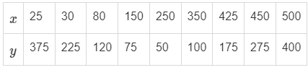  Answer: non-linear association  Scatter Plots & Data Analysis Unit Test Item #4 | Desmos
5 | Lesson 6: Trend Lines | Informally assess the model fit of a straight line to a scatter plot by judging the closeness of the data points to the line. | p. 1-8 | Use the image to answer the question.  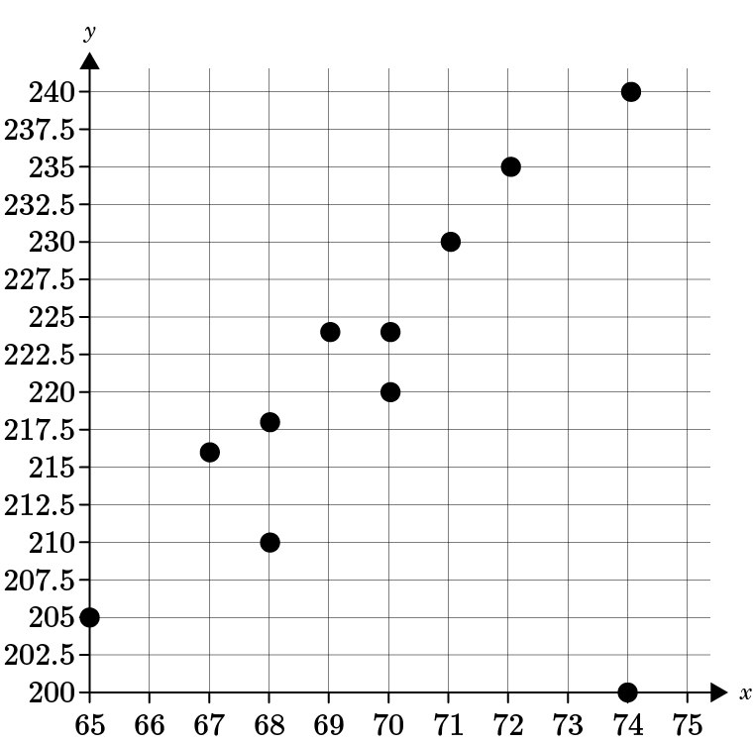  Is there a relationship between the two sets of data? Choose 1 for yes and 2 for no.  Answer: 1
6 | Lesson 6: Trend Lines | For scatter plots that suggest a linear association, determine the equation of a trend line that approximates the linear relationship. | p. 9-13 | Use the image to answer the question.  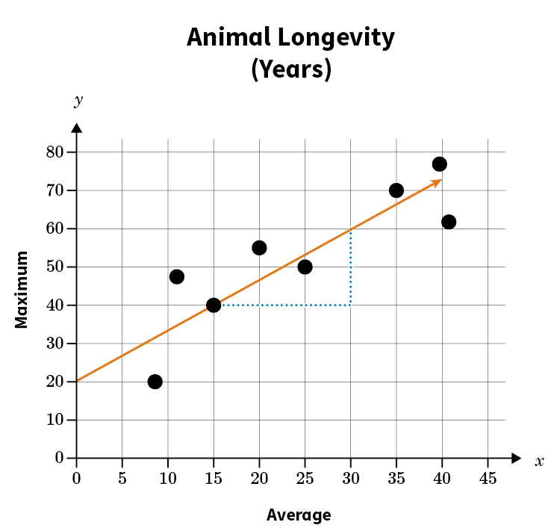  Write an equation in slope-intercept form of the trend line.  y=_____  Answer: $\frac{4}{3}x+20$  Scatter Plots & Data Analysis Unit Test Item #6 | Desmos
7 | Lesson 6: Trend Lines | For scatter plots that suggest a linear association, determine the equation of a trend line that approximates the linear relationship. | p. 9-13 | Use the image to answer the question.  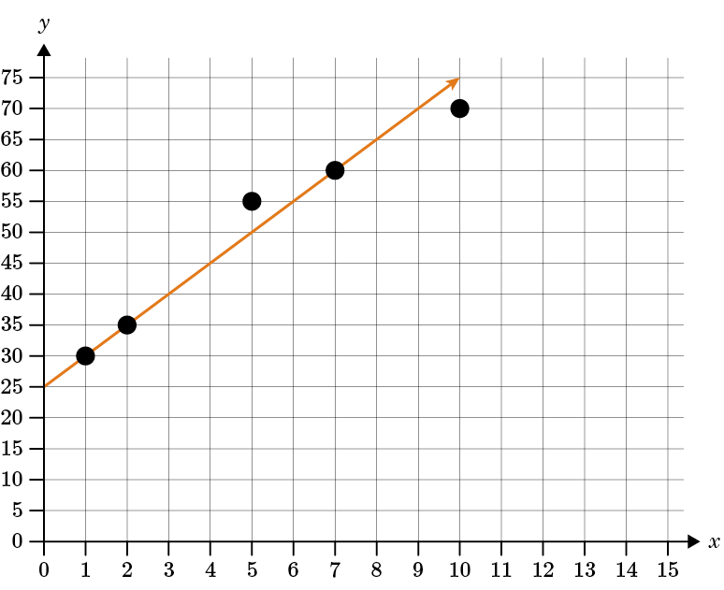  Write an equation in slope-intercept form of the trend line.  y=____  Answer: $5x+25$  Scatter Plots & Data Analysis Unit Test Item #7 | Desmos
8 | Lesson 7: Using Trend Lines | Interpret the slope and y-intercept of a linear model in terms of the data. | p. 1-5 | Use the image to answer the question.  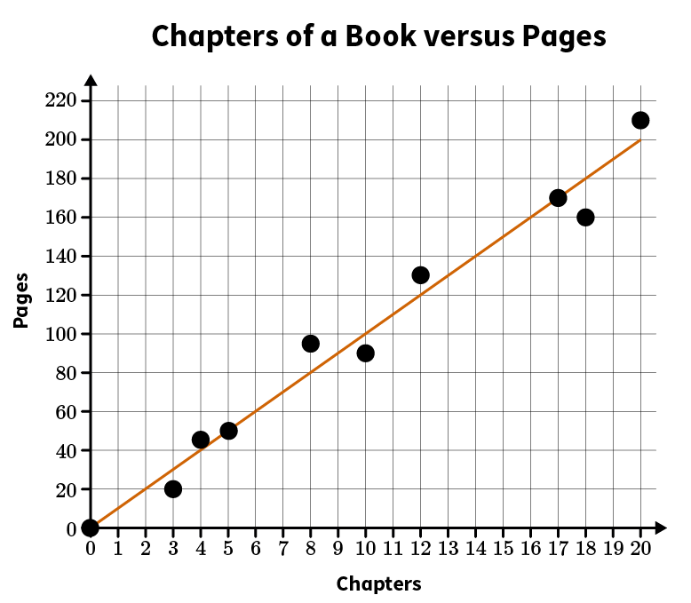  A librarian collected data on the number of pages in chapters of a book. Interpret the slope and the - intercept of the linear model. Round the slope to the nearest hundredth.  Answer: For every chapter of a book, there is an average of 10 pages.  Scatter Plots & Data Analysis Unit Test Item #8 | Desmos
9 | Lesson 7: Using Trend Lines | Interpret the slope and y-intercept of a linear model in terms of the data. | p. 1-5 | Use the image to answer the question.  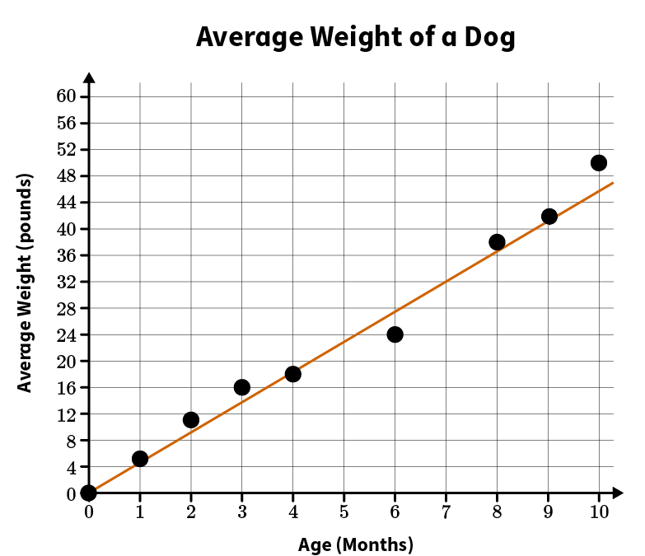  A veterinarian collected data on the average weight of dogs by age in months. Interpret the slope and the y-intercept (0, 0) of the linear model, using the ordered pair (9, 42). Round the slope to the nearest hundredth.  Answer: Every month, a dog averages a gain of 4.67 pounds.  Scatter Plots & Data Analysis Unit Test Item #9 | Desmos
10 | Lesson 7: Using Trend Lines | Use the equation of a linear model to make predictions about additional data points. | p. 6-10 | Use the image to answer the question.  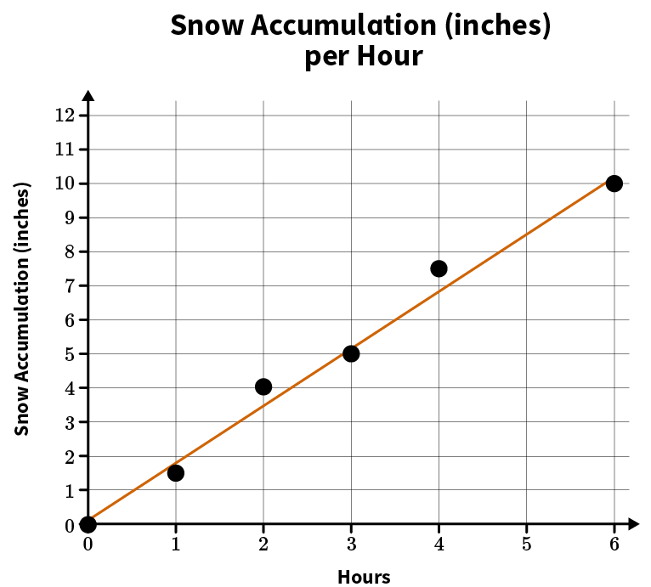  A meteorologist collected data on a recent snowfall. The meteorologist graphed the data and found the equation of the trend line to be $y=1.7x+0.1$. If the snowfall continues at this pace, use the equation to predict the number of inches of snow after 10 hours. Round to the nearest tenth.  After 10 hours, the snowfall would be _____ inches.  Answer: 17.1  Scatter Plots & Data Analysis Unit Test Item #10 | Desmos
11 | Lesson 8: Two-Way Tables | Construct a two-way table summarizing data on two categorical variables collected from the same subjects. | p. 1-6 | Use the table to answer the question.  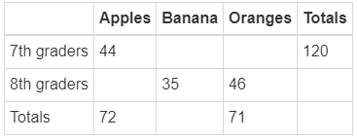  Constructing the two-way table, what is the total number of seventh graders who prefer bananas?  Answer: 51
12 | Lesson 8: Two-Way Tables | Interpret a two-way table summarizing data on two categorical variables collected from the same subjects. | p. 7-12 | Use the table to answer the question.  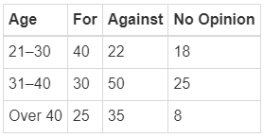  A poll was taken to explore the relationship between age and support for a candidate in an election. The results of the poll are summarized in the table. How many people above age 30 are for the candidate?  Answer: 55
13 | Lesson 9: Relative Frequencies | Determine the relative frequencies for rows and/or columns of a two-way table. | p. 1-6 | Use the table to answer the question.  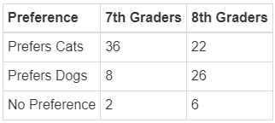  What is the relative frequency of students who prefer dogs who are 7th graders? Round the percentage to the nearest tenth.  Answer: 23.5%
14 | Lesson 9: Relative Frequencies | In two-way tables, use relative frequencies calculated for rows or columns to describe possible associations between the two variables. | p. 7-11 | Use the table to answer the question.  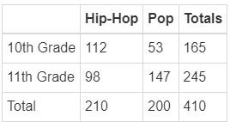  Examine the data from a survey of 10th and 11th graders about which music genre they prefer.  Using relative frequencies, which of the following is true?  Answer: If you like hip-hop, you are almost equally likely to be from 10th or 11th grade.
15 | Lesson 2: Scatter Plots | Interpret scatter plots for bivariate measurement data by describing patterns of clustering and describing outliers. | p. 6-11 | Use the image to answer the question.  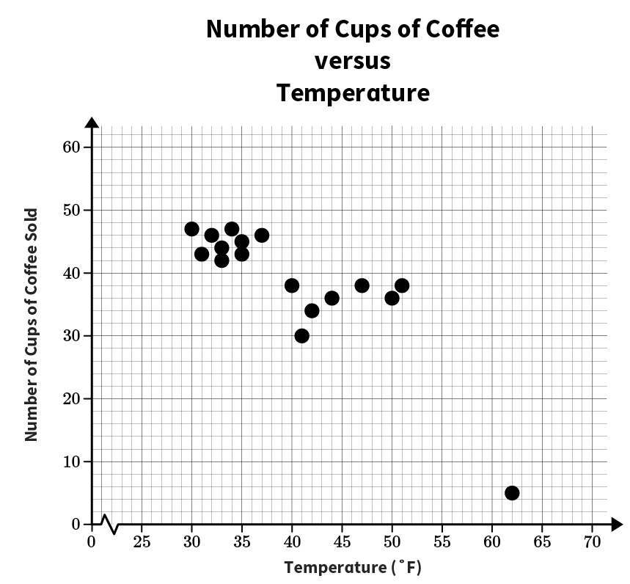  Interpret the scatterplot by describing any outliers and patterns of clustering.  Answer: The student should note that the point at (62, 5) is an outlier because it is so far away from the rest of the data points. The student should also notice that there are two clusters from 30 degrees to 37 degrees and from 40 degrees to 51 degrees. The student should explain that the scatterplot shows that coffee tends to be sold when the temperature is between 30 degrees and 50 degrees.

