Math 8 B Unit Test Guide

Graphing Linear Equations Unit Test

Item | Lesson Coverage | Objective | Lesson Page | Assessment Item
1 | Lesson 2: Proportional Relationships | Describe what makes a ratio | p. 1-6 | Write the ratio $12:9$ as an equivalent ratio of$4:x.$  Answer: $4:3$
2 | Lesson 2: Proportional Relationships | Determine if two ratios are proportional | p. 13-18 | Which of the following, Option 1 or Option 2, is a proportion?  Option 1: $\frac{5}{6}=\frac{15}{18}$  Option 2: $\frac{5}{6}=\frac{20}{18}$  Option _____ is a proportion.  Answer: 1
3 | Lesson 3: Unit Rate from Tables and Equations | Determine the unit rate of a proportional relationship from a table. | p. 1-6 | Use the table to answer the question.  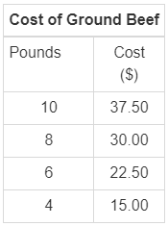  What is the cost for 1 pound of ground beef?  Answer: 3.75
4 | Lesson 3: Unit Rate from Tables and Equations | Determine the unit rate of a proportional relationship from an equation. | p. 7-12 | There are 48 inches in 4 feet, which is represented by the equation $4y=48x$. Determine the number of inches per foot.  Answer: 12 inches
5 | Lesson 4: Graphing Proportional Relationships | Derive the equation y = mx for a line through the origin. | p. 1-7 | Use the image to answer the question.  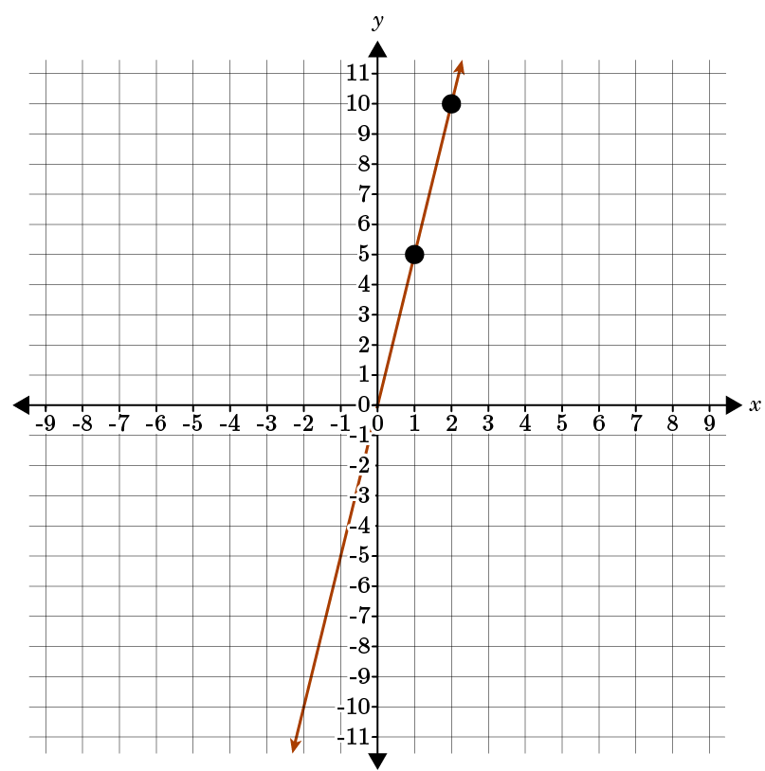  The graph shows the proportional relationship. Derive the equation of the line $y=mx$ through the origin.  Answer: $y=5x$  Graphing Linear Equations Unit Test Item #5 | Desmos
6 | Lesson 4: Graphing Proportional Relationships | Graph proportional relationships. | p. 8-13 | Graph the proportional relationship y=2x by plotting points.  Answer:  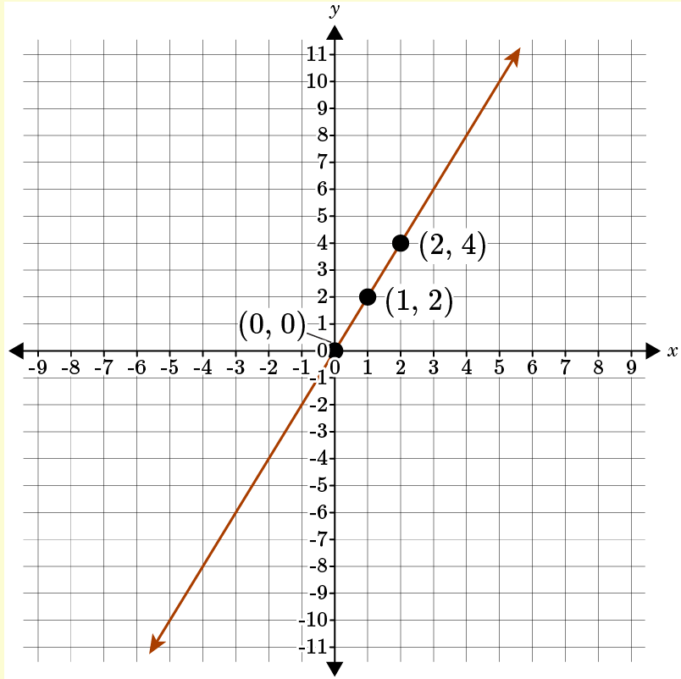  Graphing Linear Equations Unit Test Item #6 | Desmos
7 | Lesson 5: Slope as Unit Rate | Determine the unit rate of a proportional relationship using a graph. | p. 1-6 | Use the image to answer the question.  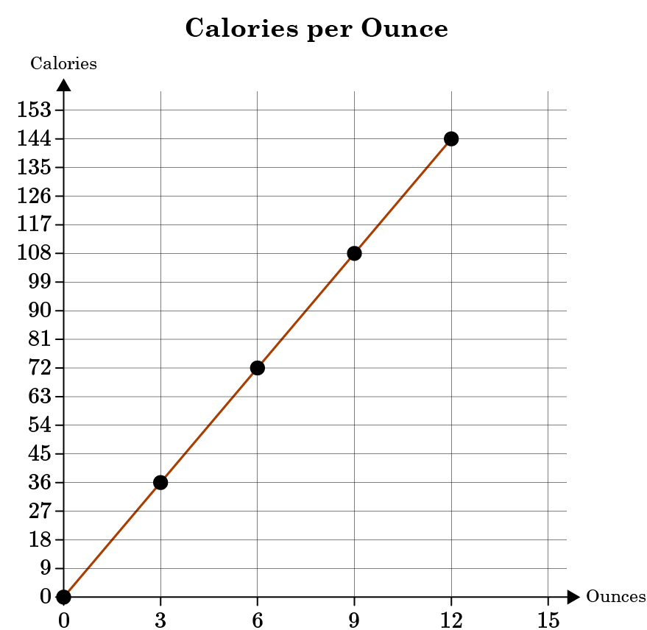  The proportional relationship between calories and ounces of soda is shown in the graph. How many calories are in 1 ounce?  There are _____ calories in 1 ounce of soda.  Answer: 12  Graphing Linear Equations Unit Test Item #7 | Desmos
8 | Lesson 5: Slope as Unit Rate | Interpret the unit rate as the slope of the graph of a proportional relationship. | p. 7-11 | Use the image to answer the question.  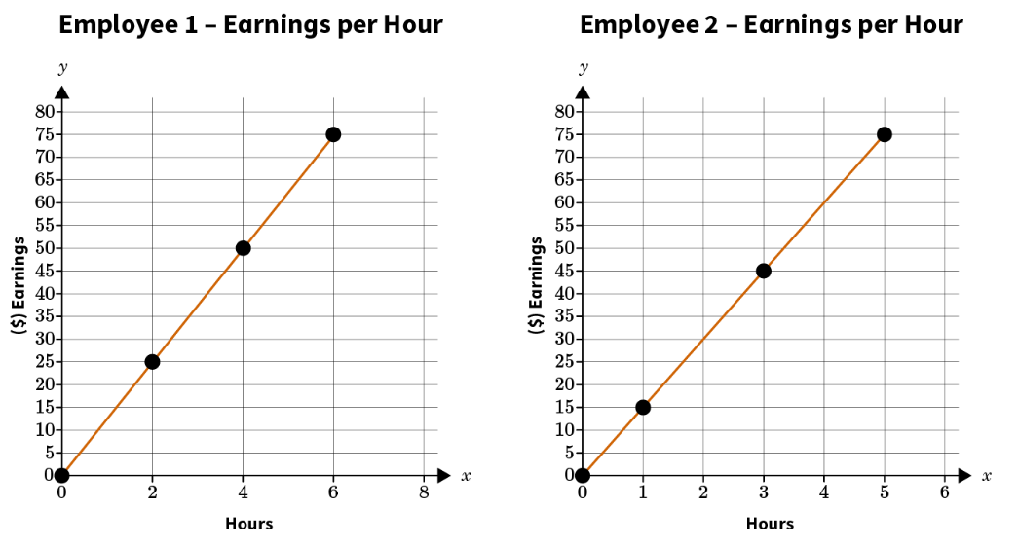  The earnings for Employee 1 and Employee 2 are displayed in the following graphs. Which employee earns more per hour?  Employee _____ earns more per hour.  Answer: 2  Graphing Linear Equations Unit Test Item #8 | Desmos
9 | Lesson 5: Slope as Unit Rate | Use similar triangles to explain why the slope, m, is the same between any two distinct points on a non-vertical line in the coordinate plane. | p. 12-18 | Use the image to answer the question.  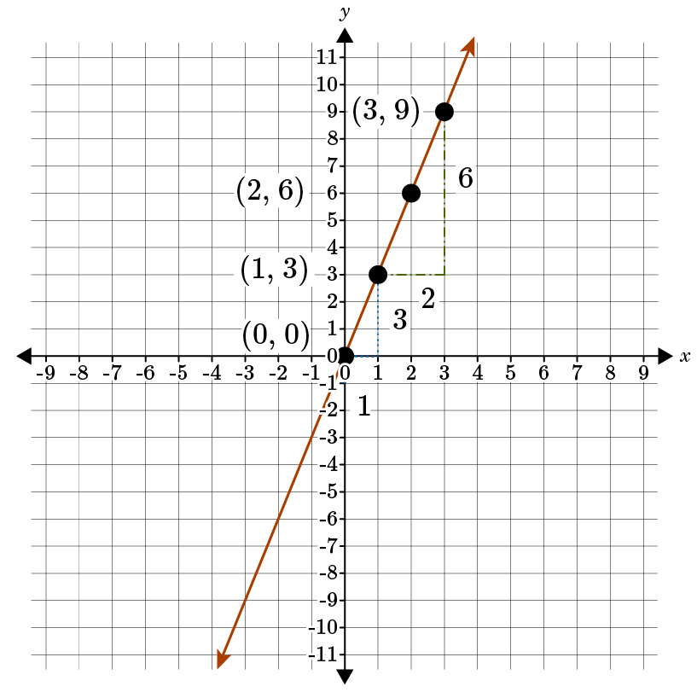  Use similar triangles to determine the slope of the line.  The slope is _____.  Answer: 3
10 | Lesson 6: Compare Proportional Relationships | Compare two different proportional relationships represented in two different ways. | All | Use the table to answer the question.  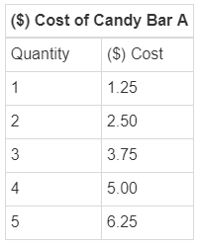  The cost of Candy Bar A is displayed in the table. The proportional relationship between the cost and quantity for Candy Bar B is represented by the equation $y=x$. Which candy bar is the cheapest cost per bar? Enter 1 for Candy Bar A. Enter 2 for Candy Bar B.  Answer: 2  Graphing Linear Equations Unit Test Item #10 | Desmos
11 | Lesson 7: Graphing Equations | Derive the equation $y = mx + b$ for a line intercepting the vertical axis at b. | p. 1-6 | Use the image to answer the question.  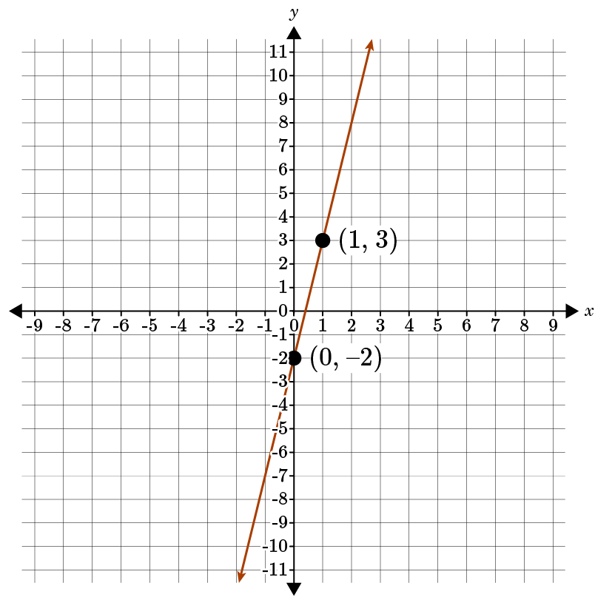  Use the graph to derive the equation of the line in slope-intercept form.  Answer: $y=5x-2$  Graphing Linear Equations Unit Test Item #11 | Desmos
12 | Lesson 7: Graphing Equations | Graph linear equations in the form $y=mx+b$. | p. 7-14 | Graph the linear equation $y=2x-3$.  Answer:  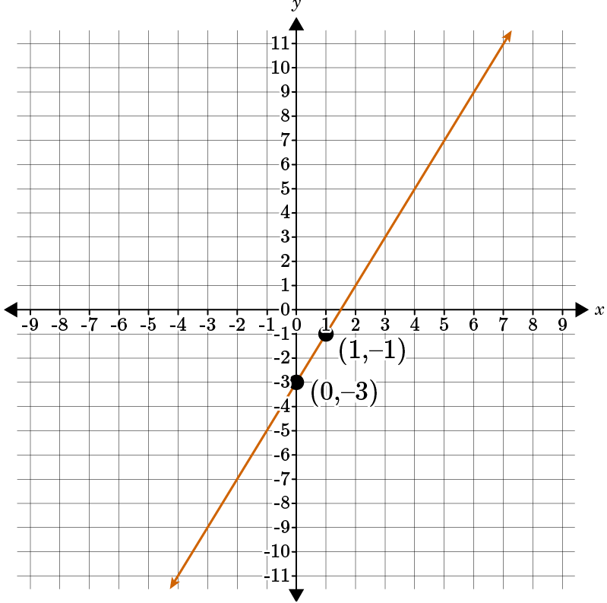  Graphing Linear Equations Unit Test Item #12 | Desmos
13 | Lesson 8: Slope-Intercept Form | Transform linear equations in any form to slope-intercept form. | p. 1-6 | Write $y-6x=5$ in slope-intercept form.  Answer: $y=6x+5$
14 | Lesson 8: Slope-Intercept Form | Graph linear equations in any form by re-writing in slope-intercept form. | p. 7-12 | Graph the equation $x-y=6$ using the form $y=mx+b$.  Answer:  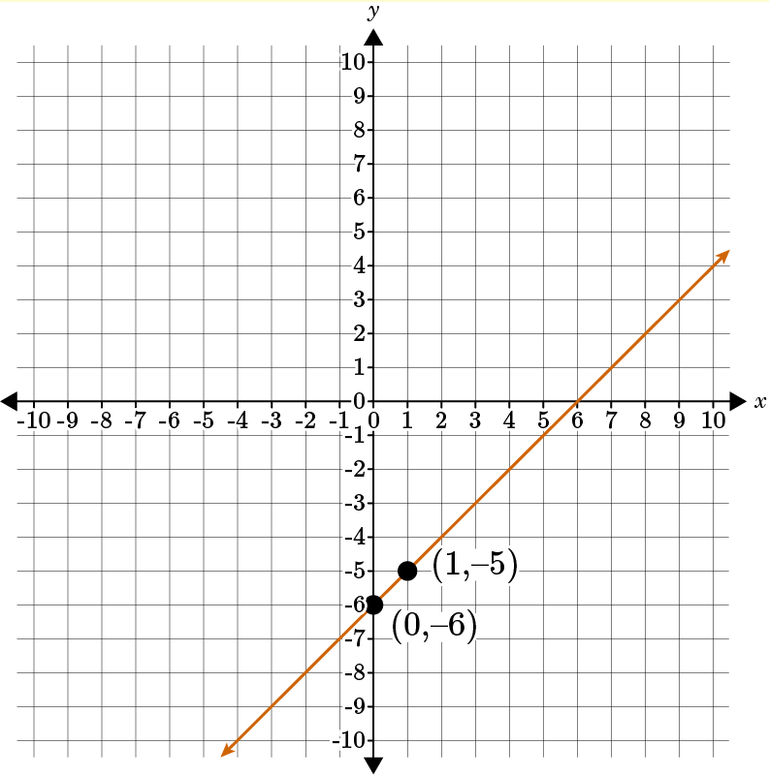  Graphing Linear Equations Unit Test Item #14 | Desmos
15 | Lesson 2: Proportional Relationships | Describe what makes a proportion | p. 7-12 | Describe what makes a proportion. Give an example of a proportion.  Answer: The student should explain that a proportion is an equation or statement that two ratios are equal to each other. The student should also provide an example of a proportion such as $\frac{1}{2}=\frac{8}{16}$ or $1:2=8:16$.

