Math 8 B Unit Test Guide

Transformations and Similarity Unit Test

Item | Lesson Coverage | Objective | Lesson Page | Assessment Item
1 | Lesson 2: Dilations | Describe the effect of dilations of line segments on the coordinate plane | p. 1-6 | Use the image to answer the question.  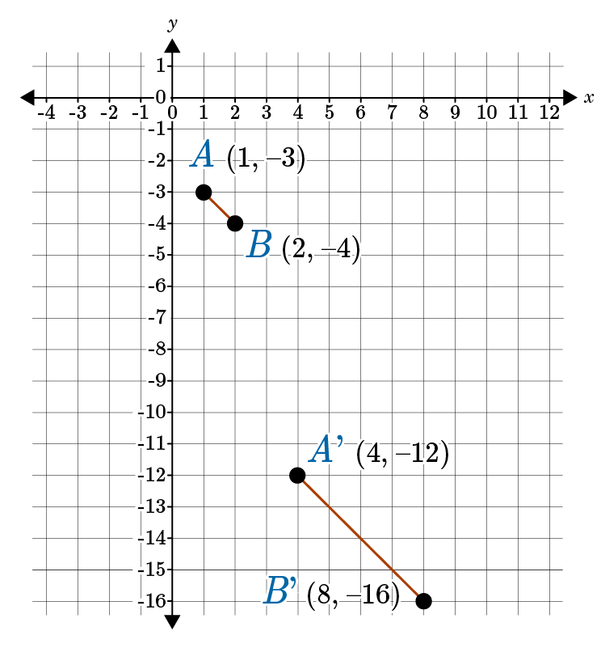  Determine the scale factor used in the dilation of line segment AB, centered at the origin.  Answer: 4  Transformations and Similarity Unit Test Item #1 | Desmos
2 | Lesson 2: Dilations | Describe the effect of dilations of lines on the coordinate plane | p. 7-12 | Use the image to answer the question.  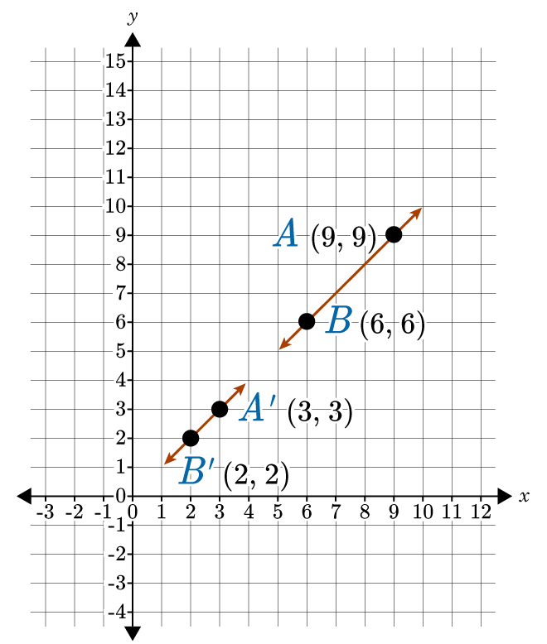  Determine the scale factor used in the dilation of line AB, with a center point of dilation at the origin.  Answer: $\frac{1}{3}$  Transformations and Similarity Unit Test Item #2 | Desmos
3 | Lesson 2: Dilations | Describe the effect of dilations on two-dimensional figures, using coordinates. | p. 13-18 | Triangle ABC has vertices point A (-2, -2), point B (-4, -3), and point C (-2, -5). Find the coordinates of A’, B’, and C’ after a dilation with a scale factor of 3 and a center point of dilation at the origin.  Answer:  $$A’=(-6, -6)$$  $$B’=(-12, -9)$$  $$C’=(-6, -15)$$  Transformations and Similarity Unit Test Item #3 | Desmos
4 | Lesson 3: Similar Figures | Describe two-dimensional figures as being similar to another figure if the second figure can be obtained from the first by a sequence of rotations, reflections, translations, and dilations. | p. 1-8 | Use the image to answer the question.  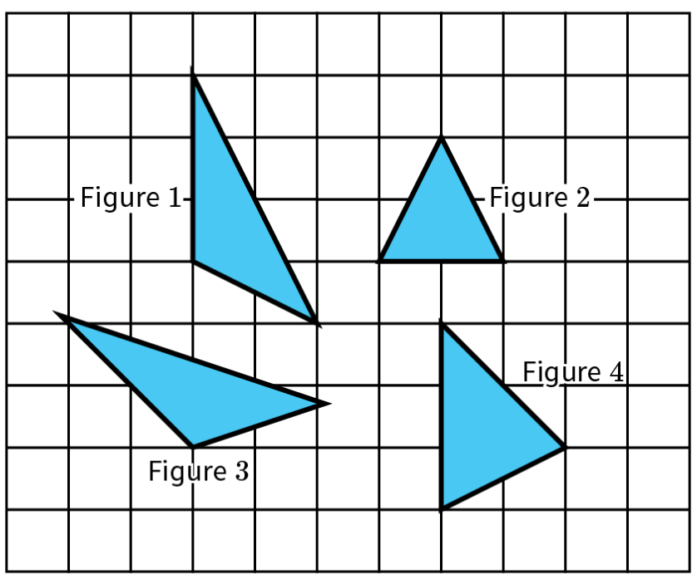  Which figure is similar to Figure 1?  Answer: 3
5 | Lesson 3: Similar Figures | Describe two-dimensional figures as being similar to another figure if the second figure can be obtained from the first by a sequence of rotations, reflections, translations, and dilations. | p. 1-8 | Use the image to answer the question.  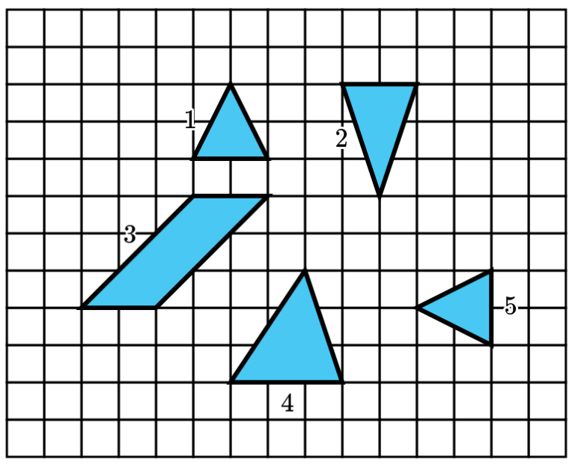  Which figure is similar to Figure 1?  Answer: 5
6 | Lesson 3: Similar Figures | Given two similar two-dimensional figures, describe a sequence of transformations that exhibits the similarity between them. | p. 9-15 | Use the image to answer the question.  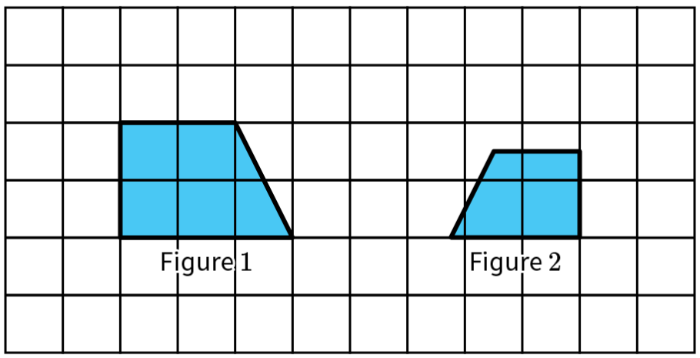  Describe the sequence of transformations that exhibits the similarity between Figures 1 and 2.  Answer: dilation and reflection
7 | Lesson 6: Scale Drawings | Relate scale drawings to dilations of geometric figures. | p. 1-6 | Use the image to answer the question.  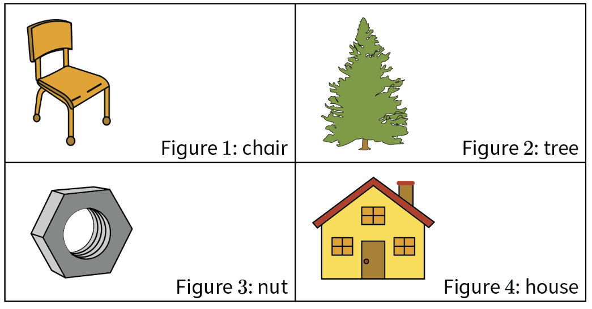  Which scale drawing is a dilation that increased the size of the original object it represents?  Answer: 3
8 | Lesson 6: Scale Drawings | Dilate geometric figures using scale factors that are positive rational numbers. | p. 7-13 | If you would like to dilate a square with a side length of 8 units to create a square with a side length of 20 units, what scale factor should you use? Write your answer in decimal form.  Answer: 2.5  Transformations and Similarity Unit Test Item #8 | Desmos
9 | Lesson 6: Scale Drawings | Dilate geometric figures using scale factors that are positive rational numbers. | p. 7-13 | You use scale factor of $\frac{3}{4}$ to create a dilated circle with a radius of 9 inches. What is the radius of the original circle?  Answer: 12
10 | Lesson 7: Sides of Similar Figures | Use proportional reasoning to find the missing side lengths of two similar figures. | All | Use the image to answer the question.  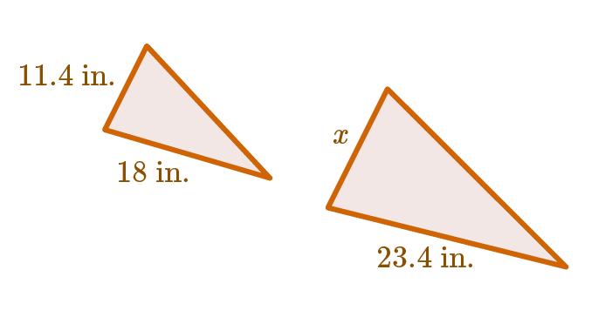  What is the length of x in decimal form to the nearest hundredth?  Answer: 14.82 inches
11 | Lesson 8: Angles of Similar Triangles | Describe two similar figures as having congruent corresponding angles. | p. 1-6 | $ΔCDE\sim ΔPQR. m∠C=13°, m∠D=65°$. What are the measures of angles, P, Q, and R?  Answer:  $$m∠P=13°$$  $$m∠Q=65°$$  $$m∠R=102°$$
12 | Lesson 8: Angles of Similar Triangles | Describe two similar figures as having congruent corresponding angles. | p. 1-6 | $ΔXYZ\sim ΔRST. m∠X=50°, m∠S=79°$. What is the measure of angle T?  Answer: $m∠T=51°$
13 | Lesson 8: Angles of Similar Triangles | Use informal arguments to establish facts about the angle-angle criterion for similarity of triangles. | p. 7-13 | Given $ΔABC\sim ΔDEF. m∠A=52°, m∠E=11°$, what is the measure of angle C?  Answer: $m∠C=117°$
14 | Lesson 8: Angles of Similar Triangles | Use informal arguments to establish facts about the angle-angle criterion for similarity of triangles. | p. 7-13 | Given $ΔPQR\sim ΔLMN. m∠Q=113°, m∠R=26°$, what is the measure of angle N?  Answer: $m∠N=26°$
15 | Lesson 2: Dilations | Describe the effect of dilations of lines on the coordinate plane | p. 7-12 | Line AB is on the coordinate plane and does not pass through the origin. Line AB is dilated with a scale factor of 3 and a center of dilation at the origin to create line A’B’. Describe the effect of the dilation on line AB. In particular, make sure to describe the relative location and size of line A’B’ compared to line AB. If line AB was dilated with a scale factor of $\frac{1}{3}$, how would your answer change?  Answer: The student should explain that the distance between points A’ and B’ will change based on the scale factor. If the scale factor is 3, the distance between A’ and B’ will increase; if the scale factor is $\frac{1}{3}$ , the distance between A’ and B’ will decrease. The student should also mention that the location of the line will change depending on the scale factor. When the scale factor is 3, line A’B’ will be farther away from the origin than line AB. When the scale factor is $\frac{1}{3}$, line A’B’ will be closer to the origin than line AB.

