Math 8 B Unit Test Guide

Functions Unit Test

Item | Lesson Coverage | Objective | Lesson Page | Assessment Item
1 | Lesson 2: Functions | Determine if a relation is a function. | p. 8-15 | Determine if the relation $y=4x-1$ is a function by first graphing the relation, then applying the vertical line test. Enter 1 if the relation is a function. Enter 2 if the relation is not a function.  Answer: 1  Functions Unit Test Item #1 | Desmos
2 | Lesson 2: Functions | Give examples of functions that are not linear. | p. 16-21 | Determine if $7x^{2}+y=5$ is a linear or nonlinear function.  Answer: The function $7x^{2}+y=5$ is a nonlinear function.  Functions Unit Test Item #2 | Desmos
3 | Lesson 3: Graph of a Function | Describe the graph of a function as the set of ordered pairs consisting of an input and the corresponding output. | p. 1-8 | Use the image to answer the question.  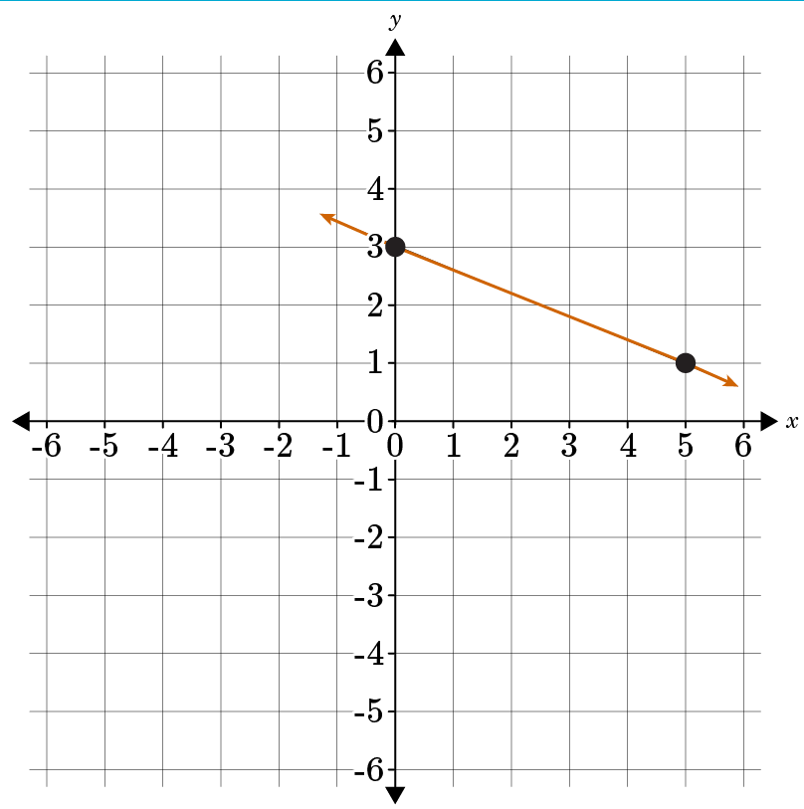  Determine if the given graph is the graph of the function $y=-\frac{2}{5}x+3.$ Enter 1 for yes. Enter 2 for no.  Answer: 1  Functions Unit Test Item #3 | Desmos
4 | Lesson 4: Slope and y-intercepts | Determine the initial value and the rate of change for a linear function given a description of the relationship between the two quantities. | p. 1-8 | Determine the initial value and the rate of change in the following description.  Last year, Joshua’s tomato plant reached a maximum height of 2 feet. He is growing another tomato plant this year, and he is tracking its growth. The plant’s height today is 10 inches, and it grows 1.7 inches each day.  The initial value is b= _____, and the rate of change is m=_____.  Answer: 10; 1.7
5 | Lesson 4: Slope and y-intercepts | Determine the initial value and the rate of change for a linear function given two (x, y) values from a table. | p. 9-16 | Use the table to answer the question.  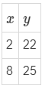  Determine the rate of change and the initial value of the linear function given here as a table of values.  The rate of change is m=_____, and the initial value is b=_____.  Answer: $\frac{1}{2};21$  Functions Unit Test Item #5 | Desmos
6 | Lesson 4: Slope and y-intercepts | Determine the initial value and the rate of change for a linear function given two (x, y) values from a graph. | p. 17-25 | Use the image to answer the question.  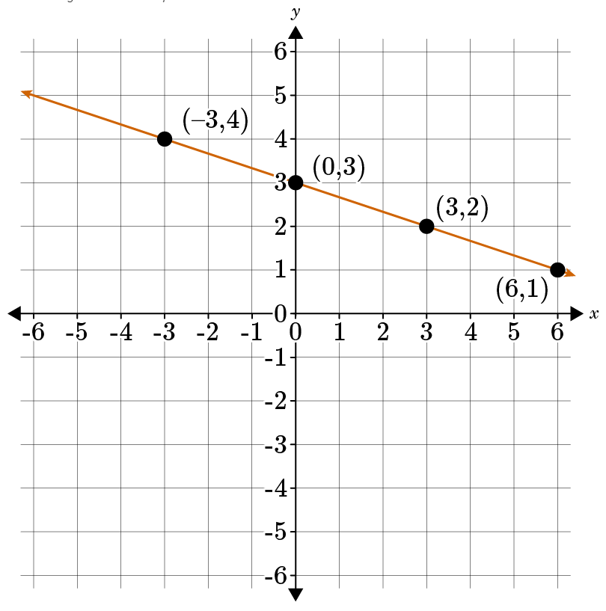  Determine the initial value and the rate of change of the linear function as given in the graph. Round the answer to three decimal places as needed.  The initial value is _____, and the rate of change is _____.  Answer: 3; $-\frac{1}{3}$  Functions Unit Test Item #6 | Desmos
7 | Lesson 5: Slope in Real-World Problems | Interpret the rate of change of a linear function in terms of the situation it models and its graph. | p. 7-11 | Use the image to answer the question.  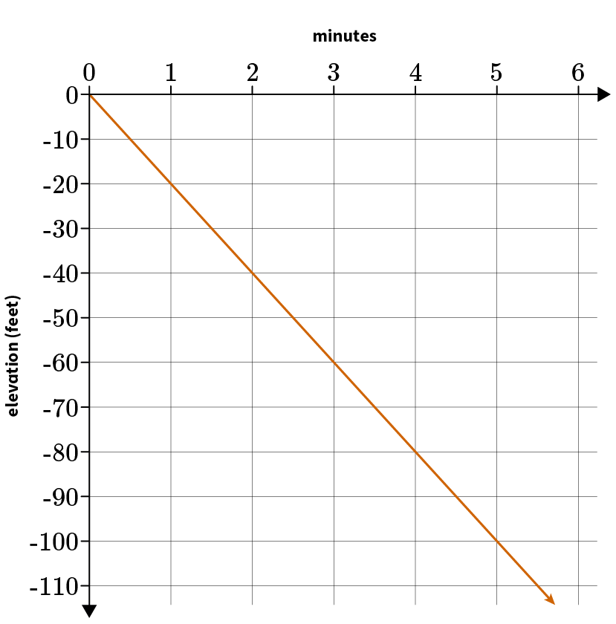  The graph shows the elevation of a deep-sea diver in relation to minutes passed. Using any two points on the graph, what is the rate of change in the diver’s elevation?  _____ feet per minute  Answer: -20  Functions Unit Test Item #7 | Desmos
8 | Lesson 6: y-intercepts in Real-World Problems | Interpret the initial value of a linear function in terms of the situation it models and its table of values. | p. 1-6 | A pan with four eggs weighs 18 ounces. A pan with eight eggs weighs 24 ounces. What is the weight of the pan?  _____ oz.  Answer: 12  Functions Unit Test Item #8 | Desmos
9 | Lesson 6: y-intercepts in Real-World Problems | Interpret the initial value of a linear function in terms of the situation it models and its graph. | p. 7-11 | Manuel got a new job and was given a hiring bonus along with his monthly salary. His earnings after months are modeled by the function $f\left(x\right)=1,500x+300$. How much did he receive as a hiring bonus?  Answer: 300  Functions Unit Test Item #9 | Desmos
10 | Lesson 7: Equations of Linear Functions | Interpret the equation y = mx + b as defining a linear function and describe the graph of a linear function as a straight line. | p. 1-5 | The equation $y=mx+b$ defines what type of function?  Answer: a linear function
11 | Lesson 7: Equations of Linear Functions | Write the equation of a linear function given a description of the relationship between the two quantities or two (x, y) values from a table. | p. 6-11 | Use the table to answer the question.  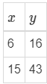  Write the equation of the linear function that models the relationship shown in the table. Enter your answer in $y=mx+b$ form.  Answer: $y=3x-2$  Functions Unit Test Item #11 | Desmos
12 | Lesson 7: Equations of Linear Functions | Write the equation of a linear function given a description of the relationship between the two quantities or two (x, y) values from a graph. | p. 12-17 | Last year, Alayah ordered 4 cubic yards of soil and spent $220. This year, she orders 7 cubic yards of soil and spends $340. Write the equation of the linear function that models the relationship between the number of cubic yards of soil ordered and the total cost. Enter your answer in $y = mx + b$ form.  Answer: $y=40x+60$  Functions Unit Test Item #12 | Desmos
13 | Lesson 8: Properties of Functions | Compare properties of two functions each represented in a different way (algebraically, graphically, numerically in tables, or by verbal descriptions). | p. 1-6 | Compare Linear Function 1 with Linear Function 2.  Which one has the greater rate of change? Choose 1 for Linear Function 1; choose 2 for Linear Function 2.  Linear Function 1: $y=x+8$  Linear Function 2:  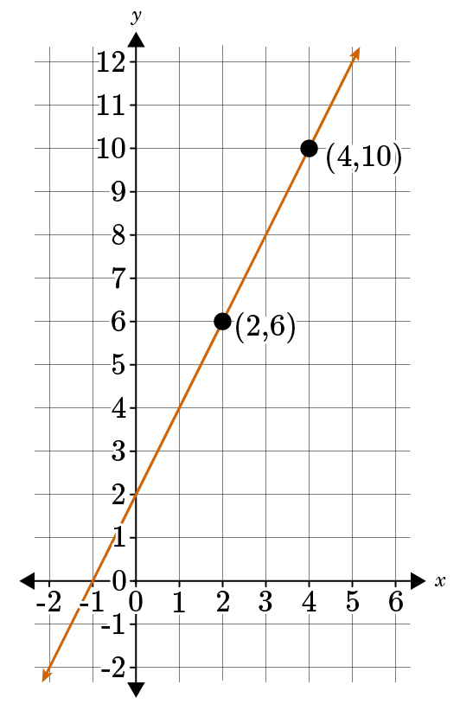  Linear Function _____ has the greater rate of change.  Answer: 2  Functions Unit Test Item #13 | Desmos
14 | Lesson 8: Properties of Functions | Sketch a graph that exhibits the qualitative features of a function that has been described verbally. | p. 7-12 | A function has an initial value of 2 and a slope equal to $-1$.  Choose the sketch of a graph that exhibits the qualitative features of the function.  Answer:  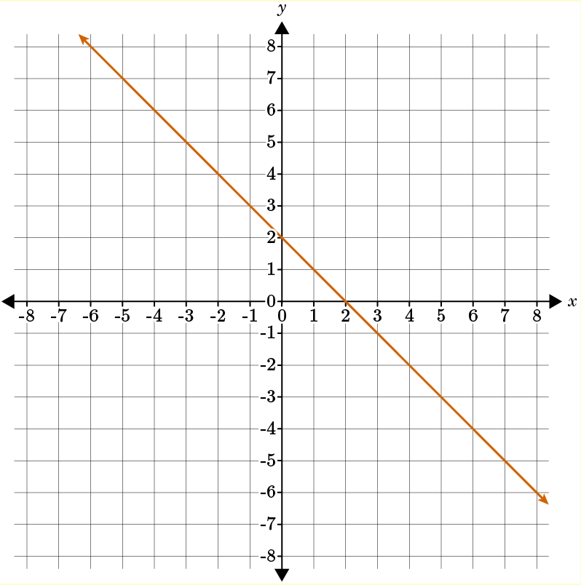  Functions Unit Test Item #14 | Desmos
15 | Lesson 2: Functions | Describe functions as rules that assign to each input exactly one output. | p. 1-7 | Use the table to answer the question.  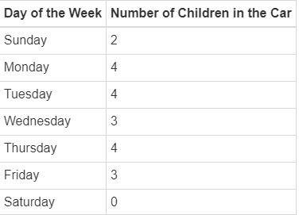  Describe the meaning of the word function in math. Then consider the table. Why does this table show a function?  Answer: In math, a function is a rule that assigns exactly one output to each input. The student should explain that the table shows a function because each input (day of the week) has only one output (a specific number of children in the car).

