Math 8 B Unit Test Guide

Systems of Linear Equations Unit Test

Item | Lesson Coverage | Objective | Lesson Page | Assessment Item
1 | Lesson 2: Solving Systems of Equations by Graphing | Show that the solution to a system of two linear equations in two variables corresponds to points of intersection of their graphs by showing that the coordinates of the intersecting points satisfy both equations simultaneously. | p. 1-5 | Use the image to answer the question.  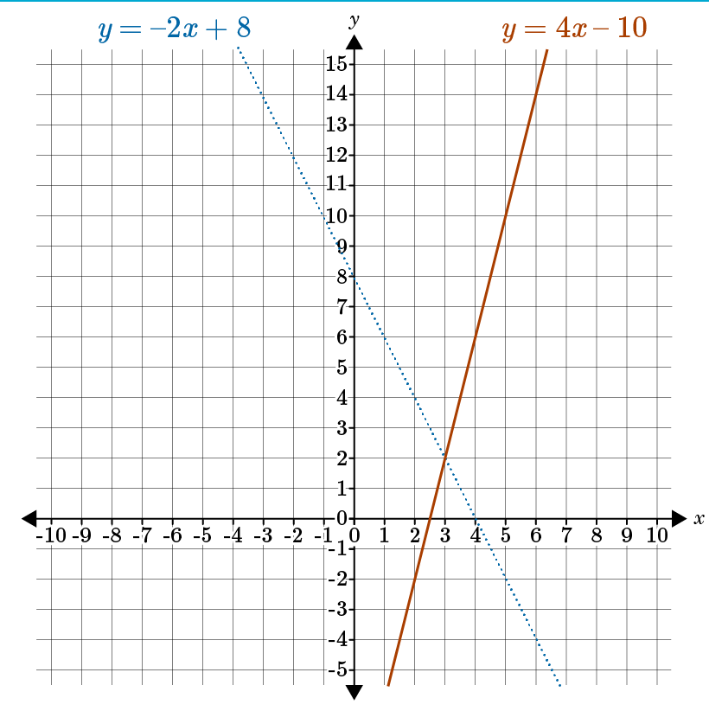  Review the graphs of a system of these two linear equations in two variables: $y=4x-10$ and $y=-2x+8$. Find the solution of the system.  The solution of the system is _____  Answer 3, 2  Systems of Linear Equations Unit Test Item #1 | Desmos
2 | Lesson 2: Solving Systems of Equations by Graphing | Estimate solutions to systems of two linear equations that have one solution in two variables by graphing the equations. | p. 6-10 | Use the image to answer the question.  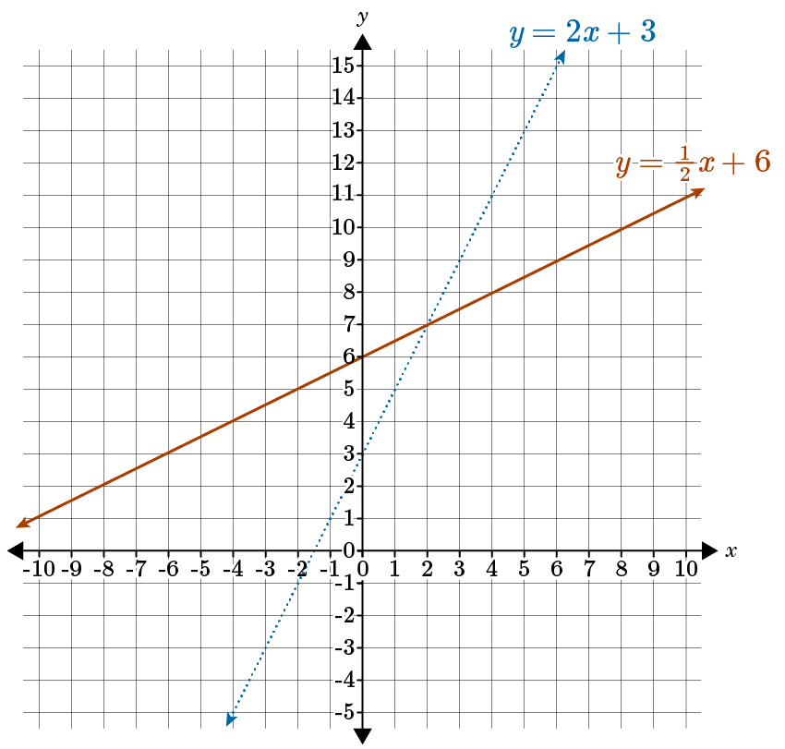  Estimate the solution to the system of these linear equations based on the graph.  $$y=2x+3$$  $$y=\frac{1}{2}x+6$$  Answer: (2, 7)  Systems of Linear Equations Unit Test Item #2 | Desmos
3 | Lesson 2: Solving Systems of Equations by Graphing | Estimate solutions to systems of two linear equations that have one solution in two variables by graphing the equations. | p. 6-10 | Use the image to answer the question.  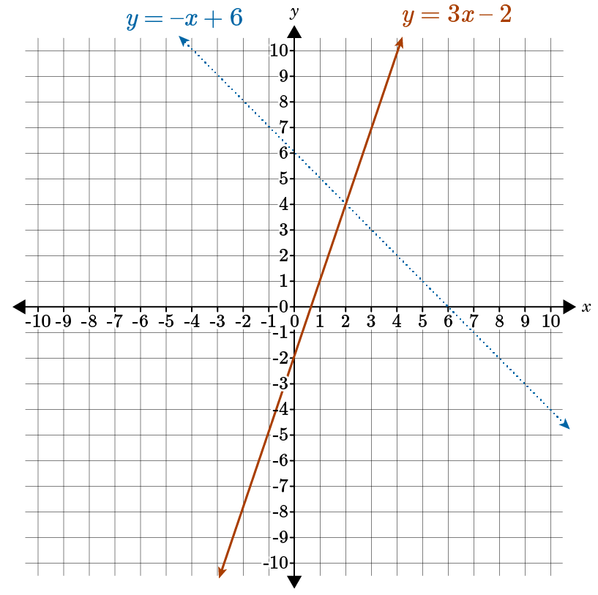  Estimate the solution to the system of these linear equations based on the graph.  $$y=-x+6$$  $$y= 3x-2$$  Answer: 2, 4  Systems of Linear Equations Unit Test Item #3 | Desmos
4 | Lesson 3: One Solution, No Solution, or Many Solutions | Solve simple systems of two linear equations in two variables by inspection. | p. 1-5 | Determine the number of solutions to this system of linear equations:  $$2x+y=6$$  $$4x+2y=8$$  Answer: 0  Systems of Linear Equations Unit Test Item #4 | Desmos
5 | Lesson 3: One Solution, No Solution, or Many Solutions | Solve systems of two linear equations in two variables by graphing the equations for systems that have no solution. | p. 6-11 | Which of the graphs with no solution correctly shows the system of equations $y=2x+4$ and $-2x+y=8$?  Answer:  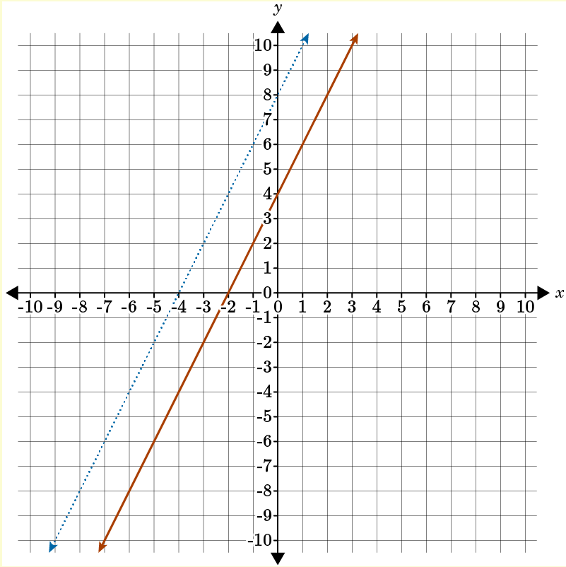  Systems of Linear Equations Unit Test Item #5 | Desmos
6 | Lesson 3: One Solution, No Solution, or Many Solutions | Solve systems of two linear equations in two variables by graphing the equations for systems that have infinite solutions. | p. 12-17 | Which of these graphs shows that the linear system $3x+2y=12$ and $6x+4y=24$ has an infinite number of solutions?  Answer:  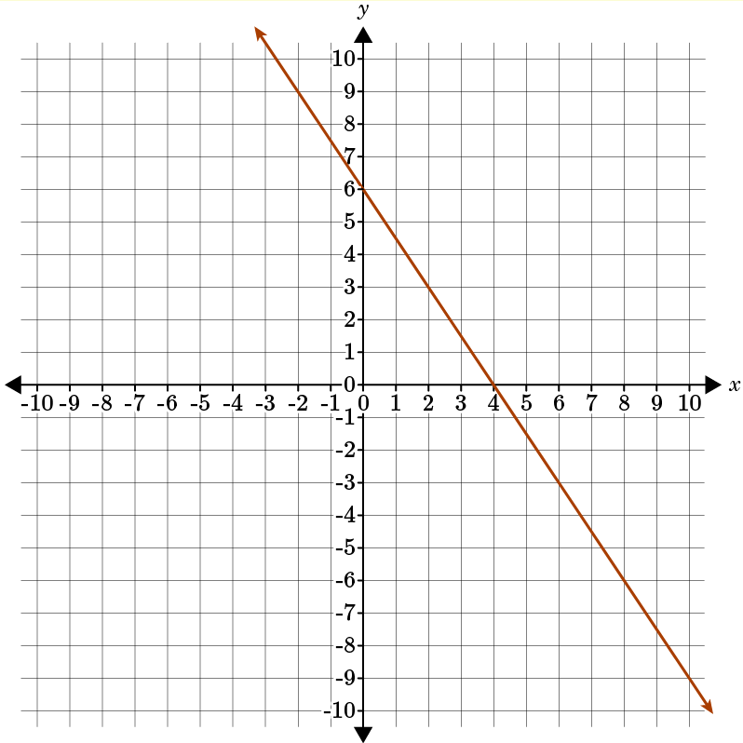  Systems of Linear Equations Unit Test Item #6 | Desmos
7 | Lesson 4: Solving equations using Substitution | Solve systems of two linear equations in two variables using substitution. | All | Solve the system of equations.  $$4x-8y=-36$$  $$-6x+y=32$$  Answer: -5; 2
8 | Lesson 5: Solving with Elimination | Solve systems of two linear equations in two variables using elimination. | p. 1-6 | Solve the system of equations.  $$6x-43=-6$$  $$9x-3y=-18$$  Answer: -4; -6
9 | Lesson 5: Solving with Elimination | Solve systems of two linear equations in two variables using elimination with multiplication. | p. 7-14 | Solve the system of equations.  $$5x-4y=-44$$  $$-x+3y=22$$  Answer: -4; 6
10 | Lesson 5: Solving with Elimination | Solve systems of two linear equations in two variables using elimination with multiplication. | p. 7-14 | Solve the system of equations.  $$-6x+2y=-32$$  $$4x+3y=-9$$  Answers: 3; -7
11 | Lesson 6: Real-World Systems of Equations | Create a pair of linear equations in two variables that represent a real-world problem. | p. 1-6 | The Math Club sold slices of pizza, p, at a profit of $3 each and cans of soda, s, at $2 each to raise money for a trip. They sold 200 items and made a profit of $550. Write the pair of linear equations that model this situation.  Equation to represent the total number of items sold: _____ = 200  Equation to represent the total profit: _____ = 550  Answer:  $$p+2$$  $$3p+2s$$
12 | Lesson 6: Real-World Systems of Equations | Solve real-world problems leading to two linear equations in two variables. | p. 7-13 | The Lakewood baseball team is selling T-shirts for a fundraiser. The shirts cost $100 for the printing design and setup, plus $10 per shirt. The team is going to sell the shirts for $15 each. How many shirts do they need to sell to break even?  _____ shirts  Answer: 20
13 | Lesson 6: Real-World Systems of Equations | Solve real-world problems leading to two linear equations in two variables. | p. 7-13 | The Kesling Middle School PTA is planning a carnival to raise money for the school’s art department. They estimate that the event will be very popular and that they will have 500 people attend. They plan to charge adults $10 and children $5 for admission. The PTA wants to earn $3,500 from admission charges. How many adults and how many children need to attend for the PTA to reach their goal of $3,500?  _____ adults; _____ children  Answer: 200; 300
14 | Lesson 3: One Solution, No Solution, or Many Solutions | Solve systems of two linear equations in two variables by graphing the equations for systems that have no solution. | p. 6-11 | Solve the following system of linear equations by graphing. Graph on your own piece of paper. In your submitted answer, describe what the graph looks like and what this tells you about the solution to the system of linear equations.  $$y=x+3$$  $$-4x+4y=28$$  Answer: The student should explain that the system of linear equations has no solution because the two lines do not intersect on the graph. They might also explain that the first equation has a y-intercept of 3 and a slope of 1, while the second equation has a y-intercept of 7 and a slope of 1. The lines have the same slopes but different y-intercepts so they are parallel.

