Math 8 B Unit Test Guide

Transformations and Congruence Unit Test

Item | Lesson Coverage | Objective | Lesson Page | Assessment Item
1 | Lesson 2: Translations and Reflections | Demonstrate the properties of reflections showing that lines are taken to lines and line segments to line segments of the same length. | p. 7-13 | A line containing the points ( −2, 3) and (2, 3) is reflected across the x-axis. How long is the reflected line?  Answer: infinitely long
2 | Lesson 3: Rotations | Demonstrate the properties of rotations showing that lines are taken to lines and line segments to line segments of the same length. | p. 1-7 | A line segment has endpoints (2, -1) and (5, -4). What are the new endpoints after rotating the segment $90°$ clockwise?  Answer: (-1, -2) and (-4, -5)
3 | Lesson 3: Rotations | Discover that orientation of the plane is preserved in rotations and translations, but not with reflections. | p. 8-14 | A rectangle has a side that is 10 units long. How long will this side be after the figure is translated down 4 units and to the right 5 units?  Answer: 10 units  Transformations and Congruence Unit Test Item #3 | Desmos
4 | Lesson 4: Vertical & Horizontal Translations | Translate geometric figures horizontally. | p. 7-12 | Use the image to answer the question.  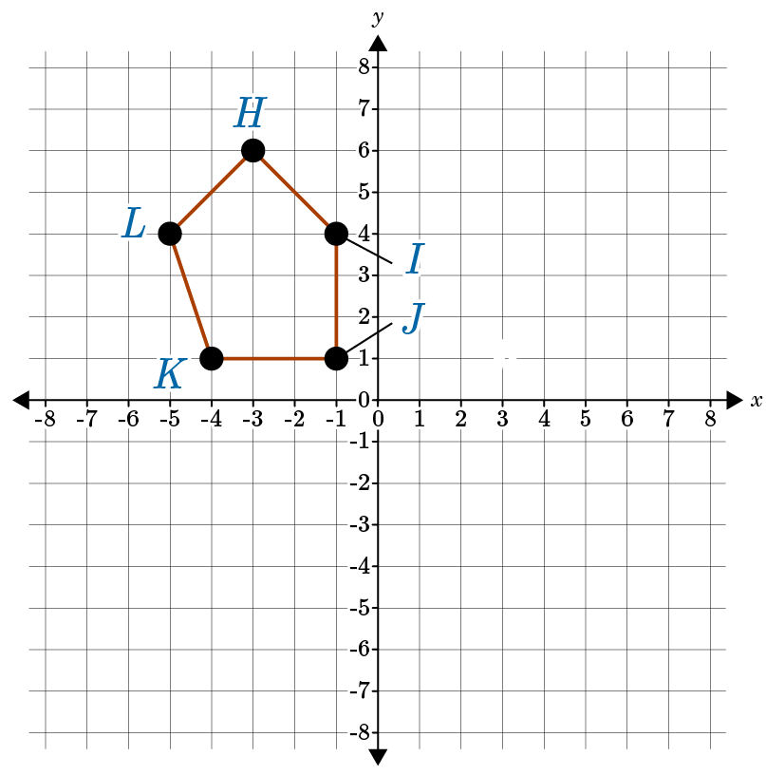  Translate the figure $HIJKL$ 3 units to the left. Which of the following would be a vertex in the translated figure?  Answer: (-6, 6)  Transformations and Congruence Unit Test Item #4 | Desmos
5 | Lesson 4: Vertical & Horizontal Translations | Translate geometric figures vertically and horizontally. | p. 13-17 | Triangle XYZ is translated down 4 units and to the left 8 units. The length of side XY is 10 units. What is the length of side X’Y’?  Answer: 10 units  Transformations and Congruence Unit Test item #5 | Desmos
6 | Lesson 4: Vertical & Horizontal Translations | Describe the effect of translations on two-dimensional figures, using coordinates. | p. 18-23 | Triangle MNO is translated up 5 units and left 2 units. Point N is located at (0, -6). What are the coordinates of N’?  Answer: (-2, -1)  Transformations and Congruence Unit Test Item #6 | Desmos
7 | Lesson 5: Reflections Across the x- or y- Axis | Reflect geometric figures with respect to the x-axis. | p. 1-5 | The shape of a heart is reflected across the x-axis. If the point at the bottom of the heart for the original figure is at $\left(3\frac{1}{4}, 7\frac{1}{2}\right)$, what are the coordinates for the point at the bottom of the heart in the reflected image?  Answer: $\left(3\frac{1}{4},- 7\frac{1}{2}\right)$  Transformations and Congruence Unit Test Item #7 | Desmos
8 | Lesson 5: Reflections Across the x- or y- Axis | Reflect geometric figures with respect to the y-axis. | p. 6-11 | Use the image to answer the question.  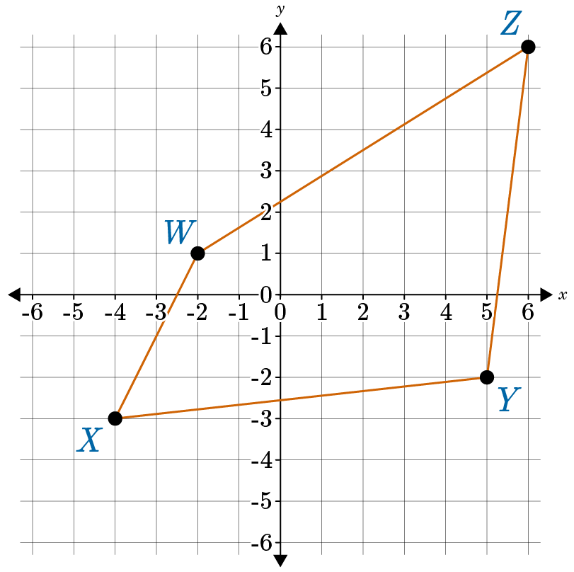  A four-sided figure WXYZ is shown on the coordinate plane. The figure is then reflected across the y-axis. Which point of the figure above will end up in Quadrant I?  Answer: Point W  Transformations and Congruence Unit Test Item #7 | Desmos
9 | Lesson 5: Reflections Across the x- or y- Axis | Reflect geometric figures with respect to the x-axis and y-axis. | p. 12-16 | Use the image to answer the question.  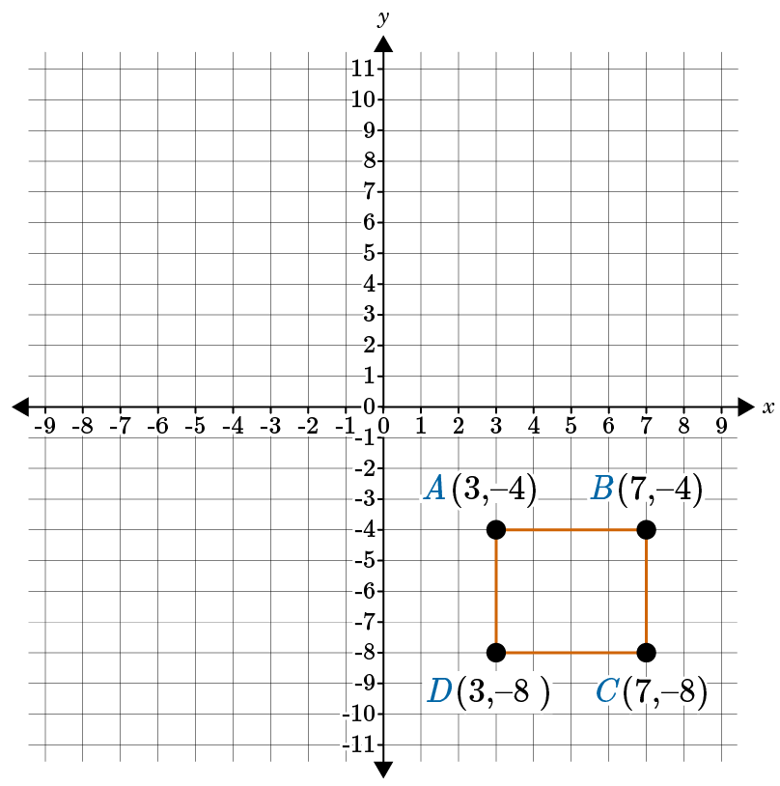  Reflect ABCD with respect to the x-axis and the y-axis. What are the vertices of square A’B’C’D’?  Answer: Square A’B’C’D has vertices A’ (-3, 4), B’ (-7, 4), C’ (-7, 8), and D’ (-3, 8).  Transformations and Congruence Unit Test Item #8 | Desmos
10 | Lesson 5: Reflections Across the x- or y- Axis | Describe the effect of reflections on two-dimensional figures, using coordinates. | p. 17-22 | Use the image to answer the question.  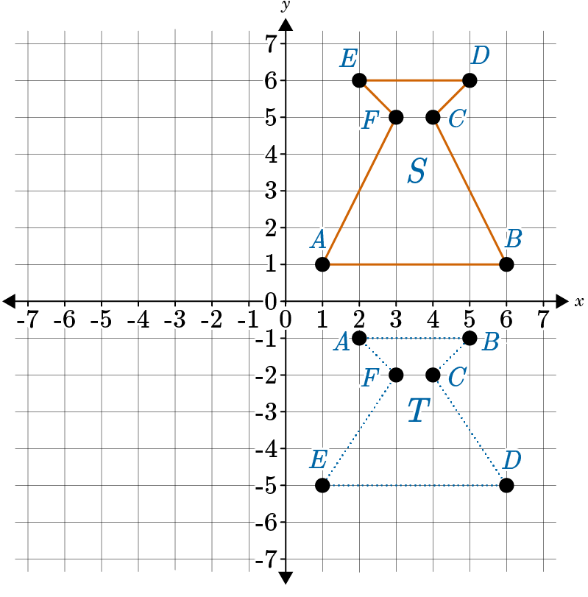  Is figure T a reflection of figure S across the x-axis? Choose 1 for yes and 2 for no.  Answer: 2
11 | Lesson 6: 90 and 270 Degree Rotations | Rotate geometric figures 90 degrees clockwise and 270 degrees counterclockwise about the origin. | p. 1-7 | Which of the following is an equivalent transformation to rotation of an object clockwise 90 degrees?  Answer: rotation about the origin of 270 degrees counterclockwise  Rotations Tool – GeoGebra
12 | Lesson 6: 90 and 270 Degree Rotations | Rotate geometric figures 270 degrees clockwise and 90 degrees counterclockwise about the origin. | p. 8-14 | Given a point (-7, 4) on a geometric figure, what is the new point after rotating the figure 90 degrees counterclockwise?  Answer: (-4, -7)  Transformations and Congruence Unit Test Item #12 | Desmos
13 | Lesson 7: 180 Degree Rotations | Describe the effect of rotations on two-dimensional figures, using coordinates. | p. 8-14 | Use the image to answer the question.  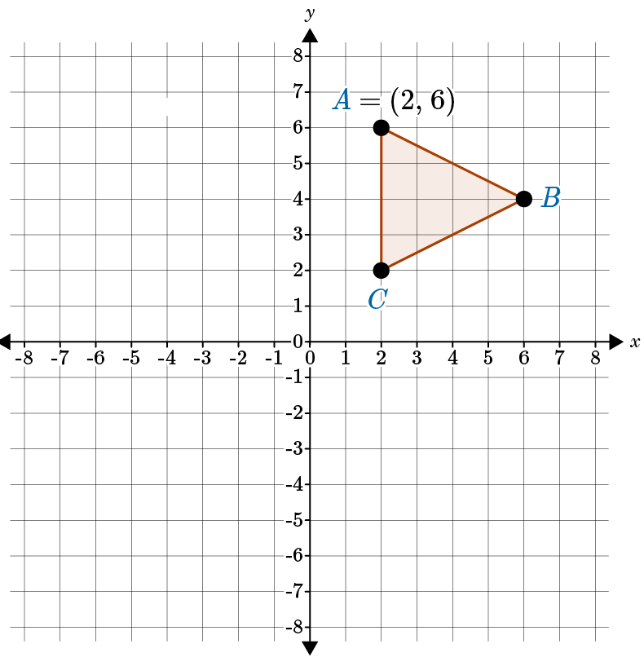  Given point A (2, 6) on the triangle, what are the new coordinates of the point after the triangle is rotated 180 degrees counterclockwise?  Answer: (-2, -6)  Transformations and Congruence Unit Test Item #13 | Desmos
14 | Lesson 8: Congruent Figures | Describe two-dimensional figures as being congruent to another figure if the second figure can be obtained from the first by a sequence of rotations, reflections, and translation. | p. 1-6 | Use the image to answer the question.  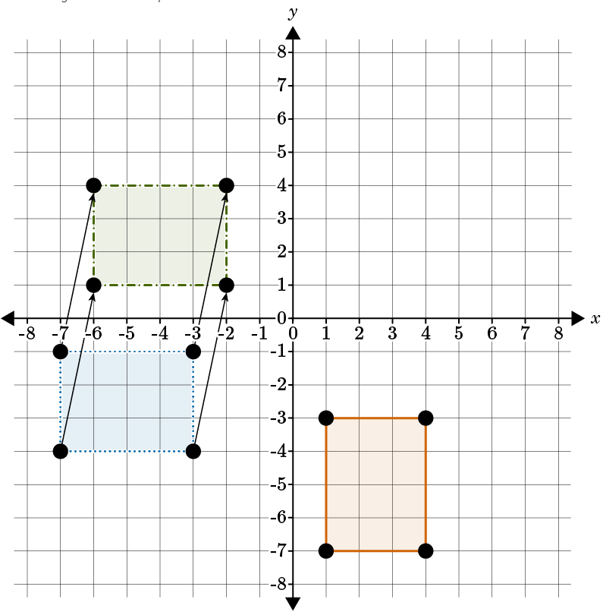  How would you describe the series of transformations that have occurred to move the rectangle in Quadrant IV to the rectangle in Quadrant II to show that the rectangles are congruent?  Answer: rotation, then translation
15 | Lesson 8: Congruent Figures | Given two congruent figures, describe a sequence of transformations that exhibits the congruence between them. | p. 7-12 | Use the image to answer the question.  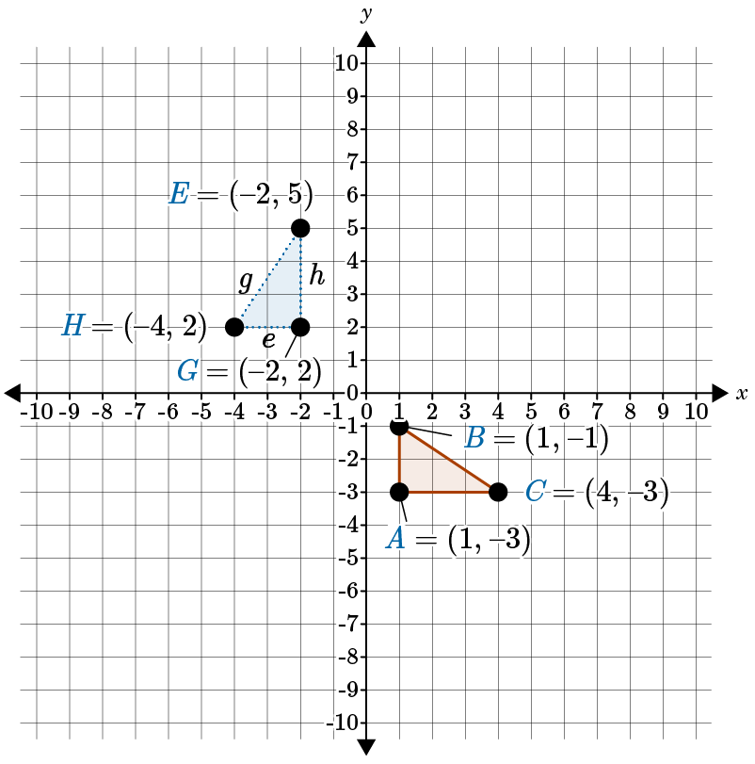  $ΔABC is congruent to ΔGHE.$ Describe a sequence of transformations from $ΔABC to ΔGHE$ that proves their congruence.  Answer: Rotate $ΔABC$ 90 degrees counterclockwise. Then translate (-5, 1): left 5 units and up 1 unit to get $ΔGHE.$

