Additional Problems: Transformations and Congruence

**Vertical and Horizonal Translations**

1. A triangle with a vertex (4, 2) is translated down 3 units. What are the coordinates of this vertex after it is translated? Draw a graph for yourself if needed.
2. A triangle with a vertex (-2, 3) is translated up 4 units. What are the coordinates of this vertex after it is translated? Draw a graph for yourself if needed.
3. If the given triangle is translated 8 units down, what are the coordinates of point C’?

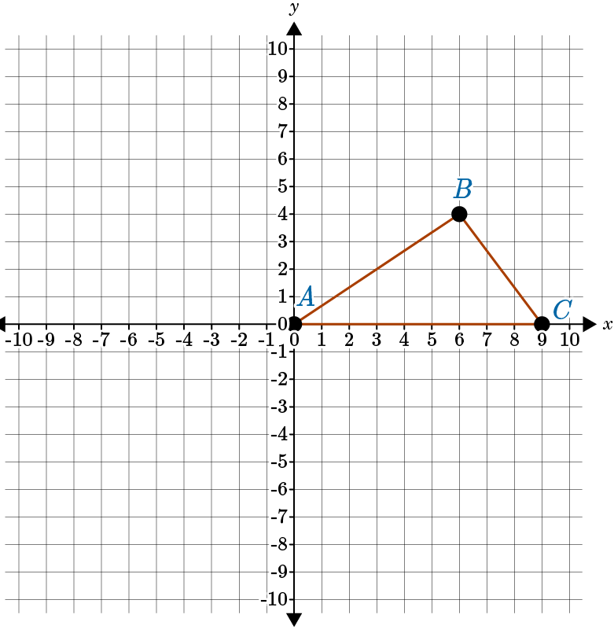

1. If the given triangle is translated 8 units down, what are the coordinates of point A’?



1. The point (2, 3) is a vertex of a triangle. If the triangle is translated 4 units to the right, what is this point in the translated figure? Draw a graph for yourself if needed.
2. The point (-1, 4) is a vertex of a triangle. If the triangle is translated 3 units to the left, what is this point in the translated figure? Draw a graph for yourself if needed.
3. If you are asked to translate a figure 4 units to the right and 5 units up, how many units should you add to each y-coordinate?
4. If you are asked to translate a figure 2 units to the left and 3 units down, how many units should you add to each y-coordinate?
5. If figure *PQRS* is translated 6 units up and 4 units to the left, what are the coordinates of point *R’*?

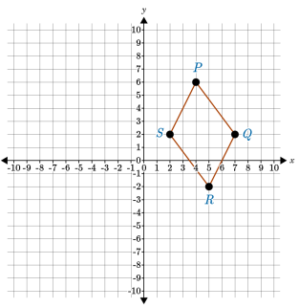

1. When you translate a geometric figure vertically, in which directions might you be moving the figure?
   1. Up or down
   2. Up
   3. Left or right
   4. Up or diagonally