Additional Problems: Transformations and Congruence

**Reflections Across the x- or y- Axis**

1. The shape is reflected over the *y*-axis. What are the coordinates of the point *A’*?

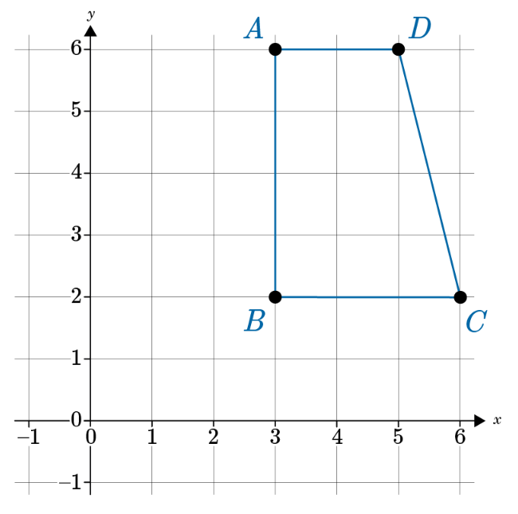

1. The shape is reflected over the *y*-axis. What are the coordinates of the point *B’*?



1. Triangle *ABC* is reflected across the *y*-axis to product triangle *DEF*. Which segment on *DEF* is congruent to the segment *AB*?

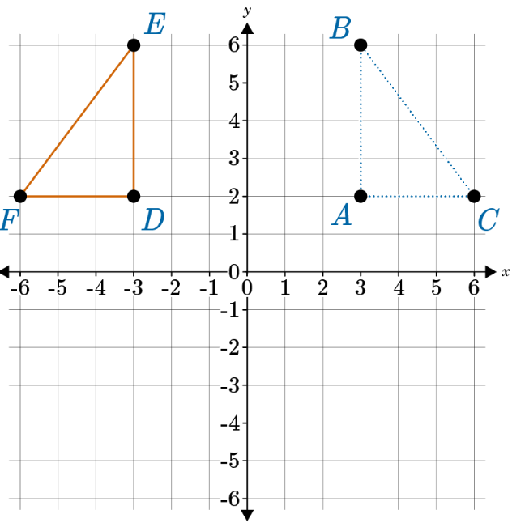

1. Point B in figure Y has an ordered pair of (-2, 3). Figure Y is reflected across the x-axis. Richard thinks that the coordinates for point B on the reflected figure is (-2, -3). Is he correct?
2. Point C in figure Z has an ordered pair of (4, -5). Figure Z is reflected across the y-axis. Juanita thinks that the coordinates for point C on the reflected figure is (-4, -5). Is she correct?
3. Triangle DEF is reflected across the y-axis. If the coordinates of the original shape are D (2, 3), E (4, 5), and F (6, 7), what are the coordinates of D’, E’, and F’?
4. Triangle GHI is reflected across the x-axis. If the coordinates of the original shape are G (-2, -3), H (-4, -5), and I (-6, -7), what are the coordinates of G’, H’, and I’?
5. Your friend produced a reflection over the *y*-axis that looks like this figure below. You notice a problem with the reflection. How would you suggest correcting the reflection?

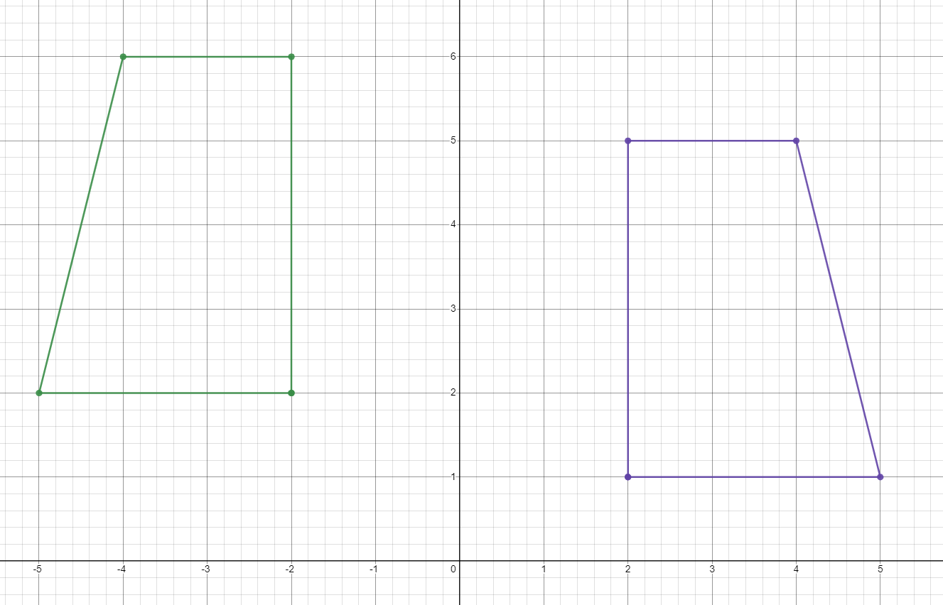

* 1. Shift the reflected figure 1 unit to the left.
  2. Shift the reflected figure 1 unit down.
  3. Shift the reflected figure 1 unit to the right.
  4. Shift the reflected figure 1 unit up.

1. Your friend produced a reflection over the *y*-axis that looks like this figure below. You notice a problem with the reflection. How would you suggest correcting the reflection?

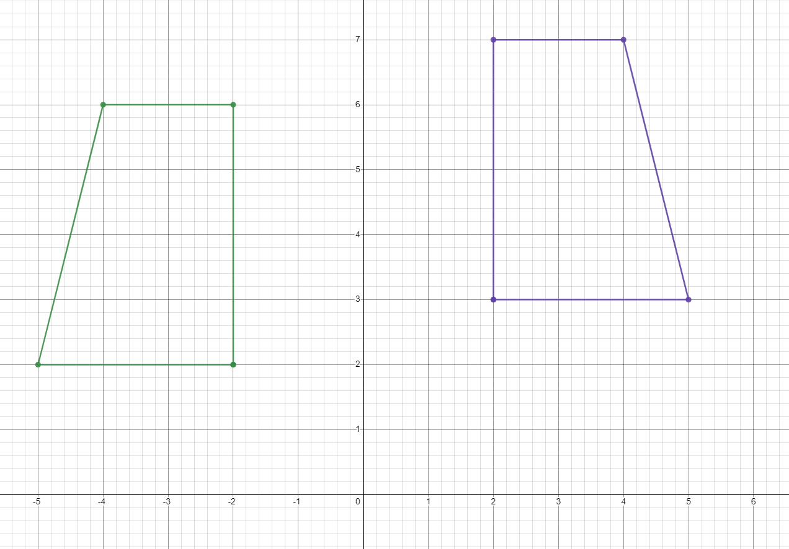

* 1. Shift the reflected figure 1 unit to the left.
  2. Shift the reflected figure 1 unit down.
  3. Shift the reflected figure 1 unit to the right.
  4. Shift the reflected figure 1 unit up.

1. Point M is on figure F and has the coordinates (-3, -2). If it is reflected across the y-axis, what would the new coordinates be for the reflected point M?