Additional Problems: Transformations and Congruence

**180 Degree Rotations**

1. What is the new point when you rotate the point (3, 4) on a geometric figure 180 degrees clockwise?
2. What is the new point when you rotate the point (-2, -5) on a geometric figure 180 degrees clockwise?
3. What is the new point when you rotate the point (6, 7) on a geometric figure 180 degrees clockwise?
4. What is the new point when you rotate the point (1, 2) on a geometric figure 180 degrees counterclockwise?
5. Given point A (2, 4) on the triangle in Quadrant l, where is the new point if the triangle is rotated 90 degrees clockwise?

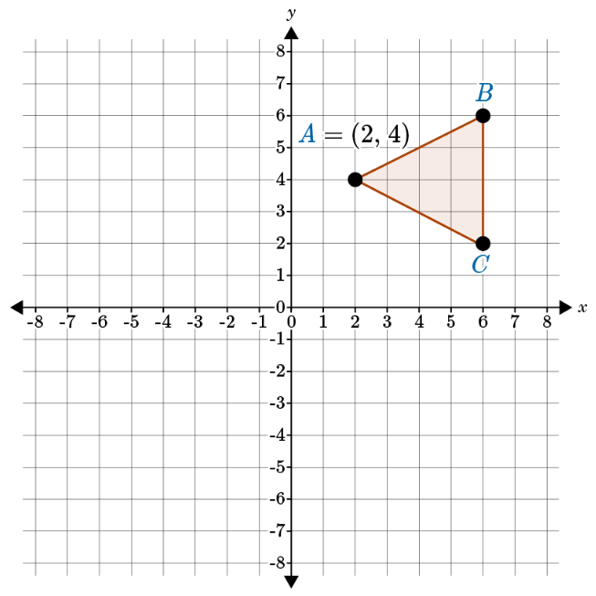

1. What is the new point when you rotate the point (6, 8) on a geometric figure 180 degrees counterclockwise?
2. What is the new point when you rotate the point (-2, -4) on a geometric figure 180 degrees counterclockwise?
3. Given a point (3, 5) in a line segment, what is the new point when the line segment is rotated counterclockwise about the origin 180 degrees?
4. Given a point (7, 9) in a line segment, what is the new point when the line segment is rotated counterclockwise about the origin 180 degrees?
5. Given point (2, 7) on the shape in Quadrant l, where is the point if the shape is rotated 180 degrees counterclockwise?

