Additional Problems: Transformations and Congruence

**Congruent Figures**

1. What is the sequence of steps to move the triangle in Quadrant IV to the triangle in Quadrant ll to show that the triangles are congruent?

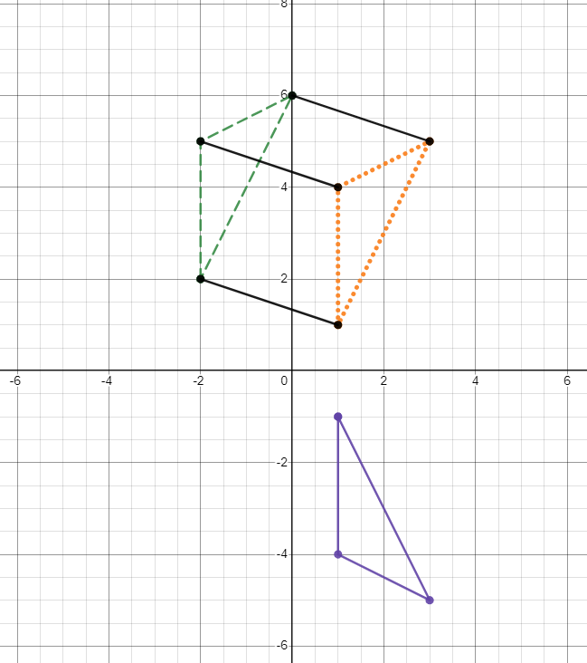

* 1. Reflection, then translation
  2. Translation, then transformation
  3. Rotation, then translation
  4. Translation, then reflection

1. What is the sequence of steps to move the triangle in Quadrant IV to the triangle in Quadrant ll to show that the triangles are congruent?
   1. Reflection, then translation
   2. Translation, then transformation
   3. Rotation, then translation
   4. Translation, then reflection

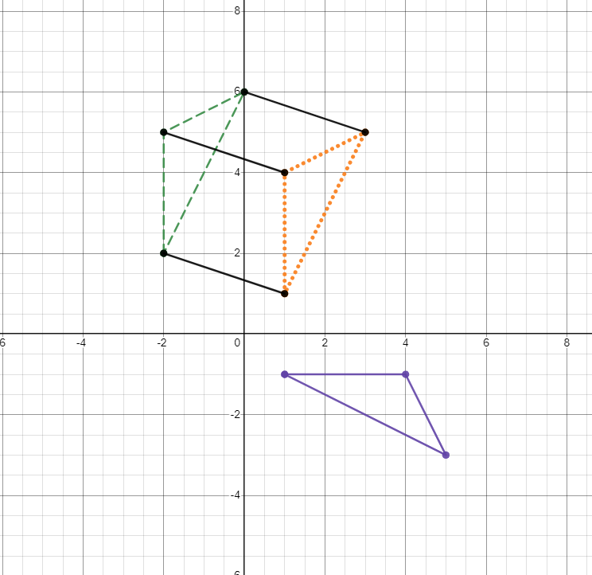

1. How would you describe this series of transformations?

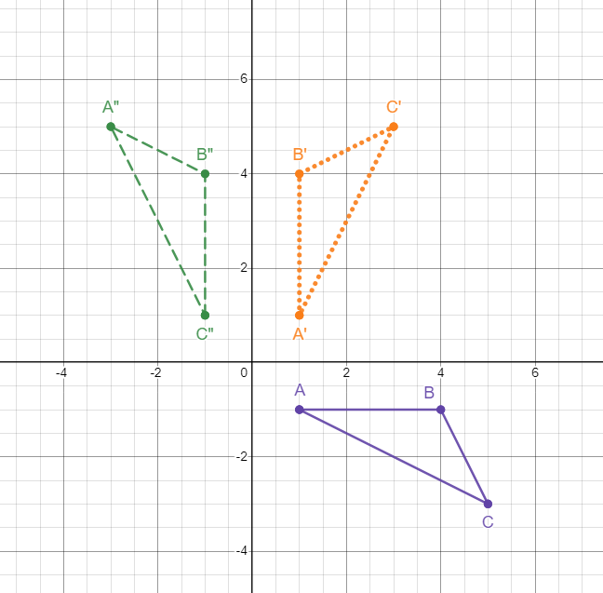

* 1. Rotation of 90 degrees counterclockwise and then reflection across the *y*-axis shows that triangle ABC is congruent to triangle A”B”C”.
  2. Rotation of 90 degrees clockwise and then reflection across the *x*-axis shows that triangle ABC is congruent to triangle A”B”C”.
  3. Reflection across *x*-axis and then a rotation of 90 degrees counterclockwise the shows that triangle ABC is congruent to triangle A”B”C”.
  4. Reflection across *y*-axis and then a rotation of 90 degrees counterclockwise shows that triangle ABC is congruent to triangle A”B”C”.

1. How would you describe this series of transformations?

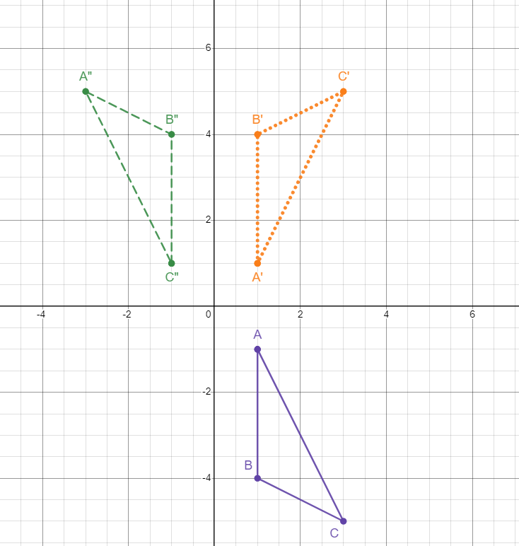

* 1. Reflection across *x*-axis and then a rotation of 90 degrees counterclockwise and then reflection across the shows that triangle ABC is congruent to triangle A”B”C”.
  2. Reflection across *y*-axis and then a reflection across the *x*-axis shows that triangle ABC is congruent to triangle A”B”C”.
  3. Reflection across *x*-axis and then a reflection across the *y*-axis shows that triangle ABC is congruent to triangle A”B”C”.
  4. Reflection across *y*-axis and then a rotation of 90 degrees counterclockwise and then reflection across the shows that triangle ABC is congruent to triangle A”B”C”.

1. Describe the series of transformations that have occurred to move the triangle in Quadrant IV to the triangle in Quadrant II to show that the triangles are congruent.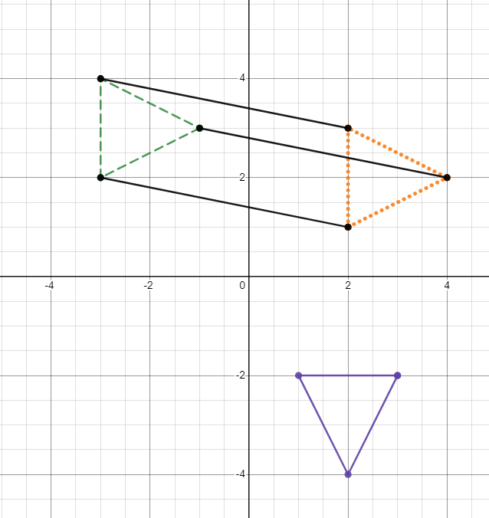
   1. Translation, then rotation
   2. Rotation, then reflection
   3. Reflection, then translation
   4. Rotation, then translation