Math 7 B Unit Test Guide

Surface Area Unit Test

Item | Lesson Coverage | Objective | Lesson Page | Assessment Item
1 | Lesson 2: Prisms | Identify the bases, faces, edges, and vertices of rectangular and triangular prisms. | p. 1-7 | Identify the face, edge, and vertex of the triangular prism. Enter 1 for the face, 2 for the edge, and 3 for the vertex.  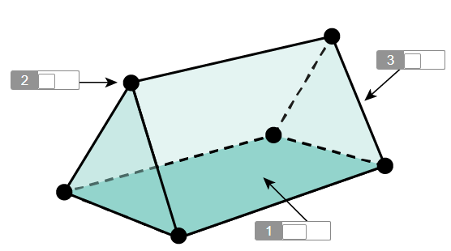  Answer:  1 – 1  2 – 3  3 - 2
2 | Lesson 2: Prisms | Describe the two-dimensional figures that result from slicing right rectangular and triangular prisms. | p. 8-13 | Use the image to answer the question.  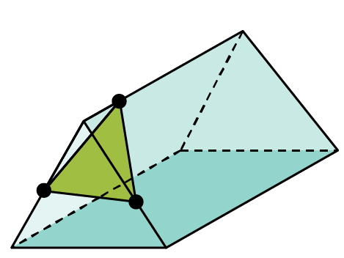  What is the two-dimensional shape created by the sliced object?  Answer: triangle
3 | Lesson 3: Surface Area of Cubes & Rectangular Prisms | Decompose a cube or right rectangular prism into squares and rectangles to derive the surface area formulas for a cube and a right rectangular prism. | p. 1-8 | What is a two-dimensional representation of a three-dimensional figure?  Answer: a net
4 | Lesson 3: Surface Area of Cubes & Rectangular Prisms | Solve mathematical problems involving surface area of cubes and right rectangular prisms. | p. 9-15 | What is the missing length of a rectangular prism where the height and width are both 9 cm and the surface area is 432 cm²?  _____ cm  Answer: 7.5
5 | Lesson 4: Surface Area of Triangular Prisms | Decompose a triangular prism into triangles and rectangles or squares to derive the surface area formula for a rectangular prism. | p. 1-6 | Fill in the blanks to complete the formula for the surface area of a triangular prism.  The surface area of a triangular prism is  Answer:  1 – bh  2 - l
6 | Lesson 4: Surface Area of Triangular Prisms | Solve mathematical problems involving surface area of triangular prisms. | p. 7-13 | Use the image to answer the question.  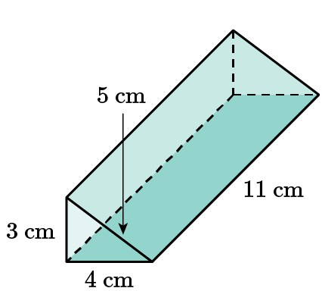  What is the surface area of the triangular prism?  _____ square centimeters  Answer: 144
7 | Lesson 5: Applications of Surface Area of Prisms | Solve real-world problems involving surface area of rectangular prisms, including cubes. | p. 1-6 | Use the image to answer the question.  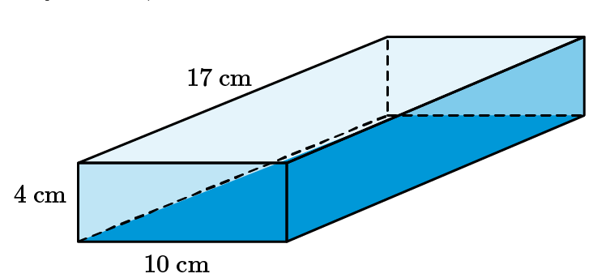  Jerry wants to wrap a present in a box for his mother. The box measures 10 cm wide, 4 cm high, and 17 cm long. How much wrapping paper will Jerry need to wrap the present?  Surface area = _____ cm²  Answer: 556
8 | Lesson 5: Applications of Surface Area of Prisms | Solve real-world problems involving surface area of triangular prisms. | p. 7-11 | Use the image to answer the question.  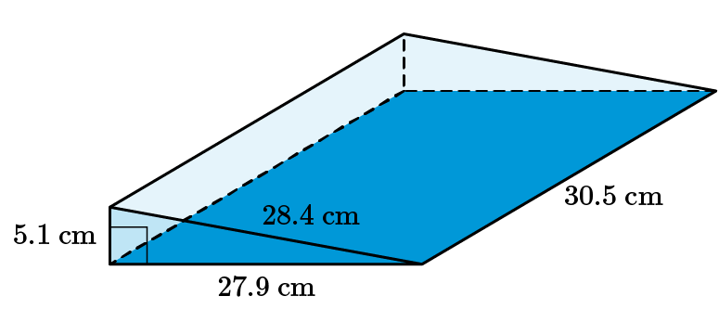  A toy came in a container that is shaped like a triangular prism. How much wrapping paper is needed to wrap the toy? Round your answer to the nearest whole number.  S. A. = _____ cm²  Answer: 2,015
9 | Lesson 6: Pyramids | Identify the bases, faces, edges, and vertices of rectangular pyramids. | p. 1-5 | What is the shape of the base of a rectangular pyramid?  Answer: rectangle
10 | Lesson 6: Pyramids | Describe the two-dimensional figures that result from slicing right rectangular pyramids. | p. 6-11 | Use the image to answer the question.  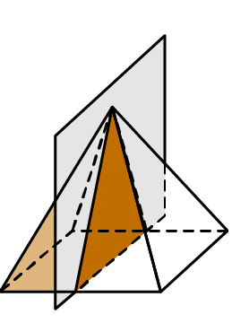  What two-dimensional shape is created by slicing a right rectangular pyramid perpendicular to the base?  Answer: triangle
11 | Lesson 7: Surface Area of Rectangular Pyramids | Decompose a rectangular pyramid into a rectangle and triangles to derive the surface area formula for a rectangular pyramid. | p. 1-6 | Use the image to answer the question.  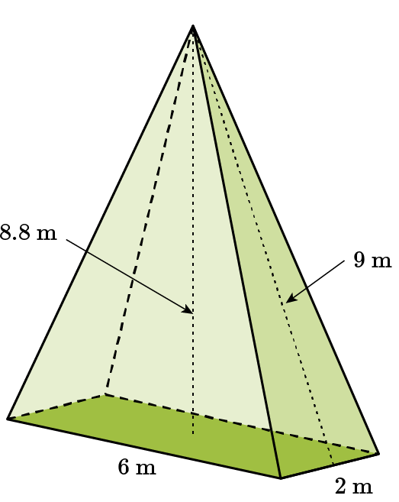  What is the length of the pyramid?  _____ m  Answer: 6
12 | Lesson 7: Surface Area of Rectangular Pyramids | Solve mathematical problems involving surface area of rectangular pyramids. | p. 7-12 | Use the image to answer the question.  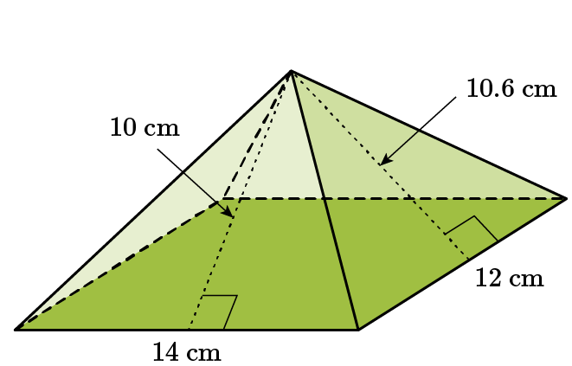  What is the surface area of the rectangular pyramid?  _____ cm²  Answer: 435.2
13 | Lesson 8: Surface Area of Composite 3D Figures | Solve mathematical problems involving surface area of three-dimensional objects composed of cubes and right prisms. | p. 1-8 | Use the image to answer the question.  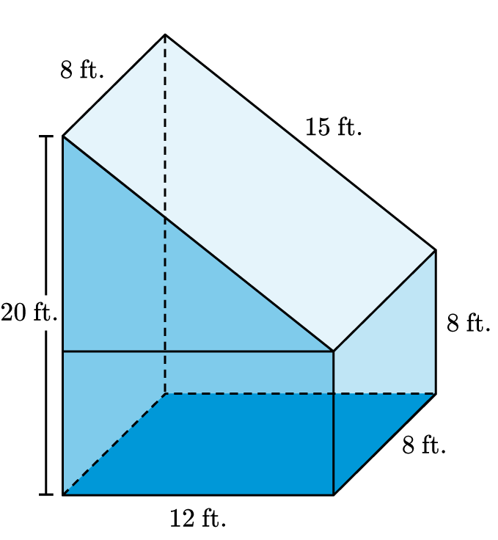  What is the surface area of the figure?  _____ ft.²  Answer: 776
14 | Lesson 8: Surface Area of Composite 3D Figures | Solve real-world problems involving surface area of three-dimensional objects composed of cubes and right prisms. | p. 9-15 | Use the image to answer the question.  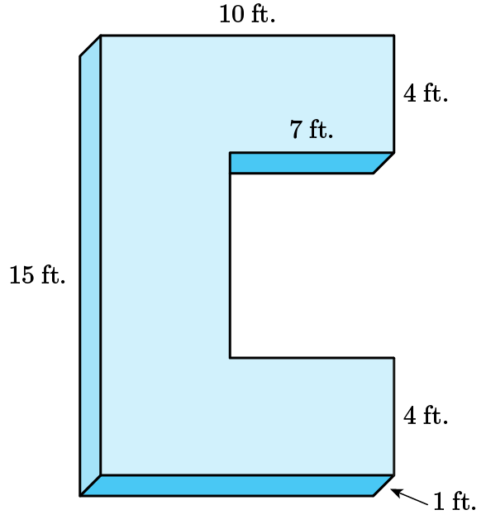  In Los Cabos, Mexico, there is a big sculpture of block letters that welcomes you. The image shows the letter C. What is its surface area?  _____ ft.²  Answer: 266
15 | Lesson 7: Surface Area of Rectangular Pyramids | Solve mathematical problems involving surface area of rectangular pyramids. | p. 7-12 | Calculate the surface area of the square pyramid that has a base length of 12 and a slant height of 18. Show your work.  Answer: Student answers should include:  Area of Square Base = $12×12=144$  Area of 1 triangle = $\frac{12×18}{2}=108$  Area of all 4 triangles = $4×108=432$  Surface Area of Square Pyramid = $144+432=576$ square units

