Math 7 B Unit Test Guide

Volume Unit Test

Item | Lesson Coverage | Objective | Lesson Page | Assessment Item
1 | Lesson 2: Volume of Prisms | Describe volume as a concept applied to three-dimensional figures such as cubes, right rectangular prisms, and right triangular prisms. | p. 1-6 | Can a refrigerator that is 21.5 cubic feet fit in a space that is 21 cubic feet?  Answer: No, the refrigerator is bigger than the available space.
2 | Lesson 2: Volume of Prisms | Use the formulas for volume of cubes appropriately. | p. 7-13 | What is the volume of a cube with a side length of 1.5 in.?  _____ in.³  Answer: 3.375
3 | Lesson 2: Volume of Prisms | Use the formulas for volume of right rectangular prisms appropriately. | p. 14-19 | If the volume of a right rectangular prism is 1.5 in.³ and its length and width have a product of 1.5 in.², then what is the height of this prism?  _____ in.  Answer: 1
4 | Lesson 2: Volume of Prisms | Use the formulas for volume of right rectangular prisms appropriately. | p. 14-19 | Lloyd bought a refrigerator that measures 76 cm x 76 cm x 170 cm to fit in a space with a volume of 975,000 cm³. Will the refrigerator fit in the space? Explain.  Answer: No, it is 6,920 cm³ too big for the space.
5 | Lesson 3: Volume of Pyramids | Solve mathematical problems involving the volume of rectangular pyramids. | p. 1-6 | Use the image to answer the question.  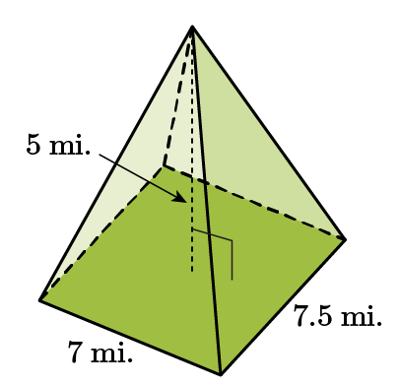  What is the volume of the rectangular pyramid?  _____ mi.³  Answer: 87.5
6 | Lesson 3: Volume of Pyramids | Solve real-world problems involving volume of rectangular pyramids. | p. 7-12 | A slice of cheese is cut from a wheel of parmesan, and the wedge approximates the shape of a rectangular pyramid. Its base is 4 cm wide and 9 cm long. The wedge is 21 cm tall. What is the volume of the piece of cheese?  _____ cm³  Answer: 252
7 | Lesson 4: Relationship Between Volume of Prisms & Pyramids | Model the relationship between the volume of a rectangular prism and a rectangular pyramid having both congruent bases and heights. | p. 1-5 | A rectangular prism has a volume of 27 in.³. If a rectangular pyramid has a base and height congruent to the prism, what is the volume of the pyramid?  _____ 27 in.³  Answer: 9
8 | Lesson 4: Relationship Between Volume of Prisms & Pyramids | Model the relationship between the volume of a rectangular prism and a rectangular pyramid having both congruent bases and heights. | p. 1-5 | A rectangular pyramid has a volume of 480 in.³. If a rectangular prism has a base and height congruent to the pyramid, what is the volume of the prism?  _____in.³  Answer: 1,440
9 | Lesson 4: Relationship Between Volume of Prisms & Pyramids | Use a model that shows the relationship between the volume of a triangular prism and a triangular pyramid having congruent bases to describe the relationship between their heights and their formulas. | p. 6-12 | Use the image to answer the question.  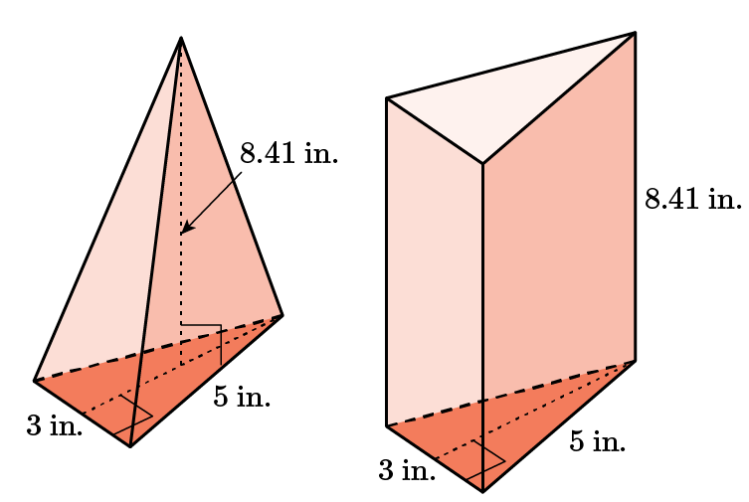  Which shape has the larger volume? How much larger is it?  Answer: The prism has a larger volume by three times.
10 | Lesson 4: Relationship Between Volume of Prisms & Pyramids | Use a model that shows the relationship between the volume of a triangular prism and a triangular pyramid having congruent bases to describe the relationship between their heights and their formulas. | p. 6-12 | Use the image to answer the question.  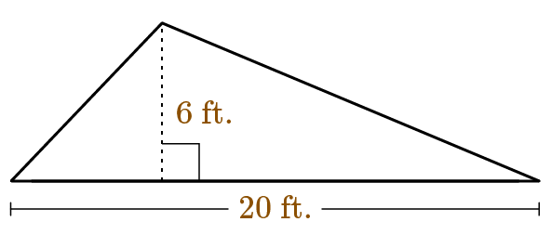  A prism and a pyramid both have this triangular base. If both shapes have the same height and the volume of the prism is 600 ft.³, what is the volume of the pyramid?  Answer: 200 ft.³
11 | Lesson 7: Volume of Composite 3D Figures | Solve mathematical problems involving volume of three-dimensional objects composed of cubes and right prisms. | p. 1-5 | Use the image to answer the question.  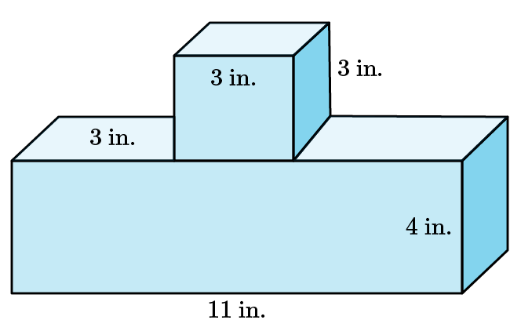  What is the volume of the composite figure?  _____ in.³  Answer: 159
12 | Lesson 7: Volume of Composite 3D Figures | Solve mathematical problems involving volume of three-dimensional objects composed of cubes and right prisms. | p. 1-5 | Use the image to answer the question.  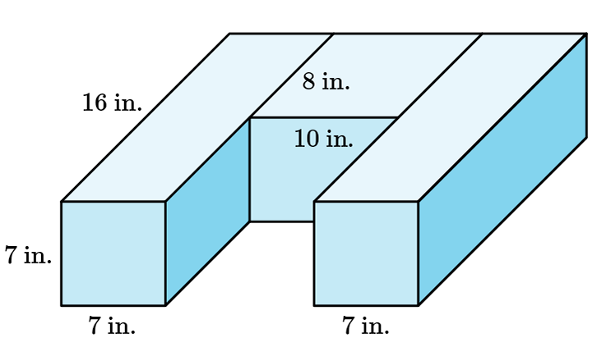  What is the volume of the composite figure?  _____ in.³  Answer: 2,128
13 | Lesson 7: Volume Composite 3D Figures | Solve real-world problems involving volume of three-dimensional objects composed of cubes and right prisms. | p. 6-10 | Use the image to answer the question.  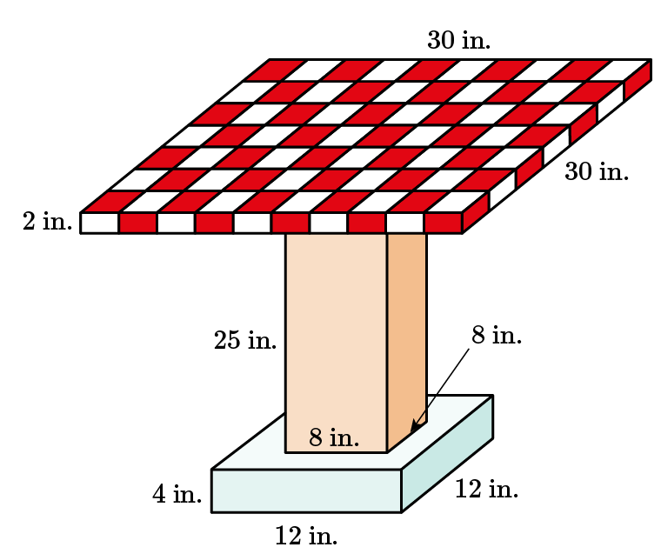  What is the volume of the table?  _____ in.³  Answer: 3,976
14 | Lesson 7: Volume Composite 3D Figures | Solve real-world problems involving volume of three-dimensional objects composed of cubes and right prisms. | p. 6-10 | Use the image to answer the question.  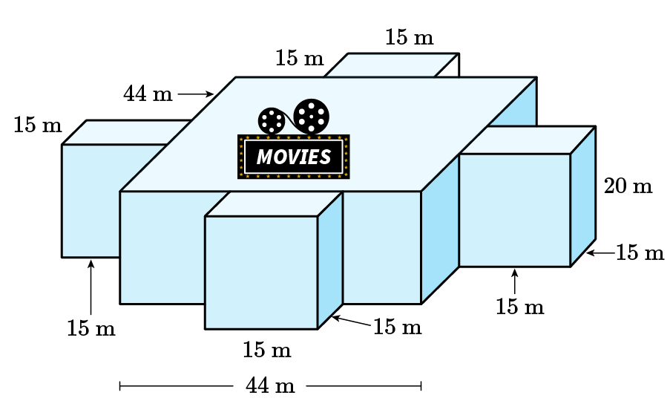  What is the volume of the movie theater?  _____ m³  Answer: 56,720
15 | Lesson 3: Volume of Pyramids | Solve real-world problems involving volume of rectangular pyramids. | p. 7-12 | Solve the problem. What is the volume of a rectangular pyramid with a base of 200 square meters and a height of 75 meters? Show your work.  Answer: The volume of a rectangular pyramid is given by $\left(\frac{1}{3}\right)bh$, or in this case $\left(\frac{1}{3}\right)\left(200\right)\left(75\right)=25\left(200\right)=5,000$ cubic meters.

