Math 7 B Unit Test Guide

Triangles Unit Test

Item | Lesson Coverage | Objective | Lesson Page | Assessment Item
1 | Lesson 2: Triangle Angle Sum Theorem | Use the triangle angle sum theorem to find a missing angle in a triangle given the other two angles. | p. 1-6 | Identify the combination of angle measures that could form a triangle.  Answer: $25°, 65°, 90°$
2 | Lesson 2: Triangle Angle Sum Theorem | Use the triangle angle sum theorem to find a missing angle in a triangle given the other two angles. | p. 1-6 | The angles of a triangle measure 2x, 3x, and 4x. Using the Triangle Angle Sum Theorem, find the measure of the smallest angle in this triangle.  Answer: $40°$
3 | Lesson 2: Triangle Angle Sum Theorem | Use the triangle angle sum theorem to find a missing angle in a triangle given the other two angles. | p. 1-6 | Use the image to answer the question.  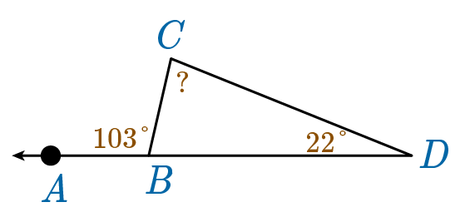  Use the Triangle Angle Sum Theorem to find the measure of the angle on point C.  Answer: $81°$
4 | Lesson 2: Triangle Angle Sum Theorem | Use the triangle angle sum theorem to find missing angles in a triangle given algebraic expressions for the measure of each angle. | p. 7-11 | Use the Triangle Angle Sum Theorem to find the largest angle in a triangle with angle measures of $\left(x-20\right)°, \left(3x+3\right)°, and \left(2x+7\right)°$.  Answer: $105°$
5 | Lesson 2: Triangle Angle Sum Theorem | Use the triangle angle sum theorem to find missing angles in a triangle given algebraic expressions for the measure of each angle. | p. 7-11 | Use the image to answer the question.  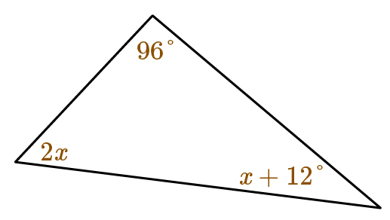  Find the measure of the smallest angle of the triangle.  Answer: $36°$
6 | Lesson 3: Triangle Inequality Theorem | Determine the conditions relating to whether three segments can form a triangle. | p. 1-5 | Two sides of a triangle are 10 mm and 7 mm. Determine the length of the third side from the choices given.  Answer: 5 mm
7 | Lesson 3: Triangle Inequality Theorem | Determine the conditions relating to whether three segments can form a triangle. | p. 1-5 | Complete the condition statements that must be met in order for three side lengths – a, b, and c – to create a triangle.  a _____ b + c and a _____ b – c  Answer: < ; >
8 | Lesson 3: Triangle Inequality Theorem | Determine the conditions relating to whether three segments can form a triangle. | p. 1-5 | Use the image to answer the question.  Complete the inequality so that it represents the whole-number values that side a could be to create a triangle.  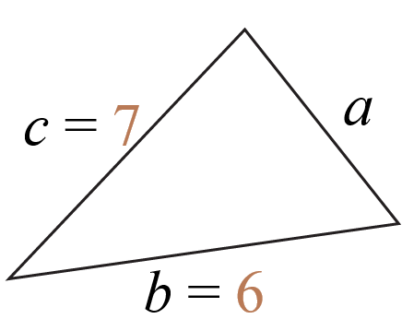  _____ < a < _____  Answer: 1; 13
9 | Lesson 3: Triangle Inequality Theorem | Apply the triangle inequality theorem. | p. 6-11 | Apply the Triangle Inequality Theorem to determine which three side lengths form a triangle.  Answer: 10, 20, 15
10 | Lesson 3: Triangle Inequality Theorem | Apply the triangle inequality theorem. | p. 6-11 | Apply the Triangle Inequality Theorem to determine the possible whole number measures of the third side of a triangle if the first two sides measure 6 and 2. List them in ascending order.  The measure of the third side could be _____, _____, or _____.  Answer: 5; 6; 7
11 | Lesson 3: Triangle Inequality Theorem | Apply the triangle inequality theorem. | p. 6-11 | Use the image to answer the question.  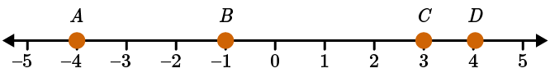  A triangle has no congruent sides. The lengths of two sides of the triangle are AB and BD. Use the number line above to determine the lengths of AB and BD. Then, use the Triangle Inequality Theorem to determine which two segments have lengths that could be used as the third side of the triangle. Select a response containing 2 possible answers.  Answer: AC and BC
12 | Lesson 2: Triangle Angle Sum Theorem | Use the triangle angle sum theorem to find missing angles in a triangle given algebraic expressions for the measure of each angle. | p. 7-11 | A right triangle has acute angles measuring $2x=6$ degrees and $3x-26$ degrees. Use the Triangle Angle Sum Theorem to find the measures of the missing angles of the triangle.  Answer:  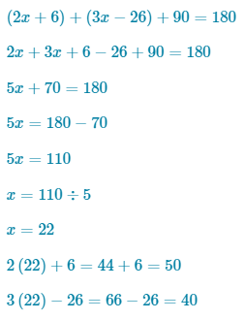  The angles of the triangle measure 40 degrees, 50 degrees, and 90 degrees.

