Math 7 B Unit Test Guide

Area and Perimeter Unit Test

Item | Lesson Coverage |  | Objective |  |  | Lesson Page | Assessment Item
1 | Lesson 2: Area of Rectangles & Triangles |  | Use the formulas for area of rectangles and squares appropriately. |  |  | p. 1-6 | Cara and Beejal make a poster for school. The poster is in the shape of a rectangle. The left side of the poster measures 7 units; the top side of the poster measures 6 units. What is the area in square units of the completed poster?  Answer: 42 square units  Area and Perimeter Unit Test Item #1 | Desmos
2 | Lesson 2: Area of Rectangles & Triangles |  | Use the formula for the area of triangles appropriately. |  |  | p. 7-13 | Ja’Miles designs a sign for a store in the shape of a triangle. His design is 7.5 square feet in area, and the triangle has a height of 2.5 feet. What is the length of the base of his sign?  Answer: 6 feet  Area and Perimeter Unit Test Item #2 | Desmos
3 | Lesson 3: Area of Composite Figures |  | Solve mathematical problems involving area of two-dimensional objects composed of triangles, quadrilaterals, and other polygons. |  |  | p. 1-8 | Use the image to answer the question.  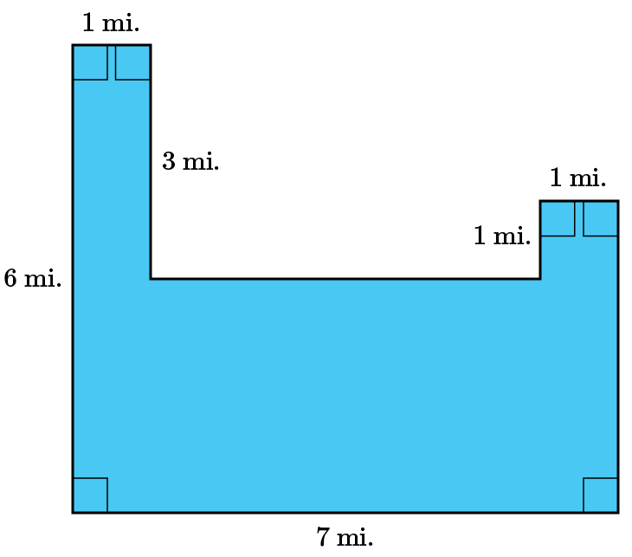  What is the area of the composite figure?  Answer: 25 square miles
4 | Lesson 3: Area of Composite Figures |  | Solve real-world problems involving area of two-dimensional objects composed of triangles, quadrilaterals, and other polygons. |  |  | p. 9-14 | Use the image to answer the question.  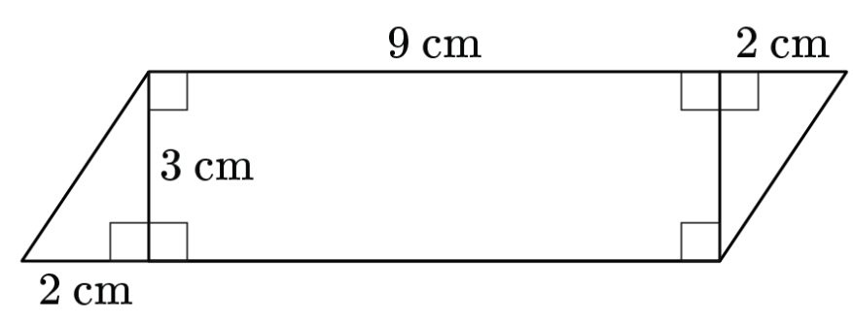  Hector designs the piece of jewelry shown below. All lengths are marked in centimeters. What is the total area of the piece of jewelry?  Answer: 33 square centimeters  Area and Perimeter Unit Test Item #4 | Desmos
5 | Lesson 3: Area of Composite Figures |  | Solve real-world problems involving area of two-dimensional objects composed of triangles, quadrilaterals, and other polygons. |  |  | p. 9-14 | Use the image to answer the question.  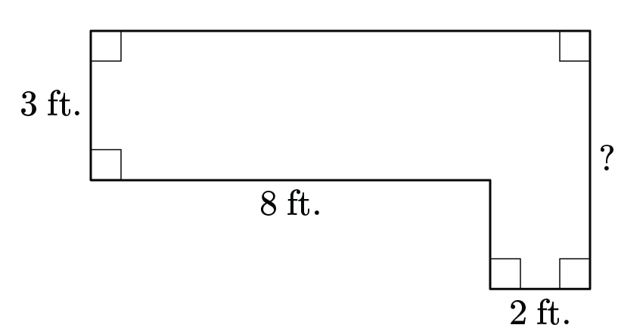  Tessa designs a supply closet as an addition to her house. The closet is pictured, and its total area is 36 square feet. What is the length in feet of the side of the supply closet labeled with the question mark?  Answer: 6 feet  Area and Perimeter Unit Test Item #5 | Desmos
6 | Lesson 4: Length and Area in Scale Drawings |  | Solve problems by computing actual lengths from a scale drawing of a geometric figure. |  |  | p. 1-6 | Ethan writes the ratio $\frac{x}{8}=\frac{y}{16}$ to help him reduce the size of a two-dimensional shape. If the new value of y is 3 units, what will be the value of x?  Answer: 1.5 units
7 | Lesson 4: Length and Area in Scale Drawings |  | Solve problems by computing actual lengths from a scale drawing of a geometric figure. |  |  | p. 1-6 | Li is a professional nature photographer. She takes a photograph of a spider web and prints a copy. The original dimensions of her copy are 6 inches by 4 inches. Li decides to advertise her business by printing smaller copies of the spider web photograph and emailing them to friends and acquaintances. Which dimensions represent a smaller scale drawing of the original printed photograph?  Answer: 1.5 inches by 1 inch
8 | Lesson 4: Length and Area in Scale Drawings |  | Solve problems by computing actual areas from a scale drawing of a geometric figure. |  |  | p. 7-14 | Use the image to answer the question.  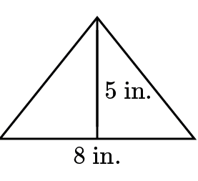  Crystal cuts a piece of wood into the shape of a triangle. The height of the triangle is 5 inches, and the base of the triangle measures 8 inches. Crystal makes a scale drawing of the triangle. If the height of her scale drawing is 2 inches, what is the area of her scale drawing?  Answer: 3.2 square inches
9 | Lesson 5: Circumference & Area of Circles |  | Use the formula for the circumference of a circle to solve problems. |  |  | p. 1-6 | What is the approximate circumference of a circle that has a radius of 90? Use 3.14 for $π$ and express your answer to the tenths place.  Answer: 565.2  Area and Perimeter Unit Test Item #9 | Desmos
10 | Lesson 5: Circumference & Area of Circles |  | Use the formula for the circumference of a circle to solve problems. |  |  | p. 1-6 | What is the approximate circumference of a circle that has a diameter of 379? Use 3.14 for $π$ and express your answer to the hundredths place.  Answer: 1,190.06  Area and Perimeter Unit Test Item #10 | Desmos
11 | Lesson 5: Circumference & Area of Circles |  | Describe the proportional relationship between the diameter and circumference of a circle and that the unit rate (constant of proportionality) is π . |  |  | p. 7-13 | The approximate circumference of a circle is 7,459 miles. What is the diameter rounded to the nearest hundredths place? Use 3.14 for $π$.  Answer: 2,375.48 miles  Area and Perimeter Unit Test Item #11 | Desmos
12 | Lesson 5: Circumference & Area of Circles |  | Use the formula for the area of a circle to solve problems. |  |  | p. 14-18 | The radius of a circle is 98 mm. What is the area of the circle? Write your answer to the hundredths place. Use 3.14 for $π$.  Answer: 30,156.56 mm²  Area and Perimeter Unit Test Item #12 | Desmos
13 | Lesson 6: The Relationship Between Circumference & Area |  | Describe the relationship between the circumference and area of a circle. |  |  | p. 1-6 | If the area of a circle is 28.26 cm², what is the radius of the circle?  Answer: 3 cm  Area and Perimeter Unit Test Item #13 | Desmos
14 | Lesson 6: The Relationship Between Circumference & Area |  | Complete a table given a radius for circumference and area. |  |  | p. 7-11 | Complete the table by finding the circumference and area of a circle with a radius of 279 inches. Substitute 3.14 for pi. Express your answers to the hundredths place.  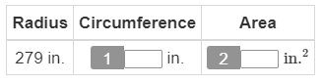  Answer:  1: 1,752.12  2: 244,420.74  Area and Perimeter Unit Test Item #14 | Desmos
15 | Lesson 4: Length and Area in Scale Drawings |  | Solve problems by computing actual areas from a scale drawing of a geometric figure. |  |  | p. 7-14 | A triangular flag has a height of 15 inches and a base length of 25 inches. Magnolia makes a scale drawing of the flag in which the base length is 10 inches. What is the area of Magnolia’s scale drawing? Solve the problem by computing the actual area from the scale drawing. Show your work.  Answer:  The scale factor is $\frac{10}{25}, or\frac{2}{5}$.  $\frac{2}{5} ∙15=6$ so the height of the flag in the scale drawing is 6 inches.  The formula for the area of a triangle is $\left(\frac{1}{2}\right)bh$, or in this case $\left(\frac{1}{2}\right)\left(10\right)\left(6\right)=30$.  The area of the flag in the scale drawing is 30 square inches.

