Math 7 B Unit Test Guide

Inequalities Unit Test

Item | Lesson Coverage | Objective | Lesson Page | Assessment Item
1 | Lesson 2: Solve Addition Inequalities | Solve linear inequalities in the form x + p > q and x + p < q, where p and q are nonnegative rational numbers. | p. 1-6 | Solve $x+15≥3$. Make sure to write your inequality so that x comes first.  Answer: $x≥12$
2 | Lesson 2: Solve Addition Inequalities | Solve linear inequalities in the form x + p > q and x + p < q, where p and q are nonnegative rational numbers. | p. 1-6 | Solve $x+2\frac{1}{2}<8$. Make sure to write your inequality so that x comes first.  Answer: $x<5\frac{1}{2}$
3 | Lesson 2: Solve Addition Inequalities | Graph the solution to linear inequalities in the form x + p > q and x + p < q, where p and q are nonnegative rational numbers. | p. 7-13 | Use the image to answer the question.  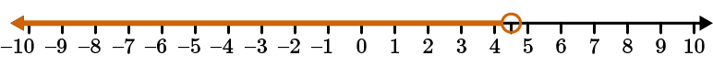  Willow solved an inequality and graphed the solution on the number line. Which of the following inequalities did she solve?  Answer: $x-2\frac{1}{3}<2\frac{1}{6}$
4 | Lesson 3: Solve Multiplication Inequalities | Solve linear inequalities in the form px > q and px < q, where p and q are nonnegative rational numbers. | p. 1-6 | Solve $5x<12$. Write the improper fraction as a mixed number. Make sure to write your inequality so that x comes first.  Answer: $x<2\frac{2}{5}$
5 | Lesson 3: Solve Multiplication Inequalities | Solve linear inequalities in the form px > q and px < q, where p and q are nonnegative rational numbers. | p. 1-6 | Solve $3.4x≥23.8$. Make sure to write your inequality so that x comes first.  Answer: $x≥7$
6 | Lesson 3: Solve Multiplication Inequalities | Graph the solution to linear inequalities in the form px > q and px < q, where p and q are nonnegative rational numbers. | p. 7-13 | Use the image to answer the question.  Paolo solved an inequality and graphed the solution on the number line. Which of the following inequalities did he solve?  Answer: $2.1x<8.4$
7 | Lesson 4: Solve Two-Step Inequalities | Solve linear inequalities in the form px + q > r and px + q < r, where p and q are nonnegative rational numbers. | p. 1-7 | Solve $8x-14≤10$. Make sure to write your inequality so that x comes first.  Answer: $x≤3$
8 | Lesson 4: Solve Two-Step Inequalities | Solve linear inequalities in the form px + q > r and px + q < r, where p and q are nonnegative rational numbers. | p. 1-7 | Solve $5.14x+2.25>15.1$. Write the rational number in your answer in decimal form to the tenths place. Make sure to write your inequality so that x comes first.  Answer: $x>2.5$
9 | Lesson 4: Solve Two-Step Inequalities | Graph the solution to linear inequalities in the form px + q > r and px + q < r, where p and q are nonnegative rational numbers. | p. 8-13 | Use the image to answer the question.  Preston solved an inequality and graphed the solution on the number line. Which of the following inequalities did he solve?  Answer: $2.1x+5.6≥8.75$
10 | Lesson 5: Applications of Inequalities | Given a real-world or mathematical problem, write an inequality in the form px + q > r or px + q < r, where p, q, and r are specific rational numbers. | p. 1-6 | Fifteen less than four times a number is more than 49. What are all the possible values of the number? Write an inequality that could be used to solve this problem. Use the letter x as your variable and write your x term first.  Answer: $4x-15>49$
11 | Lesson 5: Applications of Inequalities | Solve an inequality in the form px + q > r or px + q < r that represents a real-world or mathematical problem. | p. 7-13 | Youssef is taking a trip on an airplane. He knows that to avoid extra fees his suitcase must weigh under 50 pounds. The suitcase with his clothes weighs 35 pounds. He has room, so he decides to pack some books for his trip, too. Each book weighs on average 1.2 pounds. How many books could he bring on the trip? He writes the inequality $1.2b+35<50$, where b equals the number of books, to help figure this out. Solve his inequality. Use the letter b as your variable and write your b term first.  Answer: $b<12.5$
12 | Lesson 6: Solutions to Real-World Inequality Problems | Graph the solutions to a real-world problem that can be represented by an inequality on a number line. | p. 1-6 | Marjam has a goal of taking at least 10,000 steps today. According to her pedometer, she got 2,500 steps in the morning. There are 10 hours left in the day. How many steps will she need to get each hour (assume she walks the same number of steps each hour) for the rest of the day to meet her goal? Solve this problem. Which graph most clearly communicates the solution?  Answer:  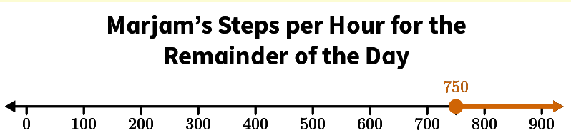
13 | Lesson 6: Solutions to Real-World Inequality Problems | Graph the solutions to a real-world problem that can be represented by an inequality on a number line. | p. 1-6 | Use the image to answer the question.  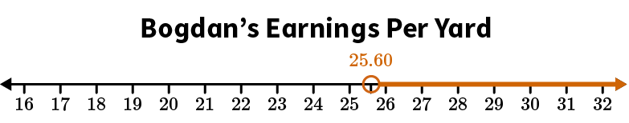  What inequality is shown on the graph? Write your inequality with the variable coming first. Use the letter m for the variable. Write your answer using a decimal number.  Answer: $m>25.60$
14 | Lesson 6: Solutions to Real-World Inequality Problems | For a real-world problem that can be represented by an inequality, interpret the solution in the context of the problem. | p. 7-12 | Lily is saving up to buy a cellphone. She needs to save at least $300 before she is able to buy the phone. Her grandfather gives her $40, and she earns $65 tutoring after school each week. Write an inequality for the number of weeks Lily will need to save to have at least $300, and describe the solutions.  $_____x + _____ ≥_____$, where x is the number of weeks Lily will need to save. Lily must save for at least _____ weeks to have at least $300.  Answer: 65; 40; 300; 4
15 | Lesson 5: Applications of Inequalities | Solve an inequality in the form px + q > r or px + q < r that represents a real-world or mathematical problem. | p. 7-13 | Solve this problem by writing and solving an inequality. Five more than four times a number is less than 25. What are the possible values of the number? Show your work.  Answer:  