Math 7 B Unit Test Guide

Statistics Unit Test

Item | Lesson Coverage | Objective | Lesson Page | Assessment Item
1 | Lesson 2: Statistics Basics | Determine whether it is valid to make generalizations about a population from a sample. | p. 8-13 | A large company wants to find out what team-building activity its employees prefer. Which of the following samples can give the most valid generalization?  Answer: 400 randomly chosen employees from the list of all employees
2 | Lesson 3: Random Sampling | Describe random sampling as a method that tends to produce representative samples and support valid inferences. | p. 1-6 | A hotel maintenance crew wants to estimate how many of the 12,000 lamps in their 30-story hotel need a new light bulb. Which of the following is a random sample of lamps to be inspected?  Answer: 100 lamps on each floor chosen randomly
3 | Lesson 3: Random Sampling | Use data from a random sample to draw inferences about a population with an unknown characteristic of interest. | p. 7-13 | A local library manager randomly surveys 80 patrons about the type of book they borrow when they visit the library. The manager finds that 3 patrons borrow novels. If the local library has 345 patrons, approximately how many of them borrow novels when they visit the library? Round your answer to the nearest whole number.  _____ patrons  Answer: 13
4 | Lesson 4: Measures of Center | Determine the mean for a quantitative data set or a data set represented in a display. | p. 1-7 | Use the table to answer the question.  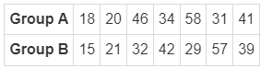  The table shows the times, in minutes, spent shopping by two different groups. First find the mean times each group spent shopping. Then determine the difference in the mean times. Round your answers to one decimal place.  The mean time Group A spent shopping is _____ minutes.  The mean time Group B spent shopping is _____ minutes.  The mean times Group A and Group B spent shopping differ by _____ minutes.  Answer: 35.4; 33.6; 1.8  Statistics Unit Test Item #4 | Desmos
5 | Lesson 4: Measures of Center | Determine the median for a quantitative data set or a data set represented in a display. | p. 8-14 | Which data set has the highest mean?  Answer: {1, 6, 15, 7, 15, 18, 14}  Statistics Unit Test Item #5 | Desmos
6 | Lesson 4: Measures of Center | Determine the median for a quantitative data set or a data set represented in a display. | p. 8-14 | Use the table to answer the question.  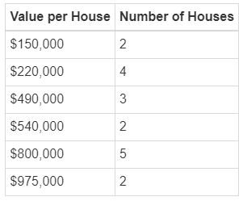  The values of several houses on Mango Street are displayed on the table. What is the median value of these houses?  Answer: 515,000  Statistics Unit Test Item #6 | Desmos
7 | Lesson 4: Measures of Center | Use measures of center for numerical data from random samples to draw informal comparative inferences about two populations. | p. 15-22 | Theo, Ara, Jose, and Dana all got 100 percent on their latest math test. Their scores on the previous six tests are listed. Whose mean test score will increase the most?  Answer: Dana: 68, 74, 83, 80, 81, 82  Statistics Unit Test Item #7 | Desmos
8 | Lesson 5: Measures of Variation | Determine the range for a quantitative data set or a data set represented in a display. | p. 1-7 | The stem-and-leaf plot shows the speeds of the fastest steel roller coasters in Europe. The table shows the speeds of the fastest steel roller coasters in North America.  Speeds of the Fastest Steel Roller Coasters in Europe (in miles per hour)  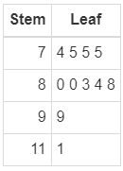  Key: $7|4=74$ miles per hour  Speeds of the Fastest Steel Roller Coasters in North America (in miles per hour)  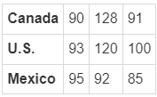  Find the range of the speeds of the fastest steel roller coasters on both continents.  The range of the speeds of the fastest steel roller coasters in Europe is _____ mph. The range of the speeds of the fastest roller coasters in North America is _____ mph.  Answer: 37; 43  Statistics Unit Test Item #8 | Desmos
9 | Lesson 5: Measures of Variation | Generate multiple samples (or simulated samples) of the same size to gauge the variation in estimates or predictions. | p. 8-13 | Anthony wants to know the average daily high temperatures in his town during the summer. He chose two random samples of 10 consecutive days and recorded the daily high temperatures. The daily high temperatures in Fahrenheit are as follows.  Sample 1: 78 82 85 87 90 85 79 86 91 88  Sample 2: 81 79 80 86 89 92 82 88 84 87  The mean daily high temperature of Sample 1 is____°.  The mean daily high temperature of Sample 2 is____°.  The mean daily high temperatures of the two samples differ by ____°.  Find the mean daily high temperatures of each sample and calculate the difference between these mean daily high temperatures.  Answer: 85.1; 84.8; 0.3  Statistics Unit Test Item #9 | Desmos
10 | Lesson 5: Measures of Variation | Generate multiple samples (or simulated samples) of the same size to gauge the variation in estimates or predictions. | p. 8-13 | The data from two random samples of 100 students regarding what pet they own is given below.  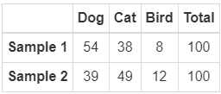  Based on the two samples, what percentage of students own a bird as a pet?  _____ %  Answer: 10  Statistics Unit Test Item #10 | Desmos
11 | Lesson 5: Measures of Variation | Use measures of variability for numerical data from random samples to draw informal comparative inferences about two populations. | p. 14-19 | These are the scores for two randomly selected lacrosse teams. Find the range of the number of goals scored by each team. Based on the range, which team has a more consistent number of goals scored?  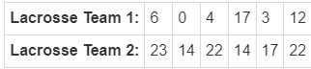  The range of the number of goals scored by Lacrosse Team 1 is_____. The range of the number of goals scored by Lacrosse Team 2 is _____. Based on the range, Lacrosse Team _____ has a more consistent number of goals scored.  Answer: 17; 9; 2  Statistics Unit Test Item #11 | Desmos
12 | Lesson 6: Comparing Data Distributions | Informally assess the degree of visual overlap of two numerical data distributions with similar variabilities. | p. 1-6 | Use the image to answer the question.  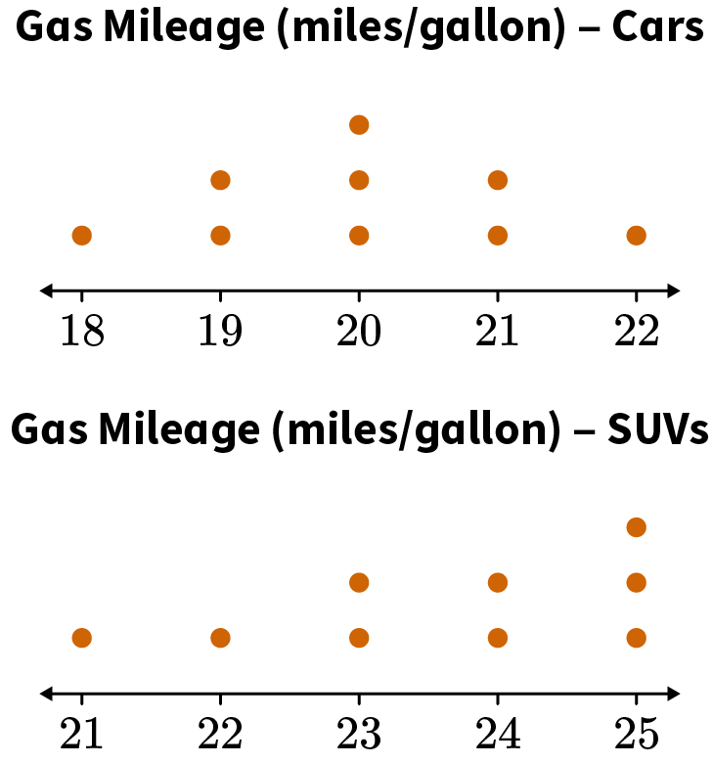  The dot plots show the gas mileage for randomly selected cars and SUVs. Which data values do both distributions have in common?  The data value in common for both distributions with the lowest number is_____.  The data value in common for both distributions for the highest number is____.  Answer: 21, 22  Statistics Unit Test Item #12 | Desmos
13 | Lesson 6: Comparing Data Distributions | For two numerical data distributions with similar variabilities, measure the difference between the centers by expressing it as a multiple of a measure of variability. | p. 7-13 | Fifteen students are randomly selected from two different classes. They were asked how many books they read during the summer. Their responses are as follows. Find the median number of books read by each class. Which class has a higher median number of books read?  Class 1: 0, 5, 3, 6, 7, 8, 10, 1, 1, 4, 5, 6, 4, 5, 6  Class 2: 2, 2, 4, 3, 0, 0, 6, 7, 10, 9, 6, 5, 3, 1, 2  The median number of books read during the summer by Class 1 is _____.  The median number of books read during the summer by Class 2 is _____.  Class _____ has a higher median number of books read during the summer.  Answer: 5; 3; 1  Statistics Unit Test Item #13 | Desmos
14 | Lesson 6: Comparing Data Distributions | For two numerical data distributions with similar variabilities, measure the difference between the centers by expressing it as a multiple of a measure of variability. | p. 7-13 | The ages of randomly selected employees at two companies are recorded. Their ages are as follows.  Company A: 34, 28, 36, 27, 45, 44, 30, 42, 41, 40, 50, 48, 52, 45, 39, 38  Company B: 29, 32, 48, 51, 49, 37, 33, 35, 36, 40, 45, 48, 43, 43, 44, 48  Which of the following statements is true?  1. The mean age of employees from Company A is higher than the mean age of employees from Company B.  2. The median age of employees from Company A is lower than the median age of employees from Company B.  3. The range of ages of employees from Company A is higher than the range of ages of employees from Company B.  Answer: statements 2 and 3  Statistics Unit Test Item #14 | Desmos
15 | Lesson 2: Statistics Basics | Describe statistics as a way to gain information about a population by examining a sample of the population. | p. 1-7 | Maritza plays in a softball league. She wants to know about how many players in the league also play basketball. Because there are 225 players in the league, she chooses the names of 45 of the players and asks them whether they also play basketball. Describe the population and the sample. What is the size of the population, and what is the size of the sample? Show your work.  Answer: The population is the number of players in the softball league, or 225. The sample is the number of players that Maritza asks about basketball, or 45.

