Math 7 B Unit Test Guide

Angle Pairs Unit Test

Item | Lesson Coverage | Objective | Lesson Page | Assessment Item
1 | Lesson 2: Adjacent Angles | Determine whether two angles in a geometric figure are adjacent. | p. 1-6 | Use the image to answer the question.  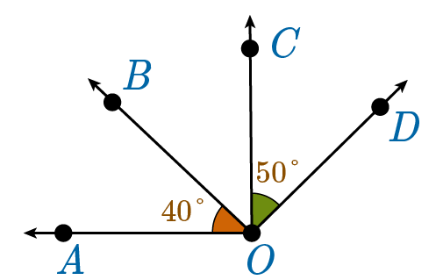  Are the two indicated angles adjacent? Why or why not?  Answer: No, the two indicated angles do not share a common ray.
2 | Lesson 2: Adjacent Angles | Use the angle addition postulate to find the measure of an unknown angle in a simple figure. | p. 7-11 | Use the image to answer the question.  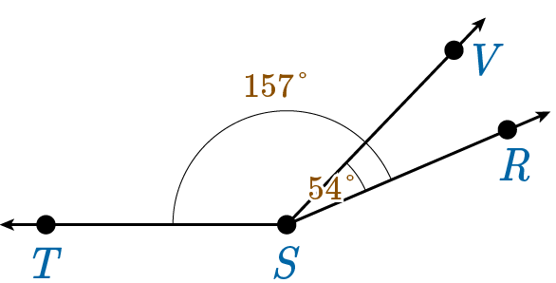  What is the measure of $∠TSV$?  Answer: 103$°$
3 | Lesson 3: Solve Equations with Adjacent Angles | Use facts about adjacent angles in a multi-step problem to write simple equations for an unknown angle in a figure. | p. 1-6 | Use the image to answer the question.  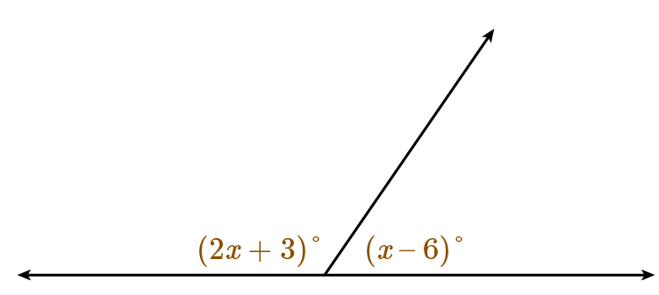  What is an equation for these two adjacent angles?  Answer: $\left(2x+3\right)°+\left(x-6\right)°=180°$
4 | Lesson 3: Solve Equations with Adjacent Angles | Use facts about adjacent angles in a multi-step problem to solve simple equations for an unknown angle in a figure. | p. 7-12 | Two adjacent angles, $∠1$ and $∠2$, form a resulting angle with measure 135°. If $m∠1=\left(2x\right)°$ and $m∠2=\left(2x+7\right)°$, what are the two unknown angle measures?  Answer: $m∠1=64°$, $m∠2=71°$
5 | Lesson 4: Complementary Angles | Use the relationship between complementary angles to find the measure of an unknown angle in a simple figure. | p. 6-10 | A figure displays two complementary nonadjacent angles. If one of the angles has a measure of $39°$, what is the other angle measure?  Answer: 51°
6 | Lesson 5: Solve Equations with Complementary Angles | Use facts about complementary angles in a multi-step problem to write simple equations for an unknown angle in a figure. | p. 1-5 | A figure shows two nonadjacent angles with measures $(2x+3)°$ and $2x°$. If the angles are complementary, what is the equation for the angle measures?  Answer: $\left(2x+3\right)°+2x°=90°$
7 | Lesson 5: Solve Equations with Complementary Angles | Use facts about complementary angles in a multi-step problem to solve simple equations for an unknown angle in a figure. | p. 6-10 | Two complementary angles have measures $\left(2x\right)°$ and $\left(3x\right)°$. What is the value of $x$ and the two angle measures?  Answer: $x=18$, $\left(2x\right)°=36$, and $\left(3x\right)°=54$
8 | Lesson 6: Supplementary Angles | Use the relationship between supplementary angles to find the measure of an unknown angle in a simple figure. | p. 7-11 | Angles $j$ and $k$ are supplementary angles. What is $m∠j$ if $m∠k=117°$?  Answer: $63°$
9 | Lesson 7: Solve Equations with Supplementary Angles | Use facts about supplementary angles in a multi-step problem to write simple equations for an unknown angle in a figure. | p. 1-5 | Two supplementary angles have measures $m∠ABC=105°$and $m∠CBD=\left(3x-24\right)°$. What is the equation to solve for x?  $$(3x-24)° + ___° = ___°$$  Answer: 105; 180
10 | Lesson 7: Solve Equations with Supplementary Angles | Use facts about supplementary angles in a multi-step problem to solve simple equations for an unknown angle in a figure. | p. 6-10 | Two angles are supplementary with measures $m∠ACB=4x°$ and $m∠BCD=\left(6x+50\right)°$. What is the measure of $∠ACB$?  $$m∠ACB=_____°$$  Answer: 52
11 | Lesson 8: Vertical Angles | Determine whether two angles in a geometric figure are vertical angles. | p. 1-6 | Use the image to answer the question.  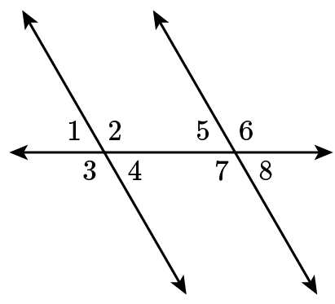  Which angle is a vertical angle with $∠5$?  Answer: 8
12 | Lesson 8: Vertical Angles | Use the relationship between vertical angles to find the measure of an unknown angle in a simple figure. | p. 7-11 | Use the image to answer the question.  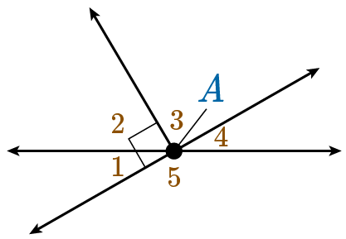  If $m∠2=47°$, what is $m∠4$?  Answer: 43
13 | Lesson 9: Solve Equations with Vertical Angles | Use facts about vertical angles in a multi-step problem to write simple equations for an unknown angle in a figure. | p. 1-5 | Use the image to answer the question.  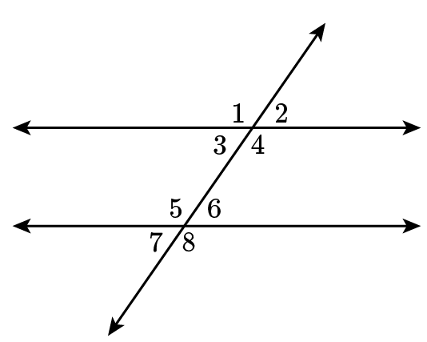  $m∠5=112°$ and $m∠8=\left(2x+8\right)°$. What equation will solve for x?  ____x° +_____° = _____°  Answer: 2; 8; 112
14 | Lesson 9: Solve Equations with Vertical Angles | Use facts about vertical angles in a multi-step problem to solve simple equations for an unknown angle in a figure. | p. 6-11 | For two vertical angles with measures $m∠1=\left(2x+26\right)°$ and $m∠3=\left(3x+32\right)°$, what is the measure of each angle?  Answer: 14
15 | Lesson 10: Find Missing Angles | Use facts about supplementary, complementary, vertical, and adjacent angles in a multi-step problem to write simple equations for an unknown angle in a figure. | p. 1-5 | In a diagram, $∠A$ and $∠B$ are vertical angles, and $∠B$ is a complementary angle with $∠C$. If $m∠A=22°$, write an equation that you can use to solve for $∠C$.  Answer: $22°+m∠C=90°$

