Geometry Unit Test Guide

Circles Unit Test

Item | Lesson Coverage | Objective | Mathematical Practice Standard | Lesson Page | Assessment Item
1 | Lesson 2: Segments Inside a Circle | In this lesson, you will identify and use radii, diameters, and chords within circles. | Look for and make use of structure. | Page 1-7 | 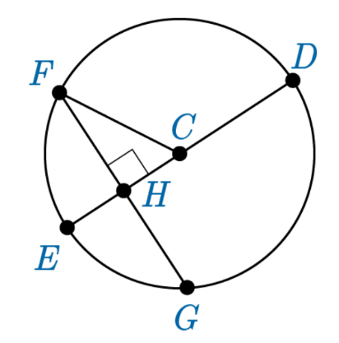  If CH=42 m and CF = 58 m, then what is the length of FG?  Correct Answer: 80m  Circles Unit Test Item #1 - GeoGebra
2 | Lesson 2: Segments Inside a Circle | In this section, you will identify and use the relationship between the radius of a circle and a line tangent to that circle at the point where the radius intersects the circle. | Look for and make use of structure. | Page 8-14 | 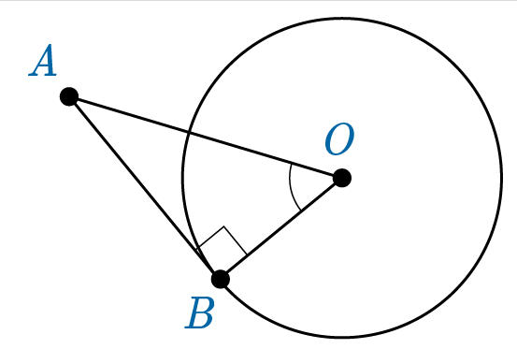  If BO = 45 in. And BA = 108 in., then what is the length of AO to the nearest whole inch?  Correct Answer: 117 in.  Circles Unit Test Item #2 - GeoGebra
3 | Lesson 3: Angles Inside a Circle | In this section, you will identify and use central angles, inscribed angles, and circumscribed angles. | Look for and make use of structure. | Page 1-9 | 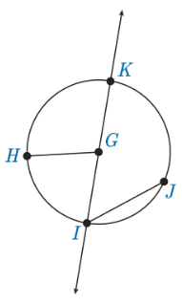  If arc KJ = 13x-10 and arc JI = 7x-10, then find the $m∠KIJ$.  Correct Answer: 60 degrees  Circles Unit Test Item #3 - GeoGebra
4 | Lesson 3: Angles Inside a Circle | In this section, you will understand and use the fact that an inscribed angle on a diameter measures 90 degrees. | Look for and make use of structure. | Page 10-15 | Triangle $XYZ$is inscribed inside a circle with diameter $XZ$and the inscribed angle at $Y$. The angle measure at $X$is 59°. Using what you know about inscribed angles, find the arc measure of $XY$.  Correct Answer: $62°$  Circles Unit Test Item #4 - GeoGebra  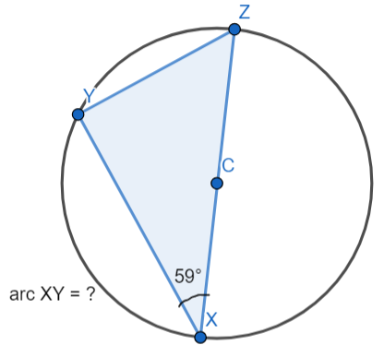
5 | Lesson 4: Circles and Triangles | In this section, you will construct the inscribed circle of a triangle. | Use appropriate tools strategically. | Page 1-6 | 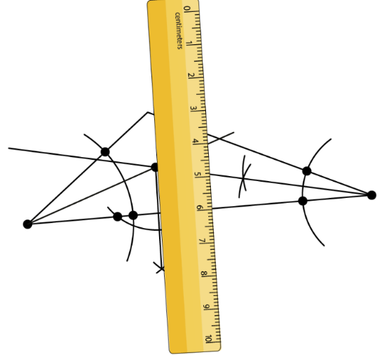  For what part of the construction is this final step?  Correct Answer: the incenter
6 | Lesson 4: Circles and Triangles | In this section, you will construct the circumscribed circle of a triangle. | Use appropriate tools strategically. | Page 7-13 | The circumscribed circle of a triangle refers to which of the following?  Correct Answer: a circle around a triangle
7 | Lesson 5: Circles and Quadrilaterals | In this section, you will prove and apply properties of opposite angles within a quadrilateral inscribed in a circle. | Look for and express regularity in repeated reasoning. | Page 1-5 | 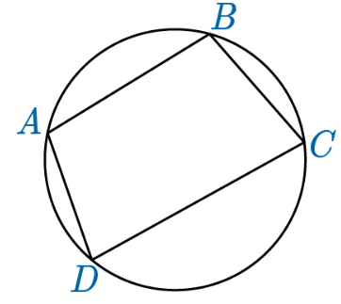  The $m∠B$is $93°$, the measure of arc BC is $58°$, and the measure of arc CD is $106°$. Find the missing angle measures.  Correct Answer: $m∠A=82°, m∠C=98°, m∠D=87°$  Circles Unit Test Item #7 - GeoGebra
8 | Lesson 6: Similar Circles | In this section, you will prove that all circles are similar. | Look for and express regularity in repeated reasoning. | Page 1-6 | The circumference of Jupiter is approximately 272,946 miles. The circumference of Earth is approximately 24,901 miles. What is the scale factor of Jupiter to Earth rounded to the nearest whole number?  Correct Answer: 11:1  Circles Unit Test Item #8 - GeoGebra
9 | Lesson 7: Trigonometry and Circles | In this section, you will describe an informal argument for the formula for the circumference of a circle. | Look for and express regularity in repeated reasoning. | Page 1-6 | Jamila wants to walk with her friend at the park but isn’t sure how long the course is. She knows it is a circular path with a walkway through the middle, and the path across the middle is $\frac{1}{2}$ of a mile. What is the distance all the way around the circle? Give the answer to the nearest tenth of a mile.  Correct Answer: 1.6 mi.  Circles Unit Test Item #9 - GeoGebra  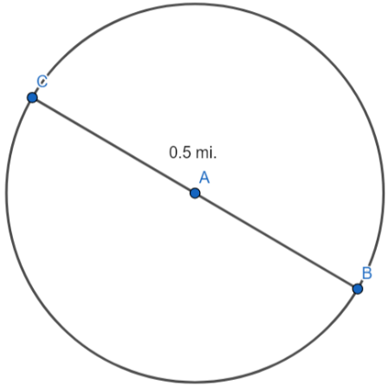
10 | Lesson 7: Trigonometry and Circles | In this section, you will describe an informal argument for the formula for the area of a circle. | Look for and express regularity in repeated reasoning. | Page 7-12 | If the area of a circle is $586 m^{2}$ , then what is the length of the diameter to the nearest meter?  Correct Answer: 27m  Geometry Unit Test Item #10 - GeoGebra  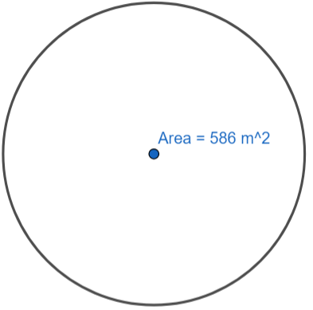
11 | Lesson 8: Radian Angle Measure | In this section, you will derive the fact that the length of the arc of a circle intercepted by an angle is proportional to the radius of the circle. | Reason abstractly and quantitatively. | Page 1-6 | If a circular pool has a circular fence around it that has a 20-foot diameter, then what is the measure of the central angle that cuts the arc that measures 4 feet?  Correct Answer: 22.9 degrees  Circles Unit Test item #11 - GeoGebra  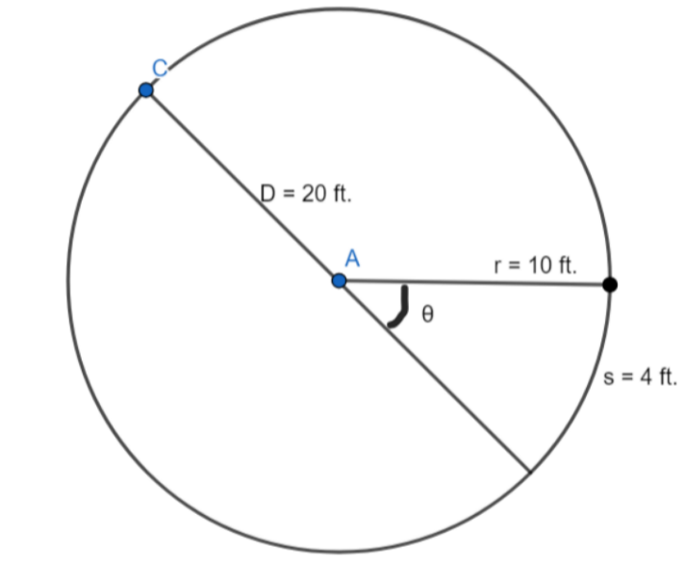
12 | Lesson 8: Radian Angle Measure | In this section, you will define the measure of an angle in radians as the ratio of the arc length created by the angle to the circle’s radius. | Reason abstractly and quantitatively. | Page 7-13 | If a circle has a central angle of $\frac{2π}{3}$ and a radius of 27 millimeters, how long is the arc formed by that angle?  Correct Answer: $18π mm$  Circles Unit Test Item #12 - GeoGebra  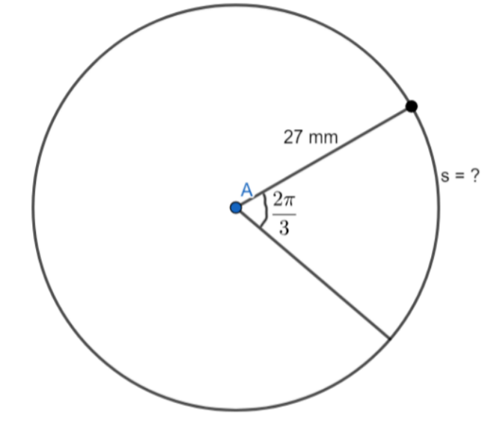
13 | Lesson 9: Area of a Sector | In this section, you will derive the formula for calculating the area of a sector. | Look for and express regularity in repeated reasoning. | Page 1-6 | What is the area of the sector of a circle with $θ=216°$and a radius of 7 inches? Express your answer in terms of pi.  Correct Answer: $29.4π in.^{2}$  Circles Unit Test Item #13 - GeoGebra  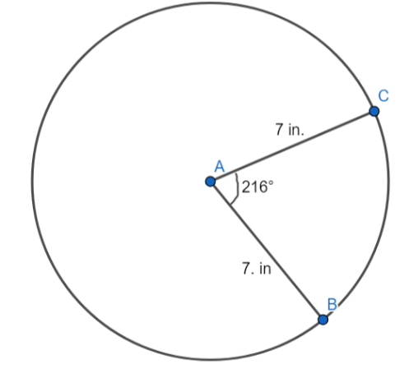
14 | Lesson 9: Area of a Sector | In this section, you will use a formula to calculate the area of a sector on a circle. | Attend to precision. | Page 7-12 | A cookie cake has a diameter of 18 in. If part the of cookie cake is eaten, the missing section forms an angle of $270°$. What is the area of the cookie cake that was eaten? Round your answer to the nearest tenth.  Correct Answer: $190.9 in^{2}$  Circles Unit Test Item #14 - GeoGebra  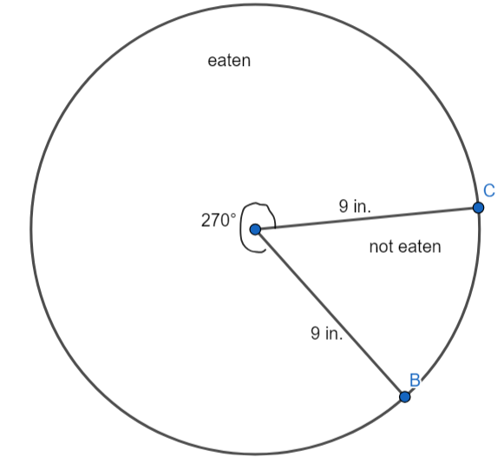
15 | Lesson 6: Similar Circles | In this section, you will prove that all circles are similar. | Look for and express regularity in repeated reasoning. | Page 1-6 | In 1–2 sentences, explain how it can be proven that all circles are similar to each other.  Correct Answer:  Student answers should explain that is possible to take the radius of any circle and transform that circle to be proportional to any other circle by dilation. Because all circles are proportional to each other, no matter their size, all circles are similar.
16 | Lesson 7: Trigonometry and Circles | In this section, you will describe an informal argument for the formula for the circumference of a circle. | Look for and express regularity in repeated reasoning. | Page 1-6 | In 1–2 sentences, describe how the lengths of a circle’s circumference and diameter relate to each other.  Correct Answer:  Student answers should state that the circumference length divided by the diameter length equals $π$. So, for any length diameter, the circumference will be approximately 3.14 times longer than the diameter.
17 | Lesson 8: Radian Angle Measure | In this section, you will define the measure of an angle in radians as the ratio of the arc length created by the angle to the circle’s radius. | Reason abstractly and quantitatively. | Page 7-13 | The formula for the circumference of a circle is $C=πd$, where $C=circumference$ and $d=diameter$. It can also be defined as $C=2πr$, where $r=radius$. If 360 degrees = $2π$ radians, and the formula for arc length is $θ=\frac{s}{r}$, then determine the length created by a 60-degree central angle in a circle with a 2-inch diameter and explain how you found it. Answer in 3-5 sentences.  Correct Answer:  Student answers should find that the circumference of the circle in the problem is $2π$radians and the radius is 1 inch. If 60 degrees is converted to radians, $\frac{\left(60\right)∙π}{180}$ , the angle measure becomes $\frac{π}{3}$radians. To find the length of the arc created by the 60- degree angle, divide the central angle measure by the radius $\frac{\left(\frac{π}{3}\right)}{1}$. Therefore, the arc is 1.05 inches.

