Geometry Unit Test Guide

2D and 3D Shapes Unit Test

Item | Lesson Coverage | Objective | Mathematical Practice Standard | Lesson Page | Assessment Item
1 | Lesson 2: Equation of a Circle | In this section, you will derive the equation of a circle using the Pythagorean Theorem when given a center and a radius. | Look for and make use of structure. | Page 1-7 | A circle is drawn on a coordinate plane with the center point at (-4,6) and a radius of 2. Derive the equation of the circle from the given information. Fill in the missing information in the following equation.  Correct Answer: ${\left(x--4\right)}^{2}+{\left(y-6\right)}^{2}=4$ or ${\left(x+4\right)}^{2}+{\left(y-6\right)}^{2}=4$  Equation & Graph of a Circle – GeoGebra: Use the sliders for h, k, and r to find the equation of a circle.
2 | Lesson 3: Using Equations of Circles | In this section, you will calculate the center and radius of a circle given by an equation by using the method of completing the square. | Look for and make use of structure. | Page 1-7 | Calculate the radius of a circle by completing the square of the equation $x^{2}+y^{2}-16x-10y+40=0$.  Correct Answer: radius = 7  2D and 3D Shapes Unit Test Item #2 - GeoGebra
3 | Lesson 4: Equation of a Parabola | In this section, you will derive the equation of a parabola given a focus and directrix. | Reason abstractly and quantitatively. | Page 1-7 | Derive the equation of a parabola given the focus is at (-4,6) and the directrix is at y = 8. Fill in the missing values of the equation in standard form.  $$y=-\frac{1}{4}x^{2}-?x+3$$  Correct Answer: $y=-\frac{1}{4}x^{2}-2x+3$
4 | Lesson 4: Equation of a Parabola | In this section, you will graph a parabola in the coordinate plane. | Use appropriate tools strategically. | Page 8-14 | You are asked to graph a parabola on a coordinate plane given the equation $y=-\frac{1}{8}x^{2}+\frac{3}{4}x+\frac{7}{8}$. Fill in the missing value on the table for the coordinates of the parabola.  x-value y-value  -1 0  3 2  ? 0  11 -6  Correct Answer: 7  2D and 3D Shapes Unit Test Item #4 - GeoGebra
5 | Lesson 5: Using Equations of Parabolas | In this section, you will solve and graph mathematical and real-world problems that are modeled with the equation of a parabola. | Make sense of problems and persevere in solving them. | Page 1-6 | A certain statue at a monument has a perimeter of rope hung by poles. Between each pole the rope forms a U-shape that, like a parabola, can be expressed by the equation $y={\left(x-\frac{3}{2}\right)}^{2}+\frac{5}{4}$. Suppose you were to graph the equation; at what point would the graph cross the y-axis?  Correct Answer: y= 3.5  2D and 3D Shapes Unit Test Item #5 - GeoGebra
6 | Lesson 5: Using Equations of Parabolas | In this section, you will interpret key features of parabolas that model mathematical and real-world problems. | Model with mathematics. | Page 7-13 | A golfer uses a tracking device to determine the data of the ball as it is in the air. She calculates that her ball, when 34 yards away from her, reached a maximum height of 72 yards before descending. The path of the golf ball can be modeled by a quadratic function where x represents the horizontal distance and y represents the height of the ball. In terms of the context, which key feature would represent the maximum height of the ball?  Option #1: vertex  Option #2: domain  Option #3: intercepts  Option #____ describes the point at which the ball reaches maximum height before descending.  Correct Answer: Option #1
7 | Lesson 6: 2D and 3D Objects | In this section, you will identify the shapes of two-dimensional cross sections of three-dimensional objects. | Reason abstractly and quantitatively. | Page 1-6 | A metronome is a device used to maintain a steady beat in music. The device has the shape of a pyramid. Identify the number of sides of the two-dimensional vertical cross-section.  The two-dimensional vertical cross-section has ____ sides.  Correct Answer: 3  Sections of Rectangular Pyramids – GeoGebra : 3D cross-section tool
8 | Lesson 6: 2D and 3D Objects | In this section, you will identify three-dimensional objects generated by rotations of two-dimensional objects. | Reason abstractly and quantitatively. | Page 7-12 | Which of the following shapes can be rotated to create a three-dimensional object like an orange?  Option #1: right triangle  Option #2: square  Option #3: hemisphere  Option #4: rectangle  Correct Answer: Option #3  Rotate Circle – GeoGebra  Sections of Spheres – GeoGebra
9 | Lesson 7: Volume of a Cylinder | In this section, you will describe the formula for the volume of a cylinder. | Reason abstractly and quantitatively. | Page 1-6 | A stack of quarters could be used in an informal argument for which of the following?  Option #1: the formula for the volume of a cone  Option #2: the formula for the volume of a sphere  Option #3: the formula for the volume of a pyramid  Option #4: the formula for the volume of a cylinder  A stack of quarters could be used in an informal argument for the formula described in Option #___.  Correct Answer: Option #4  Sections of Cylinders – GeoGebra
10 | Lesson 7: Volume of a Cylinder | In this section, you will calculate the solution to problems with the volume formula for cylinders. | Attend to precision. | Page 7-12 | The distance of the wick to the edge of a cylindrical candle is $2 \frac{1}{4}$ inches, and the volume of wax used in the candle is approximately $159 in.^{3}$Assuming the wick is located in the center of the candle, find the height of the candle to the nearest whole number.  The candle’s height is approximately ____ inches.  Correct Answer: 10  2D and 3D Shapes Unit Test Item #10 - GeoGebra  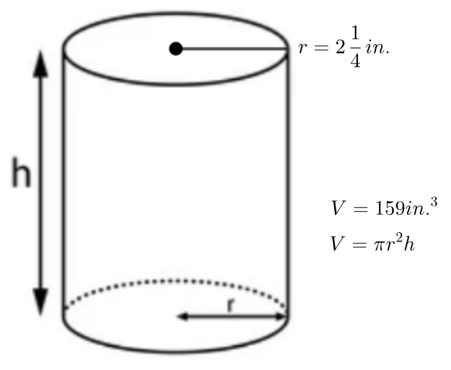
11 | Lesson 8: Volume of a Cone | In this section, you will describe an informal argument for the formula giving the volume of a cone based on the formula for the volume of a cylinder. | Reason abstractly and quantitatively. | Page 1-7 | A cone and a cylinder have the same base radius and the same height. If the volume of the cone is 10π cubic units, what is the volume of the cylinder?  Correct Answer: $30π$ cubic units  2D and 3D Shapes Unit Test Item #11 - GeoGebra
12 | Lesson 8: Volume of a Cone | In this section, you will calculate solutions to problems that require using the volume formula for a cone. | Attend to precision. | Page 8-15 | Anders finds the volume of the cone in the image. What is the volume of this cone in cubic inches? Use 3.14 to represent pi and round the volume to the nearest cubic inch.  Correct Answer: 25 cubic inches  2D and 3D Shapes Unit Test Item #12 - GeoGebra  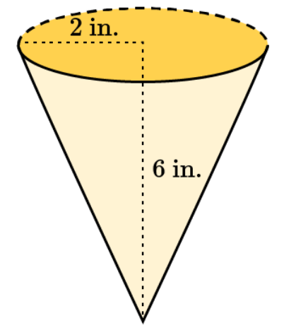
13 | Lesson 9: Volume of a Pyramid | In this section, you will describe an informal argument for the formula that gives the volume of a pyramid, based on the formula for the volume of a cube. | Reason abstractly and quantitatively. | Page 1-7 | Mei Li measures a cube and a square-based pyramid and finds that the pyramid has the same height and base area as the cube. She also calculates that the volume of the cube is 9 cubic meters. What is the volume of the pyramid?  Correct Answer: $3 m^{3}$  2D and 3D Shapes Unit Test Item #13 - GeoGebra
14 | Lesson 9: Volume of a Pyramid | In this section, you will calculate the solution to problems involving the volume of pyramids. | Attend to precision. | Page 8-14 | Arturo sketches this square-based pyramid. Each edge of the base measures 8 centimeters, as shown in the image. What is the volume of Arturo’s pyramid, rounded to the nearest whole cubic centimeter?  Correct Answer: 213  2D and 3D Shapes Unit Test Item #14 - GeoGebra
15 | Lesson 10: Volume of a Sphere | In this section, you will calculate the solution to problems using the volume formula for spheres. | Attend to precision. | Page 1-6 | Calculate the volume of the sphere using 3.14 for pi and round to the nearest tenth.  Correct Answer: 904.3 $cm^{3}$  2D and 3D Shapes Unit Test Item #15 - GeoGebra  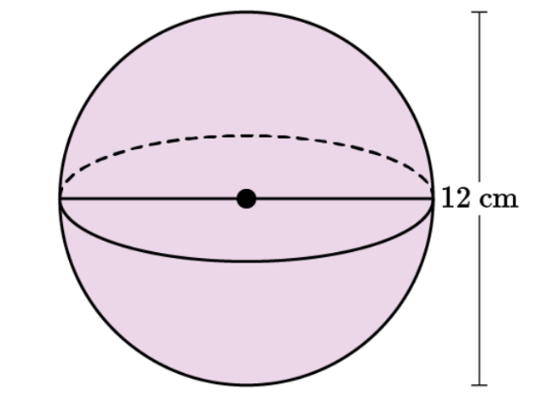
16 | Lesson 5: Using Equations of Parabolas | In this section, you will interpret key features of parabolas that model mathematical and real-world problems. | Model with mathematics. | Page 7-13 | Damar writes a book on how to save money. He wants to determine the price at which he should sell the book in order to maximize his revenue. He comes up with the equation $y=-0.1x^{2}+26x$, where x represents the selling price and y represents the revenue earned. In terms of the context, describe in 1–2 sentences at what sale price his book would return maximum revenue and what that revenue would be.  Correct Answer: Student answers should explain that if he sells his book for $130 per unit, it would return maximum revenue of $1,690.  2D and 3D Shapes Unit Test Item #16 - GeoGebra
17 | Lesson 7: Volume of a Cylinder | In this section, you will describe the formula for the volume of a cylinder. | Reason abstractly and quantitatively. | Page 1-6 | What is the formula for the volume of a cylinder with radius r and height h? In 3–5 sentences, describe an informal argument for this volume formula.  Correct Answer:  Students should state the formula for the volume of a cylinder, $V=πr^{2}h$ . They should explain that a cylinder can be thought of as a stack of h circles, each with the same radius of r and thickness of one unit. The area of each circle is $πr^{2}$. Therefore, the volume of the cylinder is the product of the area of one circle and the number of circles, or $V=πr^{2}∙h$.
18 | Lesson 9: Volume of a Pyramid | In this section, you will describe an informal argument for the formula that gives the volume of a pyramid, based on the formula for the volume of a cube. | Reason abstractly and quantitatively. | Page 1-7 | Michelle creates a cube with a height of 6 centimeters. Her friend Tasha creates a square-based pyramid with the same height and base area as Michelle’s cube. Find the volume of Michelle’s cube and use it to find the volume of Tasha’s pyramid. Show all work.  Correct Answer:  - All the lengths of a cube are equal, so the base area of Michelle’s cube is $6∙6=36$square centimeters.  - To find the volume of a cube, multiply the base area by the height: $36∙6=216$.  - The volume of Michelle’s cube is 216 cubic centimeters.  - To find the pyramid’s volume, multiply the volume of the cube by $\frac{1}{3}$.  - Since $\frac{1}{3}∙216=72$, the volume of Tasha’s pyramid is 72 cubic centimeters.

