Geometry Unit Test Guide

Modeling with Geometry Unit Test

Item | Lesson Coverage | Objective | Mathematical Practice Standard | Lesson Page | Assessment Item
1 | Lesson 2: Area of a Model | In this section, you will calculate the area of objects that can be modeled by a shape, or that can be modeled by multiple copies of that shape. | Model with mathematics. | Page 1-6 | A farmer wants to create a rectangular fence for his goats that is 12 yd. by 15 yd. Inside the same area, the farmer will also build a small rectangular fenced garden that is 3 yd. by 6 yd. If the goats are not allowed in the garden, how many square yards is the fenced area that the goats will be allowed to roam in?  Correct Answer: $162 yd.^{2}$  Modeling with Geometry Unit Test Item #1 - GeoGebra  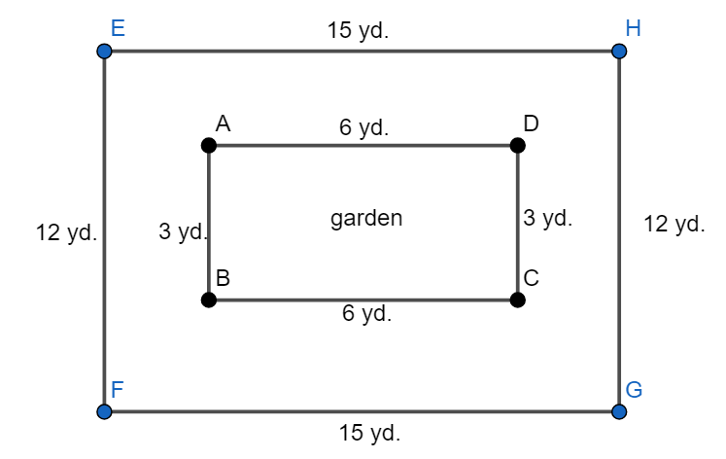
2 | Lesson 2: Area of a Model | In this section, you will calculate the area of objects that can be modeled by a shape, or that can be modeled by multiple copies of that shape. | Model with mathematics. | Page 1-6 | Katerina is purchasing wallpaper to cover one wall in her bedroom. The wall is rectangular in shape, with a height of 10 ft. and a length of 18 ft. The wall contains two rectangular windows that are 6 ft. by 4 ft. each. Determine the amount of wallpaper that Katerina should purchase to cover the wall.  Correct Answer: $132 ft.^{2}$  Modeling with Geometry Unit Test Item #2 - GeoGebra  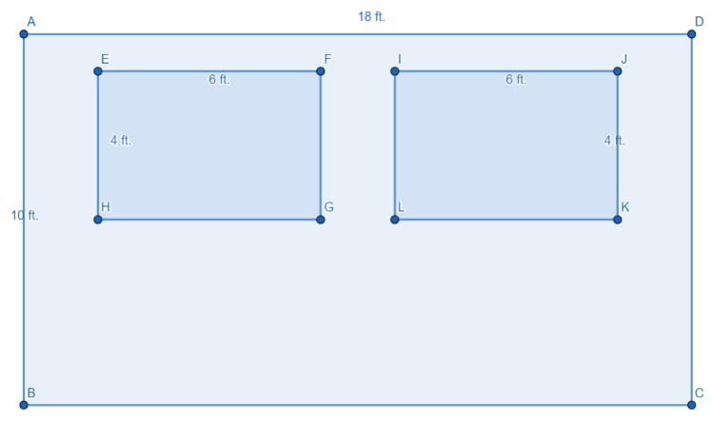
3 | Lesson 2: Area of a Model | In this section, you will calculate the area of objects that can be modeled by composite figures. | Model with mathematics. | Page 7-13 | A room is being carpeted and the model of the carpet is shown in the image. If the cost of 1 $ft.^{2}$of carpet is $20, what is the cost of the whole carpet?  Correct Answer: $1,010  Modeling with Geometry Unit Test Item #3 and #4 - GeoGebra  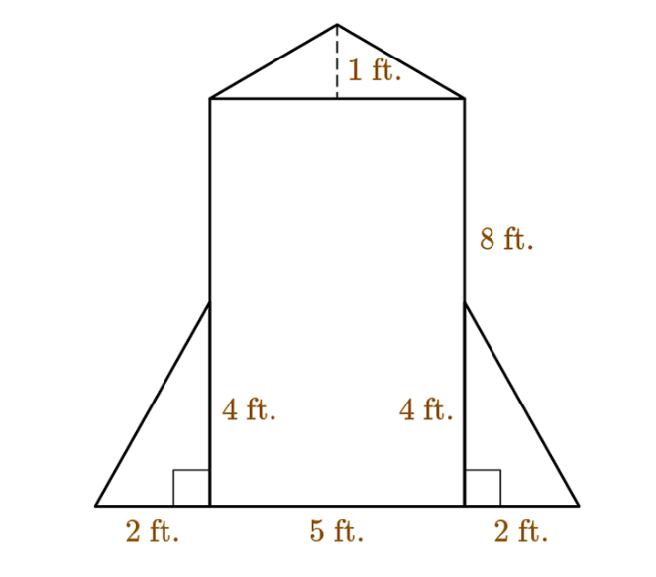
4 | Lesson 2: Area of a Model | In this section, you will calculate the area of objects that can be modeled by composite figures. | Model with mathematics. | Page 7-13 | A room is being carpeted and the model of the carpet is shown in the image. If the cost of 1 $ft.^{2 }$of carpet is $20 and you want to pay exactly $960 for the carpet, which part of the carpet should be excluded?  Correct Answer: the isosceles triangle  Modeling with Geometry Unit Test Item #3 and #4 - GeoGebra
5 | Lesson 3: Surface Area of a Model | In this section, you will calculate the surface area of objects that can be modeled by prisms or cylinders. | Model with mathematics. | Page 1-6 | Anna is cutting a cereal box into small squares with a side length of 1 in. How many squares can she cut if the box is a rectangular prism with a length of 10 in., a width of 4 in., and a height of 12 in.?  Correct Answer: 416 squares  Modeling with Geometry Unit Test Item #5 - GeoGebra
6 | Lesson 3: Surface Area of a Model | In this section, you will calculate the surface area of objects that can be modeled by prisms or cylinders. | Model with mathematics. | Page 1-6 | Filip is making a crate that is a prism with a square base. The base side length is 8 in. and the height of the prism is 20 in. Which of the following correctly calculates the surface area of this prism?  Correct Answer: 768 $in.^{2}$  Modeling with Geometry Unit Test Item #6 - GeoGebra
7 | Lesson 3: Surface Area of a Model | In this section, you will calculate the surface area of objects that can be modeled by pyramids or cones. | Model with mathematics. | Page 7-12 | Determine the surface area of a pyramid with a triangular base. The triangle base has two equal sides of 13 in., and the height of the base side is 12 in. The slant height of the pyramid is 7 in.  Correct Answer: 186 $in.^{2}$  Modeling with Geometry Unit Test Item #7 - GeoGebra
8 | Lesson 3: Surface Area of a Model | In this section, you will calculate the surface area of objects that can be modeled by pyramids or cones. | Model with mathematics. | Page 7-12 | Determine the surface area of a cone if the diameter of the base is 14 ft., and the slant height of the cone is 19 ft. Use pi = 3.14 and round your answer to the nearest hundredth.  Correct Answer: 571.48 $ft.^{2}$  Modeling with Geometry Unit Test Item #8 - GeoGebra
9 | Lesson 4: Density in Two Dimensions | In this section, you will calculate the density of two-dimensional objects. | Make sense of problems and persevere in solving them. | Page 1-7 | In 2022, the population of Europe was approximately 743.5 million people, and the population of the United States was approximately 332.4 million people. Europe is about 3.9 million square miles, and the USA is about 3.5 million square miles in land area. Which answer correctly compares the population densities of the regions?  Correct Answer: Europe is more densely populated, with a density of 190.6 people per square mile.  Modeling with Geometry Unit Test Item #9 - GeoGebra
10 | Lesson 4: Density in Two Dimensions | In this section, you will use the density calculations of two-dimensional objects to solve problems. | Attend to precision. | Page 8-13 | You have to plant 20,000 seeds, and the planting density is 4,000 seeds per acre. Which of the following correctly calculates the area of the land where you are planting?  Correct Answer: 5 acres  Modeling with Geometry Unit Test Item #10 - GeoGebra
11 | Lesson 5: Density in Three Dimensions | In this section, you will calculate the density of three-dimensional objects. | Make sense of problems and persevere in solving them. | Page 1-7 | Marcus found a toy that is in the shape of a rectangular pyramid and is made out of plastic. The rectangular base has a length of 4 cm and a width of 5 cm. The height of the pyramid is 6 cm. Marcus weighs the toy and finds that it is 25 grams. Find the density of the toy.  Correct Answer: 0.625 $\frac{g}{cm^{3}}$  Modeling with Geometry Unit Test Item #11 - GeoGebra
12 | Lesson 5: Density in Three Dimensions | In this section, you will use the density calculations of three-dimensional objects to solve problems. | Attend to precision. | Page 8-13 | A piece of magnesium has a cylindrical shape with a height of 8 centimeters and a diameter of 2 centimeters. If the magnesium has a density of $1.78 \frac{g}{cm^{3}}$, what is the mass of the cylinder sample? Round your answer to the nearest hundredth. Use $π≈3.14$.  Correct Answer: 44.71 $\frac{g}{cm^{3}}$  Modeling with Geometry Unit Test Item #12 - GeoGebra
13 | Lesson 5: Density in Three Dimensions | In this section, you will use the density calculations of three-dimensional objects to solve problems. | Attend to precision. | Page 8-13 | A rectangular bar of platinum has a width of 5 centimeters, a height of 8 centimeters, and an unknown length. You measure the platinum bar and it is exactly 1 kilogram. Find the length of the bar if you know its density is 21.4 $\frac{g}{cm^{3}}$ . Round your answer to the nearest hundredth.  Correct Answer: 1.17 cm  Modeling with Geometry Unit Test Item #13 - GeoGebra
14 | Lesson 4: Density in Two Dimensions | In this section, you will calculate the density of two-dimensional objects. | Make sense of problems and persevere in solving them. | Page 1-7 | There are 1,620 people who live in a neighborhood. If the neighborhood contains 18 residential blocks, calculate the density of people per block in the neighborhood. In 1–2 sentences, explain how you determined the density.  Correct Answer:  Student answers should use the formula for population density.  $$population density = \frac{\left(total \# of people\right)}{\left(number of blocks\right)} = \frac{1620}{18} = 90$$  The density of people per block in the neighborhood is 90.
15 | Lesson 4: Density in Two Dimensions | In this section, you will use the density calculations of two-dimensional objects to solve problems. | Attend to precision. | Page 8-13 | The area of the state of Hawaii is 10,931 square miles, and its population is 1,440,196 people. The population density of a village in France is 10.19 people per square mile. Which location is more densely populated? In 1–2 sentences, explain how you determined your answer.  Correct Answer:  Student answers should calculate that the population density of Hawaii is  $$\frac{\left(number of people\right)}{area}= \frac{1,440,196}{10,931}=131.75$$  people per square mile. Since the population density of the village is 10.19 people per square mile, that means Hawaii is more densely populated because there are more people per square mile than the village in France.
16 | Lesson 5: Density in Three Dimensions | In this section, you will calculate the density of three-dimensional objects. | Make sense of problems and persevere in solving them. | Page 1-7 | The density of water is approximately $1 \frac{g}{cm^{3}}$. An ice block with a height of 2 cm, length of 2 cm, width of 5 cm, and mass of 18.4 g is dropped in water. Will it float or sink? In 3–5 sentences, show your calculations and explain how you arrived at your conclusion.  Correct Answer:  Student answers should calculate that the volume of the ice block is  $V=lhw=2cm∙2cm∙5cm=20cm^{3}$.  The density of the block is $d=\frac{mass}{volume}=\frac{18.4g}{20cm^{3}}=0.92 \frac{g}{cm^{3}}$.  Because $0.92 \frac{g}{cm^{3}}$is less than$1 \frac{g}{cm^{3}}$ , the ice block is less dense than water. The block will float in water.

