Geometry Unit Test Guide

Inverse Trigonometry Unit Test

Item | Lesson Coverage | Objective | Mathematical Practice Standard | Lesson Page | Assessment Item
1 | Lesson 2: Pythagorean Triples | In this section, you will identify Pythagorean triples. | Make sense of problems and persevere in solving them. | Page 1-8 | Is $\left(5, 7, \sqrt{7}4\right)$ a Pythagorean triple? Enter 1 for yes or 2 for no.  Correct Answer: 2 (no)
2 | Lesson 2: Pythagorean Triples | In this section, you will identify Pythagorean triples. | Make sense of problems and persevere in solving them. | Page 1-8 | Given that $\left(20, x, 29\right)$ is a Pythagorean triple and $x<29$, what is the value of x?  Correct Answer: x = 21  Pythagorean Triple – GeoGebra: move the sides around to match the given lengths to find the missing length.
3 | Lesson 2: Pythagorean Triples | In this section, you will learn about Pythagorean triples and how to use them to solve problems. | Look for and make use of structure | Page 9-14 | A 24-foot-tall tree casts a shadow that is 10 feet long. What is the distance from the top of the tree to the top of its shadow? Apply a Pythagorean triple to solve this problem.  Correct Answer: 26 feet  Pythagorean Triple – GeoGebra: move the sides around to match the given lengths to find the missing length.
4 | Lesson 2: Pythagorean Triples | In this section, you will learn about Pythagorean triples and how to use them to solve problems. | Look for and make use of structure | Page 9-14 | Tyrese buys potting soil every January to plant vegetables in his garden. This year he bought 15 25-pound bags of potting soil. He must push them up a 6- foot-high ramp to his truck. The horizonal distance from the base of the ramp to the truck is 8 feet. Apply a Pythagorean triple to find the length of the ramp.  Correct Answer: 10 feet  Pythagorean Triple – GeoGebra: move the sides around to match the given lengths to find the missing length.
5 | Lesson 2: Pythagorean Triples | In this section, you will learn about Pythagorean triples and how to use them to solve problems. | Look for and make use of structure | Page 9-14 | Given that (11, 60, 61) is a Pythagorean triple, use (11, 60, 61) to find a new Pythagorean triple that contains 183.  Correct Answer: The new Pythagorean triple is (33, 180, 183).
6 | Lesson 5: Inverse Sine | In this section, you will learn how to use the inverse of the sine ratio to solve applied problems. | Make sense of problems and persevere in solving them. | Page 1-6 | A cat climbs onto a roof and looks down at you. You are standing 12 feet away from the house and there is an 18-foot diagonal distance between you and the cat. Using the inverse of sine function, what is the angle the cat is using to look down at you? Round your answer to the nearest whole degree.  Correct Answer: $≈48°$  Inverse Trigonometry Unit Test Item #6 - GeoGebra  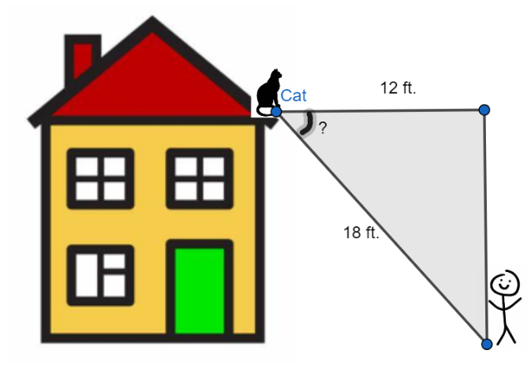
7 | Lesson 5: Inverse Sine | In this section, you will learn how to use the inverse of the sine ratio to solve applied problems. | Make sense of problems and persevere in solving them. | Page 1-6 | Oscar uses a board to form a walking plank across a small ditch that has uneven sides. The board is 6 feet in length and stretches across the entire gap. The higher side of the ditch is 3 feet above the other side. Using the inverse of sine, what is the approximate angle of elevation formed between the board and the lower side of the ditch?  Correct Answer: $30°$  Inverse Trigonometry Unit Test Item #7 - GeoGebra  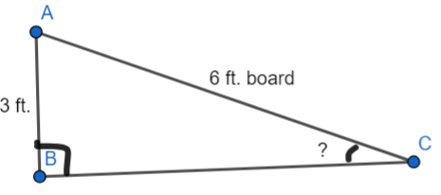
8 | Lesson 5: Inverse Sine | In this section, you will learn how to use the inverse of the sine ratio to solve applied problems. | Make sense of problems and persevere in solving them. | Page 1-6 | Jaclynn is building a cat house for her cats. She designs a ramp from one level to the other for them to climb. The ramp length is 4 feet, and the difference between the two levels is 2.5 feet. Using the inverse of sine function, what is the approximate angle of elevation formed by the ramp? Round your answer to the nearest whole degree.  Correct Answer: $≈39°$  Inverse Trigonometry Unit Test Item #8 - GeoGebra  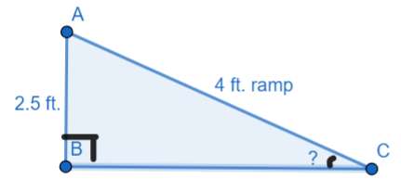
9 | Lesson 6: Inverse Cosine | In this section, you will use the inverse of the cosine ratio to solve problems. | Make sense of problems and persevere in solving them. | Page 1-7 | 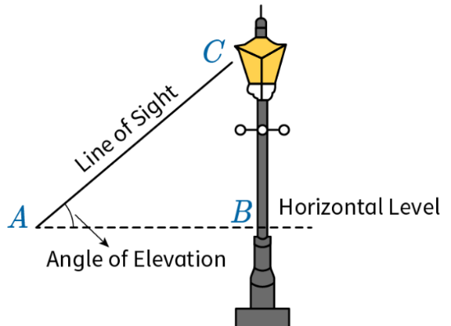  Meekah is looking at a bird perched on top of a street light. Her line of sight, which is the diagonal distance to the top of the street light, is 16 feet, and she is standing 8 feet from the base of the street light. Use the inverse of cosine to find the angle of elevation with which she is looking at the bird. Round your answer to the nearest whole degree.  Correct Answer: $60°$  Inverse Trigonometry Unit Test Item #9 - GeoGebra
10 | Lesson 6: Inverse Cosine | In this section, you will use the inverse of the cosine ratio to solve problems. | Make sense of problems and persevere in solving them. | Page 1-7 | 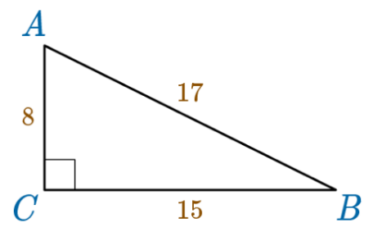  Use the inverse of cosine to find the approximate interior angle measure at vertex A. Round your answer to the nearest whole degree.  Correct Answer: $≈62°$  Inverse Trigonometry Unit Test Item #10 - GeoGebra
11 | Lesson 6: Inverse Cosine | In this section, you will use the inverse of the cosine ratio to solve problems. | Make sense of problems and persevere in solving them. | Page 1-7 | 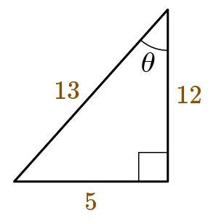  Use the inverse of cosine to find the indicated missing angle. Round your answer to the nearest tenth.  Correct Answer: $θ≈22.6°$  Inverse Trigonometry Unit Test Item #11 - GeoGebra
12 | Lesson 7: Inverse Tangent | In this section, you will use the inverse of the tangent ratio to solve problems. | Make sense of problems and persevere in solving them. | Page 1-6 | 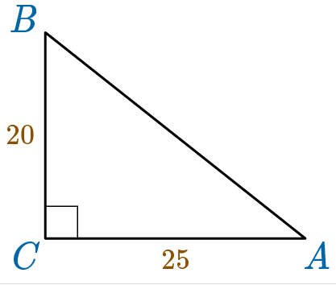  Use the inverse of the tangent ratio to find the approximate angle measure at vertex B. Round your answer to the nearest whole degree.  Correct Answer: $θ≈51°$  Inverse Trigonometry Unit Test item #12 - GeoGebra
13 | Lesson 7: Inverse Tangent | In this section, you will use the inverse of the tangent ratio to solve problems. | Make sense of problems and persevere in solving them. | Page 1-6 | 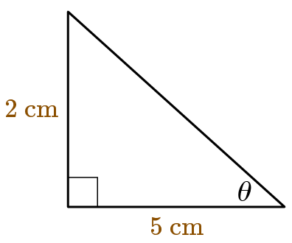  Use the inverse of the tangent ratio to find the approximate measure of the missing angle. Round your answer to the nearest whole degree.  Correct Answer: $θ≈22°$  Inverse Trigonometry Unit Test Item #13 - GeoGebra
14 | Lesson 7: Inverse Tangent | In this section, you will use the inverse of the tangent ratio to solve problems. | Make sense of problems and persevere in solving them. | Page 1-6 | Rico secures a volleyball-net pole to the ground with a rope that is attached to the top of the pole and creates a diagonal distance to the ground. The volleyball-net pole creates a 90° angle to the ground. If the pole is eight feet in height and Rico ties the rope five feet from the base of the pole, what is the angle formed between the top of the pole and the rope? Round your answer to the nearest whole degree.  Correct Answer: $32°$  Inverse Trigonometry Unit Test Item #14 - GeoGebra  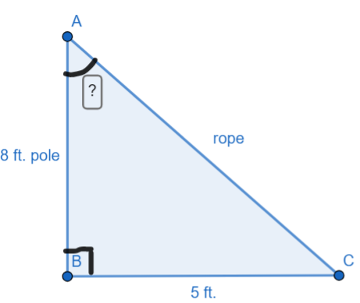
15 | Lesson 8: Solving Right Triangles | In this section, you will use trigonometric ratios to solve right triangles in applied situations. | Look for and make use of structure. | Page 1-7 | Marna is flying a helicopter at 1,350 feet and sees an airplane 2,400 feet in front of but also above her. Marna knows the angle of elevation is 54 degrees. How far is the airplane from the ground?  Correct Answer: 4,653 feet  Inverse Trigonometry Unit Test Item #15 - GeoGebra  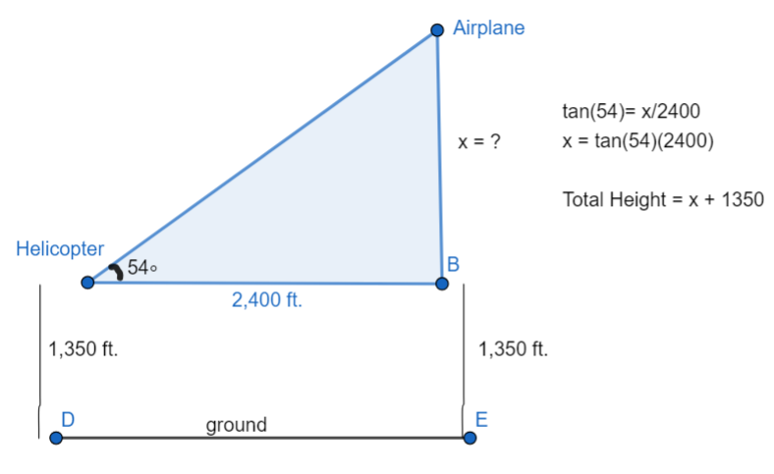
16 | Lesson 8: Solving Right Triangles | In this section, you will use the Pythagorean Theorem to solve right triangles in applied problems. | Look for and make use of structure. | Page 8-14 | 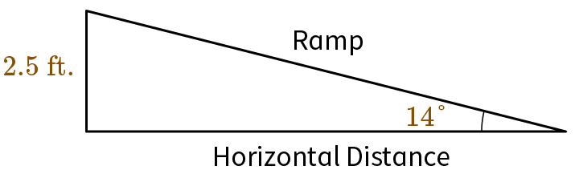  For a ramp with an angle of elevation of 14° and a height of 2.5 feet, how long is the horizontal distance of the ramp? Round the answer to the nearest tenth.  Correct Answer: The horizontal distance is 10.0 feet long.  Inverse Trigonometry Unit Test Item #16 - GeoGebra
17 | Lesson 9: The Law of Sines | In this section, you will use the Law of Sines to find unknown measurements in right triangles. | Attend to precision. | Page 1-6 | 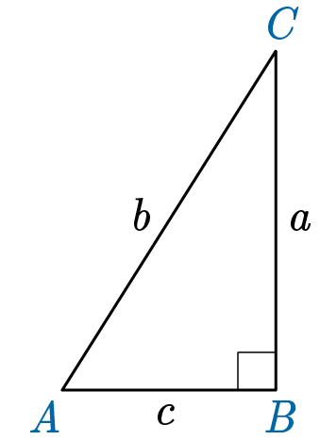  Solve the following problem. If $∠C=38$degrees and side $c=22$mi. Which equation shows how the Law of Sines can be used to find a?  Correct Answer: $\frac{\sin{3}8°}{22 mi.}=\frac{\sin{5}2°}{a}$  Inverse Trigonometry Unit Test Item #17 - GeoGebra
18 | Lesson 9: The Law of Sines | In this section, you will use the Law of Sines to find unknown measurements in non-right triangles. | Attend to precision. | Page 7-13 | 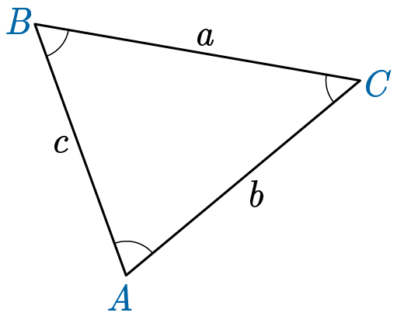  In the triangle, angle B is 52 degrees and angle A is 14 degrees. If side c has a length of 17 cm, use the Law of Sines to find the length of side b. Round your answer to the nearest centimeter.  Correct Answer: 15 cm  Inverse Trigonometry Unit Test Item #18 - GeoGebra
19 | Lesson 10: The Law of Cosines | In this section, you will use the Law of Cosines to find unknown measurements in right triangles. | Attend to precision. | Page 1-6 | Use the stated variant of the Law of Cosines, $a^{2}=b^{2}+c^{2}-2bc ∙ \cos{} A$ , to find the value of angle A in a right triangle, where $a=8$, $b=15$ , and $c=17$. Round your answer to the nearest whole number  Correct Answer: A = 28 degrees  Inverse Trigonometry Unit Test Item #19 - GeoGebra
20 | Lesson 10: The Law of Cosines | In this section, you will use the Law of Cosines to find unknown measurements in non-right triangles. | Attend to precision. | Page 7-13 | If an oblique $△ABC$, side $a=17 ft.$, side $b=20 ft.$, and $∠C=19°$, then what is the length of side c to the nearest foot?  Correct Answer: 7 ft.  Inverse Trigonometry Unit Test Item #20 - GeoGebra
21 | Lesson 2: Pythagorean Triples | In this section, you will identify Pythagorean triples. | Make sense of problems and persevere in solving them. | Page 1-8 | Consider a right-angled triangle with sides and a = 6 and c = 9. Determine whether these values form a Pythagorean triple. Show your steps and explain your answer.  Correct Answer:  Substitute a = 6 and c = 9 into the equation $a^{2}+b^{2}=c^{2}$.  $$6^{2}+b^{2}=9^{2}$$  $$36+b^{2}=81$$  $$b^{2}=81-36$$  $$b^{2}=45$$  $$\sqrt{b^{2}}=\sqrt{4}5$$  $$b=6.708203932$$  $\sqrt{4}5$ or 6.708203932 is not a whole number or integer. Side b is not a whole number or integer because the side includes a decimal. Therefore, this triangle is not a Pythagorean triple.

