Geometry Unit Test Guide

Trigonometry Unit Test

Item | Lesson Coverage | Objective | Mathematical Practice Standard | Lesson Page | Assessment Item
1 | Lesson 2: Similar Right Triangles | In this section, you will use similarity to show that side ratios in right triangles are determined by the angle measures. | Look for and express regularity in repeated reasoning. | Page 1-9 | A right triangle has a hypotenuse of length $10\sqrt{2}$ and an angle of 45 degrees, with a side opposite this angle with a length of 10. A second right triangle also has an angle of 45 degrees, with a side opposite this angle with a length of 14. Determine the length of the hypotenuse in the second triangle.  Correct Answer: The hypotenuse of the second triangle has length $14\sqrt{2}$.  Trigonometry Unit Test Item #1 - GeoGebra
2 | Lesson 3: The Sine and Cosine Ratios | In this section, you will use the sine ratio to solve right triangles in applied problems. | Make sense of problems and persevere in solving them. | Page 1-7 | A plane is descending at a $12°$ angle of depression. If the current altitude of the plane is 1,000 feet, find the distance the plane still needs to fly to reach the ground. Round the answer to the nearest foot.  Correct Answer: 4,810  Trigonometry Unit Test Item #2 - GeoGebra  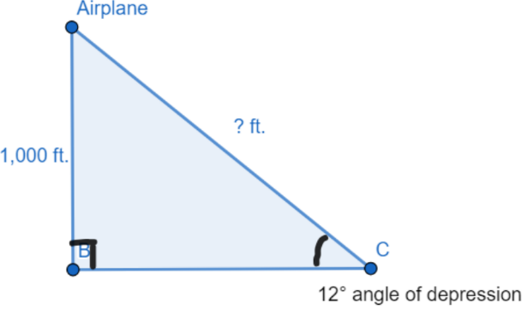
3 | Lesson 3: The Sine and Cosine Ratios | In this section, you will use the cosine ratio to solve right triangles in applied problems. | Make sense of problems and persevere in solving them. | Page 8-13 | A 20-foot ladder leans against a wall so that the ladder’s angle of elevation is 46°. Find x,c the distance from the base of the ladder to the building.  Correct Answer: 13.89 ft.  Trigonometry Unit Test Item #3 - GeoGebra  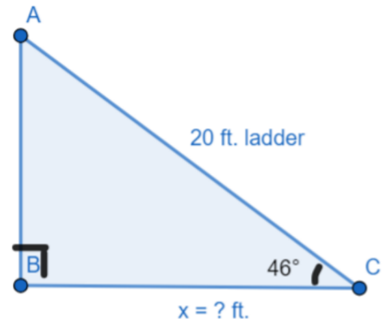
4 | Lesson 3: The Sine and Cosine Ratios | In this section, you will use the relationship between the sine and the cosine of complementary angles. | Look for and make use of structure. | Page 14-20 | 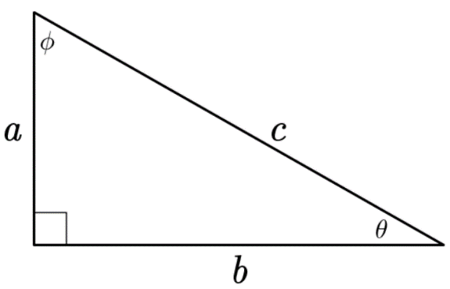  If c = 17 in. and b = 15 in., find the value of $sinθ$. Write your answer as a fraction. You do not need to simplify.  Correct Answer: $\frac{8}{17}$  Trigonometry Unit Test Item #4 - GeoGebra
5 | Lesson 4: The Tangent Ratio | In this section, you will solve for sides and angles of a right triangle by using the tangent ratio. | Make sense of problems and persevere in solving them. | Page 1-8 | Deshaun is looking up at a flag that is 50 feet away from him at an angle of elevation from ground level of $35°$. What is the flagpole’s height, x, and the distance between Deshaun and the top of the flagpole, y?  Correct Answer: x = 35.01 ft. and y = 61.04 ft.  Trigonometry Unit Test Item #5 - GeoGebra  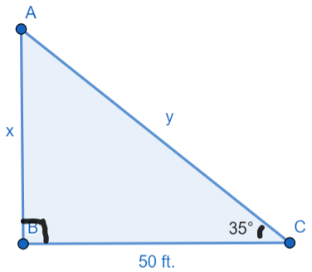
6 | Lesson 5: Special Right Triangles | In this section, you will use the relationships in a 30-60-90 right triangle to solve problems. | Look for and make use of structure. | Page 1-7 | If an equilateral triangle has a perimeter of 48, what is the length of the perpendicular bisector of any of its sides?  Correct Answer: $8\sqrt{3}$  Trigonometry Unit Test Item #6 - GeoGebra  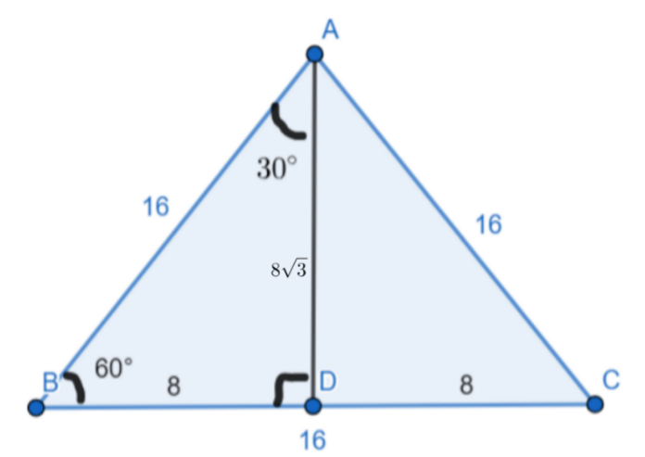
7 | Lesson 5: Special Right Triangles | In this section, you will use the relationships in a 45-45-90 right triangle to solve problems. | Look for and make use of structure. | Page 8-14 | 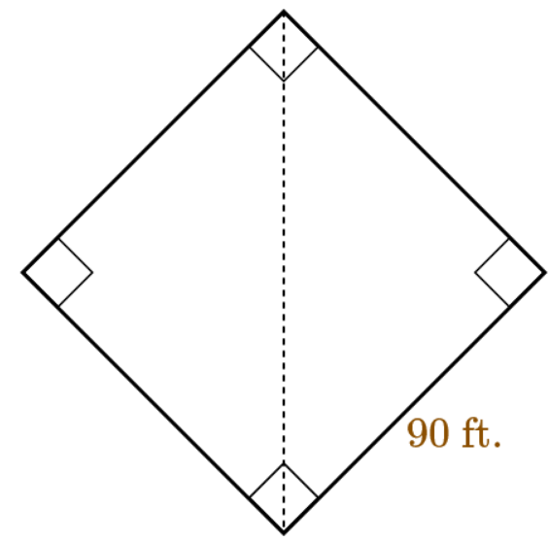  The image shows a baseball field, where the distance from home plate to first base is 90 feet. What is the distance from home plate to second base to the nearest foot?  Correct Answer: 127 feet  Trigonometry Unit Test Item #7 - GeoGebra
8 | Lesson 6: Area of Triangles | In this section, you will derive the formula A=(1/2)absinC for the area of a triangle by drawing an auxiliary line from a vertex perpendicular to the opposite side | Look for and make use of structure. | Page 1-7 | 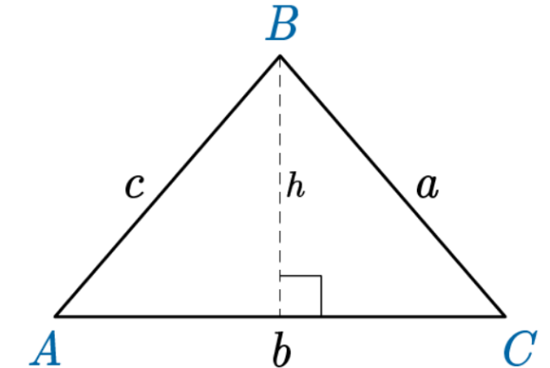  In $△ABC$, if $a=36 cm$and $m∠C=23°$, then what is the length of altitude $h$? Round your answer to the nearest whole number.  Correct Answer: 14 cm  Trigonometry Unit Test Item #8 - GeoGebra
9 | Lesson 6: Area of Triangles | In this section, you will use the formula A=(1/2)absinC to determine the area of a triangle | Reason abstractly and quantitatively. | Page 8-13 | Jasmira has a new corner shelving unit that is triangular. The unit has three identical oblique triangle shelves. Jasmira wants to put some shelving paper down but isn’t sure how much to buy. If one side of each triangle is 22 inches, an adjoining side is 35 inches, and the angle formed between them is 87 degrees, then how much paper (to the nearest square inch) does she need to cover all 3 shelves?  Correct Answer: $1,153 inches^{2}$  Trigonometry Unit Test Item #9 - GeoGebra  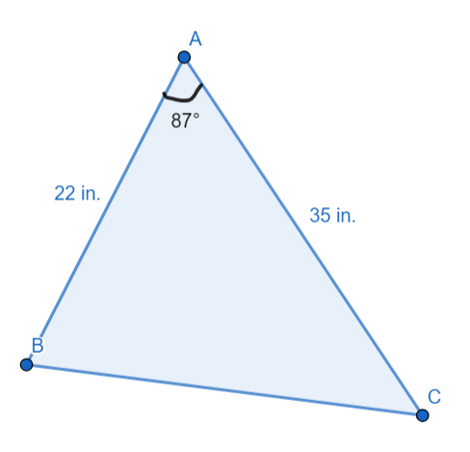
10 | Lesson 2: Similar Right Triangles | In this section, you will use similarity to show that side ratios in right triangles are determined by the angle measures. | Look for and express regularity in repeated reasoning. | Page 1-9 | Right triangle $ABC$has side lengths $AB=6, BC=8, CA=10$. A second right triangle has corresponding vertices of $A^{'}, B^{'},$and $C^{'}$, with side lengths of 32, 40, and 24. In 3-5 sentences, describe how to find the ratio of the side opposite $∠A$to the hypotenuse of triangle $ABC$. Then use this ratio to identify the location of point $A^{'}$in the second right triangle.  Correct Answer:  Students should note that the side opposite $∠A$has a length of 8, and the hypotenuse of triangle $ABC$has a length of 10. The ratio between the opposite side and the hypotenuse for $∠A$is $\frac{8}{10}$. In the second triangle, the same ratio is $\frac{32}{40}$. This means that the angle on the second triangle corresponding to $∠A$has an opposite side with a length of 32. Therefore, point $A^{'}$ is opposite the side that has a length of 32.  Trigonometry Unit Test Item #10 - GeoGebra  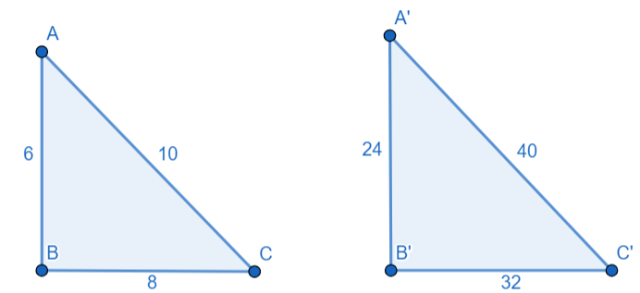
11 | Lesson 3: The Sine and Cosine Ratios | In this section, you will use the relationship between the sine and the cosine of complementary angles. | Look for and make use of structure. | Page 14-20 | In a right triangle, the acute angles have the relationship $\sin\left(x+12°\right)=\cos\left(18°+2x\right)$. What is the value of x? What is the measure of the smaller angle? Use 1–2 sentences to explain how you arrived at your answers.  Correct Answer:  Student answers should explain that complementary angles in a triangle add up to $90°$. Therefore, $x+12°+18°+2x=90°$. Then students should simplify and solve for x:  $$3x+30°$$  $$3x=60°$$  $$x=20°$$  Students should then explain that they can substitute the value of x into the expression for the smaller acute angle:  $$x+12°=20°+12°=32°$$  The measure of the smaller acute angle is $32°$.  Trigonometry Unit Test Item #11 - GeoGebra  