Geometry B

**Trigonometry**

**Unit Summary:**

In this unit, you will learn about trigonometry. Trigonometry is the branch of mathematics that deals with angles and their relationship to triangles.

This unit will:

* focus on the trigonometric ratios sine, cosine, and tangent. Using these properties, along with the Pythagorean Theorem, you will solve problems using right triangles in applied math.
* explore the relationships of special triangles such as a 30-60-90 triangle and a 45-45-90 triangle through the lens of trigonometry to solve problems
* discover how to derive the formula of area for triangles using trigonometry.
* use the Law of Sines and the Law of Cosine to find unknown measurements in right and non-right triangles.

**Lesson 2 – Similar Right Triangles**

**Key Words:**

* **AA Criterion** – if two corresponding interior angles of two triangles are congruent, then the triangles are similar
* **corresponding parts** – the sides and angles that are in the same relative position between two figures
* **cosine** – the ratio between the leg adjacent to the angle and the hypotenuse in a right triangle
* **dilation** – the act or process of expanding or reducing a shape by the same scale factor
* **hypotenuse** – the side of a right-angled triangle that is opposite the right angle
* **ratio** – the relationship in quantity, amount, or size between two or more things
* **similar** – proportional in shape but not necessarily the same size
* **sine** – the ratio between the leg opposite the angle and the hypotenuse in a right triangle
* **tangent** – the ratio in a right triangle between the leg opposite to the angle and the leg adjacent to the angle
* **trigonometric ratios** – the value of the ratios of the sides of a right triangle known as sine, cosine, and tangent

**Objective 1:** In this section, you will use similarity to show that side ratios in right triangles are determined by the angle measures.

Mathematical Practice Standard: Look for and express regularity in repeated reasoning.

**Big Ideas**: Trigonometric ratios are based on a simple principle: side ratios in right triangles are determined by the angle measures.

Focus on these three facts:

1. **Two right triangles with a second angle measurement in common are similar**.
   1. AA Criterion – if two corresponding interior angles of two triangles are congruent, then the triangles are similar
   2. This rule works because the three angles in a triangle add up to 180 degrees. If two angles are the same, it would be impossible for the third angle to be different.
2. **Ratios between corresponding parts in similar triangles share a common ratio.**
   1. dilation – the act or process of expanding or reducing a shape by the same scale factor
   2. Even though dilations change the size of a shape, the corresponding side lengths of each triangle will still share a common ratio.
   3. Ex: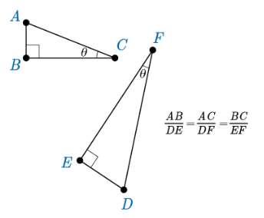
3. **A right triangle with a given angle measurement will always have the same set of side ratios.**
   1. The side ratios within a given right triangle are determined by the measures of the non-right angles in the triangle.
      1. Ex: for all the right triangles that have an angle $θ$ equal to 28 degrees:
         1. The ratio of the side opposite $θ$ to the hypotenuse (the sine ratio) will be the same. This ratio is referred to as $\sin{{28}^{°}}$.
         2. The ratio of the side adjacent to $θ$ to the hypotenuse (the cosine ratio) will be the same. This ratio is referred to as $\cos{{28}^{°}}$.
         3. The ratio of the side opposite $θ$ to the side adjacent to $θ$ (the tangent ratio) will be the same. This ratio is referred to as $\tan{{28}^{°}}$.

**An easy way to remember** all three trigonometric ratios is by the acronym:

**SOH CAH TOA**: $\sin{\frac{opposite leg}{hypotenuse}}$ $\cos{\frac{adjacent leg}{hypotenuse}}$ $\tan{\frac{opposite leg}{adjacent leg}}$

**Practice Questions and Answers**

|  |  |  |
| --- | --- | --- |
|  | Question | Answer |
| P 1 |  | 90 |
| P 2 |  | 2 |
| P 3 |  | 16 |
| P 4 |  | .6 |
| P 5 |  | Option 2 |

**Quick Check Questions and Answers**

|  |  |  |
| --- | --- | --- |
|  | Question | Answer |
| Q 1 |  | The ratio of the opposite side to the hypotenuse is 0.96, and point *A’* is opposite the side that has lenth 48. |
| Q 2 |  |  |
| Q 3 |  | The side opposite the second trianlge’s ${25}^{°}$ angle has a length of 4. |
| Q 4 |  | The hypotenuse of the second triangle has length 8. |
| Q 5 |  | The ratio of the opposite side to the hypotenuse is 0.8, and point *A’* is opposite the side that has length 24. |

**Lesson 3 – The Sine and Cosine Ratios**

**Key Words:**

* **Pythagorean Theorem** – the theorem which states that the square of the length of the hypotenuse of a right triangle is equal to the sum of the squared lengths of the other two sides
* **complementary angles** – angles whose measures add up to 90°

**Objective 1:** In this section, you will use the sine ratio to solve right triangles in applied problems.

*Mathematical Practice Standard: Make sense of problems and persevere in solving them.*

**Big Ideas**:

* Sine is the ratio between the leg opposite the angle and the hypotenuse in a right triangle.
  + Ex: 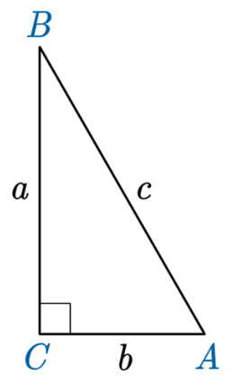
  + or 
* Use the Pythagorean Theorem when the length of a side is missing in a right triangle.

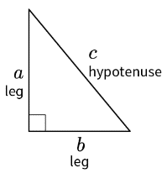

* + Pythagorean Theorem =
  + Ex: 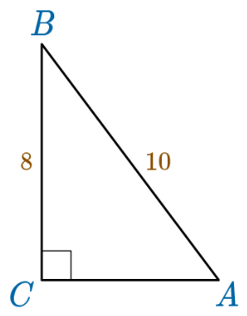
  + Side $c$ is the hypotenuse, so $c$ =10
  + Side $a$ is opposite of vertex A, so $a$ =8
  + Plug the variables into the Pythagorean Theorem to find the length of the missing side.

**Objective 2:** In this section, you will use the cosine ratio to solve right triangles in applied problems.

*Mathematical Practice Standard: Make sense of problems and persevere in solving them.*

**Big Ideas:**

* Cosine is the ratio of the adjacent side to the hypotenuse.
  + Ex: 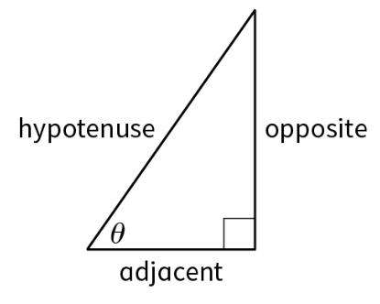
  + 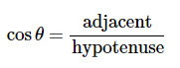
  + Keep in mind: because the hypotenuse is always the longest side of a right triangle, the value of the cosine function can never be greater than 1.

**Objective 3:** In this section, you will use the relationship between the sine and the cosine of complementary angles.

*Mathematical Practice Standard: Look for and make use of structure.*

**Big Ideas:**

* **complementary angles** – angles whose measures add up to 90°
* Remember, the three interior angles of a triangle must add up to 180°, and a 90°angle is opposite the hypotenuse, then the sum of the other two angles must equal 90°.
* Consider the equivalency between sine and cosine in complementary angles.
  + 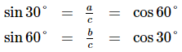
  + Ex: 

**Practice Questions and Answers**

|  |  |  |
| --- | --- | --- |
|  | Question | Answer |
| P 1 |  | 1,445 feet |
| P 2 |  | 7.3 feet |
| P 3 |  | Option 2 |
| P 4 |  | 8.49 in. |
| P 5 |  | $${64}^{°}$$ |

**Quick Check Questions and Answers**

|  |  |  |
| --- | --- | --- |
|  | Question | Answer |
| Q 1 |  |  |
| Q 2 |  | 610 feet |
| Q 3 |  | *x* = 9.18 ft. |
| Q 4 |  | $${18}^{°}$$ |
| Q 5 |  | 0.7 |

**Lesson 4 – The Tangent Ratio**

**Key Words:**

* **tangent** – the ratio in a right triangle between the leg opposite to the angle and the leg adjacent to the angle

**Objective 1:** In this section, you will solve for sides and angles of a right triangle by using the tangent ratio.

*Mathematical Practice Standard: Make sense of problems and persevere in solving them.*

**Big Ideas**:

* **tangent** – the ratio in a right triangle between the leg opposite to the angle and the leg adjacent to the angle
* 
  + ex: 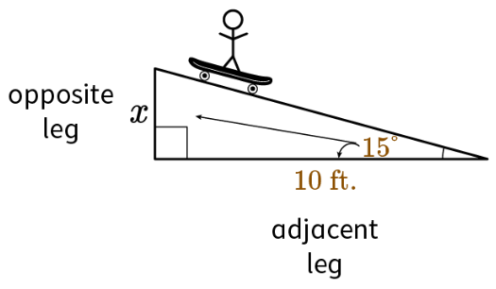

$\tan{15=\frac{x}{10}}$

**Practice Questions and Answers**

|  |  |  |
| --- | --- | --- |
|  | Question | Answer |
| P 1 |  | Ratio #2 |
| P 2 |  | 12 |
| P 3 |  | 5 |
| P 4 |  | $${34}^{°}$$ |
| P 5 |  | $${51}^{°}$$ |

**Quick Check Questions and Answers**

|  |  |  |
| --- | --- | --- |
|  | Question | Answer |
| Q 1 |  |  |
| Q 2 |  | 25.48 ft. |
| Q 3 |  | 56 ft. |
| Q 4 |  |  |
| Q 5 |  | *x* = 49.07 ft. |

**Lesson 5 – Special Right Triangles**

**Key Words:**

* **equilateral triangle** – a triangle that has three sides of equal length and three angles that each equal 60 degrees
* **isosceles right triangle** – a right triangle that has two equal length legs
* **perpendicular bisector** – a line or line segment that divides another line segment into two equal parts and intersects it at a 90-degree angle
* **Pythagorean Theorem** – the theorem which states that the square of the length of the hypotenuse of a right triangle is equal to the sum of the squared lengths of the other two sides
* **30-60-90 right triangle** – a triangle whose angle measures are 30-degrees, 60-degrees, and 90-degrees
* **45-45-90 right triangle** – a right triangle whose angle measures are 45 degrees, 45 degrees, and 90 degrees

**Objective 1:** In this section, you will use the relationships in a 30-60-90 right triangle to solve problems.

*Mathematical Practice Standard: Look for and make use of structure.*

**Big Ideas**:

* Use this ratio to find the lengths of missing sides of 30-60-90 right triangles:
  + short leg: long leg: hypotenuse
  + Ex: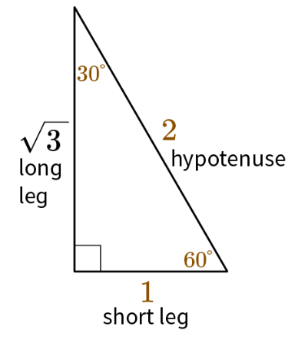

1: $\sqrt{3}$:2

* + To find the hypotenuse – multiply the short leg by 2
  + To find the length of the long leg – multiply the short leg by $\sqrt{3}$
  + To find the short leg – divide the hypotenuse by 2 or divide the long leg by $\sqrt{3}$

**Objective 2:** In this section, you will use the relationships in a 45-45-90 right triangle to solve problems.

*Mathematical Practice Standard:* Look for and make use of structure.

**Big Ideas:**

* Use this ratio to find the length of missing sides of a 45-45-90 right triangle
  + leg: leg: $\sqrt{2}$
  + ex: 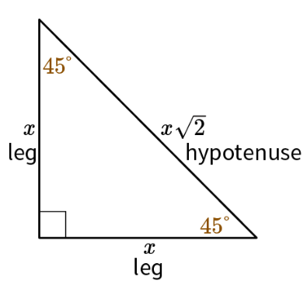

1 : 1:

* + To find the hypotenuse – multiply the leg by $\sqrt{2}$
  + To find the leg with the given hypotenuse– divide the hypotenuse by $\sqrt{2}$
  + To find the leg with the given leg – same length (they are the same length in a 45-45-90 triangle)

**Practice Questions and Answers**

|  |  |  |
| --- | --- | --- |
|  | Question | Answer |
| P 1 |  | Option 3 |
| P 2 |  | 4 $\sqrt{3}$ |
| P 3 | What is the ratio of the sides of a 45-45-90 triangle? | 1 : 1 : $\sqrt{2}$ |
| P 4 |  | 17.1 cm. |
| P 5 |  | 17 in. |

**Quick Check Questions and Answers**

|  |  |  |
| --- | --- | --- |
|  | Question | Answer |
| Q 1 |  |  |
| Q 2 |  | 14 cm |
| Q 3 |  | 12 |
| Q 4 |  |  |
| Q 5 |  | 296 feet |

**Lesson 6 – Area of Triangles**

**Key Words:**

* **altitude** – a line segment drawn from a vertex of a triangle perpendicular to the opposite side
* **area of a triangle** – the total amount of space inside the triangle, which is found by multiplying the height of the triangle by the base and dividing by two
* **oblique triangle** – a triangle with no right angle

**Objective 1:** In this section, you will derive the formula $A= \frac{1}{2}ab\sin{C }$ for the area of a triangle by drawing an auxiliary line from a vertex perpendicular to the opposite side.

*Mathematical Practice Standard: Look for and make use of structure.*

**Big Ideas**:

* Remember: **SOH CAH TOA**: $\sin{\frac{opposite leg}{hypotenuse}}$ $\cos{\frac{adjacent leg}{hypotenuse}}$ $\tan{\frac{opposite leg}{adjacent leg}}$
* Remember: the sum of all interior angles of a triangle is 180 $°$
* To solve for $A= \frac{1}{2}ab\sin{C }$ directly substitute the given side lengths and angle measure into the formula.
  + Ex: $A= \frac{1}{2}∙150∙231\sin{{123}^{°} }$

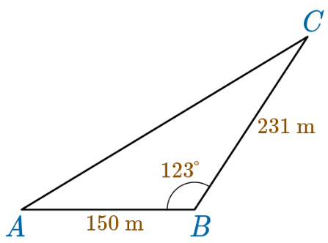

**Objective 2:** In this section, you will use the formula $A= \frac{1}{2}ab\sin{C }$ to determine the area of a triangle.

*Mathematical Practice Standard:  Reason abstractly and quantitatively.*

**Big Ideas:**

* **oblique triangle** – a triangle with no right angle
* Remember: the sum of all interior angles of a triangle is 180 $°$
* To solve for $A= \frac{1}{2}ab\sin{C }$ directly substitute the given side lengths and angle measure into the formula.

**Practice Questions and Answers**

|  |  |  |
| --- | --- | --- |
|  | Question | Answer |
| P 1 |  | 14.5 ${cm}^{2}$ |
| P 2 |  | b= 60 mm |
| P 3 |  | 12 km |
| P 4 |  | $$1,848{ m}^{2}$$ |
| P 5 |  | $412 {in}^{2}$ |

**Quick Check Questions and Answers**

|  |  |  |
| --- | --- | --- |
|  | Question | Answer |
| Q 1 |  |  |
| Q 2 |  | 16 meters |
| Q 3 |  | 17 feet |
| Q 4 |  |  |
| Q 5 |  |  |

**Lesson 7 – Trigonometry Apply**

Sample work drop box available if teacher would like to collect student work; no Practice or Quick Check

**Lesson 8 – Trigonometry Review**

**Practice Questions and Answers**

**Lesson 9 – Trigonometry Unit Test**