Math 6 B Unit Test Guide

Statistics Unit Test

Item | Lesson Coverage | Objective | Lesson Page | Assessment Item
1 | Lesson 1: Statistical Questions | For a numerical data set, describe what is being investigated, how the data is measured, and the units of measurements used. | p. 9-14 | For which experiment are the elements of the dataset most likely to be measured in liters?  Answer: Lora asks her neighbors how much water they drink each day.
2 | Lesson 2: Represent Numerical Data | Display numerical data using a dot plot. | p. 8-13 | Use the image to answer the question.  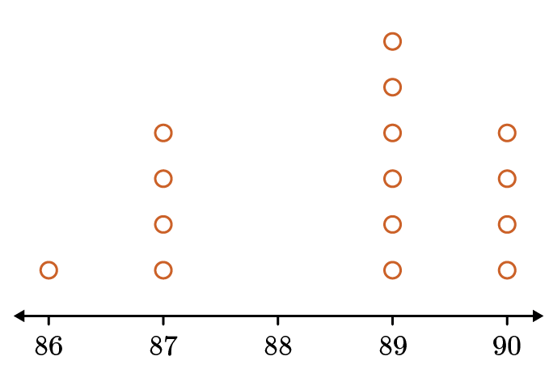  Mel creates this dot plot based on a numerical dataset. Which dataset did he use to get the information for his dot plot?  Answer:  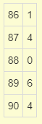  Statistics Unit Test Item #2 | Desmos
3 | Lesson 2: Represent Numerical Data | Display numerical data using a histogram. | p. 14-19 | Kwon records the low temperatures in degrees Celsius on 10 consecutive days.  His dataset includes the following numbers:  18, 16, 21, 10, 10, 15, 12, 20, 17, 11  Kwon uses the template below to create a histogram with bins as shown.  10 14 18 22  Which bar will be the highest?  Identify the range for the correct bar.  Answer: From 10 to just under 14  Statistics Unit Test Item #3 | Desmos
4 | Lesson 3: Describe Data Sets | Recognize patterns in a data set in context of the problem, including outliers. | p. 1-5 | Loren’s friends jump as far as they can and record their results in inches.  Their results include the observations 42, 47, 50, 42, 45, 41, 49, 51, and 44.  Which number, if added to the dataset, would represent an outlier in the data?  Answer: 72
5 | Lesson 3: Describe Data Sets | Describe a set of data collected to answer a statistical question as having a distribution which can be described by its center, spread, and overall shape. | p. 6-13 | Use the image to answer the question.  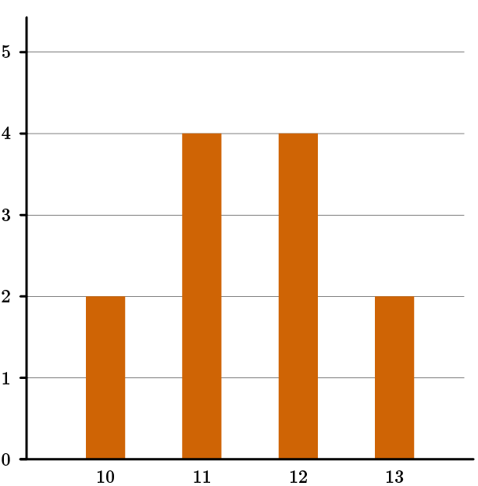  What are the values of the mean, median, and spread for the dataset shown in the bar graph?  Answers: The mean = 11.5. The median = 11.5. The spread = 3.  Statistics Unit Test Item #5 | Desmos
6 | Lesson 4: Measures of Center | Find the mean and median of a data set. | p. 1-6 | Use the table to answer the question.  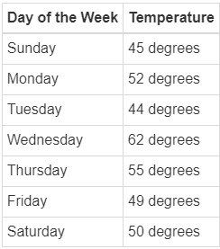  Find the mean and median of the past week’s temperatures.  Answer: During the week, the mean temperature was 51 degrees. During the week, the median temperature was 50 degrees.  Statistics Unit Test Item #6 | Desmos
7 | Lesson 4: Measures of Center | Determine whether the mean or median best describes the shape of a data set. | p. 15-20 | Use the table to answer the question.  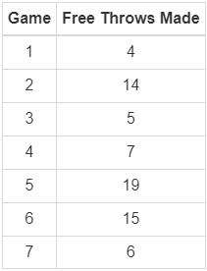  What value, the mean or median, best describes the shape of the data set that contains the number of free throws made by the basketball team? Choose 1 for mean and 2 for median.  Answer: 2
8 | Lesson 5: Measures of Variation | Determine the quartiles and extremes of a data set. | p. 1-6 | The first 10 prime numbers are 2, 3, 5, 7, 11, 13, 17, 19, 23, and 29. What are the first and third quartiles?  Answer: First quartile = 5. Third quartile = 19.  Statistics Unit Test Item #8 | Desmos
9 | Lesson 5: Measures of Variation | Find the range and interquartile range of a data set. | p. 7-14 | The highest temperatures measured at Death Valley, California, from 1995 to 2004 are given as a dataset.  127, 125, 125, 129, 123, 126, 127, 128, 128, 125  Find the range and the interquartile range of the dataset.  Answer: The range is 6, and interquartile range is 3.  Statistics Unit Test Item #9 | Desmos
10 | Lesson 6: Box Plots | Display numerical data using a box plot. | All | Use the image to answer the question.  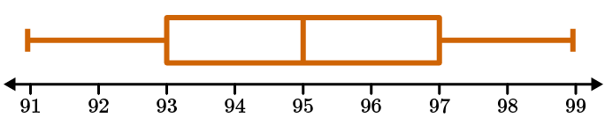  What is the median of the box plot?  Answer: 95
11 | Lesson 7: Mean Absolute Deviation | Find the mean absolute deviation of a data set. | All | The number of apples produced per tree in Zara’s orchard is 125, 198, 209, 213, 101, 178. What is the mean absolute deviation of the dataset? Round to the nearest tenth.  Answer: 38.4  Statistics Unit Test Item #11 | Desmos
12 | Lesson 8: Compare Measures of Variation | Recognize that a measure of variation for a numerical data set describes how its values vary with a single number. | p. 1-5 | Niran surveyed the students in his class on how many hours they spent on their project Here are the results:  0.5, 1.0, 1.0, 1.0, 1.5, 2.0, 2.0, 2.0, 2.5, 3.0, 3.5, 3.5, 3.5, 4.0, 5.0, 6.0, 8.0, 10  Which of the following is the IQR of the dataset and explains what the value means for this dataset?  Answer: The IQR is 2.5. This means that 2.5 hours is the range of the number of hours spent on the project for the middle 50% of the students.  Statistics Unit Test Item #12 | Desmos
13 | Lesson 8: Compare Measures of Variation | Determine whether the range or interquartile range best describes the spread of a data set. | p. 6-13 | Which measure of variability—range or IQR—best describes the spread of the dataset?  For a statistics assignment, Shayna randomly surveyed students on how many hours per week they spend playing online games:  1.0, 1.0, 2.0, 6.5, 10.0, 10.0, 10.0, 10.0, 12.0, 12.5, 14.0, 14.0, 14.0, 14.0, 15.0, 15.0, 15.5, 16.0, 17.5, 18.0  Answer: IQR; the distribution is skewed, and there are outliers in the dataset.  Statistics Unit Test Item #13 | Desmos
14 | Lesson 8: Compare Measures of Variation | Determine whether the interquartile range or the mean absolute deviation best describes the shape of a data set. | p. 14-18 | Number of goals scored in one season at Whitmore College soccer games follows:  0, 0, 2, 2, 2, 2, 2, 3, 3, 3, 3, 3, 4, 4, 4, 4  Which measure of variability—IQR or MAD— best describes the spread of the dataset?  Answer: IQR; the data distribution is skewed  Statistics Unit Test Item #14 | Desmos
15 | Lesson 9: Analyze Data Shape and Context | Summarize numerical data sets in relation to their context by relating the choice of measures of center and variability to the shape of the data distribution and the context in which the data were gathered. | All | Of the mean, median, and mode, which measure of center is most affected by outliers?  Explain your reasoning including an example with at least 10 data points.  Student answer should include:  Correct answer: mean  An example with at least 10 data points (including outlier) that shows the mean, median, and mode. Mean answer should be most different.

