Math 6 B Unit Test Guide

Equations Unit Test

Item | Lesson Coverage | Objective | Lesson Page | Assessment Item
1 | Lesson 2: True Equations | Use substitution to determine whether a given number in a specified set makes an equation true. | p. 7-12 | Use substitution to determine which number from the set $\left\{6, 7, 8\right\}$ makes the equation $54÷x=9$ true.  Answer: x = 6
2 | Lesson 3: Solve Equations By Adding or Subtracting | Solve one step equations in the form x - p = q, where p, q, and x are nonnegative rational numbers. | p. 7-13 | Solve the equation $653=x-243$.  Answer: x =896
3 | Lesson 3: Solve Equations By Adding or Subtracting | Solve real-world problems by writing equations of the forms x + p = q and x - p = q for cases in which p, q and x are all nonnegative rational numbers. | p. 14-19 | Kendall feeds her cat a total of $\frac{4}{5}$ cup of food every day. She feeds it $\frac{1}{2}$ cup of food in the evening. Solve an equation to find how much food she gives to the cat the rest of the day. Write your answer in fraction form only.  Answer: $\frac{3}{10}$
4 | Lesson 4: Solve Equations By Dividing | Solve one step equations in the form px = q, where p, q, and x are nonnegative rational numbers. | p. 1-5 | Solve for $w:3w=126.$  Answer: 42
5 | Lesson 4: Solve Equations By Dividing | Solve problems involving finding the whole, given a part and the percent. | p. 6-11 | Ms. Quarles gave the same math test to all her classes. She grades 25% of the tests, which is 30 papers. How many students does Ms. Quarles have in total?  Answer: 120
6 | Lesson 4: Solve Equations By Dividing | Solve real-world problems by writing equations of the form px = q for cases in which p, q and x are all nonnegative rational numbers. | p. 12-17 | Randy and three of his friends went to a restaurant to eat dinner. The bill was $52. How much money does each person have to pay towards the bill?  Answer: 13
7 | Lesson 5: Solve Equations By Multiplying | Solve one step equations in the form x/p = q, where p, q, and x are positive rational numbers. | p. 1-5 | Solve for $x: \frac{6}{5}x=90.$  Answer: 75
8 | Lesson 5: Solve Equations By Multiplying | Solve real-world problems by writing equations of the form x/p = q, where p, q, and x are positive rational numbers. | p. 6-10 | AJ’s office purchased a small vending machine and need to supply it with drinks. A large box from the wholesale store contains 25 bottles of assorted drinks. If each drink bottle has the same price of $1.75, how much does the large box cost?  Answer: 43.75
9 | Lesson 6: Types of Variables in Equations | Define the dependent and independent variables for a real-world problem. | All | A shipping company ships packages from New York to Chicago. The more packages the company needs to ship, the more drivers the company will need to hire. Identify the independent variable. Input 1 if the number of packages the company needs to ship is the independent variable. Input 2 if the number of drivers the company needs to hire is the independent variable.  Answer: 1
10 | Lesson 7: Write Equations | Write an equation to represent the relationship between two variables in a real-world problem. | All | A family goes on a trip. They drive 65 mph. Write an equation using two variables to show the relationship between the number of hours driven, h, and the total amount of miles drive, m. How far did they drive after 7 hours?  Answer:  Equation: m = 65h  Miles driven: 455
11 | Lesson 8: Compare Representations | In a real-world problem, analyze the relationship between the dependent and independent variables using graphs and tables. | p. 1-6 | Use the image to answer the question.  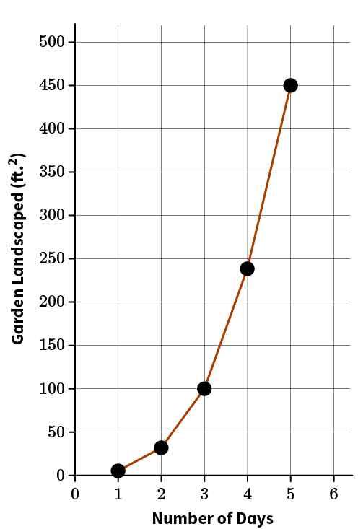  The graph shows how many square feet of Gilly’s garden she was able to landscape over the course of a week. According to the graph, approximately how many days did it take Gilly to plant 450 ft.² of her garden?  Answer: 5 days
12 | Lesson 8: Compare Representations | In a real-world problem, describe how the table, the graph, and the equation that represent the relationship are related. | p. 7-12 | Use the table to answer the question.  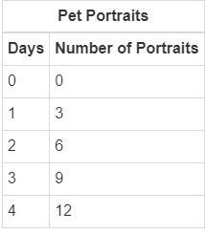  An artist can paint 3 pet portraits a day. If the artist works at an art fair that lasts 14 days how many pet portraits can the artist paint?  Answer: 42 pet portraits  Equations Unit Test Item #12 | Desmos
13 | Lesson 2: True Equations | Describe solving an equation as a process of determining values that make the equation true. | p. 1-6 | Mikayla ad Jesse both solved the equation $x-15=12-8,$using substitution. Mikayla says the answer is $x=19,$and Jesse says the answer is $x=27.$ Which student is correct, and how do you know? Show your work and explain your thinking.  Answer:  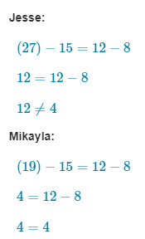  Mikayla is correct. I substituted both answers into the original equation. Jesse forgot to subtract 8 from 12, so his answer seemed to be correct, but it was missing a step. When I substituted into Mikayla’s and did all the math, both sides of the equation were the same. So, Mikayla was correct.
14 | Lesson 3: Solve Equations By Adding or Subtracting | Solve one step equations in the form x + p = q, where p, q, and x are nonnegative rational numbers. | p. 1-6 | Solve the following equation. Show all your work.  $$21.3=x+5.1$$  Answer:  