Math 6 B Unit Test Guide

Coordinate Geometry and Nets Unit Test

Item | Lesson Coverage | Objective | Lesson Page | Assessment Item
1 | Lesson 2: Polygons in the Coordinate Plane | Draw polygons in all four quadrants of the coordinate plane given coordinates for the vertices. | p. 1-5 | Which correctly shows a polygon on the coordinate plane that was drawn using the coordinates (-1, -4), (3, -2), and (3, -5).  Answer:  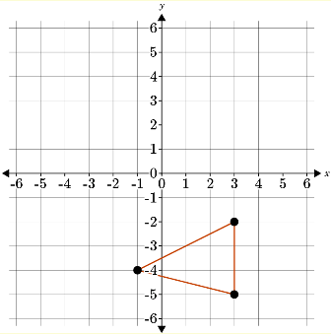  Coordinate Geometry and Nets Unit Test Item #1 | Desmos
2 | Lesson 2: Polygons in the Coordinate Plane | Draw polygons in all four quadrants of the coordinate plane given coordinates for the vertices. | p. 1-5 | The coordinates (9, -2), (12, -5), and (5-7) were plotted on a coordinate plane, and a polygon was drawn. Is the polygon in Quadrant I, II, III, or IV? Answer 1 for Quadrant I, 2 for Quadrant II, 3 for Quadrant III, or 4 for Quadrant IV.  Answer: 4  Coordinate Geometry and Nets Unit Test Item #2 | Desmos
3 | Lesson 2: Polygons in the Coordinate Plane | For polygons in the coordinate plane, use coordinates to find the length of a side joining points with the same first coordinate. | p. 6-10 | Given the coordinates (15, -3), (19, -6), and (15, -10), what would be the length of the vertical side, in centimeters?  Answer: 7  Coordinate Geometry and Nets Unit Test Item #3 | Desmos
4 | Lesson 2: Polygons in the Coordinate Plane | For polygons in the coordinate plane, apply the technique of using coordinates to find the length of a side joining points with the same first coordinate in the context of solving real-world problems. | p. 11-15 | Use the image to answer the question.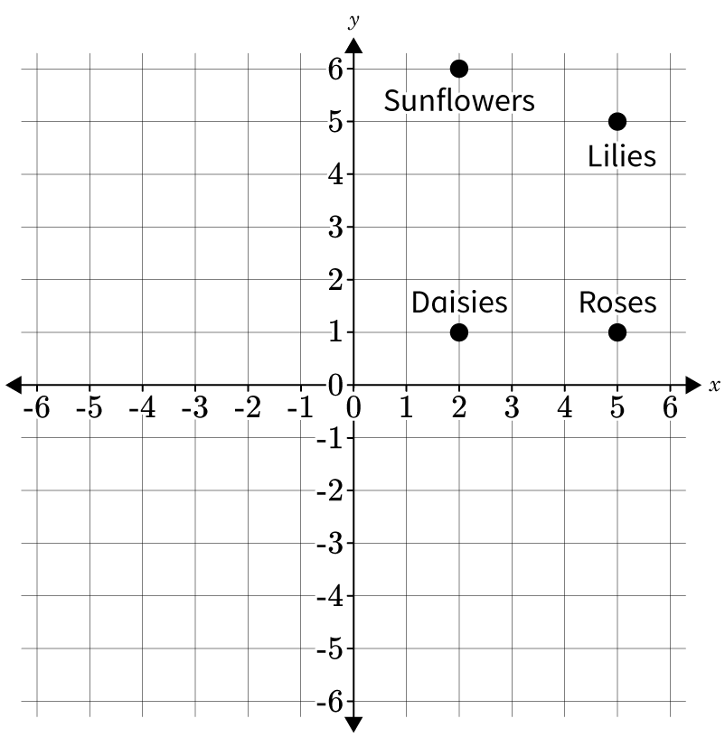  A map of a flower shop is shown. How far are the sunflowers located from the daisies? Each coordinate represents a foot.  Answer: 5 feet
5 | Lesson 3: Use Coordinate Geometry to Solve Problems | For polygons in the coordinate plane, use coordinates to find the length of a side joining points with the same second coordinate. | p. 1-5 | Use the image to answer the question.  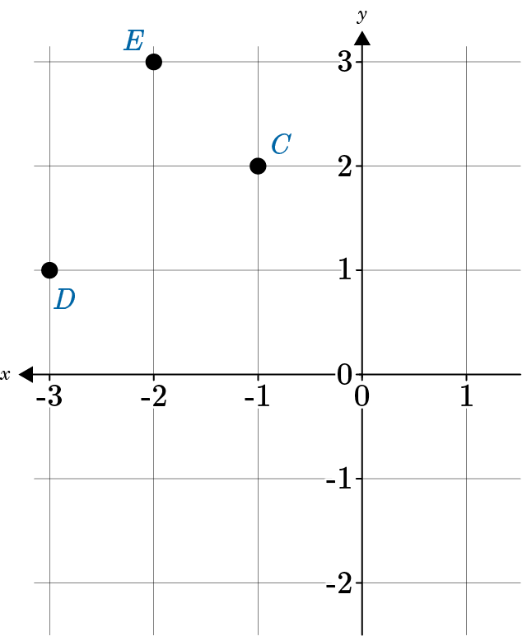  Point D and Point F have the same second coordinate and ECFD is a quadrilateral. What coordinates would Point F be plotted at to the make line segment FD have a length of 2 cm?  Answer: (-1, 1)  Coordinate Geometry and Nets Unit Test Item #5 | Desmos
6 | Lesson 3: Use Coordinate Geometry to Solve Problems | For polygons in the coordinate plane, apply the technique of using coordinates to find the length of a side joining points with the same first coordinate or the same second coordinate in the context of solving mathematical problems. | p. 6-11 | Find the area of rectangle ABCD that has vertices point A (2, -5), point B (5, -5), point C (5, -1), and point D (2, -1) in square miles.  The area of rectangle ABCD is __ square miles.  Answer: 12  Coordinate Geometry and Nets Unit Test Item #6 | Desmos
7 | Lesson 4: Nets with Rectangles and Triangles | Represent three-dimensional figures using nets made up of rectangles. | p. 1-5 | Use the image to answer the question.  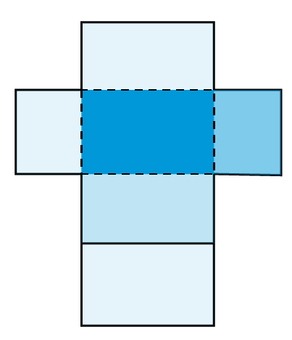  Which three-dimensional figure is represented by the net?  Answer:  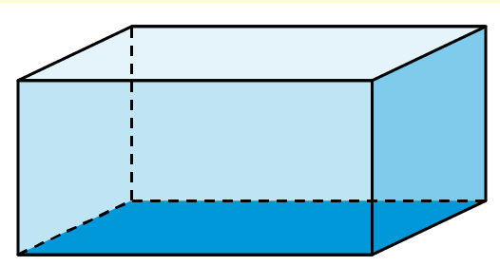
8 | Lesson 4: Nets with Rectangles and Triangles | Represent three-dimensional figures using nets made up of rectangles and triangles. | p. 6-12 | Use the image to answer the question.  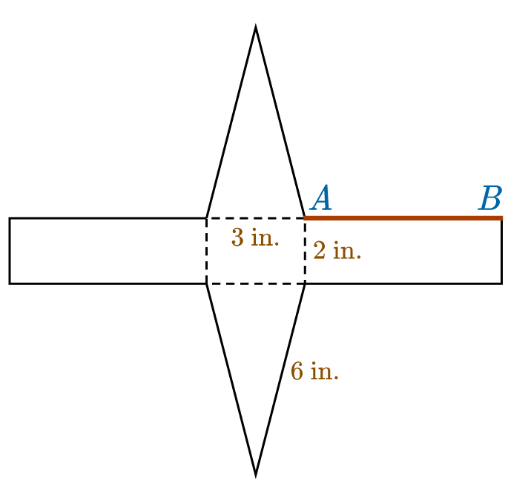  What is the length of AB?  Answer: 6 in.
9 | Lesson 5: Surface Area of Rectangular Prisms | Use nets to find the surface area of rectangular prisms. | All | Use the image to answer the question.  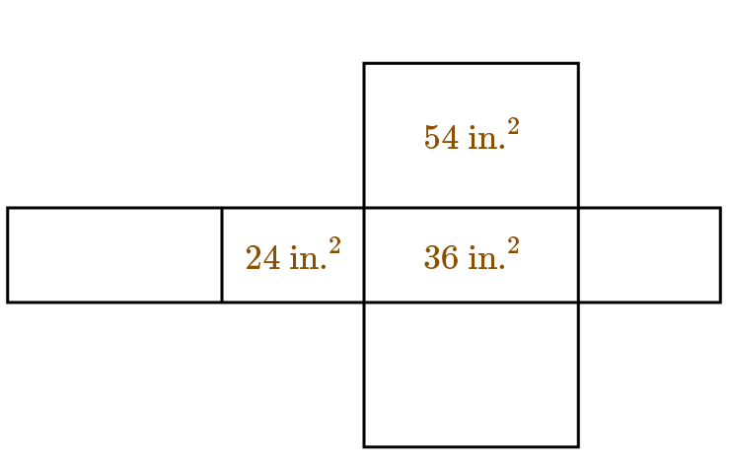  What is the surface area of the rectangular prism?  Answer: 228 in.²
10 | Lesson 6: Use Nets to Solve Rectangular Problems | Apply the technique of using nets to find the surface area of rectangular prisms in the context of solving mathematical problems. | p. 1-5 | You are drawing a net that shows a rectangular prism with an area of 52 square feet. If two of the rectangles in the net are 4 ft. x 3 ft., what is the value of the third measurement you need to know to have an area of 52 square feet?  Answer: 2 feet
11 | Lesson 6: Use Nets to Solve Rectangular Problems | Apply the technique of using nets to find the surface area of rectangular prisms in the context of solving real-world problems. | p. 6-11 | How does the net of a fish tank with no lid compare to the net of a fish tank with its lid on?  Answer: The net of the fish tank with no lid comprises five rectangles, two pairs of congruent rectangles and one odd rectangle, whereas the net of the fish tank with its lid comprises six rectangles, three pairs of congruent rectangles.
12 | Lesson 9: Surface Area of Triangular Prisms | Use nets to find the surface area of triangular prisms. | All | Use the image to answer the question.  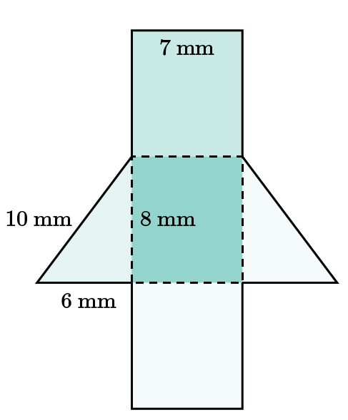  Using the net of the prism shown, what is its surface area?  Answer: 216 mm²
13 | Lesson 10: Use Nets to Solve Triangular Problems | Apply the technique of using nets to find the surface area of triangular prisms in the context of solving mathematical problems. | p. 1-6 | Use the image to answer the question.  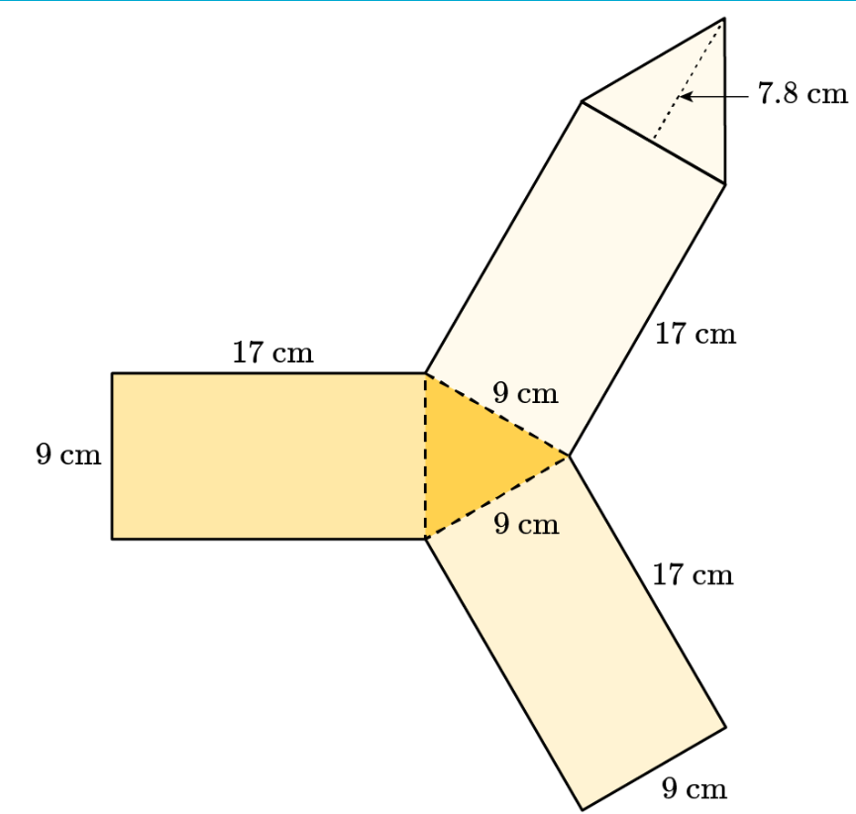  What is the total surface area represented by this net of a triangular prism? Your answer should have two decimal places.  Answer: 529.20 cm²
14 | Lesson 10: Use Nets to Solve Triangular Problems | Apply the technique of using nets to find the surface area of triangular prisms in the context of solving real-world problems. | p. 7-12 | Kym’s sawhorse is 39 inches tall, 27 inches long, and 19 inches wide. Its diagonal measurement, or the hypotenuse, is 40.14 inches. What is its total surface area? Round your answer to the nearest hundredth.  Answer: 3,421.56 in.²
15 | Lesson 2: Polygons in the Coordinate Plane | For polygons in the coordinate plane, apply the technique of using coordinates to find the length of a side joining points with the same first coordinate in the context of solving real-world problems. | p. 11-15 | Use the image to answer the question.  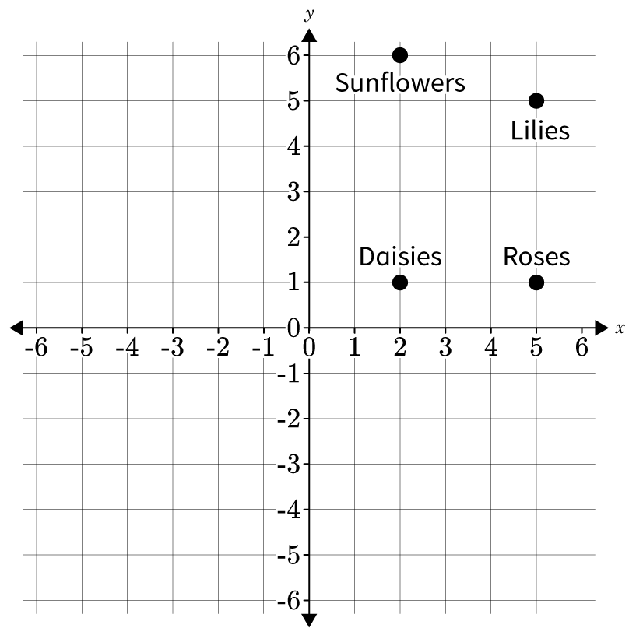  A map of a flower shop is shown. Each coordinate represents one foot. How far are the roses from the lilies? Explain how you found your answer.  Student answer should include the following:  Correct answer: 4 feet  Explanation should include the student subtracting the second coordinates (5, -1) because the first coordinates are the same.

