Math 6 B Unit Test Guide

Area and Volume Unit Test

Item | Lesson Coverage | Objective | Lesson Page | Assessment Item
1 | Lesson 2: Areas of Rectangles and Right Triangles | Find the area of a rectangle. | p. 1-6 | A rectangular poster has a length of 72 centimeters and a width of 15 centimeters. The poster is reduced in size by 6 centimeters in length and 3 centimeters in width. What is the area of the new poster?  Answer: 792 square centimeters
2 | Lesson 2: Areas of Rectangles and Right Triangles | Find the area of right triangles by composing into rectangles. | p. 7-12 | A piece of paper is in the shape of a right triangle. The base is 4.25 inches and the height is 11 inches. What is the area of the right triangle in square inches? Do not round your answer.  Answer: 23.375 square inches
3 | Lesson 3: Areas of Non-right Triangles | Find the area of non-right triangles by composing the shape into rectangles or decomposing it into triangles and other shapes. | All | Use the image to answer the question.  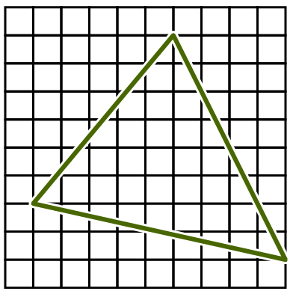  What is the area of the non-right triangle? The base and height are found by counting the squares.  The area is ___ square units.  Answer: 32
4 | Lesson 4: Area of Special Quadrilaterals | Find the area of special quadrilaterals by composing into rectangles or decomposing into triangles and other shapes. | All | Use the image to answer the question.  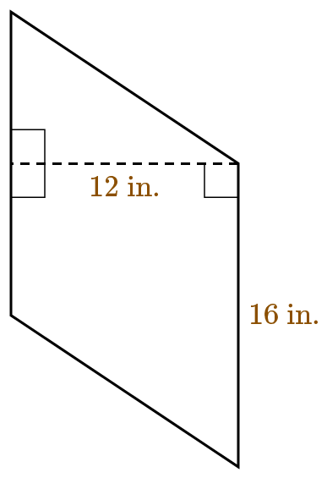  What is the area of the quadrilateral?  Answer: 192 in.²
5 | Lesson 5: Area of Polygons | Find the area of polygons by composing into rectangles or decomposing into triangles and other shapes. | All | Use the image to answer the question.  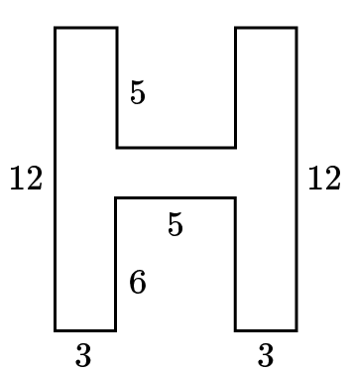  What is the area of the polygon?  Answer: 77 square units
6 | Lesson 6: Use Area to Solve Problems | Compose figures into rectangles to solve real-world problems. | p. 1-7 | Use the image to answer the question.  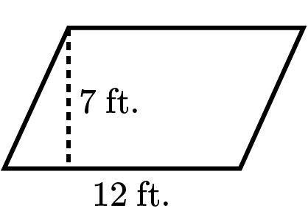  A pool company is installing a parallelogram-shaped swimming pool in a family’s back yard. Compose a rectangle to find the amount of area that the pool will take up in the yard. What is the area of the pool?  Answer: 84 square feet
7 | Lesson 6: Use Area to Solve Problems | Decompose figures into different shapes to solve real world problems. | p. 8-14 | Use the image to answer the question.  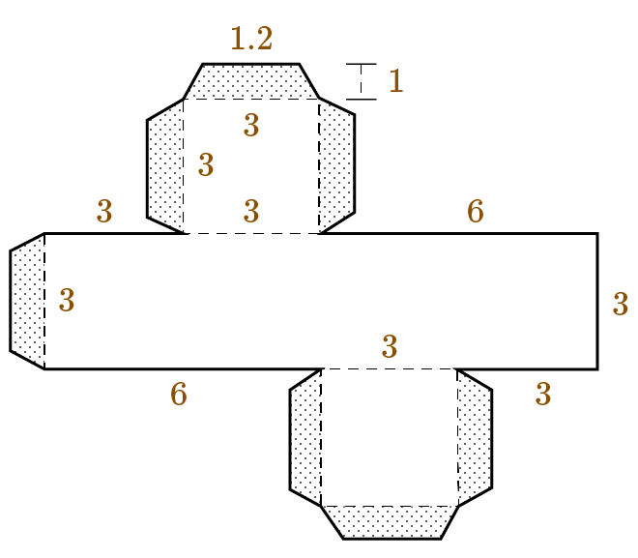  Decompose the box net into simple polygons to find how much cardboard in square inches is needed to make the cube. Assume that all angles that look like right angles are right angles. All polygons that look congruent are congruent. What is the area of the shape in square inches?  Answer: 68.7 square inches
8 | Lesson 6: Use Area to Solve Problems | Decompose figures into different shapes to solve real world problems. | p. 8-14 | Use the image to answer the question.  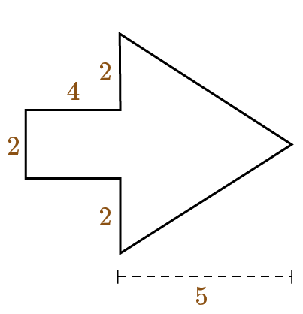  An artist is planning to paint an arrow using the pattern shown. What is the amount of area in square feet that will be painted?  Answer: 23 square feet
9 | Lesson 8: Volume of a Right Rectangular Prism | Find the volume of a right rectangular prism with whole number edge lengths using the formulas $V = l x w x h$ and$V = B x h$. | p. 1-6 | Use the image to answer the question.  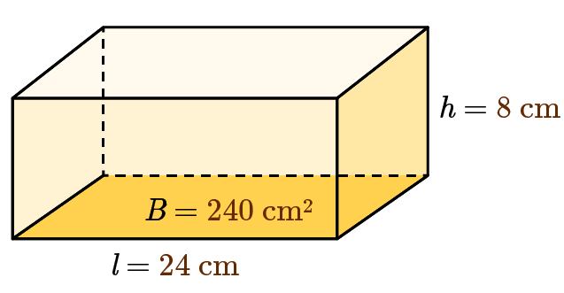  Find the volume of the right rectangular prism.  Answer: 1,920 cm³
10 | Lesson 8: Volume of a Right Rectangular Prism | Find the volume of a right rectangular prism with fractional edge lengths by packing it with unit cubes of the appropriate unit fraction edge lengths. | p. 7-12 | Use the image to answer the question.  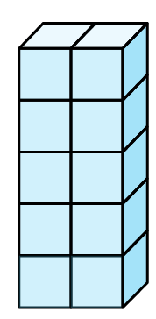  What is the volume of the right rectangular prism packed with 10 cubes? Each cube has an edge length of $\frac{1}{3}$ meter.  Answer: $\frac{10}{27}$ cubic meters
11 | Lesson 9: Compare Methods of Finding Volume | Multiply the edge lengths of a right rectangular prism with fractional edge lengths to show that the product is the same as the volume found by packing the prism with unit cubes of the appropriate unit fraction edge lengths. | All | Use the image to answer the question.  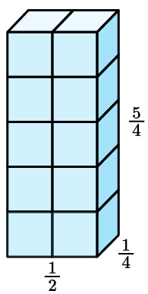  Multiply the edge lengths of a right rectangular prism with length $\frac{1}{2}$ m, width $\frac{1}{4}$ m, and height $\frac{5}{4}$ m to show that the product is the same as the volume found by packing the prism with 10 unit cubes with an edge length of $\frac{1}{4}$ m. What is the volume of the prism?  Answer: $\frac{5}{32}$ cubic meters
12 | Lesson 10: Length x Width x Height | Apply the formula $V = l x w x h$ to find volumes of right rectangular prisms with fractional edge lengths in the context of solving mathematical problems. | All | What is the volume of a rectangular prism with a length of $4\frac{2}{3}$ ft. a height of $3\frac{1}{3}$ ft., and a width of $2\frac{1}{2}$ ft.?  Answer: $38\frac{8}{9}$ ft.³
13 | Lesson 10: Length x Width x Height | Apply the formula $V = l x w x h$ to find volumes of right rectangular prisms with fractional edge lengths in the context of solving real-world problems. | All | In cubic feet, what is the volume of a toy box measuring $3\frac{3}{4}$ feet long, $2\frac{1}{2}$ feet wide, and $2\frac{1}{2}$ feet tall? Use the volume formula to solve. The answer will be a mixed fraction in cubic feet.  Answer: $23\frac{7}{16}$ ft.³
14 | Lesson 11: Base x Height | Apply the formula $V = B x h$ to find volumes of right rectangular prisms with fractional edge lengths in the context of solving mathematical problems. | p. 1-6 | Using the formula $V=B×h,$ what is the volume of a rectangular prism with a length of $7\frac{1}{4}$ m, a width of $10\frac{1}{2}$ m, and a height of $12\frac{2}{5}$ m? Your answer should be a mixed number in simplest form.  Answer: $943\frac{19}{20}$ m³
15 | Lesson 11: Base x Height | Apply the formula $V = B x h$ to find volumes of right rectangular prisms with fractional edge lengths in the context of solving real-world problems. | p. 7-12 | A preschool is shopping for sand for its sandbox. Box A is 9 inches wide by 13 inches long by 15 inches high. Box B is 6 inches wide by 12 inches long by 20 inches high. Which box has more sand? Apply the formula V = B ⋅ h to solve. Show your work.  Answer: Box A has more sand.  