Geometry

2D and 3D Shapes
Unit Summary: In this unit you will explore the formulas for the volume of spheres, cones, and pyramids by using radius, center, circumference, and the Pythagorean Theorem. You will write equations of circles and create graphs on a coordinate plane. You will graph and derive the equation of parabolas using information such as vertex, focus, and directrix.
Lesson 2 – Equation of a Circle
Key Words:
- absolute value – a nonnegative number equal in numerical value to a given real number
- center – the point around which a circle or sphere is described
- circle – a closed plane curve with every point on the curve equidistant from a fixed point within the curve
- diagonal – a segment connecting two opposite vertices of a polygon
- hypotenuse – the side of a right-angled triangle that is opposite the right angle
- leg – a side of a right triangle that is not the hypotenuse or a side of an isosceles triangle that is not the base
- origin – the intersection of coordinate axes
- Pythagorean Theorem – the theorem which states that the square of the length of the hypotenuse of a right triangle is equal to the sum of the squared lengths of the other two sides
- radius – line from the center to the circumference of a circle
- right angle – an angle whose measure is 90 degrees
- right triangle – a triangle having a right angle
- x-axis – the horizontal axis in the Cartesian coordinate system
- x-coordinate – the first coordinate in an ordered pair that tells the distance to travel left or right from the origin
- y-axis – the vertical axis in the Cartesian coordinate system
- y-coordinate – the second coordinate in an ordered pair that tells the distance to travel up or down from the origin
Formulas:
- Pythagorean Theorem: $a^{2}+b^{2}=c^{2}$
- Equation of a circle: ${\left(x-h\right)}^{2}+{\left(y-k\right)}^{2}=r^{2}$
Objective 1: In this section, you will derive the equation of a circle using the Pythagorean Theorem when given a center and a radius.
Mathematical Practice Standard: Look for and make use of structure.
Big Ideas:
$\left(h,k\right)$ is used to represent the center of the circle.  $\left(x,y\right)$ represents any point on the circle.  This distance from the center is called the radius, represented by $r$. | The standard form equation of a circle is:  $${\left(x-h\right)}^{2}+{\left(y-k\right)}^{2}=r^{2}$$  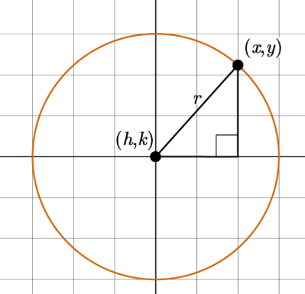
Given the center $\left(h,k\right)$ of the circle and its radius, r, you can find the equation of a circle.  Use this example to walk through the steps of writing the equation of a circle.  Step 1: Identify the center $\left(h,k\right)$.  - The center is at (-1,-2)  - $h=-1$and $k=-2$  Step 2: Identify the radius, $r$. Sometimes, you may need to count the radius from the graph. Start from the center and count on the grid to a point on the circle.  - $r=5$  Step 3: Plug these values into the standard form equation of a circle. Simplify.  - ${\left(x-h\right)}^{2}+{\left(y-k\right)}^{2}=r^{2}$  - ${\left(x-\left(-1\right)\right)}^{2}+{\left(y-\left(-2\right)\right)}^{2}=5^{2}$  - The equation of the circle is:  - ${\left(x+1\right)}^{2}+{\left(y+2\right)}^{2}=25$ | Example:  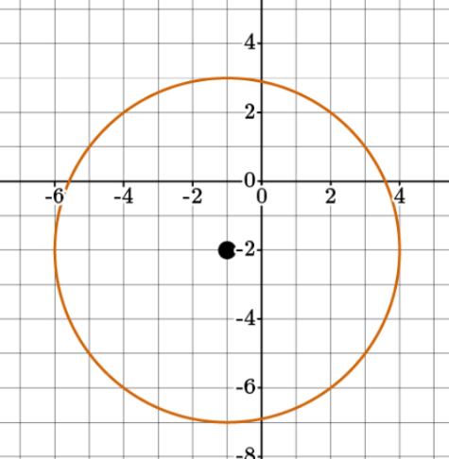
Other relationships to consider:  - In the equation of a circle, the number inside of the parentheses after $x$and $y$is always the opposite of the circle center coordinates $\left(h,k\right)$.  - The number to the right of the equal sign is always the square of the radius value.  - So, you can work backward from the equation of a circle to find the center and the radius. | Example:  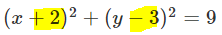  The opposite of the two numbers highlighted is the center of a circle: $\left(h,k\right)→\left(-2,3\right)$  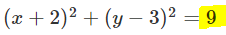  The radius is the square root of 9.  $$r=\sqrt{9}=3$$

Practice Questions and Answers
 | Question | Answer
P 1 | A circle is drawn on a coordinate plane with the center point at (-4, 5) and a radius of 2. Derive the equation of the circle from the given information. Fill in the missing information in the following equation.  (x-_____)² + (y-_____)² = _____ | 0; 3; 9
P 2 | A circle is drawn on a coordinate plane with the center point at (0, 3) and a radius of 3. In the standard form of the Pythagorean Theorem, ${(x-h)}^{2} + {(y-k)}^{2} = r^{2}$, which number would replace the variable k? | 5
P 3 | Use the image to answer the question.  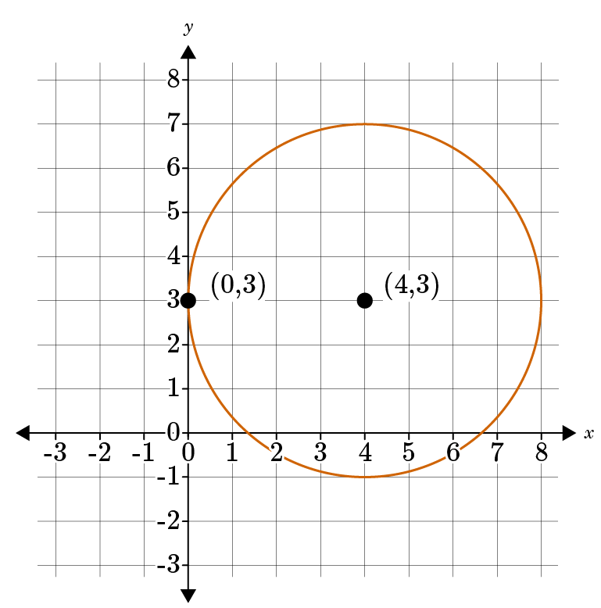  In the circle shown, which of the following equations correctly represents the circle in standard form? Enter the option number of your response.  Option #1: ${(x-3)}^{2}+{(y-4)}^{2}=4$  Option #2: ${(x-4)}^{2}+{(y-3)}^{2}=16$  Option #3: ${(x-0)}^{2}+{(y-3)}^{2}=16$ | 2
P 4 | A circle is drawn on a coordinate plane with the center point at (3, -3) and a radius of 1. In the standard form of the Pythagorean Theorem, ${(x-h)}^{2} + {(y-k)}^{2} = r^{2}$, which number would replace the variable r? | 1
P 5 | A circle is drawn on a coordinate plane with the center point at (7, -2) and a radius of 4. In the standard form of the Pythagorean Theorem, ${(x-h)}^{2} + {(y-k)}^{2} = r^{2}$, which number would replace the variable h? | 7

Quick Check Questions and Answers
 | Question | Answer
Q 1 | A circle is drawn on a coordinate plane with the center point at (-1, 3) and a radius of 5. Derive the equation of the circle from the given information. Fill in the missing information in the following equation.  (x-_____)² + (y-_____)² = _____ | $${(x+1)}^{2}+{(y-3)}^{2} = 25$$
Q 2 | A circle is drawn on a coordinate plane with the center point at (-8, -2) and a radius of 2. Derive the equation of the circle in standard form, using the given information and the Pythagorean Theorem. | $${(x+8)}^{2}+{(y+2)}^{2} = 4$$
Q 3 | Use the image to answer the question.  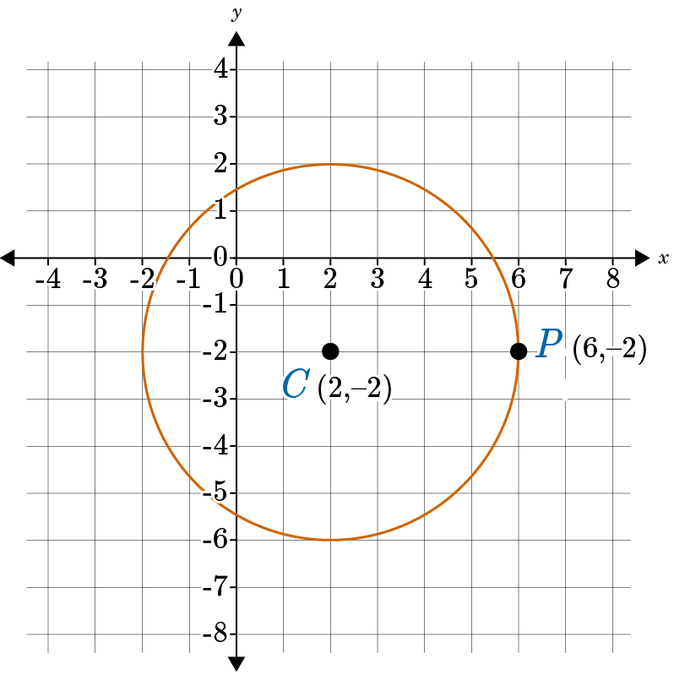  Which equation is the standard form of the equation of a circle drawn on the coordinate plane, derived from the Pythagorean Theorem? | $${(x-2)}^{2}+{(y+2)}^{2} = 16$$
Q 4 | Use the image to answer the question.  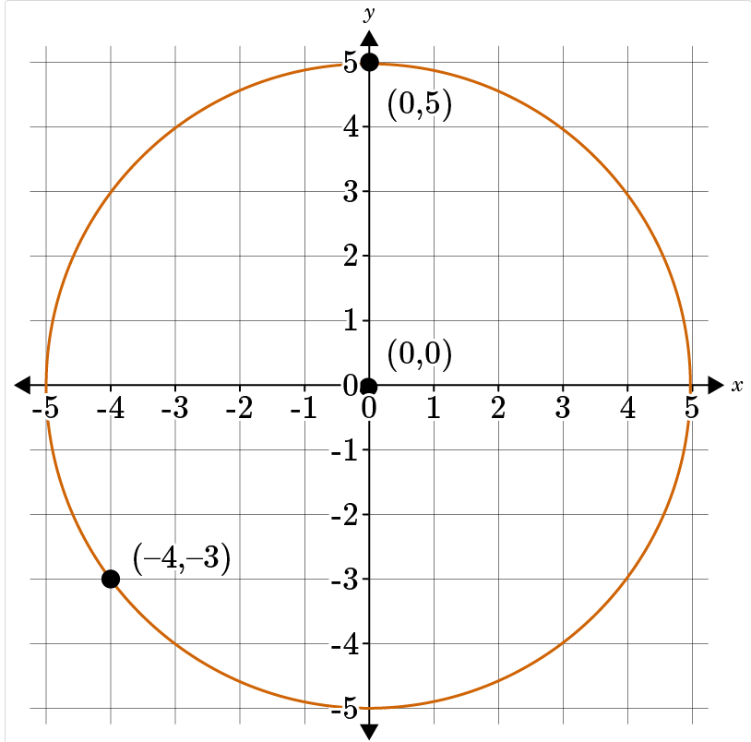  Which equation is the standard form of the equation of a circle drawn on the coordinate plane, derived from the Pythagorean Theorem? | $$x^{2}+y^{2}=25$$
Q 5 | A circle is drawn on a coordinate plane with the center point at (-2, 0) and a radius of 7. Derive the equation of the circle in standard form, using the given information and the Pythagorean Theorem. | $${(x+2)}^{2}+{(y)}^{2} = 49$$

Lesson 3 – Using Equations of Circles
Key Words:
- center – the point around which a circle or sphere is described
- circle – a closed plane curve with every point on the curve equidistant from a fixed point within the curve
- radius – a line from the center to the circumference of a circle
Formulas:
- Equation of a circle: ${\left(x-h\right)}^{2}+{\left(y-k\right)}^{2}=r^{2}$
Objective 1: In this section, you will calculate the center and radius of a circle given by an equation by using the method of completing the square.
Mathematical Practice Standard: Look for and make use of structure.
Big Ideas:
Recall that the standard form equation of a circle is ${\left(x-h\right)}^{2}+{\left(y-k\right)}^{2}=r^{2}$ where $\left(h,k\right)$ is the center of the circle and $r$is the radius.  You can find the equation by plugging $h, k,$and $r$ into that equation. | 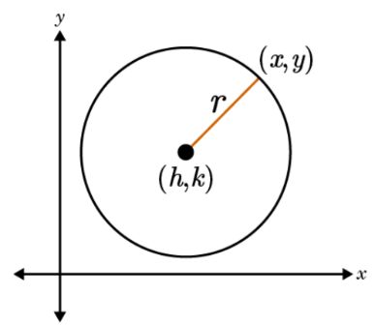
Sometimes, the equation of a circle is not written in standard form, and you need to convert it to standard form. You will need to use the method of completing the square to do so.

What does it mean to “Complete the Square”?
- Set up the equation for completing the square (see example below).
- Complete the square by dividing the coefficient of the middle term, b, by 2, then squaring the quotient; that is, ${\left(\frac{b}{2}\right)}^{2}$.
- Add the number found in Step 2 to both sides of the equation. The left side of the equation is now a perfect square trinomial.

Follow these steps to rearrange the equation of a circle into standard form.

You are given an equation that is not in standard form. | $$x^{2}+y^{2}-10x-2y-10=0$$
Step 1: Move the constant term to the right side of the equation. | $$x^{2}+y^{2}-10x-2y=10$$
Step 2: Rearrange the left side so that common terms are together. | $$x^{2}-10x+y^{2}-2y=10$$
Step 3: Set up the equation to complete the square. | $$\left(x^{2}-10x+_{---}\right)+\left(y^{2}-2y+_{---}\right)=10$$
Step 4: Complete the square for the x-variable.  ($C_{x}$ is used to not that we are completing the square for the x-variable) | $$C_{x}={\left(\frac{-10}{2}\right)}^{2}={\left(-5\right)}^{2}=25$$
Step 5: Complete the square for the y-variable.  ($C_{y}$ is used to not that we are completing the square for the y-variable) | $$C_{y}={\left(\frac{-2}{2}\right)}^{2}={\left(-1\right)}^{2}=1$$
Step 6: Balance the equation. Add the numbers found in steps 4 and 5 to both sides of the equation. | $$\left(x^{2}-10x+25\right)+\left(y^{2}-2y+1\right)=10+25+1$$
Step 7: Factor the left side of the equation to get a pair of perfect square trinomials. | $${\left(x-5\right)}^{2}+{\left(y-1\right)}^{2}=36$$
Step 8: Write the constant as a square.  *Writing $r$as a square makes it easy to identify the radius. | $${\left(x-5\right)}^{2}+{\left(y-1\right)}^{2}=6^{2}$$
The center of the circle is (5,1) and the radius is 6.
*Recall from the previous lesson how to identify the center and the radius from the equation of a circle.

Practice Questions and Answers
 | Question | Answer
P 1 | Calculate the center of the circle by completing the square of the equation $x^{2}+y^{2}-6x-12y+5=0.$ | 3, 6
P 2 | Calculate the radius of the circle by completing the square of the equation $x^{2}+y^{2}-14x-4y=11.$  Radius = | 8
P 3 | Calculate the radius of the circle by completing the square of the equation $x^{2}+y^{2}-8x+16y=-44.$  Radius = | 6
P 4 | Calculate the center of the circle by completing the square of the equation $x^{2}+y^{2}-10x+4y=20.$ | 5, -2
P 5 | Calculate the center of the circle by completing the square of the equation $x^{2}+y^{2}+2x-20y+5=0.$ | (-1, 10)

Quick Check Questions and Answers
 | Question | Answer
Q 1 | Calculate the center and radius of the circle by completing the square of the equation $x^{2}+y^{2}+12x-18y+17=0.$ | Center = (-6, 9)  Radius = 10
Q 2 | Using the equation $x^{2}+y^{2}-8x+2y=8$, calculate the center and radius of the circle by completing the square. | Center = (4, -1)  Radius = 5
Q 3 | Regina is trying to sketch a circle on graph paper with the equation $x^{2}+y^{2}-2x+22y+1=0.$ Calculate where she would need to graph the center and radius of the circle by completing the square. | Center = (1, -11)  Radius = 11
Q 4 | A circle is represented by the equation $x^{2}+y^{2}-16x-6y=-24$. Complete the square to discover the center and radius of the circle. | Center = (8, 3)  Radius = 7
Q 5 | Dedric is trying to graph a circle on a computer software program that has a grid. The equation he is graphing is $x^{2}+y^{2}-20x-14y+5=0.$ Where would he place the center of the circle and what is the radius? | Center = (10, 7)  Radius = 12

Lesson 4 – Equation of a Parabola
Key Words:
- axis of symmetry – a straight line with respect to which a body or figure is symmetrical
- directrix – a fixed straight line that is used as a reference; there is a fixed distance between this line and every point in the parabola
- distance formula – a method of calculating the distance between points on the coordinate plane
- focus – one of the fixed points that with the corresponding directrix defines a curve
- parabola – a plane curve generated by a point moving so that its distance from a fixed point is equal to its distance from a fixed line
- quadratic equation – any equation containing one term in which the unknown is squared and no term in which it is raised to a higher power
- vertex – a point where an axis of an ellipse, parabola, or hyperbola intersects the curve itself
Formulas:
- Equations of a Parabola:
  - Focus/Directrix Form: ${\left(x-h\right)}^{2}=4p\left(y-k\right)$
  - Standard Form: $y=ax^{2}+bx+c$
  - Vertex Form: $y=a{\left(x-h\right)}^{2}+k$
- Distance from the focus to any point $\left(x,y\right)$: $d=\sqrt{{\left(x\right)}^{2}+{\left(y-p\right)}^{2}}$
- Distance from the directrix to any point $\left(x,y\right)$: $d=y+p$
- Distance Formula: $d=\sqrt{{\left(x_{2}-x_{1}\right)}^{2}+{\left(y_{2}-y_{1}\right)}^{2}}$
- Formula for the Axis of Symmetry: $x=-\frac{b}{2a}$, where $a$is the coefficient of the first term in the standard form of a quadratic equation.
Objective 1: In this section, you will derive the equation of a parabola given a focus and directrix.
Mathematical Practice Standard: Reason abstractly and quantitatively.
Big Ideas:
A parabola is a curve that can be modeled by using a quadratic equation. It can be described by having a “U-Shape”.  The axis of symmetry is a line that divides the parabola into two equal halves.  Every point on the curve is an equal distance from a line, called a directrix, and a point, called the focus. | 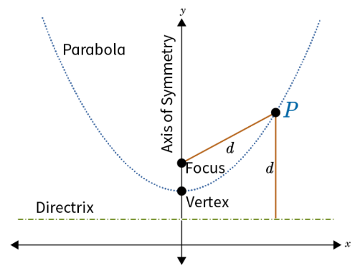
Key features of a graph of a parabola:
- The vertex is located at $\left(h,k\right)$.
- The focus is plotted above the vertex. It lies on the axis of symmetry.
- The directrix is the line drawn below the parabola.
- The distance from the vertex to the focus is equal to the distance from the vertex to the directrix. These distances are labeled $p$.
- A point is plotted on the parabola with coordinates $\left(x,y\right)$.
- The distance from the point to the focus is equal to the distance from the point to the directrix and is labeled $d$.
Equations of a Parabola
Standard Form:  $$y=ax^{2}+bx+c$$ | The quadratic equation is the standard form for a parabolic equation.
Focus/Directrix Form:  $${\left(x-h\right)}^{2}=4p\left(y-k\right)$$  Where $\left(h,k\right)$ is the vertex of the parabola. | Use this equation when you know the vertex $\left(h,k\right)$ and the focus, where $p$is the distance between the vertex and the focus. You will need to manipulate it into standard form.
$$d=\sqrt{{\left(x_{2}-x_{1}\right)}^{2}+{\left(y_{2}-y_{1}\right)}^{2}}$$ | Use this equation, the distance formula, when you know the focus and the directrix. You will need to manipulate it into standard form.  The distance between any point on the parabola $\left(x,y\right)$ is equal in distance to both the focus and the directrix. Set the distance formula for the focus equal to the distance formula for the directrix to solve.

Objective 2: In this section, you will graph a parabola in the coordinate plane.
Mathematical Practice Standard: Use appropriate tools strategically.
Big Ideas:
Graphing a Parabola in the Coordinate Plane
Type 1: Given the focus and the directrix you can graph a parabola.

Example: Graph a parabola with a focus at (6,0) and a directrix at $y=-1$
Step 1: Plot the focus and draw a horizontal line for the directrix. | 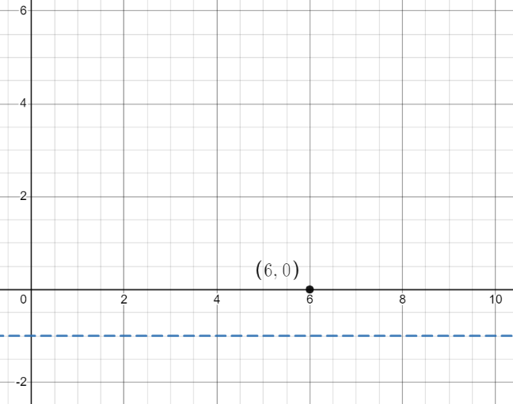
Step 2: Plot the vertex. The vertex is located halfway between the focus and the directrix.  In this example, the directrix is $y=-1$. Halfway between the focus, at $y=0$, and the directrix, $y=-1$, is $y=-\frac{1}{2}$. You will need to plot the point $\left(6,-\frac{1}{2}\right)$ as the vertex. | 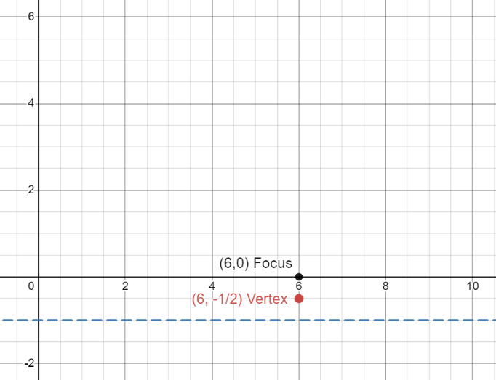
Step 3: Create the equation of the quadratic in standard form. Start by using the distance formula to set the distance between any point $\left(x,y\right)$ on the parabola and the directrix equal to the distance between the point and the focus.  In this example, the left side of the equation represents the point (0, -1), the directrix. The right side represents the point (6,0), the focus. | 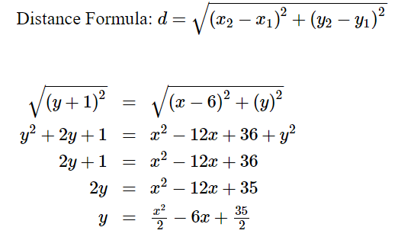
Step 4: Create a table of values using the quadratic equation obtained in step 3.  In this example, we plugged in x-values 4, 5, 6, 7, and 8 to calculate the corresponding y-values. | 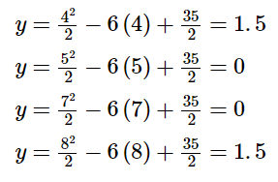  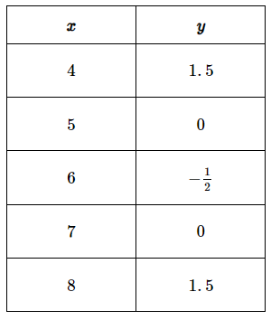
Step 5: Plot each point on the graph and connect them to form a parabola. | 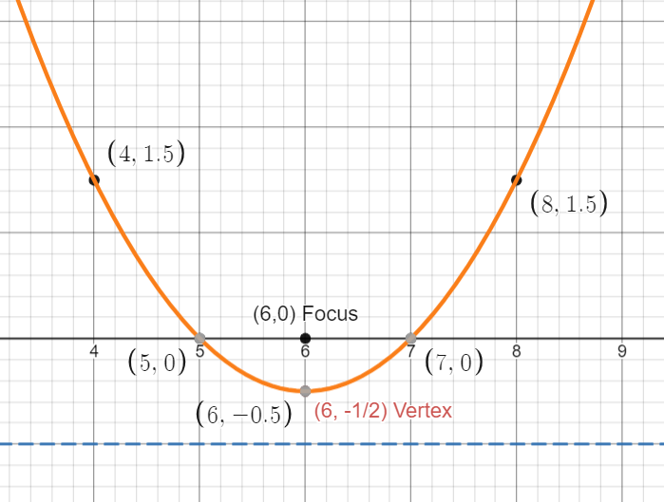
Type 2:
Often, parabolic equations are given in standard form, $y=ax^{2}+bx+c$. The steps are slightly different in this case.

Example: Graph the parabola $y=x^{2}+6x+4$.
Step 1: Find the x-value of the vertex.  To find the vertex, use the formula for the axis of symmetry:  $$x=-\frac{b}{2a}$$  Where $a$ is the coefficient of the first term in the standard form of the quadratic equation. | 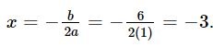
Step 2: Find the y-value of the vertex. | Evaluate $x=-3$in the given parabolic equation.  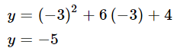
Step 3: Identify the vertex. | The first two steps gives us the x and y values of the vertex.  $$\left(-3,-5\right)$$
Step 4: Create a table of values using the quadratic equation. The vertex should be in the middle of the table. | 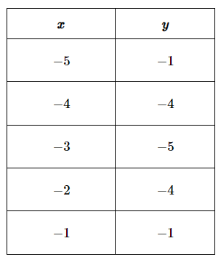
Step 5: Plot each point on the graph and connect them to form a parabola. | 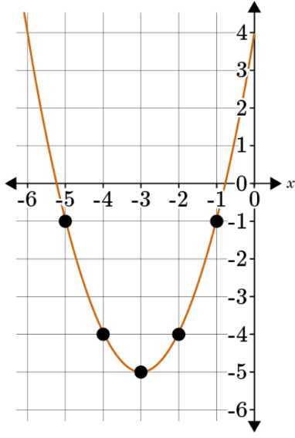

Practice Questions and Answers
 | Question | Answer
P 1 | Derive the equation of a parabola given the focus is at (3, 4) and the directrix is $y=0$. Fill in the missing values of the equation in standard form.  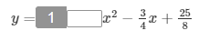 | $$\frac{1}{8}$$
P 2 | Rico is drafting a parabola on a coordinate plane. He wants the focus to be at (0, 4) and the directrix to be $y=2$. What will be the equation, in standard form, that matches this parabola? Fill in the missing values of the equation.  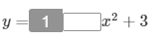 | $$\frac{1}{4}$$
P 3 | You are asked to graph a parabola on a coordinate plane. You are given the information that the focus is located at (3, 6) and the directrix is $y=2$. At which point would you graph the vertex on the coordinate plane?  Vertex: (_____, _____) | 3, 4
P 4 | What is the vertex of a parabola that has a focus at (2, 1) and the directrix at $y=-3$?  Vertex: (_____, _____) | 2, -1
P 5 | Olivia is asked to graph a parabola on a coordinate plane. The focus is located at (0, -3) and the directrix is at y=1. Fill in the missing values on the table for the coordinates of the parabola.  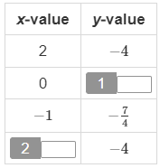 | -1  -2

Quick Check Questions and Answers
 | Question | Answer
Q 1 | Derive the equation of a parabola given the focus is at (6, -2) and the directrix is $y=0$. | $$y=-{\frac{1}{4}x}^{2}+3x-10$$
Q 2 | Demetrius is drafting a parabola on a coordinate plane. He plans to have the focus at (3, 1) and the directrix at $y=-3$. What is the equation in standard form that represents the parabola? | $$y={\frac{1}{8}x}^{2}-\frac{3}{4}x+\frac{1}{8}$$
Q 3 | Rico is asked to graph a parabola given the equation $y=-x^{2}-2x.$ At which point would he graph the vertex of the parabola? | (-1, 1)
Q 4 | Malik is graphing a parabola given by the equation $y=-{\frac{1}{4}x}^{2}+3x-6$. Which table of ordered pairs would match this parabola? | 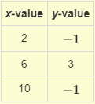
Q 5 | Suppose you were to graph a parabola given by the equation $y=-{\frac{1}{4}x}^{2}+3x-1$. Which ordered pair would be the vertex of the graph? | (-6, -10)

Lesson 5 – Using Equations of Parabolas
Key Words:
- completing the square – the process of making an expression a perfect square trinomial
- directrix – the given line that, along with the focus, helps to define a parabola
- focal length – the distance between the vertex of a parabola and its focus
- focus – the given point that, along with the directrix, helps to define a parabola
- parabola – the set of all points in a plane that are equidistant from a given point (the focus) and a given line (the directrix); the graph of a quadratic function
- quadratic function – a function in the form $f\left(x\right)=ax^{2}+bx+c$
- vertex – the point where a parabola intersects its axis of symmetry
Formulas:
- Equations of a Parabola:
  - Focus/Directrix Form: ${\left(x-h\right)}^{2}=4p\left(y-k\right)$
  - Standard Form: $y=ax^{2}+bx+c$
  - Vertex Form: $y=a{\left(x-h\right)}^{2}+k$
Objective 1: In this section, you will solve and graph mathematical and real-world problems that are modeled with the equation of a parabola.
Mathematical Practice Standard: Make sense of problems and persevere in solving them.
Big Ideas:
The equation of a parabola is a quadratic function. A parabola that opens upwards or downwards can be written in different forms.
Standard Form | $$y=ax^{2}+bx+c$$
Vertex Form | $y=a{\left(x-h\right)}^{2}+k$, where $\left(h,k\right)$is the vertex of the parabola.
Focus/Directrix Form | ${\left(x-h\right)}^{2}=4p\left(y-k\right)$ or $4p\left(y-k\right)={\left(x-h\right)}^{2}$  Where $\left(h,k\right)$ is the vertex of the parabola and $p$is the focal length.
- Sometimes, you will be given the equation of a parabola in one form and asked to rewrite it in a different form.
- If an equation is given in the standard form and you are asked to rewrite it in vertex form or focus/directrix form, you will do this by completing the square.
- Depending on the parabolic equation's form, you can identify certain key features of the parabola.
- For example, if the equation is in focus/directrix form, you can identify the focus and directrix from the equation.

Objective 2: In this section, you will interpret key features of parabolas that model mathematical and real-world problems.
Mathematical Practice Standard: Model with mathematics.
Big Ideas:
  - Parabolas have many key features. You will need to identify certain key features given an equation or a graph.
Key Features of Parabolas
Key Feature | Definition | How to Find | Example
Domain | The set of all possible inputs (x-values) of a function | The standard domain for a parabola that opens upwards or downwards is all real numbers.  Consider if the context restricts the domain in any way. Use the graph if possible. | Domain can be written in inequality notation to show that can be any number between negative infinity and positive infinity: $-∞<x<∞$  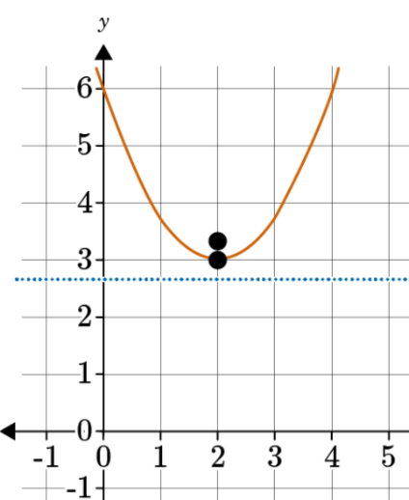
Range | The set of all outputs (y-values) of a function | The y-value of the vertex will be the maximum or minimum depending on whether the parabola opens downwards or upwards.  Consider if the context restricts the range in any way. Use the graph if possible. | The graph shows that the vertex is the minimum output value of this function (using the same graph above). Recall that the range refers to y-values.  The vertex of this graph is (2, 3).  Therefore, the range is any number greater than or equal to 3. Also written as $y≥3$.
Intercepts | The locations where a function intersects the axes | To find the x-intercept(s) algebraically, let $y=0$and solve for $x$. Remember that not all parabolas have x-intercepts.  To find the y-intercepts algebraically, let $x=0$and solve for $y$.  If possible, use the graph to identify where the parabola intersects the axes. | When given a graph, we can identify the intercepts from the graph.  There are no x-intercepts because the graph does not intersect the x-axis. There is one y-intercept at (0,6).  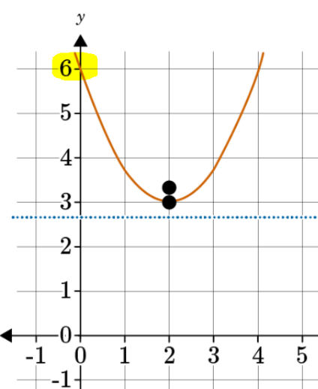
Vertex | the point where a parabola intersects its axis of symmetry; the maximum or minimum point of the parabola | In vertex form or focus/directrix form, the vertex is $\left(h,k\right)$. In standard form, the x-coordinate of the vertex is $-\frac{b}{2a}$.  If possible, use the graph to identify the max/min point. | Again, the graph is available, so we are able to see where the vertex is located at (2, 3).  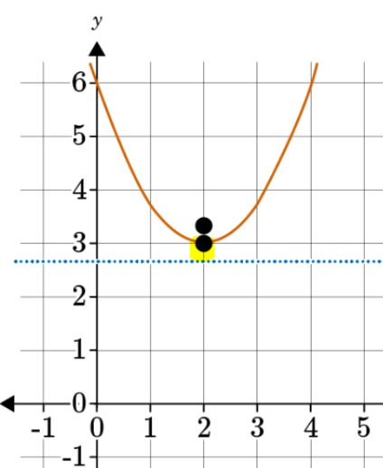  If the graph was not available. You would be able to use the equation to identify the vertex.  For example, from the focus/directrix form: 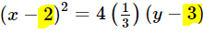
Focus | the given point that, along with the directrix, defines the parabola | Use the focus/directrix form of the equation to determine $p$, the focal length, and $\left(h,k\right)$, the vertex.  - If the parabola opens upwards, $p$will be positive.  - If the parabola opens downwards, $p$will be negative.  - The focus will be the distance of $\left|p\right|$ above the vertex at the point $\left(h, k+p\right)$.  - The directrix will be a horizontal line a distance of $\left|p\right|$ above the vertex at $y=k-p$. | Use the focus/directrix form of the equation to find the exact value of the focus and the directrix:  Recall the focus/directrix form:  $${\left(x-h\right)}^{2}=4p\left(y-k\right)$$  The equation shows the focal length to be $p=\frac{1}{3}$.  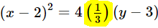  We also know that the vertex $\left(h,k\right)$ is (2,3).  Focus:  Because this parabola opens upward, we know that the focus is above the vertex, located at $\left(h, k+p\right)$.  The focus is $\left(2, 3+\frac{1}{3}\right)$ or $\left(2, \frac{10}{3}\right)$.
Directrix | the given line that, along with the focus, defines the parabola |  | Directrix:  Because the parabola opens upward, the directrix is below the vertex, located at $y=k-p$.  The directrix is $y=3-\frac{1}{3}=\frac{8}{3}$.

Maximizing Area
- The area of a region with variable dimensions can be modeled with a quadratic function.
- The quadratic function can help you maximize the area of the region given certain constraints.

Follow the steps below for problems that ask you to maximize the area using quadratic functions:
Problem Statement | Suppose you have 20 feet of string that you want to turn into a rectangle with the largest area. Let x be the width of the rectangle and y be the length of the rectangle.
Step 1: Write an equation for the perimeter of the rectangle in terms of x, y, and the length of the string. | $$2x+2y=20$$
Step 2: Solve for y. | $$y=10-x$$
Step 3: Write an equation for the area of the rectangle (A) in terms of x and y. | $$A=xy$$
Step 4: Use your equation from Step 2 to rewrite your equation for the area of the rectangle in terms of only x. | $$A=x\left(10-x\right)$$  $$A=10x-x^{2}$$
Step 5: Graph the equation from Step 4. | 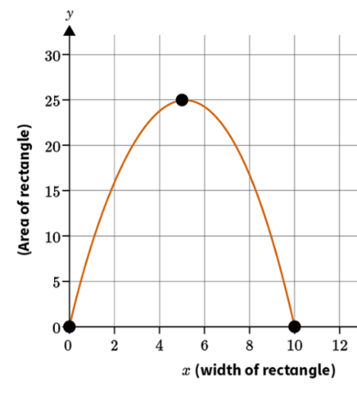
Step 6: Use your graph to explain how to turn the string into a rectangle with the largest area. | The area is represented by the y-coordinates on the graph. The rectangle with the maximum area occurs at the vertex/maximum point. This point is (5,25). When the width of the rectangle is 5 feet, the area of the rectangle will be at its maximum of 25 square feet.

Practice Questions and Answers
 | Question | Answer
P 1 | Raquel designs a new hair clip and plans to start a business selling them. She wants to sell her product at a reasonable price while still making the most money possible. She comes up with the quadratic equation $y={-.75x}^{2}+24x$ to reflect her desired revenue. Solving mathematically, if you were to graph the parabola, at what price would the hair clip earn the most revenue? | 16
P 2 | You and your grandfather attend a live NBA game. One of the players is getting ready to make a free throw. The equation $y={-.0.05x}^{2}+0.8x+6$ represents the trajectory of the ball from when it leaves the player’s hands. The player is 6 feet tall. At what distance from the player does the ball reach its maximum height? | 8
P 3 | You are attending a professional baseball game. The batter hits the ball into right field. You notice the ball, as it is hit, forms a parabolic path from the bat to where it lands in the field. The path the ball traveled can be expressed by the quadratic equation $y=-\frac{1}{42}{\left(x-50\right)}^{2}+60,$where x is the distance from home plate, and y is the height in the air as the ball travels in the air. Interpret the following key feature of the parabola in terms of the context.  Range: $0≤y≤$ _____ | 60
P 4 | While golfing with friends, you hit the ball from the tee box, then use a tracking device to determine the data of your golf ball as it is in the air. You calculate that your ball reached a maximum height of 35 yards at a distance of 40 yards, before descending. In terms of the context, which key feature would represent the maximum height of the ball?  Option #1: vertex  Option #2: domain  Option #3: intercepts  Option #_____ describes the point at which the ball reached maximum height before descending. | 1
P 5 | A farmer is fencing off an area in his yard. He buys 50 feet of fencing to make a rectangular enclosure. He wants to make the fenced area as big as possible for the amount of fencing he has. In terms of the context, what is the maximum area he can create with the fencing?  _____ feet² | 156.25

Quick Check Questions and Answers
 | Question | Answer
Q 1 | Jackie, who is 5 feet tall, throws a football into the air as if she were throwing it to someone. The path of the football can be expressed by the equation $y={-0.05x}^{2}+.75x+5$. Solve as if you were to graph the parabola to figure out how far from Jackie the ball landed. | 20 feet
Q 2 | A tennis ball is pitched from a machine into the air; the trajectory of the ball can be expressed by the equation $y={-0.05x}^{2}+\frac{4}{5}x+3$ , taking into consideration that the ball is ejected from the machine 3 feet above the ground. Suppose you were to graph the parabola; at what point would the vertex be located? | (8, 6.2)
Q 3 | The seat on a swing set sits 3 feet off the ground. The chains that are attached to the seat are 74 inches long. Suppose you were to swing: the path of the swing forms a parabola. Interpret the y-value of the vertex, in terms of the context. | y = 3
Q 4 | Regina has finished writing her first book, Successful Steps to College Success. She wants to determine the price at which she should sell her book in order to maximize her revenue. This situation is expressed by the equation $y=-{0.5x}^{2}+24x$ , where x represents the price and y represents the revenue. In terms of the context, what price should Regina sell the book to earn maximum revenue? | $24
Q 5 | A football is thrown into the air. It reaches a maximum height of 18 yards and lands 78 yards from where it was thrown. Which answer option represents the domain, in terms of the context? | $$0≤x≤78$$

Lesson 6 – 2D and 3D Objects
Key Words:
- cone – a solid bounded by a circular or other closed plane base and the surface formed by line segments joining every point of the boundary of the base to a common vertex
- cross section – a cutting or piece of something cut off at right angles to an axis
- cube – a three-dimensional regular solid made of six equal squares for sides
- cylinder – a three-dimensional solid with two parallel circular bases that are identical and joined by a curved surface
- prism – a solid with two parallel polygonal bases connected by parallelogram-shaped lateral faces
- pyramid – a polyhedron consisting of a base which may be any polygonal shape, and triangular faces meeting at a common vertex
- rotation – the circular motion of a figure around a fixed center point
- sphere – a solid that is bounded by a surface consisting of all points at a given distance from its center

Objective 1: In this section, you will identify the shapes of two-dimensional cross sections of three-dimensional objects.
Mathematical Practice Standard: Reason abstractly and quantitatively.
Big Ideas:
- A cross-section is the two-dimensional shape created when “slicing” three-dimensional shape.
  - Horizontal cross-section: This is a “left to right” cut that is parallel to the base of the shape. It will create a 2D shape that mimics the shape of the base of the 3D shape.
  - Vertical cross-section: This is an “up and down” cut and mimics the shape of the faces of a 3D shape.
3D Shape | Explore the cross-sections
Rectangular Prism  (has a rectangular base)  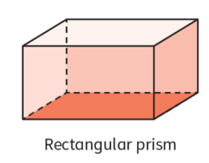  * Prisms are named by the shape of their bases and their top and bottom faces. | Sections of Rectangular Prisms (Cuboids) – GeoGebra
Triangular Prism  (has a triangular base)  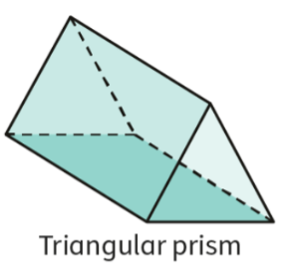  * Prisms are named by the shape of their bases and their top and bottom faces. | Sections of Triangular Prisms – GeoGebra
Pyramid  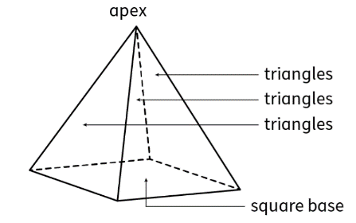  Pyramids have a square base and all its faces are triangles that meet at a common vertex. | Pyramid section – GeoGebra  Sections of Rectangular Pyramids – GeoGebra
Cube  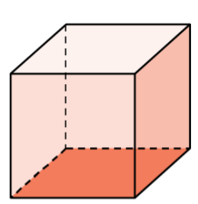  All faces of a cube are the same length and width. | The cross-section of a cube, whether sliced vertically or horizontally, is a square.  Exploring Sections of Cubes – GeoGebra
Cone  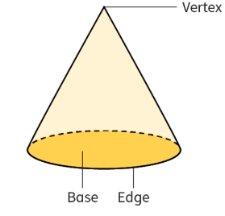 | Sections of Cones – GeoGebra
Cylinder  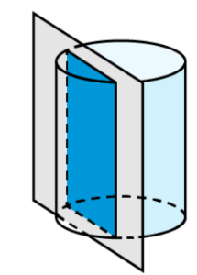 | Sections of Cylinders – GeoGebra
Sphere  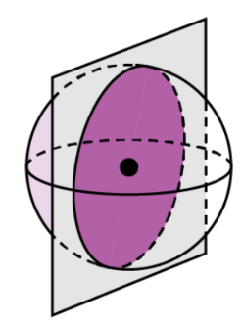 | Sections of Spheres – GeoGebra

Objective 2: In this section, you will identify three-dimensional objects generated by rotations of two-dimensional objects.
Mathematical Practice Standard: Reason abstractly and quantitatively.
Big Ideas:
- Two-dimensional figures can be rotated around a center point to create three-dimensional figures.
- Recall that a full circle is 360 degrees.
- Rotations use full circles to create a new figure.
- There is a correlation between the vertical cross-section of a 3D figure and the shape it makes when being rotated. Recall the different cross-sections of 3D figures.
- Explore what happens when rotating different two-dimensional shapes
  - Rotating 2D shapes to make 3D Shapes – GeoGebra

Practice Questions and Answers
 | Question | Answer
P 1 | Picture a triangular wedge of cheese standing on one of its bases. After determining the shape of the three-dimensional object, state the number of sides of its horizontal cross section.  The horizontal cross section of a wedge of cheese has _____ sides. | 3
P 2 | Picture a traffic cone in the street. Then, imagine taking a vertical cross section from the traffic cone. What shape will the vertical cross section be?  Option #1: circle  Option #2: triangle  Option #3: rectangle  Option #4: square  The vertical cross section is the shape of Option #_____ | 2
P 3 | Observe a common household battery, such as AA, AAA, or C, and determine its three-dimensional shape. How many sides will its vertical cross section have when the battery is standing up?  The vertical cross section of a household battery has _____ sides. | 4
P 4 | Identify the three-dimensional object created by rotating a right triangle.  Option #1: sphere  Option #2: rectangular prism  Option #3: hemisphere  Option #4: cone  Option #5: cylinder | 4
P 5 | A domino is rotated around one of its shorter edges. Which three-dimensional object is formed by this rotation?  Option #1: sphere  Option #2: rectangular prism  Option #3: hemisphere  Option #4: cone  Option #5: cylinder | 5

Quick Check Questions and Answers
 | Question | Answer
Q 1 | What two-dimensional shape is formed by a horizontal cross section of a cube? | a square
Q 2 | An Olympic swimming pool is in the shape of a rectangular prism. What is the two-dimensional shape of the horizontal cross section? | a rectangle
Q 3 | Suppose $ΔABC$ with A (0, 0), B (3, 5) and C (0, 5) is rotated about side $\overline{CD}$. Identify the three-dimensional object formed. | a cone with a height of 3 units and a diameter of 10 units
Q 4 | A circle has its center at the origin of a coordinate plane. If you were to isolate one-quarter of the circle in Quadrant III and rotate that quarter about the x-axis, what three-dimensional object would be formed? | a hemisphere
Q 5 | An isosceles right triangle with legs measuring 4 inches is rotated about one of its legs. What three-dimensional object is formed as a result? | cone with a diameter of 8 inches
Lesson 7 – Volume of a Cylinder
Key Words:
- base – a flat surface of a three-dimensional figure
- cylinder – a three-dimensional solid with two parallel circular bases that are identical and joined by a curved surface
- volume – the amount of space occupied by a three-dimensional object as measured in cubic units
Formulas:
- Volume of a Cylinder: $V=πr^{2}h$
- Calculate the radius when given diameter: $r=\frac{d}{2}$
Objective 1: In this section, you will describe the formula for the volume of a cylinder.
Mathematical Practice Standard: Reason abstractly and quantitatively.
Objective 2: In this section, you will calculate the solution to problems with the volume formula for cylinders.
Mathematical Practice Standard: Attend to precision.
Big Ideas:
- Recall that volume is the measure of the amount of space occupied by a three-dimensional object.
  - Take a cylinder, like a cup, for example. How much liquid can the cup hold?
- The formula for the volume of a cylinder is related to the formula for the area of a circle.
  - Recall the area of a circle is $A=πr^{2}$
- Think about a cylinder as a bunch of circles stacked on top of each other.
  - Each circle has an area of $πr^{2}$ and is one unit thick. The volume of the cylinder is the product of the area of each of these circles and the number of circles stacked up ($h$).
- Explore the volume of a cylinder here: Volume of a cylinder – GeoGebra
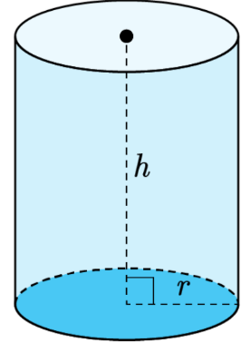 | The formula to calculate the volume of a cylinder is:  $$V=πr^{2}h$$  Where $r$represents the radius of the circle at the base, and $h$represents the height of the cylinder.  Because you are multiplying three variables together ($r, r, h$), the units for Volume will always be cubed.

- Tips for calculating the volume of a cylinder:
  - Recall that the radius is half of the diameter.
  - Sometimes, you will be asked to leave the answer in terms of $π$. Though, other times, a problem will ask you to carry out one more step by using an estimate for $π$ (usually 3.14) to get an answer expressed as a decimal.
  - Sometimes, the volume is given to you, and you are asked to find another variable. This may require you to rearrange the volume formula for the variable you need to solve for.
- Apply what you know:
Find the volume of the following cylinder:
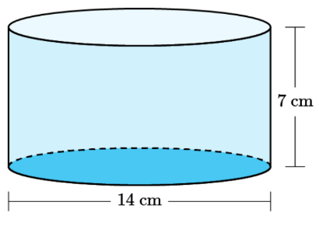
Write the formula first. | $$V=πr^{2}h$$
Identify the given values. | $$h=7 cm$$  $$d=14 cm$$  We need the radius for the volume formula.  $$r=\frac{d}{2}=\frac{14}{2}=7 cm$$
Plug the values into the volume formula and solve for V. | $$V=π{\left(7\right)}^{2}\left(7\right)$$  $$V=343π$$
State the answer. | The volume of the cylinder is $343π cm^{3}$ or cubic centimeters.

Practice Questions and Answers
 | Question | Answer
P 1 | The informal argument for the formula for the volume of a cylinder is based on thinking of a cylinder as which of the following?  Option #1: stacked squares  Option #2: stacked rectangles  Option #3: stacked circles  Option #4: stacked triangles | 3
P 2 | Which option best describes how to find the volume of a cylinder?  Option #1: Add the area of the cylinder’s base to its height.  Option #2: Multiply the area of the cylinder’s base by its height.  Option #3: Add the area of the cylinder’s lateral face to its height.  Option #4: Multiply the area of the cylinder’s lateral face by its height.  Option #_____ best describes how to find the volume of a cylinder. | 2
P 3 | Which two quantities could be used to find the volume of a cylinder?  Option #1: radius and diameter  Option #2: circumference and radius  Option #3: diameter and circumference  Option #4: radius and height  The two quantities in Option #_____ could be used to find the volume of a cylinder. | 4
P 4 | A cylindrical grain bin on a farm has a volume of 31,400 cubic feet. Find the height of the grain bin if the cylinder’s diameter is 40 feet long. Use 3.14 for π.  h = _____ ft. | 25
P 5 | A cylindrical recycling container has a height of 76 centimeters, but the radius is unknown. Find the radius if the container has a volume of 600,000 cm³. Round your answer to the nearest whole number.  The radius is about _____ cm. | 50

Quick Check Questions and Answers
 | Question | Answer
Q 1 | Which statement best describes an informal argument for the formula for the volume of a cylinder? | A cylinder is a stack of h circles, each with an area of πr² and a thickness of one unit, so its volume formula is V = πr²h.
Q 2 | Shelly knows the area of the base of a cylinder. What other information does she need to find its volume? | the height of the cylinder
Q 3 | What other formula does the formula for the volume of a cylinder rely on? | the formula for the area of a circle
Q 4 | Calculate the volume of a cylinder with a height of 25 millimeters and a diameter of 40 millimeters. | 10,000π mm³
Q 5 | Calculate the volume of a cylinder with a height of 20 centimeters and a radius of 5 centimeters. Leave your answer in terms of π. | 500π cm³

Lesson 8 – Volume of a Cone
Key Words:
- base – a flat surface of a three-dimensional figure
- cone – a solid bounded by a circular plane or other closed-plane base, and the surface is formed by line segments joining every point of the boundary of the base to a common vertex
- cylinder – a solid figure with two congruent round, flat bases and a curved surface connecting them
- height – the vertical distance from the base of a solid figure to its highest point
- radius – a line from the center to the circumference of a circle
- vertex – a point (as of an angle, polygon, polyhedron, graph, or network) that terminates a line or curve or comprises the intersection of two or more lines or curves
- volume – the amount of space occupied by a three-dimensional object as measured in cubic units
Formulas:
- Volume of a Cone: $V=\frac{1}{3}πr^{2}h$
- Calculate the radius when given diameter: $r=\frac{d}{2}$
Objective 1: In this section, you will describe an informal argument for the formula giving the volume of a cone based on the formula for the volume of a cylinder.
Mathematical Practice Standard: Reason abstractly and quantitatively.
Objective 2: In this section, you will calculate solutions to problems that require using the volume formula for a cone.
Mathematical Practice Standard: Attend to precision.
Big Ideas:
- Recall that volume is the measure of the amount of space occupied by a three-dimensional object.
  - Take a cone, for example, like an ice cream cone. How much ice cream can it hold without overflowing?
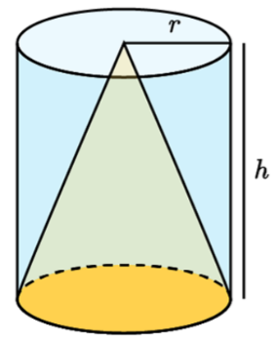 | The volume of a cone is related to the volume of a cylinder. The volume of a cone is one-third the volume of a cylinder with the same radius and height.  Explore the volume of a cone here:  Volume of a Cylinder vs Cone Investigation – GeoGebra
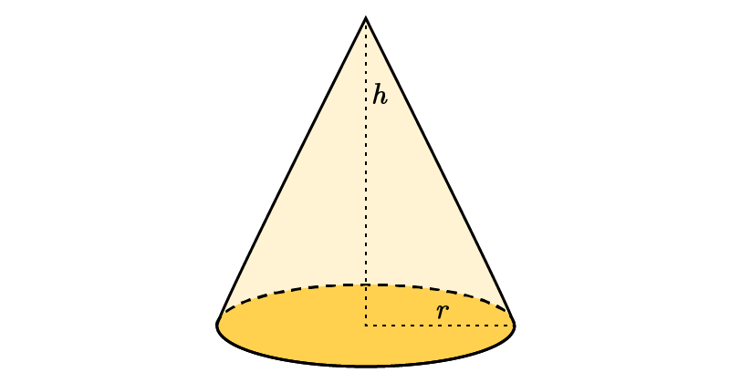 | The formula for the volume of a cone is:  $$V=\frac{1}{3}πr^{2}h$$  Where $r$represents the radius of the circle at the base, and $h$represents the height of the cone.  Because you are multiplying three variables together ($r,r,h$), the units for Volume will always be cubed.
- Tips for calculating the volume of a cone:
  - Ensure that both height and radius are measured in the same units. If not, you will need to convert them before applying the volume formula.
  - Recall that the radius is half of the diameter.
  - Sometimes, you will be asked to leave the answer in terms of $π$. Though, other times, a problem will ask you to carry out one more step by using an estimate for $π$ (usually 3.14) to get an answer expressed as a decimal.
  - Sometimes, the volume is given to you, and you are asked to find another variable. This may require you to rearrange the volume formula for the variable you need to solve for.
- Apply what you know:
Clinton wants to find the volume of a cone that has a height of 3 millimeters and a base with a radius of 2 millimeters. What is the volume of the cone in cubic millimeters?
Write out the formula. | $$V=\frac{1}{3}πr^{2}h$$
Identify the values. | Height: $h=3 mm$  Radius: $r=2 mm$
Plug the values into the formula and solve. | $$V=\frac{1}{3}πr^{2}h$$  $$V=\frac{1}{3}π{\left(2\right)}^{2}\left(3\right)$$  $$V=4π$$
State the answer. | The volume of Clinton’s cone is $4π mm^{3}$ or cubic millimeters.

Practice Questions and Answers
 | Question | Answer
P 1 | A cone has a volume of 100 π cubic inches. If the height of the cone is 12 inches, then what is the radius of the cone?  The radius of the cone is _____ inches. | 5
P 2 | A cube and a cylinder have identical heights and an identical base radius. Nevaeh knows the volume of the cylinder. What must she do to find the volume of the cone?  To find the volume of the cone, Nevaeh must multiply the volume of the cylinder by _____. | $$\frac{1}{3}$$
P 3 | Find the height of a cone that has a volume of 225 π cubic meters and a diameter of 10 meters.  The height of the cone is _____ meters. | 27
P 4 | Erik measures a cone with a radius of 12 feet and a height that is half the length of the radius. What is the volume of Erik’s cone? Use 3.14 for pi and express your answer to the nearest tenth of a cubic foot.  The volume of Erik’s cone is _____ cubic feet. | 904.3
P 5 | Use image to answer the question.  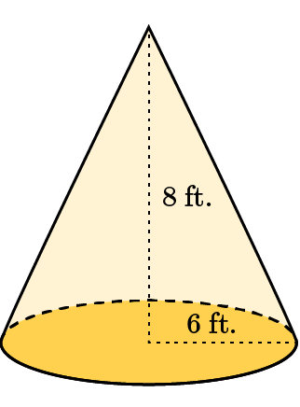  What is the volume of the cone in the image? Round the volume to the nearest cubic foot, and use 3.14 for the value of pi.  The volume of the cone is ____ cubic feet. | 301

Quick Check Questions and Answers
 | Question | Answer
Q 1 | Describe an informal argument for the volume of a cone. If you know the volume of a cylinder, what must you do to find the volume of a cone that has the same height and base radius? | You need to multiply the volume of the cylinder by $\frac{1}{3}$.
Q 2 | Eduardo makes a cone out of clay with a height that’s twice the length of the diameter. The diameter of the cone is 30 centimeters. Find the volume of the cone. | 4,500 π cm³
Q 3 | An ice cream shop currently sells soft-serve ice cream in cones that have a radius of 3 inches and a height of 6 inches. The shop wants to offer a wider cone for their hard-serve ice cream that has the same volume as their existing cone but a wider radius of 4 inches. What will be the height, to the nearest inch, of the new cone? | 3 inches
Q 4 | A cone has a height of 9 inches and a diameter of 4 inches. Calculate the volume of the cone. | 12π in.³
Q 5 | Use the image to answer the question.  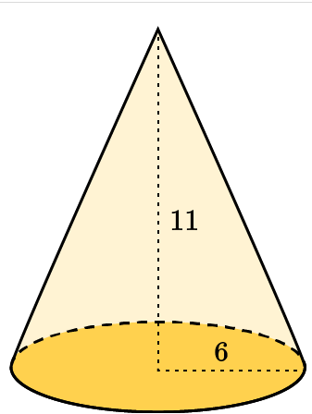  Tarik finds the volume of the cone in the image. What is the volume of the cone in cubic units? | 132π cubic units

Lesson 9 – Volume of a Pyramid
Key Words:
- base – a flat surface of a three-dimensional figure
- cube – a solid figure with six square faces
- face – a flat polygonal surface that forms the boundary of a solid object
- height – the vertical distance from the base of a solid figure to its highest point
- polyhedron – a three-dimensional shape with all flat faces
- pyramid – a polyhedron consisting of a base which may be any polygonal shape, and triangular faces meeting at a common vertex
- vertex – a point (as of an angle, polygon, polyhedron, graph, or network) that terminates a line or curve or comprises the intersection of two or more lines or curves
- volume – the amount of space occupied by a three-dimensional object as measured in cubic units
Formulas:
- Volume of a Cube: $V=lwh$
- Volume of a Pyramid: $V=\frac{1}{3}lwh$ or $V=\frac{1}{3}ah$
  - Area given height and volume: $a=\frac{1}{h}3V$
  - Height given area and volume: $h=\frac{1}{a}3V$
Objective 1: In this section, you will describe an informal argument for the formula that gives the volume of a pyramid, based on the formula for the volume of a cube.
Mathematical Practice Standard: Reason abstractly and quantitatively.
Objective 2: In this section, you will calculate the solution to problems involving the volume of pyramids.
Mathematical Practice Standard: Attend to precision.
Big Ideas:
- A pyramid is made up of a square base with triangular faces that meet at a vertex.
- Recall that volume is the measure of the amount of space occupied by a three-dimensional object.
- The volume of a pyramid has a relationship with the volume of a cube.
- Be aware that any polygon can serve as the base of a pyramid. This lesson will focus on the square pyramid.
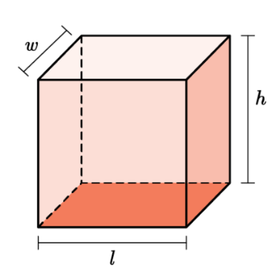 | The formula for the volume of a cube is:  $V=lwh$  Where $l,w,h$are the length width and height.
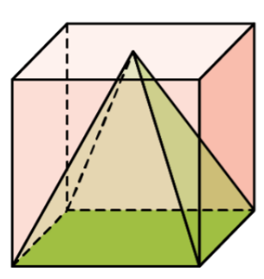 | The volume of a cube is related to the volume of a pyramid. The volume of a cube is three times the volume of a pyramid. This means that the pyramid has one-third the volume of a cube.  Explore this relationship here:  Volume of a pyramid – GeoGebra
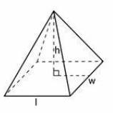 | The formula for the volume of a pyramid is:  $$V=\frac{1}{3}lwh$$  Where $l$and $w$are the length and width of the square base and $h$is the height of the pyramid from the center of the base to the vertex.
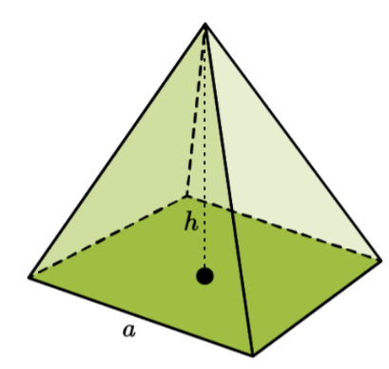 | You will also see the formula of a pyramid as this:  $$V=\frac{1}{3}ah$$  Where $a$is the area of the base ($l⋅w$) and $h$is the height of the pyramid from the center of the base to the vertex.
- Tips for calculating the volume of a pyramid:
  - The volume is expressed in cubic units because it describes the amount of three-dimensional space the figure takes up $\left(l,w,h\right)$.
  - Ensure that all measurements are in the same units. If not, you will need to convert them before applying the volume formula if not.
  - Sometimes, the volume is given to you, and you are asked to find another variable. This may require you to rearrange the volume formula for the variable you need to solve for.
    - See the formulas section for these equations.
- Apply what you know:
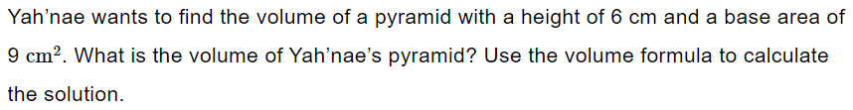
Write out the formula you will use.  The area $\left(l⋅w\right)$ is given so we will use the formula with area, $a$, in it. | $$V=\frac{1}{3}ah$$
Identify the measurements. | Height: $h=6 cm$  Area: $a=9 cm^{2}$
Plug the values into the formula. | $$V=\frac{1}{3}\left(9\right)\left(6\right)$$
Solve for the volume. | $$V=\frac{1}{3}\left(54\right)$$  $$V=18$$
State the answer. | The volume of the pyramid is $18 cm^{3}$.

Practice Questions and Answers
 | Question | Answer
P 1 | A square-based pyramid has height h and base area a. A cube has the same base area and the same height. If the cube has a volume of 195 cubic centimeters, what is the volume of the pyramid?  The pyramid has a volume of _____ cubic centimeters. | 65
P 2 | Latoria has a cube and a square-based pyramid. The two figures have the same height and their bases have the same area. Latoria knows that the volume of the cube is 330 cubic inches. What is the volume of the pyramid?  The volume of the pyramid is _____ in.³. | 110
P 3 | A square-based pyramid has a height of 3 inches and a base area of 9 square inches. Can you find the volume of a cube with the same dimensions as the pyramid? Enter 1 for yes or 2 for no. | 1
P 4 | The area of a square-based pyramid is 50 square yards. The volume of the pyramid is 250 cubic yards. What is the height of the pyramid?  The height of the pyramid is _____ yards. | 15
P 5 | Use the image to answer the question.  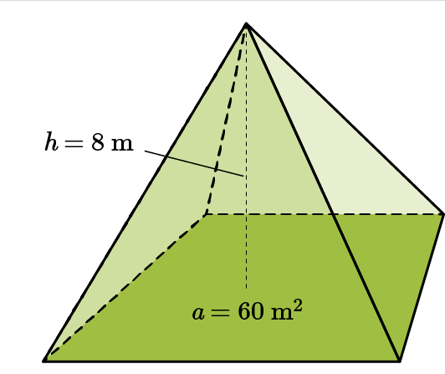  Joao constructs a square-based pyramid. What is the volume of the pyramid?  The volume of the pyramid is _____ cubic meters. | 160

Quick Check Questions and Answers
 | Question | Answer
Q 1 | Describe an informal argument for the volume of a pyramid based on the volume of a cube. A cube has a volume of 12 cubic meters. A square-based pyramid has the same base area and the same height as the cube. What is the volume of the pyramid? | 4 m³
Q 2 | A cube has a height of 12 centimeters and a base area of 144 square centimeters. What is the volume of a square-based pyramid with the same base area and height? | 576 cm³
Q 3 | Ahmad constructs a square-based pyramid and a cube out of newspaper. The two figures have the same height and the same base area. What is the volume of the pyramid if the volume of the cube is 54 cubic units? | 18 cubic units
Q 4 | Calculate the volume of a square-based pyramid in which the area of the base is 12 square units and the height is 15 units. | 60 cubic units
Q 5 | Use the image to answer the question.  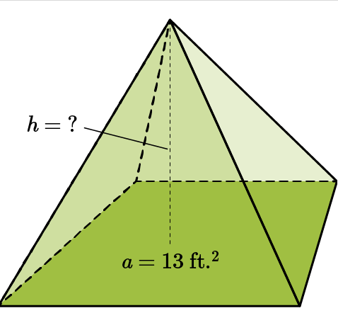  Fatima measures this square-based pyramid. She finds that its volume is 52 cubic feet. What is the height of Fatima’s pyramid? | 12 ft.

Lesson 10 – Volume of a Sphere
Key Words:
- diameter – a line segment passing through the center of a circle
- radius – a line from the center to the circumference of a circle
- sphere – a solid that is bounded by a surface consisting of all points at a given distance from its center
- volume – the amount of space occupied by a three-dimensional object as measured in cubic units
Formulas:
- Volume of a Sphere: $V=\frac{4}{3}πr^{3}$
- Radius given diameter: $r=\frac{d}{2}$
Objective 1: In this section, you will calculate the solution to problems using the volume formula for spheres.
Mathematical Practice Standard: Attend to precision.
Big Ideas:
- Recall that volume is the measure of the amount of space occupied by a three-dimensional object.
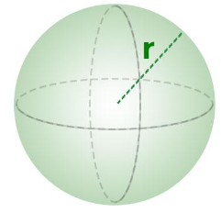 | The formula for the volume of a sphere is:  $$V=\frac{4}{3}πr^{3}$$  Where $r$is the radius.  Explore the volume of a sphere:  Volume Of Sphere – GeoGebra
- Tips for calculating the volume of a cone:
  - The volume is expressed in cubic units because it describes the amount of three-dimensional space the figure takes up $\left(r⋅r⋅r\right)$.
  - Recall that the radius is half of the diameter.
  - Sometimes, you will be asked to leave the answer in terms of $π$. Though, other times, a problem will ask you to carry out one more step by using an estimate for $π$ (usually 3.14) to get an answer expressed as a decimal.
  - Sometimes, the volume is given to you, and you are asked to find another variable. This may require you to rearrange the volume formula for the variable you need to solve for.
- Apply what you know:
Calculate the volume of a sphere that has a diameter of $4 cm$.
Write the formula you will use. | $$V=\frac{4}{3}πr^{3}$$
Identify the measurements needed. | In this problem, you are given the diameter. You need to find the radius from the diameter.  $$d=4 cm$$  $$r=\frac{d}{2}=\frac{4}{2}=2 cm$$
Plug the value into the formula. | $$V=\frac{4}{3}πr^{3}$$  $$V=\frac{4}{3}π{\left(2\right)}^{3}$$
Solve for the volume. | $$V=\frac{4}{3}π{\left(2\right)}^{3}$$  $$V=\frac{4}{3}π\left(8\right)$$  $$V=10.67π$$
State the answer. | The volume of the sphere is $10.67π cm^{3}$.
Remember, sometimes you will be asked to calculate your answer using 3.14 for $π$. | $$V=10.67\left(3.14\right)$$  $$V=33.49 cm^{3}$$

Practice Questions and Answers
 | Question | Answer
P 1 | Calculate the volume of a sphere that has a diameter of 7 inches. Use 3.14 for pi and round to the nearest tenth.  _____ inches³ | 179.5
P 2 | Raphael wants to purchase an exercise ball. The dimensions state that the ball is 20 inches in diameter when at maximum capacity. How much air can the exercise ball hold when pumped to the maximum capacity? Calculate your answer using 3.14 for pi and round to the nearest tenth.  _____ inches³ | 4,186.7
P 3 | Use the image to answer the question.  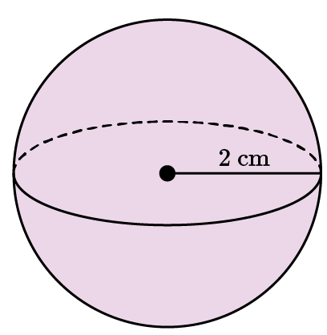  Calculate the volume of the sphere using 3.14 for pi and round to the nearest tenth.  _____ cm³ | 33.5
P 4 | You buy a sphere-shaped piece of chocolate that has a creamy center. The chocolate piece measures 1 inch in diameter. How much creamy filling can fit inside the chocolate piece? Calculate your answer in terms of π and round to the nearest tenth.  _____ inches³ | 0.5
P 5 | Calculate the volume of a sphere that has a diameter of 5 inches. Use 3.14 for pi and round to the nearest tenth.  _____ inches³ | 65.4

Quick Check Questions and Answers
 | Question | Answer
Q 1 | Calculate the volume of a sphere that has a radius of 7 cm using 3.14 for pi and round to the nearest hundredth. | 1,436.03 cm³
Q 2 | Shakira is making a round piñata for a celebration. Her plan is to fill the inside with confetti. If the piñata measures 18 inches in diameter, what is its volume using 3.14 for pi and rounded to the nearest tenth? | 3,052.1 inches³
Q 3 | Use the image to answer the question.  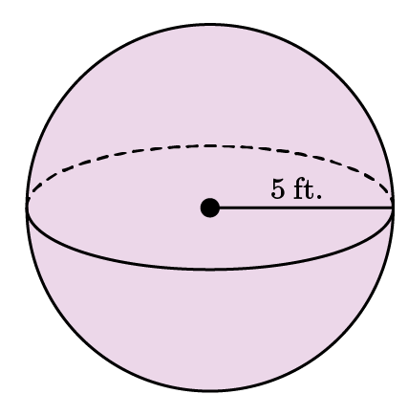  What is the volume of the sphere using 3.14 for pi and rounded to the nearest tenth? | 523.3 ft.³
Q 4 | You purchase a soccer ball that at full capacity measures 8 inches in diameter. How much air can the ball hold if it is pumped to full capacity? Calculate using 3.14 for pi and round to the nearest whole number. | 268 inches³
Q 5 | Use the image to answer the question.  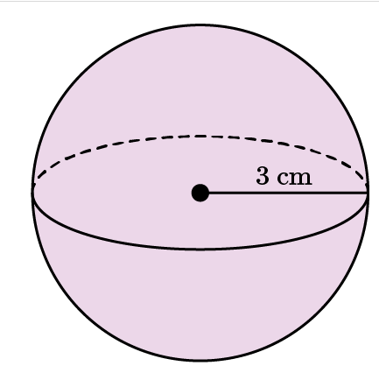  Calculate the volume of the sphere using 3.14 for pi and round to the nearest tenth. | 113.0 cm³

